

Report
MODULE: Psychology in Health and Social Care
MODULE CODE: BMSW4003
STUDENT NAME: RICHARD OJI
STUDENT NUMBER: 2013435

LECTURAL: Diya Ganguly

TABLE OF CONTENTS

Introduction……………………………………………....................3
Erik Erikson`s Stages of Development (Infancy)…….3-4-5
Role of Health Care Practitioners…………….....................6
Reflection and Application on Future Career……………….7
Conclusion……………………………………………………….…….......8
References………………………………………………………………9-10

Introduction
Erik Erikson designed one of the most applied psychosocial theories in understanding the development of humans from birth to later stages in life, and it is aimed at helping in understanding the needs that each stage entails. Knight (2016) explains that the theory explores the social experience during an individual’s life, and as such shows how the psychosocial theories and social interaction plays a role in the development of human. However, this report will be focusing on the first stage of “Erik Erikson`s psychosocial theory”, (Infancy) and analysing of the stage as described in the theory. It then continues to explain the impact, and the theory has on individual wellbeing and social care settings. Lastly, the application of the theory on the future career will be established.
Erik Erikson's Stages of Development
Erik Erikson adopted his psychosocial theory belief from (Sigmeund Freud) who believed that events in our childhood have a great influence on our adult lives, shaping our personality (Freud and Strachey, 2001). As development is characterised following some series of stage related conflicts between two perspectives and Erikson believed that you must hold both perspectives in order to achieve identity strengths, Erikson defined as virtues (Scheck, 2014). Personality development goes through various predetermined eight stages of psychosocial development stages from infancy to adulthood. However, individuals experience a psychosocial crisis which could lead to a positive or negative outcome for personality development (Mcleod, 2018). The theory establishes that development in a certain stage builds on the nature of the preceding one. Conflicts during the transitions between stages arise due to their development of a certain quality, or failure in developing a quality. Both the potential for growth and failure are high during the periods. Success in dealing with the conflicts leads to psychological strengths, and ineffectiveness in handling conflicts imply lack of development of vital skills. The theory then extends to identifying that each stage has an area of competence that should be prioritized. Once the competence is achieved, the person gets a sense of mastery.
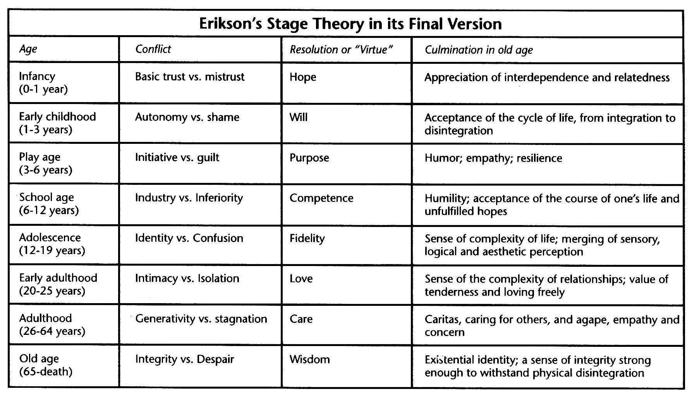
(Google.com, 2021)
The infancy stage starts from birth to about 18 months. The conflict that is prominent in the theory is Trust vs. Mistrust. The dependence that infant has on the caregivers makes it the most vital stage in life. Dependability is a major requirement infants need from their caregivers or parents for quality development and survival. Knight (2016) mentions that caregivers provide basic vital needs such as food, safety, nurture, shelter, warmth, emotion and love. As a result, infants must gain trust on the people around them, believing that they have their best interests.
This identity strengths, leads to children who can depend on their parents for these needs, trust and count on them, and children who can’t, have difficulties to trust others now and later in development (Mooney, 2013). Children who learn to trust their caretakers/parents develop the virtue of (hope) where they view the world as a good place where people can be trusted (Cohen and Waite-Stupiansky, 2017). Infancy is an instrumental stage during which their bodies are undergoing drastic changes. Cherry (2017) observes that failure to provide the needs leads to the infant becoming less trusting on the adults around them and as a result, the desired outcome that is expected to be achieved before the transition to the next stage involves developing trust and ensuring that the infant feels secure. The caregivers are then expected to be emotionally available and consistent in the provision of the needs so that the child can develop trust as compared to being afraid and believing in unpredictability of life. According to Kendra (2018), failure to develop trust can subsequently lead to the issues of drug and alcohol abuse, introversions, and pessimism, which affect the social living with other people. The theory, however, recognises that the levels of trust and doubt do not necessarily become totally absolute, but there should be a balance. The balance then helps the children to be open that despite the hope that they acquire, they should be open to what the imminent dangers can present.
The theory is, however, criticized since some of the conflicts can happen more than once during the subsequent stages in life, and as such there could be replication of the desired outcomes across the lifetime (Cherry 2017). For instance, a child could be still pursuing trust after infancy, and still achieve it. Therefore, the theory disregards some of the issues that can happen during development, such as interventions from social health workers or change of caregivers. In addition, the theory is founded on social expectations, which are not universal across all cultures. For instance, the infancy can be considered longer or shorter depending on the class and ethnicity.

Role of Health Care Practitioners
The theory is insightful into the roles of health care practitioners relating to the infants. The theory has established feeding as the important event, and the practitioner must ensure that the caregiver is knowledgeable about the best way of breastfeeding the infant. Some mothers, especially the first-time mothers, are unaware about how the baby should be handled and the diets they should take during breastfeeding (Wightman et al. 2021). The practitioner provides such information and complements it with the foods that the infant should take during and after weaning based on the nutrients that they need the most for growth.
The practitioner also has the role of advising about parenting in general. Parenting is a wide concept that encompasses all the things that the caregiver must do in order to raise happy and healthy children. Saltmarsh and Wilson (2017) assert that practitioners inform the caregivers about how they should handle the infants, including bonding with them so that there can be a friendly relationship and the children can feel safer interacting with them and other people. They also advise how they themselves can avoid behaviors that can lead to an unconducive environment in homes, such as recklessness and drug abuse. The practitioners also inform them how they can balance their work and social lives so that they can have time for children, and so they can identify any issues that could be affecting the infant.
It is also notable that the immunity of the child is boosted during the stage. Infants are quite vulnerable to diseases, and they can easily succumb to them given that they are weak. Reid et al. (2019) describe that the practitioner can then ensure that the caregiver cooperates in the immunization program as scheduled, so that the child can have a stable start of life and avoids some of the issues that could affect them. For instance, diseases can have an impact on some intellectual and physiological factors that affect the psychosocial living, which means that outcomes are not eventually realized. In addition, the practitioners must educate about child safety so that the environment in which they live can be adjusted to accommodate the infants.
Reflection and Application on Future Career
I have realized that the infancy stage is one of the most important stage in a person’s life, given that the theory states that each stage has an impact on the successive one, and as such failure to achieve the outcomes in the first stage could have a lasting effect on the individual. I have also identified that while the caregivers could be having a great contribution to the wellbeing of the infant.
However, as a professional in the health care sector, I can apply the knowledge I have received in various ways so that I can advance as well as ensure that the infants can gain the best as inspired by the theory. One of the things I will include in my practice is that I will be sensitizing the caregivers about how to take care of the infants to ensure that they achieve a high quality of life. Some of the parents as the primary caregivers are oblivious about the effect their actions have on the infants. As a result, I will be ensuring that during the prenatal and postnatal sessions, I will inform them about how to feed the baby and offer them with love so that the child can feel appreciated and that their needs are met, hence enhancing trust.
I will also apply the theory in understanding the background of the patient during the diagnosis and other procedures. Some of the behaviors can be due to the way the person was treated during infancy. For instance, it has been identified that addiction to drugs can result from lack of trust, and so any other factor complementing the behavior could be just a trigger. Therefore, when addressing the patient, getting the factors that could reveal lack of sufficient care during infancy could lead to a better approach as I will be focusing on helping the patient in gaining trust that will subsequently positively imply on their sense of safety.

Conclusion
It has been realized that there are several theories that seek to explain human development, and Erik Erikson’s has been comprehensive in exploring the aspect. The theories are crucial as they help in understanding human psychosocial facets. The infancy stage is the first and encompasses those between birth and one year six months. It exemplifies a conflict between trust and mistrust. The most important event is feeding, and hope is the desired outcome. Healthcare practitioners have the role of ensuring that they facilitate the quality of life. I aspire to apply the theory by sensitizing the people about how effective to take care of the dependent infants.

References

Cherry, K. (2017). Erik Erikson’s Stages of Psychosocial Development. Developmental Psychology, (1959), 1–11. Retrieved from https://www.verywellmind.com/erik-eriksons-stages-of-psychosocial-development-2795740
Cohen, L.E. and Waite-Stupiansky, S. (2017). Theories of Early Childhood Education: Developmental, Behaviorist, and Critical. [online] Google Books. Taylor & Francis. Available at: https://www.google.co.uk/books/edition/Theories_of_Early_Childhood_Education/3DklDwAAQBAJ?hl=en&gbpv=1&dq=erik+erikson+theory+on+infancy&printsec=frontcover [Accessed 25 Aug. 2021].
Freud, S. and Strachey, J. (2001). The Complete Psychological Works of Sigmund Freud Vol. 1: Pre-Psycho-Analytic Publications and Unpublished Drafts. [online] Google Books. Vintage. Available at: https://www.google.co.uk/books/edition/The_Complete_Psychological_Works_of_Sigm/xIM2CfFBy-QC?hl=en&gbpv=1&dq=sigmund+freud&printsec=frontcover [Accessed 25 Aug. 2021].
Google.com. (2021). [online] Available at: https://sites.google.com/site/erikeriksondl825/_/rsrc/1420115150645/home/stages-of-psychosocial-development/11eriksonstages.jpg [Accessed 25 Aug. 2021].

Kendra C. (2018). Erik Erikson’s Stages of Psychosocial Development. Developmental Psychology. Retrieved from https://www.simplypsychology.org/Erik-Erikson.html https://www.verywellmind.com/erik-eriksons-stages-of-psychosocial-development-2795740
Knight, Z. G. (2016). Erik Erikson’s eight stages of psychosocial development. Clinical Psychology & Psychotherapy.
Mcleod, S. (2018). Erik Erikson’s stages of psychosocial development. [online] Simply Psychology. Available at: https://www.simplypsychology.org/Erik-Erikson.html [Accessed 24 Aug. 2021].
Mooney, C.G. (2013). Theories of Childhood, Second Edition: An Introduction to Dewey, Montessori, Erikson, Piaget & Vygotsky. [online] Google Books. Redleaf Press. Available at: https://www.google.co.uk/books/edition/Theories_of_Childhood_Second_Edition/QSnoCAAAQBAJ?hl=en&gbpv=1&dq=erik+erikson+theory+on+infancy&printsec=frontcover [Accessed 25 Aug. 2021].
Reid, S., Bredemeyer, S., & Chiarella, M. (2019, July 1). Integrative Review of Parents’ Perspectives of the Nursing Role in Neonatal Family-Centered Care. JOGNN - Journal of Obstetric, Gynecologic, and Neonatal Nursing. Elsevier B.V.
Saltmarsh, T., & Wilson, D. (2017). Dancing around families: neonatal nurses and their role in child protection. Journal of Clinical Nursing, 26(15–16), 2244–2255.
Scheck, S. (2014). The Stages of Psychosocial Development According to Erik H. Erikson. [online] Google Books. GRIN Verlag. Available at: https://www.google.co.uk/books/edition/The_Stages_of_Psychosocial_Development_A/_NdoBQAAQBAJ?hl=en&gbpv=1&dq=erik+erikson+theory+on+infancy&printsec=frontcover [Accessed 25 Aug. 2021].
Wightman, L., Hutton, A., & Grant, J. (2021). Child and family health nurses’ roles in the care of infants and children: A scoping review. Journal of Child Health Care.

