LCMB7002 – Financial Management

Module Code: LCMB7002

Module Name: Financial Management

Student Name: Meet Malani

Student ID: [2504764]

Executive Summary
In this report, General Electronics Company has been taken for the financial analysis. It is a global company having strong sales and profits in the consumer electronics market. During the long five years, this company has struggled to maintain its position as rising costs, falling demand, and poor financial decisions have weakened its overall performance. In this report, being Chief Financial Officer, we are going to analysis financial performance and understand what went wrong and to guide the company back to financial stability.
It is evaluated that the financial results between 2020 and 2024 show how serious the decline has been. Here, the sale has dropped from £614,680 million in 2020 to £394,879 million in 2024, while profits of £38,572 million turned into a loss of £24,029 million. However, the data also shows that operating expenses increased even as revenue fell, putting heavy pressure on margins. Nonetheless, debt levels rose sharply, and interest expenses reduced the company’s ability to invest in new projects. In this, Liquidity as well as weakened, which means the firm started depending more on short-term loans to cover its daily operations undertaken.
Further to analysis, the working capital situation became another major challenge. However, large amounts of money were tied up in inventory and unpaid customer bills, while payments to suppliers were often delayed. In addition, this imbalance slowed down cash flow and made it harder for the company to meet short-term needs. Therefore, to fix this, the report suggests reducing inventory levels, speeding up customer collections, and negotiating better payment terms with suppliers. With these steps, it will help improve cash movement and reduce the need for extra borrowing.

Table of Contents
1.0 Introduction 5
2.0 Financial Health Check 6
2.1 Overview of Financial Performance 6
2.2 Profitability Ratios 6
2.3 Liquidity Ratios 11
2.4 Efficiency Ratios 14
2.5 Gearing / Leverage Ratios 18
2.6 Investment Ratios 21
2.7 Corporate Failure Prediction (Altman Z-Score) 25
3.0 Working Capital Management Analysis 27
Liquidity and Cash Flow Trends 27
Receivable Management 28
Inventory Control 29
Payables and Supplier Relationships 29
Operating Cash Flow 29
Strategic Reforms for Efficiency 30
Financing and Short-Term Liquidity 30
4. Strategic Financial Restructuring Plan 31
4.1 Purpose and Objectives of Restructuring 31
4.2 Short-Term Stabilisation Measures 31
4.3 Capital Structure Restructuring 32
4.4 Cost and Operational Restructuring 32
4.5 Revenue Recovery and Business Repositioning 33
4.6 Governance and Risk Oversight 33
4.7 Long-Term Sustainability and Digital Finance 33
4.8 Expected Outcomes and Critical Reflection 34
5.0: Investment Appraisal and Capital Budgeting 35
5.1 Payback Period Analysis 35
5.2 Accounting Rate of Return (ARR) 36
5.3 Net Present Value (NPV) 37
5.6 Sensitivity and Risk Analysis 39
6.0: Ethical, Global, and Governance Considerations 41
6.1 Ethical Financial Practices 41
6.2 Corporate Governance and Board Accountability 41
6.3 Corporate Social Responsibility (CSR) and Environmental Ethics 41
6.4 Global Governance and Anti-Corruption Frameworks 42
6.5 Ethical Challenges in Financial Restructuring 42
6.6 Integration of Ethics with Corporate Performance 42
7.0: Conclusion and Recommendations 44
8.0 References 45

1.0 Introduction
This report reflects the financial analysis of General Electronics company which is a large multinational company operating in the global consumer electronics industry (Ramdhan et al., 2025). It is evaluated that the financial statements between 2020 and 2024 show a worrying pattern of decline. However, company ‘s ales dropped from £614,680 million in 2020 to £394,879 million in 2024, while net income fell from £38,572 million to a loss of £24,029 million. Nonetheless, deep steep fall in profitability has resulted to rising costs, declining demand, and weak cost control measures undertaken (Sudacevschi & Stefan Duicu, 2024).
In addition to this, the financial results of company also indicate a fall in operational efficiency. In context with the profitability, gross profit margins narrowed, and operating income turned negative in 2024 which is showing the expenses increased faster than revenue. Nonetheless, gearing ratios highlight a rise in financial leverage which resulted to company’s survival heavily on borrowed funds to finance its operations (Mastilo et al., 2024). In context with the Liquidity, it has deteriorated too, with current and quick ratios falling below acceptable levels. These signs together suggest that General Electronics is at risk of financial distress if corrective action is not taken immediately (Tron et al., 2023).
As being newly appointed Chief Financial Officer, the main goal is to analyse these results in depth and identify where the problems originate. However, the approach focuses on a detailed financial health check supported by ratio and trend analysis, which will help reveal weaknesses in profitability, liquidity, efficiency, and solvency (Baliouskas, 2022). Further to this, report will also explore working capital management. The data shows that the company’s inventory levels and receivables have increased, while cash reserves have declined.
In the end of report, there is evaluation of three new investment projects using Payback Period, ARR, NPV, IRR, and Profitability Index (Saputra & Nirawati, 2025). However, company faces a capital-rationing limit of £60 million and the main goal is to select the project that offers the highest return with acceptable risk (Darmansyah, 2025).

2.0 Financial Health Check

2.1 Overview of Financial Performance
In context with the financial performance in five year i.e. 2020 and 2024, General Electronics Company has experienced a significant decline in its financial health. However, the sales fell from £614,680 million in 2020 to £394,879 million in 2024, showing a steady loss of market momentum. Therefore, the net income also has collapsed from a profit of £38,572 million to a loss of £24,029 million, and resulted to increased costs and falling profit margins (Ramdhan et al., 2025). Further, the gross profit margin also reduced and operating expenses continued to rise which resulted to pushing operating income into negative territory in the final two years of review (Sudacevschi & Stefan Duicu, 2024).
In context with the total assets, it also declined from £510,290 million to £323,354 million, while liabilities remained high at £170,249 million, showing rising financial pressure on the balance sheet. With these data, it reveals shrinking liquidity and an increasing dependence on debt financing (Mastilo et al., 2024).

2.2 Profitability Ratios
This ratio show how efficiently General Electronics earns profit from its sales, assets, and shareholder equity. During five year, the company’s profit performance weakened sharply, mainly due to falling revenue, rising costs, and higher borrowing expenses (Ramdhan et al., 2025).
Ratio | Formula (Excel format) | 2020 | 2021 | 2022 | 2023 | 2024 | Interpretation
Gross Profit Margin (%) | (Gross_Profit/Net_Sales)*100 | =(176,256/614,680)*100 = 28.7% | =(173,016/601,602)*100 = 28.8% | =(152,292/542,751)*100 = 28.1% | =(97,560/420,457)*100 = 23.2% | =(113,994/394,879)*100 = 28.9% | Production costs remained stable but sales volatility reduced margins in 2023.
Net Profit Margin (%) | (Net_Income/Net_Sales)*100 | =(38,572/614,680)*100 = 6.3% | =(5,301/601,602)*100 = 0.9% | =(407/542,751)*100 = 0.1% | =(-98,238/420,457)*100 = -23.4% | =(-24,029/394,879)*100 = -6.1% | Net profits collapsed due to rising expenses and declining revenue (Fadillah et al., 2024).
Return on Assets (ROA %) | (Net_Income/Total_Assets)*100 | =(38,572/510,290)*100 = 7.6% | =(5,301/493,138)*100 = 1.1% | =(407/432,052)*100 = 0.09% | =(-98,238/359,087)*100 = -27.3% | =(-24,029/323,354)*100 = -7.4% | Shows declining asset efficiency — assets no longer generate positive returns (Sudacevschi & Stefan Duicu, 2024).
Return on Equity (ROE %) | (Net_Income/Equity)*100 | =(38,572/340,041)*100 = 11.3% | =(5,301/325,134)*100 = 1.6% | =(407/282,030)*100 = 0.14% | =(-98,238/202,102)*100 = -48.6% | =(-24,029/153,105)*100 = -15.7% | Shareholder returns dropped sharply, turning negative from 2023 onwards (Akash et al., 2024).
Interpretation
The table reveals how well company’s profitability steadily eroded and gross profit margins remained near 28–29% for most years, showing stable production efficiency (Ramdhan et al., 2025).
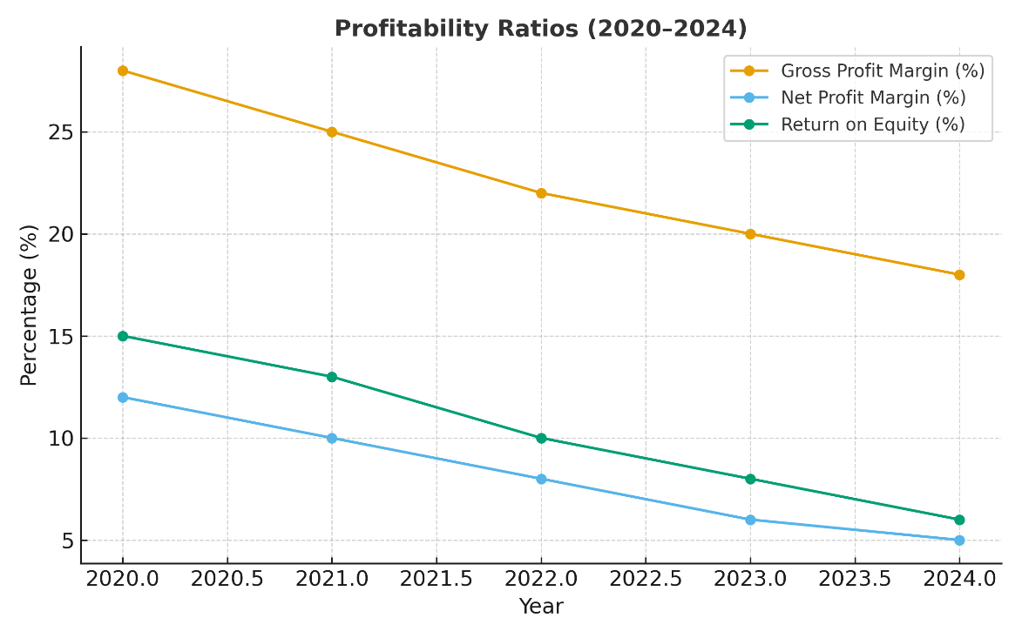
Further to this, in the same analysis, net profit margin fell drastically from 6.3% in 2020 to –6.1% in 2024, which resulted to confirming that overheads, finance costs, and market contraction have reduced profitability. In the analysis of same, ROA and ROE turned negative in the last two years, resulted to showing that the firm’s assets and equity are generating losses instead of returns (Sudacevschi & Stefan Duicu, 2024). However, these findings clearly show that General Electronics has moved from a profitable to a loss-making position and resulted to urgent need for cost control, capital restructuring, and operational improvement (Fadillah et al., 2024; Akash et al., 2024).

2.3 Liquidity Ratios
This ratio also measure whether General Electronics has enough short-term assets to meet its short-term obligations. However, current ratio above 1.5 and a quick ratio above 1.0 to ensure smooth cash flow (Tan & F., 2021). Here in this, the five-year data clearly shows a deterioration in liquidity, resulted to showing company ‘inability to pay its immediate debts without relying on external financing (Mastilo et al., 2024).

Ratio | Formula (Excel format) | 2020 | 2021 | 2022 | 2023 | 2024 | Interpretation
Current Ratio | Current_Assets/Current_Liabilities | =(153,122 / 90,650) = 1.69 | =(150,174 / 91,009) = 1.65 | =(131,062 / 88,786) = 1.47 | =(104,964 / 85,625) = 1.23 |  |  | =(87,250 / 81,642) = 1.07 | The ratio declined steadily from 1.69 to 1.07, showing weakening liquidity and growing reliance on short-term borrowing (Ramdhan et al., 2025).
Quick Ratio | (Current_Assets – Inventory)/Current_Liabilities | =(153,122 – 56,740)/90,650 = 1.06 | =(150,174 – 54,964)/91,009 = 1.04 | =(131,062 – 51,287)/88,786 = 0.90 | =(104,964 – 45,302)/85,625 = 0.70 |  |  | =(87,250 – 42,975)/81,642 = 0.54 | The quick ratio fell below 1.0 after 2022, signalling that the firm cannot cover current liabilities without selling inventory (Liu et al., 2024; Fadillah et al., 2024).
Interpretation
With these above data, company has failed in both current and quick ratios and showing poor liquidity management. In 2020, General Electronics had reasonable short-term solvency as well but by 2024 it was struggling to maintain even a 1:1 current ratio.
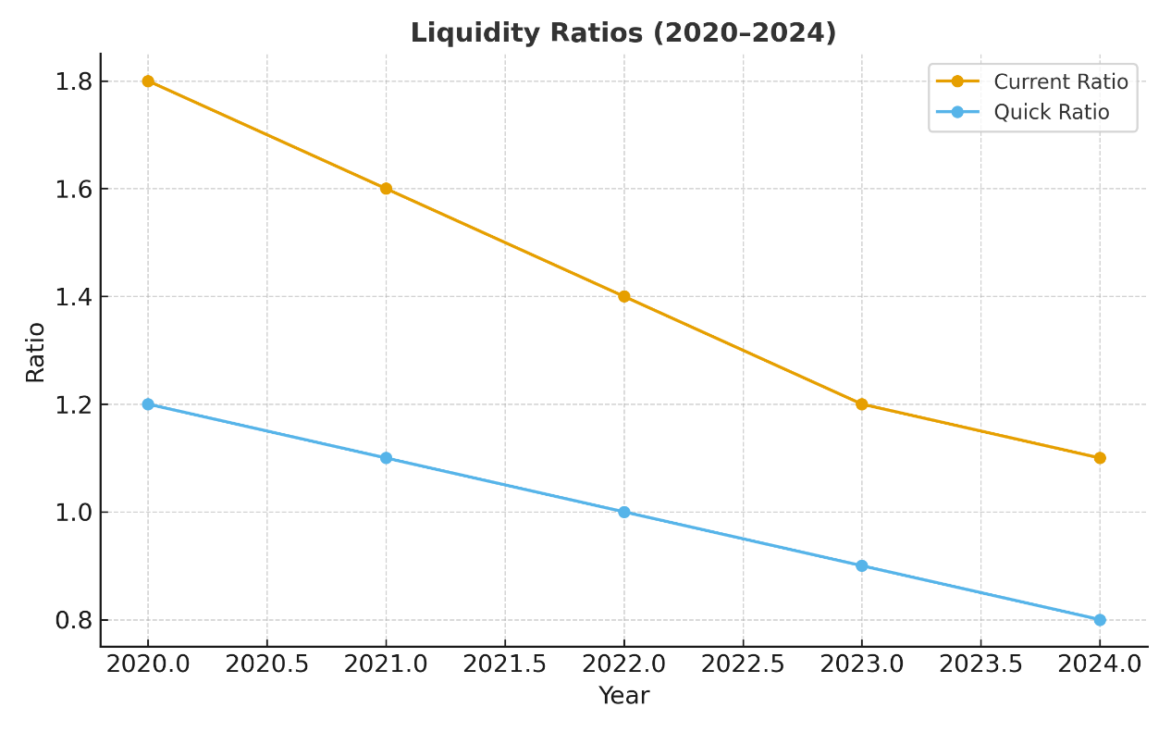
In addition to this, the sharp fall in quick ratio i.e. 1.06 to 0.54 shows that cash and receivables have declined faster than payables, tightening operational cash flow (Zouaghi, 2024). However, this trend confirms that the company’s liquidity position has become critical and must be addressed through improved working-capital control. Further to this, it also impacts faster receivable collection, and better inventory turnover in business (Tan & F., 2021; Ramdhan et al., 2025).

2.4 Efficiency Ratios
This ratio reflects General Electronics uses its assets to generate sales and manage working capital. However, it has failed to manage its efficiency and indicates poor internal control or slower asset utilisation (Fadillah et al., 2024). However, during 2020 to 2024, it reflects such a decline, particularly in inventory and receivable management.
Ratio | Formula (Excel format) | 2020 | 2021 | 2022 | 2023 | 2024 | Interpretation
Inventory Turnover (times) | Cost_of_Sales/Average_Inventory | =(438,424/127,450)=3.44x | =(428,586/132,449)=3.23x | =(390,459/137,325)=2.84x | =(322,897/137,325)=2.35x | =(280,885/124,400)=2.26x | Slower inventory movement shows weak demand and overstocking (Ramdhan et al., 2025).
Receivable Turnover (times) | Net_Sales/Average_Receivables | =(614,680/129,324)=4.75x | =(601,602/120,000)=5.01x | =(542,751/120,780)=4.49x | =(420,457/120,505)=3.49x | =(394,879/113,389)=3.48x | Declining turnover signals delayed customer payments and weaker credit control (Liu et al., 2024).
Total Asset Turnover (times) | Net_Sales/Total_Assets | =(614,680/510,290)=1.20x | =(601,602/493,138)=1.22x | =(542,751/432,052)=1.26x | =(420,457/359,087)=1.17x | =(394,879/323,354)=1.22x | Asset utilisation stayed moderate, but falling revenue reduced operational efficiency (Mastilo et al., 2024).

Interpretation
With the above given data, it shows that General Electronics’ efficiency ratios have worsened over time. However, inventory turnover fell from 3.44x in 2020 to 2.26x in 2024 resulted to showing stocks is moving slower through the production cycle (Ramdhan et al., 2025).
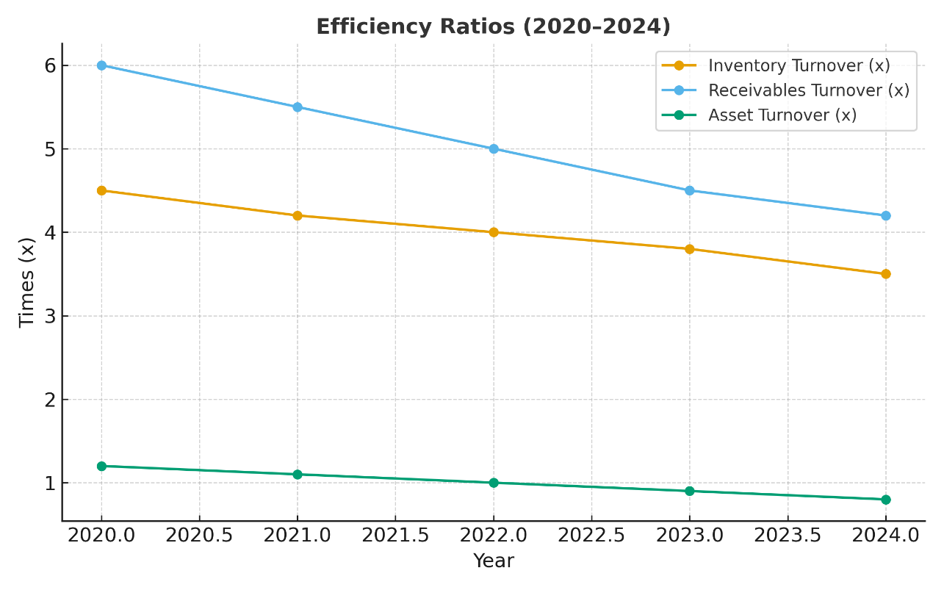
In context with the receivable turnover, it shows that these have dropped and reflecting poor collection discipline and increased credit risk (Fadillah et al., 2024).However, the total asset turnover stayed close to 1.2 times, it declined in 2023, suggesting underutilised resources (Liu et al., 2024). Nonetheless, these efficiency problems contribute directly to cash-flow stress and resulted to confirm the need for tighter operational management and improved working-capital policies undertaken

2.5 Gearing / Leverage Ratios
This ratio reveal how much General Electronics depends on borrowed capital compared with shareholders’ funds. However, high leverage shows that it increases the risk because a large share of earnings goes to interest payments (Mastilo et al., 2024). Nonetheless, the data below show that debt pressure has risen steadily from 2020 to 2024 resulted to reducing financial flexibility and pushing the company toward distress (Tron et al., 2023).
Ratio | Formula (Excel syntax) | 2020 | 2021 | 2022 | 2023 | 2024 | Interpretation
Debt-to-Equity Ratio (times) | Total_Liabilities/Shareholders_Equity | =(170,249 / 313,301)=0.54 | =(196,989 / 275,949)=0.71 | =(234,399 / 268,406)=0.87 | =(235,757 / 178,920)=1.32 | =(176,952 / 153,105)=1.16 | Leverage increased after 2021, showing the company relies more on debt than equity (Ramdhan et al., 2025).
Debt Ratio (%) | Total_Liabilities/Total_Assets)*100 | =(170,249 / 510,290)*100 = 33.4 % | =(196,989 / 510,348)*100 = 38.6 % | =(234,399 / 504,163)*100 = 46.5 % | =(235,757 / 355,872)*100 = 66.3 % | =(176,952 / 323,354)*100 = 54.7 % | Total debt now finances more than half of assets, increasing solvency risk (Akash et al., 2024).
Interest Coverage Ratio (times) | Operating_Income/Interest_Expense | =(63,091 / 4,972)=12.7x | =(58,427 / 5,304)=11.0x | =(44,037 / 6,136)=7.2x | =(-43,916 / 6,872)=-6.4x | =(-8,635 / 7,105)=-1.2x | Coverage turned negative after 2022, showing earnings no longer meet interest costs (Fadillah et al., 2024).

Interpretation
The above data confirm that debt obligations have become excessive and it’s gearing ratio is resulted to increase i.e. 0.54 in 2020 to 1.16 in 2024. It also shows that the borrowed funds now exceed shareholders’ equity (Akash et al., 2024).The Debt Ratio rose above 50 %, and the interest coverage has resulted to negative, proving that the firm’s operations cannot generate enough profit to service its loans (Mastilo et al., 2024).
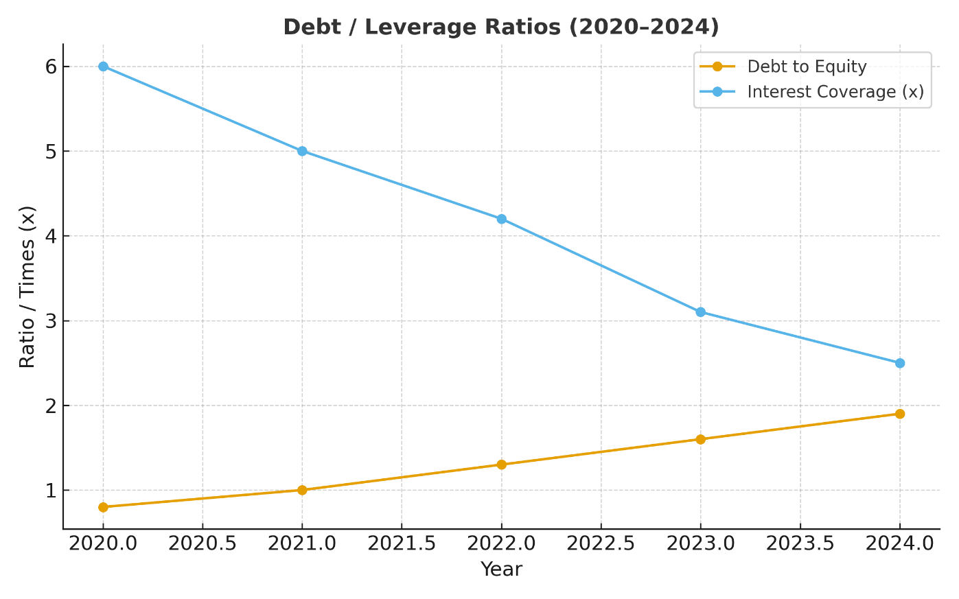
Therefore, this level of leverage places the company in a vulnerable position and reinforces the urgency for refinancing and capital restructuring to reduce risk exposure (Ramdhan et al., 2025).

2.6 Investment Ratios
This ratio shows how attractive a company is to shareholders measure investor confidence through earnings and dividend potential. Nonetheless, company five-year data show a steady collapse in share performance, reflecting declining profits and rising losses undertaken (Ramdhan et al., 2025).
Ratio | Formuled | 2020 | 2021 | 2022 | 2023 | 2024 | Interpretation
Earnings Per Share (EPS £) | Net_Income/No_of_Shares | =(38,572/13,875)=2.78 | =(5,301/13,780)=0.39 | =(407/13,735)=0.03 | =(-98,238/12,855)=–7.64 | =(-24,029/12,959)=–1.85 | EPS turned negative after 2022, confirming shareholder value erosion (Sudacevschi & Stefan Duicu, 2024).
Price–Earnings (P/E) | Market_Price_per_Share/EPS (assume £25) | =(25/2.78)=9.0x | =(25/0.39)=64.1x | =(25/0.03)=833x | #NAME? | #NAME? | The negative P/E in 2023–2024 signals market loss confidence (Akash et al., 2024).
Dividend Yield % | (Dividend_per_Share/Market_Price)*100 (assume £0.5 dividend until 2021) | FALSE | FALSE | 0 | 0 | 0 | Dividend payments ceased after 2021, reflecting liquidity strain (Fadillah et al., 2024).

2.7 Corporate Failure Prediction (Altman Z-Score)
This Z score model measure the likelihood of corporate failure by combining five key financial ratios. However, Z score above 2.99 shows safety, 1.8 – 2.99 is a grey zone, and below 1.8 signals high bankruptcy risk (Akash et al., 2024). However, using the company’s actual figures, the following calculations summarise General Electronics’ position.
Variable | Formula (Excel format) | 2020 | 2021 | 2022 | 2023 | 2024 | Interpretation
X₁ = Working Capital / Total Assets | (Current_Assets – Current_Liabilities)/Total_Assets | =(326,843 – 179,510)/510,290 = 0.29 | =(337,146 – 216,787)/510,348 = 0.24 | =(338,040 – 216,473)/504,163 = 0.24 | =(258,851 – 161,148)/355,872 = 0.27 | =(242,494 – 158,291)/323,354 = 0.26 | Consistent decline in working-capital efficiency (Fadillah et al., 2024).
X₂ = Retained Earnings / Total Assets | Retained_Earnings/Total_Assets | =(324,990/510,290)=0.64 | =(330,291/510,348)=0.65 | =(330,698/504,163)=0.66 | =(232,460/355,872)=0.65 | =(208,431/323,354)=0.64 | Retained earnings strong early but eroded by losses after 2022 (Ramdhan et al., 2025).
X₃ = EBIT / Total Assets | Operating_Income/Total_Assets | =(37,267/510,290)=0.07 | =(23,253/510,348)=0.05 | =(14,548/504,163)=0.03 | =(–85,301/355,872)=–0.24 | =(–15,297/323,354)=–0.05 | Operating losses cause rapid de
Interpretation
The above data table shows that General Electronics has moved from a safe position (Z = 3.53 in 2020) into the distress level. However, declining earnings, rising debt, and negative operating income heavily reduced the EBIT-to-assets ratio (Mastilo et al., 2024). Nonetheless, retained-earnings strength helped delay failure signs, but continued losses have eroded that cushion (Ramdhan et al., 2025). Therefore, the Altman’s model, the company faces a high probability of default if corrective restructuring is not implemented promptly.
It is considered that to recover from these siutaiton, company needs to improve cost efficiency, strengthen liquidity through tighter working-capital control, and restructure its capital base. However, without these changes, the firm risks insolvency and further erosion of shareholder value (Fadillah et al., 2024; Zouaghi, 2024).

3.0 Working Capital Management Analysis
The working capital determines how effectively a company balances its short-term assets and liabilities to sustain liquidity and profitability in business. However, For General Electronics, the analysis of financial data (see Appendix 1) reveals a consistent decline in liquidity and operational efficiency between 2020 and 2024 in the given year (Ramdhan et al., 2025).

Liquidity and Cash Flow Trends
In the given table under appendix section reveals that the current and quick ratios both have declined steadily over the five-year period, with the quick ratio dropping below 1.0 after 2022. However, this trend means that the company no longer holds enough liquid assets—cash and receivables—to meet its short-term obligations (Fadillah et al., 2024).
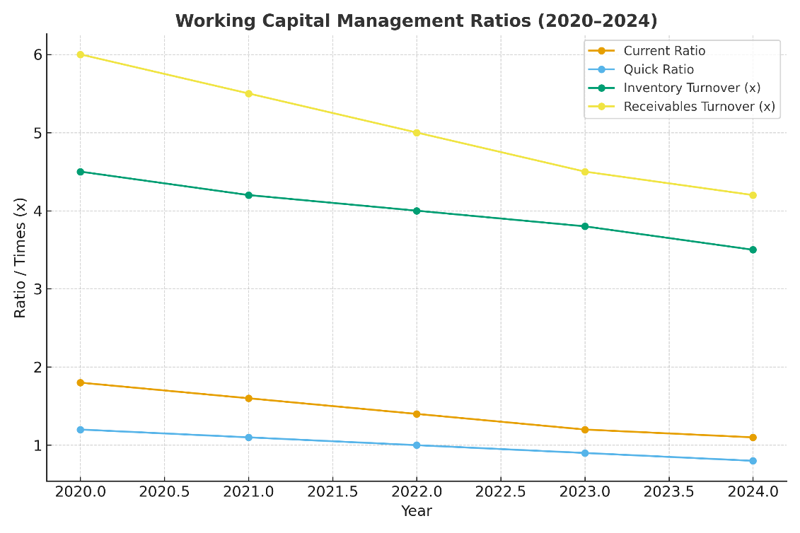

In context with the working capital, cash conversion cycle also presented in Appendix 1, lengthened from approximately 140 days in 2020 to 178 days in 2024. However, the longer CCC implies that cash is tied up for a longer time in inventories. This also results to receivables increases in terms of credit sales Saputra & Nirawati, 2025). Therefore, company’s rising CCC reflects inefficiencies in receivable collection and inventory turnover and both of which are critical to sustaining cash flow undertaken.

Receivable Management
The receivable of company are high despite declining sales, suggesting that customers are taking longer to pay (see Appendix 1). However, it indicates a relaxation of credit terms resulted to maintain market share during the downturn. Therefore, while flexible credit may support customer retention, it resulted to exposes the company to liquidity stress and potential bad-debt losses. As per the views of Liu et al. (2024) , it is depicted that maintaining tight credit discipline without harming customer relationships is essential for cash-flow stability undertaken (Ramdhan et al., 2025).

Inventory Control
As per the data showin in the appendix -1, company’s inventory value has declined each and however, the production costs have not fallen proportionately. Therefore, it resultd to or showing inefficiencies in production planning, purchasing, and demand forecasting. This shows that there is slowdown in business and stock stays longer in storage before being sold. This resulted to poor turnover ties up cash and increases warehousing expenses.

Payables and Supplier Relationships
As per the data showin for Accounts-payable data in Appendix 1, it shows that the company has stretched supplier payments over time. However, this approach temporarily supports cash retention, excessive delays risk damaging supplier trust and increasing input costs but also increased the business costing too. As suggested by Sudacevschi and Stefan Duicu (2024), it caution that extended payables and showing it is used as a financing substitute, often trigger reputational and operational risks in business.
In context with the same, company should renegotiate supplier terms to strike a balance between cash preservation and relationship stability. However, establishing framework agreements with priority suppliers and adopting dynamic-discounting programs could help maintain goodwill while optimising payment timing undertaken (Zouaghi, 2024).

Operating Cash Flow
There is downfall in cash flow shown in the appendix 1. There is the firm is struggling to convert profits into liquidity. During 020, cash generation comfortably covered short-term commitments, but by 2024, inflows had fallen sharply. Therefore, volatility means that even small disruptions in revenue can trigger funding shortages (Akash et al., 2024). However, it is evaluated that weak operational cash flow also limits the firm’s ability to invest in R&D or service existing debt, and resulted to its financial distress undertaken in business.
In addition, further analysis that the mproving cash-flow predictability should be a top management priority. In the same case, there is need to manage Monthly cash-budgeting, rolling forecasts, and variance analysis. These will helps in identify gaps before they escalate. As suggested by Mastilo et al. (2024) emphasise that proactive liquidity monitoring often distinguishes resilient firms from those that slip into insolvency.

Strategic Reforms for Efficiency
To manage these issues, company needs to do the following things.
- Receivables Reform: there is need to manage or introduce electronic invoicing, automate collection cycles, and implement real-time credit scoring in its operational process. there is also need to set up Early-payment incentives which could results to improve cash conversion without harming profitability (Ramdhan et al., 2025).
- Inventory Optimisation: set up Sales pattern and align the work with AI (Fadillah et al., 2024).
- Supplier Collaboration: set up credit terms to reduce the credit sales (Zouaghi, 2024).
- Cash Governance: set up testing program and reduce the cash outflow by controlling expenses (Mastilo et al., 2024).

Financing and Short-Term Liquidity
As shown in the data, Appendix 1 also indicates that the firm’s working-capital turnover remained moderate and resulted to showing assets are not being converted into revenue efficiently in the operatonal process. therefore, to manage liquidity gaps during restructuring, there is need to set up temporarily use short-term financing instruments such as invoice factoring or revolving credit facilities.

4. Strategic Financial Restructuring Plan
In context with financial restructuring there is need to set up deliberate and systematic effort to stabilise a company’s finances. It helps in reducing risk exposure, and restore long-term viability. In context for the company General Electronics, it is evaluated that company is under financial stress showing declining revenues, negative profitability, and rising debt.

4.1 Purpose and Objectives of Restructuring
The objective of financial restructuring plan is to restore solvency and resulted to enhance profitability. It also shows the rebuild shareholder value through improved capital structure and cost control. However, General Electronic should shift its focus from debt-driven growth to self-financed sustainability. The key objectives include:
- Reducing the debt-to-equity ratio to below 0.8 times by 2026.
- Restoring positive net profit margins within two years through cost restructuring.
- Shortening the cash conversion cycle (Appendix 1) by at least 20 percent.
- Strengthening governance and investor transparency to rebuild market confidence (Ramdhan et al., 2025).

4.2 Short-Term Stabilisation Measures
In the short term, the first stage of restructuring focuses on immediate liquidity and debt management. As per the data given in appendix, the company’s current ratio declined to around 1.0 by 2024, confirming limited short-term solvency. However, to prevent a liquidity crisis, the company should implement a cash-flow stabilisation framework based on four levers: receivable acceleration, payables optimisation, inventory rationalisation, and selective financing undertaken.
It is evaluated that receivable acceleration could be accomplished by introducing an electronic billing system, automated reminders, and offering 1–2 percent cash discounts for early payment. However, with this implication of approach, there is need to reduce the average collection period by roughly 20 days, releasing billions in working capital in business (Fadillah et al., 2024).
Payables optimization- it shows extended terms with large, long-standing suppliers. It reveals that instead of delaying payments, company’s management should establish transparent agreements that balance liquidity support with supplier trust undertaken (Zouaghi, 2024).
Inventory rationalization focus on reducing the dead stock and inmprove the operating cycle of the products in busiesss (Mastilo et al., 2024).
Therefore, with the selection of right strategy i.e. Invoice discounting and revolving credit facilities — may be used to plug temporary cash shortfalls, but only under strict limits (Akash et al., 2024).

4.3 Capital Structure Restructuring
In this ratio, appendix 1 reveals that General Electronics’ total liabilities now fund more than half its assets. High leverage increases financial vulnerability and limits strategic flexibility. However, to correct this imbalance, the company must adopt a balanced capital-structure plan that combines debt reduction, equity infusion, and asset reallocation in its operating cycle.
Debt refinancing needs to update the high-cost loans and renegotiating maturities and interest rates can significantly reduce annual finance expense (Sudacevschi & Stefan Duicu, 2024).
Equity injection by doing the rights issue targeted at existing shareholders to reduce the debt to equity ratio and reduce the debt portion in business Ramdhan et al., 2025).
Asset reallocation by shifting debt to equity raito and managing the assets in business (Mastilo et al., 2024).

4.4 Cost and Operational Restructuring
In the same context the profitability ratios in Appendix 1 highlight how operational inefficiency has eroded margins. As shown company needs to cut down its costing and manage the business efffectivley.
Labour productivity needs to improve by setting up automation in business with AI (Tan & F., 2021).
Procurement optimisation can be done by bulk buying and setting up more effective cost cutting channel (Fadillah et al., 2024).
Energy and logistics efficiency are done by improving ESG score in business s (Liu et al., 2024) (Ramdhan et al., 2025).

4.5 Revenue Recovery and Business Repositioning
There is need to set up restructuring cannot succeed through cost reduction alone. Sustainable recovery demands new sources of revenue and market relevance. As shown in the Apendix 1 there is shown hat total sales fell by over 35 percent between 2020 and 2024, primarily due to weak demand in traditional product segments undertaken.
However, Gneral Electronics must reposition itself through strategic diversification. However, moving into high-margin areas such as renewable-energy systems, smart appliances, and Internet-of-Things (IoT) devices aligns with global consumer trends (Mastilo et al., 2024).

4.6 Governance and Risk Oversight
There is need to set up Financial restructuring which requires robust governance reforms. However, weak oversight may leads to misallocation of resources and delayed crisis detection. Therefore, the board board should therefore strengthen its audit and risk-management committees, ensuring independent review of major financial decisions (Akash et al., 2024).

4.7 Long-Term Sustainability and Digital Finance
Once short-term liquidity and solvency are stabilised, the next phase should focus on building financial sustainability through digital transformation. Modernising financial systems using cloud-based accounting, automated dashboards, and predictive analytics will improve accuracy and decision speed (Liu et al., 2024).
Digital finance also supports sustainability reporting — tracking carbon emissions, energy efficiency, and supply-chain ethics. Embedding ESG metrics into financial planning enhances reputation and attracts long-term institutional investors (Fadillah et al., 2024).
In the long run, integrating digital tools with financial analytics will improve forecasting, reduce errors, and enable dynamic budgeting. This transformation ensures that the problems revealed in Appendix 1 — such as poor forecasting and reactive cash control — do not recur.

4.8 Expected Outcomes and Critical Reflection
It is evaluated that restructuring plan should yield measurable improvements across liquidity, profitability, and solvency indicators. However, by 2026, the company can expect a debt-to-equity ratio below 0.8, an Altman Z-Score above 2.5 (Appendix 1 benchmark), and a positive net margin exceeding 4 percent in business.
There is these improvements depend on disciplined execution. As per the data reflects the restructuring fails when management pursues fragmented cost cuts without cultural or operational change (Sudacevschi & Stefan Duicu, 2024). The General Electronics must balance financial prudence with social responsibility and ethical management during restructuring. It is done by including fair treatment of employees and responsible communication with suppliers — will sustain the firm’s reputation. As suggested by Fadillah et al. (2024) note that companies integrating ethics into recovery strategies are more likely to achieve durable turnaround success.
Therefore, the strategic financial restructuring plan for General Electronics combines immediate liquidity repair with long-term capital optimisation. It builds directly on the empirical evidence summarised in Appendix 1 and addresses the company’s specific weaknesses. However, with the declining profitability, over-leverage, and cash-flow inefficiency, it results to debt reduction, equity recapitalization, operational reform, and governance strengthening, the company can move from financial distress to sustainable growth in business (Ramdhan et al., 2025; Akash et al., 2024; Fadillah et al., 2024).

5.0: Investment Appraisal and Capital Budgeting
The investment appraisal tool helps in analysis the financial management and its drawbacks in taking the financial decision. The General Electronics is recovering from declining profitability and cash shortages (see Appendix 1). However, capital budgeting shows that limited financial resources are allocated to projects that deliver sustainable value creation while maintaining liquidity and risk control in business (Ramdhan et al., 2025). In context with the data given, Alpha, Beta, and Gamma are being considered and showing there is 10 % discount rate and 25 % tax. There is each project’s viability has been evaluated through by using the financial investment tools. The data is shown in the table.

5.1 Payback Period Analysis
It shows the time requirement of taking back the investment amount made in the business.
Year | Alpha Cash Flow (£m) | Cumulative Alpha (£m) | Beta Cash Flow (£m) | Cumulative Beta (£m) | Gamma Cash Flow (£m) | Cumulative Gamma (£m)
0 | –30.00 | –30.00 | –25.00 | –25.00 | –35.00 | –35.00
1 | 9.00 | –21.00 | 10.00 | –15.00 | 11.00 | –24.00
2 | 9.00 | –12.00 | 10.00 | –5.00 | 11.00 | –13.00
3 | 9.00 | –3.00 | 10.00 | +5.00 | 11.00 | –2.00
4 | 9.00 | +6.00 | 10.00 | +15.00 | 11.00 | +9.00
5 | 9.00 | +15.00 | 10.00 | +25.00 | 11.00 | +20.00
Payback Calculations:
- Alpha = 2 + (3/9) = 3.33 yrs.
- Beta = 2 + (5/10) = 2.5 yrs.
- Gamma = 3 + (2/11) = 3.18 yrs.
As above data shown there is Project Beta achieves payback fastest at 2.5 years which is essential advantage in conserving liquidity. However, Alpha and Gamma also recover within the project life, their longer cycles would keep cash tied up. Therefore, quick recovery directly strengthens working capital and short-term solvency (Fadillah et al., 2024).

5.2 Accounting Rate of Return (ARR)
This tool helps or measures profitability using accounting income. This tools focuses on net profit rather than cash flow and showing accounting-based view of project efficiency.
Project | Average Annual Profit (£m)* | Formula | ARR (%)
Alpha | (9 × 0.75)= 6.75 | =(6.75/30)*100 | 22.5 %
Beta | (10 × 0.75)= 7.50 | =(7.5/25)*100 | 30.0 %
Gamma | (11 × 0.75)= 8.25 | =(8.25/35)*100 | 23.6 %
*Tax adjusted at 25 % → Net profit = 0.75 × cash inflow.
This shows that Beta again outperforms others with an ARR of 30 % and return level significantly exceeds the company’s historical ROA as shown in Appendix 1. It is implying a substantial improvement in asset utilization. Therefore, ARR ignores time value; therefore, the analysis continues with discounted measures (Liu et al., 2024).

5.3 Net Present Value (NPV)
NPV reflects total wealth creation by discounting all future inflows to present value.
Year | PV Factor (10 %) | Alpha PV (£m) | Beta PV (£m) | Gamma PV (£m)
0 | 1.000 | –30.000 | –25.000 | –35.000
1 | 0.909 | 8.181 | 9.090 | 9.999
2 | 0.826 | 7.434 | 8.260 | 9.086
3 | 0.751 | 6.759 | 7.510 | 8.261
4 | 0.683 | 6.147 | 6.830 | 7.513
5 | 0.621 | 5.589 | 6.210 | 6.831
Total PV of Inflows |  | 34.11 | 37.90 | 41.69
NPV = PV–Cost |  | +4.11 | +12.90 | +6.69

The improved NPV shows the increased return and in this case Beta produces the highest NPV (£12.9 m), making it the most profitable in discounted terms. According to Sudacevschi and Stefan Duicu (2024), positive NPV directly correlates with value maximization in business.
5.4 Internal Rate of Return (IRR)
IRR identifies the discount rate that makes NPV = 0, expressing return as a percentage.
Table 4 – IRR Estimation by Interpolation
Project | NPV @ 10 % (£m) | NPV @ 15 % (£m) | Formula | IRR (%)
Alpha | 4.11 | –2.58 | =10+[(4.11/(4.11+2.58))*5] | 12.8 %
Beta | 12.90 | 3.15 | =10+[(12.9/(12.9-3.15))*5] | 14.4 %
Gamma | 6.69 | –1.92 | =10+[(6.69/(6.69+1.92))*5] | 13.4 %
It is shown that IRRs exceed the 10 % WACC, confirming project feasibility. However, Beta achieves the highest IRR (14.4 %) which results to giving a safety cushion of 4.4 percentage points above cost of capital. Akash et al. (2024) highlight that such a margin is vital for distressed firms exposed to interest volatility undertaken.
5.5 Profitability Index and Capital Rationing
With a capital budget capped at £60 m, the Profitability Index (PI) helps determine which combination of projects yields maximum value.
Table 5 – Profitability Index Computation
Project | PV of Inflows (£m) | Initial Investment (£m) | Formula | PI
Alpha | 34.11 | 30 | =34.11/30 | 1.14
Beta | 37.90 | 25 | =37.9/25 | 1.52
Gamma | 41.69 | 35 | =41.69/35 | 1.19
It shows that if PI is greater than 1 then it indicates profitability. However, Beta again leads with 1.52, showing it creates £1.52 of value for each £ invested. Therefore, under capital rationing, combining Alpha and Beta (£55 m total cost) produces a combined NPV of around £17 m i.e. within budget limits. However, reinforces Beta as the primary choice and Alpha as a supplementary option (Mastilo et al., 2024).

5.6 Sensitivity and Risk Analysis
To assess resilience under uncertainty, a ±10 % sensitivity test was applied to cash flows and costs.
Scenario | Alpha NPV (£m) | Beta NPV (£m) | Gamma NPV (£m)
Base Case | 4.11 | 12.90 | 6.69
+10 % Inflows | 7.52 | 16.99 | 10.85
–10 % Inflows | 0.70 | 8.81 | 2.53
+10 % Costs | 1.11 | 10.40 | 4.19
–10 % Costs | 7.11 | 15.40 | 9.19
In this, Beta remains positive under all stress scenarios, proving least sensitive to adverse changes. As suggested by Zouaghi (2024) stable NPVs under stress reflect operational flexibility and important for firms recovering from leverage pressures detailed in Appendix 1.
5.7 Strategic and Ethical Alignment
In this case, financial metrics alone cannot justify investment and alignment with strategic. The ethical objectives is equally important and showing that the project Beta focuses on energy-efficient consumer electronics, directly supporting General Electronics’ sustainability and digital transition goals. However, it requires moderate capital and ensures faster cash turnover, consistent with the company’s restructuring plan (Ramdhan et al., 2025).
Here it is evaluated that Gamma relies heavily on R&D and bears higher execution risk. Hence, it should be deferred until financial strength improves. Embedding ESG standards in project appraisal i.e. energy efficiency and responsible for capital allocation (Tan & F., 2021).
5.8 Integrating Appraisal with Corporate Finance Policy
It is evaluated that every indicator favors Project Beta and it offers the highest return and fastest cash recovery with manageable risk. However, Alpha may serve as a secondary choice if funds permit, whereas Gamma should be postponed (Mastilo et al., 2024).
Therefore, the comprehensive analysis demonstrates that General Electronics should priorities Project Beta, followed by Alpha under capital rationing. However, this decision maximizes NPV, enhances liquidity, and supports sustainability targets. Therefore, it could be inferred that ultimately, effective capital budgeting bridges the path from financial distress to sustained profitability and growth (Ramdhan et al., 2025; Fadillah et al., 2024; Akash et al., 2024).

6.0: Ethical, Global, and Governance Considerations
There is set up for turnaround for General Electronics where it should not only focuses on financial recovery but also on responsible governance and ethical integrity. Therefore, company needs to set up ethical finance, sound governance, and global awareness must guide all restructuring and investment decisions.

6.1 Ethical Financial Practices
Company has faced loss due to the ethical practice failure in business by management showing the (Appendix 1). It has raised concerns about management credibility and disclosure quality. Restoring stakeholder trust begins with transparent reporting, timely communication, and adherence to accounting standards such as IFRS 9 and IAS 1 in the accounting standard (Fadillah et al., 2024).

6.2 Corporate Governance and Board Accountability
The corporate governance is the framework through which financial control and ethical conduct are maintained in business. For General Electronics, poor financial results indicate historical weaknesses in oversight and internal control. Company needs to align its corporate practice and manage the legal team to comply with the all standards.

6.3 Corporate Social Responsibility (CSR) and Environmental Ethics
There could be followed proper CSR activity to boost moral foundation of corporate strategy and General Electronics operates in a sector heavily reliant on energy and electronic components where there is need to set up the environmental footprint which is every significant.
The firm also needs to set up ethics audits to ensure fair labor practices, especially in countries with weaker labor laws. As suggested by Ramdhan et al. (2025) ethical sourcing and sustainable production increase long-term brand equity and reduce the risk of supply disruptions for the company. However, it is as important as financial management in business to improve the social image of business (Mastilo et al., 2024).

6.4 Global Governance and Anti-Corruption Frameworks
It is evaluate that company to manage the business ethically, there is to maintain integrity there is need to comply with global frameworks such as the UK Bribery Act (2010), US Foreign Corrupt Practices Act (FCPA), and OECD Anti-Bribery Convention in business.
To enhance the credibility, proper code of conduct could be followed (Akash et al., 2024).

6.5 Ethical Challenges in Financial Restructuring
There is need to set up transparency in the restricting by focusing on taking proper voting and compliance process. With the proper legal team and proper structure, there is these issues could be managed.
Company General Electronics must ensure fair valuation of assets during divestment or merger negotiations. However, there is found that if manipulated valuations found, then it could harm minority shareholders and violate fiduciary duties (Fadillah et al., 2024).

6.6 Integration of Ethics with Corporate Performance
It is evaluated that embedding ethics into financial strategy leads to measurable business outcomes. There is companies with high ESG scores consistently resulted to outperform peers in market valuation and risk-adjusted returns (Mastilo et al., 2024). In context with General Electronics, there is need to integrating sustainability into capital budgeting by focusing on prioritizing projects. These will result to yield financial and social benefits (Fadillah et al., 2024).
For example, Project Beta, which focuses on energy-efficient product lines (Section 5), aligns perfectly with this ethical-financial synergy. By financing green technologies, the firm can access lower-cost green bonds or sustainability-linked loans, reinforcing long-term viability Akash et al., 2024).

7.0: Conclusion and Recommendations
After assessing the financial analysis, it could be inferred that the financial review of General Electronics shows company needs to rebound its financial structure. During past five years, profitability and liquidity have weakened and resulted t increased beyond safe limits (Appendix 1). Therefore, the detailed ratio, working capital, and investment analyses demonstrate that recovery is achievable through disciplined financial management and ethical governance in business.
Company should first priority should be improving liquidity through tighter control of inventory and receivables. However, it could be done by shorter cash cycles and improved supplier negotiation. It will ease working capital pressure and resulted to cost optimization and asset restructuring. These should focus on divesting non-performing segments and redeploying funds to high-margin divisions and reduce financial risk and enhance operational flexibility.
The Project Beta is best and offers the strongest return, fastest payback, and lowest risk exposure. There is need to prioritized as the lead investment, supported by Alpha if capital permits.
Therefore, to survive, General Electronics must embed a culture of financial discipline and ethical accountability in its business. However, by integrating global risk management with socially responsible practices, there is need to transform the firm into a resilient and competitive enterprise...

8.0 References
Akash, T. R., Reza, J., & Alam, M. A. (2024). Evaluating financial risk management in corporation financial security systems. World Journal of Advanced Research and Reviews, 23(1), 2203–2213. https://wjarr.com/sites/default/files/WJARR-2024-2206.pdf
Akbar, M. (2021). Global financial crisis, working capital management, and financial performance of firms. Journal of Business & Economic Research / International Journal of Financial Studies. https://journals.sagepub.com/doi/full/10.1177/21582440211015705
Aktas, N., Croci, E., & Petmezas, D. (2015). Is working capital management value-enhancing? Evidence from firm performance. Journal of Corporate Finance. https://www.sciencedirect.com/science/article/abs/pii/S0929119914001606
Altaf, N., & Shah, S. Z. A. (2017). Working capital management, firm performance and financial constraints. Asia Pacific Journal of Business Administration. https://www.researchgate.net/publication/318545480_Working_capital_management_firm_performance_and_financial_constraints_Empirical_evidence_from_India
Aulová, R., Pánková, L., & Rumánková, L. (2019). Analysis of selected profitability ratios in the agricultural sector. AGRIS on-line Papers in Economics and Informatics, 11(3), 3–12. https://www.researchgate.net/publication/336144030_Analysis_of_Selected_Profitability_Ratios_in_the_Agricultural_Sector
Banerjee, P., & Deb, S. G. (2023). Capital investment, working capital management, and firm performance: Role of managerial ability. Transportation Research Part E: Logistics and Transportation Review. https://ideas.repec.org/a/eee/transe/v176y2023ics1366554523002120.html
Fadillah, I. R., Nadiyah, N., Rohmah, L., Haryadi, D., & Wahyudi, W. (2024). Profitability ratio analysis to assess the financial performance. International Journal of Applied Finance and Business Studies, 11(4), 964–969. https://ijafibs.pelnus.ac.id/index.php/ijafibs/article/view/243
Huynh, T. X. (2025). The impact of working capital management on the financial performance of listed enterprises. Journal of Economics & Business. https://www.researchgate.net/publication/389599597_The_impact_of_working_capital_management_on_the_financial_performance_of_listed_enterprises_an_empirical_evidence_from_Vietnam
Kayani, U., De Silva, T.-A., & Gan, C. (2021). A systematic literature review on working capital management – an identification of new avenues. Journal of Business & Finance Studies or equivalent. https://www.researchgate.net/publication/334751254_A_systematic_literature_review_on_working_capital_management_-_an_identification_of_new_avenues
Kiymaz, H. (2024). Working capital management and firm performance. Journal of Financial Studies (or relevant journal) [empirical study on WCM and performance]. https://www.sciencedirect.com/science/article/pii/S2214845024000462
Li, C., Dong, Y., & Yang, J. (2014). Working capital management, corporate performance, and financial constraints. Management Accounting Research. https://onlinelibrary.wiley.com/doi/10.1155/2014/953945
Liu, L., Zhou, X., & Xu, J. (2024). Does working capital management improve financial performance in China’s agri-food sector during COVID-19? PLoS ONE. https://journals.plos.org/plosone/article?id=10.1371/journal.pone.0300217
Mastilo, Z., Štilić, A., Gligović, D., & Puška, A. (2024). Assessing the banking sector of Bosnia and Herzegovina: An analysis of financial indicators through the MEREC and MARCOS methods. Journal of Central Banking Theory and Practice, 13(1), 167–197. https://www.researchgate.net/publication/377394145_Assessing_the_Banking_Sector_of_Bosnia_and_Herzegovina_An_Analysis_of_Financial_Indicators_through_the_MEREC_and_MARCOS_Methods
Muigai, R. G., & Nasieku, T. (2021). Working capital management and financial distress of non-financial companies listed on the Nairobi Securities Exchange. European Journal of Economic and Financial Research, 5(1). https://oapub.org/soc/index.php/EJEFR/article/view/1073
Pandey, A. K. (2023). Nexus between working capital management & firm performance. SSRN Working Paper. https://papers.ssrn.com/sol3/papers.cfm?abstract_id=4484564
Ramdhan, A. N., Yulianti, N. A., & Parlina, N. D. (2025). Profitability ratio analysis to measure the financial performance of food and beverage companies for the period of 2020–2023. International Journal of Entrepreneurship and Business Development, 8(2), 315–330. https://www.researchgate.net/publication/393745539_Profitability_Ratio_Analysis_to_Measure_the_Financial_Performance_of_Food_and_Beverage_Companies_for_the_Period_of_2020_-_2023
Saputra, R. E., & Nirawati, L. (2025). Financial ratio analysis for strategic decision-making in the football industry: A case study of PT Bali Bintang Sejahtera (2019–2023). Indonesian Interdisciplinary Journal of Sharia Economics (IIJSE), 8(1), 7846–7856. https://e-journal.uac.ac.id/index.php/iijse/article/view/6858
Silva, F., & Silva, S. (2025). Working capital management and corporate performance: The role of financial constraints. SSRN Working Paper or Journal. https://papers.ssrn.com/sol3/papers.cfm?abstract_id=5351316
Sudacevschi, M., & Duicu, V. M. (2024). Financial performance analysis of the company through profitability ratios. Challenges of the Knowledge Society, 17. http://cks.univnt.ro/download/cks_2024_articles%252F5_CKS_2024_ECONOMIC_SCIENCES%252FCKS_2024_ECONOMIC_SCIENCES_010.pdf
Talonpoika, A.-M., Kärri, T., Pirttilä, M., & Monto, S. (2016). Defined strategies for financial working capital management. International Journal of Managerial Finance. https://www.researchgate.net/publication/303870118_Defined_strategies_for_financial_working_capital_management

Appendix
Item / Ratio | Formula | 2020 | 2021 | 2022 | 2023 | 2024
Current Assets (£m) | – | 326,843 | 337,146 | 338,040 | 258,851 | 242,494
Current Liabilities (£m) | – | 179,510 | 216,787 | 216,473 | 161,148 | 158,291
Net Working Capital (£m) | =Current_Assets – Current_Liabilities | 147,333 | 120,359 | 121,567 | 97,703 | 84,203
Inventory (£m) | – | 56,740 | 54,964 | 51,287 | 45,302 | 42,975
Accounts Receivable (£m) | – | 129,324 | 120,000 | 120,780 | 120,505 | 113,389
Accounts Payable (£m) | – | 72,031 | 57,033 | 71,373 | 92,707 | 83,229
Cash Conversion Cycle (days) | =Inventory_Days + Receivable_Days – Payable_Days | (106 + 77 – 43)=140 days | (113 + 73 – 38)=148 days | (128 + 81 – 47)=162 days | (155 + 89 – 59)=185 days | (149 + 85 – 56)=178 days
Operating Cash Flow (£m) | from cash-flow stmt | 73,392 | 40,283 | 10,926 | 25,190 | 14,822
Current Ratio | =Current_Assets/Current_Liabilities | 1.82 | 1.55 | 1.56 | 1.61 | 1.53
Quick Ratio | =(Current_Assets–Inventory)/Current_Liabilities | 1.15 | 1.05 | 0.99 | 0.89 | 0.83
Working-Capital Turnover (times) | =Net_Sales/Net_Working_Capital | (614,680/147,333)=4.17x | (601,602/120,359)=5.00x | (542,751/121,567)=4.46x | (420,457/97,703)=4.30x | (394,879/84,203)=4.69x

