University of wales trinity saint david
ACMA4000: Materials and Intro to Processing

Submitted by: Anneliese Edwards (2205957)
Date of submission: 04/02/2024

Abstract
This paper examines processes which are commonly used across manufacturing industries. The aim is to identify and explore a forming process, a casting process, and a miscellaneous process, each of which provides different mechanical and physical properties to the end product. The aim is to explore the advantages and disadvantages as well as looking at the resultant microstructure and ultimate tensile strength of materials processed using these methods.
Table of Contents
Abstract 1
Forging 2
Task 1 2
Task 2 3
Task 3 3
Task 4 3
Task 5 4
Task 6 4
Task 7 4
Continuous Casting 5
Task 1 5
Task 2 5
Task 3 6
Task 4 6
Task 5 7
Task 6 7
Task 7 7
Powder Metallurgy 8
Task 1 8
Task 2 8
Task 3 9
Task 4 9
Task 5 10
Task 6 10
Task 7 10
References 11

Forging

Task 1
Forging is a manufacturing process which consists of heating and working metal by either hammering, pressing, or rolling to achieve fine metallurgic structures. It can also be defined as the deformation of a material through compressive force. Forging can be categorized as, cold, warm, or hot, based on the temperature it was performed. (Gao, 2000)
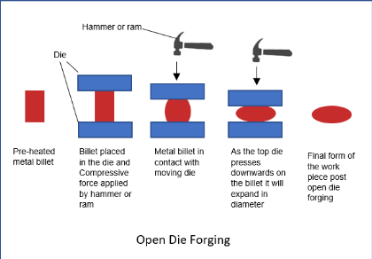
Open-die forging is the process of striking metal with a hammer to deform it, it can also be the compression of the metal between a simple, open die. Closed-die forging is the process of forming the metal using a custom-shaped die. When a closed die is closed the billet will fill the die cavity, forming the desired shape. (forge, n.d.)

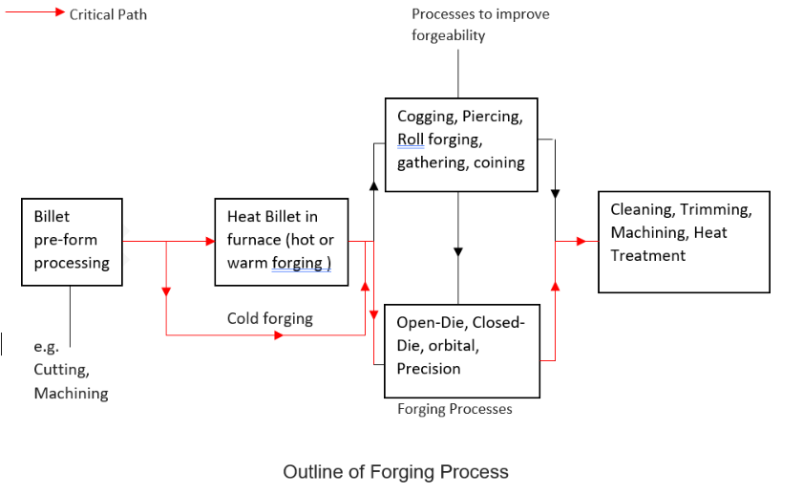
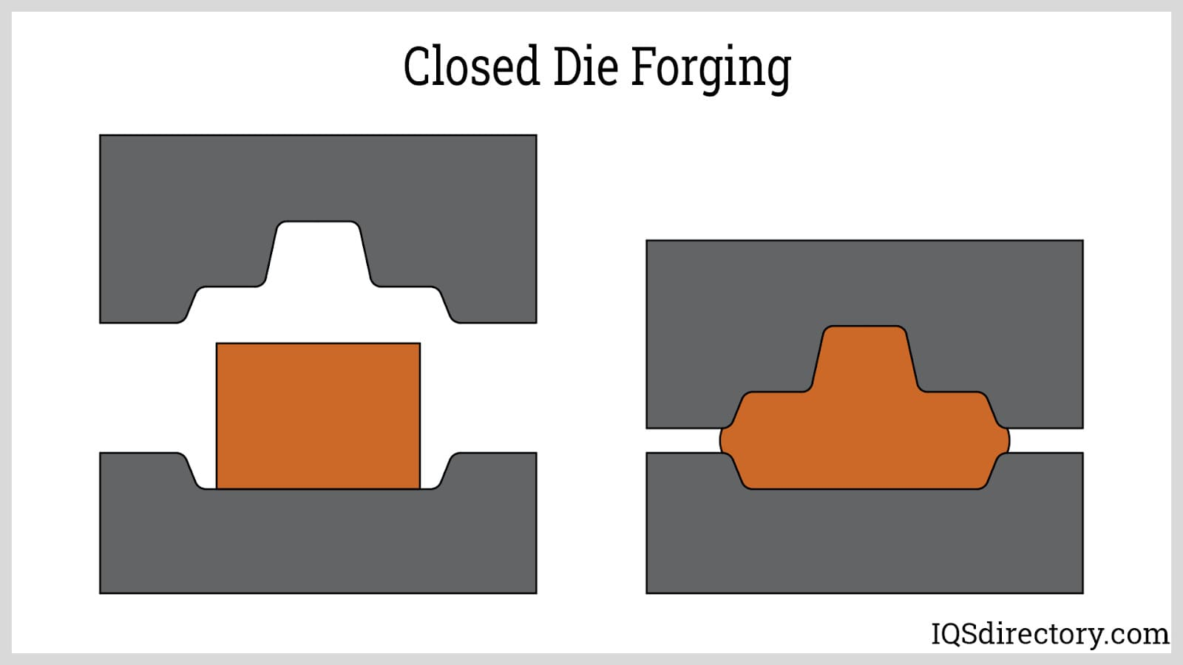
Figure 2
Figure 1

Pre-heated billet
(V.Ryan, 2020)
Upper die

Lower die
Figure 3
(IQSDirectory, n.d.)

Task 2
Die forging is commonly used a variety of industries due to the exceptional mechanical properties it produces. It is commonly used in the automotive and defence industries, producing components such as blades, rotors and crankshafts which need to withstand a high-stress environment. Die forging is typically used for applications which require strength, durability, and corrosion resistance. (Cornell Forge , n.d.)

Task 3
An advantage of using open-die forging is that it produces high strength, durable components. It also produces little material waste, making it an economical process. Open die forging also requires little tooling cost to set up the process. However, a disadvantage of open-die forging is that it is not suitable for intricate components and components often require machining after production, therefore increasing the overall manufacturing cost and production time. An advantage of closed die forging however, is that it can be used to produce more precise shapes and can be used to produce almost every shape and size component required as well as producing components with a better surface finish compared to open die forging. However, a disadvantage is the tooling costs are high so the initial set up cost is expensive. Another disadvantage is that it produces more material wastage than open die forging due to the material flow out of the die, forming flash.
(FerrAlloy, 2020)

Task 4
A common material used in forging is F70 steel. The mechanical properties of the steel can be determined by the microstructural evolution throughout the forging process. When steel is hot forged, the grain structure of the alloy changes from a course, large grain to a fine-grained microstructure, this is due to plastic deformation as the material is struck. Forging also produces directional properties in the grain, producing an optimum grain flow, perpendicular to the direction of force applied. When heated at 950C the Polygonal Ferrite disappears from the material – indicating the structure has become a fully Austenite structure, this is where the alloy is heated above its critical temperature, this makes the steel corrosion resistant, ductile, and formable.
(Forging, n/a) (Kang, 2021)
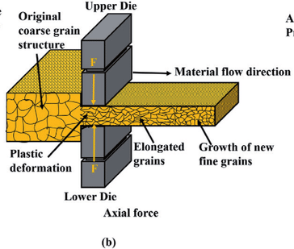

(Kumar, 2021)

Task 5
The typical UTS of F70 carbon steel is 556MPa, when hot forged at temperatures between 900 - 950C the material has a tensile strength of 739-776MPa.
(Kang, 2021)

Task 6
A common processing defect experienced when forging is surface cracking, this is when cracks occur on the surface of the metal when they are forged at too low temperatures. Cold shut is where cracks appear in the corners of the workpiece, causing sharp edges, due to incorrect cooling procedures or poorly designed dies. Die shift causes uneven forging and incorrect workpiece dimensions, it is caused by poorly aligned dies, where the top and bottom die do not meet correctly during the forging process.
(Test book , 2023)

Task 7
In order to prevent surface cracking, the workpiece should be forged at higher temperatures. Another way to prevent surface cracking is to automate the forging process to ensure optimal conditions during every forge. Cold shut can be prevented by increasing the radius of the corners of the die and also ensuring the workpiece isn’t over cooled. Die shift can be prevented by ensuring the workpiece is correctly aligned prior to forging, in order to ensure the top and bottom dies meet correctly.
(Test book , 2023) (Scheidegger, 2021)

Continuous Casting

Task 1
Continuous casting is a process which involves pouring molten metal into a horizontal or vertical mould which has the capability of rapidly cooling the material until solidified, producing components with a fine uniform grain structure. Metal is heated in an induction furnace until molten, then poured through a water-cooled die. It then moves through pull rollers, shaping the metal before being cut off.
(Olsen, 2020)
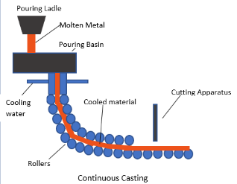

Figure 4

(Tec-Science, 2018)

Task 2
A common application of continuous casting is producing copper rods and tubes for electrical and plumbing applications. Continuous casting is also commonly used to process raw materials ready for post process finishing, most commonly using steel, which makes up the majority of raw materials used in the automotive industry. (Xometry, 2023)

Task 3
An advantage of continuous casting is that it is a highly efficient manufacturing process, which produces products with consistent quality and physical properties. As well as this it is capable of producing products with high dimensional accuracy and low tolerances. Another advantage is that it is able to produce high volumes of products, reducing the amount of energy consumed per KG of cast material, as there is a reduced number of heating and cooling cycles compared to batch processing. However, a negative of continuous casting is that the initial set up cost for the process is very high, as well as this, may require regular maintenance due to wear on the rollers, which will come at further cost. Another negative is that it can only produce 2D profile extrusions, so the applications are limited. (Xometry, 2023)

Task 4
A common material used in continuous casting is Copper (Cu). Copper processed using continuous casting is refined to form small grains, providing a more ductile material, this is due to the rate of cooling being controlled during the manufacturing process. The directional solidification of continuous casting promotes a consistently dense and homogenous grain structure. Faster cooling results in faster growth velocity, increasing the size and number of the nuclei, resulting in a fine, uniform grain structure with more desirable physical properties compared to other casting methods such as sand casting. (Bagherian, 2016) (Olsen, 2020)
Grains become longer and thinner due to the steep temperature gradient caused by rapid cooling
Columnar grains in the direction of heat transfer

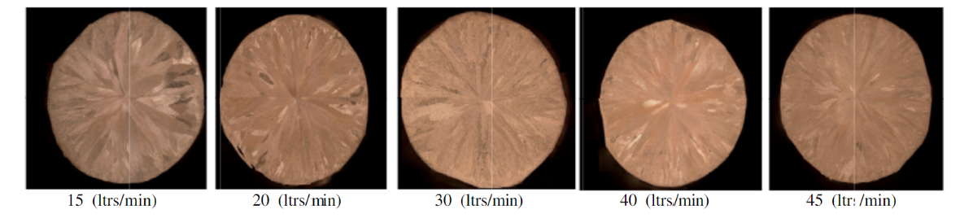

Figure 5

(Bagherian, 2016) Fig. 5. Grain structure comparison based on cooling

Task 5
The ultimate tensile strength (MPa) of copper processed by continuous casting varies by the elongation of the material. Copper alloy (CuSnp) which is elongated by 10% has a tensile strength of 310MPa, whereas copper which is elongated by 25% has a tensile strength of 248MPa. (Bagherian, 2016)

Task 6
A common processing defect is transverse and longitudinal cracking. These cracks occur during the cooling process, typically forming in the corners of the slab propagated by spontaneous cooling. These cracks are more likely to occur in low-carbon alloy steels during the austenite to ferrite transformation as the microstructure of the steel undergoes a transformation from a body centred cubic structure to face centred cubic. (Lee, 2022)
Another common defect is Porosity, this is where air or gasses are trapped either inside the casting or on the surface. These bubbles occur during the cooling process as molten metal is capable of holding large amounts of dissolved gas, whereas solid metal cannot, therefore, as the material solidifies the gas bubbles begin to appear. (Haworth Casting, 2019)
Shrinkage is another common defect; this occurs due to the metal being less dense in liquid form compared to solid. Therefore, the metal shrinks as it cools to room temperature. (Haworth Casting, 2019)

Task 7
In order to prevent cracks occurring in the slab, the temperature of the material and the die should be controlled to prevent thermal shock. (Lee, 2022)
Porosity can be prevented by ensuring the material is poured into the mould slowly to prevent air and gas bubbles forming due to turbulence. In order to prevent gas bubbles forming during the cooling process, nitrogen can be introduced before the liquid is poured. Finally, the casting can be placed in a furnace at a high temperature under pressure and heated using Argon or another similar inert gas. This applies isostatic pressure to the casting, removing the porous elements from the cast. (Haworth Casting, 2019)
To prevent the material shrinking smaller than required, a shrinkage allowances should be factored into the design of the mould at the beginning of the design process. (Haworth Casting, 2019)

Powder Metallurgy

Task 1
Powder Metallurgy is a manufacturing process involving pressing powdered metals into dies under high pressure in order to produce precision components. The powdered metal or alloy is firstly mixed, then compacted into the desired shape using pressures of up to 1600MPa, finally it is then sintered. Sintering is the process of heating the material until all loose particles bond to form a solid component. (IQS, 2023)
The combined powder is poured into the compacting machine, where it is then compacted into dies at high pressures
Powdered metals or alloys mixed together with any add ins until fully combined

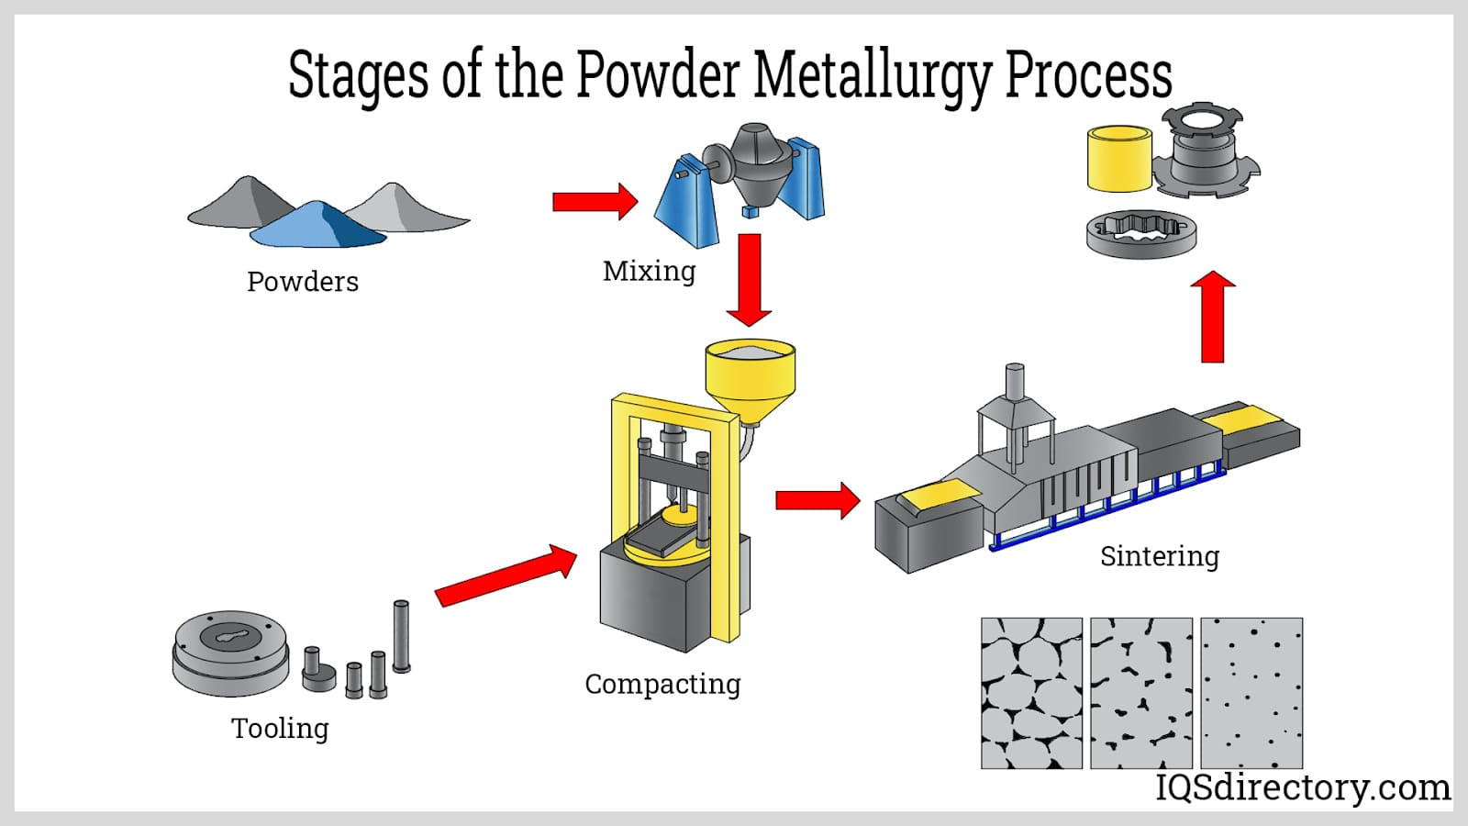
The compacted end product is then sintered. This is the process of heating up the component until the particles form a permanent bond, forming a solid component

Figure 6

Task 2
Powder metallurgy has a wide range of applications including, the automotive industry, producing wear resistant and heat resistant components including intake and exhaust valves and gears. Powder metallurgy is also commonly used in the electronics industry, producing components for phones, such as buttons, sim card trays and cable sockets. (ALPA Powder, 2021)

Task 3
An advantage of using powder metallurgy is that there is minimal waste throughout the process, therefore, it has a high material utilisation. As well as this it can be used to produce very complex, precision components. Another advantage Is that you are able to control the amount of porosity in the final product. It can also be used for hard materials which are difficult to machine, such as tungsten. A disadvantage, however, is that the setup costs of powder metallurgy is very high, as well as this, the material costs is also considerably high. (P.C., 2022)

Task 4
A common material used in Powder Metallurgy is Titanium (Ti), if pure Ti is used there is typically a lack of stored energy which is needed to drive recrystallization, therefore Ti is typically alloyed with another material such as copper. When TiCu is sintered at 900oC the material forms a fine grained nanocrystalline and multiphase structure. During the sintering process, lubricant used in previous processes is evaporated and the surface oxide from the powder particles are reduced. During sintering, the grain size increases, closing the gaps between grains. As the grain structure becomes tightly packed the hardness of the material increases. (Akbarpour, 2020)
Grain structure post sintering
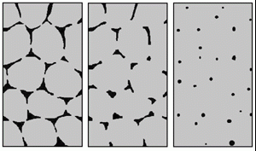
Grain structure prior to sintering

(PM Review , n.d.)

Task 5
A common alloy used in powder metallurgy is Ti-Cu, this has an ultimate tensile strength of 904MPa. (Alshammari, 2019)

Task 6
A common processing defect in powder metallurgy is density variation. This is where the density of the compressed product varies throughout the compact. This variation is typically caused by differing pressure being applied to the metal particles. Therefore, the density will vary depending on the distance from the die and the force being applied. (Sundaram, 2017)
Another common defect is Ejection cracks. Microcracking first occurs in the material when it is under pressure, then as the compact is removed, the microcracks expand due to the stress applied to the compact as it is removed from the die. (Garner, 2014)
Poor sintering is another common defect, this is where the material doesn’t sinter correctly, so the material isn’t completely fused together, this decreases the strength of the end product. (TWI Global , 2024)

Task 7
In order to prevent density variation, you can increase the pressure applied to the compact. Another way to prevent variation is to apply biaxial pressure rather than only applying uniaxial pressure. (Sundaram, 2017)
To prevent ejection cracks, the die can be lubricated to prevent friction as the component is removed from the die. Also ensuring the tooling is smooth with a good surface finish as well as utilising tapered edges will reduce the stress on the product when ejecting, reducing ejection cracks. (Talati, 2022)
To prevent poor sintering, the temperature could be increased, or the sintering time could be increased in order to better sinter the material. (TWI Global , 2024)

References
Akbarpour, M., 2020. Densification and Mechanical and Antibacterial properties of low cost Powder Metallurgy TiCu Alloy as a potential Biomedical Material. JOM, 72(9).
ALPA Powder, 2021. Powder Metallurgy process and applications. [Online]
Available at: https://www.alpapowder.com/109499/
[Accessed 15 01 2024].
Alshammari, Y., 2019. Low Cost powder metallurgy Ti-Cu alloys as a potention antibacterial material. Journal of the Mechanical Behaviour of Biomedical Materials, Volume 95, pp. 232-239.
Bagherian, E.-R., 2016. Effects of water flow rate, casting speed. alloying elements and pull distance on tensile strength elongation percentage and microstructure of continous cast copper alloys. Metallurgical Research & Technology, Volume 113, p. 13.
Chen, F., 2014. Prediction of microstructural evolution during hot forging. Manufacturing Rev , 05 08, 1(6), p. 21.
Cornell Forge , n.d. Ultimate guide to forging applications. [Online]
Available at: https://www.cornellforge.com/ultimate-guide-forging-applications/#:~:text=For%20example%2C%20engine%20components%20like,%2C%20steering%20knuckles%2C%20and%20hubs.
[Accessed 23 01 2024].
FerrAlloy, 2020. Open die forging applications. [Online]
Available at: https://www.ferralloy.com/post/open-die-forging-applications
[Accessed 6 12 2023].
forge, C. d., n.d. Closed-Die Forging vs Open-Die Forging. [Online]
Available at: https://cantondropforge.com/open-vs-closed-die-forging/
[Accessed 28 11 2023].
Forging, n/a. Product advantages of forging. [Online]
Available at: https://www.forging.org/forging/design/14-product-advantages-forging.html#:~:text=Directional%20Strength%20Forging%20refines%20the,fracture%20toughness%20and%20fatigue%20strength.
[Accessed 5 12 2023].
Gao, Z., 2000. Microstructure optimization in design of forging processes. International Journal of Machine Tools and Manufacture , 40(5), pp. 691-711.
Garner, S., 2014. Mechanisms of crack formation in die compacted powders during unloading and ejection: An experimental and modeling comparison between standard straight and tapered dies. Powder Technology, 09.pp. 114-127.
Haworth Casting, 2019. Casting defects and how to prevent them. [Online]
Available at: https://www.haworthcastings.co.uk/news/casting-defects-and-how-to-prevent-them-part-1/#:~:text=Porosity%20is%20the%20most%20common,surface%20or%20inside%20the%20casting.
[Accessed 15 01 2024].
Infonet, 2013. The hot chamber casting process, s.l.: Youtube.
IQS, 2023. Powder Metallurgy. [Online]
Available at: https://www.iqsdirectory.com/articles/powder-metal-parts/powder-metallurgy.html
[Accessed 05 12 2023].
IQSDirectory, n.d. Open vs closed die forging. [Online]
Available at: https://www.iqsdirectory.com/articles/forging/open-vs-closed-die.html
[Accessed 03 01 2023].
Kang, M., 2021. Effect of Heat Treatment on Microstructure and Mechanical Properties of High-Strength Steel for in Hot Forging Products. Metals, Volume 11, p. 768.
Kumar, S., 2021. Plastic Defomation in Materials. s.l.:s.n.
Lee, Y.-S., 2022. Mechanism of crack initiation and propagation in high-alloy steel slabs during the cooling and scarfing processes after hte continous casting process. Mechanics of Materials, Volume 166.
Murphy, P., n.d. Extrusion Porcess,: working, types, application, advatnages and disadvantages. [Online]
Available at: https://paulmurphyplastics.com/2019/09/25/extrusion-process-working-types-application-advantages-and-disadvantages/#:~:text=Extrusion%20is%20widely%20used%20in,in%20automotive%20industries.
[Accessed 12 12 2023].
Olsen, D., 2020. What is the continous casting process?. [Online]
Available at: https://www.metaltek.com/blog/what-is-the-continuous-casting-process/#:~:text=Overview%20of%20Continuous%20Casting&text=The%20rapid%20chilling%20in%20the,produced%20are%20tubes%20and%20solids.
[Accessed 04 01 2024].
Olsen, D., 2020. What is the continuous casting process?. [Online]
Available at: https://www.metaltek.com/blog/what-is-the-continuous-casting-process/
[Accessed 29 11 2023].
P.C., A., 2022. Powder Metallurgy, Second Edition: Science, Technology and Applications. 2 ed. s.l.:s.n.
PM Review , n.d. Sintering in the Powder Metallurgy Porcess. [Online]
Available at: https://www.pm-review.com/introduction-to-powder-metallurgy/sintering-in-the-powder-metallurgy-process/
[Accessed 22 01 2024].
Ryobi, n.d. What is Die casting?. [Online]
Available at: https://www.ryobi-group.co.jp/en/glance/02.html#:~:text=Die%20casting%20is%20a%20metal,of%20aluminum%2C%20magnesium%20and%20zinc.
[Accessed 29 11 2023].
Scheidegger, B., 2021. The most common types of forging defects. [Online]
Available at: https://controlsystemsdesign.com/blog/the-most-common-types-of-forging-defects/#:~:text=A%20cold%20shut%20defect%20is,fillet%20radius%20of%20the%20die.
[Accessed 11 12 2023].
Sundaram, M. V., 2017. Processing Methods for Reaching Full Density Powder Metallurgic Materials, Gothenburgh, Sweden: s.n.
Talati, J., 2022. 3D metal powder mixing. Meal Powder, 77(2).
Tec-Science, 2018. From steel to semi-finished products- Continuouse casting. [Online]
Available at: https://www.tec-science.com/material-science/steel-making/steel-semi-finished-products-continuous-ingot-casting/
[Accessed 29 11 2023].
Test book , 2023. Forging Process: Comprehensive insight with types, defects , advatages, disadvantages, and applications. [Online]
Available at: https://testbook.com/mechanical-engineering/forging-process-steps-and-types#:~:text=Sharp%20corners%2C%20poorly%20designed%20forging,root%20cause%20of%20these%20misalignments.
[Accessed 11 12 2023].
TWI Global , 2024. What is sintering?. [Online]
Available at: https://www.twi-global.com/technical-knowledge/faqs/what-is-sintering
[Accessed 23 01 2024].
V.Ryan, 2020. Open Die Forging. [Online]
Available at: https://technologystudent.com/despro2/forging21.html
[Accessed 28 11 2023].
Xometry, 2023. Continuous Casting. [Online]
Available at: https://www.xometry.com/resources/casting/continuous-casting/#:~:text=Continuous%20casting%20is%20employed%20to,the%20manufacturing%20of%20automotive%20components.
[Accessed 2 1 2024].
Yadav, R. R., 2018. A study of metal extrusion process. International Journal of LNCT, 2(6).

