Emerging Leadership Skills in the Workplace

PORTFOLIO
Task 2


Women Love Tech (2021)

Student Name | Deon Rose Lobban
Student ID | 1919079
Module Name | Emerging Leadership Skills in the Workplace
Module Code | BMSW6101_Birm
Lecturers Name | Sujeewa Herath
Part 1 | Academic Essay Report

CONTENTS
Introduction………………………………………………………………..4
Case study……………………………………………….………………...5
What is leadership…………………………… ………..………………….5
Leadership position…..…………………………………………………….6
Management position…………..…………………………………….……6
The difference between a leader and a manager…….…..…………….7
People oriented leadership…….………………………………………….7
Task oriented honey leadership…………..…………………………..….. 8
Different leadership styles……………….………..………………………..8
Douglas McGregors motivational X and Y theory………………………..9
Laissiz-faire leadership………………………………………………………9
Autocratic leadership…………………………………………………………9
Transactional leadership…………………………………………………..9
Transformational leadership………………………………………………9
Democratic leadership…………………………………………… ………10
Effective leadership styles…………………………………………… ….10
Leadership style in COVID-19 era and other emergencies……………11
Ethical leadership………………………………………………………… .11
Conclusion……………………………………………………………… ….12

Reflective essay: Part 2………………………………………………… …13
My leadership styles………………………………………………… ……13
My questionnaire results…………………………………………… ….13,14
My feelings……………………………………………………… …… …….15
Evaluation………………………………………………………… …………15
Analysis……………………………………………………………… ……..16
Conclusion…………………………………………………… …… ………16
References………………………………………………………… ……17,18

Introduction
This portfolio is written to give an insight into emerging leadership's styles within the workplace, the different styles of leadership and theories behind them.
- Leadership styles include
- Leadership and management
- Effective leadership styles
- Leadership styles during the COVID-19 pandemic
- Ethical leadership style
Also, Part 2 reflective essay, reflecting on my learning style about emergent leadership skills, traits, personal learning at the university, included what kind of leadership style align with my own leadership technique and personality.

Case study
According to the Cambridge Dictionary (2022) “Case Study: a detailed account giving information about the development of a person, group, or thing, especially in order to show general principles” The organisation chosen for this case study is: De’on Rose Caribbean Kitchens.
De’on Rose Kitchens are a company of five restaurants allocated in Birmingham, London, Manchester Liverpool, Oxford and are in the process of expanding the chain further afield with the demand home deliveries and outside catering. The company employs 2 area mangers, 5 chefs and 60-70 staff throughout the five restaurants depending on the flow of customers. All the restaurants have the same layout and operate in the same order. The staff work well together as a team. and are associated with each other’s jobs, which is done to the highest standard, and knows what is needed to make the restaurants work.
The staff are at ease to speak freely, express ideas, and work in the restaurant of their choosing, swopping around with given notice and agreed consent. Holidays and time off are discussed and arranged by the staff, finalised, and documented by the manager or team leader, who offer employees guidance, support, and mentoring, making sure everyone is in agreement and are happy with the end result.
The managers and employees are highly qualified in their jobs and confident enough that they do not need to be micro-managed for the business to be successful. There is constant communication through each restaurant via company web site and WhatsApp groups, so nothing is missed.
What is leadership?
Leadership is one's ability to be able to influence/command or direct a group of individuals to achieve relative tasks, this involves having strong principles, morals, and ethics. Leaders are born with special qualities which cannot be taught. They know how to build relationships and trust amongst their followers. Boerma et al. (2017) believes that “To understand leadership, both nature (the genetic component) and nurture (the environmental influences) must be considered.” It is just as important to have a good leader as it is to have a good manager for the team to reach their goals.

Leadership Position - influencer
A leader should clearly communicate any intentions, instructions, goals, or visions to the team to make sure there is no misunderstandings, and everyone knows what is expected of them and the direction they're going. A leader should know how to organise the team with a positive attitude, guide, direction, motivation and empower them towards success without conflict, anger, or bullying, making sure the team is happy and engaged, be a good listener, be supportive, understanding empathic when needed.
A leader leads by example, how a leader leads tells the team what type of leader they have and if they are worth following. A leader should inspire and show respect to the team to gain respect from the team.
A good leader should get to know the team well enough as individuals, their capabilities, who’s best suited for the required position, their faults so forth and so on, as it is the leader’s job to inform the manager of what kind of team, he/she has. Leaders usually work alongside the manager to make sure the business is successful.

Manager Position - goal motivated
A manager’s position can be demanding and stressful, as mentioned before they operate the day to day running of the business using strategic planning. Their mission is to create goals and deadlines, attend meetings, delegate staff, making sure they know what is expected of them for the company to make a profit. Managers also handle the finances and most of the paperwork. A manager, just like a leader needs to have the ability to influence and encourage staff to follow his/her lead, setting example which would help lessen the stress of the workload. De’on Rose (2022) “you can train to be a manager, but leaders are born” Hence the saying a natural born leader. According to Boerma, et al (2017) The Great Man Theory, popularized in the 1840s by Thomas Carlyle, suggested that leadership traits are intrinsic, meaning that great leaders are born and will emerge when confronted with the appropriate situation.

The Difference between Leadership and Management
There is a difference between management and leadership even though they are both a necessity to the company, have defining rolls, hold authoritative positions and are responsible for their team/employees or group. Indeed (2022) agree “Managers are in control of a group of people, whereas leaders inspire others within an organisation, but aren't necessarily in a position of power.”
Their roles are similar as they both need to possess strong qualities, but the responsibilities are somewhat different as seen below.
Leadership | Manager
- Only focus on leading and directing  - Is a visionary  - Motivate staff  - Encourage change | - Oversees the operating of the business (including the team leader)  - Needs only to focus on the business  - Has the power to hire or fire staff (a leader does not)  - Solve issues  - Manage the staff

Leadership and management both work in contrast to each other as it is important to maintain a good working relationship between them to allow the company run more smoothly. It is just as important to have a good leader as it is to have a manager for the team to reach their goals.
People Oriented Leadership: focus on personal relationships and developing a positive cultural environment, motivating & encouraging staff to achieve goals and be successful.​
This kind of leadership relates strongly to De’on Rose Caribbean Kitchens as the company focuses on personal relationships and developing a positive cultural environment with staff. Motivating, encourage and support each other to achieve and learn the business. Any relevant training is automatically appointed to any staff that need it. Employees oh more confidence when they know what they're doing.

Advantages: Interpersonal relationship increases productivity. The focus is on the well-being of the staff who feel employers are trustworthy, staff are comfortable speaking out in situations, in turn, their development producing a positive outcome in the workforce,
Disadvantage: jealousy amongst staff- watching others more qualified perform better, staff may not agree, prefer to be told what to do
Task Oriented Leadership:
Task orientated leadership can be highly stressful, as the focus and priority is on the getting the job done. Staff are expandable and can be replaced it they cannot keep up with the expected workload.
Advantages:
This kind of leadership, goals are met and completed, focus is on the main goal, step by step planning schedules, strong sense of control, priority used as a measure of success.
A task-oriented leader places a heavy emphasis on structure, plans, and schedules for getting things done. (STU, (2014)
Disadvantages: lack of support, dominant co-worker trying to confirm weaker colleagues, employees can be overwhelmed with the demand of keeping up, trying to keep the boss happy.

Different leadership styles
Leadership styles refer to the behavioural approach employed by leaders to influence, motivate, and direct their followers. A leadership style determines how leaders implement plans and strategies to accomplish given objectives while accounting for stakeholder expectations and the wellbeing and soundness of their team. (Team Leadership Styles, 2022) There are many styles of leaderships, but it is their trait which helps us distinguish the difference of what find of leadership you are under. Listed below are some of the more common leaders and what they expect of employees.

Douglas McGregor's Motivational
X & Y theory
Theory X | Theory Y
- Lazy  - Self-centred  - Lack ambition  - Dislike change  - Neede's to be told what to do | - Active rather than passive  - Long for growth  - Work on own initiative  - Engage in responsibilities  - Self-motivated

Theory X says that the average human being is lazy and self-centred, lacks ambition, dislikes change, and longs to be told what to do. Theory Y maintains that human beings are active rather than passive shapers of themselves and of their environment. (Aithal and Kumar, 2016)

Laissez-faire:
style of leader allows the team/workers to self-direct according to Indeed Editorial Team (2022) “laissez-faire leadership takes the strengths and talents of each employee into account when deciding who should work on a task or project.”
Autocratic leaders:
lack communication, likes total control in decision making without Involvement from the team members.
Transactional:
Employees have set goals, rewarded for success, punished for failure.
Transformational:
Employees are encouraged to develop with company, communications are clear, inspired, motivated by the team

Democratic leadership:
Democratic leadership focuses on the team/workers and their performance, involving employees with decision-making, whose opinion are of value. The democratic leadership style is a very open and collegial style of running a team. Ideas move freely amongst the and are discussed openly. Everyone is given a seat at the table, and discussion is relatively free flowing. (Ray and Ray, 2018. P3)

De’on Rose Caribbean Kitchens are proud of the culture of the restaurant as it has a relaxed easy layback Caribbean atmosphere. this is due to the fact it is a flat run organisation with a democratic style of leadership, allowing reasonable flexibility with its staff. The company promotes health living and encouraging employees to attend team building events.
The advantages:
Can be successful in most organisations/workplace, encourages participation, help improve performance, an effective problem-solving solution, encourages commitment, helps build trust between staff and employees, builds team relationship, increased job satisfaction, and bring clarity to the future.
The disadvantages involve: employees may be reluctant to participate/get involved decision-making may be slow affecting deadlines and production, blurred lines may occur among staff, consensus can take time affecting leadership and staff.

Effective leadership skills
As mentioned previously, a leader is defined to lead a team/group etc depending on the trait of the leader and their style, as most do not give the freedom like a democratic leader who have the most effective leadership style in De’on Rose’s Caribbean Kitchen. Allowing staff to be express and contribute in their own way, making them better people to work with, other leadership styles are restricting, leaving little time to allow employees to be who they truly are. The rapid changes in business, technology, political and social factors has required the development of effective leadership skills (Cacioppe,1998)

Leadership during emergency, COVID-19
Given the situation being Covid 19 pandemic which has changed the style of leadership forever, Transformational leadership and Democratic Leadership, which is quite a combination, but can still work as the demarcates would make sure the people get what is need at such a crucial time, and Transformational leadership which is a task-oriented model would be ideal in a crisis where things need to move quickly, this is a leadership style with the drive, commitment and vision. This kind of leadership would be effective in understanding things need to change fast.
China knows how to move fast in a crisis, building a hospital to house 1000 patients 10 days, originally hoping for six day, even though it was said it was started there, they did an amazing job that took some organising to have everyone working In Syncs, everything happening all at once. According to Sophie Williams (2020) “The Chinese city of Wuhan is set to complete a hospital in six days in order to treat patients suspected of contracting the coronavirus.” In a volatile situation like COVID 19 The country still needs a leader to stop it from collapsing completely, deal with the infected, uninfected and people who have died, at the same time organising medication, and establish a vaccine is a lot to deal with all at once.

Ethical leadership
Ethical leadership is all about ethics, a leader who conducts himself ethically in his mannerism, his relationships and workplace when dealing with others he does not take advantage of his position as a manager, leader, or boss e.g., touch another person or speak in a vulgar or offensive way tone to staff, male or female. Anything else is unethical and against the law. Almost no one day seems to go by without some media exposure up on ethical behaviour up organisational leaders. (Mendonca and Kanungo, 2007)
This kind of action would destroy the harmony built up in the Caribbean kitchen, removing all the trust and friendship built by the employees.
Staff have a right to feel safe and secure in the workplace and trust their employees. Nevertheless, precautions are in place for reassurance purposes. To start with staff are appointed a mentor of trust to talk to in confidence, with the option to inform head office if not satisfied, who will take action straight away to solve the issue. According to the Oxford learner's dictionary (2022) Ethics are “moral principles that control or influence a person’s behaviour”

Conclusion
De’on Rose Kitchens are a company of five restaurants allocated in Birmingham, London, Manchester Liverpool, Oxford is todays case study, incorporating the different leadership styles within the business. This included leadership management, effective leadership styles, effective leadership skills, ethical leadership, which should have been a focal point many years ago due to the seriousness of it. The best leadership style during COVID-19 pandemic, which has changed the style of leadership for permanently.

Reflective essay
Part 2

My leadership styles
My leadership styles are Democratic leader, Ethical leader & people oriented. I tend to draw on relative points from different leadership styles using my own initiative, assessing people, and evaluating situations to achieve successful results. I really need balance when I'm working which helps me mentally, it’s not so hard to do if you are organised and everyone knows their positions and what is expected of them to succeed as a team.

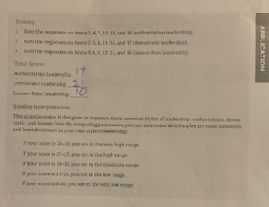
Week 8
Democratic leader - believes in being a team player, is adaptable, believes in fairness, respect, and trust amongst the team members, doesn't mind getting their hands dirty and believe strongly in inspiring team members.
this style of leadership values collaboration and affirmation

My Wk4 task and relationship questionnaire results
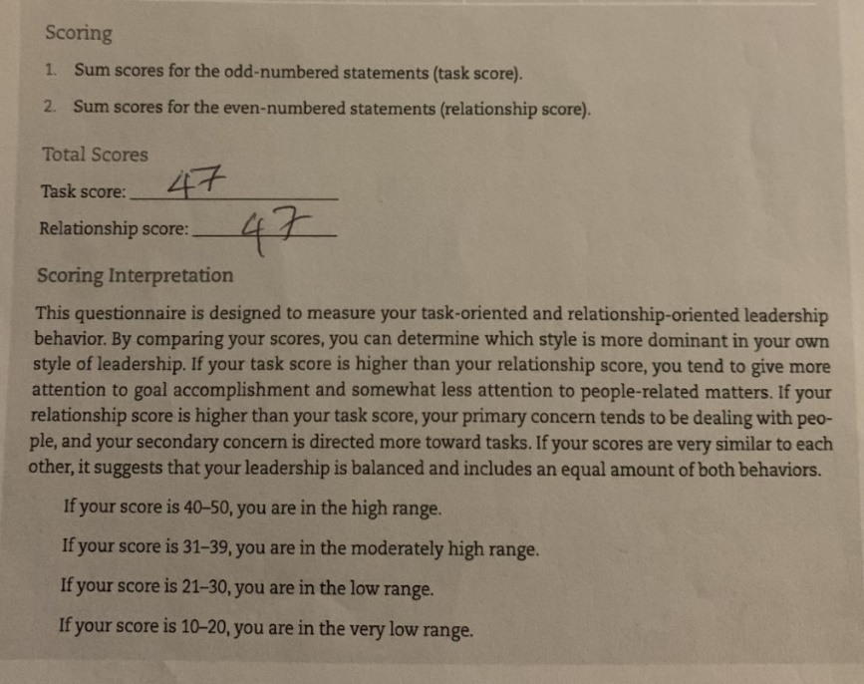
The questionnaire below shows a balanced combination of 47/47 this is portrayed in the task and relationship questionnaire results, I completed during a study conducted by the UWTSD

WK3; Leadership Philosophy Style
Ethical Leadership Results
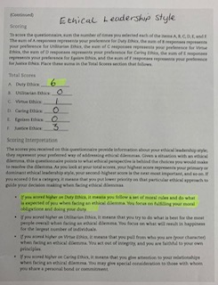

My learning has been complicated as I am dyslexic and suffer with a number of illnesses which affects my concentration. I find myself struggling in class, but I just get on with it as I am determined to pass. It can be difficult learning with lecturers who are unexperienced to teach dyslexic people, I just think differently can be a lot smarter than most.
I recently had an A bit of a disagreement with one of my lecturers during the rail strike when we were online, the lecturer asked us to write down a few comments for a question which she gave us, allowing us 5 minutes grace time. She then asked was anybody ready to give the answer in which I answered yes! nobody else appeared to be ready but she insisted that I should wait and let somebody else have a go, this surprised me as no one else was willing to go first and was not ready, she continued to ask their opinion but only one person gave it a go.
My feelings
At the time I felt annoyed because I couldn't understand why I needed to wait considering I was the first one ready, even when the class was asked what their opinion was not many people had much to say, so the lecturer asked everyone again then eventually asked if I wanted to give my opinion and I said no. I said that I don't think it was right that I should be dismiss that way as I am part of the class and I deserved better and did not understand why she wasn't prepared to hear my answer. I then continued on to give my answer to the question asked, in which my lecturer replied it was a good response to the question and everyone in the class also said it was a good question and that was what they wanted to say but couldn't find the words and my description of the particular question was spot on. My lecturer continued to apologise and said that it was not meant in a negative way but I said there was no other way I could have taken it there was no reason why I could not have answered the question at the time. my lecturer continued to apologise in which I told her I accept her apology but don't do it to me again because I'm not someone who allows people to dismiss me as I am a student and I'm here to learn, if I'm doing something wrong then please tell me but don't dismiss me.
Evaluation
well I was sitting listening to the class, I evaluated the situation wondering why I was put in that position, but I didn't let it bother me too much, that's just the type of person I am I didn't see it's important enough to make a big issue, even though I thought she should be told how is feeling and why I was feeling the way I was feeling. I'm not somebody who likes to old grudge I like to get things done and move on. I enjoy my classes and pride myself in admitting I've only missed one class in three years I've been here, and would like to learn as much as I possibly can I found my modules quite challenging; I know I've improved over the years as I can feel can see a difference in the way I think and right post up

Analysis
What I've learned from this module is patience, more understanding in my learning and the fact that we are being taught how to conduct ourselves in business, how to teach employees and to pass on what has been taught in university but I must admit the university doesn't always practise what it preaches kind of lets it down a little bit. I feel in order to help expand my thinking and my knowledge is a specific system which I've used in the past to help me to focus and repeat so the information will stay in my mind. Since we only have 10 weeks I feel a rushed, when we first started we had three modules which was spread out over a longer period of time, now everything is condensed down which doesn't help me very much, it's only made things worse.

Conclusion
I'm not sure if there was much more I could have done help my learning situation as I am doing my best now and has drawn on my teaching skisso help me deal with situations as I have always done. I feel I've learned a lot t in the leadership modules, as I have been accredited in the past for being a good leader, supervisor, manager by my employees and family members. I have learned more about leadership I do feel associated with the democratic, so I do things and the ethical side, when it comes to being around people, meeting and working with people I usually get along quite well as I'm very sociable. This module just told me about the different kinds of leaderships and the kind of leadership that I am, something I didn't know before I started the course and how important it is to know what kind of leader you're following, at least then you'll know what to expect and it will be less of a surprise their attitude, trait or personality, this module will definitely help me in my future ventures of employment.

References
Aithal, P.S. and Kumar, P.M., 2016. Comparative analysis of theory X, theory Y, theory Z, and Theory A for managing people and performance. International Journal of Scientific Research and Modern Education (IJSRME), 1(1), pp.803-812. ISSN (Online): 2455 – 5630), (2016). Available at: https://mpra.ub.uni-muenchen.de/72974/1/MPRA_paper_72974.pdf (Accessed 11/12/2022)
Boerma M, Coyle EA, Dietrich MA, Dintzner MR, Drayton SJ, Early JL 2nd, Edginton AN, Horlen CK, Kirkwood CK, Lin AYF, Rager ML, Shah-Manek B, Welch AC, Williams NT. Point/Counterpoint: Are Outstanding Leaders Born or Made? Am J Pharm Educ. 2017 Apr;81(3):58. doi: 10.5688/ajpe81358. PMID: 28496278; PMCID: PMC5423074. Available at: https://www.ncbi.nlm.nih.gov/pmc/articles/PMC5423074/#:~:text=The%20Great%20Man%20Theory%2C%20popularized,confronted%20with%20the%20appropriate%20situation. (Accessed 11/12/2022)
Boerma, M., Coyle, E.A., Dietrich, M.A., Dintzner, M.R., Drayton, S.J., Early, J.L., Edginton, A.N., Horlen, C.K., Kirkwood, C.K., Lin, A.Y. and Rager, M.L., 2017. Point/counterpoint: Are outstanding leaders born or made?. American journal of pharmaceutical education, 81(3). April 2017, 81 (3) 58; DOI: Available at: https://doi.org/10.5688/ajpe81358 (Accessed 11/12/2022)
Cacioppe, R., 1998. An integrated model and approach for the design of effective leadership development programs. Leadership & organization development journal. Available at: https://scholar.google.co.uk/scholar?q=effective+leadership+skills&hl=en&as_sdt=0&as_vis=1&oi=scholart (Accessed 11/12/2022)
Cambridge online dictionary (20220 Available at: https://dictionary.cambridge.org/dictionary/english/case-study (Accessed 11/12/2022)
Indeed Editorial Team (2022) Laissez-faire Leadership: definition, tips and examples. Available at: https://uk.indeed.com/career-advice/career-development/laissez-faire-leadership (Accessed 11/12/2022)
Indeed Editorial Team (2022) Management and leadership: the difference is and similarities Available at: https://uk.indeed.com/career-advice/career-development/management-and-leadership (Accessed 11/12/2022)
Mendonca. M and Kanungo. R.N (2007) Ethical leadership Available at: https://books.google.co.uk/books?hl=en&lr=&id=TScwwcJrA4QC&oi=fnd&pg=PP1&dq=ethical+leadership+theory&ots=vncKt49j0h&sig=9gKWAkMBvtGlFm6IlgAzLAJfDdM#v=onepage&q=ethical%20leadership%20theory&f=false (Accessed 11/12/2022)
Oxford learner's dictionary (2022) Available at: https://www.oxfordlearnersdictionaries.com/definition/english/ethic?q=ethics+ (Accessed 11/12/2022)
Ray, S. and Ray, I.A., 2012. Understanding democratic leadership: some key issues and perception with reference to india’s freedom movement. Afro Asian Journal of Social Sciences, 3(3.1), Quarter I 2012 ISSN: 2229 – 5313. pp.1-26. Available at: https://onlineresearchjournals.com/aajoss/art/83.pdf (Accessed 11/12/2022)
Sophie Williams (2020) Coronavirus: How can China build a hospital so quickly
Available at: https://www.bbc.co.uk/news/world-asia-china-51245156 (Accessed 12/12/2022)
STU Online (2014) What is task orientated leadership? Available at: https://online.stu.edu/degrees/education/what-is-task-oriented-leadership/ (Accessed 11/12/2022)
Team Leadership Styles (2022) The behavioural approach employed by leaders to influence, motivate, and direct their followers Available at: https://corporatefinanceinstitute.com/resources/management/leadership-styles/ (Accessed 11/12/2022)
Team Leadership Styles (2022) The behavioural approach employed by leaders to influence, motivate, and direct their followers Available at: https://corporatefinanceinstitute.com/resources/management/leadership-styles/ (Accessed 11/12/2022)
Women Love Tech: Women in leadership: the real reason why there’s so few female leaders, (2021) Available at: https://womenlovetech.com/why-are-theres-so-few-female-leaders/ (Accessed 10/11/2022)

