

Business and Web Management

Module Code: | ACCA5033
Assignment Title: | Website Redesign for Online Business Presence
Student Name: | Ioana Catalina Sava
Student number: | 2329918
Lecturer’s name: | Dr. Mobolante Bello
Submission Deadline: | 6th March 2026  14:00 (2PM)
Table 1: course and student informations.


Figure 2: web design image

Table of Contents

1.0 INTRODUCTION 3
2.0 MEAL SWIFT WEBSITE REDESIGN 3
3.0 RESPONSIVE DESIGN IMPLEMENTATION 6
3.1 IMPLICATIONS OF RESPONSIVE DESIGN IMPLEMENTATION IN E-COMMERCE WEBSITES FOR IMPROVING USER EXPERIENCE 6
3.2 IMPLICATION OF RESPONSIVE DESIGN IMPLEMANTATION IN E-COMMERCE WEBSITES FOR IMPROVING SALES 7
4.0 IMPLEMENTATION SECTION 8
MOODBOARD SCREENSHOT 8
WIREFRAME SCREENSHOT 8
HOMEPAGE WIREFRAME SCREENSHOT 8
PAGE 2 WIREFRAME SCREENSHOT 9
PAGE 3 WIREFRAME SCREENSHOT 9
PAGE 4 WIREFRAME SCREENSHOT 10
PAGE 5 WIREFRAME SCREENSHOT 10
WEB DESIGN SCREENSHOTS 11
HOMEPAGE WEB DESIGN SCREENSHOT 11
PAGE 2 WEB DESIGN SCREENSHOT 11
PAGE 3 WEB DESIGN SCREENSHOT 12
PAGE 4 WEB DESIGN SCREENSHOT 12
PAGE 5 WEB DESIGN SCREENSHOT 13
4.1 MOODBOARD AND WIREFRAME DESIGN 13
5.0 CONCLUSION 14
REFERENCES 15

INTRODUCTION
This report presents the redesign process and proposed user interface improvements for the MealSwift food delivery website. The purpose of the project is to address existing usability problems, modernise the visual identity, and create a smoother and more engaging experience that encourages customers to complete orders and remain loyal to the platform. The scope of the report covers research into current website limitations, the development of a new design direction, and the creation of key design artefacts including a mood board, wireframes, and an interactive prototype.
A user-centred design methodology was followed throughout the project. First, common pain points such as confusing navigation and weak calls-to-action. These findings informed visual exploration and branding decisions in the mood board. Wireframes were then produced to organise layout, structure, and functionality before moving into higher-fidelity interactive screens. This step-by-step approach ensured that user needs, accessibility, and business goals remained central to every design decision.
The significance of this report lies in demonstrating how a structured UI/UX process can transform an underperforming e-commerce platform into a modern, intuitive, and conversion-focused digital experience.

2.0 MEAL SWIFT WEBSITE REDESIGN
MealSwift’s rapid growth shows that customers value its service, but the current website experience does not fully support its success. When users visit a food delivery website, they are often hungry, busy, or looking for convenience. They expect speed, clarity, and simplicity. Unfortunately, the existing MealSwift website creates friction at multiple points in the user journey.
Confusing Navigation
One of the main problems is confusing navigation. Categories are not clearly structured, filters are limited, and important actions such as viewing the cart or proceeding to checkout are not immediately visible. Users are forced to spend extra time figuring out where to click, which can quickly lead to frustration. In competitive digital markets, even small usability issues can significantly reduce engagement and conversions [1].
The website should be redesigned with a clear and logical information architecture. Food categories should be structured in a way that matches how users think. A powerful search bar with auto-suggestions and smart filters should be added. The cart and checkout buttons must be clearly visible and fixed in consistent positions. The goal is simple: users should always know where they are and what to do next.

Outdated Visual Design
The visual design also feels outdated, with inconsistent fonts, poor spacing, and low-quality food images that fail to create an emotional connection. Since food delivery decisions are strongly influenced by visual appeal, unappealing imagery can directly impact ordering behaviour.
A modern and cohesive visual identity should be introduced. This includes consistent typography, improved spacing, and a clean layout that reduces clutter. High-quality, professional food photography should replace low-resolution images. A warm, appetite-stimulating colour palette aligned with the brand can enhance emotional engagement. A visually appealing interface builds trust and encourages users to browse longer and order more.

Lack of detailed description
Restaurant pages often lack detailed descriptions, allergen information, dietary labels, estimated preparation times, and transparent pricing. This creates uncertainty and may reduce trust. Customers hesitate when they don’t feel fully informed.
Each restaurant page should provide complete and structured information: detailed dish descriptions, ingredients, allergen warnings, dietary tags, preparation time, delivery estimate, and transparent pricing. Adding FAQs sections can further increase clarity and confidence.

Inefficient Ordering and Checkout Process
The checkout process contains too many steps, lacks a progress indicator, and does not clearly summarise the order before payment. Complicated checkouts are one of the main reasons users abandon carts.
The checkout flow should be simplified into fewer, clearly defined steps. A visible progress bar helps users understand where they are. A clear order summary should be displayed before payment. Features such as saved addresses, auto-filled forms, multiple secure payment options, and one-click checkout for returning users would significantly reduce friction and improve conversion rates.

Lack of Personalisation
MealSwift currently offers a generic experience. It does not remember user preferences, suggest favourite meals, or recommend restaurants based on past behaviour. Modern users expect personalised digital experiences.
Introduce a recommendation system based on browsing history, previous orders, and user preferences. Features like “Order Again,” “Recommended for You,” and personalised promotions can make the experience feel tailored. Loyalty programs and reward points can also strengthen long-term engagement and retention.

Slow Loading Time
Pages take too long to load, users become impatient and may leave before completing an order. In a competitive food delivery market, even a few extra seconds of waiting can reduce engagement and lower conversion rates. A slow website also negatively affects brand perception, making the platform feel unreliable or outdated.
Website performance should be optimised through technical improvements. High-resolution images should be compressed without reducing quality, and lazy loading can ensure that images load only when needed. Implementing browser caching and reducing unnecessary scripts will improve page speed. Clean, efficient coding practices and server optimisation can further reduce response times. Regular performance testing should be conducted to identify bottlenecks and ensure the website remains fast and responsive. A faster website creates a smoother browsing experience, increases completed orders, and strengthens user trust in the platform.

No Real-Time Order Tracking
After placing an order, customers are left uncertain about its status. The absence of real-time tracking reduces transparency and can create anxiety.
Integrate live order tracking with clear status updates. Push notifications and SMS updates can keep users informed. A map-based tracking feature adds reassurance and improves overall satisfaction.

Accessibility Issues
The website currently has limited keyboard navigation, weak colour contrast, and missing alternative text for images. This makes it difficult for users with disabilities to use the platform comfortably.
Redesign the platform following accessibility standards. Improve colour contrast, enable full keyboard navigation, add descriptive alt text for images, and ensure screen reader compatibility. Accessibility improvements not only support inclusivity but also enhance usability for all users.

Minimal Customer Review and Rating
Customer reviews and ratings are either minimal or not prominently displayed. Without strong social proof, users may hesitate to try new restaurants.
Make verified customer ratings and reviews highly visible on restaurant and menu pages. Include filtering by rating and highlight top-reviewed dishes. Encouraging users to leave feedback after delivery can build community trust and guide future customers in their decisions.

3.0 RESPONSIVE DESIGN IMPLEMENTATION
Responsive design is an approach in which one interface automatically adapts its layout, media, and interactions to different screen sizes and orientations. It commonly uses flexible grids, scalable assets, and CSS breakpoints to maintain usability and consistency across contexts [5]. In practice, this means customers can focus on evaluating products rather than struggling with navigation or readability.

3.1 IMPLICATIONS OF RESPONSIVE DESIGN IMPLEMENTATION IN E-COMMERCE WEBSITES FOR IMPROVING USER EXPERIENCE
Responsive design strongly influences how customers feel when using an e-commerce website. Shoppers expect buying online to be effortless whether they are on a desktop or a phone. When a site adapts smoothly to any screen, it communicates respect for the user’s time and comfort [6]. This positive feeling can easily determine whether someone simply browses or actually makes a purchase [7].
A major implication for user experience is better usability. Properly sized buttons, readable text, and well-scaled images allow visitors to focus on products rather than technical difficulties. The path from homepage to checkout becomes clearer, giving users a sense of control and reducing frustration.
Consistency across devices also builds trust. When navigation feels familiar, customers are more confident about sharing personal and payment information. Responsive layouts further support accessibility, ensuring that more people can shop comfortably.
Because interactions feel easy, visitors stay longer, explore more, and are more likely to return. In this way, responsive design quietly removes barriers and makes digital shopping feel natural and human.

3.2 IMPLICATION OF RESPONSIVE DESIGN IMPLEMANTATION IN E-COMMERCE WEBSITES FOR IMPROVING SALES
Responsive design is more than a technical preference; it is a major influence on e-commerce sales in a mobile-first marketplace. Customers move across phones, tablets, and desktops and expect the experience to remain smooth. When websites adapt effortlessly, shoppers feel comfortable and are more willing to complete purchases. If the interface is clumsy, many simply leave, resulting in lost revenue.
One clear sales benefit of responsive design is stronger mobile performance. Users want fast pages, clear layouts, and visible calls-to-action. Studies show that responsive platforms achieve higher conversion rates and lower bounce rates than non-adaptive ones [8]. By reducing friction in browsing and checkout, businesses make it easier for intention to become action.
Responsive design also shapes trust. When product information is readable and navigation feels intuitive, customers gain confidence and are more prepared to share payment details. This perception of ease and professionalism is closely linked to purchase intention [9].
Consistency across devices further encourages repeat visits, building loyalty and long-term revenue growth.

4.0 IMPLEMENTATION SECTION

MOODBOARD SCREENSHOT
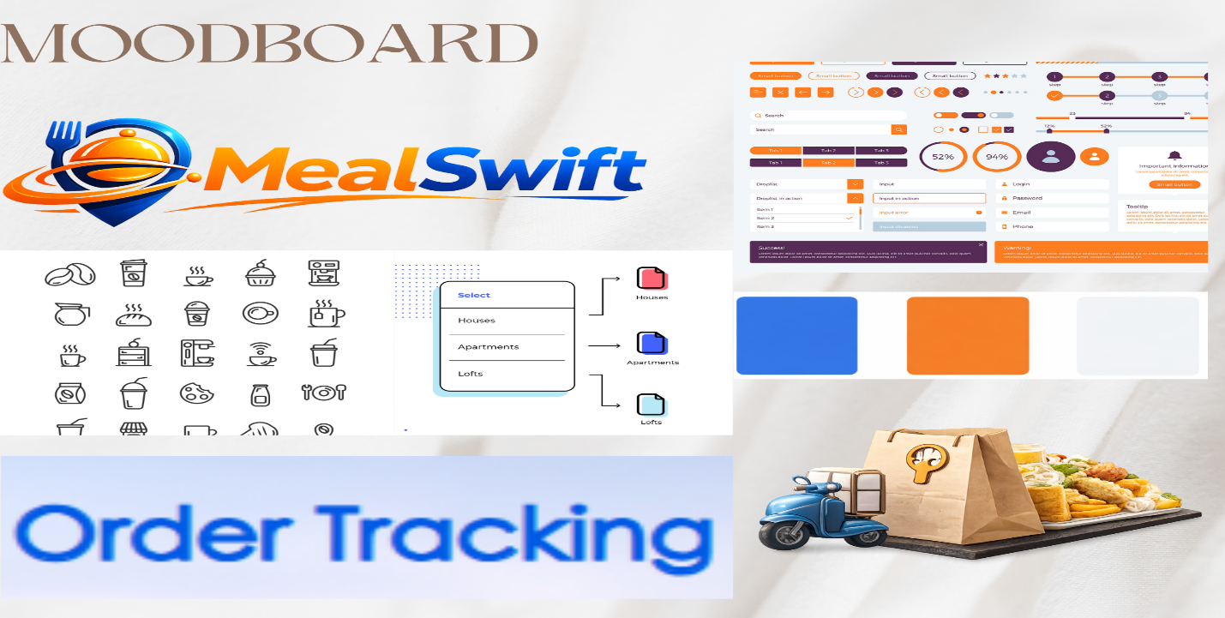
Figure 2: image of moadboard

WIREFRAME SCREENSHOT

HOMEPAGE WIREFRAME SCREENSHOT
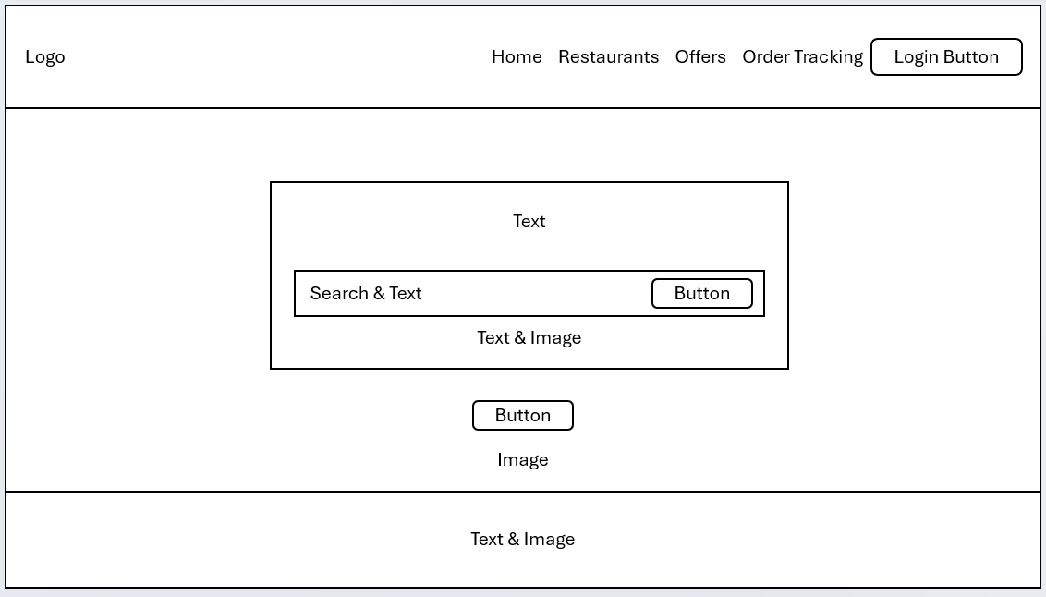
Figure 3: screenshot of home page

PAGE 2 WIREFRAME SCREENSHOT
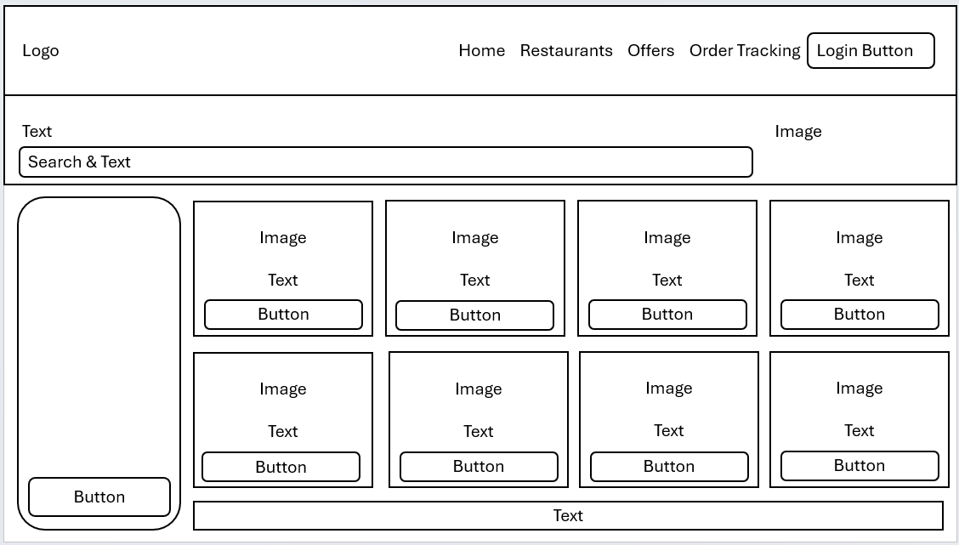
Figure 4: screenshot of restaurants page

PAGE 3 WIREFRAME SCREENSHOT
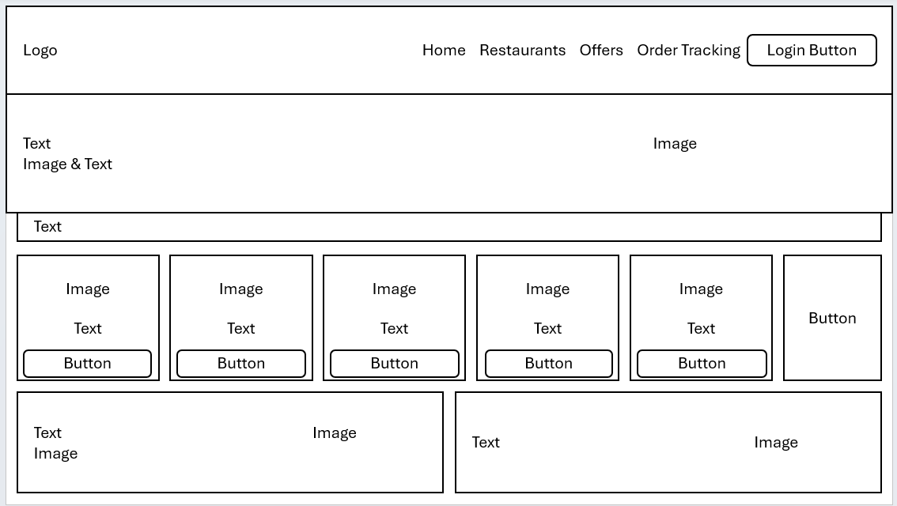
Figure 5: sreenshot of offers page

PAGE 4 WIREFRAME SCREENSHOT
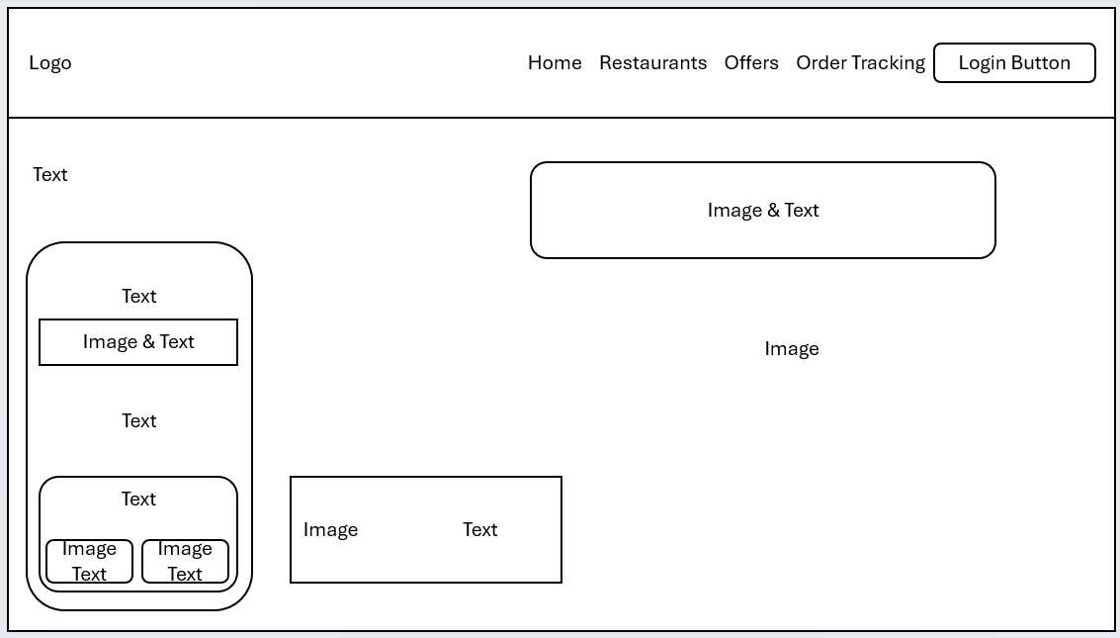
Figure 6: screenshot of order tracking page

PAGE 5 WIREFRAME SCREENSHOT
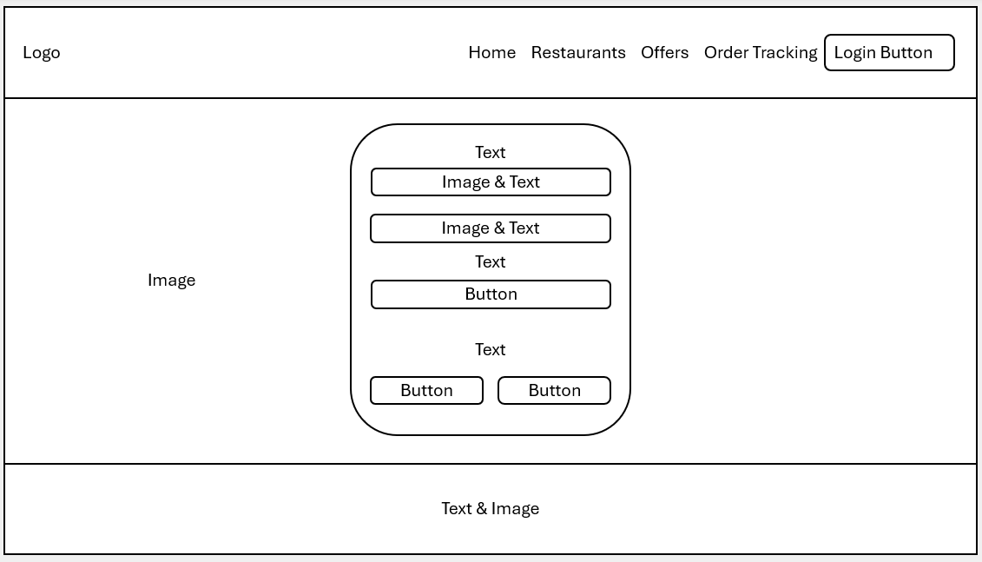
Figure 7: screenshot of login page

WEB DESIGN SCREENSHOTS

HOMEPAGE WEB DESIGN SCREENSHOT
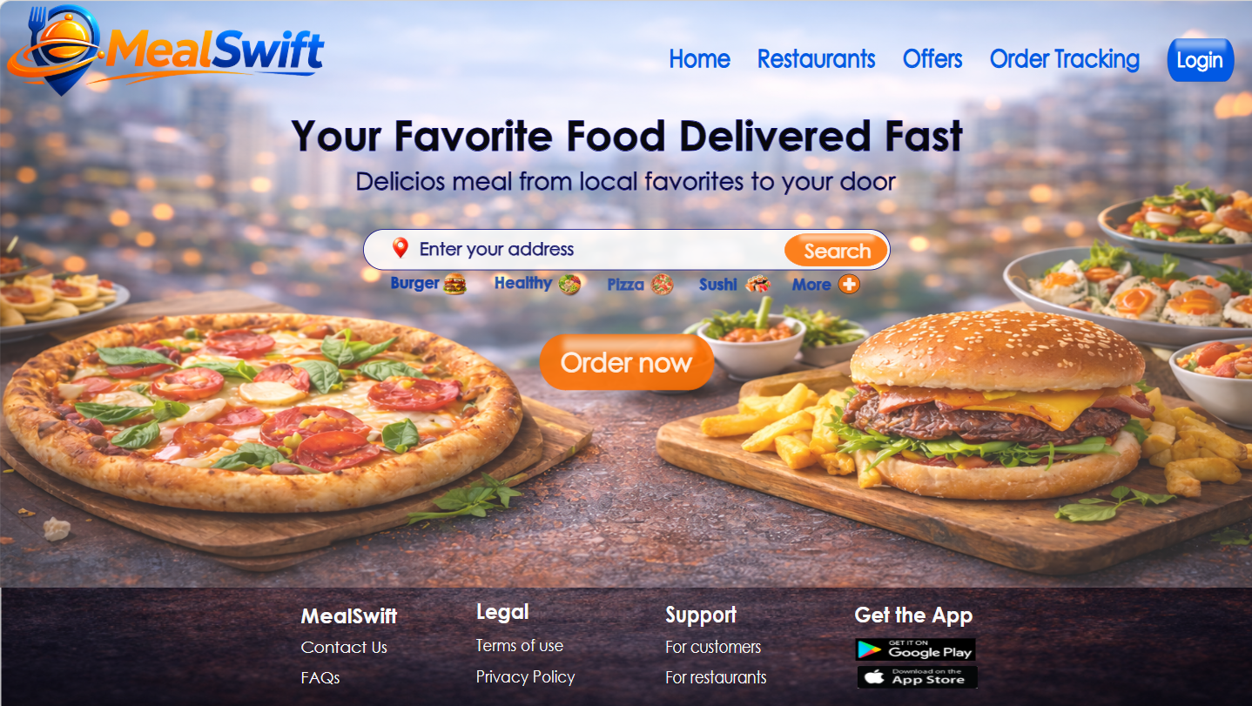
Figure 8: screenshot of home page

PAGE 2 WEB DESIGN SCREENSHOT
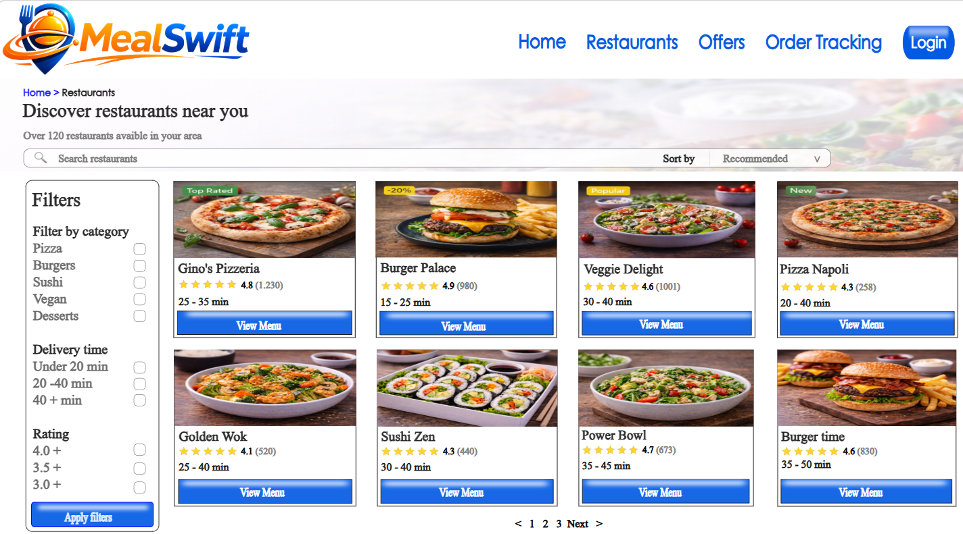
Figure 9: screenshot of restaurants page

PAGE 3 WEB DESIGN SCREENSHOT
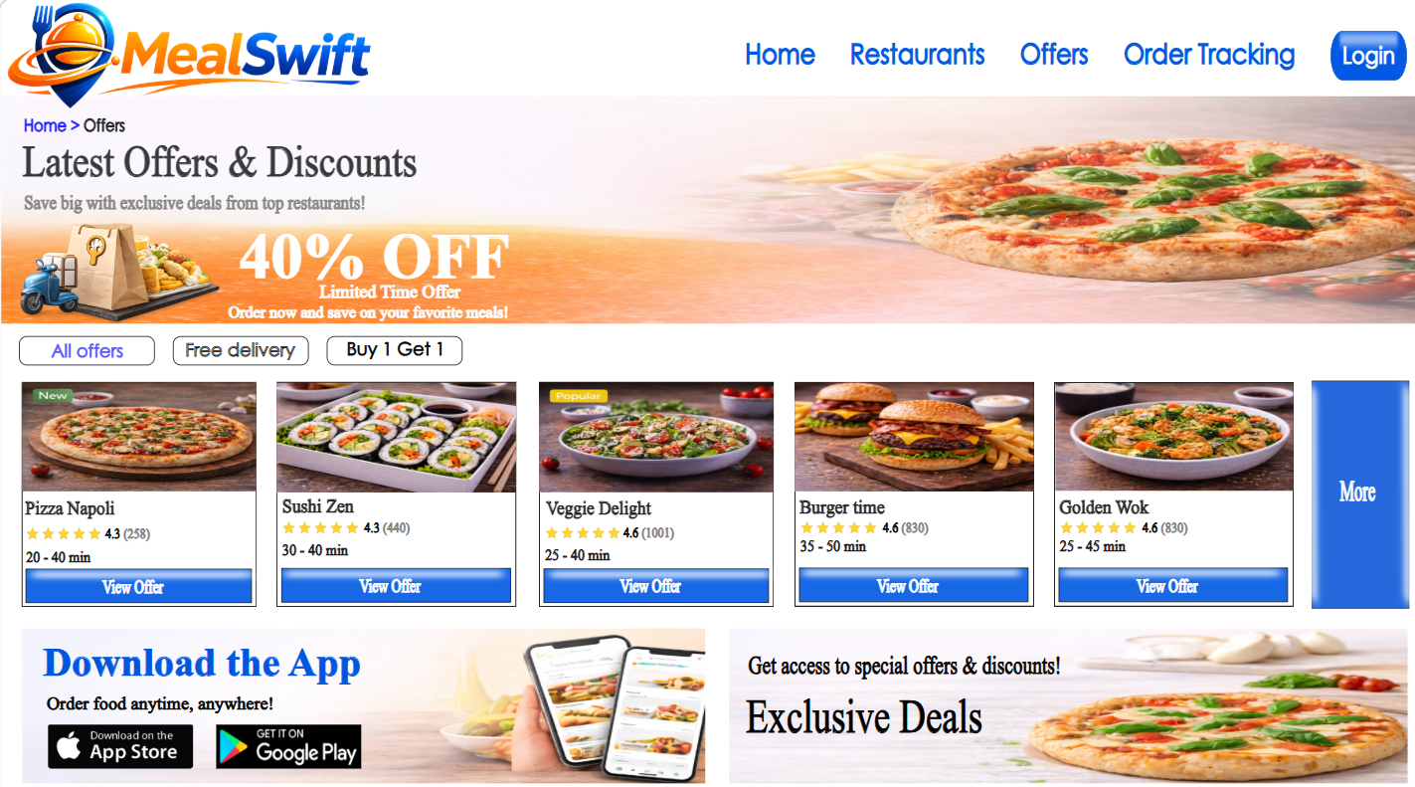
Figure 10: screenshot of offers page

PAGE 4 WEB DESIGN SCREENSHOT
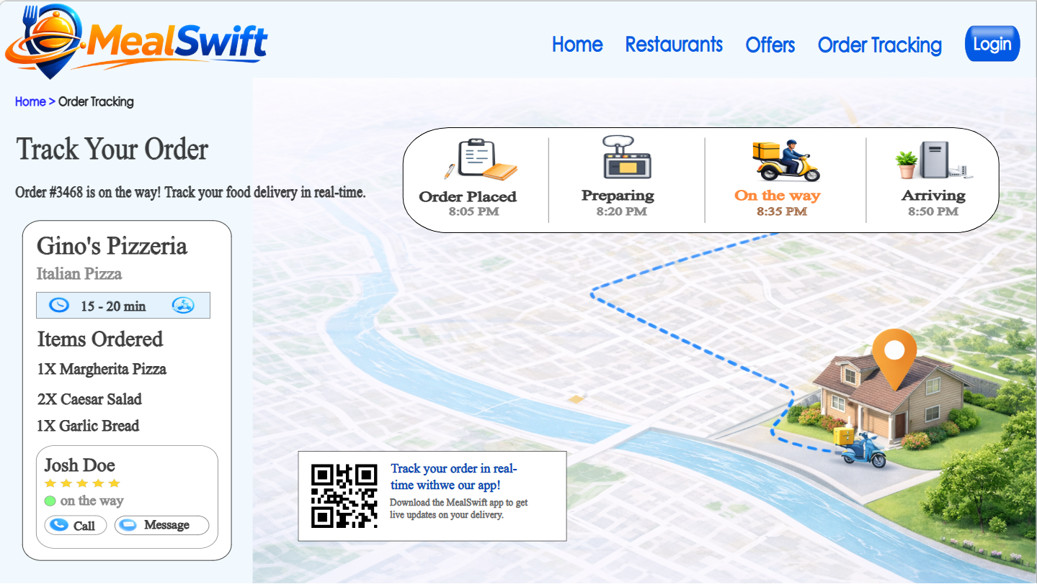
Figure 11: screenshot of order tracking page

PAGE 5 WEB DESIGN SCREENSHOT
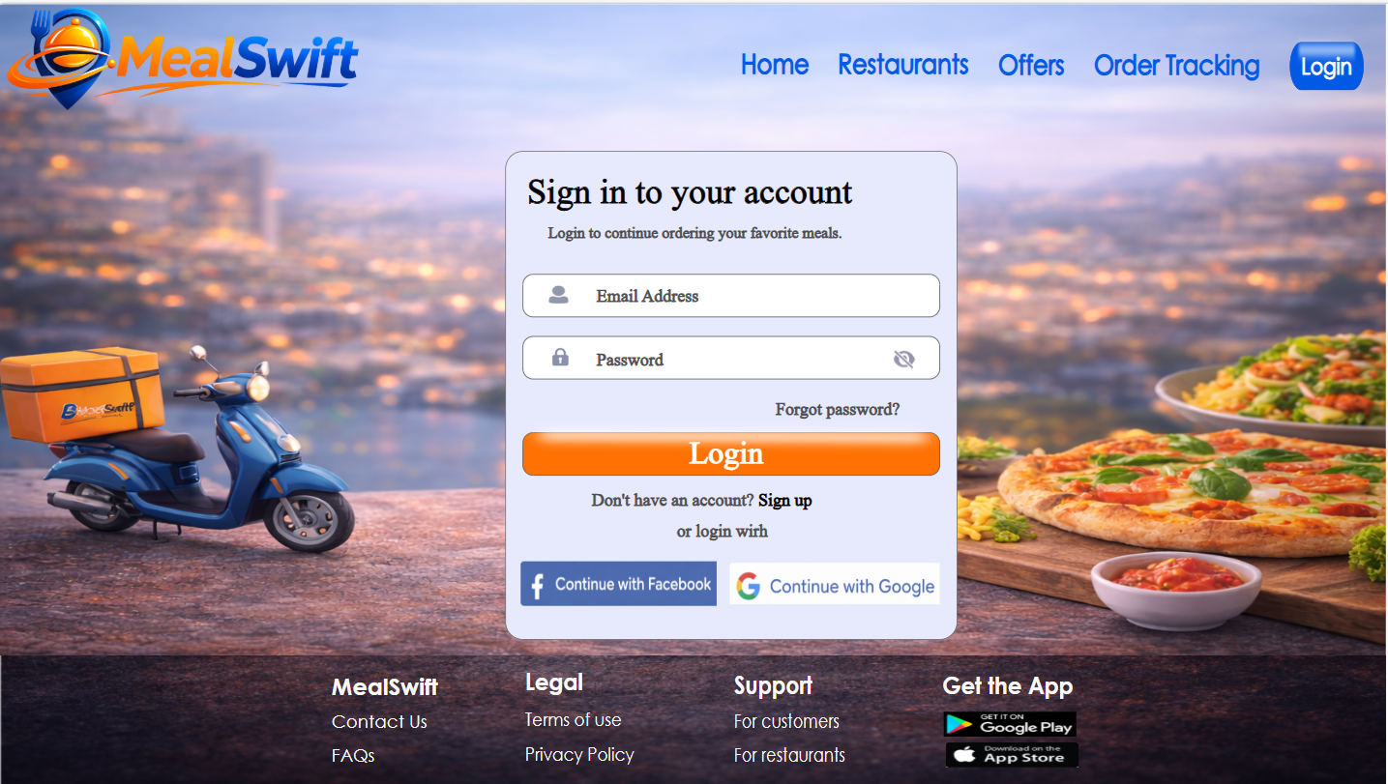
Figure 12: screenshot of login page

4.1 MOODBOARD AND WIREFRAME DESIGN
A moodboard is a visual collection of colours, typography, imagery, icons, and interface inspirations that communicates the overall look and emotional direction of a design project before detailed development begins [10]. It serves as a creative reference point that aligns the design team with the brand’s personality, tone, and user expectations. In the MealSwift project, the moodboard helped define a modern, energetic, and appetising identity through the use of vibrant orange and blue tones, clean interface components, food imagery, and delivery-themed visuals. By reviewing the moodboard before moving into high-fidelity design, I ensured that every layout decision reflected consistency in colour palette, button styles, iconography, and overall visual hierarchy. It influenced my design by guiding the emotional feel of the platform—making it appear friendly, trustworthy, and dynamic—while also ensuring that UI elements such as cards, navigation bars, and call-to-action buttons followed a cohesive visual system.
A wireframe is a low-fidelity structural blueprint of a website or application that outlines layout, content placement, navigation flow, and functional components without focusing on final visual styling [11]. It acts as the architectural foundation of a digital product, allowing designers to prioritise usability, user flow, and content hierarchy before adding branding details. In the MealSwift redesign, the wireframes for the home page, restaurants page, offers section, login screen, and order tracking page helped me clearly define how users move from browsing to checkout. They allowed me to test the placement of search bars, restaurant cards, buttons, and tracking information to ensure logical progression and simplicity. The wireframes influenced my design by identifying spacing issues, improving call-to-action visibility, and organising content into clear sections before applying colours and imagery from the moodboard. Together, the moodboard and wireframes created a balanced process: the moodboard shaped the emotional and visual identity, while the wireframes ensured structure, usability, and functionality were carefully planned from the beginning.

5.0 CONCLUSION
Throughout this project, I learned that designing a successful e-commerce website is not only about making it visually attractive, but about carefully balancing usability, performance, branding, and business goals. By analysing MealSwift’s initial challenges and redesigning the Home, Restaurants, Offers, Login, and Order Tracking pages, I focused on creating a smoother and more intuitive user journey. I improved navigation clarity, strengthened call-to-action buttons, enhanced visual consistency, and integrated features such as filtering options and real-time tracking to increase engagement and trust.
The moodboard helped me establish a vibrant and modern brand identity, while the wireframes allowed me to structure content logically before applying final design elements. This step-by-step design process ensured that every decision supported both user needs and MealSwift’s objective of increasing orders and customer loyalty. Overall, this experience reinforced the importance of user-centred design and responsive layout planning in building a high-quality digital platform that meets real business demands and delivers a satisfying customer experience.

REFERENCES
[1] A. Kumar and R. Singh, “Impact of Website Usability on Customer Satisfaction and E-Loyalty in E-Commerce,” International Journal of Human–Computer Interaction, vol. 38, 2022.
[2] M. Alshibly, “E-Commerce Website Quality and Online Purchase Intention: The Role of User Experience,” Journal of Theoretical and Applied Electronic Commerce Research, vol. 16, 2021.
[3] R. Kohavi, D. Tang, and Y. Xu, Trustworthy Online Controlled Experiments: A Practical Guide to A/B Testing, Cambridge, UK: Cambridge University Press, 2020.
[4] S. Krug, Don’t Make Me Think, Revisited: A Common Sense Approach to Web Usability, Updated ed. Indianapolis, IN, USA: New Riders, 2021.
[5] A. Marcotte, Responsive Web Design, 2nd ed. New York, NY, USA: A Book Apart, 2020.
[6] V. Aienobe and M. Z. Iqbal, “Responsive Web Design for Enhanced User Experience (UX) and User Interface (UI),” International Journal of Computer Applications, vol. 187, no. 34, Aug. 2025.
[7] N. Bhanarkar, A. Paul, and A. Mehta, “Responsive Web Design and Its Impact on User Experience,” International Journal of Advanced Research in Science, Communication and Technology, vol. 3, no. 4, Apr. 2023.
[8] M. Khosrow-Pour, Advanced Methodologies and Technologies in Business Operations and Management, 2021.
[9] H. Treiblmaier and P. B. Lowry, E-Commerce and the Digital Economy, Cham, Switzerland: Springer, 2021.
[10] C. Babich and J. Smashing Media, UX Design: The Ultimate Guide to User Experience Design, 2nd ed. Freiburg, Germany: Smashing Media AG, 2021.
[11] R. Unger and C. Chandler, A Project Guide to UX Design: For User Experience Designers in the Field or in the Making, 3rd ed. Berkeley, CA, USA: New Riders, 2020.

