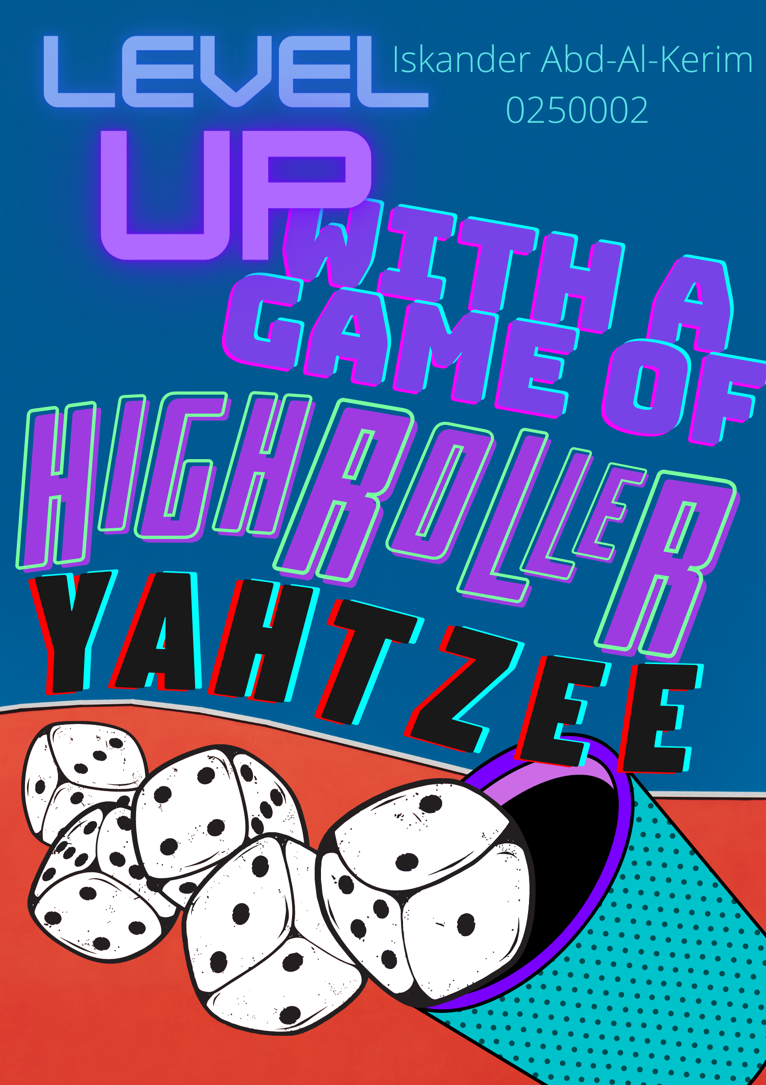  Scrabble algorithm  The work of this report completed under no supervision as I am studying from home. I declare that this report is the product of my own work and is not being submitted for any other degree etc. Iskander Abd-Al-Kerim | Abstract  A modern-day digital solution to the wonderful dice rolling game we know as, Yahtzee! In this report we will look at the rules of Yahtzee and a digitalised solution for improving gameplay.  Iskander Abd-Al-Kerim 0250002  Analysing and Solving Problems M4X01499

Table of Contents
1.0 Main 2
1.1 Introduction 2
1.2 Rules of Yahtzee 2
1.2.1 HighRoller Quads 3
1.2.2 HighRoller Full House 3
1.2.3 HighRoller Yahtzee 3
1.3 Requirements Features List 4
1.4 Variables and Constants 4
1.4.1 Variables 4
1.4.2 Constants 5
1.5 Pseudo Code and Sub Processes 5
1.5.1 Randomise Process. 8
2.0 Conclusion 8
3.0 Limitations 8
4.0 Appendices 9
5.0 Acknowledgments 12
6.0 References 13
7.0 Research List 14

1.0 Main

Introduction

In this report we will look at a feature within a digital version of the game of Yahtzee, a minigame of sort. Yahtzee was Made by Milton Bradley and was first realised in the early 1940`s. It was originally marketed as Yatzie by the National association Service of Toledo until 1956 when Edwin. S. Lowe changed its marketing name to Yahtzee [1].
This report will discuss the rules entailed in the minigame and briefly cover the rules of a standard game of Yahtzee. Then delving into a detailed section covering requirements feature list, variables and constants as well as pseudo code and sub processes. These sections will give you the reader an insight of how the minigame of Yahtzee will claim its righteous place accompanying any digital version of Yahtzee.

1.2 Rules of Yahtzee
You can see how a normal game of Yahtzee is scored see appendices 1. You have 13 turns with 13 scoring categories [2].
In HighRoller Yahtzee we look at making a game have minimum three hand types which the players can select as well as having the ability to alter number of rolls per turn from 3 up to 7 and the game turns will be alterable from the base 13 in normal Yahtzee can now be moved up to 42.
The scoring is slightly altered though in HighRoller Yahtzee. For this report we are only looking at Quads, Full House and Yahtzee being qualifying hands. You may use the same hand type more than once and score higher points the higher your roll value is.
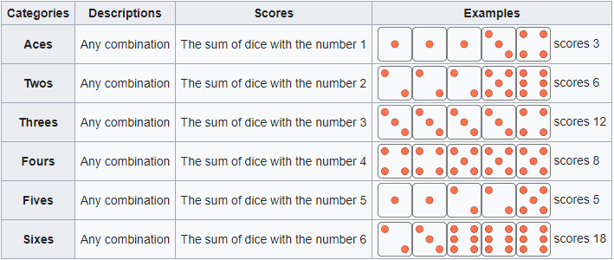
[1]
In standard Yahtzee you have an upper section and a lower section, the upper section is made up of dice with matching face value, so you have a scoring slot for 1s, 2s, 3s, 4s, 5s, and 6s. You can have one or even up to five of each to score in the upper section however if you have got five of the same that is a Yahtzee and if it is your second Yahtzee and you place the hand in its corresponding upper slot you will get the Yahtzee score and the upper section value added. The aim is to score over 63 in the upper section with an average of 3 dice per section to gain the upper section bonus 35 points.

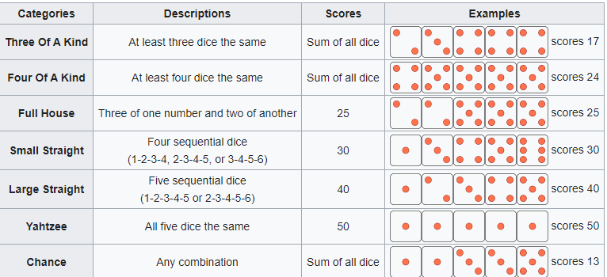
[1]
The lower section is then made up of 3 and 4 of a kind, the points here are the total of all dice not just the 3or4 of a kind. 2 types of straights a small straight grants 30 points and a large straight grants 40 points. Large being made up of five consecutive dice 1 through 5 or 2 through 6 and small being made up of four 1-4 2-5 or 3-6. The full house gets you 25 points and is then made up of a pair and a set of triples. Yahtzee is five of a kind and will score you 50 points then a second Yahtzee will score you 100, so let us say you second Yahtzee is made up of 6s and you place it in the upper section for 6s you will gain your 100 bonus Yahtzee score as well as 30 points for the face value of the dice. Last but in most cases likely not to be the least is Chance. Chance is made up of whatever dice you have and their total value is added to your score.
The game can be played alone or in multiple players versus each other competing for whom will gain the most points to crown a winner.

1.2.1 HighRoller Quads

HighRoller Quads will be made up of four dice equalling the same value however its dependant on which Quads you roll to determine how many points you acquire.

- 1&2s scores 50 points.
- 3&4s scores 100 points.
- 5&6 gives 150 points.

1.2.2 HighRoller Full House

As with Quads normally you could only score one full house. In HighRoller the aim is to roll as many as possible, but the aim is to try for higher dice values as they score the most points.
So, if your full house adds up to
- 7,8,9,10,11,12,13 score 50.
- 13,14,15,16,17,18,19,20 score 100.
- 21 get you a wonderful bonus extra turn as well as 200 points.
- 22,23,24,25,26,27,28 gets you 150 points.
Players also have the option to activate odds and evens bonus which means if your full house is made up of all odd or even dice, they would gain extra points.

1.2.3 HighRoller Yahtzee
Even in HighRoller Yahtzee we do not dare change the true meaning of Yahtzee. In normal Yahtzee it takes 5 of the same digit dice to be able to scream out” Yahtzee!” Well in High Roller the requirements are the same however if you get a second Yahtzee, we do not ask you to use up one of your other free had slots we just score you more if you get a HighScore.
Scoring for Yahtzee in HighRoller is simple.
- 1&2s score you 100.
- 3&4s score you 200.
- 5&6s score you 300.
- No Yahtzee bonus offered.

Requirements Features List
In the MOSCOW table below, you can see what the mini game must include, should include, could include and won’t include. The augmented reality feature which I greatly hope it includes within some version soon is the one I am most excited about. Its classed as emerging tech and will place this digitalised version of Yahtzee claiming the podium the race to be top Yahtzee rolling on the digitalised gaming scene.
Must Have | Should Have | Could Have | Won`t Have
All Yahtzee hand types  available for selection | option to change rolls  per turn number | Log in for user progression and ranking storage allowing users to change devices and keep their rank | need to a steering wheel
score keeper | number of turns per  game selection option | 21 bonuses of full hose rolls scoring 21
randomiser process |  | online gameplay | over 18 xxx content
single player mode | Vs AI mode | two player mode over  a network
Normal Yahtzee  game option | ads to generate  revenue | tournament play
two player localised gameplay |  | playing for money
HighRoller Yahtzee |  | tournament prises paid for by ad revenue
Augmented reality
allowing players to see the dice being rolled on any surface they choose

1.4 Variables and Constants

In a normal game of Yahtzee, we have several variables and constants. Our main Variable will be the dice_one, dice_two, dice three, dice_four and dice_five which will be stored in an array of five elements [3] An integer [4] dice_val can be anything from 1-6 to represent a dice value.

1.4.1 Variables

Initially the intention was to place computer, player_one and player_two in as constants however having looked at it further once the introduction of usernames happens player_one = user_id, this can also happen for computer if the introduction of ai characters was to be introduced into the game for more realistic play. The dice variables will have their valued randomised with rolls unless there are dice being held so in a sense held dice variables can be seen as constants for the duration of the rolls during which they are held.
- computer,
- player_one,
- player_two,
- dice_one
- dice_two
- dice_three
- dice_four
- dice_five
- quads_count
- yahtzee_count
- full_house_count
- game_score
- turn_val
- roll_count
- turn_count

1.4.2 Constants
The constant variable is one of which the data corresponding to them i.e. single_player, will always be the same. Meaning single_player will always be referring to a single player game and will never change there is no alternative scenario in which the value of this variable will be altered.
- single_player,
- head_to_head,
- versus_ai,

As you can see we don’t seem to have many constants showing up we will once we get some design done though. This will be our celebrations and commiserations for example and mainly things related to items that change positions on screen or appear and disappear “Congratulations You Won!” image for example.

1.5 Pseudo Code and Sub Processes

Input | Processes | Output
dice value,  roll,  qualifying_hands  input selection of game type  exit game.  view instructions  dice to hold, | Ad values of held dice,  Update score  Check for qualifying hand.  Randomise 0-5 based on srand 6%+1  quands_check  yahtzee_check  full_house_check  two1_check | game_score  turn_val, turn_count, roll_count  dice_one, dice_tow, dice_three  dice_four, dice_five  full_house, full_house_count  yahtzee, yahtzee_count  Quads, quads_count  two1_bonus_count

- dice_one
- dice_two
- dice_three
- dice_four
- dice_five
- quads_count
- yahtzee_count
- full_house_count
- game_score
- turn_val
- roll_count
- turn_count
- player_one,
- player_two,
- computer,
- single_player,
- head_to_head,
- versus_computer,

Now we will look at some Pseudo code leading from the point a single player game begins, the game contains three qualifying hand types of Full House, Yahtzee and Four of a Kind or as we like to call it Quads. It is set up with 13 turns and up to 3 rolls per turn.
The trace table in appendices illustrates the full game in the pseudo code you will see the game play out to the end of turn 6 by which time we would have seen the player complete a non-scoring roll, a Full House, Quads a Yahtzee and a 21-bonus Full House which grants the user an extra turn. Even though the player has selected a 13-turn game we can see 15 turns being played in the trace table in appendixes as a Full House with dice valuing a total of 21 was rolled twice and grants the player an extra turn each time.

- START
- SET game_score=0, ramamining_turn_count=13, full_house=0, Yahtzee=0, two1_bonus=0, quads=0
- DISPLAY “Go ahead and Roll the Dice”.
- SET roll_count = 0
- INPUT roll
- DISPLAY “You rolled, 2,2,2,1,6. Select dice to hold and then roll again”.
- INPUT roll
- SET roll_count = 1
- INPUT 2,2,2, roll.
- DISPLAY “You rolled, 2,2,2,1,1. Select dice to hold and then roll again”.
- SET roll_count = 2
- INPUT 2,2,2,1,1, roll
- DISPLAY “Full House, 50 points!”
- SET turn_count = turn_count – 1, game_score = game_score + 50, full_house_count = full_house_count + 1, roll_count = 0.
- DISPLAY “You rolled, 4,4,4,4,5. Select dice to hold and then roll again”.
- INPUT roll
- SET roll_count = 1
- INPUT 4,4,4,4, roll
- DISPLAY “You rolled, 4,4,4,4,1. Select dice to hold and then roll again”.
- SET roll_count = 2
- INPUT 4,4,4,4, roll
- DISPLAY “You rolled, 4,4,4,4,1. Select dice to hold and then roll again.”.
- INPUT 4,4,4,4, roll
- INPUT roll
- DISPLAY “You rolled, 4,4,4,4,4. Medium Yahtzee, 200 points!
- SET turn_count = turn_count – 1, game_score = game_score + 200, yahtzee_count = yahtzee_count + 1, roll_count = 0.
- DISPLAY “You rolled, 5,5,5,2,1. Select dice to hold and then roll again”.
- SET roll_count = 1
- INPUT 5,5,5, roll.
- DISPLAY “You rolled, 5,5,5,2,3. Select dice to hold and then roll again”.
- SET roll_count = 2
- INPUT 5,5,5, roll.
- DISPLAY “You rolled, 5,5,5,6,4. No combination, better luck next time”.
- SET turn_count = turn_count – 1, roll_count = 0.
- DISPLAY “You rolled, 4,4,4,2,3. Select dice to hold and then roll again”.
- SET roll_count = 1
- INPUT 4,4,4, roll.
- DISPLAY “You rolled, 4,4,4,4,6. Select dice to hold and then roll again”.
- SET roll_count = 2
- INPUT 4,4,4,4, roll.
- DISPLAY “You rolled, 4,4,4,4,5. Medium Quads, 100 points!”
- SET turn_count = turn_count – 1, game_score = game_score + 100, quads_count = quads_count + 1, roll_count = 0.
- DISPLAY “You rolled, 3,3,6,6,5. Select dice to hold and then roll again”.
- SET roll_count = 1
- INPUT 3,3,6,6. Roll
- DISPLAY “You rolled, 3,3,6,6,6. Select dice to hold and then roll again”.
- SET roll_count = 1
- INPUT 3,3,6,6,6. Roll
- DISPLAY “Medium Full House, 150 points!”
- SET turn_count = turn_count – 1, game_score = game_score + 150, full_house_count = full_house_count + 1, roll_count = 0.
- DISPLAY “You rolled, 6,6,3,3,5. Select dice to hold and then roll again”.
- SET roll_count = 1
- INPUT 6,6,3,3. Roll
- DISPLAY “You rolled, 6,6,3,3,1. Select dice to hold and then roll again”.
- SET roll_count = 2
- INPUT 6,6,3,3. Roll
- DISPLAY “You rolled, 6,6,3,3,3. 21 Bonus FULL House! Well done you get 200 and an extra turn!”
- SET turn_count = turn_count – 1 + 1, game_score = game_score + 200, full_house_count = full_house_count + 1, two1_bonus = + 1, roll_count = 0.
- ………..

1.5.1 Randomise Process.
Random number generation process will look as follows when coded out in c++,
#include <iostream>
#include <cstdlib>
#include <ctime>

int main() {
srand(time(0));
std::cout << (rand() % 6 + 1) <<std::endl;
return 0;
} [5]

To simply ask the computer to generate a random (rand) number is not enough we need it to generate either 1,2,3,4,5 or 6. To do this we need to add the function “srand” [6] which is based on a number inputted however to create a varying result we use “time” which gives a second count from the start of computer time. Unix epoch [7] which is 00:00:00 on 1st of January 1970. This will ensure that the number generated is based on an input of time elapsed in seconds from Unix epoch and will ensure a true random number output.

2.0 Conclusion
I feel I have achieved the requirements of this report in whole and have endeavoured to prove my algorithm will function without incident. Both the pseudo code and trace table coincide with the flow chart and present corresponding outcomes.
The lean product playbook is the reason I looked at the market [8] first and foremost. This being a game coming close to century old I felt the need to give it an update that caters to players of this day and age. The UX see appendices of a person playing on a mobile phone differs greatly from that of an individual playing with physical dice. The needs of the user demand more choice in how games play out. This can give a great deal of variety when it comes to online player vs player and tournament game play.
The mini game HighRoller Yahtzee will most likely incorporate the code of its hierarchy Yahtzee with a few slight differences to how games are set out we can easily create a better user experience.

3.0 Limitations

More could have been added to the flow chart had I had a greater understanding of how the randomisation process would function. However, that said I feel I have managed to stay within the word count and present my prospective on what a digitalised version of the game called Yahtzee should entail in a manner that is clear and concise to the reader.

4.0 Appendices
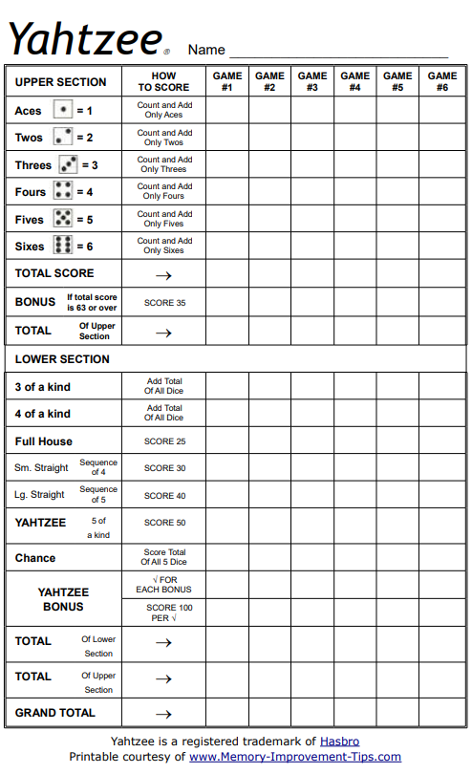 [2]
Turn | Line | dice_one | dice_two | dice_three | dice_four | dice_five | yahtzee_count | full_house_count | tow1_bonus | quads_count | turn_count | roll_count | turn_val | game_score
1 | 1001 | 2 | 2 | 2 | 1 | 6 | 0 | 0 | 0 | 0 | 13 | 1 | 0 | 0
1 | 1002 | 2 | 2 | 2 | 1 | 1 | 0 | 1 | 0 | 0 | 13 | 2 | 50 | 50
2 | 1003 | 4 | 4 | 4 | 4 | 5 | 0 | 1 | 0 | 0 | 12 | 1 | 0 | 50
2 | 1004 | 4 | 4 | 4 | 4 | 1 | 0 | 1 | 0 | 0 | 12 | 2 | 0 | 50
2 | 1005 | 4 | 4 | 4 | 4 | 4 | 1 | 1 | 0 | 0 | 12 | 3 | 200 | 250
3 | 1006 | 5 | 5 | 5 | 2 | 1 | 1 | 1 | 0 | 0 | 11 | 1 | 0 | 250
3 | 1007 | 5 | 5 | 5 | 2 | 3 | 1 | 1 | 0 | 0 | 11 | 2 | 0 | 250
3 | 1008 | 5 | 5 | 5 | 6 | 4 | 1 | 1 | 0 | 0 | 11 | 3 | 0 | 250
4 | 1009 | 4 | 4 | 4 | 2 | 3 | 1 | 1 | 0 | 0 | 10 | 1 | 0 | 250
4 | 1010 | 4 | 4 | 4 | 4 | 6 | 1 | 1 | 0 | 0 | 10 | 2 | 0 | 250
4 | 1011 | 4 | 4 | 4 | 4 | 5 | 1 | 1 | 0 | 1 | 10 | 3 | 100 | 350
5 | 1012 | 3 | 3 | 6 | 6 | 5 | 1 | 1 | 0 | 1 | 9 | 1 | 0 | 350
5 | 1013 | 3 | 3 | 6 | 6 | 6 | 1 | 2 | 0 | 1 | 9 | 2 | 150 | 500
6 | 1014 | 6 | 6 | 3 | 3 | 5 | 1 | 2 | 0 | 1 | 8 | 1 | 0 | 500
6 | 1015 | 6 | 6 | 3 | 3 | 1 | 1 | 2 | 0 | 1 | 8 | 2 | 0 | 500
6 | 1016 | 6 | 6 | 3 | 3 | 3 | 1 | 3 | 1 | 1 | 8 | 3 | 200 | 700
7 | 1017 | 6 | 6 | 6 | 6 | 5 | 1 | 3 | 1 | 1 | 7 | 1 | 0 | 700
7 | 1018 | 6 | 6 | 6 | 6 | 6 | 2 | 3 | 1 | 1 | 7 | 2 | 300 | 1000
8 | 1019 | 1 | 2 | 3 | 4 | 5 | 2 | 3 | 1 | 1 | 7 | 1 | 0 | 1000
8 | 1020 | 3 | 3 | 3 | 4 | 5 | 2 | 3 | 1 | 1 | 7 | 2 | 0 | 1000
8 | 1021 | 3 | 3 | 3 | 2 | 1 | 2 | 3 | 1 | 1 | 7 | 3 | 0 | 1000
9 | 1022 | 6 | 6 | 6 | 6 | 5 | 2 | 3 | 1 | 1 | 6 | 1 | 0 | 1000
9 | 1023 | 6 | 6 | 6 | 6 | 4 | 2 | 3 | 1 | 1 | 6 | 2 | 0 | 1000
9 | 1024 | 6 | 6 | 6 | 6 | 2 | 2 | 3 | 1 | 2 | 6 | 3 | 150 | 1150
10 | 1025 | 2 | 5 | 5 | 5 | 6 | 2 | 3 | 1 | 2 | 5 | 1 | 0 | 1150
10 | 1026 | 3 | 5 | 5 | 5 | 4 | 2 | 3 | 1 | 2 | 5 | 2 | 0 | 1150
10 | 1027 | 3 | 5 | 5 | 5 | 2 | 2 | 3 | 1 | 2 | 5 | 3 | 0 | 1150
11 | 1028 | 1 | 1 | 1 | 1 | 1 | 3 | 3 | 1 | 2 | 4 | 1 | 100 | 1250
12 | 1029 | 2 | 2 | 2 | 3 | 5 | 3 | 3 | 1 | 2 | 3 | 1 | 0 | 1250
12 | 1030 | 2 | 2 | 2 | 5 | 6 | 3 | 3 | 1 | 2 | 3 | 2 | 0 | 1250
12 | 1031 | 2 | 2 | 2 | 2 | 6 | 3 | 3 | 1 | 3 | 3 | 3 | 50 | 1300
13 | 1032 | 2 | 2 | 2 | 5 | 5 | 3 | 4 | 1 | 3 | 2 | 1 | 100 | 1400
14 | 1033 | 3 | 4 | 1 | 5 | 5 | 3 | 4 | 1 | 3 | 1 | 1 | 0 | 1300
14 | 1034 | 4 | 6 | 5 | 5 | 5 | 3 | 4 | 1 | 3 | 1 | 1 | 0 | 1300
14 | 1035 | 3 | 3 | 5 | 5 | 5 | 3 | 5 | 2 | 3 | 1 | 1 | 200 | 1500
15 | 1036 | 1 | 1 | 6 | 5 | 4 | 3 | 5 | 2 | 3 | 1 | 1 | 0 | 1500
15 | 1037 | 1 | 1 | 2 | 5 | 3 | 3 | 5 | 2 | 3 | 1 | 1 | 0 | 1500
15 | 1038 | 1 | 1 | 2 | 2 | 3 | 3 | 5 | 2 | 3 | 1 | 1 | 0 | 1500
 | 1039 | 0 | 0 | 0 | 0 | 0 | 3 | 5 | 2 | 3 | 0 | 1 | 0 | 1500
[Own work]
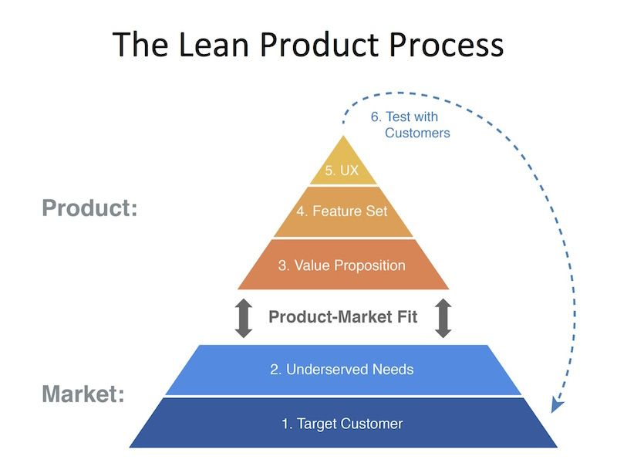 [8]

5.0 Acknowledgments
I used Canva to design the poster for the front cover of this report.
I would like to thank my academic skills lecturer for the supporting me in understanding how to properly reference using the IEEE format, Mr G. Jones
My lecturers for analysing and solving problems Sue Maw and David Williams, both of whom have enabled me greatly to understand Pseudo code, creating flowcharts and the core needs of software development planning.
The many game creators whose games I have spent time playing to gain a better insight of how I would plan and execute this report.
The many YouTube channels I have been using for information. The Cherno has given me great insights and ensured I am highly informed. This channel has brought unbelievable value to my tech journey not simply for concepts related to this report.

6.0 References

[1] | M. Various, “Yahtzee,” wikipedia, 24 12 2020. [Online]. Available: https://en.wikipedia.org/wiki/Yahtzee#:~:text=A%20Yahtzee%20occurs%20when%20all,get%20an%20extra%20100%20points.. [Accessed 06 01 2021].
[2] | grail.sourceforge.net, “The Rules of Yahtzee,” [Online]. Available: http://grail.sourceforge.net/demo/yahtzee/rules.html. [Accessed 01 02 2021].
[3] | freeCodeCamp.org, “Data Structures - Computer Science Course for Beginners,” NullPointer Exception, 08 09 2020. [Online]. Available: https://www.youtube.com/watch?v=zg9ih6SVACc. [Accessed 22 01 2021].
[4] | MrBrowCS, “Data Types, Variables & Constants,” 6 11 2017. [Online]. Available: https://www.youtube.com/watch?v=9QIFXyBYJQY. [Accessed 22 01 2021].
[5] | T. a. N. Smile, “C++, random number w/ range of 1-6,” StackOverflow, 12 01 2011. [Online]. Available: https://stackoverflow.com/questions/4665832/c-random-number-w-range-of-1-6/4665858. [Accessed 09 01 2021].
[6] | thenewboston, “Buckys C++ Programming Tutorials - 27 - Random Number Generator,” 09 04 2011. [Online]. Available: https://www.youtube.com/watch?v=naXUIEAIt4U. [Accessed 09 01 2021].
[7] | Various, “Unix time,” 07 01 2021. [Online]. Available: https://en.wikipedia.org/wiki/Unix_time#:~:text=The%20Unix%20epoch%20is%20the,%2D01T00%3A00%3A00Z.. [Accessed 10 01 2021].
[8] | D. O. n. b. W. Dixon, “The Lean Product Playbook,” Gildan Media, 19 05 2016. [Online]. Available: https://www.audible.co.uk/pd/The-Lean-Product-Playbook-Audiobook/B01FV60HZU?ref=a_library_t_c5_libItem_&pf_rd_p=7bf74090-5cb9-4f5e-bc6f-6ea28d055287&pf_rd_r=WJYHP923B5VEGMFCEQD2. [Accessed 09 07 2019].
[9] | M. Kelsey, “A playbook for achieving product-market fit,” invisiont, 2 05 2016. [Online]. Available: https://www.invisionapp.com/inside-design/playbook-for-achieving-product-market-fit/. [Accessed 27 01 2021].
[10] | stabguy, “YouTube,” 11 08 2011. [Online]. Available: https://www.youtube.com/watch?v=3xbASZBmUh0. [Accessed 20 01 2021].

7.0 Research List
- After watching these two videos on YouTube as well as looking on some sites I managed to grasp the concept behind random number generation.
https://www.youtube.com/watch?v=8eU4TDicf38
https://www.youtube.com/watch?v=naXUIEAIt4U
https://stackoverflow.com/questions/4665832/c-random-number-w-range-of-1-6/4665858
https://www.daniweb.com/programming/software-development/threads/229023/yahtzee-game-random-number-generation
- I acquired a better understanding of loops through this video.
https://www.youtube.com/watch?v=_1AwR-un4Hk

- Had fun watching this video related to flowcharts and Yahtzee.
https://www.youtube.com/watch?v=ECkZMfZkVGA
- These how-to videos.
https://www.youtube.com/watch?v=sQM7sN4NPz8
https://www.youtube.com/watch?v=OLRkXr5WFlE

- Gained great insight into how some code would look like from this video.
https://www.youtube.com/watch?v=VWffrh13CjI
- Learning the rules of Yahtzee
https://www.youtube.com/watch?v=5RHKMV21mek
https://www.youtube.com/watch?v=OLRkXr5WFlE

