Module Code: ECPS4018
Study Skills for Psychology

TABLE OF CONTENTS

Article Summary Page 3

Infographic Page 4

Essay Outline Page 5

Search examples Page 8

References Page 9

ARTICLE SUMMARY (Penn, 2019)
How to succeed in your degree, with psychology…
Research has identified that many students fail to employ effective study strategies, consequently limiting their ability to fulfil their academic potential during an undergraduate degree. In response, the article articulates key evidence-based approaches that will help a student achieve the best possible learning outcomes:
Reflection and recall
Reflection on how we learn alongside continuous review, especially of new concepts and ideas, is essential. One of the most effective study tools observed has been recollection of concepts and themes from memory, followed by focused time on learning the information that was not recalled.
Goal setting
Research has found that setting timebound specific goals is the most effective way to avoid procrastination. Therefore, having a strategy to develop clear goals and to begin study is fundamental.
Text engagement
Making connections between key points and concepts leads to a deeper level of understanding. This can be achieved by active engagement with the text, through asking questions of what is being presented as you read.
Language matters
Always write using language that can be easily understood. Furthermore, using your words when producing any written work rather than copying someone else’s work avoids plagiarism. Similarly, if creating a presentation, ensure all slides contain key points and aren’t overloaded with information.
Teamwork
Peer feedback, evaluation and task division is an effective way to work as a team. By doing so it introduces useful accountability.
Exam revision
Embedding learning throughout your studies, rather than relying on last minute efforts, produces a richer, depth of understanding of your subject and yields better outcomes.
Conclusion
These approaches enable the intentional learner to optimise their studies not only in results, but also in personal enjoyment and satisfaction throughout the whole process.

ESSAY OUTLINE

Describe and discuss the psychological, social and physical benefits of engaging in sporting activity (1500 words)

Key Words: sport, exercise, benefit, advantage, psychological, social, physical.

Introduction (200 words)
- Benefits of sporting activity well researched over time.
- Cite ancient (Greek) understanding that exercise and healthy mind interlinked (Martín-Rodríguez et al., 2024)
- Defining sporting activity vs exercise [Various references by comparison].
- Acknowledging barriers to engagement e.g. physical, socio-economic, cultural.

First Paragraph – Physical benefits (325 words)

Point: Sporting activity is shown to have proven and documented benefits on physical health.
Evidence: Describe benefits (physical and cognitive) - include lower risk of being overweight and obesity; cardiovascular disease, muscle strength, increased bone density etc. (Malm et al., 2019).
Immediate benefits of endorphins, sense of belonging etc. but also long-term impact such as better health outcomes.
Evaluate: Discuss positive health outcomes on both young and old. Discuss potential negative physical impact of overtraining (Brooks & Carter, 2013).

Second Paragraph – Social benefits (325 words)

Point: Being involved in a sporting activity is shown to have a positive impact on social outcomes. Benefits exceed those who engage in other forms of physical activity (Eather et al., 2024).
Evidence: Sense of belonging, common purpose, interpersonal communication; social and emotional support, reduces feelings of isolation and loneliness (Logan et al., 2019).
Evaluate: Discuss potential barriers to engagement e.g. Significant physical and mental health conditions. Role of coach – positive mentoring vs abuse of position?

Third Paragraph – Psychological benefits (325 words)

Point: Engaging in sport has a positive impact on mental wellbeing in general. Improved sleep, decreases cortisol, releases endorphins, stabilizes mood, boosts self-esteem.
Evidence: Boost to self-esteem, efficacy and identity. Positive impact on depression and anxiety, gambling, addictive behaviours, PTSD etc. (Mandolesi et al., 2018).
Evaluate: Preventative as well as treatment. Highly competitive sports can lead to psychological pressure at elite level including distortion of social norms; development of other psychological disorders such as OCD and eating issues (Martín-Rodríguez et al., 2024; Wang & Ashokan, 2021).

Conclusion (300 words)
Clear evidence of physical, social and psychological benefits to engaging in sporting activity. Summarising how these areas are interlinked and transferable skills for life e.g. value of setting achievable goals and working towards them, managing disappointment and building resilience.

SEARCH EXAMPLES
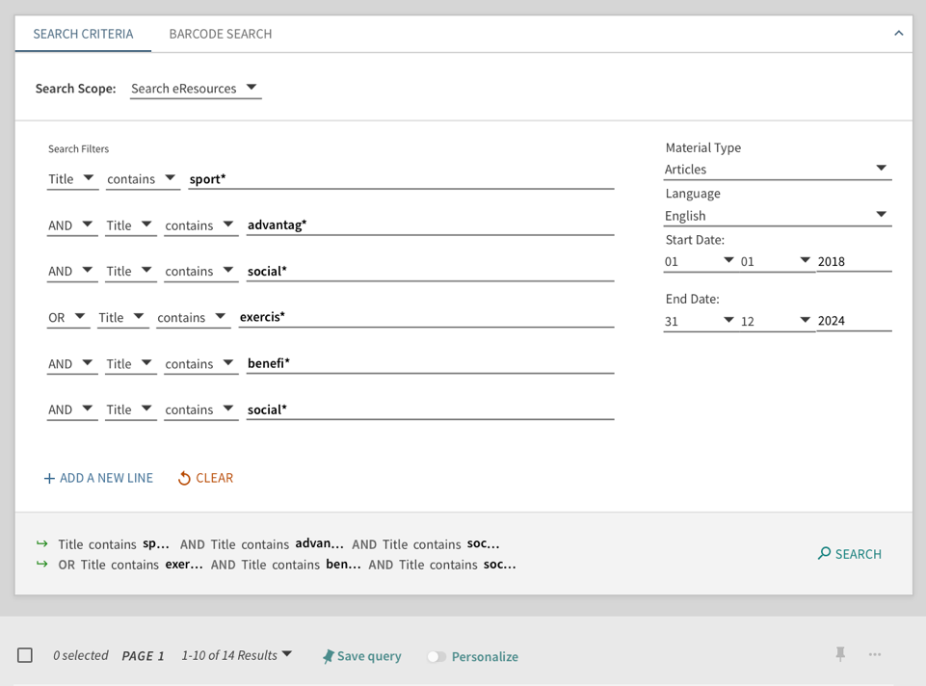
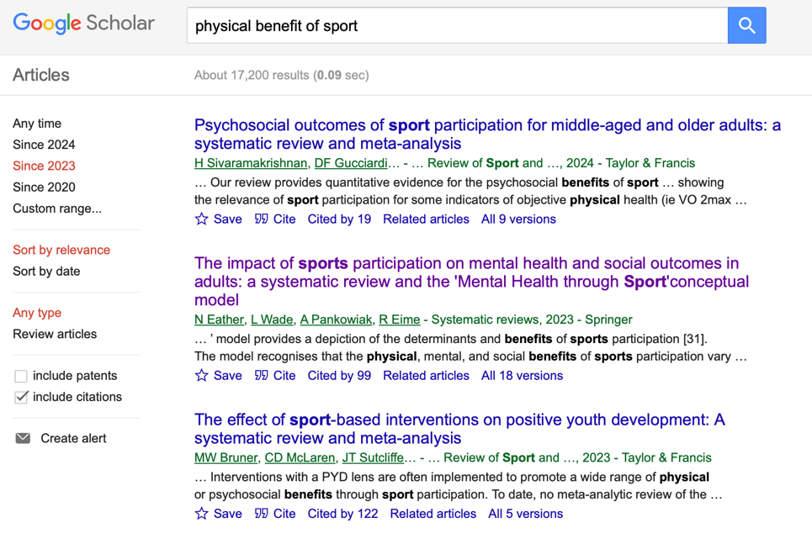

REFERENCES

American Psychological Association. (2020). Publication manual of the American Psychological Association (7th ed.). https://doi.org/10.1037/0000165-000
Brooks, K. A., & Carter, J. G. (2013). Overtraining, exercise, and adrenal insufficiency. Journal of novel physiotherapies, 3(125).
Eather, N., Wade, L., Pankowiak, A., & Eime, R. (2023). The impact of sports participation on mental health and social outcomes in adults: a systematic review and the ‘Mental Health through Sport’conceptual model. Systematic reviews, 12(1), 102
Logan, K., Cuff, S., LaBella, C. R., Brooks, M. A., Canty, G., Diamond, A. B., ... & Stricker, P. R. (2019). Organized sports for children, preadolescents, and adolescents. Pediatrics, 143(6).
Malm, C., Jakobsson, J., & Isaksson, A. (2019). Physical activity and sports—real health benefits: a review with insight into the public health of Sweden. Sports, 7(5), 127.
Mandolesi, L., Polverino, A., Montuori, S., Foti, F., Ferraioli, G., Sorrentino, P., & Sorrentino, G. (2018). Effects of physical exercise on cognitive functioning and wellbeing: biological and psychological benefits. Frontiers in psychology, 9, 509. https://doi.org/10.3389/fpsyg.2018.00509
Martín-Rodríguez, A., Gostian-Ropotin, L. A., Beltrán-Velasco, A. I., Belando-Pedreño, N., Simón, J. A., López-Mora, C., ... & Clemente-Suárez, V. J. (2024). Sporting Mind: The Interplay of Physical Activity and Psychological Health. Sports, 12(1), 37.
Penn P. (2019). How to succeed in your degree, with psychology… https://www.bps.org.uk/psychologist/how-succeed-your-degree-psychology
Wang, Y., & Ashokan, K. (2021). Physical exercise: An overview of benefits from psychological level to genetics and beyond. Frontiers in Physiology, 12, 731858. https://doi.org/10.3389/fphys.2021.731858

