

LOCATION: Swansea | LLEOLIAD: abertawe
LEVEL 4 | LEFEL 4
EXAMINATION PERIOD | CYFNOD ARHOLIADAU
may 2019 | mai 2019

MODULE CODE: M4X00386
ENGINEERING SCIENCE 2
TIME: 2 HOURS
answer all questions

Equipment or materials required – Calculator, Thermodynamics Tables

FORMULAE BOOKLET FOR ELECTRICAL ENGINEERING

$$Q=CV$$ | $$Q=It$$ | $$V=IR$$ | $$V=V_{0}e^{-\frac{t}{RC}}$$ | $$I=I_{0}e^{-\frac{t}{RC}}$$
$$Q=Q_{0}e^{-\frac{t}{RC}}$$ | $$P=IV$$ | $$P=I^{2}R$$ | $$P=\frac{V^{2}}{R}$$ | $$E=\frac{1}{2}CV^{2}$$
$$E=\frac{1}{2}QV$$ | $$ρ=\frac{RA}{l}$$ | $$R_{T}=R_{1}+R_{2}+R_{3}$$ | $$\frac{1}{R_{T}}=\frac{1}{R_{1}}+\frac{1}{R_{2}}+\frac{1}{R_{3}}$$ | $$V=ε-Ir$$
$$V_{rms}=\frac{V_{0}}{\sqrt{2}}$$ | $$I_{rms}=\frac{I_{0}}{\sqrt{2}}$$ | $$V_{rms}=I_{rms}R$$

FORMULAE BOOKLET FOR THERMODYNAMICS

- BASIC CONCEPT:
The change in the energy content of a body or any other system is equal to the difference between the energy input and the energy output, and the energy balance is expressed as:
$$∆E=E_{in}-E_{out}$$

E₂ – E₁

WORK:
Work done by the system is considered: POSITIVE
Work done on the system is considered: NEGATIVE

HEAT:
Heat transfer into the system is considered: POSITIVE.
Heat transfer out of the system is considered: NEGATIVE.

- CLOSED SYSTEMS:
Non-flow energy equation:
$$∆U=Q-W$$

- ENTHALPY:
$H=U+P.V$ (J)

Where:
- U = internal energy
- P = pressure
- V = volume

- FLOW WORK:
The flow work, or flow energy, or again displacement energy:

$$W_{flow}=P×V$$

- OPEN SYSTEMS / Steady-flow systems
- Mass Balance:
$$\sum_{in}{\dot{m}=}\sum_{out}{\dot{m} (kg/s)}$$

- Energy Balance:

$$\dot{Q}-\dot{W}=\sum_{out}{\dot{m}.\left(h+\frac{1}{2}.c^{2}+g.z\right)}-\sum_{in}{\dot{m}.\left(h+\frac{1}{2}.c^{2}+g.z\right)}$$
- CONTINITY OF MASS FLOW:
$$\dot{m}=mass flow in {kg}/{s A=cross sectional area in m^{2}}$$
$$v=specific volume in {m^{3}}/{kg} c=velocity in m/s$$
Consider the volume of substance passing the section per second = $\dot{V}$ in m³/s
$\dot{V}=\dot{m}.v also \dot{V}=A.c$ (Continuity equation)
Therefore:
$$\dot{m}.v=A.c$$
From which
$$\dot{m}=\frac{A.c}{v}$$

- OPEN SYSTEMS / Unsteady-flow systems
- Mass Balance:
$$m_{i}-m_{e}={\left(m_{2}-m_{1}\right)}_{CV}$$

Where:
- i = inlet, and e = exit.
- 1 = initial state, and 2 = final state of the control volume.
- Often one or more terms in this equation are zero.
- Energy Balance: (when kinetic and potential energy changes associated with the control volume and fluid streams are negligible)

$$Q-W=\sum_{out}{mh-\sum_{in}{mh+}}{\left(m_{2}u_{2}-m_{1}u_{1}\right)}_{CV}$$

- IDEAL GAS:
We defined an ideal gas as a gas whose temperature, pressure, and specific volume are related by:

$$P.v=R.T$$

where:
- R is the gas constant (kJ/kg.K) or (kPa.m³/kg.K)
- P the absolute pressure (kPa)
- T the absolute temperature (K)
- v is the specific volume (m³/kg)
The change in internal energy or enthalpy for an ideal gas during a process from state 1 to state 2 are defined as:
$$u_{2}-u_{1}=c_{v}\left(T_{2}-T_{1}\right) ({kJ}/{kg})$$
$$h_{2}-h_{1}=c_{p}\left(T_{2}-T_{1}\right) ({kJ}/{kg})$$
where:
- c_{v} is the specific heat at constant volume
- c_{p} is the specific heat at constant pressure

Reminder:
$$°C=K-273 K=°C+273$$
ELECTRICAL ENGINEERING

- QUESTION ONE (10 marks)

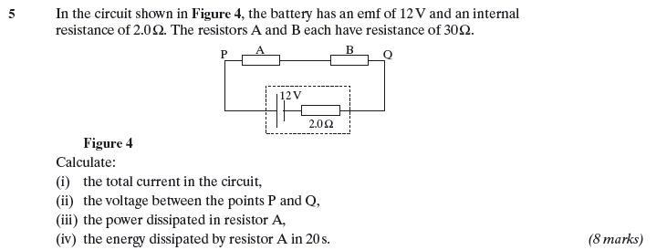

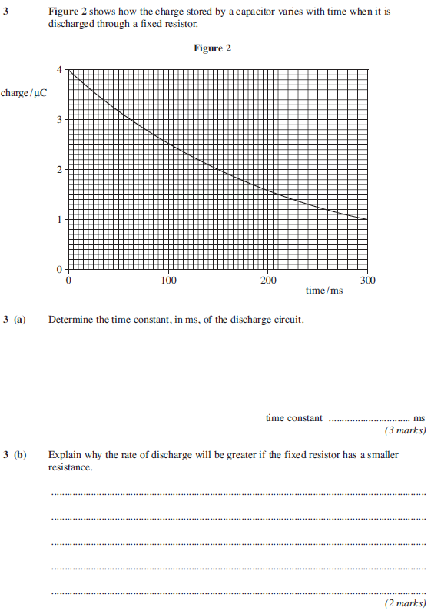

- QUESTION TWO (20 marks)

Figure 2 shows an ac waveform that is displayed on an oscilloscope screen.

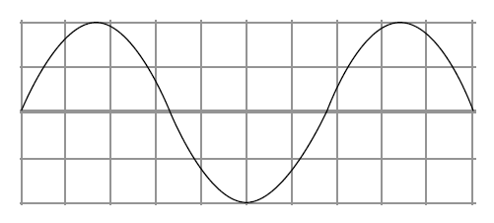
Figure 2

a) The time base of the oscilloscope is set at 3ms per division and the y-gain at 3V per division.
i Calculate the period of the waveform [2]
ii Calculate the peak to peak voltage [2]
iii Calculate the frequency [2]
iv Calculate the rms current if this voltage was across a 20kΩ resistor [2]

b) State and explain the effect on the oscilloscope if the time base is switched off [2]
c) In the US, domestic users are supplied with mains electricity at a root mean square voltage of 110V
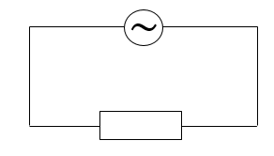
Figure 3

i State what is meant by root mean square voltage [2]
ii Calculate the peak value of the supply voltage [2]

