Manufacturing Process for a Connecting Rod

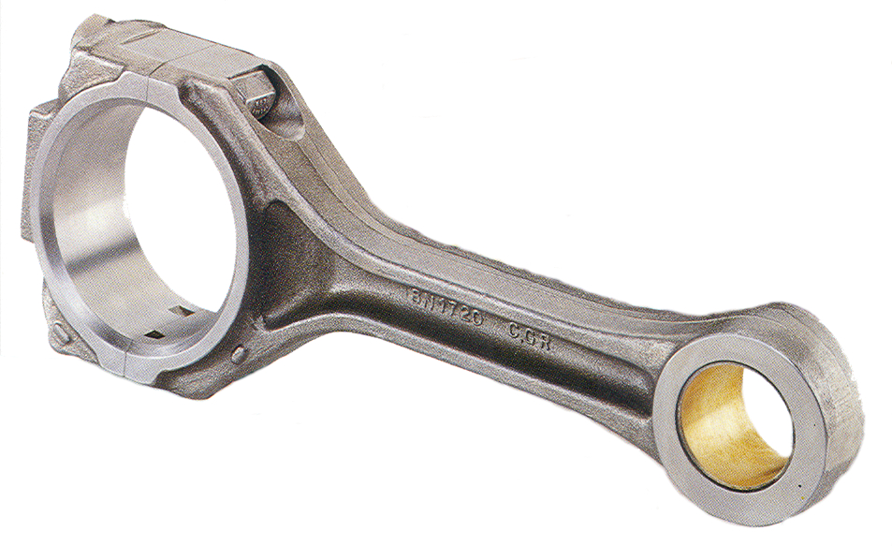
Ahmed, Josef (J.I.) | P152238
Executive Summary
This report firstly introduces what a connecting rod is. It discusses the design of the con rod as well as its role in a combustion engine and what it is connected to. Following this, the report goes into more depth on the manufacturing processes used to produce a connecting rod, starting with sand casting which is a method not used as frequently any more. It then continues to discuss forging/powder metallurgy, covering the benefits and reasons for using this method, such as accuracies and cost. The operation procedure for Scania is shown for the machining side of the process with steps from the first operation up until the final operation of packaging. Material selection is then covered, talking about the fatigue strength of powder forging with a table to compare. Finally, it is explained how quality control plays a big role in the process and how statistical quality control can be benefited from by many companies.

Table of Contents
Executive Summary 1
Introduction 3
Main Body 4
Introduction to a connecting ROD 4
How is a connecting rod manufactured? 5
Sand Casting 5
Forging 5
Why Use Powder Metallurgy? 6
Operation Sequence and volume 7
Material selection 7
Quality Control 8
Conclusion 9
Reference List 10
Bibliography 11

Introduction
The following report will identify and justify the material/manufacturing process using for a connecting rod found in a combustion engine. It will consider the different types of manufacturing processes and systems giving a comparison of different methods used to produce a connecting rod. The report will touch on what materials are used to produce a connecting rod as well as the benefits of using this material. It will then discuss quality control and how it affects the manufacturing process. Finally the report will be concluded.

Main Body

Introduction to a connecting ROD
A connecting is one of the most important components in a combustion engine, it can also be called the ‘backbone’ of an engine. The connecting rod as we know it today, operating inside the cylinder of an internal combustion engine, was first used in 1860 (Visser, D). Connecting rods are the connecting part between the crank shaft and piston. It is designed to rotate the crank shaft with aid from the piston, which after turning the transmission, should finally rotate the vehicle’s wheels. A connecting rod withstands high power loads whilst still remaining low in weight. (Precious Industries, 2014)
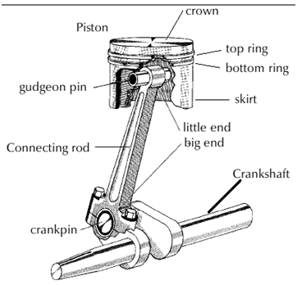
The connecting rod is quite a simple design to look at and can be seen in figure 1. It is made up of mainly a big end and little end. The little end is connecting to the piston using a gudgeon pin. The big end is connected to the crankshaft, but uses a different method. The rod’;s big end is generally split to allow it to be clamped onto te crank pin. The big end is clamped onto the crank using connecting rod bolts and nuts. (Mechanicalmania.com 2011)
Figure 1

The material used for a connecting rod is commonly plain carbon steel. This may differ if the goal to achieve a lighter engine is needed. If this is the case, aluminum alloys may be used.

How is a connecting rod manufactured?
The two main methods used for manufacturing connecting rods are as follows:
- Sand Casting
- Forging
Both these methods have been used in the motoring industry to produce connecting rods. The following section will discuss reasons for use and the process of both methods.

Sand Casting
Sand casting is a popular type of casting to be used when casting metals. This is due to its usability with metals with a higher melting temperature. The process involves pouring molten metal into a mold and allowing it to cool as explained by (Groover, M):
“Sand casting, also known as sand-mold casting, consists of pouring molten metal into a sand mold, allowing the metal to solidify, and then breaking up the mold to remove the casting. The casting must then be cleaned and inspected, and heat treatment is sometimes required to improve metallurgical properties. The cavity in the sand mold is formed by packing sand around a pattern (an approximate duplicate of the part to be cast), and then removing the pattern by separating the mold into two halves.”
Sand casting was used for a period of time as using this method had a longer tool life than using the forging process. General Motor’s Central Foundry produced approximately 50 million connecting rods using the sand casting method. The material they used to do this was pearlitic malleable iron. The iron was cast in green sand molds and adhered to the following process:
- Annealed at 1750®F 18hours
- Air Cooled
- Heated to 1600®F
- Quenched in oil
- Tempered for 3-4 hours at 1150-1180®F
A study in 1993 showed that ductile iron rods were a much more reliable option over malleable iron due to the atomic structure of the two. Unfortunately for sand casting, this method is not heavily used in the automotive industry anymore due to it being labor intensives and was not economical for the engines due to their weight. (Visser, D).

Forging
The process which is most commonly used for producing connecting rods is forging. Traditionally, wrought forging was used to produce connecting rods but was then later improved and replaced by powder forging or drop forging by most automotive companies. This was due to the machining process having a reduction in steps and saving approximately 10% in costs. The comparison of the two processes can be seen in figure 2.
Figure 2 – (Visser, D)
This section will focus on the manufacturing process of powder forging due to it currently being one of the most common method of manufacturing for a connecting rod.
Powder forging is a form of powder metallurgy, this a technique used for producing parts from metal powders. (Groover, M. Pg 344) explains the process:
“In the usual PM production sequence, the powders are compressed into the desired shape and then heated to cause bonding of the particles into a hard, rigid mass. Compression, called pressing, is accomplished in a press-type machine using tools designed specifically for the part to be manufactured. The tooling, which typically consists of a die and one or more punches, can be expensive, and PM is therefore most appropriate for medium and high production. The heating treatment, called sintering, is performed at a temperature below the melting point of the metal.”

Why Use Powder Metallurgy?
The main reason for most companies opting for a powder metallurgy method is due to cost. Powder forging allows for much higher complexity and tighter tolerances whilst withholding mechanical and physical properties in which wrought forging achieves. By having these tighter tolerances the material is utilized much more efficiently and higher accuracy can be achieved leading to less waste material. In some cases weigh-balancing process can be reduced massively or even eliminated completely. (Jones, P. 2014) Some other benefits of powder forging are:
- Densification of part
- Lower tooling costs
- High production rate
(Groover, M. Pg, 360)

Operation Sequence and volume
Below is a table of the machining operation sequence of a connecting rod for Scania right up until the packing of the product:
Op 10,20,30 – Rough machining
Op 40 – Oil hole
Op 45 – Washing
Op 50 – Pre-finishing
Op55 – Washing & Drying
Op 60 – Laser, splitting, assembly screws, pressing bushing
Op 65 – Weight balancing
Op 70 – Finishing
Op 80 – Washing & Drying
Op 90 – Quality Control & Packaging
Scania’s Floby factory in Sweden estimated to have produced the following in 2014 (Gonzalez S, 2015):
“Floby plant possesses 4 lines to manufacture 9 variants of petrol engines and 7 variants of diesel engines, whose forged blanks are bought to external suppliers. The amount of connecting rods manufactured in the plant was estimated to be 4700000 in 2014.”
Connecting rod manufacturing is done in very high volumes. This is due to the fact each engine on average contains approximately 5 connecting rods.

Material selection
A connecting rod plays an important part in the make-up of an engine. Not only does it connect the crank to the piston, it also needs to withstand inertial forces and bearing loads. It must withstand both of these forces and loads over and over again. This is where material selection plays a part. The aim goal for a connecting rod, is to be light but have a very high fatigue strength, but also needs to be as cost effective as possible, especially when mass producing.
Due to modern engines producing more torque due to the higher use of forced induction, it is essential that the material used can withstand this extra power/torque. Dr Ilia stated that that the key to powder forging improvements was down to the contents of the material:
“Dr Ilia, was the optimisation of the alloying contents in the PM Fe-Cu-C material which has resulted in significant improvements in static and dynamic properties. The recently optimised high strength PF materials have Cu contents ranging from 3% to 3.5% (grades HS150M, HS160M, and HS170M) and these are said to be more robust to graphite segregation than materials with 2% Cu and 3% Cu content.”
Dr Ilia reported on fatigue strength tests that were carried out to compare powder forged connecting rods (HS170M) and drop forged materials. This can be seen in the table below:
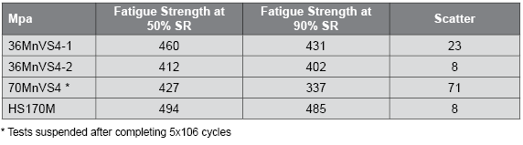(Williams, B. 2013)
The table shows that powder forging materials have a higher fatigue strength than those that have been drop forged. Proving powder forging has its benefits.

Quality Control
Quality plays a vital role in connecting rod production. Quality control should be carried out at each different stage of the manufacturing process right from the raw material up until the finished product. In order for companies to compete with and competitors they must ensure they establish a sufficient quality control system. By improving the quality of the product companies will be able to save money on cost and improve sales due to a higher end product.
Quality control could include taking readings of dimensions at each stage ensuring the product is within its specified tolerances. Statistical data can then be used to improve the products if any error is found. Armand V (1991) argues that statistical quality control is can benefit a company massively in the problem solving area.

"Statistical quality control is a problem-solving techniques that are used to monitor, control, analyze, manage, and improve products and processes using statistical methods. Statistical quality control (statistical quality control) is often referred to as statistical process control (statistical process control). Statistical quality control and statistical process control is the two terms are interchangeable, which, if done together then the user will see the picture of the performance of the process of the present and the future. "

Conclusion
In conclusion to the report, it is clear that the manufacturing process has come a long way since its first production in 1860. There has been massive progression in the methods used to improve reliability and strength. Not only has the product itself improved, but it has also reduced the cost of the product when mass produced. The connecting rod is clearly a vital component in the combustion engine therefore high quality is essential. Sand casting seemed to be a good method for a short while, but as time progressed and technologies improved as well as the increase of physical demands, forging has been the way forward. With the combination of good quality control and correct selection of material it appears connecting rods can be made to withstand vast amounts of power enabling them to become more and more reliable. The reliability of a connecting rod is vital for a company especially when it out performs its competitors. All in all, it appears that the manufacturing process and quality of the connecting rod will only improve along with the technology used to produce it.

Reference List
Front cover image- http://www.espa.co.za/wp-content/uploads/2013/12/Connecting-Rod.jpg
Preciousind.com (2014) ‘ What is the importance of a con rod in engine?’ [Online]. Available: http://www.preciousind.com/connectingrod-importantance-in-engine.php
Mechanicalmania.blogspot.co.uk(2011) ‘Components of automobile engine’ [Online]. Available: http://mechanicalmania.blogspot.de/2011/07/components-of-automobile-engine_24.html
Jones, P. (2014) ‘The technical and economic advantages of powder forged products’ doi.org [Online]. Available:http://www.tandfonline.com/doi/abs/10.1179/pom.1970.13.26.003
Williams, B. (2013) ‘Advances in high strength PM materials help powder forged connecting rods gain market share’, ‘Powder Metallurgy Review’ [Online]. Available: http://www.pm-review.com/advances-in-high-strength-pm-materials-help-powder-forged-connecting-rods-gain-market-share/
Supriana, N (2015) ‘ Analysisof quality control connecting rod with statistical process control’, International journal of science and research’ [Online]. Available: https://www.ijsr.net/archive/v5i5/NOV163599.pdf
Diva portal (DU). [Online], available:http://www.diva-portal.org/smash/get/diva2:826427/FULLTEXT01.pdf
Groover, M. (2010), Fundamentals of Modern Manufacturing, (4th edition), United States.

Bibliography

