Student Name: Ramona Robu
Student Code: 1913214
Module Name: Introduction to Physiology
Module code: BMHP5003_BIRM
Health Assessment Report

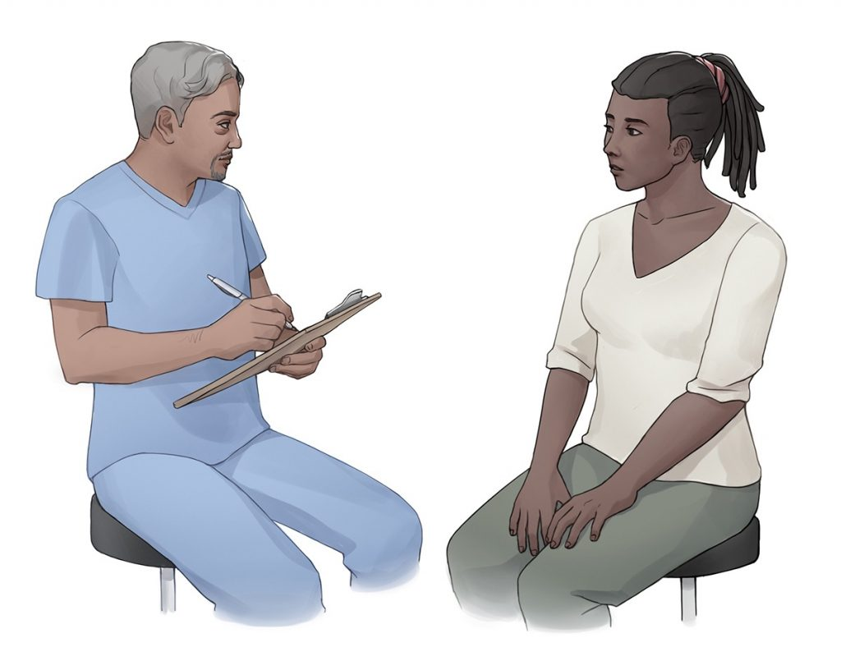
This Photo by Unknown Author is licensed under CC BY-NC

Lecturer: Mumtaz Goolam

Table of Contents
Introduction…………………………………………………………………………………………..3
Case Study: Mr. Williams 3
Assessment Report: Mr. Williams 4
Recommendation: Lifestyle Changes & Care plan 5
Conclusion 6
References 7
Appendix 1: Lifestyle Questionnaire- Template Based. 8

Introduction

A Health Assessment is a safeguard wellbeing that investigates investigating the clinical and non-prominent tests to give a current wellbeing and prosperity outline. There are prepared and trained medical nurses and healthcare counsellors that work on completing a health assessment with the main purpose of tracking the lifestyle of a patient periodically (Weber, 2009). Going from this definition, this report is willing to report to three main learning objectives of the Introduction to Psychology Module while focusing on a case study of an individual that is in need.

The aim of this report, therefore, is to investigate the health of the individual for the case study, which in the current circumstance is a 60-year-old individual dealing with coronary heart disease because obesity. The objective, however, is to identify the normal and abnormal physiological conditions that should be considered based on the assessment findings that have been undertaken using the individual’s circumstances. By the end of the report a personalized care plan with recommendations will be represented to make sure that the individual is aware of what changes need to be made in the daily lifestyle it follows to ensure that the conditions are at least prevented from getting worse.

Case Study: Mr. Williams

As mentioned in the introduction the individual of the today’s case study is Mr. Williams, a 60-year-old individual that has started to deal with obesity and anxiety after it has lost its wife and due to this, he developed cardiovascular disease and his heart is not functioning normally, thing making him often have heart attacks. Before losing his wife, Mr. Williams was a very sociable person that liked going out every day and enjoy life in his retirement years, however, since the tragedy, all the individual has is his daughter and when she is not at home, he is struggling to gain motivation in doing anything, this leading to him consuming substances such as tobacco in cigarettes and alcohol.
This section of the report requires the discussion of the baseline health status report of the individual. A baseline health status report is defined as being a report which to identify the state of the individual when being firstly seen (Alma & Wittmann 2019). During this report, some of the key things that the assessor has looked at include vital signs, imaging studies, individual’s behaviour, etc.
Particularly speaking about the baseline health status report of the individual of this case study, the first thing to mention is that the individual has been found eating junk food while staying on the sofa and watching TV. The individual did not seem to provide any signs of being happy or being communicative to speak about his feelings. When firstly approached, the individual seemed not to care about the way it looks and this has been seen through the clothes that it was wearing, which were dirty, and through the fact that he mentioned that there is no point in taking care of him, when he does not have any longer reasons to live. It was clear that eating junk food daily took him to the current situation where he has a body fat content of 52.2% and a BMI of 37.6, which automatically gives the result of being obese and being required to take care of his daily lifestyle to prevent any other abnormal physiological conditions especially because being obese can cause a lot of abnormal damage to the human body and to the way it functions (Shelly & Stettler, 2010). Having in mind those mentioned, another important thing to point out about the current situation of Mr. Williams is that he only seems to be a bit more active when his daughter is around, however, because of the job his daughter has, there is limited amount of time that she can spend with him, this being another factor that influences our individual to stand alone in the house and make itself feel better by drinking alcohol and eating unhealthy without moving around inside or outside its house.
It is now the time when Mr. Williams has realized that he needs support from professionals which are ready to help him rehabilitate and improve is physical condition as well as its mental condition, because as mentioned before, since he has lost his wife, he feels anxious and with no interest in living actively.

More to add, speaking about the effect that the coronary heart disease is affecting the individual’s immune system, it is important to mention that the damage caused by a heart attack triggers an inflammatory reaction which degrades the affected tissue. This response is orchestrated by immune cells that reside in the nearby pericardial adipose tissue, as a new study shows (Ludwig, 2017). More to add, the white blood cell (WBC) count increments during contaminations and incendiary sicknesses and has been displayed to coronary health illness (CHD) free of customary cardiovascular danger factors. This clear affiliation might mirror a connection between the WBC count and other coronary danger factors. Studies in patients with CHD are scant and give clashing outcomes.

Assessment Report: Mr. Williams

This section of the report requires a discussion of the normal and abnormal physiological conditions while constantly referring to the case study of this paper. Before going into the discussion, it is firstly important to discuss on the meaning of normal and abnormal physiological conditions in relation to obesity. According to Spodick, 1993, the physiological disorders per general are caused when the normal function of the body has been affected once the body’s orgasm has malfunctioned or when the structure of the cellules in the human body has changed and started to cause illness. Identifying an individual’s psychological observation tends to be a task that must be completed on a daily basis by the people in charge at the ward. Answorth has outlined that the non-normal values are generally identified in the individuals that have a risk of mortality increased. Considering that the chosen individual is dealing with heart disease because of obesity, and apart from this he is lonely too, it is hard to mention yet what are the normalities in his condition, however, the abnormal circumstances can be easily identified only from hearing that he is obese (Leibowitz, 2021). Because he is obese and has problems with his heart, more elements of his body are affected. For example, speaking about the nervous system, because the individual has a heart failure due to its disease, the sympathetic nervous system is activated, and it is put into an imbalance of the activity of the sympathetic nervous system that makes the vagal activity interaction occur (Labarthe, 2011). This is not a good thing because the mentioned aspect can in time make the condition of the individual even worse (Kishi, 2011). Apart from this as mentioned in the previous section, the immune system is being affected mainly in a very bad way because the body is very slow and unhealthy and automatically the infection prevention reaction that the body has is not good at all. Being obese and having heart problems, imparts to most constant infections the presence of an incendiary part, which represents the advancement of metabolic sickness and other related wellbeing modifications. This incendiary state is reflected in expanded flowing degrees of supportive of fiery proteins, and it happens in grown-ups as well as in youths and youngsters. The ongoing fiery reaction has its starting point in the connections existing between the fat tissue and the insusceptible framework. Heftiness, as different conditions of lack of healthy sustenance, is known to hinder the resistant capacity, modifying leucocyte considers well as cell-interceded safe reactions. What's more, proof has emerged that a changed invulnerable capacity adds to the pathogenesis of stoutness (Gomez & Marcos, 2012).

Recommendation: Lifestyle Changes & Care plan
Because the individual from the case study is dealing with heart problems, and because he is obese, it is of a massive importance for him to make some serious changes in his lifestyle to be able to lower the risk from having strokes. Some encouragements for Brad are going to be outlined within the following lines along with clear reasons why that change is important.
- Choose good nutrition: A solid eating routine is perhaps the best weapon you need to battle cardiovascular illness. The food you eat (and the sum) can influence other controllable danger factors: cholesterol, circulatory strain, diabetes and overweight. Pick supplement rich food varieties — which have nutrients, minerals, fibber, and different supplements however are lower in calories — over supplement helpless food sources. Pick an eating routine that underscores admission of vegetables, natural products, and entire grains; incorporates low-fat dairy items, poultry, fish, vegetables, non-tropical vegetable oils, and nuts; and cut-off points admission of desserts, sugar-improved refreshments, and red meats. What's more to keep a solid weight, organize your eating regimen with your actual work level so you're spending however many calories as you take in.
- Be physically active daily: Different studies have demonstrated that at least 150 minutes out of each seven days stretch of moderate-power actual work can assist lower with blooding pressure, lower cholesterol and keep your weight at a sound level. What's more something IS superior to nothing. Assuming, that you're inert now, begin slow. Indeed, even a couple of moments all at once may offer some medical advantages. Concentrates on show that individuals who have accomplished even a moderate degree of wellness are considerably less prone to bite the dust right on time than those with a low wellness level.
- Limit use of alcohol: Excessive consumption of alcohol can raise the pulse, increment cardiomyopathy, stroke, malignant growth, and different infections It can add to high fatty substances and produce unpredictable pulses. Unnecessary liquor utilization adds to heftiness, liquor addiction, self-destruction, and mishaps. Notwithstanding, there is a cardioprotective impact of moderate liquor utilization. On the off chance that you drink, limit your liquor utilization to close to two beverages each day for men (Smith, 2019).
Having in mind the BMI of the individual, its lifestyle and its general health, which is under higher risk since he has developed heart disease, it is extremely important for Brad to be under observation for a considerable period of time with the main purpose of making sure that his lifestyle and his general health condition is improving, as otherwise he has the increased chance of dealing with even worse heart condition that could make him have often strokes or even have an increased chance of death.

Conclusion
Overall, the report has managed to discuss respond actively to the task handed out for the introduction to psychology module. The individual of the today’s case study, Brad, has been in-detail been analysed considering his current health state relating to the heart condition he has developed because of obesity and stress because of being lonely. Each section of the report has focused on discussing the relationship between his coronary heart disease and the chosen system- the immune system, thing that took the audience to indicating that having poor nutrition can make the body of a person go crazy from multiple different ways including the infection prevention that the immune system should be in charge of.

References:

Alma, H., & Wittmann, M., (2019), Baseline health status and setting impacted minimal clinically important differences in COPD: an exploratory study., ELSEVIER Publishing.

Gomez, S. & Marcos, A. (2012) Obesity, Inflammation and the immune system., National Library of Medicine.

Kishi, T. (2011) Heart failure as an autonomic nervous system dysfunction. Journal of Cardiology. Elsevier.

Labarthe, D. (2011) Epidemiology and prevention of cardiovascular disease: A global challenge., Jones & Barletta Learning, pp:450-462.

Leibowitz, J. O. (2021) The history of coronary heart disease. University of California Press., pp: 180-195.

Ludwig, M. (2017) cardiovascular disease: The immune response to heart attacks. Science Daily.

Shelly, S., & Stettler, N., (2010), Living with obesity., Infobase Publishing.

Spodick, D., (1993), Normal and Abnormal Physiology and diseases of the pericardium., Volume B., Journals Law.

Smith, J. (2019) heart disease: Simple Lifestyle Changes to prevent and reverse heart disease naturally., Insight Health Communication., PP: 30-32.

Weber, J. R., (2009), Nurses’ Handbook of Health Assessment., Lippincott Williams & Wilkins., pp: 460-465

Appendix 1: Lifestyle Questionnaire- Template Based

Introduction:
This questionnaire represents the current lifestyle of the individual of this case study Mrs. Williams, a 61-year-old person, which need occasional personal care when he lives alone without his daughter taking care of him.

Name: Mr. Williams Date of Birth 16/02/1960

Do you smoke? |  | Yes | [ | ] No [x]
If yes, do you –
smoke less than 1 | cigarette/day |  | [ | ]
1 – 9 | cigarettes/day |  | [ | ]
10-19 | cigarettes/day |  | [ | ]
20-39 | cigarettes/day |  | [ | ]
more than 40 | cigarettes/day |  | [ | ]
smoke a pipe |  |  | [ | ]
smoke cigars |  |  | [ | ]

If no, have you –

never ever smoked  given up smoking in the last year not smoked for more than 1 year |  | [  [  [ | ]  x]  ]
Do you have high blood pressure? | Yes | [ | x] | No | [ | ]
Have you ever had a heart attack or suffered from angina? | Yes | [ | ] | No | [ | x]

Have you ever had a stroke, “shock”?
or any weakness down one side? Yes [x] No [] Have any of the following – mother, father,
X
X
x
brothers or sisters had –
a heart attack below the age of 60 | Yes | [ | ] | No | x | )
a heart attack above the age of 60 | Yes | [ | ] | No | [ | ]
a stroke | Yes | [ | ] | No | [ | ]
trouble with very high cholesterol | Yes | [ | ] | No | [ | ]

(hyperlipidemia)

………………………………………………………………………………………

Practice Use Only
Health Education Smoking ………….

BP …. / …..

Height ………….

Weight …………

