
contracting methods in project MANAGEMENT: a critical evaluation
PROJECT MANAGEMENT – LCBB6006_LON

STUDENT NAME: JANINA-EVELINE OROS
STUDENT ID: 2128948
LECTURER: DR. ZAINAB ATTA DATES OF SUBMISSION: 19.12.2025

Table of Contents
1. Introduction 3
2. Overview of Project Management Contracts 3
3. Method 1: Turnkey Contracting 4
4. Method 2: Multicontracting 5
5. Method 3: Do-It-Yourself (DIY) Contracting 7
6. Method 4: Multicontract + DIY 9
7. Conclusion 10
Reference 12

Table of Figure
Figure 1: Project Contracting Flowchart 3
Figure 2: Process Diagram 5
Figure 3: Work Breakdown Structure 7
Figure 4: Gantt chart 8
Figure 5: Network diagram 8
Figure 6: Multicontract + DIY – Venn Diagram 10
Figure 7: Risk Management Matrix for Contracting Methods 11

Table of Table
Table 1: Schedule Table 8

1. Introduction
Project management refers to the art of planning, organizing and completing projects to the end and accomplishing predetermined objectives and getting the end results (AL Jarrah, Jarah and Altarawneh, 2022). The decision of the contracting method is a very important element of project management, as it determines the relations between the client and the contractors or suppliers. Project management contracts do not only define the scope of work but also the responsibilities involved, risks involved and rewards involved in the project. The contracting techniques are meant to meet the special needs of various projects, with flexibility, control and risk management. This essay provides an examination of four major contracting approaches in project management, i.e., Turnkey, Multicontract, Do-It-Yourself (DIY) and a composite Multicontract + DIY strategy. Every approach is discussed in regard to its pros and cons as well as its applicability to particular types of project.
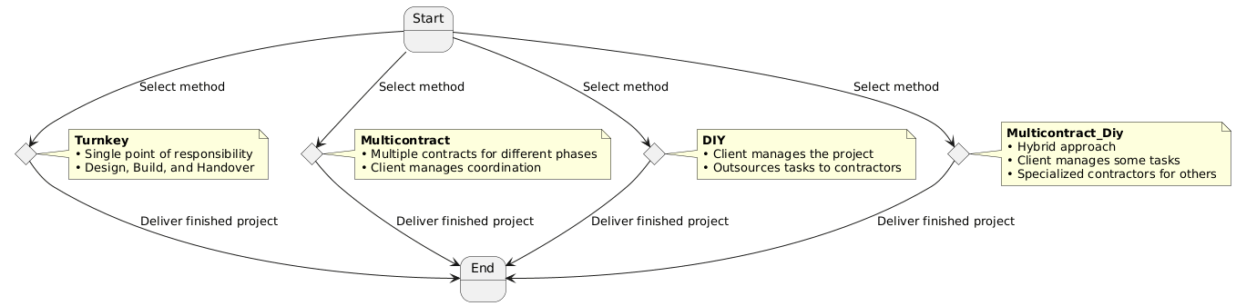
Figure 1: Project Contracting Flowchart

2. Overview of Project Management Contracts
Project contract involves a legally binding and formal contract between two or more parties that entails the scope of work, deliverables, time frame, responsibilities and terms on which the project will be implemented (Ahmed et al., 2021). Contracting approach adopted in project management has a great influence on the eventually delivered projects, cost management, and risk allocation.
The fact that the choice of a suitable contracting method is very important and that it establishes the scope of control the client will have on the project and the level of responsibility taken by the contractors. The four contracting approaches that were mentioned in this essay Turnkey, Multicontract, Do-It-Yourself (DIY), and Multicontract + DIY are not pricing approaches, but models of how the project work is structured and distributed. All these approaches have their own benefits and limitations based on the focus of a project and needs of a client.
Critically assessing the strengths and weaknesses of any method, a project manager can make a sound decision that would address requirements of a particular project (Chinta, 2025). The knowledge of these techniques will enable greater control over resources, minimize the number of risks that might occur as well as enhance the chance of the project being completed within the deadline, scope and budget, thus maximizing success of the project.

3. Method 1: Turnkey Contracting
Advantages
Turnkey contracting is a method of project delivery, in which the contractor undertakes the entire project i.e. design, construction and commissioning of a project and hands it over to the client in ready-to-use condition. Among the key benefits of this approach, there are simplification as it provides the client. In a turnkey contract, the client is able to provide multiple subcontractors/ vendors with one point of contact, the contractor, which gets rid of the complexity of dealing with multiple contractors/ vendors (Omran, 2021). This makes the communication and decision-making process less complicated resulting in a faster resolution. Furthermore, since turnkey contracts enable the ability to predict the costs and ensuring a fixed price, clients are having a greater control of the total project cost. Being relieved of the administrative tasks, the client puts his trust in the contractor to ensure everything in the project is done, including the coordination between various parties and the control of the day-to-day affairs. The best approach application is appropriate with a client who emphasizes convenience and efficiency in that all services are handled under a single umbrella.
Disadvantages
Turnkey contracting has some disadvantages although it has its benefits. The major drawback is that the client cannot exert a lot of control on the design and building stages since the company in charge is the contractor who has the ultimate control. This may pose a problem in the thoroughness of the contractor in comprehending or addressing the unique needs or preferences of the client. The possibility of increased cost is another problem. The cost of the contract should be higher when compared to other forms of contracting since contractors can overcharge their bids to cover the wide scope of responsibility they take. Moreover, the clients can be less engaged into the decision-making process, which can also mean that the client lacks possibilities to make amendments within the course of the project implementation.
Suitability for Projects
Turnkey contracts are best applicable in large scale projects where a high level of convenience is needed and the client is not much involved in the decision-making process (Donati, Copiello and Pietro Bonifaci, 2024). Examples of these projects include infrastructure development, heavy construction projects or an elaborate IT implementation project where the client has a fixed budget in which he/she requires a fully functional solution within the stipulated time. This approach is very useful where the client does not have enough expertise and resources to handle such projects on their own.
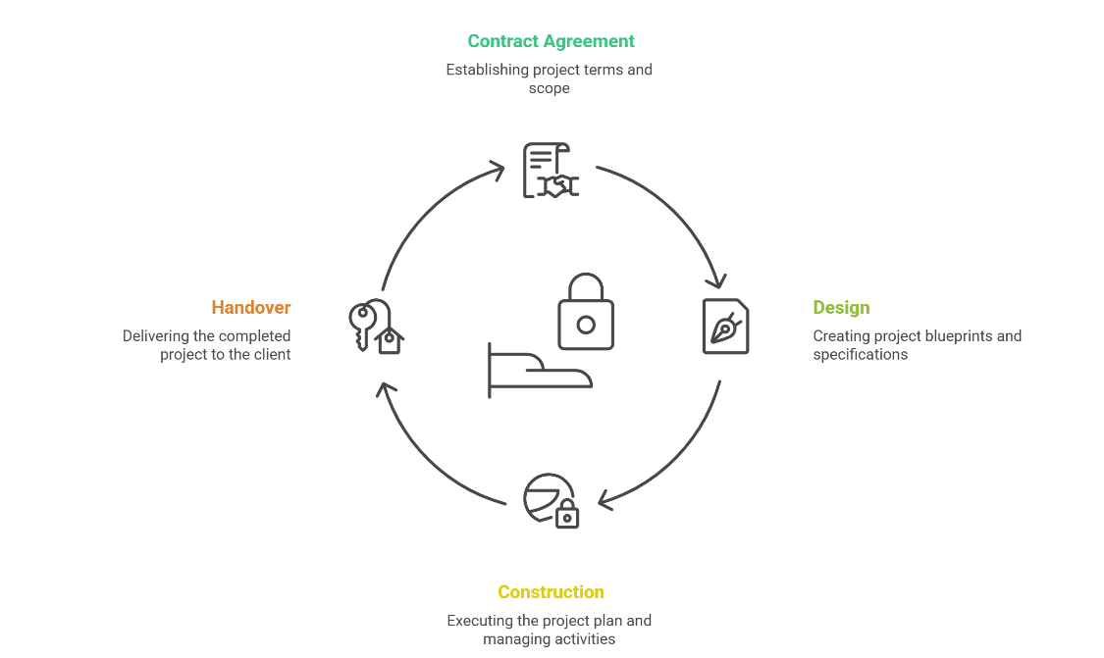
Figure 2: Process Diagram

4. Method 2: Multicontracting
Advantages
A multicontracting project management approach involves splitting a project into several contracts which are given to various contractors to do. This strategy has a number of benefits especially with regards to flexibility, and specialization. The approach guarantees that specialists in respective field of the project deal with the work by utilizing various contractors. Such specialization is likely to result in the increased quality of each element of the project (Raza et al., 2023). Besides, multicontracting gives the customer more control in the handling and monitoring of every separate contract. The client is in position to have a direct contact with every contractor, thus able to keep track of the progress and resolve problems as they arise so that the project will stay within schedule. Moreover, customers, who have in-house project management skills will have the opportunity to use this approach so that they can have a direct control that may eliminate the requirement of a single contractor to provide control over the project.
Disadvantages
Multicontracting has its disadvantages despite the benefits that it brings. The main drawback is the further complexity of coordination of several contractors. The presence of a number of contractors treating various aspects of the project also increases the risks of delays or disagreements between them (Do, Nguyen and Nguyen, 2022). Without addressing them appropriately, these issues may interfere with the project schedule and come at a high cost. The client plays a major role in the administration of the contracts, tracking of progress as well as arising disputes between the contractors. This may be resource intensive and take some time especially to clients who lack adequate project management experience. There is also the risk of miscommunication and coordination failure among contractors, and this complicates the process further.
Suitability for Projects
Multicontracting is best applied to major and complicated projects in which specific skills and expertise are needed in various components. They include such projects as massive construction efforts, infrastructure projects and system integration projects. Under this sort of situation, every section of the project is individual, but they all have to collaborate to produce a unified finished product. This approach is the best where the project needs the contribution of various professional contractors yet needs to be coordinated closely to enable a successful delivery of the entire project.
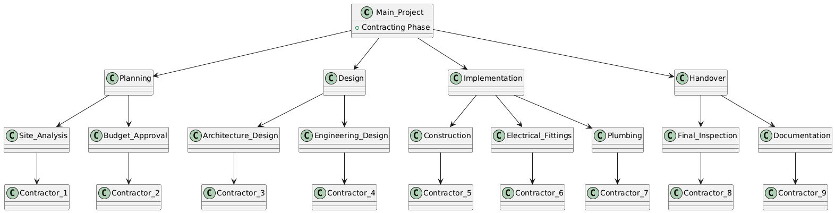
Figure 3: Work Breakdown Structure

5. Method 3: Do-It-Yourself (DIY) Contracting
Advantages
Another approach used is DIY contracting in which the client takes up the majority of project management activities and employs individual contractors to complete certain elements (Simonaitis, Daukšys and Mockienė, 2023). The benefits of DIY contracting include high levels of control that the client has. Clients will be able to do the work by managing it themselves and thereby attain chances of ensuring that work is performed as per their needs and preferences. Moreover, DIY contracting offers a potential of savings in the costs since clients are able to deal directly with the contractors ditching possibly the overall costs facing the intermediaries or the project management costs.
Disadvantages
Although these are the benefits, DIY contracting has significant limitations. The greatest obstacle is the knowledge and time that the client will have to invest. A serious project management is needed in the management of a project particularly when there are more than one contractors involved. Without these skills, the clients might fail to maintain the project on track, and they might end up taking their time or realizing that they are achieving the best. Moreover, in case they do not have a central hub of responsibility, it can be challenging to arrange the work of contractors, which may cause misunderstandings or work incorrect hours.
Suitability for Projects
Small and less complex projects with a client with enough knowledge and means to cope with the project are best handled under DIY contracting (Yap et al., 2021). Home renovations or minor technology updates or interior designer work are the best projects one would want to apply this approach. In such situations, one of the objectives is often cost reduction and the level of complexity of project can be handled without hiring specific project manager. The method of DIY contracting is also appropriate in the situations when the client has a solid idea of what the project is intended to achieve and can afford to spend time and energy on the details.
Table 1: Schedule Table
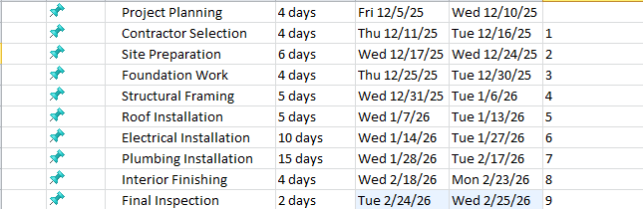
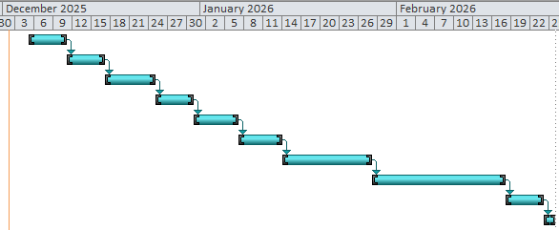
Figure 4: Gantt chart
Figure 5: Network diagram

6. Method 4: Multicontract + DIY
Multicontract + DIY is a process involving a compromise between the nature of multicontract and DIY which involves the hands-on type of the latter operational approach alongside the flexibility characteristic of the former (Farooq et al., 2025). Under this model, the client will undertake the role of overseeing some of the parts of the project, and he outsources specialized work to the contractors.
Advantages
The Multicontract + DIY approach has several benefits, one of which is that it allows to strike a balance between control and specialization. Management of the easier aspects of the project e.g. procurement or schedule, gives the client a chance to control, making the project less expensive and giving the sense of ownership. Specific work, such as engineering, design or construction, can be outsourced to a contractor who has specialized expertise. This technique gives the room to adapt the contracting approach that would fit the project requirements and provide cost-efficiency as well as quality assurances.
Disadvantages
The Multicontract + DIY approach has its challenges despite its benefits. The client has to deal with various contractors, and therefore it may pose a challenge in terms of coordination, particularly with large projects (Farrell and Sunindijo, 2020). This is a demanding role that needs good knowledge of project management principles and ability to cope with such complexities of dealing with different contractors. Clients with lack of the necessary expertise might be too overwhelmed by the need to set rules and manage it, thus causing possible inefficiency or misunderstandings.
Suitability for Projects
Multi-contact + DIY can best be used in the kind of medium-scale projects or projects like IT improvement, office make-over or product developmental works where a combination of in-house management and specialized contractor can pay off. It is appropriate when a client has some experience on project management and needs to have expertise in some specific areas but also wants to exercise the control of the overall processes of project management.
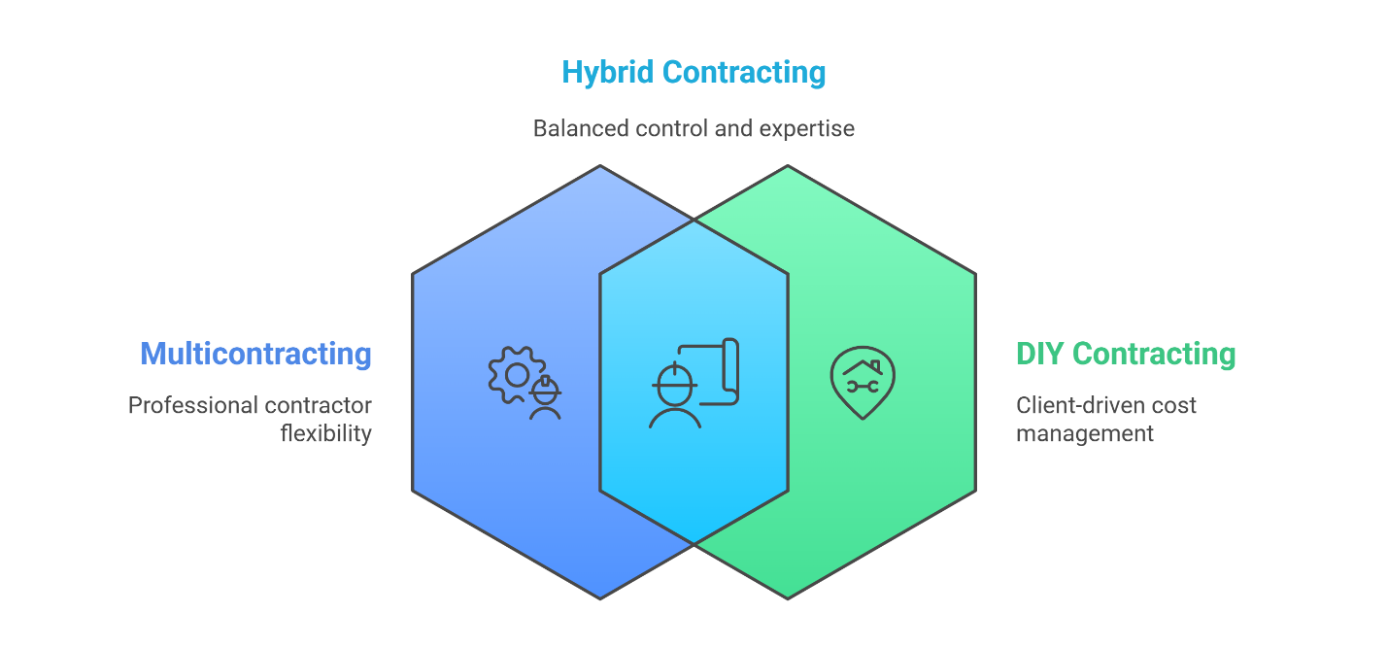
Figure 6: Multicontract + DIY – Venn Diagram

7. Conclusion
In summary, all the methods of contracting involve its own advantages and disadvantages, and the selection of a method greatly depends on the nature of the project, the requirement of the client, and the amount of control. Turnkey contracts are simple and convenient, and therefore they are satisfactory in large and elaborate projects that do not need much management by the client. The advantage of multicontracting is that it allows flexibility, but it should be highly coordinated to bypass delays. DIY contracting is also controllable and cost effective and is specifically applicable in small less complicated projects where the client is more than capable of handling the process. Lastly, Multicontract + DIY model offers a middle-point solution that offers more control and competence but requires more management skills. Grasping the peculiarities of each approach will make the project managers choose the best possible strategy of contracting, which will result in a viable project implementation.
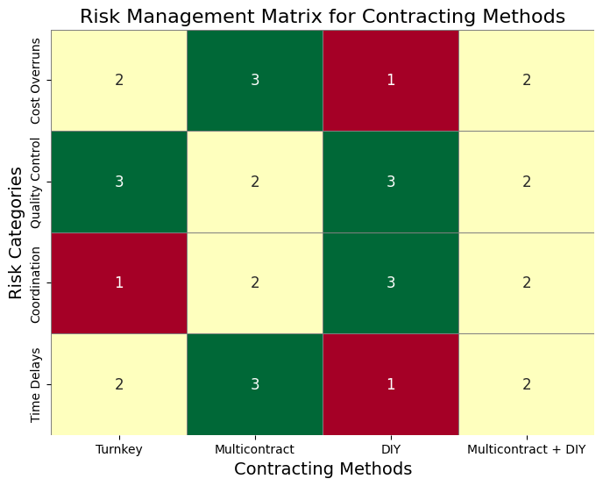
Figure 7: Risk Management Matrix for Contracting Methods

Reference
Ahmed, M.O., Abdul Nabi, M., El-adaway, I.H., Caranci, D., Eberle, J., Hawkins, Z. and Sparrow, R. (2021) Contractual Guidelines for Promoting Integrated Project Delivery. Journal of Construction Engineering and Management, 147(11), p.05021008. doi:https://doi.org/10.1061/(asce)co.1943-7862.0002173.
AL Jarrah, M., Jarah, B. and Altarawneh, I. (2022) Toward successful project implementation: Integration between project management processes and project risk management. Problems and Perspectives in Management, 20(3), pp.258–273. doi:https://doi.org/10.21511/ppm.20(3).2022.21.
Chinta, P.C.R. (2025) The Art of Business Analysis in Information Management Projects: Best Practices and Insights. SSRN Electronic Journal. doi:https://doi.org/10.2139/ssrn.5102494.
Do, S.T., Nguyen, V.T. and Nguyen, N.H. (2022) Relationship networks between variation orders and claims/disputes causes on construction project performance and stakeholder performance. Engineering, Construction and Architectural Management. doi:https://doi.org/10.1108/ecam-01-2022-0066.
Donati, E., Copiello, S. and Pietro Bonifaci (2024) Applications and Economic Profiles of the Turnkey Contract Business Model. Lecture notes in computer science, pp.143–161. doi:https://doi.org/10.1007/978-3-031-65273-8_10.
Farooq, N., Bashir, S., Banka, A.A., Malla, A.M., Manzoor, H. and Farooq, M. (2025) Blockchain Architecture and Development Process. Transactions on computer systems and networks, pp.115–161. doi:https://doi.org/10.1007/978-981-96-4078-2_4.
Farrell, A. and Sunindijo, R.Y. (2020) Overcoming challenges of early contractor involvement in local government projects. International Journal of Construction Management, 22(10), pp.1–8. doi:https://doi.org/10.1080/15623599.2020.1744216.
Omran, A. (2021) A Web-Based Change Control Management Toolkit for Lump-Sum Turnkey Contractors: Transformation to Third Generation. AUC Knowledge Fountain. Available at: https://fount.aucegypt.edu/etds/1587/.
Raza, M.S., Tayeh, B.A., Abu Aisheh, Y.I. and Maglad, A.M. (2023) Potential features of building information modeling (BIM) for application of project management knowledge areas in the construction industry. Heliyon, 9(9). doi:https://doi.org/10.1016/j.heliyon.2023.e19697.
Simonaitis, A., Daukšys, M. and Mockienė, J. (2023) A Comparison of the Project Management Methodologies PRINCE2 and PMBOK in Managing Repetitive Construction Projects. Buildings, [online] 13(7), pp.1–31. doi:https://doi.org/10.3390/buildings13071796.
Yap, J.B.H., Lim, B.L., Skitmore, M. and Gray, J. (2021) Criticality of project knowledge and experience in the delivery of construction projects. Journal of Engineering, Design and Technology, ahead-of-print(ahead-of-print). doi: https://doi.org/10.1108/jedt-10-2020-0413.

