Work Based Project
Thomas Caddell (2217174)
University of Wales Trinity St David

Table of Contents

- Proposed Research Title……………………………………………2

- Abstract……………………………………………………………….2

- Introduction…………………………………………………………..3

- Aims and Objectives………………………………………………...4

- Literature Review…………………………………………………... 4
5.1. Importance of risk management within construction……….4
5.2. Key challenges and opportunities……………………………5
5.3. Methodologies and tools used within the industry………….5
5.4. Integration with project management processes……………6
5.5. Importance of Health and Safety within risk management…6

- Methodology………………………………………………………….7

- Data and Analysis……………………………………………………10

- Conclusion……………………………………………………………22

- Bibliography…………………………………………………………..24

- Proposed Research Title
How well is risk management used in construction projects? How are employees affected by risk management? And are the measures that are then put in place effective for both employees and employers?

- Abstract
This research report will look at risk management within construction projects and how it is used to ensure safety, speed, and quality of work to fit the schedule of works. This will be shown by examining the ideas, procedures, and methods of risk management in building projects, with an emphasis on finding out how effective they are for both employee and employer.
This study looks at the importance, difficulties, and potential of risk management in construction projects using a thorough literature review, case studies, and expert interviews. The identification, evaluation, and mitigation of risks as well as their integration with project management procedures are important themes.

- Introduction
A risk is an event that could occur in a project, either internal or external, and if it does, it could prevent the project from achieving one or more of its goals.
By definition, a project aims to implement change of some kind, such as a new structure, method of production, or methodology. Due to change entails uncertainty, undertakings are more vulnerable to becoming sidetracked by a possible future event. Put differently, projects are by their very nature dangerous endeavours within the construction industry. (Porritt, 2023) (Jones, 2024)
Recognising and actively managing risks is a must for project managers; this is not a sign of failure but rather of successful project management. By anticipating possible occurrences that could have an influence on the project and by taking appropriate action before the construction phase of the project. This can also be carried into the construction phase by proactively taking precautionary measures to ensure safety, quality, and speed of the work to be carried out. (Ellis, 2022) (Indeed Editorial Team, 2023)

A risk is composed of two elements:

- The predicted chance or likelihood that an event will transpire.
the anticipated result, should it materialise.
- In the language of project management, an "issue" is something that is currently taking place that puts at risk, or shortly puts at risk, the accomplishment of one or more project goals or deliverables. Thus, it might indicate a risk that has materialised, or one for which the possibility has increased to 100%. An issue won't become a risk because, by definition, it has already happened; a risk may become an issue (when the risk arises).
- The goal of risk management is to identify probable issues as soon as possible to optimise the window of opportunity for prompt and efficient action.

- Aims and Objectives
Aims:
- To examine the significance of risk management in construction projects.
- To analyse the key challenges and opportunities associated with risk management.
- To explore best practices and strategies for mitigating risks and enhancing project resilience.
- To determine if the relevant information is passed onto the workforce and taken into consideration with employers.
Objectives:
- To investigate methodologies and tools used for risk identification, assessment, and mitigation.
- To discuss the implications of effective risk management for project performance, sustainability, and stakeholder satisfaction.
- To review relevant literature on risk management theory and practice in the construction industry.
- To provide qualitative and quantitative data through primary and secondary research that will be analysed to then come to a conclusion on the overall significance of risk management in construction from the data collected from reliable resources.

- Literature Review

5.1) Importance of risk management within construction:
Risk management plays a crucial role in the success of construction projects by helping stakeholders anticipate, assess, and respond to potential threats and opportunities. Effective risk management contributes to improved project outcomes, including cost control, schedule adherence, quality assurance, and stakeholder satisfaction. In the context of increasingly complex and uncertain environments, pro-active risk management practices are essential for enhancing resilience and ensuring project viability. (Killough, 2024) (CIOB, 2022)

5.2) Key challenges and opportunities:
Despite its importance, risk management in construction projects faces several challenges, including:

- Uncertain project requirements and scope.
- Limited access to reliable data and information.
- Inadequate risk awareness and communication among project stakeholders.
- Resistance to change and risk aversion.
- Budgetary constraints and resource limitations.
However, these challenges also present opportunities for innovation and improvement in risk management practices. Advances in technology, such as Building Information Modelling (BIM), Artificial Intelligence (AI), and data analytics, offer new tools and approaches for risk assessment, prediction, and management. Moreover, the increasing recognition of the importance of sustainability and resilience in construction projects has led to the integration of risk management with broader strategic objectives. (The Constructor, 2021) (Buildren, 2023) (Belmont, 2023)
5.3) Methodologies and tools used within the industry:
Various methodologies and tools are available for managing risks in construction projects, including:

- Risk Identification: Techniques such as brainstorming, checklists, and interviews are used to identify potential risks and uncertainties associated with project scope, schedule, cost, quality, safety, and environmental factors.
- Risk Assessment: Quantitative and qualitative methods, such as probabilistic analysis, sensitivity analysis, and risk matrices, are employed to assess the likelihood and impact of identified risks on project objectives.
- Risk Mitigation: Strategies for mitigating risks may include risk avoidance, risk transfer (e.g., insurance), risk reduction (e.g., redundancy, diversification), and risk acceptance (e.g., contingency planning).
- Risk Monitoring and Control: Regular monitoring and review of project risks are essential for timely identification of emerging threats and adjustments to risk management strategies. Performance indicators, dashboards, and reports facilitate effective risk communication and decision-making. (Parker Brent, 2023) (CIOB, 2022)

5.4) Integration with project management processes:
Integrating risk management with project management processes enhances the effectiveness and efficiency of risk management efforts. Key integration points include:

Risk Planning: Developing a risk management plan outlining roles, responsibilities, procedures, and resources for managing project risks.
Risk Identification: Incorporating risk identification activities into project planning, design, and procurement phases to proactively identify and address potential risks.
Risk Assessment: Integrating risk assessment results into project schedules, budgets, and resource allocations to inform decision-making and prioritise risk mitigation efforts.
Risk Response Planning: Developing contingency plans and response strategies for addressing identified risks and minimising their impact on project objectives.
Risk Monitoring and Control: Establishing mechanisms for ongoing monitoring, review, and adjustment of risk management strategies throughout the project life cycle. (Buildren, 2023) (The Constructor, 2021)
5.5) Importance of Health and Safety within risk management:
Construction projects entail diverse risks stemming from hazardous materials, equipment malfunctions, environmental factors, and human errors. These risks can result in severe consequences, from minor injuries to fatalities, along with project delays, cost overruns, and reputation damage. Consequently, proactive risk management practices are imperative for identifying, evaluating, and mitigating health and safety risks to safeguard workers and ensure project success. (HSE, 2024) (Minett, 2022)
Strategies for Health and Safety Risk Management:
Efficient health and safety risk management in construction projects involves several strategies-
- Risk Identification: Conducting thorough assessments to pinpoint potential health and safety hazards associated with construction activities, equipment, materials, and environmental conditions. Techniques like job hazard analysis, safety inspections, and incident investigations aid in identifying and prioritising risks.
- Risk Assessment: Evaluating the likelihood and severity of identified health and safety risks through qualitative and quantitative methods. This may entail assessing factors such as exposure levels, frequency of exposure, and potential consequences on worker health and project outcomes.
- Risk Mitigation: Implementing control measures to mitigate or eradicate health and safety risks in construction projects. This encompasses engineering controls (e.g., machine guarding, ventilation systems), administrative controls (e.g., safety procedures, training programs), and personal protective equipment (PPE). Moreover, integrating safety into the design phase of construction projects helps minimise risks throughout the project life-cycle.
- Monitoring and Enforcement: Establishing mechanisms to monitor compliance with health and safety regulations, standards, and best practices on construction sites. Regular inspections, audits, and safety meetings facilitate continual risk assessment and improvement of safety performance. Enforcement of safety policies and procedures via disciplinary actions and incentives reinforces a safety-oriented culture among project stakeholders.
- Worker Engagement and Training: Involving workers in identifying, assessing, and mitigating health and safety risks fosters a sense of responsibility for safety outcomes. Providing comprehensive training on hazard recognition, safety procedures, and emergency response enhances worker competency and reduces the likelihood of accidents and injuries.
(Lets Build, 2023) (CIOB, 2022) (Ng, 2021)
- Methodology
This report adopts a mixed method approach, combining case studies and expert interviews to provide relevant data within risk management practices in construction projects.
The methodology consists on the following steps to gather the relevant data:
- Literature review/Case studies:

- Case study data, this will be gathered through interviews, observations, documents, and archival records that pre-exist will play a major part in this form of secondary information data collection. By employing purposive sampling to select cases that align with the research objectives this allows for coincidence due to the units being selected are influenced due to the similarity in characteristics. Both qualitative and quantitative data are produced from this method of collection as it is comprehensive.
- Literature review, when analysing data from secondary data it must be checked for reliability, relevance, date and useful information. Again the data that is collected will be done systematically by assessing the reviewed field by using- Books, the internet, case studies, relevant reports and blogs and note taking from lectures. Information will be organised and displayed thematically and chronologically to best showcase results.

- Expert Interviews:
The way in which these expert interviews will be conducted are listed below-

- Identify Experts: Identify individuals with expertise relevant to the research topic through literature review, professional networks, and recommendations.
- Establish Contact: Reach out to experts via email or professional networking platforms, providing clear information about the research purpose, objectives, and expected time commitment.
- Schedule Interviews: Arrange interview times convenient for both parties, ensuring flexibility and respect for experts' schedules.
- Conduct Interviews: Conduct semi-structured interviews, allowing for open-ended questions and follow-up probes to explore insights deeply.
- Record Data: Record interviews with consent using audio or video recording devices, ensuring accurate data capture.
- Transcribe and Analyse: Transcribe interview recordings verbatim and analyse data thematically, identifying patterns, trends, and key insights.
- Ensure Confidentiality: Maintain confidentiality and anonymity of experts' responses unless explicitly granted permission for attribution.

- Questionnaire:

How questionnaires and the presentation of the data collected will be conducted as below-
- Questions will be designed to clearly align with the overall objective of the data collection. Questions will be clear, concise, and unbiased to facilitate accurate responses reducing risk of confusion and assuring the best data collection possible. A mixture of closed-ended and open-ended questions will be used to gather both quantitative and qualitative data.
- Pilot-testing the questionnaire with small samples will identify any potential issues with clarity, wording, or response options. By revising the questionnaire accordingly based on feedback an accurate and greatest quality of results can be collected.
- A suitable sampling method will be selected, such as random sampling or stratified sampling, to ensure representation of the targeted experts. The Questionnaire will be distributed through appropriate channels, such as email, online surveys, or in-person administration.
- Collecting and collating responses systematically will be the next step, ensuring data integrity and confidentiality. Then onto analysing the data using appropriate statistical or qualitative analysis techniques to derive insights and draw conclusions.

- Data Analysis and Presentation:
- The data analysis and presentation of the data collected will be presented in many forms in order to give a clear, concise and best visual representation of the particular data collected.
- Quantitative data, will be shown by visualising findings using charts, graphs and tables. This will be done by utilising software such as Excel for statistical computations. By doing this it will allow for conduction of descriptive and inferential analyses to uncover patterns and relationships that correlate between results.
- Qualitative data will be analysed by thematic analysis or content analysis to identify themes and patterns within the results; this data is likely to be collected from expert interviews and be presented by analysing and comparing with the literature review and case studies, by comparing primary and secondary data this will allow for interpretation of of results and a conclusion.

- Ethics/Consent:
- As an ethical entity committed to respecting individual autonomy and upholding the principles of consent, I prioritize transparency, respect, and empowerment in the gathering of data.
- Transparency is foundational to ethical data collection. I ensure that individuals are fully informed about the purpose of data collection, how their information will be used, and any potential risks involved. This transparency fosters trust and allows individuals to make informed decisions about whether to provide consent.
- Respect for individual autonomy is non-negotiable. I recognize that every person has the right to control their own personal information. Therefore, I seek explicit consent from individuals before collecting any data about them. This consent is freely given, without coercion or manipulation, and individuals have the right to withdraw their consent at any time.
- Empowerment is central to ethical data collection practices. I empower individuals by providing them with meaningful choices and opportunities to exercise control over their data. This includes offering clear options for opting in or out of data collection, as well as providing mechanisms for individuals to access, correct, or delete their personal information.
- In adhering to these principles of ethics and consent, I strive to ensure that data collection processes are not only legally compliant but also morally sound. By prioritizing transparency, respect, and empowerment, I uphold the dignity and rights of individuals while promoting trust and integrity in data-driven practices.

- Data and Analysis
- Expert Interviews-

Below are the interviews that were conducted with an expert in their respective field, their answers are also included. In this case this from a Managing Director and head of Health and Safety for the current company I work for.

Interview 1-

- Question1) Can you provide an overview of your experience in risk management within the construction industry?

Answer-
My experience in risk management within the construction industry encompasses several key areas. Firstly, I have a strong foundation in identifying various risks inherent in construction projects, ranging from safety hazards to financial uncertainties. This involves thorough risk assessments and analysis of project plans to anticipate potential issues.

Secondly, I specialize in evaluating the likelihood and potential impact of identified risks. This involves both qualitative and quantitative methods, utilizing historical data, site inspections, and stakeholder consultations to gauge risk factors accurately.

Lastly, I excel in developing effective risk mitigation strategies. This includes devising proactive measures to minimize or eliminate risks, as well as implementing contingency plans to address unforeseen challenges that may arise during construction projects. Overall, my experience in risk management within the construction industry underscores my ability to navigate complexities and ensure the successful execution of projects while safeguarding against potential threats.

- Question 2) What methodologies or frameworks do you typically employ when assessing and managing risks on construction projects?

Answer-
When assessing and managing risks on construction projects, I employ a variety of methodologies and frameworks tailored to the specific needs and complexities of each project.
Some of the key approaches I utilize include, risk identification workshops; I often conduct collaborative workshops with project stakeholders to identify and brainstorm potential risks comprehensively. This participatory approach ensures that diverse perspectives are considered, leading to a more robust risk register.

Quantitative risk analysis known as QRA this involves the use of numerical techniques to quantify the likelihood and impact of identified risks. This may include probabilistic modelling, sensitivity analysis, and Monte Carlo simulations to assess the overall project risk exposure accurately.

And construction risk assessments, I develop customized risk assessment matrices specifically tailored to construction projects, categorizing risks based on their likelihood and impact. This matrix serves as a practical tool for prioritizing risks and allocating resources for mitigation efforts effectively.

- Question 3) How do you prioritise risks within a construction project, and what factors do you consider when determining their significance?

Answer-
While determining which risks to prioritise in a construction project, I consider the possibility of occurrence as well as the possible impact on project goals, such as budget, time, quality, safety, and stakeholder satisfaction. I also take into account how serious the outcomes will be and how quickly risk occurrences can happen. I also consider the organization's desire and tolerance for risk, as well as the viability of mitigating actions. By assessing these variables, I make sure that risks are efficiently prioritised, enabling the distribution of funds and proactive mitigation initiatives where they are most required.

- Question 4) Can you share an example of a particularly challenging risk management situation you encountered in a construction project and how you successfully navigated it?

Answer-
In a previous construction project, we encountered a challenging risk related to adverse weather conditions during the critical phase of structural work. The forecast predicted prolonged periods of heavy rain, which posed a significant threat to project timelines and safety.
Some of the proactive measures we put in place were;
- Early Monitoring: In order to obtain timely information, we kept a careful eye on weather forecasts far in advance and maintained open lines of communication with meteorological services.

- Contingency Planning: We created thorough plans that included flexible scheduling, the distribution of extra resources, and alternate work methods in order to prepare for the possible impact of unfavourable weather.

- Site Preparation: To reduce potential damage, we put in place site preparation procedures like fastening materials, strengthening temporary buildings, and making sure sufficient drainage was in place before bad weather arrived.

- Real-time Monitoring and Adaptation: In order to reduce hazards and ensure safety during bad weather, we installed real-time monitoring systems to evaluate site conditions. We then promptly modified work schedules and activities as necessary.

- Question 5) How do you approach risk communication and stakeholder engagement throughout the lifecycle of a construction project?

Answer-
I place a high priority on informing stakeholders about risks in construction projects in a straightforward, regular manner using understandable language and visual aids. I make sure stakeholders are informed and involved throughout the project lifecycle by encouraging two-way communication and quickly addressing concerns. This helps with risk management and makes the project successful.

- Question 6) What measures do you implement to ensure compliance with relevant regulations and standards related to risk management in construction?

Answer-
In construction risk management, ensuring compliance with relevant regulations and standards is essential. To achieve this, I maintain awareness of regulatory requirements and industry standards. Thorough documentation of risk management processes helps demonstrate adherence to regulations. Regular training sessions keep project teams informed about compliance requirements and best practices. Internal audits and reviews are conducted to identify any non-compliance issues, which are promptly addressed. When needed, external consultation with legal and regulatory experts provides additional guidance. Collaboration with regulatory agencies and industry stakeholders ensures alignment with evolving regulations and industry norms. These measures collectively ensure that construction projects adhere to regulatory standards, mitigating legal risks and promoting project success.

- Question 7) How do you integrate risk management into the overall project planning and execution processes?

Answer-
Integrating risk management into project planning and execution is vital for success. I start early by identifying and prioritizing risks. Mitigation plans are then developed and implemented. Throughout the project, risks are monitored closely, and communication with stakeholders remains regular. Lessons learned are used for continuous improvement. This proactive approach ensures that risks are addressed effectively, minimizing disruptions and enhancing project outcomes.

- Questionnaire-

Questionnaires were handed out to 10 members of the construction company I work for, below are the questions that were included in the questionnaire:

Construction Project Risk Management Questionnaire
Personal Information (You will remain anonymous through presentation of results):
- Name:
- Age:
- Gender:
- Occupation:
- Role in Construction Industry (e.g., Project Manager, Engineer, Foreman, Worker):

(Please Circle Your Answer)

Section 1: Understanding of Risk Management
1. How familiar are you with the concept of risk management in construction projects?
- Very familiar
- Somewhat familiar
- Not very familiar
- Not familiar at all

2. In your opinion, how significant is risk management in construction projects?
  - Extremely significant
  - Very significant
  - Moderately significant
  - Slightly significant
  - Not significant

Section 2: Key Challenges and Opportunities
3. What do you perceive as the biggest challenges associated with risk management in construction projects?
- Poor project planning
- Lack of communication among stakeholders
- Budget constraints
- Changing regulations
- Other (please specify)

4. What opportunities do you see in effectively managing risks in construction projects?
  - Improved project outcomes
  - Enhanced safety measures
  - Better stakeholder relationships
  - Cost savings
  - Other (please specify)

Section 3: Best Practices and Strategies

5. What strategies or best practices do you believe are effective in mitigating risks in construction projects?

- Comprehensive risk assessments
- Regular safety training
- Clear communication protocols
- Contingency planning
- Other (please specify)

6. Have you implemented any specific risk management strategies such as below in your construction projects? If so circle the one most used.
- Risk assessments
- Stakeholder meetings
- Risk reporting and monitoring
- Cost monitoring data sheets
- None of the above

Section 4: Information Dissemination and Implementation

7. How is relevant risk management information communicated to the workforce on construction sites?
- Training sessions
- Safety briefings
- Posters and signage
- Digital communication tools
- Other (please specify)

8. Do you feel that risk management considerations are adequately taken into account by employers and project stakeholders?
  - Yes
  - No
  - Not sure

Thank you for participating in this survey! Your input is valuable for our research.

Results-

For section1 question 1-
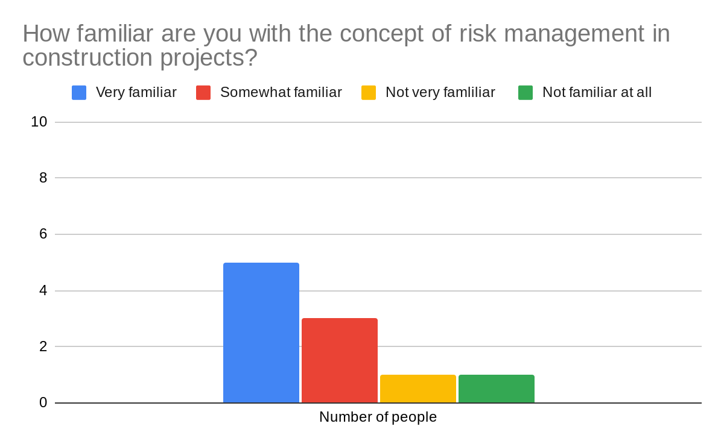
From the results above we can see that most of the participants of the questionnaire have a form of understanding of risk management in construction, with 50% of them being very familiar and 30% being somewhat familiar with risk management. Thus shows that the answers to the following questions are of relevance and have meaning behind the answers.

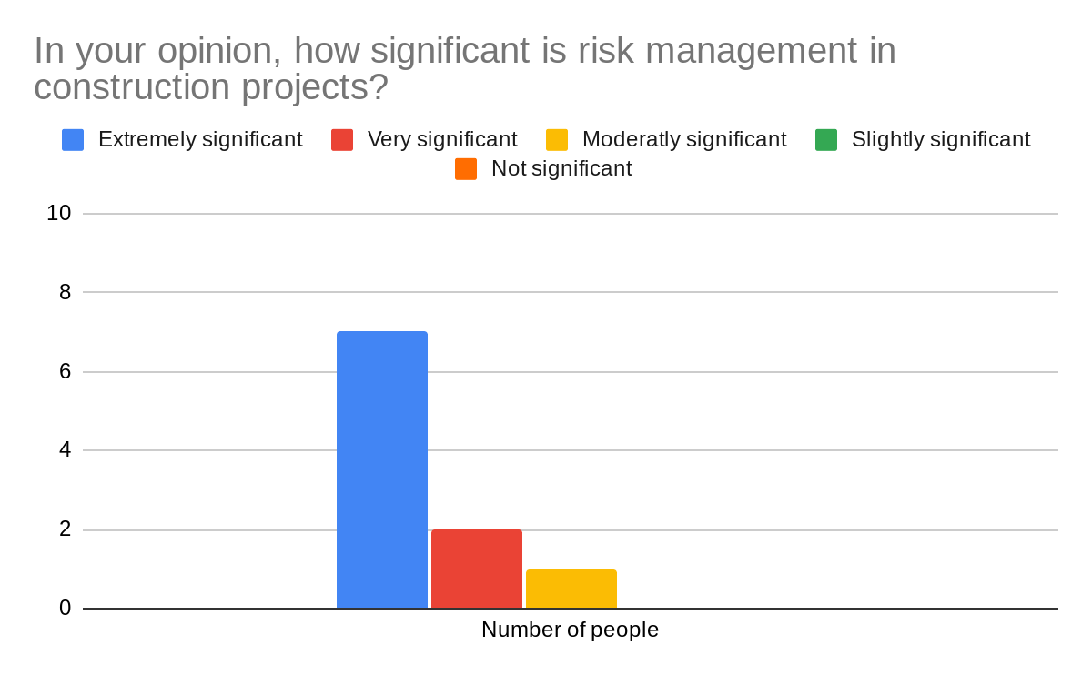
Section 1 question2-
As we can see in the results above, risk management in construction projects is ‘Extremely significant’ to the majority of stakeholders, with 6 times the number of ‘Moderately significant’. Interestingly no one thinks that it has a slight or no significance, this shows that within a project risk management is used and is needed to carry out a project efficiently.

Section 2 question 3-
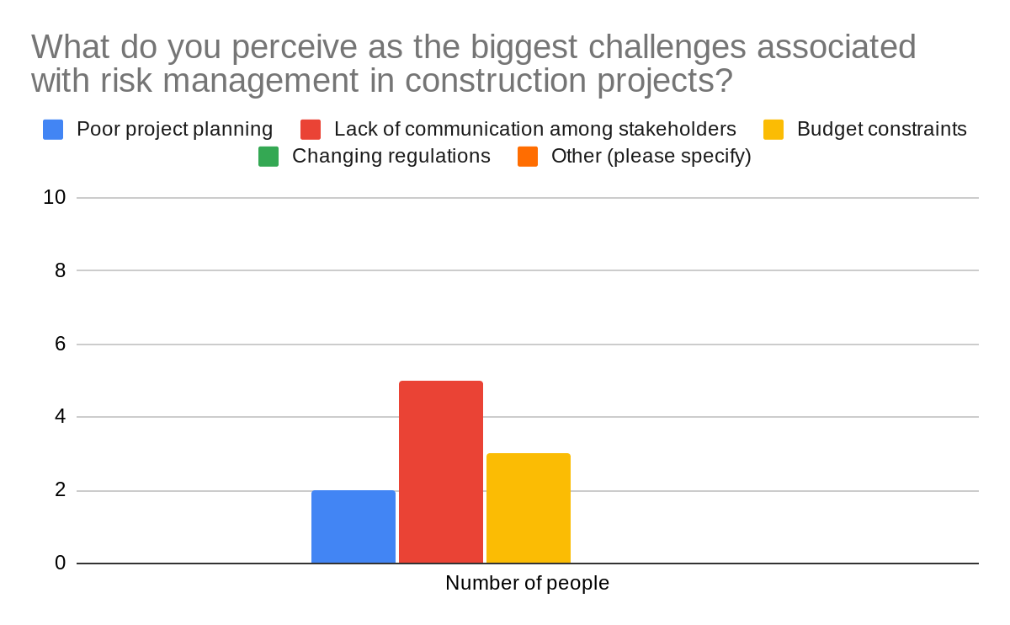
‘Lack of communication among stakeholders’ is the biggest challenge associated with risk management from the results obtained, this being 50% of the amount of people asked. ‘Budget constraints’ is also a big factor with 30% of people saying it is the biggest challenge and only 20% saying ‘Poor project planning’.
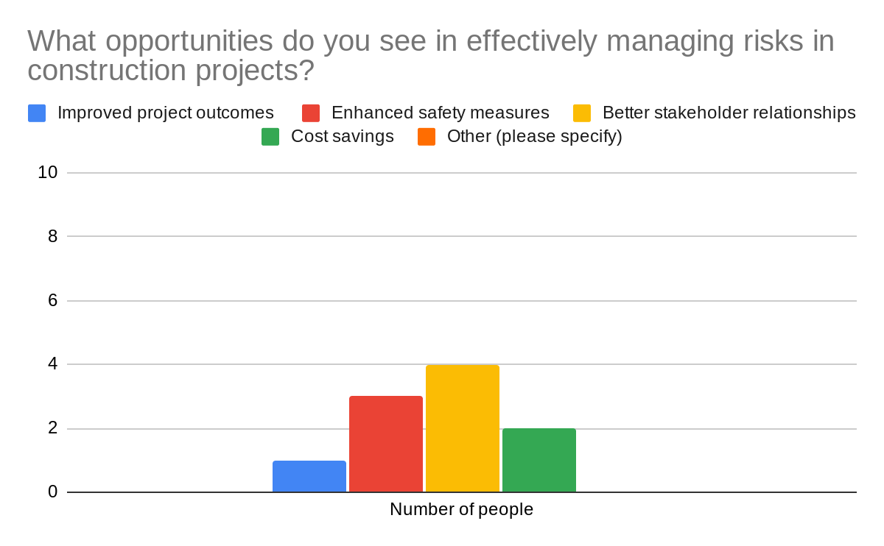
Section 2 question 4-
From the results above we can directly colarate that ‘Better stakeholder relationships’ and ‘Lack of communication among stakeholders’, the two results show that they are the largest areas of either being a challenge or being an opportunity to effectively manage risk in construction.
‘Enhanced safety measures’ with 30% of people saying it is also an opportunity that effectively manages risks in construction. This could have a connection to the ‘Lack of communication of stakeholders’, meaning the better the communication between stakeholders the improvement in safety measures. The same can also be said for ‘Cost savings’.
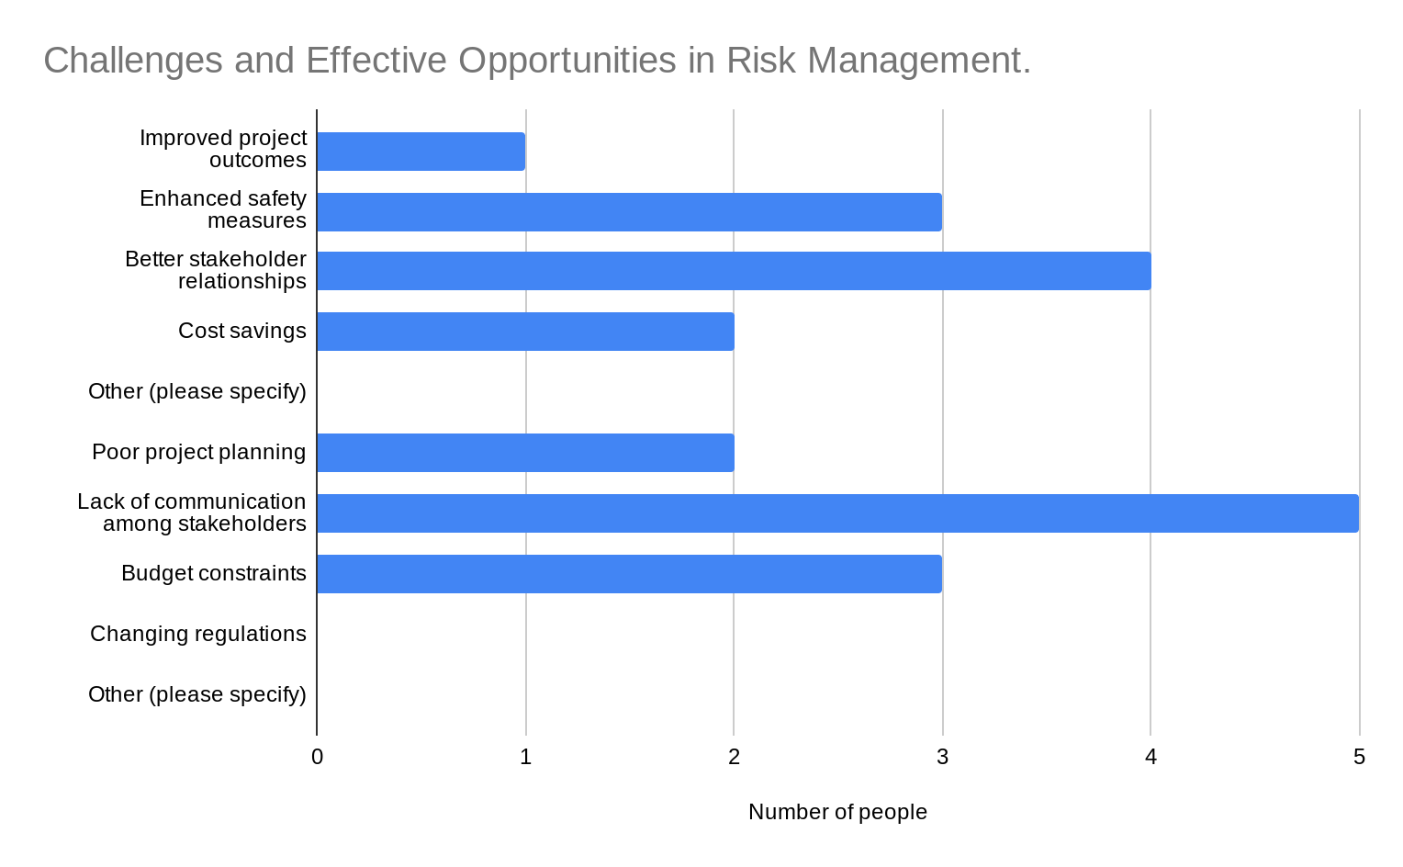
To put this in perspective a chart below shows the correlation of the two-

Section 3 question 5-

The results above show that more than half of the people think ‘regular safety training’ and ‘clear communication protocols’ are the best practices in effectively mitigating risks within projects, with the other 40% believing ‘comprehensive risk assessments’ and ‘contingency planning’ are most effective.

Section 3 question 6-

From the results above the majority (40%) of people have used risk assessments in previous projects, closely followed by ‘stakeholder meetings, risk reporting and monitoring and cost monitoring data sheets.’ Comparing this to the previous data from question 5 shows us that there is a close link between mitigating factors and strategies, with the increase of safety training and clear communication protocols the lower the risk reporting and monitoring is.
Section 4 question 7-
From the data above we can see that ‘posters and signage’ is the main way of communicating risk management on site with 40% of the people believing so, this is more than double the amount thinking ‘digital communication tools’ giving us a good indicator that most workers do not use digital tools on site and that posters and signage are effective in showing visual representation of management of certain risks on site. To coincide with this ‘training sessions’ and ‘safety briefings’ are also used by the majority, this ensures that relevant information is passed onto the workforce to carry out the work to the best standard possible from a safety, time and economic perspective.

Section 4 question 8-

As the chart shows, 90% of the people find that risk management considerations are taken into account by employers and project stakeholders. With 10% of people said ‘No’ showing that not all employers and project stakeholders adequately take risk management into account.
- Conclusion
In conclusion, from the data that has been obtained the significance of risk management in construction is great. From the secondary data collected construction project success is greatly influenced by risk management, which assists stakeholders in identifying, evaluating, and reacting to possible risks and opportunities. Combining this with the primary data that was collected with 80% of people having an understanding what risk management is and 90% of people thinking that risk management plays a very significant role within a project. On the other hand, during the interview the questions that were put forward did not derive an answer for this particular aim of the project. When conducting this again I will ensure interview questions cover the aims of the project and ask more questions to many professionals in the industry to compare the data and come to more of a unbiased conclusion.

Key challenges and opportunities in risk management, the data collected provided clear evidence of the challenges and opportunities faced; looking at the secondary data the main risks involved were as listed-
- Uncertain project requirements and scope.
- Limited access to reliable data and information.
- Inadequate risk awareness and communication among project stakeholders.
- Resistance to change and risk aversion.
- Budgetary constraints and resource limitations.
With the primary data this shows us that communication between project stakeholders and budgetary issues are the most common challenging factors in risk management. Opportunities within this area are then taken from the main challenges to ensure efficiency and standards are then met in projects. Form the secondary data innovation and advancement in certain technology is spoken about, the use of BIM plays a major role in conducting pre risk management plan before a project begins. Data analytics are also a major factor in projects as risk assessments and predictions can be implemented before project start allowing all stakeholders to plan accordingly. To coincide with this, the primary data shows that stakeholder relationships and enhanced safety measures are areas of opportunity within risk management, I believe that this is from the job role that the individual holds; most of the questionnaires were filled out by site managers providing a slightly biased view, with that the questionnaire was only handed out to employees of the company I work for suggesting there could be a form of biased there too. To ensure the results are fair the next time this is carried out I will look to broaden the number of people the questionnaire is handed out to and a variety in job role and company.

In the case of best practices and strategies for mitigating risks and enhancing project resilience form the data collected the best ways of mitigating risks are-
- Clear communication protocols (with all stakeholders)
- Regular safety training
- The use of BIM in planning
- Real time monitoring as the project ensues
From the primary data collected safety measures can be pro-actively put in place when clear communication between stakeholders is carried out. To add to this strategies and mitigating variables are closely related; the more safety training and clear communication protocols there are, the less risk is being reported and monitored. Although in my opinion contingency planning plays a major part in effective mitigating strategies, by being pro-active measures can be implemented for certain areas of a project before even coming close to commencement.
With relevant information being passed onto the workforce and taken into consideration by the employers, this information is mostly gathered from the primary sets of data with 90% of people who completed the questionnaire saying ‘Yes’ project stakeholders and employers adequately take into account risk management throughout projects. This provides a clear answer that risk management is depended on during projects and the right information is provided to the workforce. Adding to this the workforce believe that relevant risk management is communicated through many ways during a project but the main two being ‘Posters and signage, Training sessions’ telling us that simple instruction and visual representation are the best ways of communication across a project as it is adequate for all stakeholders to follow.
Overall I believe that the main aims of the project have been met with relevant information from both primary and secondary data, risk management as a whole is clearly significant across projects and practises and mitigating strategies are constantly being developed and implemented to proactively effect projects. Opportunities and challenges are a constant in construction and finding the most common ones can result in pre project integration as they arise fairly often. To show that this has been met means that all employees understand the information they have received and I believe this has definitely been shown in the results of the data collected. On the other hand I think that the collection of data was not broad enough to give a definitive answer on all aims, if I was to carryout the collection of data again I would ask multiple professionals across various professions and include more questions to provide a more rounded answer. I would also add more questions to the questionnaire more focused on best practises and strategies of risks management and ask a wider audience; from different construction companies and various fields of work in construction projects.

Bibliography
Belmont, T., 2023. bigrentz.com. [Online]
Available at: https://www.bigrentz.com/blog/construction-risk-management
[Accessed 17 04 2024].
Buildren, 2023. buildern.com. [Online]
Available at: https://buildern.com/resources/blog/construction-risk-management-8-effective-tips-to-success/
[Accessed 17 04 2024].
CIOB, 2022. designbuildings.co.uk. [Online]
Available at: https://www.designingbuildings.co.uk/wiki/Risk_management
[Accessed 17 04 2024].
Ellis, G., 2022. autodesk.com. [Online]
Available at: https://www.autodesk.com/blogs/construction/reduce-construction-risks/
[Accessed 17 04 2024].
HSE, 2024. hse.gov.uk. [Online]
Available at: https://www.hse.gov.uk/simple-health-safety/risk/steps-needed-to-manage-risk.htm
[Accessed 17 04 2024].
Indeed Editorial Team, 2023. indeed.com. [Online]
Available at: https://uk.indeed.com/career-advice/finding-a-job/what-is-risk-management-construction
[Accessed 17 04 2024].
Jones, K., 2024. constructconnect.com. [Online]
Available at: https://www.constructconnect.com/blog/identifying-managing-construction-project-risks
[Accessed 17 04 2024].
Killough, D., 2024. procore.com. [Online]
Available at: https://www.procore.com/library/construction-risk-management
[Accessed 17 04 2024].
Lets Build, 2023. letsbuild.com. [Online]
Available at: https://www.letsbuild.com/blog/risk-management-plan-in-construction-guide
[Accessed 17 04 2024].
Minett, A., 2022. chas.co.uk. [Online]
Available at: https://www.chas.co.uk/blog/risk-assessment-importance/
[Accessed 17 04 2024].
Ng, M., 2021. jonasconstruction.com. [Online]
Available at: https://www.jonasconstruction.com/blog/construction-risk-management-plan/
[Accessed 17 04 2024].
Parker Brent, 2023. parkerbrent.com.au. [Online]
Available at: https://www.parkerbrent.com.au/blog/navigating-uncertainty-effective-strategies-for-managing-risk-in-construction-projects/
[Accessed 17 04 2024].
Porritt, S., 2023. technologyadvice.com. [Online]
Available at: https://technologyadvice.com/blog/information-technology/construction-risk-management/
[Accessed 17 04 2024].
The Constructor, 2021. theconstructor.org. [Online]
Available at: https://theconstructor.org/construction/risk-management-construction-projects/24873/
[Accessed 17 04 2024].

