E-portfolio report
Learning in the Digital Era – BMPL4007/BMPS4009
Galina Zasheva
2227456
Table of Contents

Task 1 – Written summary: Preparing for Higher Education 2
Task 2 – Mind map: Becoming a digital learner 4
Task 3 – Presentation 6
Task 4 – Reflection 9
Reference list 11

Task 1 – Written summary: Preparing for Higher Education
Higher education is the stage that makes anyone prepare for future career challenges. Anyone who wants to get admitted to an institution requires to take preparation before starting university life. Before preparing to start a university individual requires to do some basic things. The first and foremost task is to make plans for how individuals will select a good institution for study. Anyone can select a good university based on ranking, education system, student feedback, and so on (Combs et al., 2022). A good institution is required for a student to gain a basic understanding of the subject topic and get themselves ready for the future. A good teacher and educational support make a student able to understand any topic easily and apply them in practical life. The second thing is to focus on the skills. Students who have a basic set of skills like communication skills, time management skills, presentation skills, and report writing skills always perform well both in their academic and professional life. Time management skill is highly needed for students to get themselves prepare to start the university (Jacoby, 2009). It will help them to set the propriety of work by removing the distractions from the important task. It will also help them to give proper attention to study time
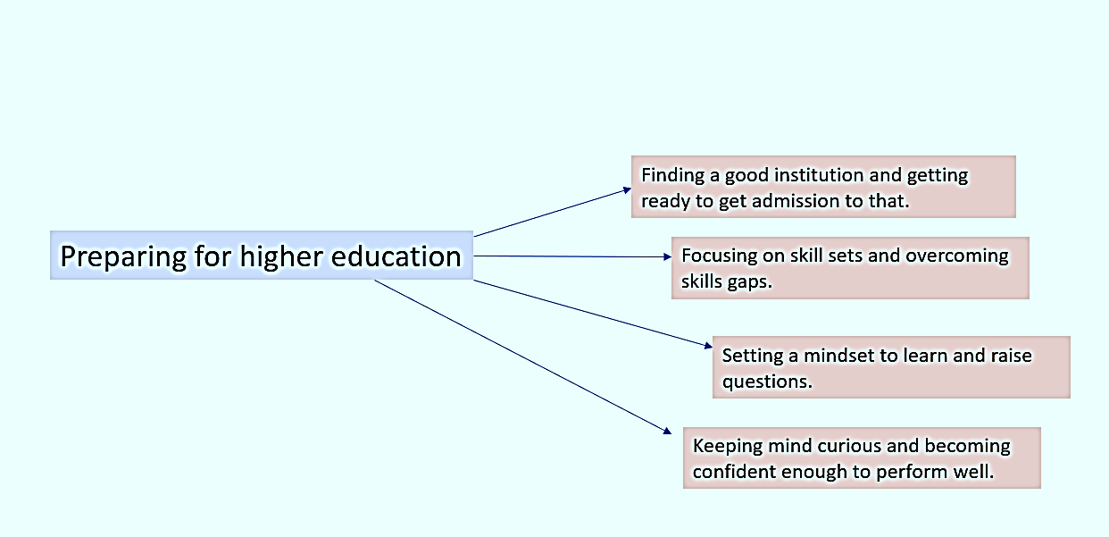
Figure 1: Preparing for higher education (Johnson et al., 2019).
While preparing for higher education a student needs to set a learning mindset. Higher education makes students capable, skilled, and ready for employment. To raise questions is also a process in higher education and this habit is not developed overnight. It requires practice to make a comfort zone in the university setting and asking questions to the course teachers if the class lecture is not clear enough (Ahmad, 2015). The next to do as a student before preparing to start university is to become confident and keep the mind curious. A confident and curious mind helps to perform well in a university. It also makes the learning process interesting and valuable. However, these are the basics for starting university. A student can make his/her routine for each work, communicate with friends and teachers, seek help from seniors, and take whelp from online sources to make themselves competent enough (Murtagh, 2012). They can also work on their skills gaps to overcome any barriers in their study life. However, the more the preparation the more the chance to get into a good university and fill up the dream to perform well.

Task 2 – Mind map: Becoming a digital learner
Mind mapping is a process of expanding the thinking of a particular issue and connecting it with the main issue. For example, the topic of this mind mapping is to become a digital learner. The mind-mapping process will start by keeping the topic in the middle and then connecting the other things related to it by expanding the ideas (Buzan, 2006). It can also be referred to as brainstorming which brings new ideas for a specific topic and finds effective ways to give concentration on that. However, mind mapping related to the topic is given below:
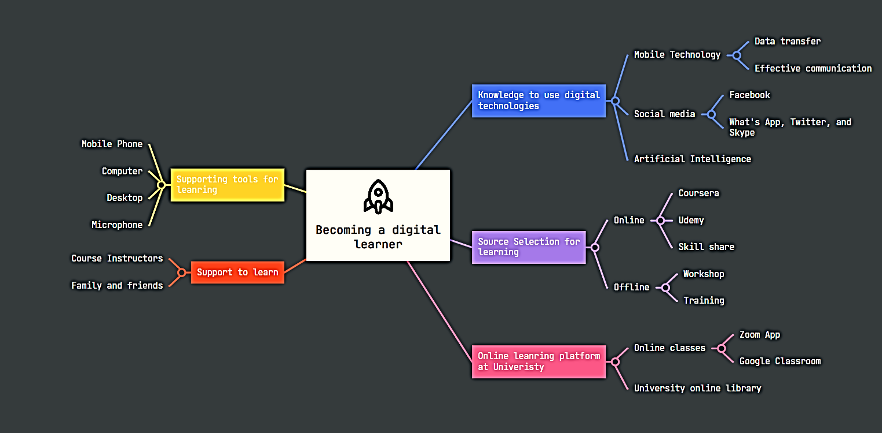
Figure 2: Mind Map (self-made)
To become a digital learner, a mind map considering the other related factors has been prepared. A digital learner requires basic and advanced level skills to operate the latest technologies. The first concept is about the knowledge to use digital technologies like mobile, social media, and artificial intelligence. It helps learners to use different platforms for learning and it is related to the given topic (Martens et al., 2019). The second concept is about learning source selection. Anyone can learn both from online and offline sources. Online sources for digital learners are many such as Udemy, SkillShare, and Coursera. On the other hand, offline courses like training and workshop are also a source of learning. There remain online learning platforms in the university setting to help students become digital learners. University takes online classes through Zoom App, and Google classroom, and also offers an online library facility to help the digital learner (Erstad et al., 2013). To become digital learners’ students also need supporting tools like computers, mobile phones, desktops, or microphones to give concentration on learning. The most important thing is to get support both from the family and teachers that encourage learners to learn. All of these things are interconnected with the main theme of becoming a digital learner. Anyone who has experienced digital learning or thinking to learn will get benefit both in academic study and future career (Vander, 2011). The knowledge about digital learning will enable a student to use the technologies properly to attend classes online and submit the assignments work in due time. Furthermore, it will also help to make good career progress by applying the digital learning knowledge to think and work differently from others.

Task 3 – Presentation
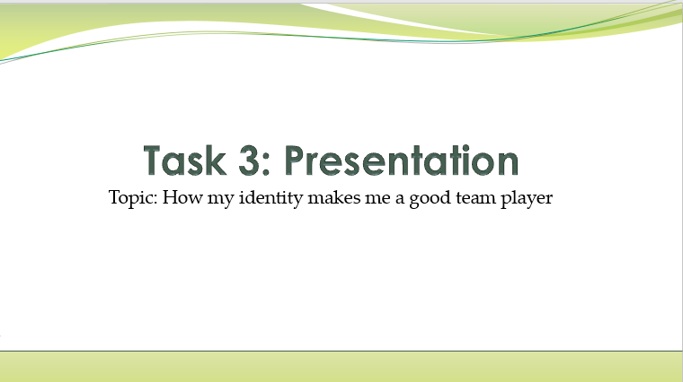
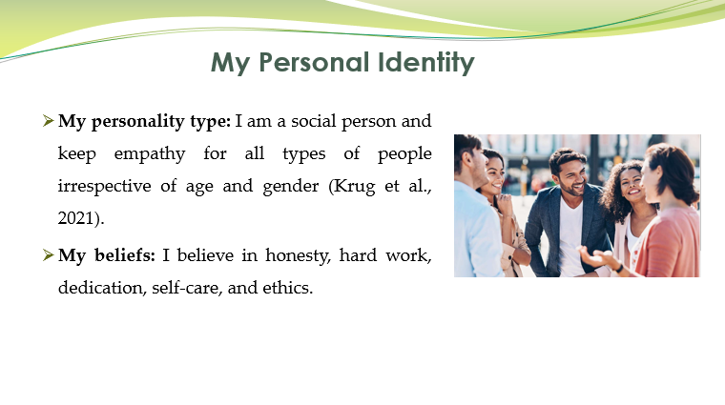
Speaker Notes: As a person, I am social in nature and this makes me feel worthy to live. I love to communicate with everyone and keep empathy for every people in their good and bad times. This has helped me to create a personal identity among the people I live. I have developed some beliefs inside me and this has always helped me. I believe in honesty, hard work with full dedication. I also believe in self-care and maintaining ethics while doing any set of tasks.
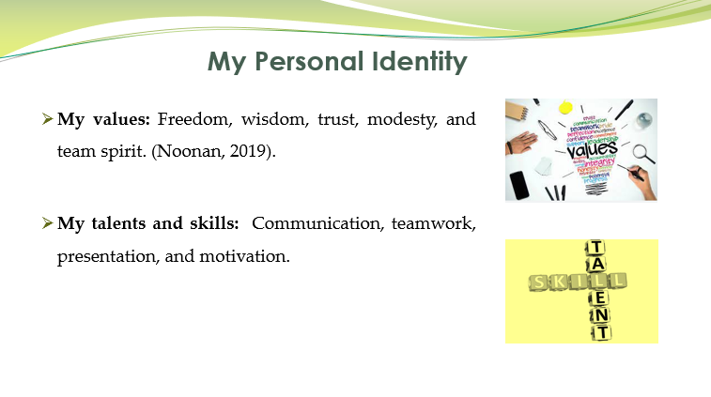
Speaker Notes: I have some values and I follow those strongly. I emphasized freedom and which is highly needed by anyone. I value wisdom and love to stay with those. I also value trust, modesty, and team spirit. I think team spirit helps to perform well in teamwork. I have also some skills like communication, presentation, and teamwork. These have always helped me.
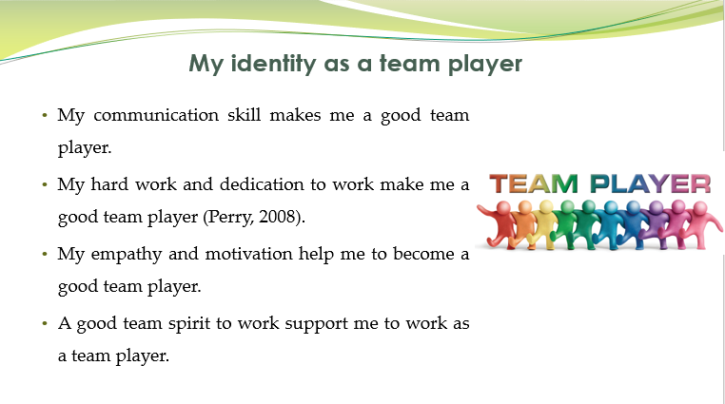
Speaker Notes: My identity has helped me to become a team player. Communication skill has helped me to talk with team members and discuss the work in detail. Hard work and dedication to perform well as a team helped me to become a good team player. On the other hand, my motivation skill, and team spirit mentality supported me to give my best as a team player and get good remarks from the whole team.
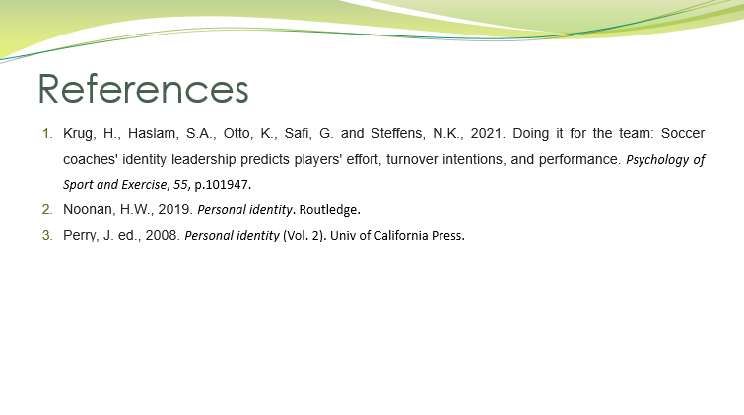

Task 4 – Reflection
Reflection on learning helps to describe the situation and supports doing the same thing in a better way in the future. I will be using Borton’s reflective cycle to describe my experience of starting university along with the learning and future course of action.
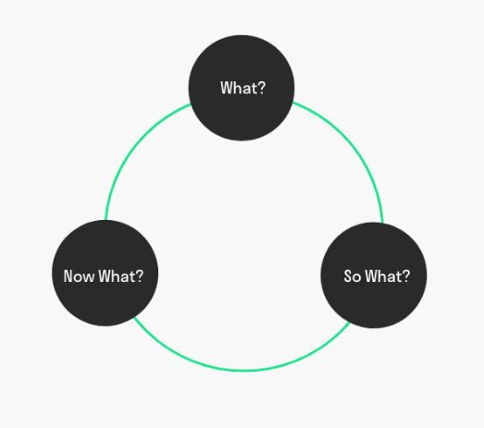
Figure 3: Borton’s reflective cycle (Lucas, 2012).
This reflective cycle has three parts that help to describe an experience in a better way. I will be following those three steps to describe my experience.
What: The first stage helps to describe what happened in that situation. The experience is about my starting at the university. I started to go to a university. I have faced many things while starting the university (Beddoes et al., 2007). I have made a routine for my learning, joined online classes, and wrote my first assignment. The journey was not easy at all because I faced many problems and something did not go well as I planned. One thing I can say is that I have learned many new things from this university.
So What: The next stage of this reflective cycle is so what which helps to describe the feeling and learning in detail. When I first started university, I was quite shy and nervous as it was a completely new place for me. I made some friends with the same personality. I made a new routine for learning. I made a study schedule and fixed time for each course to make the best use of my learning (Sicora, 2010). I faced some issues when I got to know about online learning and online resources in the university setting. University course teachers used to take online classes where they describe the study materials and used to give links for further study. At first, I was facing issue to use the online learning platform because I was unable to make communication with my course teacher. Then one day, I asked help from one of my teachers and she helped me to understand how to use the online resources for learning. On the other hand, my experience of writing my first assignment was quite good (Smith et al., 2009). I used to ask questions to my course teacher if something was not clear to me. I also took the help of online resources available at the university setting and at the internet. I successfully completed my assignment in due time.
Now What: I have learned about communication skills, online learning skills, and giving importance to course work. I will not all of my experience was good enough because I had difficult time also. However, the knowledge I have gained is outstanding and remarkable (Lucas, 2012). If I have to face this kind of situation again in future I will perform even better. I will apply communication skills, team work skills, and dedication to give my level best to a work.

Reference list
- Ahmad, T., 2015. Preparing for the future of higher education. On the Horizon.
- Beddoes, L., 2007. Using reflective models to enhance learning: experiences of staff and students. Nurse education in practice, 7(3), pp.135-140.
- Buzan, T. and Buzan, B., 2006. The mind map book. Pearson Education.
- Erstad, O. and Sefton-Green, J., 2013. Digital disconnect? The ‘digital learner’and the school. Identity, community and learning lives in the digital age, pp.87-106.
- Jacoby, B., 2009. Civic engagement in higher education: Concepts and practices. John Wiley & Sons.
- Johnston-Guerrero, M.P., Combs, L.D. and Malaney-Brown, V.K., 2022. Preparing for Higher Education's Mixed Race Future. Springer International Publishing.
- Krug, H., Haslam, S.A., Otto, K., Safi, G. and Steffens, N.K., 2021. Doing it for the team: Soccer coaches' identity leadership predicts players' effort, turnover intentions, and performance. Psychology of Sport and Exercise, 55, p.101947.
- Lucas, P., 2012, October. Critical reflection. What do we really mean. In 2012 Australian Collaborative Education Network National Conference (p. 163).
- Murtagh, L., 2012. Enhancing preparation for higher education. Practitioner Research in Higher Education, 6(1), pp.31-39.
- Noonan, H.W., 2019. Personal identity. Routledge.
- Perry, J. ed., 2008. Personal identity (Vol. 2). Univ of California Press.
- Schnackenberg, H.L. and Johnson, C. eds., 2019. Preparing the Higher Education Space for Gen Z. IGI Global.
- Sicora, A., 2010. Self-evaluation of Social Work Practice through Reflection on Professional Mistakes. Practice Makes “Perfect”?. Revista de Asistenţă Socială, (4), pp.153-164.
- Smith, D., Hedley, P. and Molloy, M., 2009. Design learning: a reflective model. Design Studies, 30(1), pp.13-37.
- Stokhof, H., De Vries, B., Bastiaens, T. and Martens, R., 2019. Mind map our way into effective student questioning: A principle-based scenario. Research in Science Education, 49, pp.347-369.
- Vander Ark, T., 2011. Getting smart: How digital learning is changing the world. John Wiley & Sons.

