  APPLE INC. | LCBB4004_MKF_A1_OCT. 20 - TERM 2 _ GR.2 (WKD) UNIVERSITY OF WALES TRINITY SAINT DAVID STUDENT ID:1919080

Table of Contents

History of Apple Inc. 2
Logo 2
Apple Inc.-Mission and Vision 3
Apple Products 3
Strategies used by Apple in the market 7
References 10

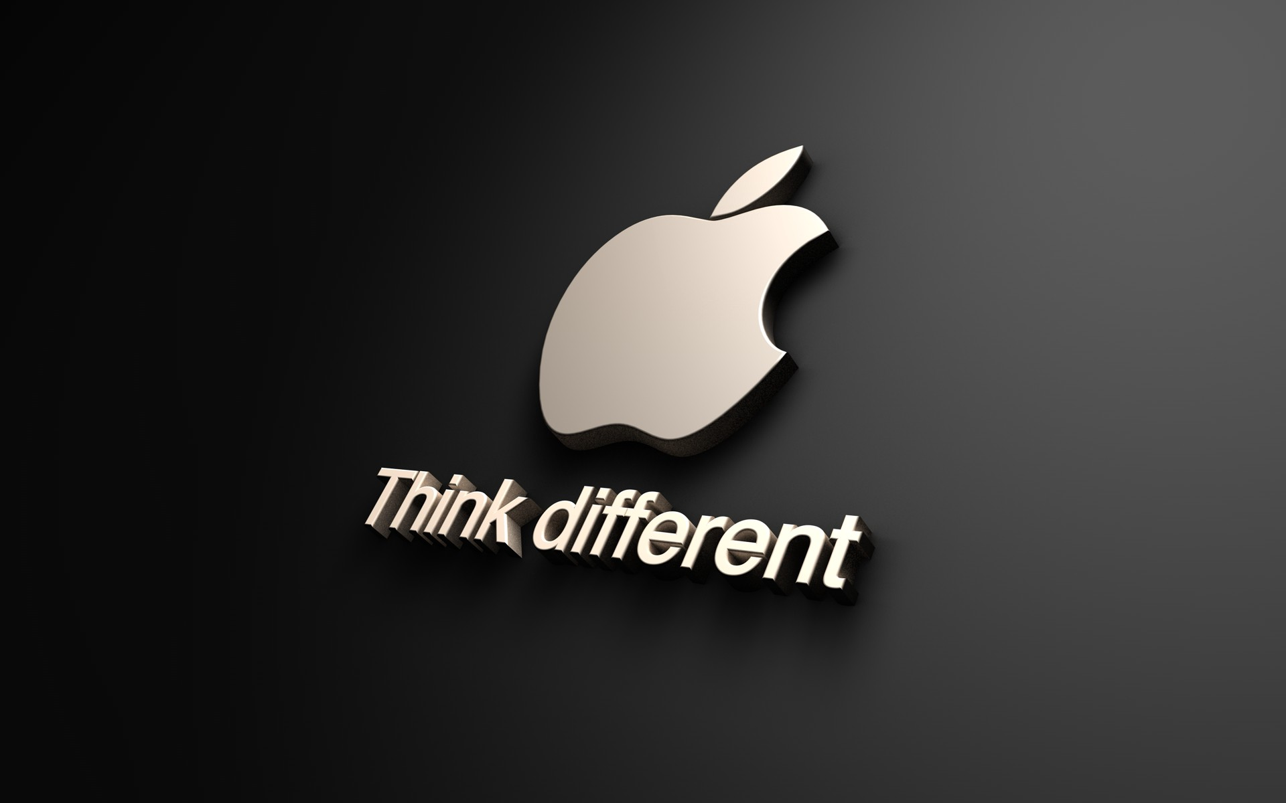

HISTORY OF Apple Inc
Apple is an American multinational technology company founded by Steve Jobs. Headquarter of Apple inc. in Cupertino, Californian where manufacture and testing and research laboratory. It considers a big technology company. Founder of Apple Incorporation was Steve Jobs, Steve Wozniak and Ronald Wayne and found in 1st April 1976 and incorporates as Apple Computer Inc in January 1977 (Gvili, 2020).
In 2007 Apple changed its name into Apple Inc. Steve Jobs and Steve Wozniak launched the first computer in 1976, which desktop computer is known by the Apple 1 and produces and sold 200 units of Apple 1. Apple Incorporation has several industries such as computer hardware, computer software, consumer electronics, cloud computing, digital distribution, fables silicon design etc ( Heracleous, L., 2013).
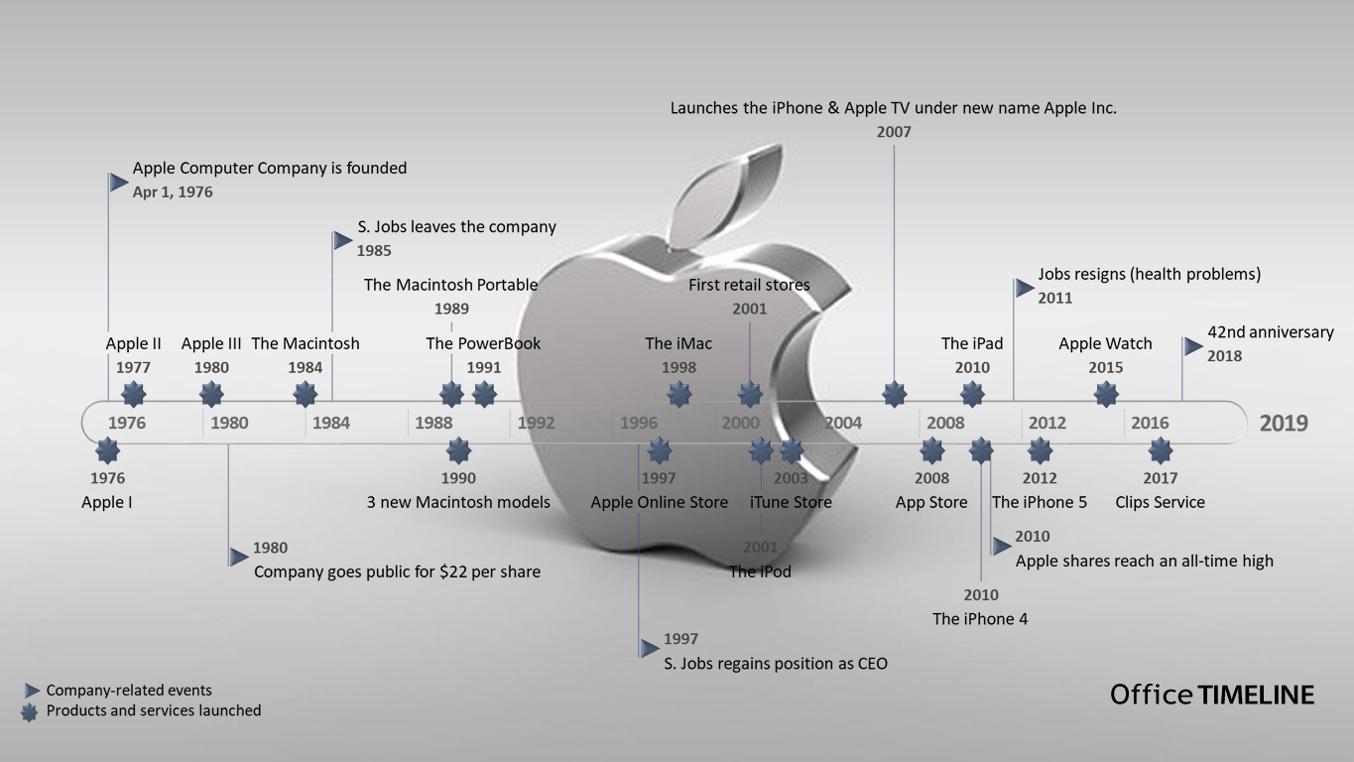

Logo
Apple Incorporation logo is one of the famous logos on a worldwide level. The first logo of Apple Incorporation was craft by Ronald Wayne, who is one of the founders of Apple incorporation. In the logo, Ronald Wayne wants to show the neutron’s gravity low through this logo and motivated by Apple incorporation (Jobs et al., 2013). Steve Jobs was not satisfied by 1st logo and he decides to explore the logo and find something different, later Steve job appoint a graphic designer whose name was Rob Janoff, then he creates the classic and world-famous logo of the bitten Apple. Steve jobs remove the old Newton logo and establish the bitten Apple as a new logo from the end of the company 1st year. Steve jobs say the “the fruit of creation, Apple. It was simple but strong”. Bitten Apple is not just a logo now it is a brand image. “Newton’s image setting under the Apple tree” was the first slogan of Apple and coin in the 1970s (Johnson et al., 2012).

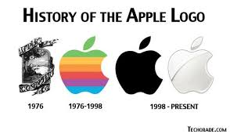

Apple Inc.-Mission and Vision
Apple incorporation’s mission is “to bringing the best user experience to its customers through its innovative hardware, software, and services”.
Apple Incorporation aim is to reduce the carbon footprints from the earth by making its product without using resources from the earth. The main aim of Apple Incorporation to reduce carbon emissions is an important part of this attempt. Apple is taking the liability of carbon footprint. Apple measures the three-carbon footprints in five areas such as corporate facilities, product manufacturing, product use, and product transport and product end of the life processing. Apple decreases its carbon footprints by 35 per cent in the last three years (Heracleous, L., 2013).
Apple incorporation’s corporate vision is “to make the best products on earth, and to leave the world better than we found it”.
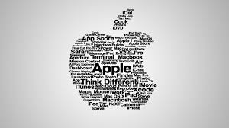
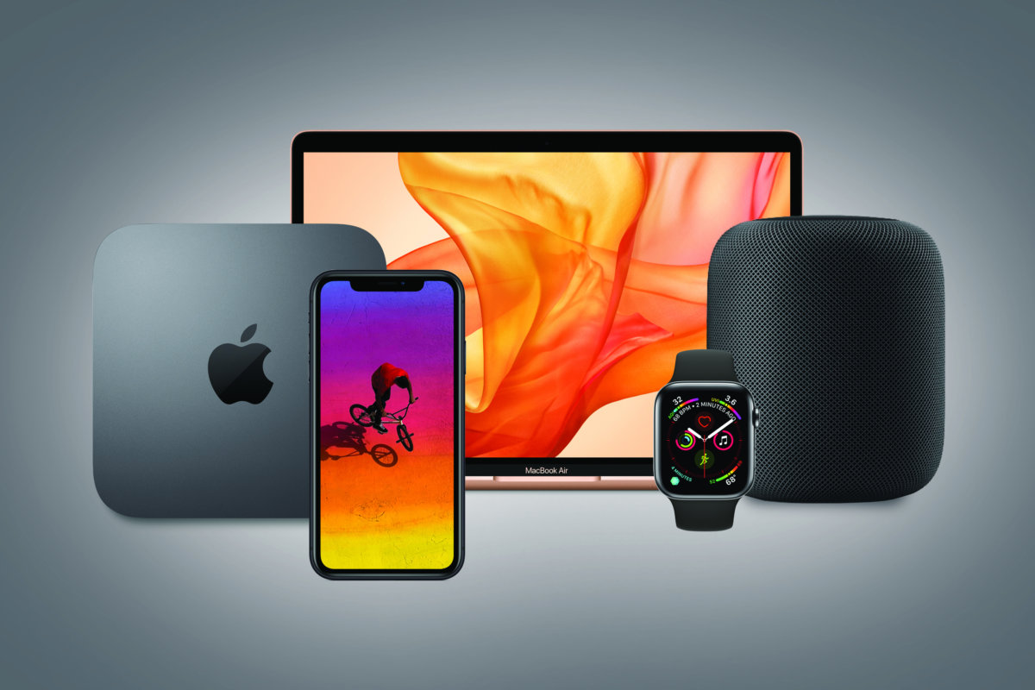
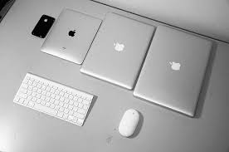
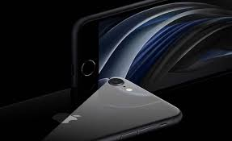
Our products are our image
A product is known as something that is generated to fulfill a specific demand. Apple Incorporation uses Apple as a brand to compete with several competitors in the market. Apple Incorporation uses the product strategy and providing updated technology to its customers. The branding strategy of Apple concentrated on the emotions, the brand personality of the Apple is about imagination regained, innovation, passion, hopes, dreams, aspirations and liberty provided to the customers through technology. Apple brand personality is also known through its product design facility, customize product and make better relationships with their customers. Apple believes to make a strong customer base. Apple connects with this position from beginning to end from one of the most market campaigns “Think Different”. Think Different is represented smart innovative, clever and creative (Gvili, 2020). Apple Incorporation design its product is very simple because the motive of the Apple brand is simple is different and never attempt to overdo things in its product design. Apple makes a heartfelt relationship with its customers, in several forms such as; build trust to create a group of customer around a product (Jobs et al., 2013).
Apple” technology creates crazed fans that stand in queue for hours and hours, for just to acquire the new model of any product of Apple brand. Apple creates the product for their target market; loyal customers who believe create this product life better, easier and more fun.
Products
iPhone smartphone: iPhone is a series of touch screen smartphones which produce and marketing by the Apple Inc. the first iPhone was launch by the Steve Jobs, who is the founder of Apple on 9 January 2007. In iPhones use the iOS mobile operating system. In the iPhone all apps and function are performing in a manner the Apple planned them to perform, which permit for a very simple user experience. All the iPhone series work in a similar way. Currently, Apple Incorporation launches iPhone 12 pro and 12 pro max on 23 October 2020 and 13 November 2020 ( Johnson et al., 2012)
iPad tablet computer: tablet in iPad tablets have IOS AND IpadOS operating system which have Apple's operating system. In 2010 Apple was launched the first iPad in the market and September 2020 launch eighth-generation iPad. In all these tablets have great features such as a vertical keyboard, camera, play music, game, GPS Navigation, social networking etc. Apple Incorporation also releases mini Ipad (Yoffie et al., 2012).
Mac personal computer- Mac is a short form of Macintosh. Apple Incorporation manufacturer, design and sold a group of personal computers is called Mac computer. Apple Incorporation sold Mac computers since January 1984. Mac computers usually use in mass media market because in Mac computer have the great feature of the graphical design user interface, built-in screen and cursor (O'Grady & J.D., 2009).
iPod portable media player- it is a digital music player and type of portable media player which is design and manufacture by the Apple incorporation. First iPod launched on 23 2001 by Apple inc. touch iPod is only the touch media and 1st touch iPod was launch on 28 May 2019 remains in production. It is a type of digital media. Apple Incorporation also launches iTunes, which is software and it is a version of the Macintosh version. Some iPod is used as the external data storage device (Sanchirico & C.W., 2014).
Apple smartwatch- Apple Incorporation manufactures and designs the smartwatches. First Apple watch was launched in April 2015. Apple watches bestselling product in the category of the wearable device. In the second quarter, Apple Incorporation earns 4.2 million forms selling the device in the market. Apple Incorporation improves in features and components, and sale in the market consequent years. In Apple watch have many features such as fitness tracking, health-oriented capabilities and wireless communication. In Apple, watches use the iOS operating system (Jobs et al., 2013).

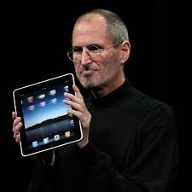
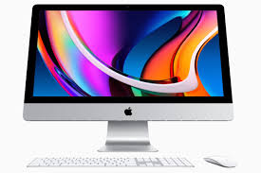
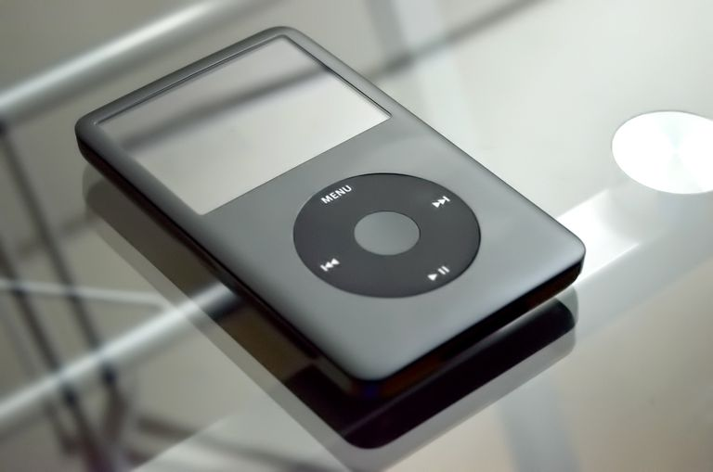
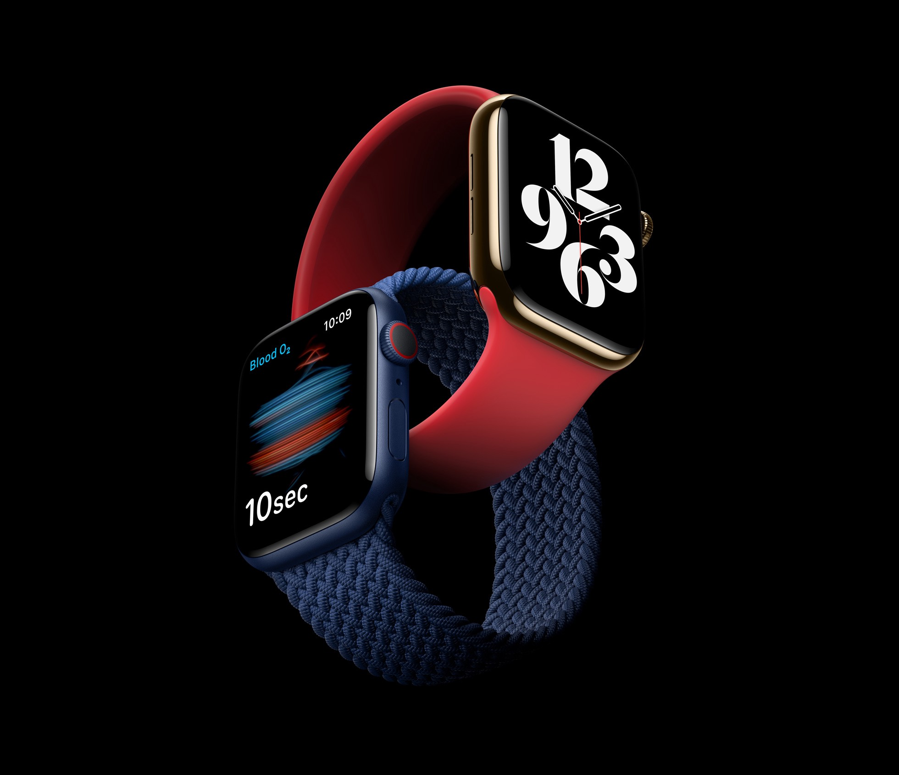

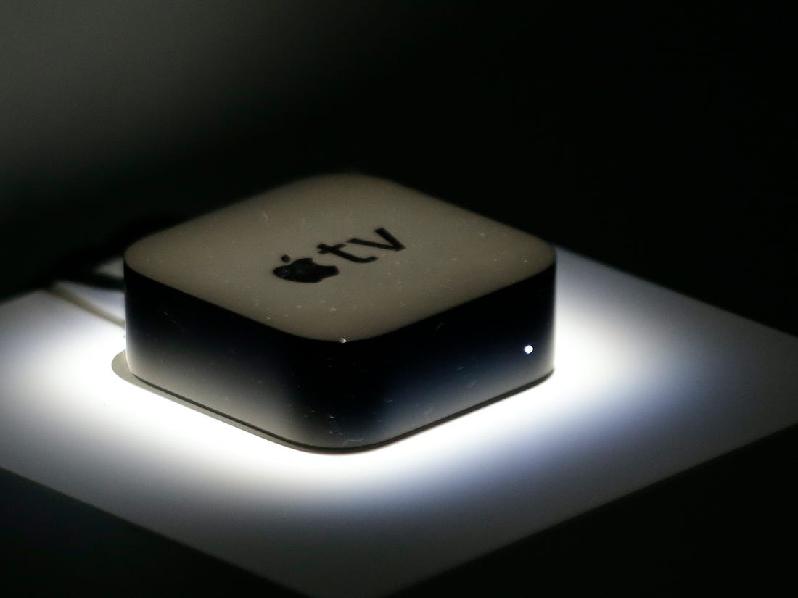
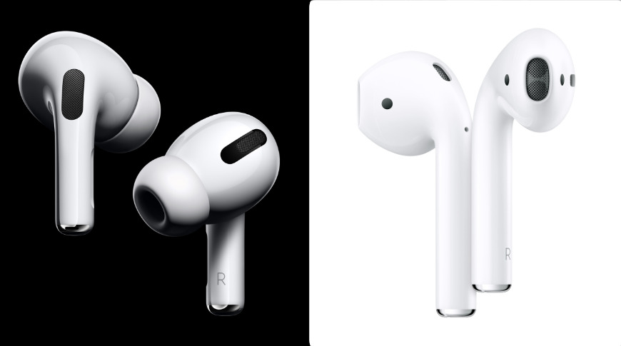
Apple TV: Apple TV manufactures and design by the Apple incorporation. Apple TV use as a small networking device and entertainment device that can receive virtual data for visual and audio content such as video, music, video games, can play it on a connected TV set. Apple TV was based on HDMI. HDMI is a quality of the display. Quality of Apple TV is enhance-definition or high-definition device. Apple TV also a feature of Wi-Fi connectivity and it run on preinstalled software tvOS.

AirPods wireless earbuds: it is a product of Apple Incorporation which is design and manufacture by the Apple Company. AirPods is wireless Bluetooth. 1st AirPods was launch on 13th December 2016. 2nd generation of AirPods was launch on the 20 March 2019. The main feature in the AirPods is long durability of battery backup, easy to connect devices and important feature is it filters out the background noise. In this create optical sensors can identify the taps for example double tab to pause audio (Yoffie et al., 2012).

Supply chain strategy market:


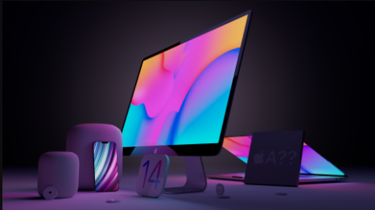
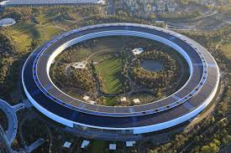
Apple Incorporation does not produce all product in their company, its production and manufacture are based on outsourcing. For example, Mac computer, a Mac computer made by a combine, set and assembles with many parts. All the parts allocated from other regions such as made in us, made in Mongolia, made in Korea and Taiwan, made in Europe, made in china.
- Made in US-Apple Incorporation generate approx. 600000 jobs for us workers and appoint engineers to delivery workers are from our country. Apple Incorporation outsources from US country such products design, software development and marketing.
- Made in Mongolia- from magnolia country Apple Incorporation outsources the components of Mac computers because components are made by the minerals and magnolia country has an available huge amount of minerals recourses.
- Made in Korea and Taiwan- Korea and Taiwan country are providing the high technology and essential parts to Apple incorporation (Jobs et al., 2013)..
- Made in Europe- European companies producing a part which name is Gyroscope and this product use for the display and it could change between horizontal and vertical.
- Made in china- china provides the facility of assembling the product and Apple Incorporation assembled many products from the china country (Sanchirico & C.W., 2014).

Innovation & Global strategy

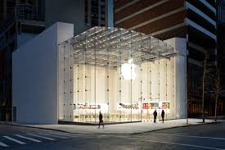
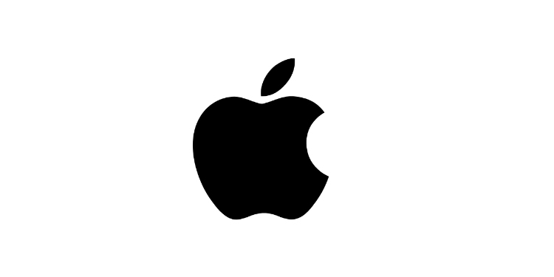
Innovation strategy- Apple Incorporation is the best example of manufacturing innovative or invented products. Apple Incorporation innovate the new products and launches the differently new product such as the iPod, iTunes, iPhones and Mac computers. Apple Incorporation is the first organization that launches the new products, new technologies and innovative products in the markets.

Global strategy- Apple Incorporation applies the concept of global in their organization. Apple sale their product in global and apply one dimension fits- all approach. Apple Inc manufacture standardizes design for the entire county, set the same price of the product for all the regions. Apple reputed as a global brand with a strong personality (Yoffie et al., 2012).

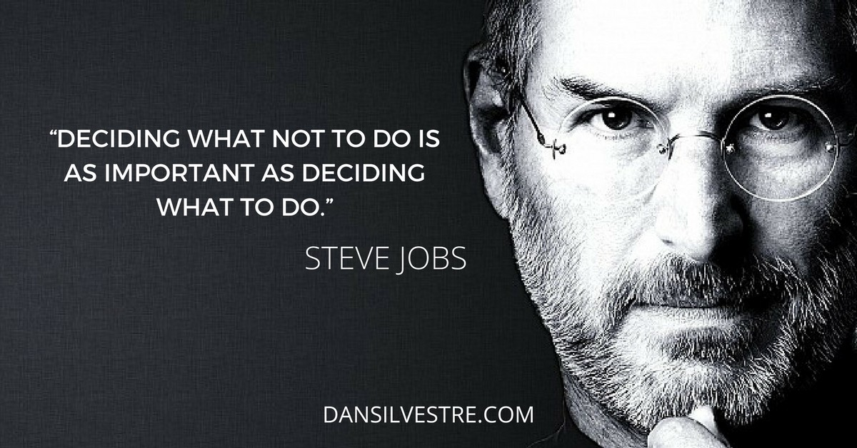

References
Gvili, Y., 2020. Security analysis of the covid-19 contact tracing specifications by apple inc. and google inc. IACR Cryptol. ePrint Arch., 2020, p.428.
Heracleous, L., 2013. Quantum strategy at apple inc. Organizational Dynamics, 42(2), pp.92-99.
Jobs, S.P., Forstall, S., Christie, G., Lemay, S.O., Herz, S., Van Os, M., Ording, B., Novick, G., Westerman, W.C., Chaudhri, I. and Coffman, P.L., 2013. Touch screen device, method, and graphical user interface for customizing display of content category icons. U.S. Patent 8,564,544.
Johnson, K., Li, Y., Phan, H., Singer, J. and Trinh, H., 2012. The Innovative Success that is Apple, Inc
Johnson, W.J., Apple Inc, 2011. System and method for anonymous location based services. U.S. Patent 8,060,389.
O'Grady, J.D., 2009. Apple Inc. ABC-CLIO.
Sanchirico, C.W., 2014. As American as Apple Inc.: international tax and ownership nationality. Tax L. Rev., 68, p.207.
Yoffie, D.B. and Rossano, P., 2012. Apple Inc. in 2012. Harvard Business School.

