

Module Name: Knowledge and Information Management Skills for the Workplace
Module Code: (BMSK5013)
Assignment Name: Knowledge & Information Management Skills
Student Name: Roqia haji haidar
Student Number:2422002
Lecturer: Paul Tinkler
Deadline: 31/05/2026
Wordcount: 4087
AI Acknowledgement
I confirm that I have not presented any AI generated materials as my own work.
I confirm that I have copies of my drafts, notes, and other resources I used, which I may be asked to provide in evidence.

Table of Contents
Executive Summary -----------------------------------------------------------------------4
1. Introduction to Knowledge Management----------------------------------------5
1.1 Definition of Knowledge Management----------------------------------------------5
1.2 Importance of Knowledge Management in Organisations---------------------5
1.3 Knowledge Management in workplace---------------------------------------------6
1.4 Information Management and GDPR Compliance------------------------------6
1.5 Purpose of the Report------------------------------------------------------------------6
2. Evaluation of Knowledge Management -----------------------------------------7
2.1 Data, Information, Knowledge and Wisdom (DIKW Model) -------------7
2.1.1 Data---------------------------------------------------------------------------------------7
2.1.2 Information------------------------------------------------------------------------------8
2.1.3 Knowledge------------------------------------------------------------------------------8
• Explicit Knowledge----------------------------------------------------------------------8
• Tacit Knowledge-------------------------------------------------------------------------9
2.1.4 Wisdom---------------------------------------------------------------------------------10
2.1.5 Importance of Analysing Information--------------------------------------------10
2.2 Relationship Between Individual and Organisational Knowledge----11
2.2.1 Individual Knowledge----------------------------------------------------------------11
2.2.2 Organisational Knowledge---------------------------------------------------------11
2.2.3 The SECI Model and Knowledge Transfer-------------------------------------12
2.3 Evaluation of Knowledge Sharing and Organisational Learning------14
2.3.1 Importance of Knowledge Sharing and Organisational Culture-----------14
2.3.2 Technology and Organisational Success---------------------------------------15

3. Framework for Creating a Knowledge Management Culture---------------17
3.1 Business Case for Knowledge Collection and Distribution---------------17
3.1.1 Importance of Knowledge Management------------------------------------------17
3.1.2 Improved Customer Service and Organisational Performance-------------18
3.1.3 Better Employee Performance------------------------------------------------------18
3.1.4 Better Decision-Making---------------------------------------------------------------19
3.1.5 Improved Efficiency--------------------------------------------------------------------20
3.1.6 Information Security and Compliance---------------------------------------------21
4. Conclusion ---------------------------------------------------------------------------------23
5. References ---------------------------------------------------------------------------------25
6. Appendices ----------------------------------------------------------------------------28-31

Executive Summary
Knowledge Information Management (KIM) is important for businesses because it helps organisations manage data, information and knowledge effectively. In today’s digital world, companies rely on customer records, employee knowledge and business systems to improve services and support better decision making. This report explains how information and knowledge can be collected, stored, shared and used more efficiently in the workplace to improve overall performance.
The report also explains the difference between data, information, knowledge and wisdom. Data refers to basic raw facts, information is organised data, knowledge is understanding gained through learning and experience, and wisdom is the ability to apply knowledge to make good decisions. Together, these elements help organisations solve problems, improve performance and increase customer satisfaction.
Furthermore, the report highlights how employee and organisational knowledge support teamwork, training and decision making. When knowledge is shared between employees, it improves communication, increases efficiency and helps businesses deliver better customer service. It also allows employees to learn from each other and develop their skills, which improves workplace productivity.
In addition, the report discusses how organisations can create a positive knowledge sharing culture through teamwork, training programmes and the use of digital systems. It also emphasises the importance of information security and protecting customer and business data by using secure systems and following data protection rules and policies.

1. INTRODUCTION TO KNOWLEDGE MANAGEMENT
1.1 Definition of Knowledge Management

Knowledge management refers to the process of collecting, organising, storing, sharing and using information and knowledge within an organisation to improve performance and support effective decision making (Knowledge Management in Organizations, 2018). It helps ensure that valuable knowledge is not lost and can be accessed by employees when needed. By managing knowledge properly, organisations can improve efficiency, reduce mistakes and support better problem solving. It also encourages employees to share their expertise and learn from each other, which strengthens teamwork and continuous improvement. Overall, effective knowledge management supports organisational learning, improves service quality and helps businesses achieve their goals more successfully and consistently (Thomas, 2024).

1.2 Importance of Knowledge Management in Organisations

Knowledge management is important in many businesses because organisations manage substantial amounts of information every day. Effective knowledge management helps organisations improve communication, support decision making, increase efficiency and maintain high standards of service. By ensuring that employees can access and use relevant information when needed, organisations can improve productivity and overall performance. It also supports better learning and knowledge sharing across teams, which improves organisational effectiveness (Bourgeois et al., 2019).

1.3 Knowledge Management in workplace
For example, in a workplace such as Vision Express Opticals, staff work with customer prescriptions, eye examination records, appointment systems, training information and product knowledge. Employees need quick access to correct information so they can provide good customer service and maintain professional standards. Effective knowledge management systems help ensure this information is available and well organised, supporting accurate decision making and efficient service delivery (Knowledge Management in Organizations, 2018). This example shows why effective knowledge management is important in the workplace.
1.4 Information Management and GDPR Compliance
Technology has changed the way businesses manage information. Many organizations now store enormous amounts of digital data using computer systems and cloud storage. Businesses must also follow laws such as the General Data Protection Regulation (GDPR) to ensure customer information is kept safe and secure (The General Data Protection Regulation, 2018). Protecting data helps organisations build trust with customers and avoid legal issues while improving overall efficiency and accountability in handling sensitive information. Secure systems also support compliance, reduce risk, and ensure that organisations support customer confidence in an increasingly digital and data driven business environment and improve overall efficiency.
1.5 Purpose of the Report
This report explains how organisations can improve workplace performance by managing knowledge and information more effectively. It also explains the relationship between data, information and knowledge, the importance of knowledge sharing, and how workplace systems can support employees and managers in their daily work. to enhance efficiency, decision making, communication and overall organisational productivity and effectiveness across all departments consistently

2. Evaluation of Knowledge Management
2.1 Data, Information, Knowledge and Wisdom (DIKW Model)
Knowledge management is based on the relationship between data, information, knowledge, and wisdom. This relationship is known as the DIKW hierarchy because it explains how raw facts are transformed into valuable knowledge that supports decision making (Bratianu & Bejinaru, 2023).
2.1.1 Data
Data refers to raw facts and figures that have not yet been organised or interpreted. On its own, data has limited meaning because it lacks context and understanding.
Examples of data collected at Vision Express Opticals include:
- Number of eye appointments each day
- Sales figures for glasses and lenses
- Customer contact details
- Staff attendance records
- Stock levels
These facts are collected regularly but cannot effectively support decision making until they are processed into meaningful information (Bourgeois et al., 2019).
2.1.2 Information
Information is created when data is organised, processed, and presented in a meaningful way. It provides context and helps organisations understand business performance and make informed decisions.
Examples of information at Vision Express Opticals include:
- Weekly sales reports
- Customer feedback summaries
- Stock management reports
- Staff performance reports
Managers can use this information to improve customer service, manage stock levels efficiently, and support employee development. Information is important because it helps organisations solve problems, improve efficiency, and plan for future growth (Business Intelligence, 2026).
2.1.3 Knowledge
Knowledge is created when information is combined with experience, understanding and skills, allowing people to apply what they know in real situations (Knowledge Management in Organizations, 2018). It is more than just facts because it involves knowing how and when to use information effectively. Knowledge helps employees make better decisions, solve problems and complete tasks more efficiently. It is developed over time through learning, training and everyday work experience. As employees gain more knowledge, their confidence and performance improve, which helps the organisation. Knowledge is also important because it supports continuous learning and improvement in the workplace. When employees share and use their knowledge, organisations can improve service quality and work more effectively. For example, in a workplace such as Vision Express, staff use their knowledge to help customers choose suitable glasses, explain lens options and answer questions in a professional way. This improves customer satisfaction and helps achieve organisational goals (Knowledge Management in Organizations, 2018).
Explicit Knowledge
Explicit knowledge is knowledge that can be documented, stored, and easily shared. Examples include:
- Training manuals
- Company policies
- Product guides
- Sales reports
- Customer records
Organisations typically store explicit knowledge in databases and information systems, allowing employees to access it whenever required (Hu, 2020).
Tacit Knowledge
Tacit knowledge is personal knowledge gained through experience and practice. It is difficult to document because it exists in an individual's skills, judgement, and understanding (Adesina & Ocholla, 2020).
Examples of tacit knowledge include:
- Communication skills
- Experience helping customers choose products
- Problem-solving abilities
- Leadership skills
Tacit knowledge is particularly valuable because experienced employees often understand the most effective ways to manage customer interactions and workplace situations. At Vision Express Opticals, experienced staff can support new employees by sharing practical advice and demonstrating effective customer service techniques.
Organisations should encourage knowledge sharing through teamwork, mentoring, training sessions, and daily communication. Knowledge sharing improves employee performance, reduces errors, and supports organisational learning by enabling employees to learn from each other's experiences (Guerra-Gómez & Pérez-Sánchez, 2025).

2.1.4 Wisdom
Wisdom is the ability to use knowledge, experience, and understanding to make effective decisions in different situations (Bratianu & Bejinaru, 2023). It represents the highest level of the DIKW hierarchy because it allows individuals to apply knowledge appropriately to solve problems and achieve organisational objectives.
For example, managers at Vision Express Opticals may analyse sales reports, customer feedback, and staff performance information to determine how customer service can be improved, sales increased, and employees better supported. Wise decision making helps organisations achieve business goals, improve operational efficiency, and enhance customer satisfaction.
2.1.5 Importance of Analysing Information
The DIKW model demonstrates that organisations must do more than simply collect data, they must also analyse and interpret it correctly. Employees and managers require critical thinking skills to evaluate information before making decisions. Critical thinking enables organisations to identify problems, understand situations clearly, and select the most appropriate solutions.
For example, if customer satisfaction levels decline at Vision Express Opticals, managers must investigate the underlying causes. Possible factors may include long waiting times, poor communication, staff shortages, or inadequate employee training. Simply reviewing data will not resolve the issue unless the information is carefully analysed and the root cause is identified.
Critical thinking plays an essential role in knowledge management because it helps organisations make better decisions, improve customer service, and increase workplace efficiency. Businesses that effectively analyse and apply information are more likely to achieve their objectives and maintain professional standards (J. Robert Thompson, 2022).

2.2 Relationship Between Individual and Organisational Knowledge
2.2.1 Individual Knowledge
Individual knowledge refers to the knowledge, skills, abilities and experience that employees acquire and develop through education, training and practical workplace experience. It is built over time as employees perform tasks, solve problems, interact with colleagues and customers, and participate in professional development activities. Individual learning is essential because it enhances employees’ competence, increases job performance and enables them to contribute more effectively to organisational objectives. It also supports career development by helping employees build expertise and adapt to changing workplace demands (Guerra-Gómez & Pérez-Sánchez, 2025).
At Vision Express Opticals, employees develop individual knowledge through a combination of customer service experience, product training programmes, teamwork and day to day workplace learning opportunities. Staff apply this knowledge when assisting customers with frame selection, explaining different lens options, processing sales and supporting eye care services. Through continuous learning and practical experience, employees become more confident, knowledgeable and efficient in their roles, enabling them to deliver high quality customer service and contribute to the organisation’s overall success.
2.2.2 Organisational Knowledge
Organisational knowledge refers to the collective knowledge that is stored, shared and maintained within an organisation. This knowledge is usually captured through databases, information systems, company policies, procedures and training materials, making it accessible to employees when required (Bourgeois et al., 2019).
Examples of organisational knowledge at Vision Express Opticals include:
- Customer databases
- Appointment management systems
- Workplace procedures
- Staff training programmes
- Company policies and guidelines
Organisational knowledge helps ensure consistency in business operations and allows employees to access important information needed to perform their duties effectively. It also supports organisational memory by retaining valuable knowledge even when employees leave the organisation.

2.2.3 The SECI Model and Knowledge Transfer
There is a close relationship between individual and organisational knowledge because organisations depend on employees to create, share and apply knowledge. Individual knowledge becomes organisational knowledge when employees communicate their experiences, skills and ideas to others within the organisation.
The SECI Model, developed by Nonaka and Takeuchi, explains how knowledge is created and transferred through four stages:
- Socialisation – Sharing tacit knowledge through observation, interaction and experience.
- Externalisation – Converting tacit knowledge into explicit knowledge through discussion and documentation.
- Combination – Organising and combining explicit knowledge into systems, procedures or databases.
- Internalisation – Employees learning and applying explicit knowledge, turning it into personal knowledge and experience.
Knowledge continuously moves between individuals and the organisation through the process of knowledge transfer. Effective knowledge transfer plays a vital role in supporting organisational learning, enhancing overall performance and fostering innovation (Adesina & Ocholla, 2020). By sharing ability, skills and experience, employees help preserve valuable organisational knowledge and ensure that best practices are kept over time. This exchange of knowledge contributes to keeping professional standards, improving the quality of decision making and reducing the risk of knowledge loss. Furthermore, organisations that encourage knowledge sharing are better positioned to adapt to change, respond to challenges and achieve long term success (Thomas, 2024).

2.3 Evaluation of Knowledge Sharing and Organisational Learning
2.3.1 Importance of Knowledge Sharing and Organisational Culture
Knowledge sharing is a key factor in improving organisational performance because it allows employees to learn from each other's skills, knowledge and workplace experience. Experienced employees can support newer staff members by helping them develop confidence, improve their abilities and understand workplace procedures more effectively. As a result, organisations can increase productivity, reduce mistakes and improve problem solving capabilities (Knowledge Management in Organizations, 2018).
Organisational learning is strengthened when employees continuously exchange ideas and information. Research by Abbas Khakpour et al. (2009) suggests that organisational culture has a significant influence on employees' willingness to share knowledge. Employees are more likely to collaborate when they feel respected, trusted and supported by both managers and colleagues.
A positive organisational culture encourages:
- Teamwork
- Open communication
- Trust and cooperation
- Continuous learning
- Employee engagement
These factors help strengthen relationships between employees and management while encouraging the sharing of valuable knowledge. In contrast, organisations with poor communication, low levels of trust or highly competitive working environments may discourage knowledge sharing because employees may feel reluctant to share information or expertise (Creating Knowledge Sharing Culture at Work: [2024 Guide], n.d.).
Evidence also suggests that organisations benefit from creating a learning culture where employees are encouraged to continuously develop their knowledge and skills. Training programmes, mentoring schemes and collaborative working practices enable employees to share experiences and learn from one another. The SECI Model supports this view by demonstrating that knowledge is created and transferred through social interaction, observation and shared experiences (Adesina & Ocholla, 2020). This process can improve innovation and help organisations respond more effectively to changes in the business environment (Thomas, 2024).
2.3.2 Technology and Organisational Success
Technology plays an important role in supporting knowledge management by providing systems that allow information and knowledge to be stored, shared and accessed efficiently. Examples include:
- Databases
- Intranets
- Cloud computing systems
- Communication and collaboration software
- Knowledge management systems
These technologies play an important role in helping organisations improve information sharing, collaboration, and organisational learning. They enable employees to access, store, and exchange knowledge more efficiently, supporting better decision making and problem solving across different departments. However, technology alone cannot guarantee successful knowledge management .While digital platforms, databases, and communication tools provide the infrastructure for managing knowledge, their effectiveness depends on how people use them (Cloud Computing in Libraries, 2020).

Successful knowledge management also requires strong leadership, employee engagement, and a supportive organisational culture. Leaders must encourage knowledge sharing behaviours and create an environment where employees feel valued and motivated to contribute their expertise. Open communication, trust, and teamwork are essential for ensuring that knowledge is shared rather than retained by individuals.

Overall, organisations are more likely to achieve effective knowledge management when they combine advanced technology with strong leadership, active employee participation, and a culture of continuous learning. Such organisations are better positioned to improve performance, drive innovation, and achieve sustainable long term growth (Business Intelligence, 2026).

3. Framework for Creating a Knowledge Management Culture
3.1 Business Case for Knowledge Collection and Distribution
Knowledge collection and distribution help organisations share information effectively, improve decision making, increase efficiency and support business success (Knowledge Management in Organizations, 2018; Thomas, 2024).
3.1.1 Importance of Knowledge Management
Knowledge management is a vital organisational process that involves the systematic collection, storage, sharing and application of information and expertise within a business. Its primary purpose is to ensure that valuable knowledge is accessible to employees when needed, allowing organisations to improve communication, increase efficiency, support innovation and enhance decision making. According to Knowledge Management in Organizations (2018), knowledge management enables organisations to transform information into a strategic asset that contributes to long term organisational success and sustainability.
A strong knowledge management culture encourages employees to share their knowledge, skills, experiences and best practices with colleagues. This collaborative approach helps organisations retain critical knowledge, reduce duplication of effort and respond more effectively to changing market conditions. In competitive business environments, effective knowledge management can provide a significant advantage by supporting continuous learning and organisational adaptability.
Within Vision Express, knowledge management is particularly important because employees regularly handle customer records, healthcare information, product knowledge and company procedures. By effectively collecting, storing and distributing knowledge, the organisation can improve customer service, ensure regulatory compliance and enhance employee performance. Knowledge management systems also support training and development by providing employees with easy access to accurate and up to date information. Furthermore, Thomas (2024) argues that organisations that invest in knowledge management systems and supportive leadership practices are better positioned to drive innovation, improve collaboration and successfully achieve digital transformation objectives.

3.1.2 Improved Customer Service and Organisational Performance
One of the most significant benefits of knowledge management is improved customer service. Organisations that effectively manage customer information can provide more personalised, accurate and efficient services. At Vision Express, employees rely on customer records, prescription information and eye care histories to provide suitable product recommendations and effective customer support.
Customer Relationship Management (CRM) systems are closely linked to knowledge management because they help organisations collect, store and analyse customer information. According to Gede Juanamasta et al. (2019), CRM systems strengthen customer loyalty and enhance organisational reputation by improving communication and customer support.
Knowledge sharing also ensures that employees remain informed about new products, healthcare guidance and organisational procedures. As a result, customers receive consistent and reliable information regardless of which employee assists them. Workplace learning and continuous training further support service quality by improving employee confidence, competence and performance (The Cambridge Handbook of Workplace Training and Employee Development, 2017).
Consequently, organisations that manage knowledge effectively are more likely to improve customer satisfaction, strengthen organisational performance and achieve long term business success.
3.1.3 Better Employee Performance
Knowledge management contributes significantly to employee performance because it provides staff with easy access to the information and resources required to perform their roles effectively. Employees who understand company procedures and can access relevant training materials are generally more confident, productive and efficient.
Within Vision Express, employees regularly require guidance on appointment systems, prescription handling, healthcare procedures and customer service standards. Organised knowledge management systems allow staff to access policies, manuals and training documents quickly whenever required.
Knowledge sharing between employees is equally important. Experienced employees possess valuable practical knowledge gained through workplace experience. Through mentoring, collaboration and teamwork, this knowledge can be transferred to newer employees, reducing skill gaps and improving workforce capability. Guerra-Gómez and Pérez-Sánchez (2025) explain that organisational learning environments support individual development and encourage continuous improvement.
Knowledge retention is another important benefit. Organisations that capture and preserve employee knowledge reduce the risk of losing valuable expertise when experienced employees leave. According to Knowledge Retention (2026), retaining organisational knowledge helps maintain operational stability and service quality.
3.1.4 Better Decision Making
Effective knowledge management supports better decision making by ensuring managers and employees have access to accurate and relevant information. Decision makers rely on organisational knowledge when making choices related to staffing, customer service, products and operational improvements.
At Vision Express, managers may analyse customer feedback, sales reports and appointment data to identify trends and areas requiring improvement. For example, if customer feedback highlights long waiting times, managers can review staffing arrangements and operational processes to improve service delivery.
Business intelligence systems further enhance decision-making by analysing organisational data and identifying patterns. According to Business Intelligence (2026), organisations use analytical tools and data mining techniques to improve strategic planning and business performance.
Knowledge management also promotes collaboration between departments and employees. By sharing ideas, experiences and expertise, organisations benefit from a wider range of perspectives, helping them identify innovative solutions and respond effectively to business challenges (Thomas, 2024).
3.1.5 Improved Efficiency
Knowledge management improves organisational efficiency by enabling employees to access information quickly and avoid duplication of work. Without effective systems, employees may spend unnecessary time searching for information, repeating tasks or correcting preventable errors.
At Vision Express, digital systems support the management of customer appointments, prescriptions, stock levels and internal communications. These systems improve accuracy, save time and support efficient service delivery. Bourgeois et al. (2019) explain that information systems enhance organisational performance by supporting communication, data management and daily business operations.
Knowledge sharing also improves communication between departments, reducing misunderstandings and delays. Employees are better able to solve problems and complete tasks efficiently when they can access accurate information and collaborate with colleagues.
Cloud based systems further enhance efficiency by allowing employees to access information remotely and collaborate across multiple locations. According to Cloud Computing in Libraries (2020), cloud technology improves information storage, accessibility and collaboration while supporting the management of large volumes of information.
Continuous learning and workplace training also contribute to organisational efficiency. Employees who receive regular training are more likely to adapt successfully to new technologies, products and organisational procedures. Effective training programmes improve confidence, competence and overall organisational performance (The Cambridge Handbook of Workplace Training and Employee Development, 2017).
Furthermore, business intelligence systems and Key Performance Indicators (KPIs) help organisations identify inefficiencies, monitor performance and implement improvements. Camilleri (2024) notes that KPIs enable organisations to measure productivity, customer satisfaction and operational success, supporting continuous improvement initiatives.
Overall, effective knowledge management improves communication, collaboration, productivity and service quality while reducing operational costs and errors.
3.1.6 Information Security and Compliance
Information security and legal compliance are critical components of knowledge management. Organisations such as Vision Express manage significant volumes of sensitive information, including customer personal details, medical records, prescription information and appointment histories. This information must be protected to maintain customer trust and comply with legal requirements such as the General Data Protection Regulation (GDPR).
Knowledge management systems help organisations control access to confidential information, manage records effectively and ensure data is handled responsibly. Employees should only have access to information relevant to their job responsibilities, reducing the risk of unauthorised disclosure.
The Confidentiality, Integrity and Availability (CIA) model is closely linked to knowledge management:
- Confidentiality means keeping information private so that only the right people can see it.
- Integrity ensures that information remains accurate, reliable and unchanged.
- Availability ensures that information is accessible when required.
According to Fruhlinger (2024), these three principles form the foundation of effective information security.
Healthcare related organisations face increasing cybersecurity threats, including phishing attacks, hacking and data breaches. Fadi Al-Turjman (2024) highlights the importance of continuously improving cybersecurity systems to protect sensitive healthcare information and digital infrastructure.
Technology alone cannot guarantee information security. Employees must understand organisational security policies, password management requirements and data protection responsibilities. Regular training helps staff identify security risks and follow appropriate procedures when handling confidential information.
Cloud computing systems provide additional opportunities for collaboration and accessibility but also introduce potential security risks. Organisations must implement appropriate security controls and monitoring processes to protect information stored in cloud environments (Cloud Computing in Libraries, 2020).
Overall, effective knowledge management supports information security and legal compliance by ensuring information is managed responsibly, protected appropriately and made available to authorised users when required. Organisations that invest in secure systems, employee training and robust policies are more likely to maintain customer trust, comply with regulations and achieve long term organisational stability.

4. Conclusion
In conclusion, there is a strong business case for knowledge collection and distribution because effective knowledge management improves customer service, employee performance, organisational efficiency, decision making and information security. Organisations depend on correct information and effective communication to complete daily operations successfully. Knowledge management allows businesses to collect, organize, store and share information so employees can access the knowledge they need to perform their roles effectively. According to Knowledge Management in Organizations (2018), organizations that manage knowledge successfully are more likely to improve organizational performance, innovation and long term business success (Knowledge Management in Organizations, 2018).
In organizations such as Vision Express Vision Express, knowledge management supports operational success by helping employees manage customer information, appointment systems, product knowledge and workplace procedures efficiently. Employees who can access correct information quickly are more likely to provide high quality customer care and keep professional standards. Knowledge sharing between employees also improves teamwork, communication and organisational learning, helping businesses create more supportive and productive working environments.
Technology such as databases, cloud systems and communication platforms has made knowledge management more effective by improving access to information and supporting collaboration across organizations. However, successful knowledge management also depends on employee training, leadership and organisational culture. Businesses must encourage continuous learning and create environments where employees feel comfortable sharing ideas and experiences.
Knowledge management is also important for information security and legal compliance because organisations must protect sensitive customer and organisational data. Strong security systems, staff training and compliance with regulations such as the General Data Protection Regulation GDPR help organisations keep customer trust and reduce organisational risks. Overall, businesses that invest in knowledge management, employee development and effective communication are more likely to achieve innovation, operational efficiency and long term competitive advantage.

5.References
- https://books.google.co.uk/books?hl=en&lr=&id=fhFQDwAAQBAJ&oi=fnd&pg=PP1&dq=1.%09Knowledge+Management+Theory++o%09Definitions+and+importance+of+knowledge+management+in+organisations.+&ots=0UE0cr5DBv&sig=hIcnpjMSt03LpT3ySwvmOZgoVzI&redir_esc=y#v=onepage&q&f=false
- Bratianu, C., & Bejinaru, R. (2023). From Knowledge to Wisdom: Looking beyond the Knowledge Hierarchy. Knowledge, 3(2), 196–214. https://doi.org/10.3390/knowledge3020014
- J. Robert Thompson. (2022). The Routledge Handbook of Philosophy and Implicit Cognition. In Routledge eBooks. https://doi.org/10.4324/9781003014584
- Hu, Y. (2020). The SECI model and external sources of knowledge: a field study on the distribution of search routines. Unsw.edu.au. https://doi.org/10.26190/unsworks/21807
- Guerra-Gómez, J., & Pérez-Sánchez, E. O. (2025). Individual learning in organizational learning contexts: A literature review. Human Systems Management, 44(1), 6–19. https://doi.org/10.3233/hsm-230214
- Abbas Khakpour, Yrd. Doç. Dr.mohammad Ghahremanı, & Pardakhtchı, H. (2009). THE RELATIONSHIP BETWEEN ORGANIZATIONAL CULTURE AND KNOWLEDGE MANAGEMENT (CULTURAL BARRIERS AND CHALLENGES OF KNOWLEDGE SHARING). Bilgi Ekonomisi ve Yönetimi Dergisi, 4(2), 43–58. https://dergipark.org.tr/en/pub/beyder/article/47334
- Gede Juanamasta, I., Made, N., Wati, N., Hendrawati, E., Wahyuni, W., Pramudianti, M., Wisnujati, N., Setiawati, A., Susetyorini, S., Elan, U., Rusdiyanto, R., Astanto, D., Ulum, B., Khadijah, S., Trimarjono, A., Syafii, M., Mubarroq, A., Kristiningsih, K., Pratiwi, R., & Veri, V. (2019). The Role Of Customer Service Through Customer Relationship Management (CRM) To Increase Customer Loyalty And Good Image. https://erepository.uwks.ac.id/17554/1/The%20Role%20of%20Customer%20Service%20Through%20Customer%20Relationship%20Management%20(CRM).pdf
- Bourgeois, D., Smith, J., Wang, S., & Mortati, J. (2019). Information Systems for Business and Beyond Information Systems for Business and Beyond Part of the Databases and Information Systems Commons, Information Security Commons, Management Information Systems Commons, Programming Languages and Compilers Commons, and the Systems Architecture Commons. http://thuvienso.ktkt.edu.vn:8080/jspui/bitstream/BETU_TV/3384/1/Information%20Systems%20for%20Business%20and%20Beyond.pdf
- Business Intelligence. (2026). Google Books. https://books.google.co.uk/books?hl=en&lr=&id=Yl_yAn2bhZ0C&oi=fnd&pg=PR13&dq=9.+Business+Intelligence+and+Decision-Making++book&ots=YHJiay66-E&sig=m0lERbyZtr9N6A7neqSGfnrQm4w&redir_esc=y#v=onepage&q=9.%20Business%20Intelligence%20and%20Decision-Making%20%20book&f=false
- Thomas, A. (2024). Knowledge Management, Leadership, and Innovation in Digital Transformation. https://doi.org/10.4324/9781032614700
- Knowledge Retention. (2026). Google Books. https://books.google.co.uk/books?hl=en&lr=&id=rciYtZsirzMC&oi=fnd&pg=PP1&dq=book+Knowledge+Retention+and+Staff+Turnover++%E2%80%A2+Preventing+loss+of+organisational+knowledge.+&ots=asgnYNRkL3&sig=UeJTzdWVMeOyzde1UYSJHxgIU18&redir_esc=y#v=onepage&q&f=false
- The Cambridge Handbook of Workplace Training and Employee Development. (2017). Google Books. https://books.google.co.uk/books?hl=en&lr=&id=OAVADwAAQBAJ&oi=fnd&pg=PP1&dq=Employee+Training+and+Development+Systems++book&ots=8iAzB02PIW&sig=HrkVQRFAyr7iIZEU9I9UptuKFL0&redir_esc=y#v=onepage&q=Employee%20Training%20and%20Development%20Systems%20%20book&f=false
- The General Data Protection Regulation. (2018). https://www.faintranet.co.uk/wp-content/uploads/FOOT-ANSTEY-GDPR-_Digital-Version.pdf
- Fadi Al-Turjman. (2024). Computational Intelligence and Blockchain in Complex Systems. Elsevier.
- Camilleri, E. (2024). Key Performance Indicators. https://doi.org/10.4324/9781032685465
- Cloud Computing in Libraries. (2020). Google Books. https://books.google.co.uk/books?hl=en&lr=&id=s43_DwAAQBAJ&oi=fnd&pg=PR7&dq=bookCloud+Computing+and+Knowledge+Storage++%E2%80%A2+Benefits+and+risks+of+cloud-based+systems.+&ots=_yB79wK5iW&sig=k1eToGSyXC8tKVYOf5Q0FLQ0mJ4&redir_esc=y#v=onepage&q&f=false
- Dierking, K. (2025, April 8). Resistance to Change in the Workplace: How to Overcome It. Yourthoughtpartner.com. https://www.yourthoughtpartner.com/blog/resistance-to-change-in-the-workplace
- Fruhlinger, J. (2024, July 12). The CIA triad: Definition, components and examples. CSO Online. https://www.csoonline.com/article/568917/the-cia-triad-definition-components-and-examples.html
- Adesina, A. O., & Ocholla, D. N. (2020). The SECI Model in Knowledge Management Practices. Mousaion: South African Journal of Information Studies, 37(3), 1–34. https://doi.org/10.25159/2663-659x/6557
- Creating Knowledge Sharing Culture at Work: [2024 Guide]. (n.d.). Www.edstellar.com. https://www.edstellar.com/blog/knowledge-sharing-culture-in-organizations

‌

‌

2.1.5 Importance of Analysing Information- page10

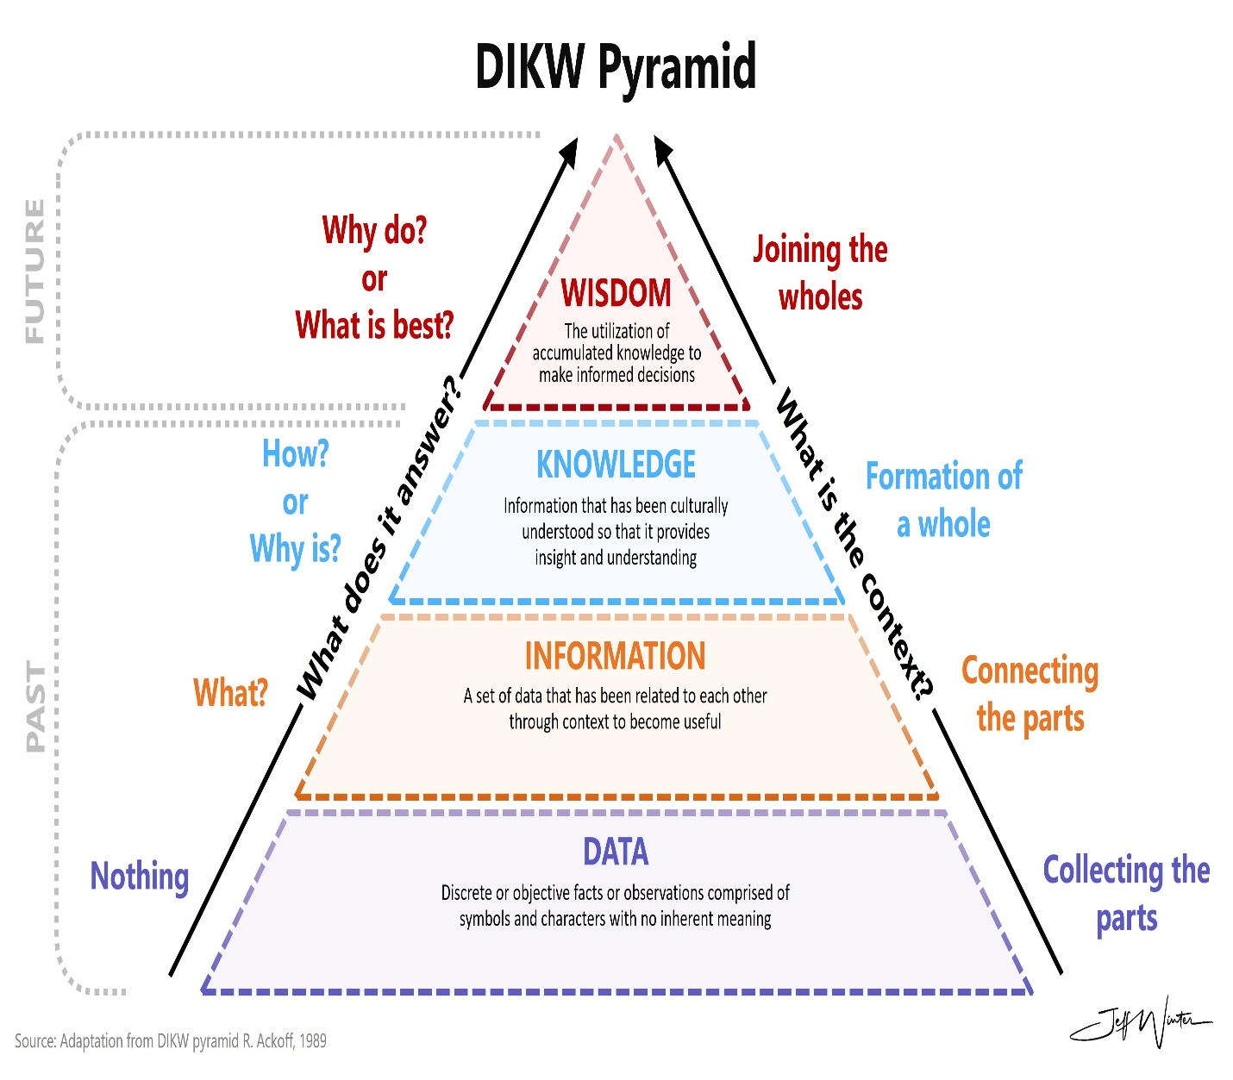
‌

2.2.3 The SECI Model and Knowledge Transfer-page 12
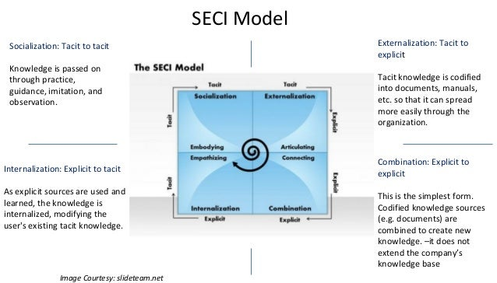

3.1.5 Improved Efficiency-page 20

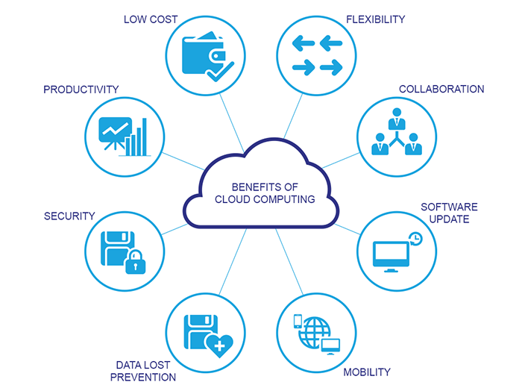
‌

‌

3.1.6 Information Security and Compliance -page 21



