LCBB 4001
Accounting Fundamentals

Student Name: Daniela Nadia Stochita
ID: 2113969
Table of Contents
Introduction 3
Question 1 4
Adjusted trial balance of General Suppliers Ltd. 4
Income statement of General Suppliers Ltd. 6
Balance sheet of General Suppliers Ltd. 8
Question 2 10
Consistency Principle 10
Monetary Unit Principle 11
Materiality principle: 12
Going Concern Principle 13
Conclusion 15
References 16

Introduction
Accounting statements and principles are essential to organisations because they help the organisation keep track of its assets, liabilities, and equity. It allows the organisation to see where their money is going and decide if they need to change or update anything on their end. This report is represented in two parts. The first part has basically focused on the financial statements of General Suppliers Ltd. Those statements include the adjusted trial balance, the income statement, and the statement of financial performance. On the adjusted trial balance, it will show account balances and the difference between debits and credits after all corrections following a trial balance. An income statement will show the profit or loss that a company has made over a period of time. A statement of financial position covers a single point in time and shows what a company owns, owes, and is owed at that particular moment. The second part will show the necessary principles that accounting uses for its daily operations. By following this report, one will have a clear understanding of accounting principles and statements.

Question 1

The adjusted trial balance of General Suppliers Ltd.
An adjusted trial balance represents an accounting document that companies use to prepare their financial statements (Warren, Jonick, and Schneider, 2020). It is prepared after the end of an accounting period and includes the last adjustments made before the financial statements are produced. The adjusted trial balance serves as a final check on accuracy, making sure that all debits equal credits and that it agrees with the income statement and balance sheet (Warren, Reeve, and Duchac, 2016).
General Supplies Ltd.
Adjusted Trial balance
For the year End of 2021
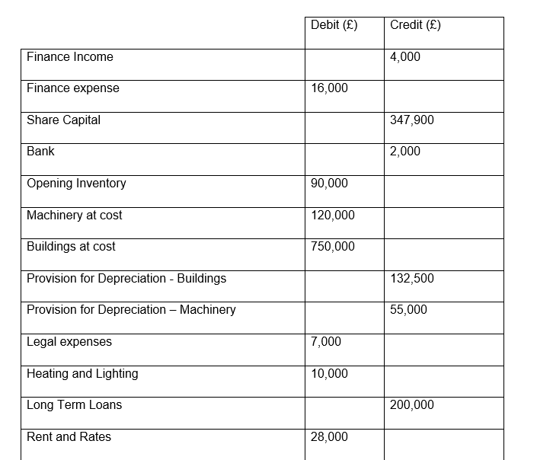
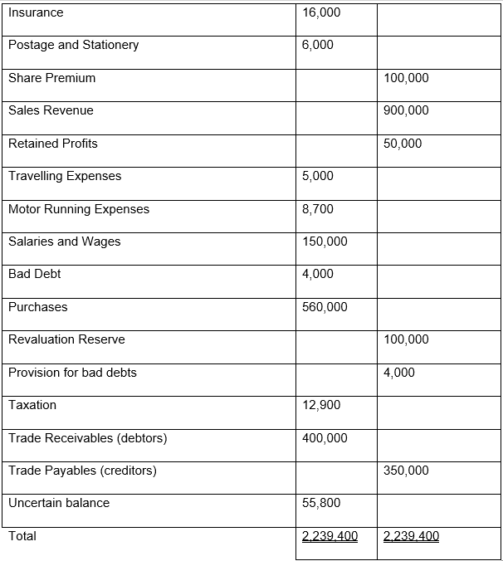

Income statement of General Suppliers Ltd.
An income statement, also called a statement of earnings, shows the revenue and expenses generated by a company during a specific period of time. It is used to determine whether a business made or lost money during that period. This information is generally used by investors and creditors to assess the current and future health of a business (Kieso, Weygandt, and Warfield, 2016).
General Supplies Ltd.
Income Statement
For the year End of 2021
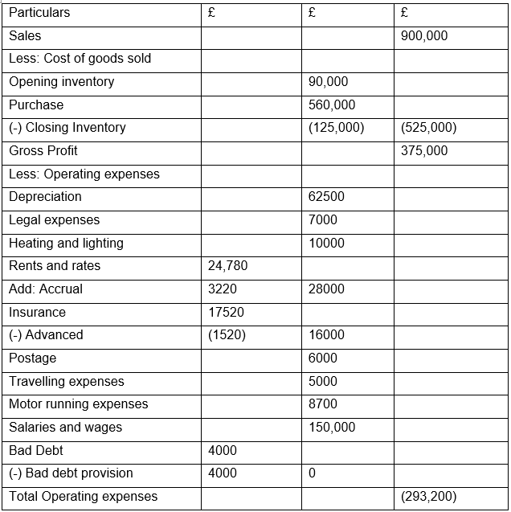
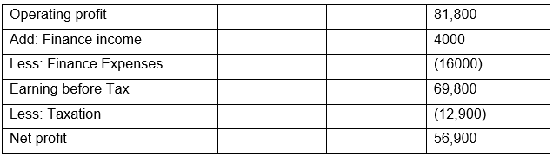

The balance sheet of General Suppliers Ltd.
A Statement of Financial Position, also known as a balance sheet, is one of the most critical accounting documents. It represents the current standing of a business—its assets, liabilities, and shareholders' equity. This information may be used to help determine whether a company is a good investment opportunity or whether it is financially sound enough to offer credit or extend loans (Bobryshev et al., 2014).
General Supplies Ltd.
Statement of Financial Position
For the year End of 2021
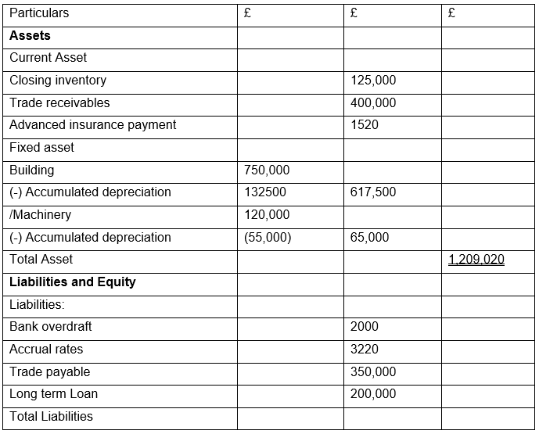
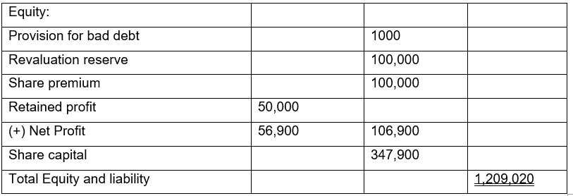

Question 2

Consistency Principle
The principle of consistency is used to express the close relationship of one year with the other years of a reckoning period (Weygandt et al., 2019). The accounting information of any organization should be maintained in the same manner during each accounting period. E.g., ABC ltd for determining depreciation of a property. If they use the linear method, then they have to use the linear method in every calculation. ABC LTD refers to the principle of consistency (Navid, 2022). An accountant will adopt a specific policy and perform an accounting operation by applying a specific accounting method. In this case, they will apply the same accounting policy or method in the future as well. That is, apply the same policy consistently every year. In no way can individual policies or procedures be applicable to the conduct of business activities in a single year. If ABC ltd. If a year seeks to change a policy or practice that is currently followed, the reasons and effects of such change must be clearly stated, and the changed policy or method must be applied in subsequent years. If the consistency policy is applied, the financial statements of one year are comparable to other years. One of the primary purposes of accounting is to present a comparative picture of financial accounts. If the same policy or method is applied in each year, then there is no similarity between the financial statements of different years so that no comparison can be made between the financial statements of each year. In this case, the principles of some of the significant roles of accounting are violated (Navid, 2022). This is why the principle of consistency is so important in accounting.
It also creates an opportunity to record all the information of a company in a specific structure. Auditors can also analyze the accounting data of different periods, and there are many benefits to analyzing them (Coetsee, 2010). This policy plays a significant role in staff control and management for Abc LTD. Applying the same policies and procedures every year does not require additional training of the staff, and the management department participates in a guessing process with all the policies from which a good idea about organizational skills is created for all. Thus the balance of the organization's accounts is maintained for efficient staff management and regulatory framework.
This policy also has some drawbacks for ABC LTD. Since a specific policy and procedure has to be implemented continuously every year, the company is more suitable and cannot implement any new policy. Despite having many appropriate and enforceable policies, a company is not able to implement those policies very quickly and often has to manage its accounting through outdated or outdated policies. In this case, ABC ltd. The company is often at a loss because the implementation of new policies may increase the efficiency of the company and improve the accounting activities. If ABC LTD companies go for a loan from a bank and their financial statement for their bank loan shows an excess profit, there may be a violation of this policy (Liebert, 2021). If ABC LTD suddenly adopts the method from the FIFO method to the LIFO method, then this figure will be directly violated.
Finally, ABC ltd. The reason why the principle of consistency is so important can be explained as the closing of oversetting on profit and net income. If the company constantly changes its policy, the managers will be able to manipulate the financial statements at any time and change the income tax, net profit, net loss. Therefore, it is imperative for a company to implement the policy while maintaining a sure consistency.

Monetary Unit Principle
The monetary unit principle, which is also one of the GAAP principles, is made upon the theory that any business organization should record or express only those transactions or events that can be converted into monetary units, i.e., according to this principle, those transactions or events that cannot be measured or converted into monetary units cannot be included or recorded as a business transaction in any financial statements of that particular company (Schaltegger and Burritt, 2017)). There are plenty and numerous types of events that occur within a particular business organisation and are considered to be essential if considered from the perspective of qualitative perspective, but if considered from quantifiable monetary value, those events or transactions should not be added or shown as a transaction in the financial statements of the company because those events, according to this principle cannot be converted into money directly (Weygandt, Kimmel and Kieso, 2018). Another critical assumption based on which these principle works is that over time the monetary value of that particular currency unit in which business transactions are recorded remains stable across a more extended period which is a very arbitrary and incorrect assumption if the inflation factor is considered (Gibson, 2012). The economic condition of almost all the countries keeps changing, and the level of inflation also keeps changing with this; hence the unit value of currency also keeps changing, especially in the countries with high inflation tendencies, the unit value of currency keeps decreasing. Thus, the assumption of stability of currency value is incorrect, which is a significant limitation of this principle and can act as an advantage for the companies that adopt this principle for recording or analyzing their financial statements over different financial periods (Weygandt, Kimmel and Kieso, 2018). ABC Ltd. follows the monetary unit principle to record its financial transactions, and hence while complying with this principle, the accountants of this company only record those transactions or events that can be measured in monetary values; along with this, the finance and accounting managers make use of these recorded transactions to analyze the business operations and supply that information to help the management make wise informed crucial business decisions (Schaltegger and Burritt, 2017). While following this principle, the company gets both positively and negatively impacted because of the inherent advantages and limitations of the principle. As the accounting manager only keeps a recording of those transactions and events that can be measured in monetary value, the management of ABC ltd. Can easily make a decision based on the analysis of those transactions that are influential and necessary, the management does not need to consider irrelevant events that are not financially impactful, which enables the company to financially become more valuable (Weygandt, Kimmel and Kieso, 2018). On the other hand, because of its limitation in the inflationary economy, the management of the company cannot make a decision based on the updated monetary value; thus, oftentimes comparing financial values across different financial periods become difficult, which acts as a significant drawback for the company, but the management of the company can minimize the effect of this limitation by paying more careful attention to the strategies based on which decisions are taken (Needles, Powers, and Crosson, 2013).

Materiality principle:
The key of the materiality principle is that the accountant will apply his or her knowledge, experience, and intelligence through relevant-irrelevant considerations in conducting his / her accounting work. According to the materiality principle in business, an accounting standard can be ignored if doing so has little or no material impact on the financial statements (Eilifsen and Messier, 2015). Any business activity or transaction that affects the financial statements significantly should be accounted for according to the GAAP exclusively. In case of any transactions or activities that happened in the business throughout the year that would influence or affect how the investors view the company must be included in the financial statements according to GAAP (Kumor and Mackowiak, 2018). Transaction or event that does not have any influence on the investors or creditors' view of the company are and affect how they perceive the financial statements in case of making decisions deemed to be immaterial and need to be included in the financial statements because non-material events hardly or does not have any effects on financial statements at all. The principle of materiality is essential in the preparation and presentation of financial statements as it helps the accountant to determine which information should be included in the financial statements and which should not (Edgley, 2014). There are four constraints by GAAP, and materiality is one of them. Financial statements should be easily readable and easy to understand by its users. Including unnecessary information defeats this purpose (Kumor and Mackowiak, 2018). That is where the materiality principle comes into play. They guide the accountant about which information and transition should be recorded and collected and which should not. What is to be included in the financial statements and not in case of preparation and presentation of efficient and easy-to-understand financial statements which can prove relevant and the correct information (Eilifsen and Messier, 2015). Determining materiality is often the subject of professional judgments. For example, The ABC company buys a waste bin for $30 a year, which is estimated to be used for five years. According to the matching principle, the ABC company needs to record their purchase of this waste bin as an asset then depreciate it over the useful life of 5 years, incurring a depreciation expense of $5 per year. Materiality allows ABC company to expense this $30 immediately instead of reporting this depreciation expense over the years because no shareholders, creditors, or users of the financial statements of ABC company will be misled by this immediate expense of $30. Again, suppose ABC company is a billion-dollar company and has a net worth of 878 billion. It occurred an expense of $21 in addition. This is not material to ABC company because a transaction of such a magnitude does not affect its financial statements or the decision of its users. So, it is not mandatory to include this transition. Nevertheless, if ABC were a $2500 company, this transaction again would be material for the company and be mandatory to be recorded.

Going Concern Principle
The Going Concern Principle is an accounting principle where a company assumes that it will stay in business for the foreseeable future (Jensen et al., 2015). This assumption allows the company to avoid having to calculate how much money they would need to liquidate their assets and pay off their debts at their current value, which follows GAAP (Generally Accepted Accounting Principles). The Going Concern Principle also allows companies to report expenses, assets, and liabilities on their financial statements without adjusting them to their current market values.
The Going Concern Principle is used to determine the book value of assets and liabilities to create a balance sheet (Collier, 2015). Company income statements provide information on current and past performance based on current market values, not liquidation values. These principles help them make accounting decisions more quickly and efficiently. It also helps them avoid having to revalue assets and liabilities, which can be costly both in terms of time spent and actual dollars spent hiring people or paying other companies to do the work (Drury, 2013).
A company's net worth is calculated by subtracting the value of all its liabilities from the value of all its assets. The Going Concern Principle assumes that a company will not be liquidated or go bankrupt, which means that all of its assets can be used to pay off any debts without being sold. In addition, under the Going Concern Principle, companies are allowed to record assets and liabilities based on their original cost instead of their market values. An example of the Going Concern Principle is when a company has a building worth $2 million that was purchased for $500,000 20 years ago. Rather than selling the building and recording it at its current market value of $2 million, it continues to be used by the company and is recorded in the balance sheet at $500,000 as per its original cost. The same can be said about equipment, automobiles, or other assets still in use by a company.

Conclusion
This report provides a brief understanding of accounting principles and statements. It is divided into two parts. The first part represented various accounting statements of General Suppliers Ltd. The trial balance shows that the debit and credit sides are matched. The income statement has shown that general suppliers have a net profit of 56,900 pounds. The balance sheet is also represented here, which shows the assets and liabilities of General Suppliers Ltd. Various accounting principles are necessary for accounting and its operation. The second part of this report is mainly focused on this. The efficient use of those accounting principles can make the accounting process more accessible and more effective.

References
Bobryshev, A.N., Uryadova, T.N., Lyubenkova, E.P., Yakovenko, V.S. and Alekseeva, O.A., 2014. Analytical and management approaches to modeling of the accounting balance sheet. Life Science Journal, 11(8), pp.502-506.
Coetsee, D., 2010. The role of accounting theory in the development of accounting principles. Meditari: Research Journal of the School of Accounting Sciences, 18(1), pp.1-16.
Collier, P.M., 2015. Accounting for managers: Interpreting accounting information for decision making. John Wiley & Sons.
Drury, C.M., 2013. Management and cost accounting. Springer.
Edgley, C., 2014. A genealogy of accounting materiality. Critical Perspectives on Accounting, 25(3), pp.255-271.
Eilifsen, A. and Messier Jr, W.F., 2015. Materiality guidance of the major public accounting firms. Auditing: A Journal of Practice & Theory, 34(2), pp.3-26.
Gibson, C.H., 2012. Financial reporting and analysis. Cengage Learning.
Jensen, T., Popowich, W., Hurley, S., Koumarelas, R.S. and Meacher, R., 2015. Fundamental accounting principles. W. Ross MacDonald School Resource Services Library.
Kieso, D.E., Weygandt, J.J. and Warfield, T.D., 2016. Intermediate accounting. John Wiley & Sons.
Kumor, I. and Mackowiak, E., 2018, June. Materiality in accounting and auditing. In Economic and Social Development (Book of Proceedings), 32nd International Scientific Conference on Economic and Social (p. 218).
Liebert, K., 2021. An Analysis of Accounting Principles Through Case Studies.
Navid, K., 2022. How Many Single Rulebooks? The EU's Patchwork Approach to Ensuring Regulatory Consistency in the Area of Investment Management. European Business Organization Law Review, pp.1-44.
Needles, B.E., Powers, M. and Crosson, S.V., 2013. Principles of accounting. Cengage Learning.
Schaltegger, S. and Burritt, R., 2017. Contemporary environmental accounting: issues, concepts and practice. Routledge.
Warren, C.S., Jonick, C. and Schneider, J., 2020. Financial accounting. Cengage Learning.
Warren, C.S., Reeve, J.M. and Duchac, J., 2016. Financial & managerial accounting. Cengage Learning.
Weygandt, J.J., Kieso, D.E., Kimmel, P.D., Trenholm, B., Warren, V. and Novak, L., 2019. Accounting Principles, Volume 2. John Wiley & Sons.
Weygandt, J.J., Kimmel, P.D. and Kieso, D.E., 2018. Financial Accounting with International Financial Reporting Standards. John Wiley & Sons.

