

Cover Page
STUDENT NAME: | MERCY NYARKOA QUIST ANANE
STUDENT NUMBER: | 2323101
PROGRAMME: | BSC HEALTH AND SOCIAL CARE
MODULE: | CHANGEMAKER: CREATIVITY AND VALUE CREATION
MODULE CODE: | BMHP5014
LECTURER: | TSIWANI KHUMALO
ASSIGNMENT TITLE: | COMPONENT 2: WRITTEN ASSIGNMENT (REPORT)
SUBMISSION DEADLINE: | 24th NOV 2025 14:00 (2 PM)

CAMPAIGN POSTER
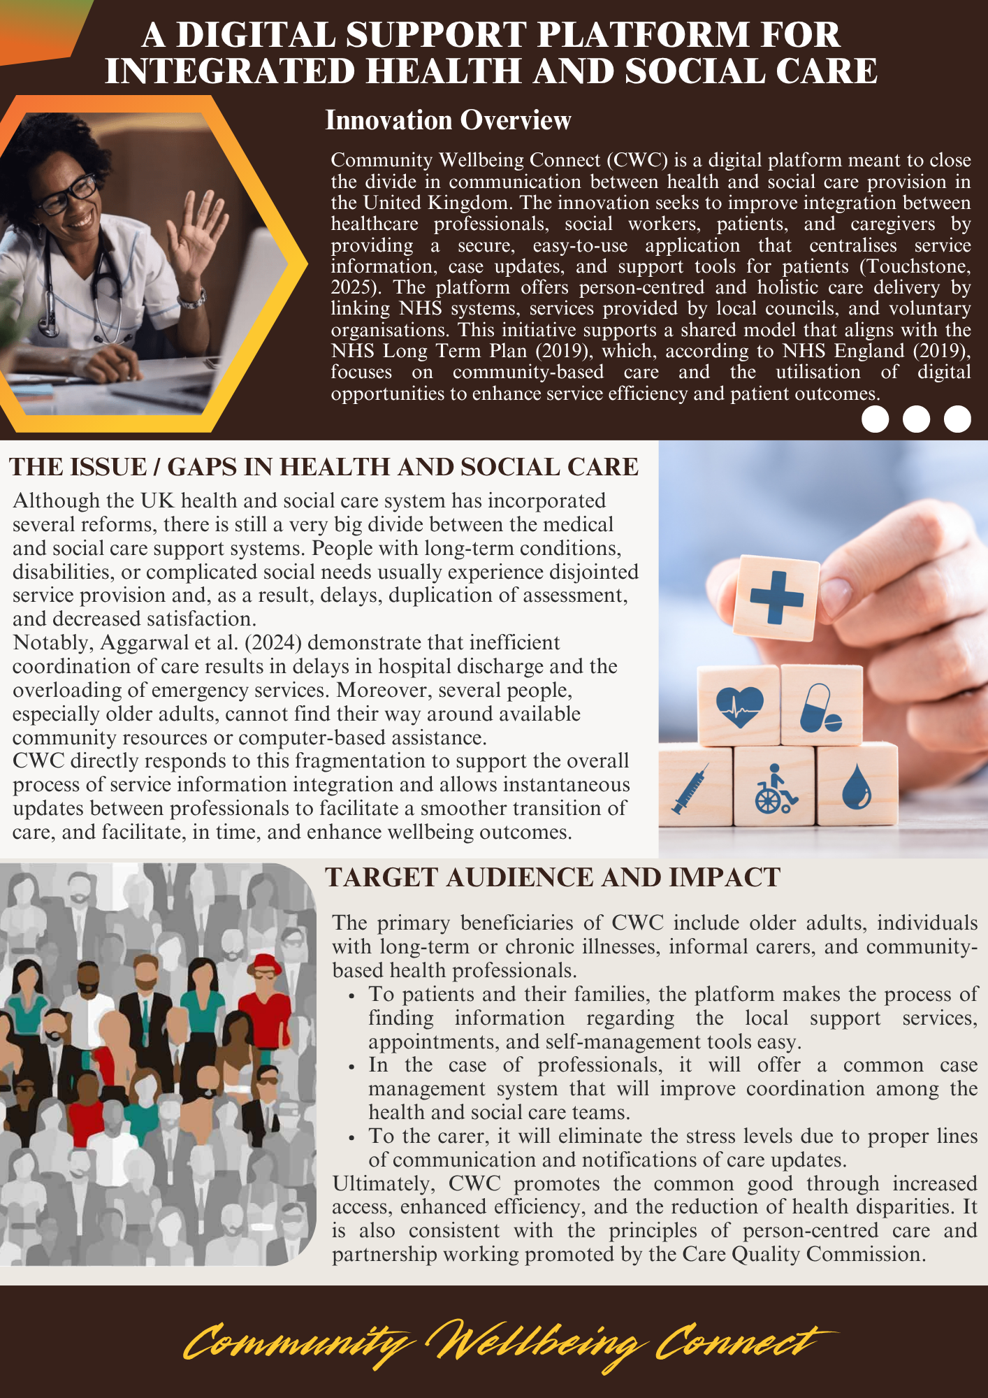
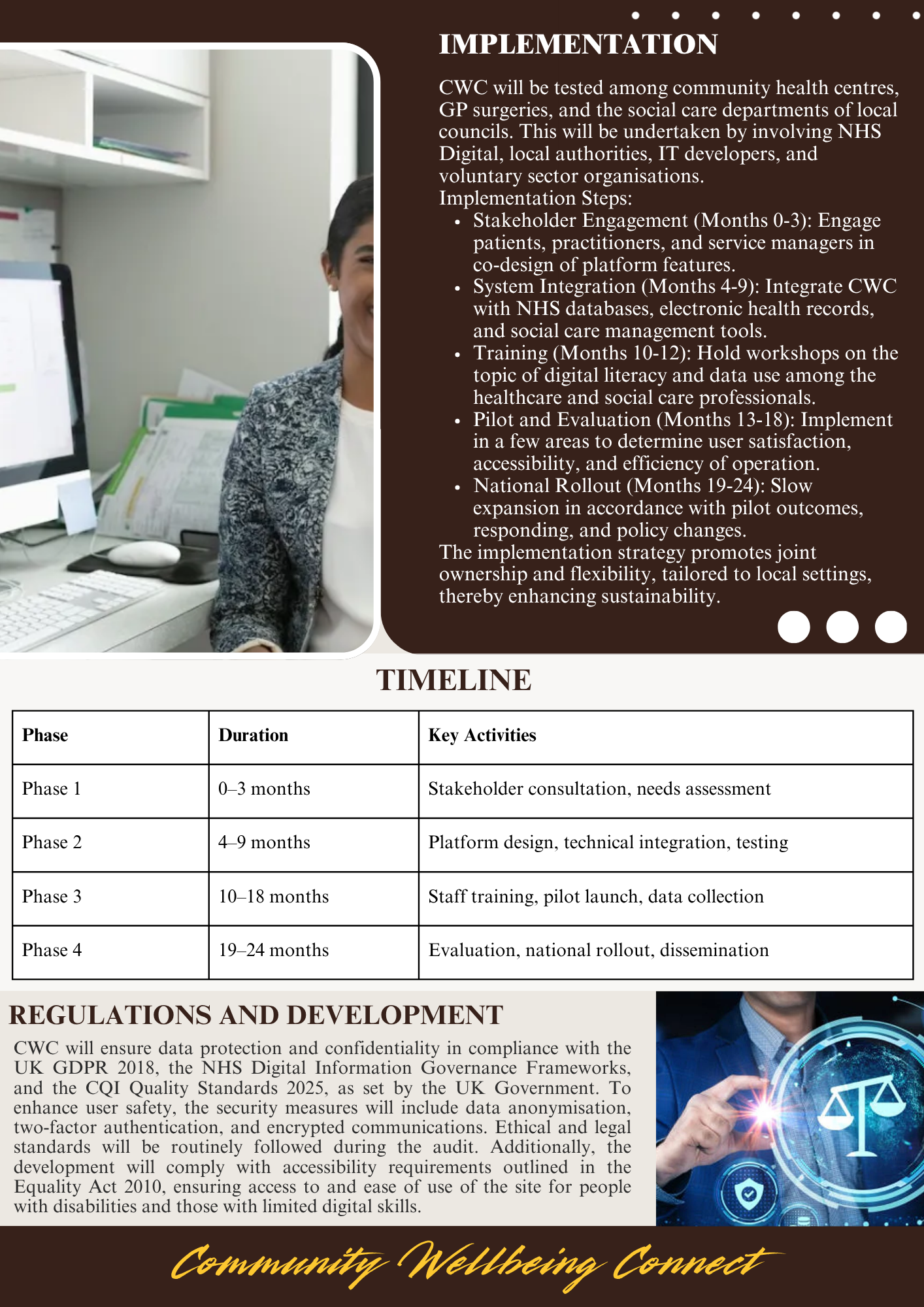
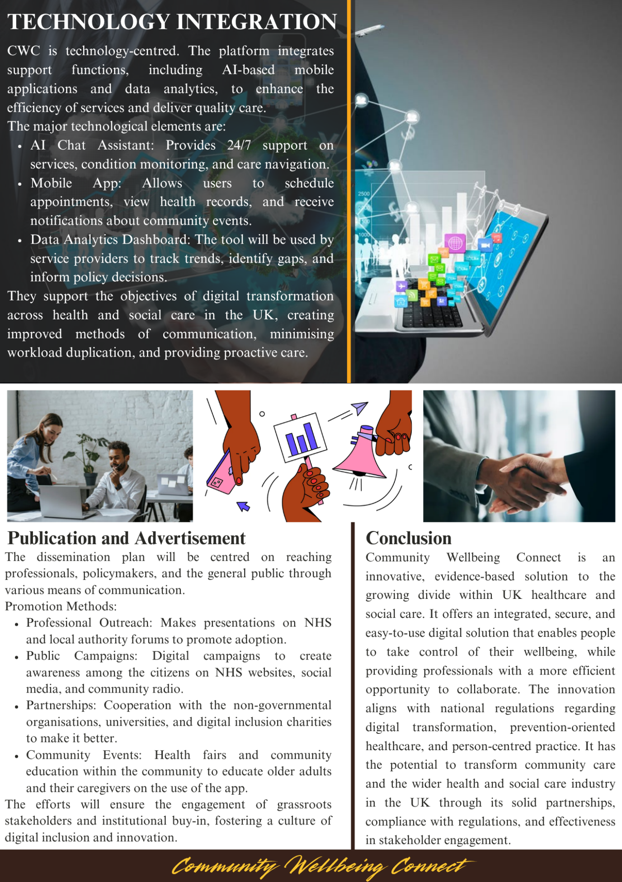

Pitch: Advocating for Community Wellbeing Connect — A Digital Innovation for Integrated Health and Social Care
Fragmentation between health and social care remains one of the intractable problems that affects service delivery, the continuum of care, and wellbeing in the UK. Other people with complex needs still experience delays, duplication, and a lack of communication from service providers, despite policy efforts to ensure the nurturing of integration. This fact, in particular, is an uphill struggle for the elderly population, those with chronic conditions, and their family caregivers, as they are forced to navigate several poorly aligned systems (Thomson, 2024). Community Wellbeing Connect will be a new, technology-enabled solution to bring together the health and social care stakeholders on one digital platform. The initiative supports the overall objectives of the NHS Long Term Plan, which encourages the use of digital-enabled care and the integration of services and care within a community.
CWC is conceptualised as a secure and practical digital space where healthcare providers, social care agencies, and voluntary organisations are bound together to share information and assist in coordinating support for people in need. It emerged from the realisation that the silo nature of the current setup is inconsistent with the complexity of care management. The interactive interface on the web and mobile platform enables professionals to update care plans, patients to access real-time information on services, and caregivers to be alerted or guided. The promise of efficiency and the ability to humanise digital health, giving people control of their care pathway while at the same time taking a lot of the administrative load off the professional community, is its value proposition.
Such innovation is eminently reflected in the need for it. As The King's Fund (2022) has noted, even with the implementation of ICSs to ensure better coordination, operational gaps persist due to inconsistencies in data sharing and organisational culture. Similarly, about 25 per cent of delays in hospital discharge are cited as resulting from inefficient coordination between health and social care (Rojas-García et al. 2017; Micallef et al. 2020). These delays result in increased costs, but more importantly, negatively affect the recovery and independence of patients. Through these weaknesses, CWC will ensure that coordination is smooth and open. The architecture allows the system to interface with other NHS databases and local authority management systems, while ensuring secure data transfer between agencies.
The innovation also brings the national strategies of the importance of digital transformation in the services of the country. According to the report Data Saves Lives, prepared by the Department of Health and Social Care (2022), better use of data may lead to higher savings of resources and time, as well as to better decision-making. The same vision is reflected directly in CWC, which utilises data analytics to find the bottlenecks of its services and anticipate high-demand regions to respond rather than react to the situation proactively. Due to that, the platform will be capable of generating appointment-related reminders automatically, identifying possible risks, and suggesting a proper community response program that would suit a specific user with the help of artificial intelligence. Such a combination of qualities is not merely a technical innovation, but also a tool to guarantee preventive and holistic care—a contemporary ideology of health and social care provision.
The implementation strategy for CWC is participative and sustainable. The development of this platform will begin with a pilot level within some of the local authorities and community health centres. This will enable the patients, professionals, and policymakers to give comments on the development process. There shall be a co-design approach to make sure that the system fulfils the realistic needs of the users. Initial implementation will be carried out in those regions where readmission into the hospital is high or the services are fragmented, as indicated by regional data at the NHS. Noticeably, the employees of both sectors will have learning opportunities to transform into more digitally savvy and assured individuals. This can be done through such an inclusive approach in order to make sure that the innovation does not undermine the existing structures of care.
CWC has a robust ethical and policy framework with a legislative foundation. Integrated care delivery and collaborative commissioning are rooted in the Health and Care Act of 2022. The Act bridges the communication gaps in facilitating the sharing of data across organisations by providing technological means of sharing data, like CWC (GOV.UK, 2022). Moreover, accountability and transparency are guaranteed by adherence to the CQC guidance and a governance system within NHS Digital. The design principles correlate with the ideas developed in the Equality Act of 2010, thus allowing the system to be used by all citizens (GOV.UK, 2010). The consideration of ethics, particularly based on the privacy and consent of data, is one of the simplest when developing. The data will have encryption, two-factor authentication, and anonymisation measures to avoid losing confidentiality while allowing the legal use of the information to enhance services.
CWC is expected to achieve not only an increased efficiency of the functionality, but also quantitative enhancements in the patient performance and the integrity of the systems. Duplication at the administrative level will decrease, and the professionals will have additional time to deal directly with patients. In the family and personal aspect, the platform will allow people to make their own decisions by providing them with information concerning the services, and then they can rely on the information to make well-informed decisions. There are signs that clinical health interventions that widespread technology can help reduce anxiety levels, enhance full adherence to the therapeutic programs, or lead to a sense of more profound control (Ahmed et al., 2025). For the policymakers, the analytics aspect of the platform will be valuable because they can plan and distribute resources according to the data regarding the service utilisation and population health patterns.
Performance indicators based on success measurement will be developed and will consist of fewer delayed transfers of care, higher user satisfaction scores, and an increase in community-based service activity. A feedback system will be integrated right into the platform, where users can report any issues or recommend improvements to the services provided to them at all times. This will be augmented with periodic reviews by independent reviewers and user surveys to see that CWC is still addressing the evolving needs and regulatory requirements.
The massive use of CWC necessitates networking and integration. This will involve a multi-layered communication policy that would focus on health and social care professionals, policy makers, and the general population. The presentation of the pilot results and demonstration of the best practice in the conferences in the NHS and local authorities would be in the professional circles. The masses would be sensitised on the internet, the local radio, and social media platforms. Such campaigns would be made about how digital inclusion will help people have their care controlled and reached through the assistance of CWC. It would find it quite useful with community engagement and establishing the trust that was present in cooperation with such advocacy groups as Age UK and Healthwatch England. The feeling of co-ownership is one of the key factors in the success of the initiative that will be promoted through the promotion of co-production and transparency.
In conclusion, Community Wellbeing Connect is a breakthrough to the current health and social care system in the UK. It integrates technology, policy congruency, and the human-centred design in order to develop a sustainable model of service delivery in the modern world. CWC is associated with the vision of the NHS of high-quality and person-centred care, which is directly enabled with the help of communication, user empowerment, and professional collaboration. Not only does the solution represent a technological one due to the market values that it represents- inclusivity, ethical government, and cooperation, but it is a force that brings about a cultural change in the industry. CWC is a formidable concept in the UK, in which the predicament of the ageing population and the lack of fulfilled needs in service delivery is yet to be addressed, and the dream of collaboration is yet to be realised in a breathing reality.
Reference List
Aggarwal, K., Singh, B., Banker, H., Stoltzfus, M.T., Hong, J., Anamika, F.N.U., Nishkamni, F.N.U., Munjal, J., and Jain, R. (2024). Exploring the Ramifications of Delayed Hospital Discharges: Impacts on Patients, Physicians, and Healthcare Systems. Cureus, [online] 16(5). doi:https://doi.org/10.7759/cureus.61249.
Ahmed, M.M., Okesanya, O.J., Olaleke, N.O., Adigun, O.A., Adebayo, U.O., Oso, T.A., Eshun, G., and Lucero-Prisno, D.E. (2025). Integrating Digital Health Innovations to Achieve Universal Health Coverage: Promoting Health Outcomes and Quality Through Global Public Health Equity. Healthcare, 13(9), p.1060. doi:https://doi.org/10.3390/healthcare13091060.
Charles, A. (2022). Integrated Care Systems Explained. [online] The King's Fund. Available at: https://www.kingsfund.org.uk/insight-and-analysis/long-reads/integrated-care-systems-explained (Accessed 5 Nov. 2025)
Department of Health and Social Care (2022). Data Saves Lives: Reshaping Health and Social Care with Data. [online] GOV.UK. Available at: https://www.gov.uk/government/publications/data-saves-lives-reshaping-health-and-social-care-with-data/data-saves-lives-reshaping-health-and-social-care-with-data (Accessed 6 Nov 2025)
GOV.UK (2010). Equality Act 2010. [online] Legislation.gov.uk. Available at: https://www.legislation.gov.uk/ukpga/2010/15/contents (Accessed 6 Nov. 2025)
GOV.UK (2022). Health and Care Act 2022. [online] Legislation.gov.uk. Available at: https://www.legislation.gov.uk/id/ukpga/2022/31 (Accessed 6 Nov. 2025)
Micallef, A., Buttigieg, S.C., Tomaselli, G., and Garg, L. (2020). Defining Delayed Discharges of Inpatients and Their Impact in Acute Hospital Care: A Scoping Review. International Journal of Health Policy and Management, [online] 11(2). doi:https://doi.org/10.34172/ijhpm.2020.94.
NHS England (2019). NHS England» NHS Long Term Plan to tackle major killer conditions and save up to half a million lives. [online] England.nhs.uk. Available at: https://www.england.nhs.uk/2019/01/long-term-plan (Accessed 6 Nov. 2025)
Rodrigues, S., Kanduri, A., Nyamathi, A., Dutt, N., Khargonekar, P., and Rahmani, A. (2021). Digital Health-Enabled Community-Centred Care: A Scalable Model to Empower Future Community Health Workers utilising Human-in-the-Loop Artificial Intelligence (Preprint). JMIR Formative Research, 6(4). doi:https://doi.org/10.2196/29535.
Rojas-García, A., Turner, S., Pizzo, E., Hudson, E., Thomas, J., and Raine, R. (2017). Impact and Experiences of Delayed discharge: a mixed-studies Systematic Review. Health Expectations: an International Journal of Public Participation in Health Care and Health Policy, [online] 21(1), pp.41–56. doi:https://doi.org/10.1111/hex.12619.
Thomson, L. (2024). Barriers and Enablers of Integrated Care in the UK: a Rapid Evidence Review of Review Articles and Grey Literature 2018–2022. Frontiers in Public Health, [online] 11(1). doi:https://doi.org/10.3389/fpubh.2023.1286479.
Touchstone (2025). Community Wellbeing Connectors - Touchstone. [online] Touchstone. Available at: https://touchstonesupport.org.uk/community-wellbeing-connectors (Accessed 7 Nov. 2025)
UK Government (2025). Data Protection Act. [online] Gov.uk. Available at: https://www.gov.uk/data-protection (Accessed 7 Nov. 2025)

