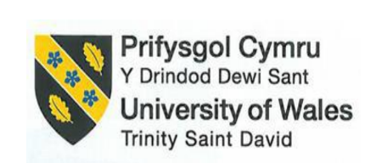

Student name: Mihaela Calin
Student ID number: 2226828
LEVEL 5 ASSESSMENT SPECIFICATION
Programme: BA International Hotel Management
Module: Management & Organisational Behaviour
Module code: BMIH5004
Assignment Title:Case Study Report based on Hyatt Hotels Corporation
Lecturer: Scott James

Acknowledgment Statment
I confirm that I have not used any AI tools in the research and creation of this assignment. I confirm that I have not presented any AI generated materials as my own work. I confirm I have copies of my draft, notes, and other resources I used, which I may be asked to provide in evidence.
Table of Contents
Introduction 4
Organisation Structure, Culture and Goals of Hyatt Hotels Corporation 4
Recent Change Initiatives 7
Strategic Direction of Hyatt Hotels Corporation 8
Conclusion 10
Recommendation 10
Reference 12

Executive Summary
Throughout the overall report structure it has been summarised based on the organisational structure and culture make strategic management function and organisational behaviour. The study has been discussed with a decentralised divisional organisational structure, Hyatt Hotels Corporation manages its many properties throughout the world under different brands, including Park Hyatt, Hyatt Regency, and Andaz. Each brand caters to distinct market segments. In this study, it has been mentioned the recent change initiative which plays a significant role in long-term business decisions. Being a global hospitality industry company needs to focus on digital transformation, sustainable business operation and inclusive work structure as well as maintaining sustainability. The recent change initiative can have a great impact on the business Hyatt’s leadership, combining Transformational as well as Situational Leadership, drives its global strategies in this conducive business environment. The company CEO Mark Hoplamazian promotes innovation and inclusivity, empowering employees to adapt to evolving market demands. Additionally, it is noticed that regional leadership of the company focus on managing local needs by ensuring both global as well as local responsiveness to expanding their business in this competitive business environment.

Introduction
Hyatt Hotels Corporation was founded in 1957 by Jay Pritzker and the headquarters of Hyatt Hotels Corporation is situated in Chicago. At present Hyatt Hotels Corporation is a leading global hospitality company and focuses on providing premium high-quality service to the guests. The mentioned company maintains multiple brand portfolios such as Hyatt Regency, Park Hyatt and Andaz and operates its business in almost 70 countries. The mentioned company has more than 130,000 employees all over the world. In the workplace of Hyatt Hotels Corporation all races, genders, cultures, and ethnicities are embraced and treated equally (Hyatt, 2024). The aim of the report is to explore Hyatt's organisational structure, culture, strategic direction and goals. Side by side the study will focus on the company's recent change initiatives and this report will describe the impact of these changes on its business operations and employee performances. The decentralised approach of the mentioned company will be covered in this report.

Organisation Structure, Culture and Goals of Hyatt Hotels Corporation
Organisational Structure
The creative activities of an organisation are directed by an organisational structure which provides an outline of the roles and responsibilities of the employees and other associates of that organisation can achieve its goals (Wood et al., 2024). It is determined by organisational structure and how information flows between different levels within the organisation. A specific hierarchy is defined by organisational structure. There are several types of organisational structures such as hierarchical organisational structure, functional organisational structure, horizontal organisational structure, divisional organisational structure, team-based organisational structure, matrix org structure, processed-based structure, network organisational structure and many more. Hyatt Hotels Corporation operates its business function under a decentralised divisional structure which controls its numerous global properties into various brands such as Park Hyatt, Hyatt Regency and Andaz. Each brand serves different market segments. The strategic guidelines are set in the headquarters. At this, the regional leaders of the mentioned hotel company are empowered and the individual hotel managers of the Hyatt Hotel corporation become adaptable and flexible to understand the local market needs. The senior management level of the mentioned hotel company's organisational structure provides insight and strategic vision to ensure strategic alignment with the mentioned company's business objectives (Rocketreach , 2024). The decentralised organisational structure of Hyatt Hotels corporation helps the mentioned organisation to flow its reporting lines and necessary directions from the corporate headquarters to its regional offices. A decentralised organisational structure brings innovation to the workplace of the mentioned company.
In this connection, a theoretical framework such as Mintberg's Organisational Structure is aligned with Hyatt Hotels Corporation which utilises functional structure at the corporate level. This functional structure indicates a Machine Bureaucracy. Semi-autonomous units of Hyatt are controlled under Hyatt's corporate-level strategic leadership which drives innovation and growth (Organimi , 2024).
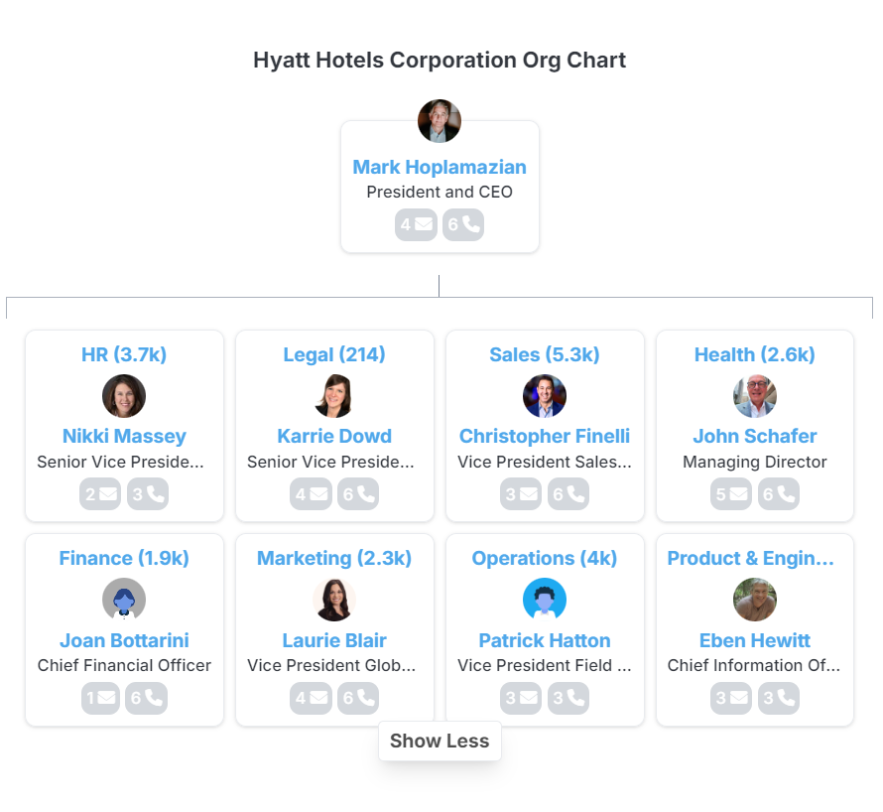
Figure: Organisational Structure of Hyatt Hotels Corporation
(Source: Rocketreach , 2024)

Corporate culture
The corporate culture of Hyatt Hotels Corporation is centred on inclusivity, integrity and care and these crucial elements have created a supportive environment for both the mentioned company's guests and employees (Usgbc, 2024). In order to build a cohesive community, Hyatt’s organisational culture is dependent on respect, integrity, empathy and inclusion (Жулидов, 2022). These fundamental principles of the mentioned company are maintained by its effective leadership who guides the organisation’s daily operations (Dimitriou, 2022). The employees of Hyatt feel valued in the workplace. By promoting diversity and inclusion through effective resources, recruitment initiatives, and proper training and development programs, Hyatt removes biases and conflict from its workplace. In this perspective, Hyatt has launched unconscious bias training and maintains the Global Inclusion & Diversity Council. Hyatt is committed to aligning diversity, equity and inclusion into its corporate strategy and this commitment is reflected through its business practices. Hyatt's several training programs and mentorship opportunities foster talent development. By offering flexible working hours to its employees, Hyatt provides its employees work-life balance. Employees at Hyatt are encouraged to set personal development goals. Hyatt emphasises creating a people-first culture to drive a high level of employee engagement which boosts its operational efficacy and organisational success. Hyatt's open culture motivates its employees to go beyond expectations and they serve their guests at their best. Hyatt's inclusive culture helps it to remain in this competitive landscape related to the luxury and hospitality industry.
Goals
Hyatt's corporate-level goals emphasise three main areas- guest satisfaction, employee retention and sustainability. These goals have been implemented in all Hyatt properties and side by side the mentioned company ensures individual hotel-level objectives such as maintaining service consistency, earning profitability and as well as engaging positively with local communities. Hyatt mainly focussed on maximising its guest satisfaction and promoting its brands. In this connection initiatives such as the world of Hyatt app drive its commitment to enhance the guest experience by digital engagement. Hyatt's social care team optimises its social care efforts. Hyatt has set ambitious sustainable goals by 2030 and the mentioned company aims to reduce population waste and to care about climate, water, diversity and responsible sourcing (Products, 2023). In this regard, Hyatt launched the World of Care program which prioritises responsible practices and diversity and fixed science-based decarbonisation targets(Hyatt, 2024).

Recent Change Initiatives
Identify recent change initiatives inside Hyatt Hotel Corporation.
Digital transformation: Digital transformation in order to enhance the strategy of communication with customers and optimise the work processes within Hyatt Hotels Corporation. Digital transformation makes an initiative strategy to improve business process management (Fischer et al., 2020). One of these transformation factors is the introduction of a new generation of mobile solutions, which would include applications that introduce innovations, such as mobile registrations and electronic keys, as well as service requests through smartphones. The company has also deployed artificial intelligence and big data in their operations to help the company understand customer needs, to optimise experience delivery by Hyatt (Orientsoftware, 2024). Not only have these digital improvements improved the experience value for customers, but they have also improved efficiency for Hyatt’s locations.
Sustainability initiatives: Another area of concern adopted by Hyatt is the aspect of sustainability. One of the prime change processes is sustainability initiatives which drive an innovative transformation to gain management function (Shrivastava et al.. 2020). The environmental strategy is another managerial area of interest because it has specific and measurable goals for decreasing water usage, waste, and carbon dioxide output. Measures such as the program of plastics-free, energy-saving, and environment-friendly food management have become a part of Hyatt’s annual plan implemented across hotel chains all over the globe. All of these sustainability policies are the result of consumers turning to green travel and these efforts have helped to further cement Hyatt’s position as an environmentally responsible company (Scoones et al., 2020).
Maintain well-being and inclusivity: Hyatt has embraced reorganisation with a focus on the well-being and diversity of its business. Coming up with the “World of Care” program brings out the DEI principles, as well as the health and wellness of Hyatt team members and guests (Hyatt, 2024). This is done alongside Hyatt’s ‘Hyatt Together’ campaign that provides exclusive well-being activities including mediations, workouts, and nutrition lessons. Measures such as the restructuring above fit well with the increasing trend in wellness tourism, as well as enhancing staff interest and customer loyalty.
Impact of Change Initiatives
The result of such approaches has been generally helpful. Adapting the change initiatives strategy helps to maintain organisational culture. Moreover, changing the organisational management maintains inclusivity to run long-term business support (Mullins and Dosser, 2013). Hyatt has found benefits from its digital enhancement strategy as it enhances its guests’ experiences, and increases satisfaction and brand recognition. Several sustainable measures have given a perception of the firm as environmentally conscious thus attracting responsible tourists. Also, the centre of well-being and inclusiveness have increased employee satisfaction and enriched a guest portfolio making Hyatt adapt to the contemporary tendencies and demands (Tolici, 2021).
Management of Change initiative
Hyatt has been able to address these changes well by incorporating them with the corporate strategic goals and objectives as well as ensuring good communication throughout all the levels in the company. ’Engaging’ the employees and other stakeholders ensured that resistance was kept to a minimum level and training was conducted to increase compatibility with new technologies and to enhance sustainability acts. Despite the following issues mainly difficulties in the organisation’s ability to embrace the use of technology especially to support the uptake of digital platforms and guarantee sustainability across its international operations.

Strategic Direction of Hyatt Hotels Corporation
Global expansion
The company continuously focuses on expediting its business into the global market in which the company focuses on increasing its presence in various emerging markets such as Asia as well as Latin America. The company also focuses in order to utilise the benefits of the partnership as well as acquisitions to enter into new markets in this dynamic business environment. Hyatt aims to introduce various luxuries and lifestyles within emerging markets by the end of 2025 (Hyatt, 2024). Additionally, the company is building a partnership with acquiring Apple Leisure Group in 2021. These help to increase the presence across the European market (Hyatt, 2024). Additionally, Hyatt's global expansion coincides with Ansoff's Growth Matrix, mainly the market development quadrant, as the company strives to reach new regions while exploring its current brand power to win market share (Mullins, 2023). The company also focuses on strategic alliances with local developers in order to reduce the risk related to market entry in this dynamic business environment (Annual Reports, 2024).
Digital Innovation
Hyatt has implemented various types of effective as well as advanced digital innovation in order to enhance guest experiences as well as streamline operational efficiency. The company builds its mobile apps for check-ins as well as smart room features. The company worked with Google to continue listening and identifying new ways to improve guest happiness (Thinkwithgoogle, 2024). These digital innovations resonate with operational efficiency theories, such as Lean Management, by minimising unnecessary steps in service delivery (Armstrong, 2021).
Sustainability
The company's sustainability initiative focuses on reducing the environmental impact as well as promoting eco-friendly practices. The company also committed in order to minimise carbon footprints by the end of 2030 focusing on reducing renewable energy uses and waste reduction (Businesswire, 2022). Hyatt's actions can be critically examined using the Triple Bottom Line (TBL) concept, which focuses on the balance of environmental stewardship, economic growth as well as social responsibility (Boddy, 2017).
Leadership and role in strategy
It is seen that Hyatt’s leadership plays a critical role in the operation of the business in which the company adopts a blend of Transformational as well as Situational Leadership styles, which is necessary for driving its strategic initiatives. Under CEO Mark Hoplamazian, transformational leadership fosters innovation as well as inclusivity, empowering employees to adapt to global market demands as well as digital transformation. Additionally, Situational leadership as proposed by Hersey as well as Blanchard is also employed in Hyatt’s regional management. This approach balances global coherence as well as local responsiveness, enhancing both operational efficiency and customer satisfaction (Simons and Lomax, 2021).
Effectiveness of leadership in strategic changes
The effectiveness of Hyatt’s leadership refers to managing strategic changes mainly in the context of adopting digitisation as well as sustainability. It has critically assessed through Kotter’s 8-Step Change Model Hyatt’s leadership successfully navigated the challenges posed by its digital transformation by developing a sense of urgency as well as guiding employees through the change process. Furthermore, the adaptability of Hyatt’s leaders mainly in responding to examining market needs has been instrumented in focusing on company success in this dynamic as well as competitive business environment (Salman and Broten, 2017).

Conclusion
In conclusion, the organisation culture, structure and goals of Hyatt Hotels Corporations reflect a decentralised approach by which local managers of the mentioned company are empowered to address the market demands and customer preferences quickly. The effective leaders of Hyatt Hotels Corporation maintain their strategic alignment with corporate objectives. The organisational culture of the mentioned company fosters integrity, inclusivity and care. This culture helps Hyatt to foster employee engagement through mentorship, diversity initiatives and work-life balance. Organisation Structure, Culture and Goals of Hyatt Hotels Corporation have been analysed with theoretical examples in this report. Recent changes such as digital transformation and sustainability efforts initiated in the Hyatt hotel have been identified and described how these changes have impacted on the organisation.

Recommendation
In order to enhance employee satisfaction, Hyatt should strengthen its leadership development programs. In an organisation, employees feel more valued and satisfied if they are offered more opportunities for growth and advancement. By applying Maslow's hierarchical needs, Hyatt can fulfil its employees' higher-level needs such as self-actualisation and esteemed values. Sidebide Herberg's two-factor theory is very effective for organisations to address hygienic factors such as work policies, job security and so on as well as motivate factors such as achievements and recognition. In this connection, Hyatt can apply this theory to reduce turnover and increase job satisfaction. To streamline its business process and to offer a personalised customer experience, Hyatt should leverage data analytic tools and advanced technologies. All these features enhance guest interactions and drive the business process smoothly. To promote sustainable efforts, Hyatt should use renewable energy across its global business.

Reference
Annualreports, (2024). Hyatt Hotels Corporation AnnualReports.com. Available at: https://www.annualreports.com/Company/hyatt-hotels-corporation (Accessed: 07 October 2024).
Armstrong, M. (2021). Armstrong's Handbook of Performance Management (7th Ed), London: Kogan Page.
Boddy, D. (2017). Management: An Introduction (7th Ed), Harlow: Pearson.
Businesswire, (2022). La Vuelta al Mundo del Cuidado: Hyatt Comparte Una Actualización del Progreso en los compromisos e Iniciativas ambientales, Sociales y de Gobernanza Business Wire. Available at: https://www.businesswire.com/news/home/20220713005971/es/ (Accessed: 07 October 2024).
Dimitriou, C.K., (2022). The critical role that national culture and ethical leadership play in fostering employee commitment to service quality in the hotel industry. Research in Hospitality Management, 12(3), pp.255-271.https://www.tandfonline.com/doi/abs/10.1080/22243534.2022.2133770
Fischer, M., Imgrund, F., Janiesch, C. and Winkelmann, A., (2020). Strategy archetypes for digital transformation: Defining meta objectives using business process management. Information & Management, 57(5), p.103262.https://www.sciencedirect.com/science/article/pii/S0378720618303197
Hyatt, (2024) 2030 environmental goals. Available at: https://about.hyatt.com/content/dam/hyatt/woc/2030EnvironmentGoals.pdf (Accessed: 07 October 2024).
Hyatt, (2024) Hotel reservations | book hotel rooms online - hyatt hotels and Resorts. Available at: https://www.hyatt.com/ (Accessed: 07 October 2024).
Hyatt, (2024). Hyatt grows luxury and lifestyle brand footprint across the Americas Region Hyatt Newsroom. Available at: https://newsroom.hyatt.com/news-releases?item=124526#:~:text=Strategic%20Growth%20in%202025,Hyatt%20hotel%20in%20Grand%20Cayman (Accessed: 07 October 2024).
Hyatt, (2024). Hyatt Hotels Corporation - Hyatt completes acquisition of Apple Leisure Group, creating Global Leader in leisure and luxury all-inclusive travel. Available at: https://investors.hyatt.com/news/investor-news/news-details/2021/Hyatt-Completes-Acquisition-of-Apple-Leisure-Group-Creating-Global-Leader-in-Leisure-and-Luxury-All-Inclusive-Travel-11-02-2021/default.aspx (Accessed: 07 October 2024).
Hyatt, (2024). World of care. Available at: https://www.hyatt.com/world-of-care/en-US/caring-for-people (Accessed: 07 October 2024).
Mullins, L and Dosser, P. (2013) Hospitality Management and Organisational Behaviour (5th Ed) Harlow, Pearson.
Mullins, L. (2023). Management and Organisational Behaviour (13th edition) Harlow: Pearson.
Organimi, (2024) Hyatt Hotels’ organizational structure [Interactive Chart] organimi Organimi. Available at: https://www.organimi.com/organizational-structures/hyatt-hotels/ (Accessed: 07 October 2024).
Orientsoftware, (2024). How big data in hospitality is reshaping the customer experience How Big Data in Hospitality is Reshaping the Customer Experience. Available at: https://www.orientsoftware.com//big-data-in-the-hospitality-industry/ (Accessed: 07 October 2024).
Products, T.H.T. (2023) Hyatt hotels and their goals for Sustainability, LinkedIn. Available at: https://www.linkedin.com/pulse/hyatt-hotels-goals-sustainability-transworld-services-perde/ (Accessed: 07 October 2024).
Rocketreach, (2024) Hyatt Hotels Corporation Management rocketreach.co. Available at: https://rocketreach.co/hyatt-hotels-corporation-management_b5c54562f42e0e03 (Accessed: 07 October 2024).
Salman, Y. and Broten, N., (2017). An analysis of John P. Kotter's leading change. Macat Library.
Scoones, I., Stirling, A., Abrol, D., Atela, J., Charli-Joseph, L., Eakin, H., Ely, A., Olsson, P., Pereira, L., Priya, R. and Van Zwanenberg, P., (2020). Transformations to sustainability: combining structural, systemic and enabling approaches. Current Opinion in Environmental Sustainability, 42, pp.65-75.https://www.sciencedirect.com/science/article/abs/pii/S1877343519300909
Shrivastava, P., Smith, M.S., O’Brien, K. and Zsolnai, L., (2020). Transforming sustainability science to generate positive social and environmental change globally. One Earth, 2(4), pp.329-340.https://www.cell.com/one-earth/fulltext/S2590-3322(20)30161-5
Simons, J. and Lomax, H., (2021). Leadership and vision. In Leading, managing, caring: understanding leadership and management in health and social care (pp. 61-88). Routledge.
Thinkwithgoogle, (2024). Hyatt brings its brand experience to life with Google Solutions Google. Available at: https://www.thinkwithgoogle.com/marketing-strategies/video/hyatt-brings-its-brand-experience-to-life-with-google-solutions-video/#:~:text=Listening%20to%20customers,or%20more%20of%20its%20affiliates (Accessed: 07 October 2024).
Tolici, D., (2021). Strategic management initiatives that promote organizational performance. Management dynamics in the knowledge economy, 9(2), pp.165-176.https://www.ceeol.com/search/article-detail?id=965968
Usgbc, (2024) Hyatt Hotels Corporation U.S. Green Building Council. Available at: https://www.usgbc.org/organizations/hyatt-hotels-corporation (Accessed: 07 October 2024).
Wood, J.M., Wiesner, R., Morrison, R.R., Factor, A. and McKeown, T., (2024). Organisational behaviour: Core concepts and applications. John Wiley & Sons.
Жулидов, С., (2022). The Hotel Business. Litres.

