Module Name: FOREIGN LANGUAGES AND CULTURAL AWARENESS

INTERCULTURAL COMPETENCE REPORT
Module Code: BMIH5003
Lecturer: Lisa Bassler
Student Name: Abdul Quiyum
Student ID: 2229328
Executive Summary
France and England have several differences in terms of culture and customs, which can impact the entire process of working in the hospitality industry. The leaders may face challenges in terms of understanding the cultural aspects of the team members due to the diversification in the workforce in the said industry.
Table of Contents
Introduction 4
Main Body 4
Cultural Overview 4
GLOBE Country Analysis 4
Leadership Study 7
Discussion on the challenges of intercultural leadership in the hospitality industry 8
Conclusion 9
Recommendations 9
References 10

Introduction
Intercultural competence refers to the ability to understand and respect each other in all types of cultural obstacles through knowledge and skills (Ineta, 2023). This report has selected France to compare it with the culture and customs of England. Furthermore, this report also compares the factors present in the countries as per the GLOBE framework. In this study, the author also discusses in terms of the challenges in leadership in the hospitality industry especially in the context of “Inclusivity Hotel & Spa” that are related to the intercultural aspects.

Main Body

Cultural Overview
There are multiple differences present between France and England in terms of customs and cultures. In terms of France, hospitality is presented warmly and familiarly. The greetings engage kissing on cheeks or handshakes and the meals are noticed as leisurely social programmes in which the guests get encouragement to savour each course and expand their stay (Nazarian et al. 2024). On the other hand, the hospitality of England is categorised through a more reserved way. However, their greetings are highly formal along with handshakes that have become the norm and less physical contact. In terms of communication, it remains indirect mostly in France and also heavily relies on the non-verbal factors and expressive language (Ishaq et al. 2023). Hence, the hospitality services are highly personalised in France which helps in developing longer-term relationships with the customers. On the other hand, the dining experiences in England remain well-structured along with punctuality and efficiency. Communication is very direct, clear and also holds dry humour. Hence, the service in hospitality is highly professional and courteous in England, which also focuses on the fulfilment of the requirements of the guests appropriately.

GLOBE Country Analysis
The GLOBE framework provides a comprehensive structure for conducting comparisons related to multiple dimensions, such as, "power distance", "Uncertainty Avoidance", "Individualism vs Collectivism", "Masculinity vs Femininity" and "Long-term Orientation" (Adamovic, 2023).
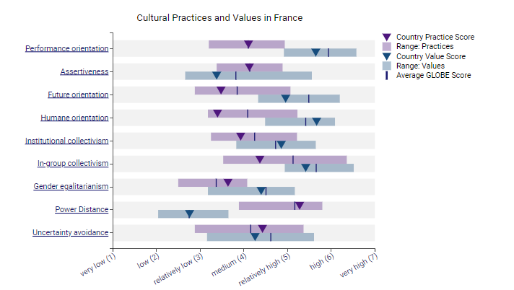
Figure 1: Culture Visualisation of France; Source: (GLOBE Project, 2004)
The “power distance” in France is moderate to high in the countries, where hierarchical structure is mostly accepted in the hospitality industry and the management is respected. The uncertainty avoidance in France is moderate to high in the countries and employees also have preferences for rules, structured atmosphere and regulations in workplace in the hospitality for the mitigation of uncertainty (McKearney et al. 2023). The culture of France is more towards collectivism and also emphasises the strong bonds with the family along with group cohesion. In France, loyalty for family and community is highly valued and also decisions remain collective. France mostly exhibits the characteristics related to Masculinity, including competitiveness, focus on material success and assertiveness. The gender roles remain traditional along with unique expectations for both females and males. The culture of France has a longer-term orientation that also values perseverance and respect for each tradition and the culture.
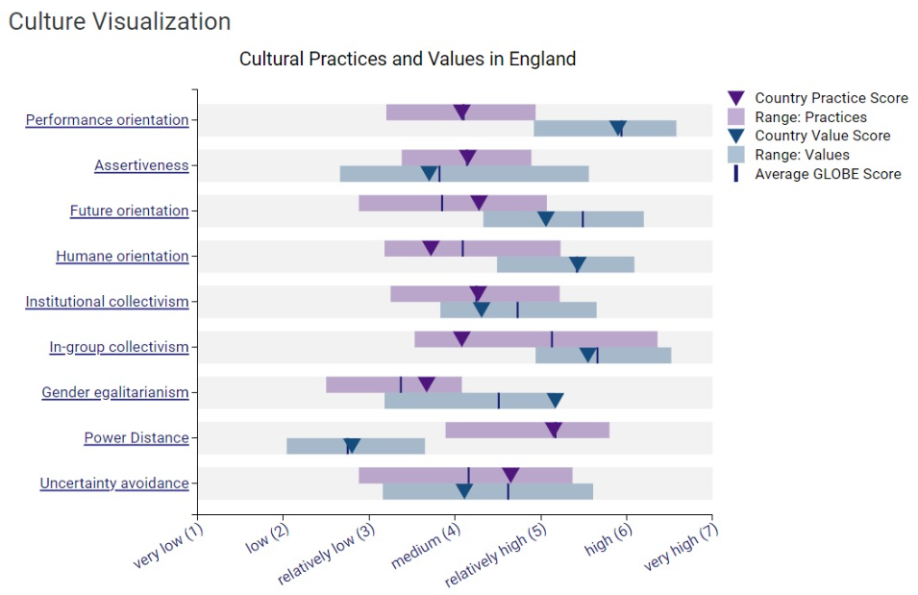
Figure 2: Culture Visualisation of England; Source: (GLOBE Project, 2004)
“Power distance” is lower in England in comparison to France and there is also a greater demand for equality and less acceptance in hospitality organisations. England normally has "lower uncertainty avoidance" in comparison to France. The tolerance for ambiguity is very high in England along with the willingness to embrace the changes in the work processes in terms of hospitality. On the other hand, England holds a highly individualistic nature in comparison to France. However, there is high emphasis in terms of autonomy, self-expression and individual attainments. England also holds masculinity more in a balanced manner in comparison to France. The country appreciates both the conventional masculine values and fosters the quality of caring related to femininity. England also holds a longer-term orientation with a high focus on sustainability, planning and investing in the hospitality industry.

Leadership Study
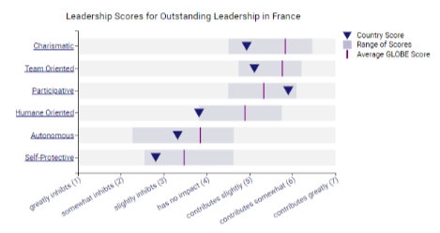
Figure 3: Leadership Visualisation of France; Source: (GLOBE Project, 2004)
The “charismatic/ value-based leadership” in France reflected the abilities of leaders related to inspiring, motivation, and expectation of higher performance results from team members as per the organisations that held core values, including visionary, “self-sacrifice”, “decisive” and “performance-orientation” (GLOBE Project, 2020). The “team orientation” includes “collaborative team orientation”, diplomatic, malevolent and integrator etc. Furthermore, the “humane-oriented leadership” reflected modesty and humane orientation in “France”.
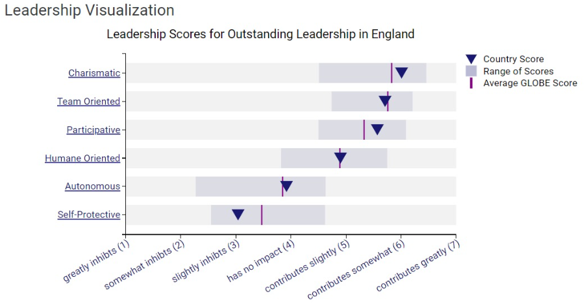
Figure 4: Leadership Visualisation of England; Source: (GLOBE Project, 2004)
The leadership visualisation of England showcases the “charismatic”, “team-oriented” and “participative” leadership style, which somewhat contributes to the country and is preferred among the leaders in the country. In this case, the leaders are highly realistic and have influential vision in England as showcased in the GLOBE Project’s visualisation. Hence, this means that individuals in the country mostly prefer the leaders who facilitate the “participative leadership” and also encouragement towards the “independent thought process”. Furthermore, the “self-protective” is slightly inhibit in England.

Discussion on the challenges of intercultural leadership in the hospitality industry
Challenges in "intercultural leadership" in the countries of France and England include differentiation of communication styles and non-verbal aspects, which often lead towards the creation of misunderstandings and conflicts between staff and guests in the hospitality industry (Raby et al. 2023). Furthermore, the hospitality industry often includes a diverse workforce along with people from multiple cultural backgrounds (Siyal et al. 2023). Hence, a lack of understanding regarding the cultural diversification among the team members often leads towards the creation of team conflicts.

Conclusion
It is concluded that the hospitality industry deals with people who are from multiple cultural backgrounds which often leads towards the creation of team conflicts. It has also been concluded that there are high differences present in the culture and customs of France and England that may impact the entire work process of the hospitality industry.

Recommendations
- It is recommended to the company that they should implement the "language training programmes", which will help to develop the skills and competencies of the staff in the countries. The "language training programmes" help to provide understanding in terms of personal and professional development (Banerjee et al. 2023).
- It is also recommended to the company that it should implement the personal and professional development workshops, which will help to improve the abilities of the staff in terms of mitigating the team conflicts.
- Furthermore, it is also recommended to the company that they should implement the remote working mechanism, which will help to include the local community and also understand the culture of the regions more efficiently.

References
Adamovic, M., 2023. Unlocking the Cultural Mosaic: A Comparison of Hofstede and Modern Cultural Value Frameworks. Cross-cultural Business and Management: Perspectives and Practices, p.181.
Banaruee, H., Farsani, D. and Khatin-Zadeh, O., 2023, April. Culture in English Language Teaching: A curricular evaluation of English textbooks for foreign language learners. In Frontiers in Education. 8. pp.1012786. Frontiers.
GLOBE Project (2004). GLOBE 2020-France. Available at: https://globeproject.com/study_2004_2007.html., [Accessed on: 19 February, 2024]
Ineta, L., 2023. Eliminating Intergenerational and Intercultural Communication Problems in Tourism and Hospitality Enterprises. Acta Universitatis Sapientiae, Philologica, 15(2), pp.14-32.
Ishaq, M.I., Sarwar, H., Franzoni, S. and Palermo, O., 2023. The nexus of human resource management, corporate social responsibility and sustainable performance in upscale hotels: a mixed-method study. International Journal of Emerging Markets. 1(1). pp.121.
McKearney, A., Prouska, R., Tungtakanpoung, M. and Opute, J., 2023. The influence of national culture on employee voice in small and medium enterprises: a cross-cultural perspective. Employee Relations: The International Journal, 45(2), pp.478-494.
Nazarian, A., Shabankareh, M., Ranjbaran, A., Sadeghilar, N. and Atkinson, P., 2024. Determinants of intention to revisit in Hospitality Industry: A cross-cultural study based on Globe Project. Journal of International Consumer Marketing, 36(1), pp.62-79.
Raby, R.L., Fischer, H. and Cruz, N.I., 2023. Community college international leaders' sensemaking: Entrepreneurial leadership skills and behaviour. Community College Review, 51(1), pp.52-74.
Siyal, S., Liu, J., Ma, L., Kumari, K., Saeed, M., Xin, C. and Hussain, S.N., 2023. Does inclusive leadership influence task performance of hospitality industry employees? Role of psychological empowerment and trust in leader. Heliyon, 9(5). pp.133-134.
The GLOBE (2004). GLOBE 2020-England. Available at: https://globeproject.com/results/countries/GBR%3Fmenu=list.html#list [Accessed on: 19 February, 2024]

