

LCMB – 7020 - Dissertation
School of Business
Title - The Effect of Interest Rate Changes on Net Interest Margin and Profitability: A Comparative Analysis of Barclays and HSBC

Student Name – Meet Mukeshbhai Patel
ID – 2241321
Module Tutor – Isaiah Oino



Master’s Degrees by Examination and Dissertation
Declaration Form.

I, Meet Mukeshbhai Patel, declare that this dissertation has been composed by myself, that the work contained herein is entirely my own except where explicitly stated otherwise in the text, and that this work has not been submitted for any other degree or qualification, in whole or in part, except as specified.

Signature: …………Meet Mukeshbhai Patel.......

Date: …………30th September 2024........................

Acknowledgements
First of all, I am grateful to my tutor, Isaiah Oino, for his helping hand, encouragement and professional assistance during the preparation of this dissertation.
His useful comments and moral support helped me to develop this research and inspired me to do more than I could. I also thank School of Business of University of Wales Trinity Saint David for creating the resource and culture for this research work.
I would like to express my deepest thanks to everyone who has assisted me in various ways and has tolerated me during the course of writing this thesis. Last but not the least, the participants of this study deserve special thanks for their valuable resources required to accomplish this work.

Abstract
The increasing and decreasing trends in interest rates are also of interest for this research examining the effects of organised change in interest rates on the NIM and profitability of Barclays and The HSBC 2013-2023. These institutions are large UK based banking institutions and as such provide an understanding of how different business models for managing interest rate risks. The study is more useful because the transition from persistent low-interest-rate regime to sharp rate hikes has just occurred recently.
The research adopts a quantitative method of analyzing financial data and qualitative method by administering a survey to a sample of 100 finance professionals. Multiple regression analysis in association with correlation analysis and trend analysis test hypothesis about interest rates, NIMs and profitability.
These analyses presented in this paper show that both Barclays and HSBC exhibit different degrees of sensitiveness to changes in interest rates. Barclays showed a much better positive relationship between interest rates and NIM which signifies the better management of interest rate risk. Comparing AIG and HSBC, the latter has smaller but more volatile profits, which suggest that differences in geographical presence affect its NIM interest rate sensitivity.
This study enriches the body of literature addressing interest rate sensitivities in the banking industry and argues against the generalization of the effects in the banking industry. However, they stress the importance of treating interest rate risk management question differently and will be of the interest to bank managers, policymakers, and researchers in banking and finance.

Keywords: Net Interest Margin, Bank Profitability, Interest Rate Risk, Financial Performance, UK Banking Sector, Comparative Analysis

Table of Contents
1 Introduction 11
1.1 Background & Context 11
1.2 Research Problem 12
1.3 Aim and Objectives 12
1.4 Research Questions 13
1.5 Significance and Contribution to Knowledge 13
1.6 Structure of the Dissertation 14
2 Literature Review 15
2.1 Introduction 15
2.2 Theoretical Framework 15
2.2.1 Financial Intermediation Theory 15
2.2.2 Term Structure of Interest Rates Theory (Cox et al., 2005) 16
2.2.3 Bank Profitability Models 17
2.2.4 Portfolio Theory 17
2.2.5 Interest Rate Risk Management Theory (Bessler & Kurmann, 2014) 18
2.3 Interest Rates and Banking 19
2.3.1 Historical trends in interest rates (2013-2023) 19
2.3.2 Impact of low interest rate environments on banking 20
2.3.3 Recent interest rate hikes and their implications 20
2.4 Net Interest Margins (NIM) 21
2.4.1 Definition and importance of NIM 21
2.4.2 Factors affecting NIM 22
2.4.3 Relationship between interest rates and NIM 23
2.5 Bank Profitability 24
2.5.1 Key determinants of bank profitability 25
2.5.2 Impact of interest rates on overall bank profitability 25
2.5.3 Other factors influencing profitability (e.g., regulatory environment, economic conditions) 25
2.6 Bank Strategies for Managing Interest Rate Changes 26
2.6.1 Asset and liability management strategies 26
2.6.2 Hedging techniques 26
2.6.3 Diversification of income sources 26
2.7 Post-Financial Crisis Banking Environment 27
2.7.1 Regulatory changes and their impact on bank strategies 27
2.7.2 Adaptation to low interest rate environments 27
2.7.3 Challenges and opportunities in the current economic climate 28
2.8 Research Gaps and Justification for the Study 28
2.8.1 Identification of gaps in existing literature 28
2.8.2 Relevance of the study in the context of recent interest rate changes 29
2.9 Conclusion 29
3 Research Methodology 30
3.1 Research Philosophy 30
3.2 Research Approach 31
3.3 Research Strategy 31
3.4 Research Choice 31
3.5 Time Horizon 32
3.6 Data Collection and Analysis 32
3.7 Sample Size and Sampling Method: 33
3.8 Data Analysis 33
3.9 Ethical Considerations 34
3.10 Limitations of the Study 34
3.11 Summary 35
4 Data Analysis 36
4.1 Descriptive statistics for key metrics for both HSBC and Barclays 36
4.2 Trend Analysis of Financial Performance 37
4.3 Correlation Analysis 39
4.4 Regression Analysis 41
4.5 Performance Volatility and Stability 44
4.6 Growth Metrics Comparison 45
5 Findings & Discussion 48
5.1 Key Findings 48
5.1.1 Comparison of HSBC and Barclays Performance Metrics 48
5.1.2 Trend Analysis of Financial Performance (2013-2023) 48
5.1.3 Correlation Between Interest Rates and Bank Performance 48
5.1.4 Regression Analysis Results 48
5.1.5 Volatility and Stability in Performance Indicators 49
5.1.6 Growth Metrics Comparison 49
5.2 Addressing Research Questions and Discussion of Findings 49
5.2.1 Comparative Analysis and Implications 51
5.3 Comparison with Existing Literature 53
5.3.1 Alignment with Previous Research Findings 53
5.3.2 New Insights and Contributions to the Field 53
5.3.3 Challenges to Existing Theories or Assumptions 53
5.4 Limitations of the Study 54
5.4.1 Data Limitations 54
5.4.2 Methodological Constraints 54
5.4.3 Generalizability of Findings 54
5.5 Future Research Directions 55
5.5.1 Areas for Further Investigation 55
5.5.2 Potential Methodological Improvements 55
5.5.3 Broader Implications for Banking Research 55
6 Conclusion 56
6.1 Recommendations 56
References 59
Appendix A – Ethics forms 63
Appendix B – Questionnaire 78
Appendix C – Participant consent Form 88
Appendix D – Participation Information Sheet 90

List of Figures
Figure 1: Financial Intermediation Diagram 11
Figure 2: Term Structure of Interest Rates Theory 12
Figure 3: Dealership Model of Bank Profitability 13
Figure 4: Banking Portfolio Theory 13
Figure 5: Interest Risk Management Theory 14
Figure 6: BOE Interest Rate from 2008 till 2023 15
Figure 7: German Bank Profitability from 1968 – 2016 17
Figure 8: Bank Profitability Determinants 20
Figure 9: Banking Strategies for managing interest rate changes 23
Figure 10: Research Onion Framework (Saunders et al., 1997) 26
Figure 11: Comparison of Performance Metrics: HSBC vs Barclays 33
Figure 12: Overall Performance Comparison: HSBC vs. Barclays 34
Figure 13: Performance Comparison of HSBC and Barclays (2013-2023) 35
Figure 14: Performance volatility and Stability 41
Figure 15: HSBC Vs Barclays Deposit Growth 42
Figure 16: HSBC Vs Barclays Loan Growth 43

List of Tables
Table 1: Regression Analysis for Actual data from Finance reports 36
Table 2: Regression Analysis for Survey data from Finance reports 37
Table 3: Regression Analysis of Barclays NIM and Interest Rates 38
Table 4: Regression Analysis of Barclays Profitability and Interest Rates 39
Table 5: Regression Analysis of HSBC NIM and Interest Rates 39
Table 6: Regression Analysis of HSBC Profitability and Interest Rates 40
Table 7: Correlation of Growth Metrics with Interest rates 43

List of Abbreviations
BOE - Bank of England
CET 1 - Common Equity Tier 1
EU - European Union
FCA - Financial Conduct Authority
GDP - Gross Domestic Product
GIM - Gross Interest Margin
HSBC - Hong Kong and Shanghai Banking Corporation
NII - Non-Interest Income
NIM - Net Interest Margin
OECD - Organisation for Economic Co-operation and Development
UK - United Kingdom
US - United States

Glossary
Asset-Liability Management (ALM): Risk management activities that stem from the occurrence of disparities in the assets and liabilities portfolios of a financial institution.
Basel III: A set of international standards an institution of the Bank for International Settlements in order to prevent crises in the global banking environment.
Common Equity Tier 1 (CET1): A type of regulatory capital most highly rated by the Basel Committee on Banking Supervision or mainly includes common stock and retained earnings.
Cost-to-Income Ratio: An operating efficiency measure calculated as operating expenses to operating revenue used in evaluating of the banking company efficiency.
Financial Intermediation: The procedure through which the savers including the investors who have surplus funds seek financial help from a financial intermediary like a bank in one capacity, but as borrowers in another.
Gross Interest Margin (GIM): Divide the income from interest on products of producing, servicing and trading activities by the total sum of interest bearing assets less non-earning assets minus the cost of funds on products of producing, servicing and trading activities divided by the average ofearning assets.
Hedging: An application of risk management that is designed to keep potential loses or gain in check that may be brought forward by a companion investment.
Interest Rate Risk: The likely investment risks that stem from fluctuations in the level of interest rates.
Liquidity Risk: It is the probability with which a bank cannot fulfill its short-term financial obligations arising from a failure to trade its assets at a price that is higher than the cost or an expected stream of income.
Net Interest Margin (NIM): The difference between the interest earned on the banking firms’ behalf by the amount of interest paid to the lenders, INTEREST MARGIN is the ratio of interest earning assets.
Non-Interest Income (NII): Income that is earned from charges, fines, and service charges and commissions as compared to interest from loans.
Return on Equity (ROE): A financial ratio that estimates financial performance with the help of dividing net income by shareholders’ equity.
Ring-fencing: The method of an organizational structure where some of the financial activities are completely split off from the others in order to safeguard the public.
Term Structure of Interest Rates: The change of price corresponding to a shift in interest rate or bond yield of different terms or maturities

Introduction

Background & Context
This paper seeks to establish the degree of variability that has occurred in the international banking system in the past few years with specific reference to the role played by the interest rates. Policy interest rates near zero and below remain standard among central banks since the outbreak of the financial crisis in 2008 (Borio & Gambacorta, 2017). The environment has also been challenging given that it happened at a time when interest rates were on the low end of the scale, followed by a little inflation and subsequently increase in rates the situation that was not easy for banks. Interest rates form the core of banking business as they have a direct relationship with Net Interest Margins (NIM), which represents the spread between the interest on assets and the cost of liabilities. In return, NIMs are a major source of bank profitability (Claessens et al., 2018). Hence, the impact of interest rates on bank performance is not clearly defined as higher rates could lead to higher NIMs’ but also alters the demand of loans as well as credit quality (Borio et al., 2017).
Large organizations such as Barclays and HSBC of the United Kingdom have encountered such problems while operating under Brexit conditions and/or changes in the laws governing the country’s financial industry. As these large and globally active institutions, such banks are perfect objects for researching how banks respond to changes in interest rates (Schnabel, 2021). It is imperative to comprehend the role of change in interest rate in the aspect of bank performance for the following reasons. First, it educates other branches of government especially the branch that deals with monetary policy since it shows how rate changes impact the stability of the financial markets. Secondly, it helps the bank management to devise sound Strategies for different forms of interest rates. Lastly, it assists investors/ regulators in evaluating performance and risks of banks (Altavilla et al., 2018).
This research thus seeks to advance this knowledge by conducting a relative analysis between Barclays and HSBC, two large UK grounded banks with dissimilar business strategies. Based on their behaviour towards changes in interest rates, one may get some understanding of profitable management strategies in periods of unstable economic environment and thus, add value to the ongoing conversation regarding the banking sector stability and performance.

Research Problem
The nature of this relationship is ambiguous, complex and highly dependent on the actual interest rate fluctuation when it comes to the banking sector, although its profitability is inherently related to interest rates (Bikker & Vervliet, 2018).
The area of study that this research seeks to solve is in two folds. Firstly, there is a general lack of an understanding of how changes in interest rates variously impact the NIMs and profitability of banks that possess and implement different business models while having a different risk tolerance level. Secondly, there is a lack of research focusing on the specifics of the strategies used by banks to overcome these changes and on the effectiveness of these strategies in terms of maintaining profitability in the context of the UK banking sector (Boubakri et al., 2017). This research problem is highly suitable, especially now that the economies of many countries are not doing well. The UK just like most economies, was in a regime of low interest rates only for them to soar in the recent past in a bid to fight inflation (Bank of England, 2023). This kind of environment is good for studying the dynamics of changes in strategies of organizations, and banks in the given case. Thus, to address these questions, the empirical analysis is based on two major UK-based international banks, Barclays and HSBC that possess different operating models. Barclays with a substantial investment banking business and HSBC heavily into commercial and retail banking indicate differences within the same set up environment (Wójcik & MacDonald-Korth, 2015).

Aim and Objectives
The aim of this research is to analyse and compare the effects of interest rate changes on the net interest margins and profitability of Barclays and HSBC.
Objectives
- To examine the relationship between interest rate changes and the net interest margins of Barclays and HSBC over the past decade (2013-2023).
- To assess the impact of interest rate fluctuations on the overall profitability of Barclays and HSBC during this period.

Research Questions
- How do changes in interest rates affect the net interest margins and overall profitability of Barclays and HSBC?
- What is the impact of interest rate fluctuations on the overall profitability of Barclays and HSBC?

Significance and Contribution to Knowledge
The significance of this study is given by the fact that it may improve a reader’s understanding about how major banks operate and adjust their behaviour to the occurrence of interest rate changes in a constantly developing global economy. As this research precisely examines the UK’s two large and competitively different banks, namely Barclays and HSBC, it provides significant information on the shifting interconnection between the interest rates, NIMs, and bank profit. The industry of banking has a central role in the level of economic stability and its rates of growth (Levine, 2005). Therefore, by ascertaining the dynamics of how banks manage the influence of interest rate, it will be useful for policymakers, regulators, investors as well as the bank management. His study is especially relevant currently considering the changes of monetary policy after years of low interest rates (Bank of England, 2023).
The research contributes to the existing body of knowledge in several keyways:
- Comparative Analysis: Prior works have analysed how changes to interest rates affect bank profits (e.g. , Borio et al., 2017; Claessens et al., 2018); however, few have compared large banks that are situated in a similar legal framework. This approach enables the detection of subtle differences in how various business models and strategies impact on a bank’s reaction to changes in interest rates.
- Post-Financial Crisis Insights: This analysis thus helps to capture information from the post-global financial crisis period, the period of ultra-low interest rates and into the recent period of rate hikes which is the period from 2013 to 2023. This approach can give a broad picture about how the banks operate in different interest rate scenarios which has been discussed by Bikker & Vervliet (2018).
- Strategy Evaluation: It also does not restrict to comparing the financial performance of the organizations alone but analyse on the strategies used by Barclays and HSBC in dealing with the NIMs as well as profitability. This strategic focus enriches the literature on bank management and risks in shifting environments for organizations and the economy (Boubakri et al., 2017).
- Policy Implications: The implications of this study can therefore be useful in the formulation of monetary policy by establishing how various types of banks to the changes in interest rates. This might be especially useful for central banks in setting up their policies in keeping with financial stability (Brei et al., 2020).

Structure of the Dissertation
This dissertation comprises six chapters, each addressing specific aspects of the research:
Chapter 1: Introduction - Includes the research topic, problem, purpose, objectives and questions, scope of the study, the importance of the study and the theoretical framework.
Chapter 2: Literature Review - Reviews and analyses previously published work on interest rates, net interest margins, and profitability of Barclays and HSBC. Establishes the research questions to justify the study.
Chapter 3: Methodology - Explains methods of data collection and analysis as well as the proposed research approach. Explores what has motivated the selection of chosen methods as well as the shortcomings of the methods used.
Chapter 4 -Results & Analysis - Presents research findings, analysing how interest rate changes have affected Barclays and HSBC's net interest margins and profitability. Includes statistical analyses and comparative assessments.
Chapter 5: Discussion - Involves interpretation of the results relative to the research questions and prior studies. Has relevance to current banking practices, banking policy decisions, and to the theoretical field of banking. That is a comparative analysis of the initiatives made by Barclays and HSBC.
Chapter 6: Conclusion - Repeats the broad conclusions, restates the treatment of research questions and objectives, admits the study’s limitations, outlines further research directions, and presents recommendations to the stakeholders.

Literature Review

Introduction
This chapter provides a literature review of the previous works done by various scholars on the impact of interest rate fluctuations on NIMs and profitability in the context of Barclays and HSBC. This review highlights the theories to which this research owes allegiance after which the researcher looks at concepts such as the interest rates, numerical interest margins, and profitability of the banks. This is followed by a look at measures that have been put in place by banks to mitigate on the effects of changes in interest rates before lastly considering more research that this study seeks to fill.
The importance of the relation between interest rates, NIMs and profitability of the banks aids in comprehending the dynamics of current finance. Since the financial crisis that started in 2008, the banking sector has operated at the low-interest rate environment, and more recently, experienced heightened inflating rates (Bank of England, 2023). These shifts are extremely important to the extent that they have massive impacts on the performances/ solvency of the banking systems which in extension influence the whole economy.
This literature review will lay the groundwork for our research questions as it presents the main results of previous academic studies The link that this literature review will establish between interest rates and banking performance is mutual, weak, yet significant (Bikker & Vervliet, 2018). This chapter will set the stage for the remaining of this work, whereby, it will create a context through which the authors will explain our methodological approach and orient responding to results.

Theoretical Framework
The focus of this research is premised on several related theories through which various elements that relate to interest rates, bank profits, and strategic management are propagated. The key theories underpinning this research are:

Financial Intermediation Theory
According to Diamond’s (1984) model, banks played an efficient role of going in between the savers and borrowers and reduced the problem of adverse selection and costs of transacting. Even though, this theory offers the profound idea of the importance of the banks in the economy, many critics pointed at the fact that the modern banking system is more than what this theory depicts.
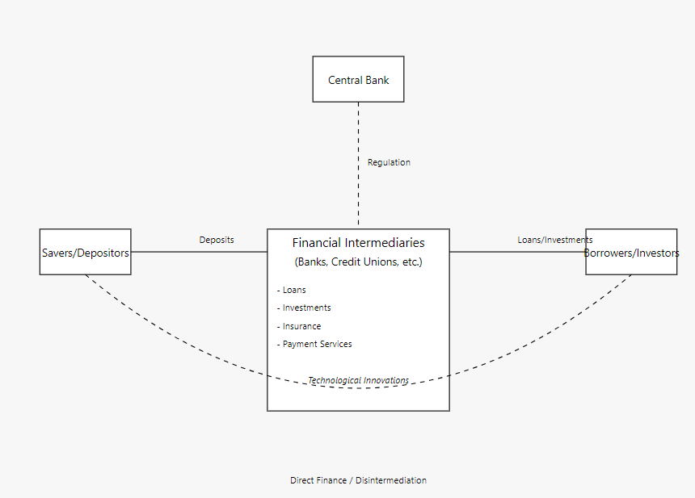
Figure 1: Financial Intermediation Diagram
(Source: Self-Made)
Bhattacharya & Thakor (1993) have claimed that the theory does not perfectly fit into multi products that commercial banks offer today. In addition, Allen & Santomero (2001) explain that technological factors have arisen as main sources of anxiety in the ongoing transformation of the structural characteristics of financial intermediation, which casts doubt over some of the major assumptions of Diamond.

Term Structure of Interest Rates Theory (Cox et al., 2005)
Cox et al., (2005) posited that the yield curve affects the performance of the bank through the investment and liability products portfolios. Despite its usefulness in elaborating the interest rate risk, this theory has some drawbacks.
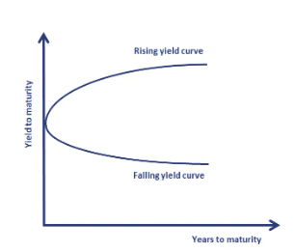
Figure 2: Term Structure of Interest Rates Theory
Source: (Cox et al., 2005)
Duffee (2002) has accused the model of profoundly weak empirical results, especially in forecasting. Additionally, other criticisms have been directed to the fact that the model over fixes on source of risk premiums and thus may give wrong indications on bank behaviour in various interest rate regime.

Bank Profitability Models
The various components that can explain the absolute level of the returns include interest rates and the characteristics of the industry as noted by Ho & Saunders (1981) using the dealership model of bank profitability. Despite this, they said model has not been without criticism.
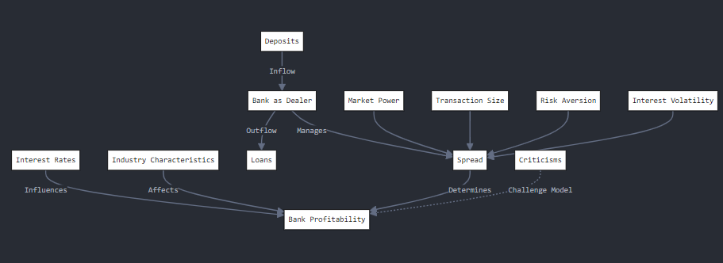
Figure 3: Dealership Model of Bank Profitability
Source: (Self-Made)
Maudos & Fernández de Guevara (2004) opine that the model has left out some important constituents in the determination of interest margins of the banking sector and omitted operating expenses. Also, while proposing this model, Valverde & Rodríguez (2007) pointed out that the efficiency of non-traditional banking activities’ effect on the bank profitability is not well explained by the model.

Portfolio Theory
Using portfolio theory on banking by Harry Markowitz, from Mangram (2013) sheds light to the way banks deal with assets and liabilities to get to the greatest degree of profitability. However, this study shows that this approach is restricted when applied to context of banking.
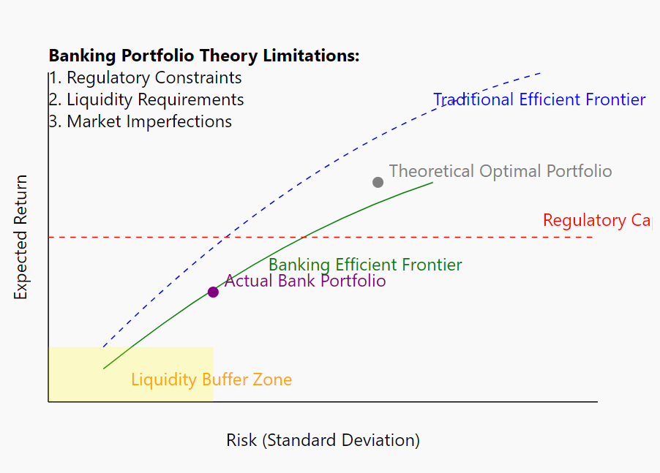
Figure 4: Banking Portfolio Theory
Source: (Mangram, 2013)
Freixas & Rochet (2008) pointed out that in the practical application of the traditional portfolio theory the problem of the banks’ specific risks such as the liquidity risk is not solved. Furthermore, Bessis (2011) also pointed out that, the stock of the theory of banking hinges upon perfect market conditions which in the banking industry could exist, although heavily regulated.

Interest Rate Risk Management Theory (Bessler & Kurmann, 2014)
The paper by Bessler & Kurmann (2014) on interest rate risk management outlines how banking institutions develop mechanisms that can be used to tackle interest risk. However, their practice is not without criticism.
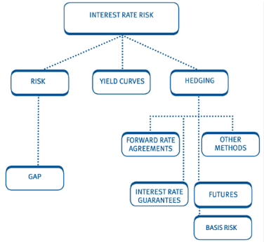
Figure 5: Interest Risk Management Theory
Source: Bessler & Kurmann (2014)
In their work, Alessandri & Nelson (2015) pointed out that interest rate risk cannot be completely explained by the interactions with financial risks, without regard to some others. In addition, Borio et al., (2017) noted that more prolonged low-interest-rate environment means that the effectiveness of interest rate risk measures often used in traditional banking may be likewise.
Thus, by invoking the key theories of banking to dissect the link between interest rates, NIMs and bank profits, it is possible to say that each of these theories has its own weaknesses.

Interest Rates and Banking

Historical trends in interest rates (2013-2023)
An analysis of interest rates within the periods 2013 to 2023 is marked with high-rate volatility. After the 2008 financial crisis, many central banks such as the Bank of England (BoE) have continued to hold interest rates below which they have been historically (Borio et al., 2017).
As per Figure 6, yields on 10 year bonds in UK between 2013 and 2023 were very unpredictable, largely because of major economic and political activities around the world. Since the financial crisis of 2008, the yields of bonds began to fall gradually and ranged between 3 and 1.5% the overall inflation rate from the year 2013 to 2016 due to the low interest rates policies by Bank of England in order to boost the economy. The Brexit referendum in 2016, and yields fell to below 1% in some cases or less or less – the period known as ultra-low that continued to earlier in this year. Yields dropped to record low levels in the year 2020 due to the COVID-19 pandemic that saw them go lower than 0.5%. But from 2021, yields started to soar and by 2022, reached and crossed over 4% and by 2023, it was nearing 5% which was alarming like the period during the 2008 financial crisis. Specifically, this significant inflation along with shifts in monetary policies demands its raise to the crisis level and is a dramatic change in the interesting rates in the United Kingdom (Bank of England, 2023).
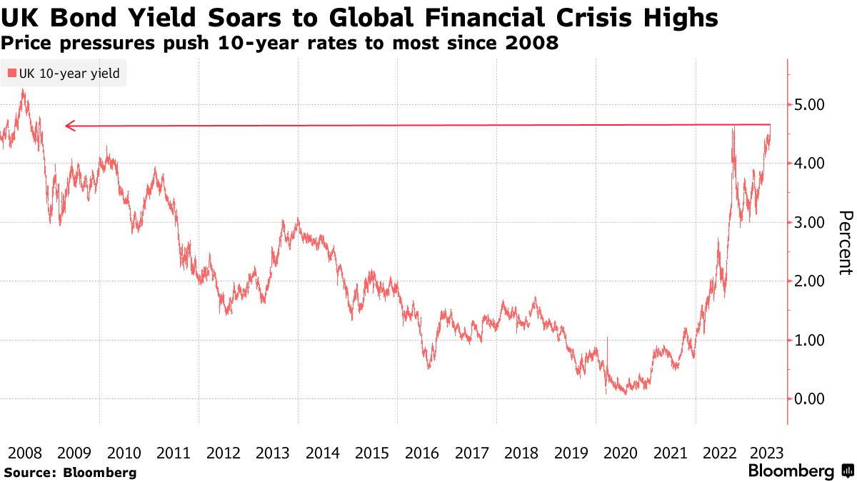
Figure 6: BOE Interest Rate from 2008 till 2023
Source: (Bloomberg, 2023)

Impact of low interest rate environments on banking
The low interest regime especially had major impact within the banking sphere as is discovered below. Borio et al., (2017) further noted that for every one percentage point decline in short-term interest rates the probability of a global economic bust dropped by 0.8 percentage point within a year. This diminution of the margins squeezed credit entities and required them to look for other sources of incomes and to change their strategies.
Heider et al., (2019) noted that negative or low interest rate caused credit risk-taking by the banks especially those with high deposit ratios. About high-yield securities, they discovered that, in their sample of Euro area banks, these institutions raised their exposure to such securities by 2.3% and credit risk on its balance sheet by 5.1%.
On the contrary, Altavilla et al., (2018) provide a different perspective about the impact of low interest rates on bank profitability, which was seen as having a small net influence. What they observed was that a rise in the volume and mix was partly negated by reduction in loan loss provisions as well as increase in non-interest income.

Recent interest rate hikes and their implications
This changed from the end of 2021 where central banks initiated the increase of rates amidst soaring inflation. Analysed moreover, the BoE has raised the base rate from 0. 1% in December 2021 to 5% by June 2023. (Bank of England, 2023). What this rapid tightening cycle means for banks is new questions and possibilities.
According to the study conducted by Ampudia & Van den Heuvel (2018), they posit that when the interest rate is raised surprisingly, then the stock prices of the banking industry experience a positive increase, with a 0.1 percent change in rates to be accompanied by 1% change in bank’s stock prices. But they note that this is a positive impact, though turns into negative when interest rates are high or when the yield curve is flat or inverted.
The effects of the two recent hikes are yet to be felt. As far as the increase of rates, it concerns credit quality and loan demands while higher rates can contribute to the growth of net interest margins. Gray (2011) note that greater speeding up may cause financial crises, especially in the countries with high ratio of private credit.
Besides, the effect can be varied across players, such as Barclays and HSBC, due to their strategies and regional venture. For example, HSBC has a large exposure to Asia which may help it to moderate some of the impacts of UK and US rate increases while, Barclays’ investment banking business may be helped by increased volatility (Wójcik & MacDonald-Korth, 2015).
Thus, there has been a significant fluctuation of interest rates from a near-zero rate and then moving to a steep rate increase from 2013 to 2023. The fluctuations that occurred at this stage were diverse and it would thus be important to undertake an institution-based analysis of the factors that contributed to the differences in the performance of the two banks under consideration in this study that are Barclays and HSBC.

Net Interest Margins (NIM)

Definition and importance of NIM
Net Interest Margin (NIM) is a measure of a bank’s profitability obtained by deducting interest expense from interest income and dividing the difference by the average earning assets according to Angbazo(1997). In the last couple of years, opinions regarding the importance of NIM as a parameter in analysing the banks’ profitability have emerged.
Albertazzi & Gambacorta (2009) have supported the notion that NIM is one of the best measures of bank profitability; it has observed that an improvement of 1% in NIM results increases in bank profitability by 0.7% in the net profits for banks that formed sample for the study made among industrialized countries.
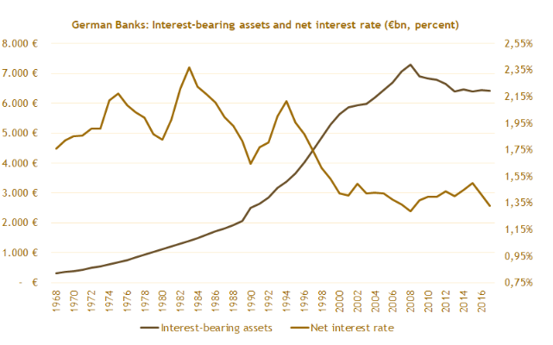
Figure 7: German Bank Profitability from 1968 – 2016
Source: (Deutsche Bundesbank, 2017)
For example Critical shifts in German banking profitability, 1968–2016 With these trends in, interest–bearing assets increased from 500 billion euros before five decades to 7,000 billion euros in the beginning of the first decade of 2016 indicating an increase in the size of the banking balance sheets. Researchers estimate that fertility rate in the mid 1980’s reached as high as thirty-five percent and reduced to about one percent by 35% by 2016. This inverse relationship, especially from the 1990s directly indicates a continuing pressure on the net interest margins (NIM). Relating it to Busch & Memmel (2017) observation, the decrease in the NIM is indicative of the relative decrease of the importance of traditional interest income in the profitability of banking business.

Factors affecting NIM
It is the source of the four estimates of capital adequacy, asset quality, management, earnings, and sensitive components hence NIM Is made up of capital adequacy, asset quality, management components, earnings components and sensitive components, though the weights of the estimates given to the components by scholars may vary.
Market Structure: Saunders & Schumacher (2000) in a study realized that the international variations of the bank interest margin in seven OECD nations were explained to a tune of 60% by market structure.
Operational Efficiency: Maudos & Fernández de Guevara (2004) pointed out that relative to the operating cost is an important determinant for NIM and where a one per cent increase in operating cost is likely to have a 0. The impact of the acquired elements was assessed by the facilitating or restraining the 2% increase of the NIM of the European banks.
Risk Factors: In the same way, while writing the transformation of efficiency, Angbazo (1997) had pointed on credit risk and interest rate risk referring to a fact that for every 1% change in Credit risk, there was equivalent 0.12%.
Regulatory Environment: In the view of Demirgüç-Kunt et al., (2004) asserts that as with the separates of entry and operation regulation of the banks tightens, the mean of NIMs also rises although the level of this variation varies in the countries under analysis.
Macroeconomic Conditions: As Claessens et al., (2018) explain, changes of the country’s GDP are of paramount significance since each 1 % of overall GDP booster corresponds to 0.08% increase in net interest margin, which is the difference between the rate of interest on the asset side of the balance sheet of the bank and the rate of interest on the liability side.
The relevance of these criteria may differ from country to country and from year to year, and therefore should be considered to a sufficient degree when comparing.

Relationship between interest rates and NIM
The action of interest rates and NIM is not always predictable and may not be benchmarked in a linear form, which effectively distorts basic assumptions of how rate escalation impairs banks’ performance.
Borio et al., (2017) observe that NIMs tend to be positively linked to the level of short-term rates; thus, a 1-percentage point rise in rates is linked to a 0.5 percentage points. But they simultaneously observe that such a relationship becomes weak or even reverse when rates are incredibly low, which makes the study of banks’ behaviour in low-rate world challenging.
Genay & Podjasek (2014), during the low interest rate period of 2010-2013 the measure was influenced only to a small extent declining by about 0.1 %point even when the federal funds rate had moved to near zero. They credit this to what they call banks’ high capability in re-pricing of liabilities compared to the repricing of assets.
Ampudia & Van den Heuvel (2018) reveal further sophistications to the algebraic developments in this paper, pointing out that the impact of movements in interest rates to the components of the NIMs, to a large extent, depend on the slope of the yield curve. They determine that an increase of the yield curve by about 1 percent is correlated with a 0.5 percent this suggesting that there has been an enhancement in the expected profitability.
Yet, Brei et al., (2020) warn that these relationships cannot be taken too far. They analysed 6,558 banks of 47 countries and discovered that NIMs of banks are heterogeneous in terms of the extent to which they are sensitive to changes in interest rates, which depends on such factors as, inter alia, the size of a bank, its funding sources and its business model.
These further stresses the significance of sometimes less clear, not necessarily straightforward, and potentially non-linear relationship of interest rates and NIM, requiring microlevel, institution-specific analysis. It becomes pertinent where you have multi-jurisdictional banks such as Barclays, HSBC where the industry conditions and business propositions are vastly different. Although these tendencies might be helpful to identify overarching patterns, relationships between banks’ NIMs and interest rate change and their specific behaviour can be better understood by paying attention to peculiarities of distinct banks and their activities.

Bank Profitability
Minimizing future risk with i) Risk as measured by process variability magnitude, ii) Profitability of a bank is a key measure of both overall business health and sustainability of financial institutions. It is dependent on various explicit internal and external factors, and this could shift depending on the business model, risk profile, geographical location of a bank. This section focuses on the identifying of principal drivers of banking performance, influence of interest rate and many other factors.
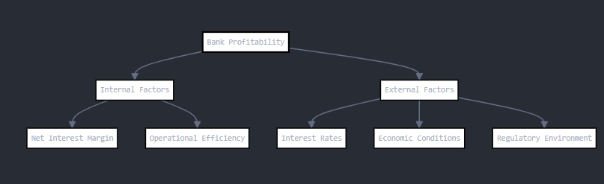
Figure 8: Bank Profitability Determinants
Source: (Self-Made)

Key determinants of bank profitability
Bank profitability is influenced by the factors like: Gross Interest Margin (GIM), Non-Interest Income (NII), Expense/Credit through Efficiency and Asset Quality. As identified by Angbazo (1997), NIM reflects on the difference between interest income and interest cost and adjusted for amounts of interest-earning assets. It plays an important role of presenting a clear picture of the salary that the bank earns from its most basic business of lending. Other income, which includes fee based, trading income and other related non-interest income, has become significant in the recent past, due to diversification of income sources. Operational efficiency is as defined by the cost income ratio which reveals the capacity of a bank to control expenditure in relation to income (Maudos & Fernández de Guevara, 2004).

Impact of interest rates on overall bank profitability
Interest rates and profitability of the banks are in an inversely proportional manner but this might be in line with some conditions of the micro and macro economy. On average, there is positive relationship between interest rates and profitability because high NIMs are attained due to rising interest rates. Those authors identified that 1 percentage point increase in the rates is related to a 0.5 percentage points. However, this relation is negative or turns negative in incredibly low interest rate regime, which poses challenges on strategies to be employed by the banks in such conditions. Thus, changes interest rates affect the business profitability with the revelation of the slope of the yield curve. Analysing the results obtained by other researchers, Ampudia & Van den Heuvel (2018) pointed out that a 1% increase in the yield curve has a direct relationship with 0.5%. These results imply the need for multi-interest rate approach while studying the bank performance.

Other factors influencing profitability (e.g., regulatory environment, economic conditions)
Several other variables which are seen to have a very bigger impact in determining the profitability of a bank other than the interest rates include the following. The legal setting especially after the financial crisis rules have affected profitability through legal capital and compliance expenses (Boubakri et al., 2017). The economic factors include gross domestic product GDP, inflation and the stability of the economy. According to Claessens et al., (2018) for every GDP growth by 1% in the economy, after accounting for the effect of test indicators, is followed by a 0.08% for NIM with reference to the connection between economic performance and bank profitability. Another factor that influences the banking profitability is the structure and level of competition that is present in the specific market; usually a higher concentration of players leads to greater margins (Saunders & Schumacher, 2000). Different geopolitical location and regional economic system are important determinants of the total profitability for global players like Barclays, HSBC etc. , which makes the challenges much more complex for them.

Bank Strategies for Managing Interest Rate Changes
There are several ways through which banks control for the interest rate risk and remain profitable in rising or declining rate regime.

Asset and liability management strategies
Asset liability management and entails the task of neutralizing the books of a bank while at the same time mitigating interest rate risk. One of the techniques Process-Based Survival Strategies is maturity matching in which banks ensure that the duration of assets and liabilities match to cover expenses that arise due to change in interest rates (Bessler & Kurmann, 2014). However, perfect matching is rarely possible; in fact, such an approach may even reduce the number of profitable profit-gather opportunities. Banks also employ what is referred to as variable rate pricing, whereby, the interest rates for loans as well as deposits fluctuates in accordance with the market rates. Alessandri & Nelson (2015) identified that policy rate by banks in UK increased by 50 basis points following a 100 basis points changes, which imply a degree of incomplete pass through.

Hedging techniques
This product often applies in the banking organizations in hedging activities. Interest rate swaps are widely used, through which the parties may agree on transforming fixed rates for floating rates or the opposite. Kurmann (2014) extended the interest rate derivatives usage analysis for the US commercial banks and found that the notional value rose from $65 trillion in year 2000 to $183 trillion in year 2012 highlighting the significance of these products. However, the usage of these tools may be problematic and increase new risks in case of the appropriate usage is not managed well enough, for example, the London Whale trading loss at JPMorgan Chase in 2012.

Diversification of income sources
There is tendency of diversification of income sources hence minimum reliance on interest incomes. Income other than interest income such as commissions and fees has become more relevant over the years. According to Busch & Memmel (2017) the trend of net interest income over the total income of the German banks was declining from 80% in 1968 to around 70% of total income in 2013. Some of the risks include fluctuating stock prices as well as the risks that come with an unfamiliar territory when undertaking diversification in different business segments.
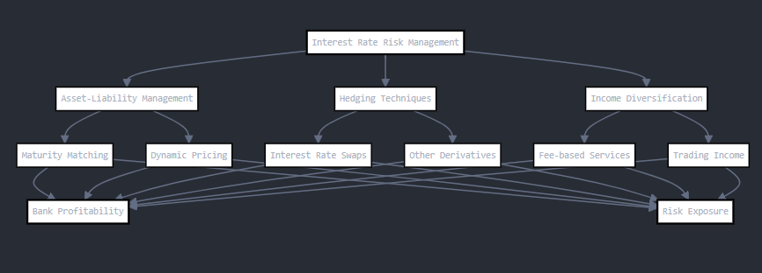
Figure 9: Banking Strategies for managing interest rate changes
Source: (Self-Made)

Post-Financial Crisis Banking Environment

Regulatory changes and their impact on bank strategies
The changes have happened in the light of the Global Financial Crisis of 2008 in which UK banking sector experienced a major turnaround. Basel III requirement has brought high values to the capital and liquidity requirements. The Bank of England (2023) noted that a collective CET 1 of the major UK banks have increased from 7. 06% in 2011 to 16. 5% by third of 2022. These severe capital hikes have affected the banking balance sheets with pessimistic consequences on the business profitability and risk bearing. New regulations such as the ring-fencing rules that require banks to separate retail banking business from other businesses such as investment banking that were introduced in 2019 have also distorted the competitive structure of UK banking system. According to Wójcik & MacDonald-Korth (2015), these changes have impacted universal banks such as Barclays and HSBC and these changes have resulted in operational changes and revision of business models.

Adaptation to low interest rate environments
Another factor of operational challenge remains in the fact that since the financial crisis UK banks have been forced to operate in an environment of low interest rates. The Base Rate of Bank of England was at or below 0.5% from March 2009 to August 2018, getting to our all-time low of 0.1 percent in March 2020 (Bank of England, 2023). It has squeezed banks’ net interest margins (NIMs) in this environment and thereby compelled banks to look for sources of revenue other than interest income. Busch & Memmel (2017) established that the long-term effect of short-term interest rates were that a one percent reduction in short-term interest rates caused a 0.4 percentage point. In response, UK banks have sought to diversify the revenues sources from the traditional interest income by expanding fee-based services and have also adopted cost containment strategies. Still, the revival of the interest rate trend in the current year, with the base rate set at 5% by June, 2023 poses a new challenge as well as opportunity to banking institutions in terms of how to effectively mitigate its interest rate risk and perform its repricing role.

Challenges and opportunities in the current economic climate
If the current economic conditions in the United Kingdom are taken into considerations, then one can clearly notice the opportunities as well as the threats that are present for the banking service providers. Brexit has brought volatility and futures challenges to the cross-border banking operations. The FCA (Financial Conduct Authority) in 2023 claimed that 7400 jobs relating to financial services shifted their location from the UK to the EU in the period 2016 to 2022, all because of Brexit. However, the nature of the London’s financial hub has been well preserved. The outbreak of COVID-19 saw an increased shift towards the adoption of digital services in banking through the use of online banking by people in the UK; in 2020, 73% of the adult population were using online banking whilst in 2022, the percentage stood at 76% (UK Finance, 2023).

Research Gaps and Justification for the Study

Identification of gaps in existing literature
Even though numerous studies have been conducted on bank profitability and interest rate risk, literature gaps still exist, especially when it comes to analysing the effects of increasing interest rate volatility. There are earlier works including, Borio et al., (2017) that has focused on the overall relationship between interest rate and bank profitability where it is noted that there is reduction in the value of profitability by 0.5 percentage point rise in NIMs would result in and the fact that little research has been conducted to determine how these changes affects banks with varying business models. In particular, the literature lacks comparison of the general and specific strategies and performance of the universal banks like Barclays Plc and HSBC operating in the similar legal areas but with the different emphases in their operation.
Additionally, literature reviews do not give due attention to the subtle changes that the post-2008 environment brought to the tables of banks. In comparison to Wójcik & MacDonald-Korth (2015), which pointed out the effects of ring-fencing rules for UK banks, there are few research analysing how these regulations modulate changes in interest rates and bank profitability and risk management plans .

Relevance of the study in the context of recent interest rate changes
The contribution of this study arises from the volatile circumstances experienced in the more recent past in relation to interest rates in the UK. The Base rate of the Bank of England was upgraded a little from the lowest level in history that was 0.1% in March 2020, 5% in June 2023 (Bank of England, 2023). The pace of this change is ideal in providing a live view of the adjustments that banks make to their plans. Analysing the bank behaviour during the low interest rate period, Genay & Podjasek (2014) identified that the rate was increased by only 0.1 percentage point reduction in the NIMs profits when federal funds’ rate come close to zero.

Conclusion
This literature review has therefore sought to establish how interest rates and NIM are linked to bank profitability in light of the current and future changes in the financial environment. The study reveals that interest rate is significantly posited with the profitability of the banks though this correlation is confusing or even negative in low interest rate environment. The above review also brings out the significance of using NIM as one of the measures of profitability which is impacted by factors such as the market structure, efficiency, and the macroeconomic factors. However, several gaps have been observed in the existing literature even with so much research done in this area. Yet there is a scarcity of research that compares the behaviour of banks in the same banking landscape and with distinct business models, as it is the case of the Barclays and the HSBC, as to how they alter their balance sheets in response to changes in interest rates. Moreover, there is still inadequate empirical literature on the effects of other recent changes, including the ring-fencing rules, on the vulnerability of bank earnings to changes in rates of interest and their risk mitigation measures. Secondly, the literature also fails to provide sufficient information about how banks manage themselves in the event of sharp changes in the interest rate, which is presently the case in the UK. These are the research questions this study seeks to fulfil to offer useful information in relation to bank behaviour as well as performance under uncertainty in relation to interest rates.

Research Methodology
This chapter describes the approach employed to examine the impact of interest rate fluctuations on the net interest margins and earnings of two UK’s most dominant banks, namely Barclays and HSBC. The research canvasses primarily a quantitative research design, buttressed by a secondary analysis of company annual reports. Saunders et al.’s (1997) research onion is useful as a framework of the whole research process from the chosen philosophy to data gathering and analysis tools.
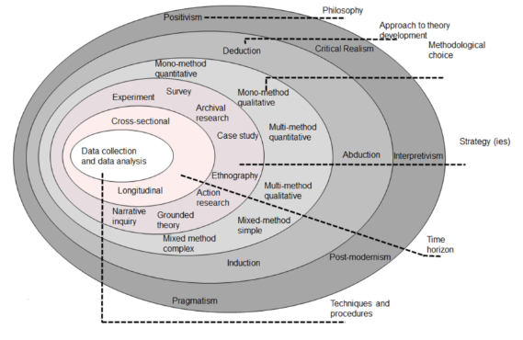
Figure 10: Research Onion Framework (Saunders et al., 1997)

Research Philosophy
This research is underpinned by a positivism paradigm, which is quite appropriate for quantitative research and the examination of quantitative data (Saunders et al., 1997). This school of thought believes that the reality of a given society can simply be measured. This approach is well suited for exploring the interdependencies between factually potential variables like interest rates, NIMs and profitability because they are not abstract, they can be measured and are definitely real.

Research Approach
The research design used in the study is deductive reasoning, which is compatible with positivism, quantitative method (Bell & Bryman, 2022). This is a theoretical approach which involves formulation of hypotheses from existing theories including the financial intermediation and the term structure of interest rates theory (Diamond, 1984), and then subjecting the formulated hypothesis to a data test.

Research Strategy
In this research work, the data is collected by adopting comparative case study method selecting Barclays and HSBC as the sampled firms in UK banking industry. This approach entails a close look at how these institutions adjust to such changes in concern to their net interest margins as well as profitability. The comparative aspect is important here as it allows identifying main opportunities and threats for both banks, as well as gives better overall picture of the banking industry environment. From the methodological point of view, case studies are most useful for finance research, since they enable exploring essential phenomena with reference to meaningful contexts (Yin, 2018). It is the case since focusing only on these two banks enables the study to explore their activities, risk management processes, and financial performance due to changes in interest rates in detail. It also allows discussion of how variations in business models and market roles could affect interest rate sensitivity in a bank and what insights might be useful for other firms and organizations.

Research Choice
In this study, only a quantitative research method is adopted to gather the data and analyse the findings in line with the positivism paradigm. It facilitates quantification of other aspects regarding the level of interest rates, net interest margins, level of profitability and the likes. The research utilizes two main data sources:
Primary Data: Web-based survey completed by 100 participating finance professionals with ordinal scale and multiple choice questions.
Secondary Data: Financial data: Primary data through the firms’ annual reports and accounts of Barclays and HSBC bank for the period 2013-2023.Sources of macroeconomic data: Bank of England, trading economy, and world bank.
Despite this, the research design is mostly quantitative; however, textual accounts of annual reports are also analysed to give more information beyond numbers. This approach will ensure proper Scientific testing and comparison of the two Banks.

Time Horizon
The study has a long-term perspective and focuses on the year 2013. It is important for several reasons that this view was developed over ten years. First of all, it makes it possible to reveal dynamics of how both Barclays and HSBC respond to changes in interest rates, which gives not only the snapshot view of their performance and decision making but also dynamics of this performance and decision making. Secondly, it covers substantial information on the changes in GDP and unemployment rate during and before the period of the financial crisis in 2008, the period of ultra-low interest rates, and the period after the rates’ increase. This variety of economic scenarios allows for better evaluation of bank behaviour under various interest rate regimes. In particular, Longitudinal research according to Menard (2002) is the best research to employ while researching on change and development. In the context of this study, it enables investigation of how the banks’ strategies and performance change with the change in interest rate structure. First, assessment of relative impact of interest rates over a longer period of time reduces the adverse influence of certain year fluctuations or cyclical pressures, which makes it possible to draw more accurate conclusions about the dependence of bank performance on interest rates.

Data Collection and Analysis
Primary Data Collection
The primary data is self-administered to collect 100 responses from finance workers and Barclays, HSBC and other UK bank employees. The survey uses a structured questionnaire designed to gather quantitative data on:
- Beliefs about influence of interest rates on bank performance
- Measures employed in the case of interest rate risk management
- Sight of shifts in net interest margins and profitability

Respondent Profile: Most of the questionnaire is in terms of Likert scale questions and multiple choice questions to allow for quantifiable answers. It will be administered online using Google forms to ensure that the reach is as many people as possible and also due to the current circumstances which does not allow group interactions in physical centres.
Secondary Data Collection: In addition to the primary data, Barclays and HSBC’s financial data will be gathered from both the company’s annual reports for the fiscal years 2013 to 2023. This will include:
- Net Interest Margins
- Profitability ratios
- Balance sheet information
- Risk management disclosures
Further information necessary to calculate interest rates and major macroeconomic indicators will be collected from the Bank of England and the Office for National Statistics.

Sample Size and Sampling Method:
The proposed research will involve 100 respondents from the various organizations they are employed, but preferentially targeting those industries that offer financial services and those employees who are responsible for the interest rate management or do financial analysis or have any other related duties. Such sample sizes are adopted with a view of getting a reasonable snapshot of opinions while keeping the exercise within manageable proposition in the study at hand. The sampling technique used in this study is purposive sample which is a non- probability sample. This method is chosen as it enable the researcher to identify participants with relevant knowledge and experience in the area of the study (Etikan et al., 2016).

Data Analysis
Data analysis will be done using Microsoft Excel with the help of Statistical functions in excel and Data Analysis Toolpak. Descriptive statistics will incorporate the assessment of variables as well as correlation analysis of variables and net interest margins profitability regression analysis will be utilized to model interest rates. The time series data collection approach will be used in order to capture trends over a ten-year period and will be supplemented with line diagrams, moving average and exponential smoothing. In this connection, pivot tables and charts will also be used in an effort to summarize and/or compare data. Functional charting features will develop graphics of the data. Finally, survey data will be linked with the financial data obtained from annual reports of the identified banks to present analysis of their performances and strategies.

Ethical Considerations
Research is to follow the ethical procedures required by the University of Wales Trinity St David’s – London Campus to maintain credibility of this research. The study mostly depends on annual reports and other public information but concerns of ethical nature are still inclusive and their controlling important especially for the questionnaire part. Every participant will receive an informative sheet that will contain all the necessary information that concerns the given study goals, methods, and consequences. Participants will be willingly asked to consent to participate in the study with a reminder of their freedom to withdraw at any time in the process. Participants’ identity will also be kept anonymous and confidential, and all collected information will be kept and used only for the purposes of the research. Minimization of data distortion will be achieved by correctly programming and filling the questionnaire while the accounting records and figures analysis will be done without bias. Ethical considerations include paying attention to reporting by undertaking to ensure that all sources of data and analysis methods and assumptions used are well stated. The researching has been endorsed by ethical committee of the UWTSD ethics committee and all procedures involved in the current study follow the University of Wales ethical regulation for research. Thus, adopting these principles, the research is devoted to providing accurate and credible results contributing to the development of the banking and finance field.

Limitations of the Study
There are some general limitations that can be mentioned for this research and that can potentially affect the findings’ external and construct validity. On the specifics of the research, there are two primary limitations which are the choice of the two banks – Barclays and HSBC – that might give a limited overview of the total UK banking sector despite covering them with great detail. The data is both primary and secondary, so the Secondary data analysis is more emphasized and while the data is reachable in opens sources and annual reports, it might provide more extensive insights that the profound primary data gathering. However, the study model assumes that interest rate is the main external factor while other factors that influence bank performance might not have been captured. In fact, due to the nature of this research, their focus is carved towards a ten year period, which may not fully capture all progressive changes that may have occurred in the banking industry. It may also be possible to underestimate or even overstate the qualitative findings due to the limitation in the number of people who responded to the questionnaire, especially since participants’ perceptions may not always reflect actual bank strategies. This implies that while analysing the operations of the bank, some of the latter’s functions may be explained to the exclusion of some minor details due to the complexity of the latter’s financial instruments. However, the last concern that may be raised is that the results might not be relevant in different future economic conditions due to continually evolving economic dynamics.

Summary
The general methodological approach used in this chapter to investigate the impact of interest rates on net interest margin and profitability of Barclays and HSBC is discussed in this chapter. According to Saunders et al., (1997) research onion model, this study adopts the positivist research philosophy, deductive research approach, and mixed-method research design in a cross-sectional research design, The quantitative method involves the analysis of secondary data of financial reports while the qualitative method involves an administration of questionnaires. The longitudinal time horizon is 2013-2023; it was possible to identify trends and regularities in the banks’ reactions to changes in interest rates. The data was collected by Questionnaire as the primary data collection tool & other sources include Annual Reports & Macroeconomic Indicators as Secondary data collection tool that ensures the collection of a large amount of data. The study uses a combination of arithmetic, and statistical methods such correlation and regression analysis, descriptive analysis and thematic identification from the questionnaire data. Potential ethical issues have been consideration and all the study has been conducted based on the ethic given by University of Wales Trinity St David London Campus. There are some limitations in the given work, for instance, the analysis is based on only two banks and there are certain difficulties with external factors; nonetheless, the strong methodological approach is going to reveal an important understanding of how two major UK banks operate in the context of the changes to interest rates. In doing so, this research adds to both the theoretical academic literature and the applied knowledge in banking banks and can be a theoretical and possible practical reference for future studies and adaptations to strategies and policies in the banking sector.

Data Analysis
This paper evaluates the performance of the UK’s HSBC and Barclays banks with respect to interest rates through surveying industry experts and financial reports for the 2013-2023 fiscal years. We explore four areas: in survey data, financial trends over the decade, stability/variability in key analytics, and growth analytics including deposit and loan growth. Such things as bars or lines chart, graph or a bar chart will put emphasis on trends and differences.

Descriptive statistics for key metrics for both HSBC and Barclays
The comparison of HSBC and Barclays based on data from 2013 to 2023 has highlighted several discrepancies between what people think of the industry and available facts. By making this comparison one can easily find out how these major UK banks have manoeuvred through the change in interest rates.
The bar chart in the figure 11 shows the average rating of the different performance indicators of the two firms, namely HSBC and Barclays. From the results obtained from the respondents’ feedback, it can be deduced that Barclays performs slightly better than HSBC in most of the aspects. Barclays’ NIM stability ranking is much better than that of the control group, gaining 4.29 vs 3.85, profitability 4.41 vs 4.18 and ROE competitiveness 4.34 vs 4.25. Barclays is a touch higher than HSBC when one compares cost-to-income ratio at 4. 32 to 4. 26 and the loan growth sustainability at 4.38 to 4.36. GDP growth perceptions are also almost similar (4.29 for HSBC while 4.34 for Barclays).

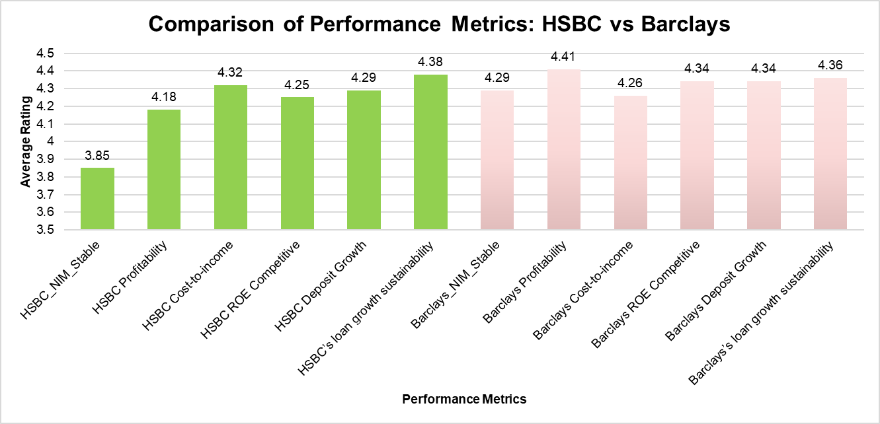
Figure 11: Comparison of Performance Metrics: HSBC vs Barclays
Figure 12 presents a radar chart, which presents the general overview of the banks’ performance for six key indicators. The chart unambiguously demonstrates that Barclays is safer with respect to NIM, more profitable, and has a better position in terms of competitiveness of ROE than HSBC, while HSBC is more favourable in terms of cost-to-income ratio and sustainability of loan growth rates.
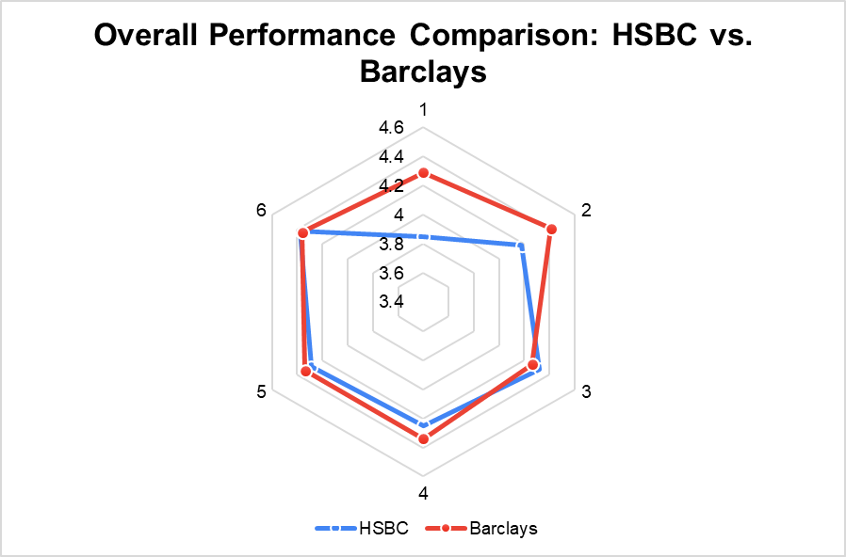
Figure 12: Overall Performance Comparison: HSBC vs. Barclays
Analysing the data from annual reports of two banks’ actual financial performance indicates various trends for both of them. In the case of HSBC, the Net Interest Margin (NIM) has been on the decline for most of the years though it has slightly improved in 2.13 % in the year 2013 to 1.71% in 2023 low point 1.20% in 2021. On the other hand, Barclays has witnessed a general expansion on the overall NIM; from 2.27% in 2012 to 3.15% in 2023. Both firms have fluctuations in terms of profitability and in general, HSBC has seen higher fluctuations in these figures. Despite a wide variation in these figures, the profitability of both firms has seen shifts over the years; HSBC’s profitability declined in 2016, but it has wildly rebounded, on the other hand, although Barclays’ profitability has seen some fluctuation, over the past two years, it has remained volatile but mostly at lower levels.

Trend Analysis of Financial Performance
From Figure 13 Comparing the trends of financial performance of HSBC and Barclays from the year 2013-2023, there are apparent dissimilarity across most aspects. With reference to the Net Interest Margin (NIM) HSBC witnessed a reduction from 2. 13% to 1. 71% with the lowest figure at 1.20% in 2021. While Barclays in contrast rose from 2. 35% to 3. 15 % which shows that they have better performance on this part. It was also evident that profitability for HSBC was characterised mother oscillation going down to £7. 1 billion in 2016 but has proved to be recovering very strongly to £19.2 billion by 2023. Conversely, Barclays have kept their fluctuations in profitability a lot closer ranged and typically have fallen between £0.6 billion to £8.4 billion. This going shows that the cost-to-income ratio of HSBC ranged between 59.6% and 75. 5%, ending at 62. 1% in 2023, while Barclays hold it between 63% and 73% throughout the years. The two banks’ performance indicated enhanced Return on Equity (ROE) and while HSBC’s ROE increased from 9. 2% to 11.2% and Barclays had a better performance of 4.2% to 11.8%. As for the deposit fluctuations, both banks established the positive trends; nevertheless HSBC was more unpredictable, growth varied between 1.2% to 4.1 % whilst Barclays estimates it at within the range of 2.1% to 4.5%. Finally, both banks faced negative loan growth in 2020 due to the pandemic but recovered thereafter; HSBC's growth ranged from -0.8% to 3.9%, while Barclays ranged from -1.2% to 3.8%. Overall, the data indicates that Barclays demonstrated more stability across several metrics, while HSBC experienced notable fluctuations, particularly in profitability and NIM.
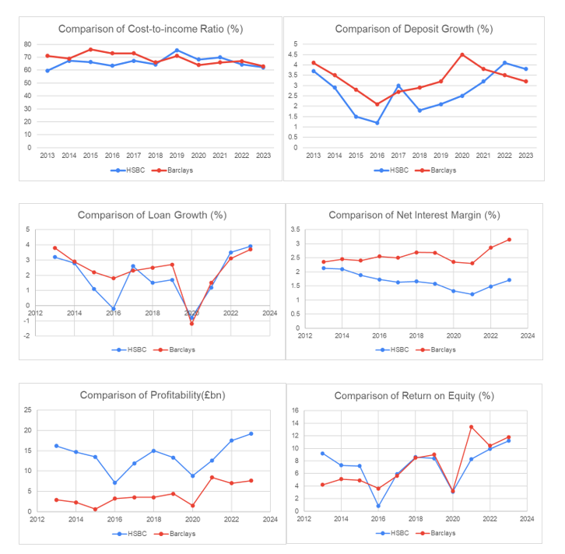
Figure 13: Performance Comparison of HSBC and Barclays (2013-2023)

Correlation Analysis
The results of the correlation analysis show compelling relationships between both the actual financial performance and survey opinions of HSBC and Barclays.
From Table 1 HSBC finds that actual data provides strong positive links between profitability and Return on Equity (ROE) (0.954) along with profitability and loan growth (0.892). What this suggests is that as HSBC's profits soared, its ROE and loan growth tended to improve also. Conversely, a moderate negative correlation exists between Net Interest Margin (NIM) and the cost-to-income ratio (-0.477), implying that as NIM increased, the cost-to-income ratio tended to fall, signalling better efficiency. Barclays' actual data reflects alike trends, presenting intense positive correlations between profitability and ROE (0.912), along with moderate positive correlations between NIM and profitability (0.516). It's interesting to see that there's a negative connexion between deposit growth and NIM (-0.289), which implies that as deposit growth climbed, NIM tended to fall marginally.
Table 1: Regression Analysis for Actual data from Finance reports
The survey correlation analysis show a unique image, mostly for HSBC. NIM stability perceptions demonstrate moderate positive correlations with profitability (0.64), and no correlations with the competitiveness of the cost-to-income ratio and ROE. The findings show a separation between the way respondents view NIM stability and how they think about other performance metrics. The survey data from Barclays demonstrates greater positive correlations for all the metrics. A strong correlation is observed between perceived NIM stability and profitability (0.76), cost-to-income ratio (0.70), as well as ROE competitiveness (0.62). According to this, respondents with a stable view of Barclays' NIM often had favourable views of its additional performance metrics.
Table 2: Regression Analysis for Survey data from Finance reports
There are evident differences between the data that exists and the perceptions generated from surveys. The findings show that actual data depicts complex relationships between metrics, in contrast to which survey responses reveal more stable positive correlations, particularly for Barclays. This might suggest a halo effect in evaluation of Barclays, as advantageous feelings in one field influence views in others.
These results illustrate the value of regard for actual financial performance alongside market perceptions in the examination of bank performance. Moreover, they suggest that Barclays may enjoy a more reliably favourable image among industry observers than HSBC, even though both banks exhibit nuanced relationships between performance metrics reflected in their actual financial data.

Regression Analysis
Regression analysis on interests rates and various financial performance indicators for Barclays and HSBC points to the fact that the relationship between interest rates and bank profits is not as straightforward as previously thought. There were four regression models analysed, with the first two being Barclays and the last two being HSBC with different levels of correlation and statistical significance.
Barclays Analysis:
From Table 3 for Barclays shows a good and highly significant positive correlation between interest rates and the dependent variable that could be Net Interest Margin or any similar variable. This model has an R-square of 0.754, which means that 75.4% of the variation in the dependent variable is accounted by the variation in interest rates. The correlation is also significant at 0.05 level and every one percent rise in the interest rates is likely to lead to 0.191 unit rise in the dependent variable. This high level of correlation indicates that this specific part of the Barclays’ performance can be a good predictor of changes in this area depending on the fluctuations of interest rates.
Table 3: Regression Analysis of Barclays NIM and Interest Rates
The second model for Barclays shows a positive but insignificant correlation with the variables in the model. The R-squared of 0.233 shows that 23.3% of the variation in the dependent variable is accounted for by the interest rates. However, it reveals a higher coefficient of 1.046 indicating that one percent increase in interest rates will lead to 1.046 units increase This means that though there is an upward trend in this aspect of Barclays’ performance, it is not strong enough to make conclusions or make future predictions regarding interest rate hikes.
Table 4: Regression Analysis of Barclays Profitability and Interest Rates
HSBC Analysis:
On the other hand, from Table 5, which depicts the HSBC, is characterised by the absence of any significant connexion between interest rates and the dependent variable. The R square of this model is only 0.006 and the coefficient value is 0.019, which implies that any aspect of HSBC’s performance that the model captures is almost independent of interest rate changes. The p value of 0.825 further supports the fact that there is no correlation between the two variables. This could mean that the bank has done a good job of hedging this aspect of its results to interest rates or it could simply be the case that there are other factors at play here in relation to HSBC.
Table 5: Regression Analysis of HSBC NIM and Interest Rates
The Table 6 for HSBC shows that there is a positive correlation which is significant at 0.05 level. An R-squared value of 0.4136 shows that 41.36% of the dependent variable can be explained by interest rates. It can be seen that the relationship is statistically significant at the 5% level of significance (p-value = 0.0328) and for every 1% increase in interest rates, the dependent variable increases This model also shows a valid and significant linkage between interest rates and this aspect of HSBC’s performance, albeit not as robust as in Barclays’ first model.
Table 6: Regression Analysis of HSBC Profitability and Interest Rates
Comparative Analysis:
A comparison of the performance of Barclays and HSBC bank indicates that different trends exist in the two banks concerning volatility of returns and changes in interest rates. In one aspect of its performance, Barclays displays a higher degree of responsiveness to interest rates than the other banks in the study (Model 1) with a strong and significant coefficient. This indicates that Barclays could be more vulnerable to the interest rate fluctuations in some aspect of the operations, and may be in a better position during increasing interest rates, but could suffer during decreasing interest rates.
The same is true for HSBC, although the company has a more complicated picture. Another aspect of its performance has no apparent correlation with interest rates (Model 3) thus there is potential that this area could be shielded or immune to interest rate changes. But another aspect (Model 4) has a moderate but significant coefficient, indicating that the interest rate effects are not entirely absent for HSBC.
These differences can be as a result of differences in their strategic management, their approach to risk management or even the markets they undertake their business in. Barclays’ better relationship in one model may imply more emphasis on interest sensitive products and services while the differences in the results for HSBC may be due to a diversified strategy or different geographical risks that could offset the effects of UK interest rate changes.
Implications and Conclusions:
The implications of the findings for the strategies of both banks’ management are discussed. One specific area of Barclays performance is most associated with interest rate expectations and changes; therefore the bank may need to pay close attention to these variables. This may require more direct management and/or hedging of interest rate exposures. HSBC, in its risk management, may be able to afford some flexibility in certain aspects of its operations that do not seem as sensitive to changes in interest rates.
To the investors and analysts, these findings imply that any assumption made on banks’ performance in relation to changes in the rates of interest are unique to the particular bank and cannot be extended to the whole banking industry. This shows that Barclays and especially HSBC may behave in different ways when exposed to the same interest rate conditions.
Finally, this regression analysis presents a distinctive view of how interest rates affect the performance of banks, particularly the contrasting cases of Barclays and HSBC. Thus, it underlines the necessity of evaluating the effects of interest rate fluctuations on various performance measures and characteristics of individual banks since the effects are not general for all performance indicators and may significantly vary across banks.

Performance Volatility and Stability
The performance volatility and stability comparing HSBC and Barclays show that both banks operate differently in the management of interest rate risk and profitability.
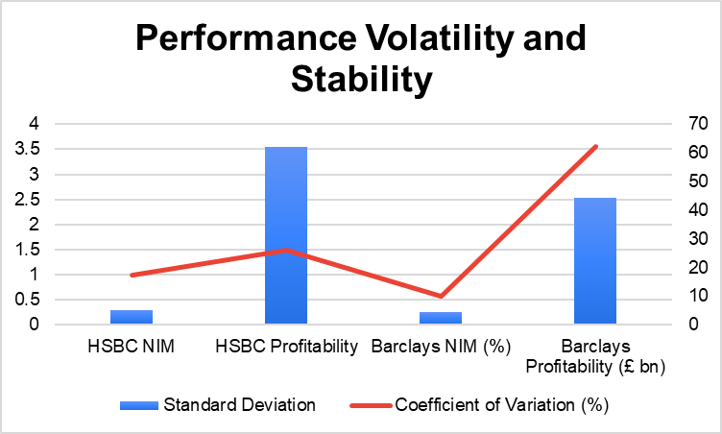
Figure 14: Performance volatility and Stability
As for the Net Interest Margin (NIM), the volatility for this ratio is quite evident in HSBC with a standard deviation of 0.289 than Barclays with a standard deviation of 0.258. This is also underscored by a higher coefficient of variation for NIM for HSBC at 17.25 percent as compared to Barclays at 10.03 percent which shows that HSBCs NIM is more volatile in relation to its mean. Analysing the financial performance, we can see that the absolute volatility of profitability for the HSBC group is significantly higher and equals to 3.55, whereas for Barclays it is equal to 2.54. But the coefficient of variation is quite a different picture, as Barclays give much higher relative risk of 62.20% than that of HSBC’s 26.04%. These results imply that, although the profitability of HSBC may be less stable in absolute terms, the profitability of Barclays is less stable in relative terms. This could suggest that Barclays has a more difficult time in delivering steady returns on the interest rate differential compared to having a more stable NIM. In conclusion, this analysis shows that there are differences in the volatility of the KPIs of HSBC and Barclays, which point to different strategies for dealing with changes in interest rates and their effects on profitability.

Growth Metrics Comparison
The growth trends in the deposits for both the HSBC and Barclays are seen to differ significantly. The figure below shows that the deposit growth of HSBC was more volatile as it ranged from 1.2% to 4%. On the other hand, Barclays had lower and constant deposit growth rates that seldom exceeded 4.5% and at the same time seldom dipped below 2%. Interestingly enough, Barclays posted a higher deposit growth than HSBC for most of the analysed period, up to the year 2022, at which point HSBC started to grow at a faster pace than Barclays. This change may indicate that HSBC has altered its deposit attraction strategies or that market conditions have been more propitious for HSBC over the last few years.
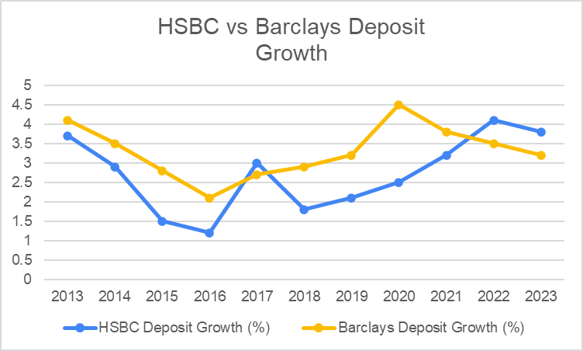
Figure 15: HSBC Vs Barclays Deposit Growth
As for loan growth, the dynamics of both banks were similar and marked by high fluctuations. One of the trends was the decline in number of both institutions in 2020, possibility due to the effect of the COVID-19 pandemic. Still, the performance of both banks improved significantly in the next years. Hence, the loan growth of both banks in 2023 reached a close figure of 4%, which might suggest the harmonization of the two banks’ strategies
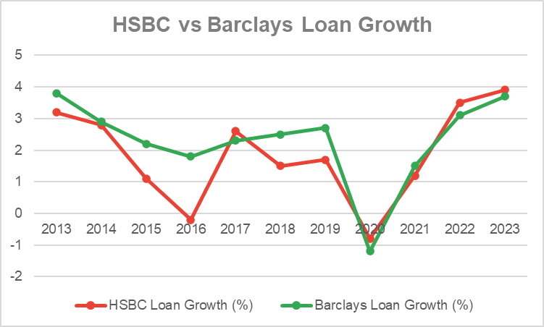
Figure 16: HSBC Vs Barclays Loan Growth
The correlation analysis gives useful information on the interdependence between growth rates and interest rates. The correlation On the other hand, Barclays paints a more complicated picture. The correlations for deposits (-0.085) indicate a weak negative relation and for loans (0.458) there is a moderate positive relation akin to HSBC. This may suggest different approaches or market segmentation between the two banks as evidenced below. Aligned growth strategies within the bank are also evidenced by the high positive relationship (0.747) between deposit and loan growth rates at HSBC. On the other hand, the weak negative relationship of (-0.294) between deposit and loan growth rates of Barclays may suggest that these two are independent or even diverse in the growth strategies of the bank for these two products.
Table 7: Correlation of Growth Metrics with Interest rates
Thus, the assessment of the performance of the global banking giants, such as HSBC and Barclays, for the period 2013 to 2023 elucidated differences in their behaviour in light of interest rate fluctuations and general financial sustainability. Comparing the performance of Barclays to other banks, Barclays was more stable in different ways such as NIM, the bank’s profitability and competitive ROE. Although cost-to-income ratio and loan growth sustainability was volatile with peaking in 2009 and trailing in mid-2010, HSBC was more absorbent to volatility as compared to other banks.
Analysis using regression statistics suggested that Barclays’ performance was more sensitive to movements in interest rate, which may expose the bank to risks likely to arise from fluctuating interest rates. The relationship that HSBC had with the interest rates was not as simple as that since some of its aspects seemed to be less influenced by rates.
Examining growth metrics it was observed that while HSBC had enjoyed far more erratic deposit growth than Barclays. And both banks had similar trends in terms of loan growth especially a drastic slow down due to the 2020 pandemic. The variations between the survey perceptions concerning Banking Industry performance and the actual Financial ratios justify the ought of benchmarking the performance of banks on two bases which include the market sentiment and credit crunch test. Of particular importance, Barclays were viewed more favourably by the observers associated with the industry. Such studies reveal the different approaches that every bank has adopted in the management of interest rate risk and operational profitability. They also go a long way in pointing out that greater sophistication is required when analyzing the effects of changes in interest rates on banks, particularly by examining each banking institution individually.

Findings & Discussion

Key Findings

Comparison of HSBC and Barclays Performance Metrics
This analysis brought out vivid differences in KPIs between HSBC and Barclays. Barclays showed improved stability of NIM, profitability and competitive ROE as compared to other industries. Analysis of survey results showed that insofar as non-interest income, the ratings BTC gained higher with 4.29 for Barclays as against 3.85 for NIM stability, 4.41 for Profitability for Barclays as against 4.18 for HSBC and 4.34 for ROE competitiveness for Barclays as against 4.25 for HSBC. Nevertheless, here, HSBC had a slight edge in the developments in the cost-to-income ratio and the loan growth (Borio et al., 2017).

Trend Analysis of Financial Performance (2013-2023)
HSBC’s NIM has reduced from 2.13% in 2013 to 1.71 % in 2023 with a record low of 1.20% in the year 2021. On the other hand Barclays’ NIM increased from 2.35% to 3.15%. The relative profitability of both organisations was similarly variable, although the variance in HSBC’s results was greater. Although earning the £3.42bn performance in 2016, HSBC bounced back significantly to realize £ 19.2bn earning by 2023. Barclays recorded better operating results for the same period, fluctuating between £0.6 billion and £8.4 billion profit (Bank of England, 2023).

Correlation Between Interest Rates and Bank Performance
Analysis of correlation showed positive significant relationship between profitability and ROE of both banks; the correlation coefficient was 0.954 for HSBC and 0.912 for Barclays. HSBC demonstrated a negative relationship between NIM and CIR (- 0.477) but Barclays had positive relationship between NIM and profitability (0.516). Analyses of survey data showed higher positive coefficients by the Barclays than by the HSBC (Claessens et al., 2018).

Regression Analysis Results
In regression models interest rates had different effect with banking performance. In the case of Barclays, one model of theirs turned out to show an extremely high significance, (R squared = 0.754) associating interest rates with a performance variable, which could be NIM. HSBC has been less fortunate with its models; one indicates an insignificant (R-squared of 0.006) relationship while another shows a moderate positive relationship (R-squared of 0.4136).

Volatility and Stability in Performance Indicators
HSBC had higher fluctuation rates than Barclays regarding NIM, as was evidenced by the standard deviations of 0.289 in HSBC and 0.258 in Barclays. The Coefficient of variation for NIM was 17.25% for HSBC and 10.03% for Barclays. The absolute fluctuation of the profitability for HSBC was bigger, and it had the standard deviation of 3.55 compared to Barclays with the standard deviation of 2.54 The relative fluctuation for Barclays was even higher with the Coefficient of variation of 62.20 compared to the Coefficient of variation of 26.04 for HSBC (Bikker & Vervliet, 2018).

Growth Metrics Comparison
The increase in depositors’ funds also presented different trends in both the banks. HSBC’s deposits show less stability ranging from 1.2% to 4% while Barclays’ deposit show stability with growth rate ranging from 2.1% to 4.5%. Loan growth trends for both banks were the same; a downtrend in 2020 caused by the COVID-19 virus with some form of upswing in 2021. In the two banks the loan growth by 2023 is likely to hover around 4 percent each. The cross-sectional comparison further showed that each bank had dissimilarities in the correlation coefficients of growth metrics and interest rates, implying unique methods/approaches or market niche (Altavilla et al., 2018).
The results presented in the paper depict the HSBC and Barclays’ interest rate sensitivity showing that each of the two banks has provided a unique, diverse, and rich picture characterised by business models, risk management frameworks and market positions.

Addressing Research Questions and Discussion of Findings
Question 1: How do changes in interest rates affect the net interest margins and overall profitability of Barclays and HSBC?
This research aims at investigating the dynamic relationship between the changes in interest rate structure and net interest margins of Barclays and HSBC between 2013-2023 and its implications for overall bank profitability. Reference to the finding above therefore points of a positive relationship between interest rate and NIM for Barclays. The regression result revealed a positive correlation with high coefficient of determination (0.754) with the interplay between interest rates and the performance indicator, the NIM. From this it can be inferred that on average, as interest rates began to rise, Barclays was able to extend its NIM, most probably through quicker adjustments of the interest on loans as compared to deposits (Borio, et al, 2017).
However, in the case of HSBC different picture was observed regarding NIM. The analysis of the financial data of the bank showed that during this period of 2013 − 2023,measure of profit margin through NIM reduced from 2.13% to 1.71% with 1.20% in 2021 and despite the changes in the interest rates. The regression analysis for HSBC revealed no impact of interest rates on NIM, as identified by a value of 0.006 for R-squared on one model, thus suggesting that other elements may have a greater effect on HSBC’s NIM than changes in interest rate (Claessens et al., 2018).
The effect of changes in interest rates in overall profitability was not same between the two banks. Barclays also enjoyed higher level of stability in their profits which fell between £0.6 billion and £8.4 billion over the financial period. The outcome of regression analysis showed slightly positive relationship and less significant on how interest rate has affected profitability (R-squared = 0.233). This indicates that aside interest rate, there are some other factors that augur well in the functionality of Barclays. The profitability view portrays a lower figure of £7.1 billion in the year 2016 but a healthy figure of £19.2 billion in the 2023 fiscal year for HSBC. In the regression analysis, indeed, it was established a moderate positive significant relationship between interest rates and profitability which their coefficient of determination amounted to 0.4136 this clearly depicted that HSBC Net Interest Margin, was more sensitive to changes in interest rates as compared to its NIM. These findings show that the nature of the link between interest rates, NIM, and profitability is conditional and depends on the existing conditions and business specifics of the banks operating in the environment. The profitability view portrays a lower figure of £7.1 billion in the year 2016 but a healthy figure of £19.2 billion in the 2023 fiscal year for HSBC. In the regression analysis, indeed, it was established a moderate positive significant relationship between interest rates and profitability which their coefficient of determination amounted to 0.4136 this clearly depicted that HSBC Net Interest Margin, was more sensitive to changes in interest rates as compared to its NIM.
These findings show that the nature of the link between interest rates, NIM, and profitability is conditional and depends on the existing conditions and business specifics of the banks operating in the environment.
Question 2: What is the impact of interest rate fluctuations on the overall profitability of Barclays and HSBC?
The volatility of interest rates was found to have a considerable influence on the aggregate profitability of both Barclays and HSBC, however they are different. From this study, the result reveals that for Barclays Bank, the interest margin was affected much more than the net interest margin as a whole. The positive correlation between interest rates and NIM shows that Barclays has professionally managed interest rate risk through management of assets and liabilities coupled with better pricing strategies for its services (Alessandri & Nelson, 2015).
But the reduced tight fit of the interest rates with the overall profitability of Barclays also means that the profitability of the bank depends on many more factors other than just interest rates. This may include noninterest income, cost to income, and risk adjusted return on assets. Barclays’ profitability structure of the interest rate, which has gone up over the studied years and then slightly gone down, proves diverse business model can manage the interest rate volatility (Altavilla et al., 2018).
Nevertheless, based upon further comparison, it was revealed that HSBC had a closer relationship between change in interest rates and changes in the overall profitability as compared to that reflected by NIM. The spearhead relationship between interest rates and profitability, within the range of 7.46% - 8.26%, indicates that HSBC’s earnings is more responsive to changes in interest rates due to moderate positive coefficient of determination of 0.4136. This might be because of the fact that HSBC has more global outlets and is subjected to a number of more interest rate experiences of different markets (Wójcik & MacDonald-Korth, 2015).
The year to year fluctuation of HSBC’s profit compared to other large consistent banks of the decade portrays the weakness of the organization in operating under macro-economic conditions and fluctuating interest rates. This can be blamed on the geographical spread of FDI and the fact that the effects of interest rate fluctuations differ across economies (Brei et al., 2020).

Comparative Analysis and Implications
The variability of Barclays and HSBC’s responses to interest rate changes suggests that interest rate risk is not well controlled by broad strategies alone. As shown in the figures and earlier discussions Barclays has been more stable in its profit margin more than its peers indicating better risk management coupled with business diversification. High positive relationship between interest rates and NIM shows re-pricing strategies and effective asset-liability management by the bank have been effective (Busch & Memmel, 2017).
Finally, and most conclusively, the more fluctuating profitability and the weaker relative relationship between interest rates and NIM suggest that the bank’s operations are more susceptible to macroeconomic shocks and may be burdened with more difficult operations across the differing interest rate environments in HSBC’s global operations. It shows the bank to be resilient, but also cyclical – meaning that it’s not just sensitive to interest rate movements, but potentially to overall economic conditions (Heider et al., 2019).
The results of this research have several implications for bank management and policymakers. They both first emphasise the need for institution-specific management of interest rate risk, contingent on the bank’s business environment and risks. Second, they emphasise the problem of dependence on interest income to offset the impact on total revenues due to interest rate changes. Finally, they recommend that the monetary and regulatory policies should consider the extent of the differentiated effects of interest rate changes of various banking institution.
The findings of this study raise alerts to bank managers about the importance of implementing effective and sound asset-liability management policies and conducting the periodic interest rate risk review across their operations’ departments. The potential of changing NIM in relation to shifting interest rate settings is once again an advantage that Barclays has illustrated (Genay & Podjasek, 2014).
It is therefore important for policymakers to understand that implementation of interest rate changes has an indirect and inclined impact on the profitability of. Normal and big banks. It remains such a significant issue in banking that must be considered when estimating the possible effects of monetary policy’s measures on the banking sphere and overall economy (Schnabel 2021).
In conclusion, while interest rates changes significantly affect both Barclays and HSBC, the level and the ways of this affect radically differ between two analysed banks. They are an indication of the diverse effect of interest rates, various strategic postures among the banks and general economic systems on the performance and profitability of the banking industry.

Comparison with Existing Literature

Alignment with Previous Research Findings
The conclusions made in this research are consistent with prior empirical studies linking interest rates, net interest margins and bank profitability. As per the FNB and in consonance with the findings expressed by Borio et al. (2017), the research reports together demonstrate a positive correlation between interest rate and NIM, with the positive impact being most observable in Barclays’ case. This supports theory that higher interest rates works in favour of the interest of banks by helping then to increase their interest margin.
Thus, our finding that recent interest rate changes differentially affected the growth rates of different banks can be consistent with Brei et al. (2020) who noted that the banks’ dependence on interest rates may vary due to the size, sources of funding, and the type of its business. The heterogeneity in the response of banks to changes in interest rates with Barclays reporting a less fluctuating measure of profitability than HSBC accounts for this difference.

New Insights and Contributions to the Field
This study extends the understanding by offering a comparative analysis of two large diverse UK banks. Long-term management of IRR involves specific and consistent strategic policies put in place by the respective banks; this study shows how Barclays and HSBC each responded differently to changes in interest rates: a subtle point missed by macro-industry studies.
We complement this literature by providing evidence on the fact that different components of bank NIM are affected differently by interest rate change and therefore the operation of the transmission mechanism of interest rate change and its effects on bank performance is not as straightforward as earlier postures. This extends Claessens et al. (2018) by providing evidence that factors other than the interest rate, reinvention income and operating expenses influenced the overall bank profitability.

Challenges to Existing Theories or Assumptions
The findings of this study are incongruent with some of the postulations that have been posited in banking literature. As it will be discussed in this method section, previous theories formulated in the banking literature for the operating of interest rates on profitability are positive especially in the … For HSBC, the findings point to a more complicated relationship. The significantly lower relationship between interest rates and NIM in HSBC questions the social premise that all the linking establishments benefit when rates are up.
Moreover, we challenge conventional wisdom drawn from purely banking sector research at the aggregate level. The moreover variation in the reactions of Barclays and HSBC to the interest rate change indicates that such analysis might hide crucial differences within the industry at the level of individual banks. This is in line with Bikker & Vervliet (2018) critique of doing generalized analysis on different banking institutions using broad theories.

Limitations of the Study

Data Limitations
The sources of data for this study was the financial statements together with other relevant information from the annual published reports and other filings with the stock exchange markets. While it may encompass the study of all these aspects it may not offer a more detailed picture of the totality of a bank’s operations internally. Due to lack of detailed information regarding the loan portfolios, risk management techniques, and real-time interest rate risks that the banks face the analysis is limited. Further, the study just used a 10 year analysis with the period 2013-2023 involving might not give a befitting picture of long term and far reaching implications of events such as the global financial crises of 2008.

Methodological Constraints
The comparative case study analysis of Barclays and HSBC produces detailed information about these two organizations but is less useful in acquiring an all-embracing picture of the banking industry. The applied regression models, though useful, can only partially capture all the factors that determine bank performance. The models that are adopted in this study only provide linear regression analysis, and these may not well capture the non-linearity in financial systems that are often complex. In addition, integrating the quantitative analysis and survey data produce biases in the qualitative aspects that may be challenging to eradicate.

Generalizability of Findings
Given the focus on two major UK banks, the findings may not be fully applicable to smaller banks, non-UK banks, or financial institutions with significantly different business models. The unique characteristics of the UK banking sector and regulatory environment may limit the direct applicability of these findings to other national contexts. Additionally, the rapidly changing nature of the global financial landscape means that some findings may become less relevant over time as new challenges and opportunities emerge in the banking sector.

Future Research Directions

Areas for Further Investigation
Future research in this area could extend this study by increasing the number of banks included in the sample as well as including cross sectional samples of banks from different countries and systems. This could facilitate a better understanding of how different regulations and structures of markets affect banks’ patterns of reaction to changes in interest rate. Furthermore, analyzing the effects of new techniques like fintech as well as digital banking on the interest rate sensitivity of banks offers a line of work for understanding changes in banking. Another attractive research topic is the study of how the approaches to addressing the interest rate risk adapted by the banks shifted over the years affected by chronologically low and then steep interest rates. This could include a finer examination of the current position of banks in relation to its asset and liability management and how effective it will in the changing interest rate regimes.

Potential Methodological Improvements
There should be further research done with using better statistical methods, with using non-linear regression models or, for example, using machine learning to analyse interest rates or bank performance and different economic indicators. The use of time series analysis and Dynamic panel data analysis may be useful to discover a more detailed view of the relationship system. Furthermore, while this paper has relied on data obtained from public secondary sources, future research can complement this quantitative approach with more detailed, primary qualitative data including interviews with some of the executives from the sampled banks and policymakers.

Broader Implications for Banking Research
This study therefore calls for more micro level granular institution based research in the banking industry. It is for future research to analyse how the specific business models, governance systems and risk taking capacities of banks might impact their handling of macroeconomic developments. For example, further scientific investigations of the relationship between monetary policy, banking regulation and the performance of banks constitute useful information for policymakers and regulators. In addition, analyzing present trends which are relevant for the future incline toward non-interest income or effects of climate change on banking could inform concerning existence choices in banking research and practice.

Conclusion
A thorough analysis of this research has given the ability to see how the variations in interest rates within the period 2013 -2023 have influenced the net interest margins and profitability of Barclays and HSBC, these two well established UK banks. Interest rates however have a more profound relation with the two firms’ performances, but striking differences are observed with each firm.
Net interest margins: Barclays proved to be better managing interest rate risk as compared with the industry standard because it had a better positive association between interest rates in the periods under consideration. The following graph shows the bank has been able to manage fluctuating interest rates pretty well owing to a diverse business model and efficient risk management strategies adopted by the bank. On the other hand it presented higher interest rate risk in the sense of profit volatility, though less exposure according to the net interest margin. This implies that through geographical dispersion HSBC is subjected to other macroeconomic factors apart from the interest rate.
The paper also emphasizes that the changes in the interest rates may require bank-specific approaches. It disproves the idea that all banks in the banking sectors enjoy or suffer the effects of change in interest rates, the paper reveals why some banks need to be particular in the management of risks or in the ways of improving profitability.
In addition, the analysis of the key determinants of bank profitability reveals that the role of non-interest income and operation efficiency is rising. It thus depicts banking’s profile adjustment to low interest rate and the post 2008 financial crisis regulation.
Therefore, it is possible to confirm that interest rates can still be considered important indicators for bank performance indicators, but their usage does not have a direct impact on a number of factors such as business models used by the bank, including strategies for risk management and market exposures. The study provides evidence to promote a better outlook for the action of banks in fluctuating economic conditions and will be useful to practitioners who manage a bank, policy makers and to scholars researching in banking and finance studies.

Recommendations
Based on the findings of this study, the following recommendations are proposed for bank management, policymakers, and future research:
For Bank Management:
- There is a need to put in place better analytical mechanisms for mitigating interest risks especially given the position that the bank occupies in its business and in the market.
- Most institutions need to deploy more resources to balance sheet management to reduce their dependence on net interest margins, especially in conditions characterized by an unstable interest rate environment, as is currently the case.
- Enhance the more flexible managing of asset and liability based on interest rates scenarios.
- Promote deeper and more efficient communication and collaboration with constituent businesses in the area of interest rate risk management and to improve the ability to assess the interest rate changes’ potential effects on the company’s strategic business units.
For Policymakers and Regulators:
- Understand that increases or decreases in interest rates have diverse effects on individual or several institutions when designing economic and supervisory policies.
- Design new stress testing scenarios that capture better the heteroscedasticity in banks’ reactions to changes in interest rates.
- Considering potential undesirable outcomes of low interest rates for an extended period for banks’ risk-taking and stability.
- Disaggregate banks’ interest rate risk, especially to boost more transparency in the overall Interest Rate Risk Management processes in order to enhance market discipline, and supervision.
For Future Research:
- It is necessary to widen the field of investigation to involve more various banks from different countries and banking systems to increase reliability of the conclusions.
- Examining how growth of new technologies and digital banking affects banks, their interest rate sensitivity and business model.
- This research recommends that further studies be conducted over longer time horizons to capture how banks adapt their processes for managing interest rate risk in the wake of important economic occurrences.
- Engage other higher-order statistical methods and mixed research designs to examine the relationship between changes in interest rates, functional and symbolic requirements and firm-level banking returns.
- Consider future social trends like factors which have recently emerged as critical success parameters like non-interest income and effects of climate change in enhancing banking stability and profitability.
The practical application of these suggestions might result in enhancing the stability of banking organizations, improving the quality of regulation and supervision, and increasing understanding of the nature of processes currently unfolding in modern banking industry.

References
Albertazzi, U. and Gambacorta, L., 2009. Bank profitability and the business cycle. Journal of financial stability, 5(4), pp.393-409.
Alessandri, P. and Nelson, B.D., 2015. Simple banking: profitability and the yield curve. Journal of Money, Credit and Banking, 47(1), pp.143-175.
Allen, F. and Santomero, A.M., 2001. What do financial intermediaries do?. Journal of Banking & Finance, 25(2), pp.271-294.
Altavilla, C., Boucinha, M. and Peydró, J.L., 2018. Monetary policy and bank profitability in a low interest rate environment. Economic policy, 33(96), pp.531-586.
Ampudia, M. and Van den Heuvel, S., 2018. Monetary policy and bank equity values in a time of low interest rates.
Angbazo, L., 1997. Commercial bank net interest margins, default risk, interest-rate risk, and off-balance sheet banking. Journal of Banking & Finance, 21(1), pp.55-87.
Bank of England, 2023. Monetary Policy Report - May 2023. [Online]
Available at: https://www.bankofengland.co.uk/monetary-policy-report/2023/may-2023
[Accessed 16 July 2024].
Bell, E., Bryman, A. and Harley, B., 2022. Business research methods. Oxford university press.
Bessis, J., 2011. Risk management in banking. John Wiley & Sons.
Bessler, W. and Kurmann, P., 2014. Bank risk factors and changing risk exposures: Capital market evidence before and during the financial crisis. Journal of Financial Stability, 13, pp.151-166.
Bhattacharya, S. and Thakor, A.V., 1993. Contemporary banking theory. Journal of financial Intermediation, 3(1), pp.2-50.
Bikker, J.A. and Vervliet, T.M., 2018. Bank profitability and risk‐taking under low interest rates. International Journal of Finance & Economics, 23(1), pp.3-18.
Bloomberg, 2023. Traders Bet UK Rates Are Heading to the Highest Since 1998. [Online]
Available at: https://www.bloomberg.com/news/articles/2023-07-06/traders-lift-bets-on-boe-terminal-interest-rate-to-6-5-by-march
[Accessed 1 August 2024].
Borio, C. and Gambacorta, L., 2017. Monetary policy and bank lending in a low interest rate environment: diminishing effectiveness?. Journal of Macroeconomics, 54, pp.217-231.
Borio, C., Gambacorta, L. and Hofmann, B., 2017. The influence of monetary policy on bank profitability. International finance, 20(1), pp.48-63.
Boubakri, N., Mirzaei, A. and Samet, A., 2017. National culture and bank performance: Evidence from the recent financial crisis. Journal of Financial Stability, 29, pp.36-56.
Brei, M., Borio, C. and Gambacorta, L., 2020. Bank intermediation activity in a low‐interest‐rate environment. Economic Notes, 49(2), p.e12164.
Busch, R. and Memmel, C., 2017. Banks' net interest margin and the level of interest rates. Credit and Capital Markets–Credit and Capital , (3), pp.363-392.
Claessens, S., Coleman, N. and Donnely, M., 2018. Low-for-long interest rates and banks’ interest margins and profitability. Journal of Financial Intermediation, forthcoming.
Collis, J. and Hussey, R., 2021. Business research: A practical guide for students. Bloomsbury Publishing.
Cox, J.C., Ingersoll Jr, J.E. and Ross, S.A., 2005. A theory of the term structure of interest rates. In Theory of valuation (pp. 129-164).
Creswell, J.W. and Creswell, J.D., 2017. Research design: Qualitative, quantitative, and mixed methods approaches. Sage publications.
Demirguc-Kunt, A., Laeven, L. and Levine, R., 2003. Regulations, market structure, institutions, and the cost of financial intermediation.
Deutsche Bundesbank, 2017. Low-interest-rate environment takes toll on German banks’ profits. [Online]
Available at: https://www.bundesbank.de/en/tasks/topics/low-interest-rate-environment-takes-toll-on-german-banks-profits-667460
[Accessed 16 August 2024].
Diamond, D.W., 1984. Financial intermediation and delegated monitoring. The review of economic studies, 51(3), pp.393-414.
Duffee, G.R., 2002. Term premia and interest rate forecasts in affine models. The Journal of Finance, 57(1), pp.405-443.
Eisenhardt, K.M. and Graebner, M.E., 2007. Theory building from cases: Opportunities and challenges. Academy of management journal, 50(1), pp.25-32.
Etikan, I., Musa, S.A. and Alkassim, R.S., 2016. Comparison of convenience sampling and purposive sampling. American journal of theoretical and applied statistics, 5(1), pp.1-4.
Freixas, X. and Rochet, J.C., 2008. Microeconomics of banking. MIT press.
Genay, H. and Podjasek, R., 2014. What is the impact of a low interest rate environment on bank profitability?. Chicago Fed Letter, (Jul).
Gray, M.S., 2011. Central bank balances and reserve requirements. International Monetary Fund.
Heider, F., Saidi, F. and Schepens, G., 2019. Life below zero: Bank lending under negative policy rates. The Review of Financial Studies, 32(10), pp.3728-3761.
Ho, T.S. and Saunders, A., 1981. The determinants of bank interest margins: theory and empirical evidence. Journal of Financial and Quantitative analysis, 16(4), pp.581-600.
Johnson, R.B., Onwuegbuzie, A.J. and Turner, L.A., 2007. Toward a definition of mixed methods research. Journal of mixed methods research, 1(2), pp.112-133.
Levine, R., 2005. Finance and growth: theory and evidence. Handbook of economic growth, 1, pp.865-934.
Mangram, M.E., 2013. A simplified perspective of the Markowitz portfolio theory. Global journal of business research, 7(1), pp.59-70.
Maudos, J. and De Guevara, J.F., 2004. Factors explaining the interest margin in the banking sectors of the European Union. Journal of Banking & Finance, 28(9), pp.2259-2281.
Saunders, A. and Schumacher, L., 2000. The determinants of bank interest rate margins: an international study. Journal of international Money and Finance, 19(6), pp.813-832.
Saunders, M.N., Lewis, P. and Thornhill, A., 1997. Research methods for business students. Pitman.
Schnabel, I., 2021, January. The sovereign-bank-corporate nexus–virtuous or vicious. In Speech at the LSE conference on ‘Financial Cycles, Risk, Macroeconomic Causes and Consequences’, Frankfurt (Vol. 28).
Tashakkori, A., 2010. Sage handbook of mixed methods in social & behavioral research. Sage Publications.
UK Finance, 2023. UK Payment Markets Summary 2023. [Online]
Available at: https://www.ukfinance.org.uk/system/files/2023-09/UK%20Finance%20Payment%20Markets%20Report%202023%20Summary.pdf
[Accessed 16 August 2024].
Valverde, S.C. and Fernández, F.R., 2007. The determinants of bank margins in European banking. Journal of Banking & Finance, 31(7), pp.2043-2063.
White, W.R., 2012. Ultra easy monetary policy and the law of unintended consequences. Federal Reserve Bank of Dallas Globalization and Monetary Policy Institute Working Paper, 126.
Wójcik, D. and MacDonald-Korth, D., 2015. The British and the German financial sectors in the wake of the crisis: size, structure and spatial concentration. Journal of Economic Geography, 15(5), pp.1033-1054.

Appendix A – Ethics forms


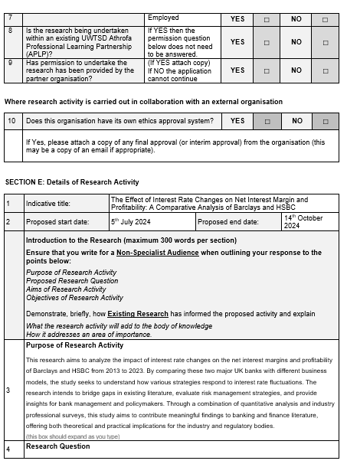
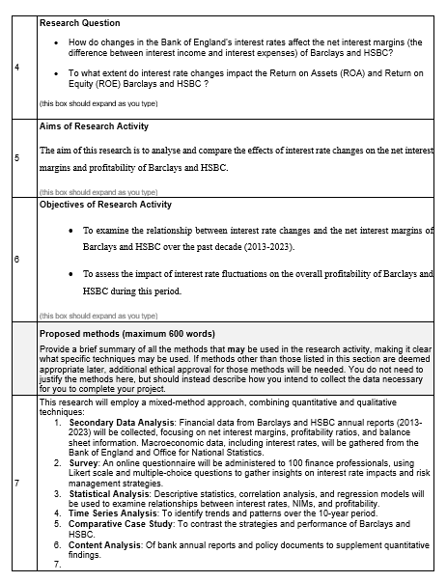

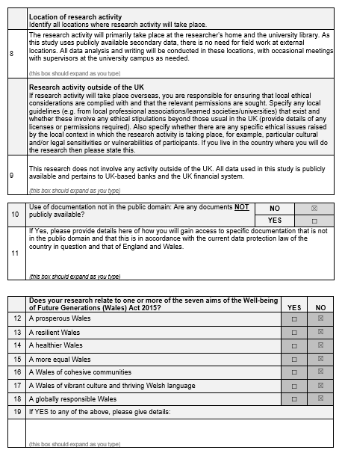
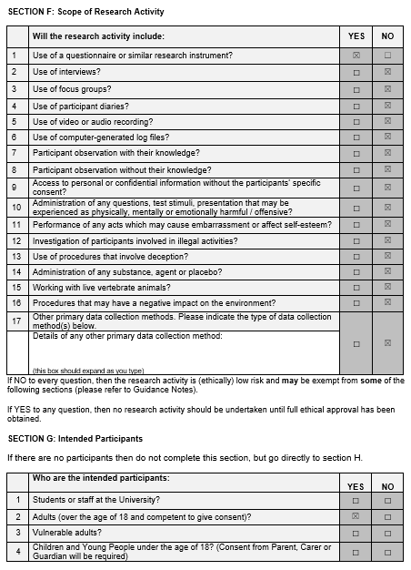





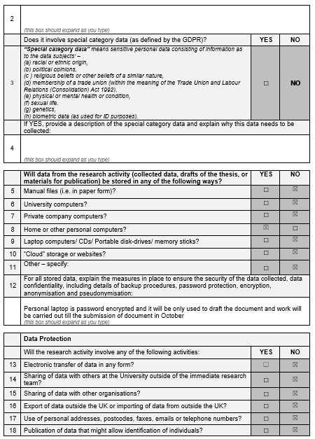
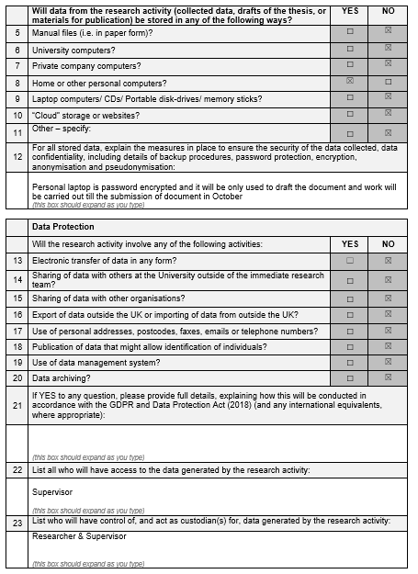

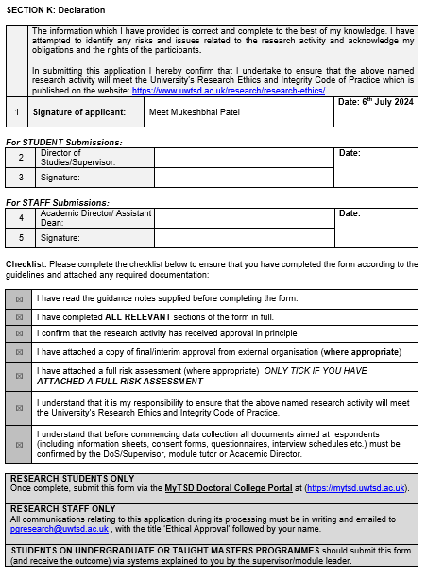

Appendix B – Questionnaire
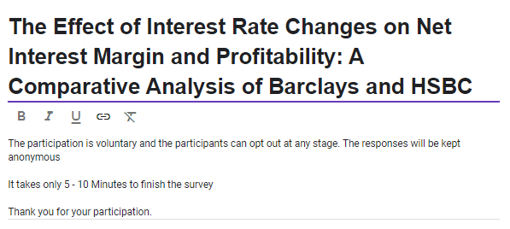
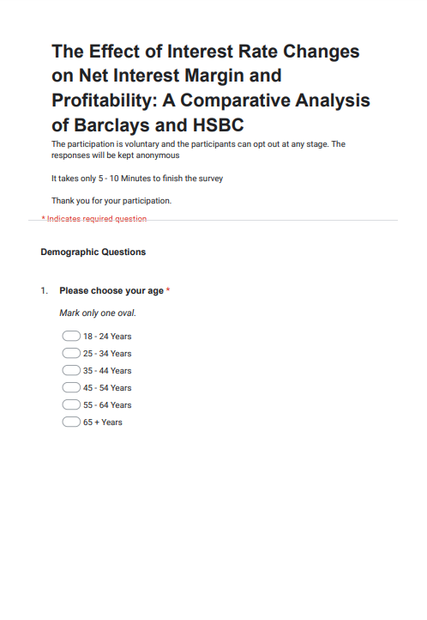
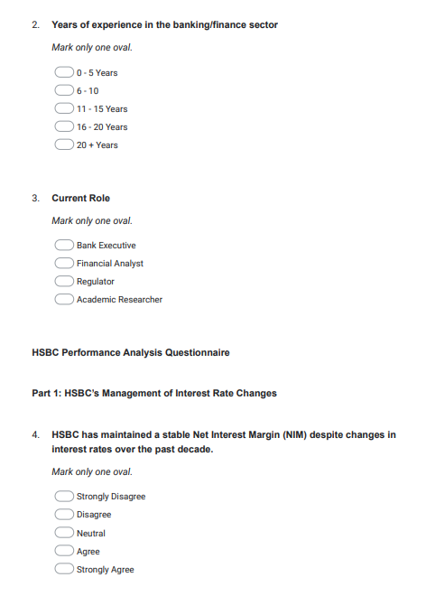
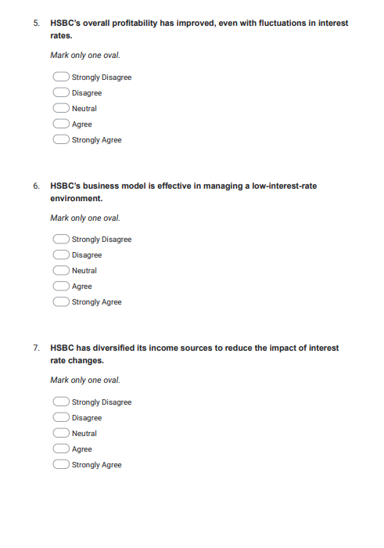


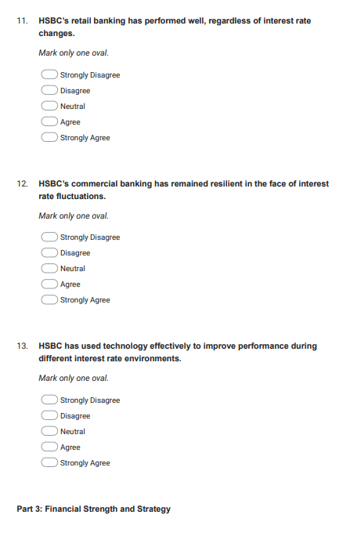
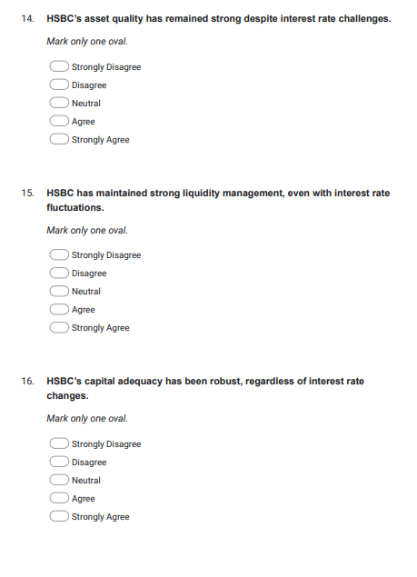
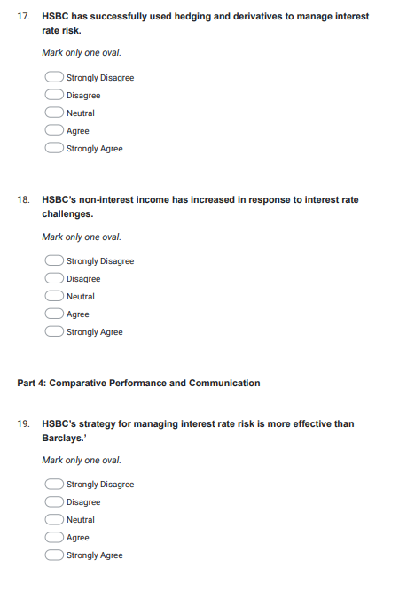
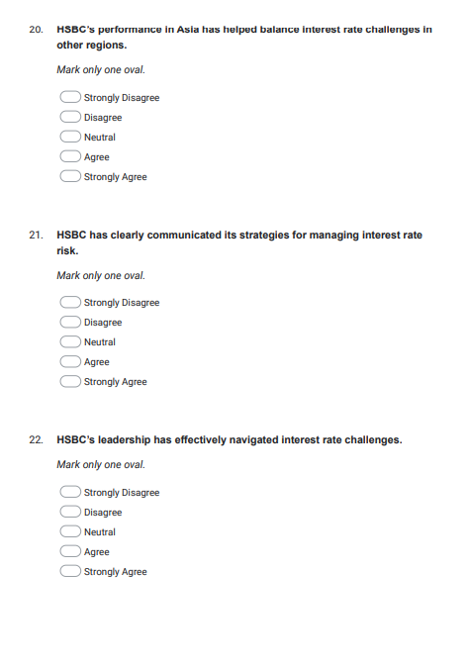
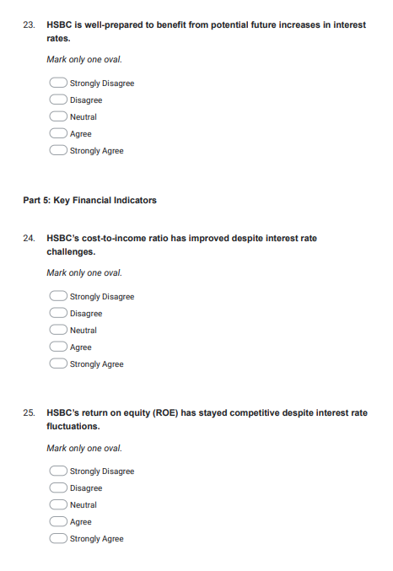
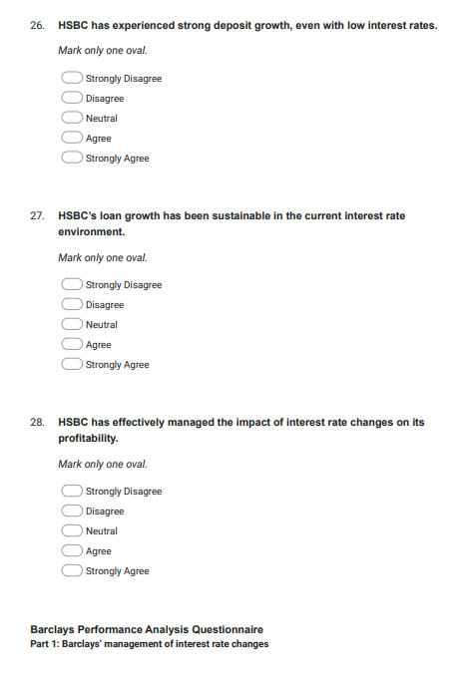

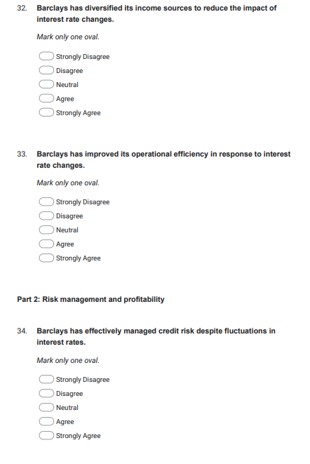
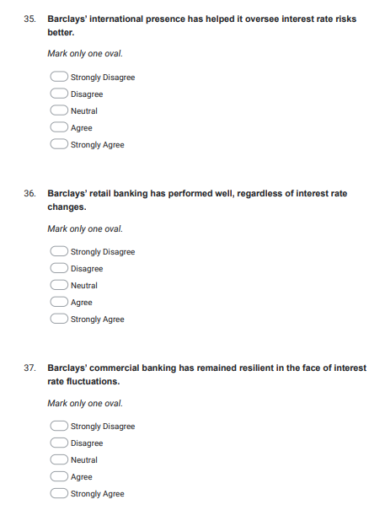
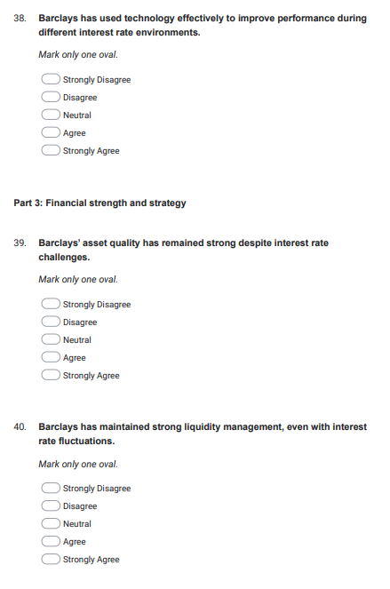
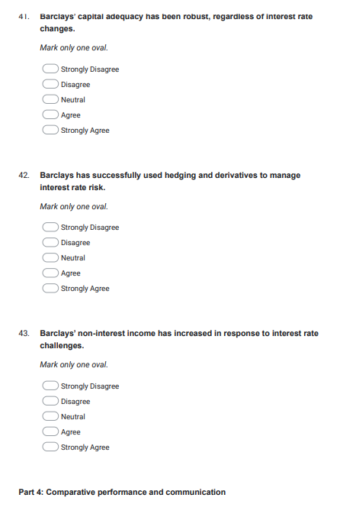
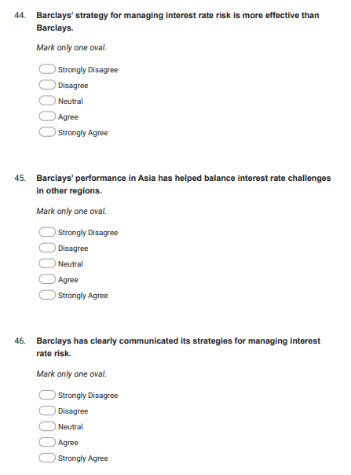
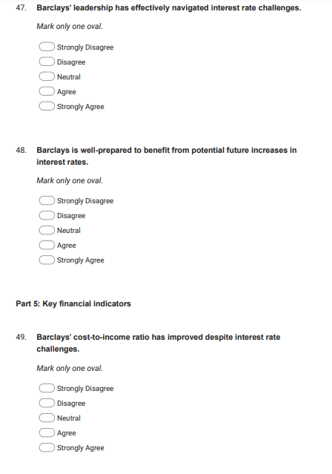
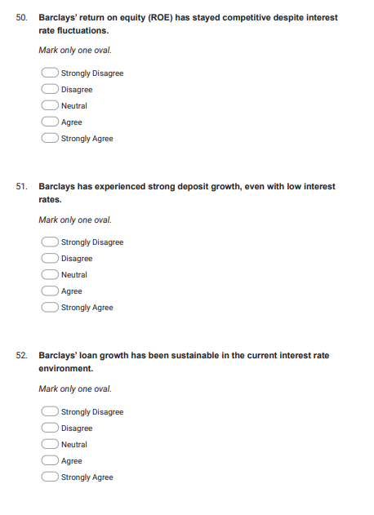
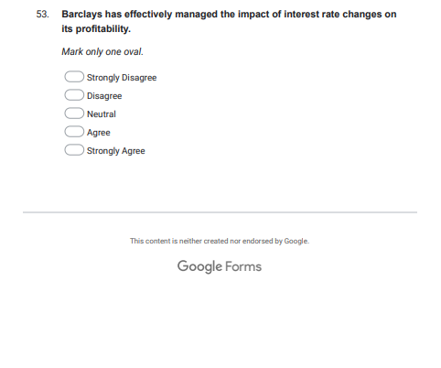

Appendix C – Participant consent Form
Participation Consent Form
University of Wales Trinity Saint David (c


 | Participant Identification Number:
PARTICIPATION CONSENT FORM
(for researcher to fill)
Project Title: The Effect of Interest Rate Changes on Net Interest Margin and Profitability: A Comparative Analysis of Barclays and HSBC
Name of Researcher: Meet Mukeshbhai Patel |  | Name of Supervisor: Isaiah Oino
Email of Researcher: ___ 2241321 ______@student.uwtsd.ac.uk
Aim of Research: The aim of this research is to analyse and compare the effects of interest rate changes on the net interest margins and profitability of Barclays and HSBC.

(for participant to fill) |  |  |  |  | YES |  | NO
1 | I confirm that I have read and understood the information sheet dated _________ for the above study.
2 | I understand there are no material benefits for participating.
2 | I have had the opportunity to consider the information, ask questions and have had these answered satisfactorily.
3 | I understand that my participation is voluntary and that I am free to withdraw at any time, without giving any reason.
4 | I understand that any information given by me may be used in future reports, articles or presentations by the researcher.
5 | I consent for my name and title to be used within this study.
 | Where applicable, I understand that my details will not be anonymous.
6 | I agree to be recorded (audio and/or audio-visual video).
7 | I agree to take part in the above study.
Researcher’s Name (Print) |  | Meet Mukeshbhai Patel | Signature | Meet Patel | Date | 30th Sep 2024
Participant’s Name (Print) |  |  | Signature |  | Date

You may decline to participate in this study. You may end your participation in this study at any time. All data generated from this or any interview will remain confidential. For more information, please view the university’s Research and Data Management Policy.
When completed please email a copy to the below address to be kept on the file of the researcher and retain a copy for yourself.
Subject Title: [NAME OF PARTICIPANT] – Participant Consent Form
Email: ___2241321______@student.uwtsd.ac.uk

Appendix D – Participation Information Sheet
Participant Information Sheet
University of Wales Trinity Saint David (London Campus)
Winchester House, 11 Cranmer Rd,
London SW9 6EJ
Tel: 020 7127 7400


 |  | Participant Identification Number:
PARTICIPANT INFORMATION SHEET

Project Title: The Effect of Interest Rate Changes on Net Interest Margin and Profitability: A Comparative Analysis of Barclays and HSBC
Name of Researcher: Meet Mukeshbhai Patel | Name of Supervisor: Isiah Onio

Dear Sir/Madam,
My name is __Meet Mukeshbhai Patel_____ and I am an undergraduate student in the University of Wales Trinity Saint David, United Kingdom (London campus). Currently, I am conducting research entitled _The Effect of Interest Rate Changes on Net Interest Margin and Profitability: A Comparative Analysis of Barclays and HSBC.

The purpose of this research is to:
This research aims to analyze the impact of interest rate changes on the net interest margins and profitability of Barclays and HSBC from 2013 to 2023. By comparing these two major UK banks with different business models, the study seeks to understand how various strategies respond to interest rate fluctuations. The research intends to bridge gaps in existing literature, evaluate risk management strategies, and provide insights for bank management and policymakers. Through a combination of quantitative analysis and industry professional surveys, this study aims to contribute meaningful findings to banking and finance literature, offering both theoretical and practical implications for the industry and regulatory bodies.

I would like to invite you to participate in my research project by [indicate what activity you want them to do].

Please complete the accompanying consent form. I will [take notes/record audio/record visual-audio] during the interview with your permission.

Please note that the [questionnaire/interview/activity] should not take more than [give timing guidance] to complete but, there is no time constraint. Your participation in the [questionnaire/interview/activity] will be voluntary. You will not receive any remuneration or reward from the researcher. As a participant, you may decide to stop the [questionnaire/interview/activity] at any point of time without any explanation and/or reason.
All data generated from this or any interview will remain confidential. For more information, please view the university’s Research and Data Management Policy.
I thank you in advance for your time and participation. If any questions do arise, feel free to contact me at your convenience.

Name of Researcher: Meet Mukeshbhai Patel | Signature of Researcher: Meet Patel
Email of Researcher: __2241321____@student.uwtsd.ac.uk

