
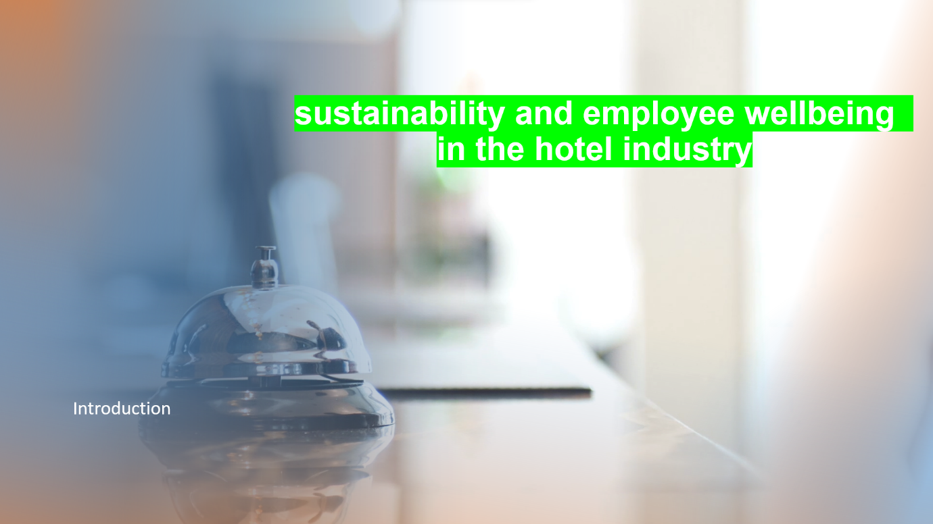
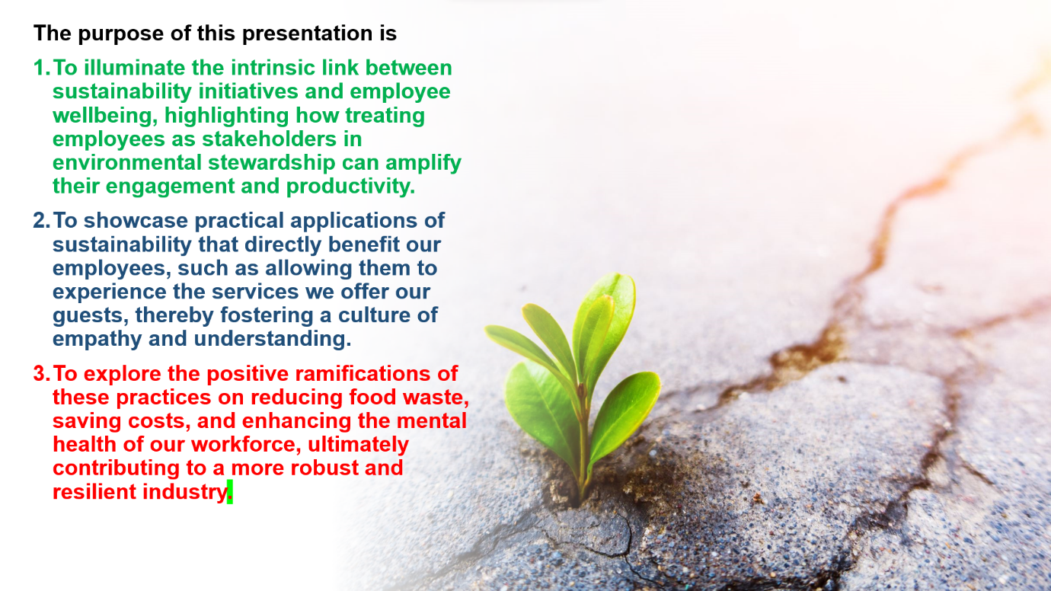
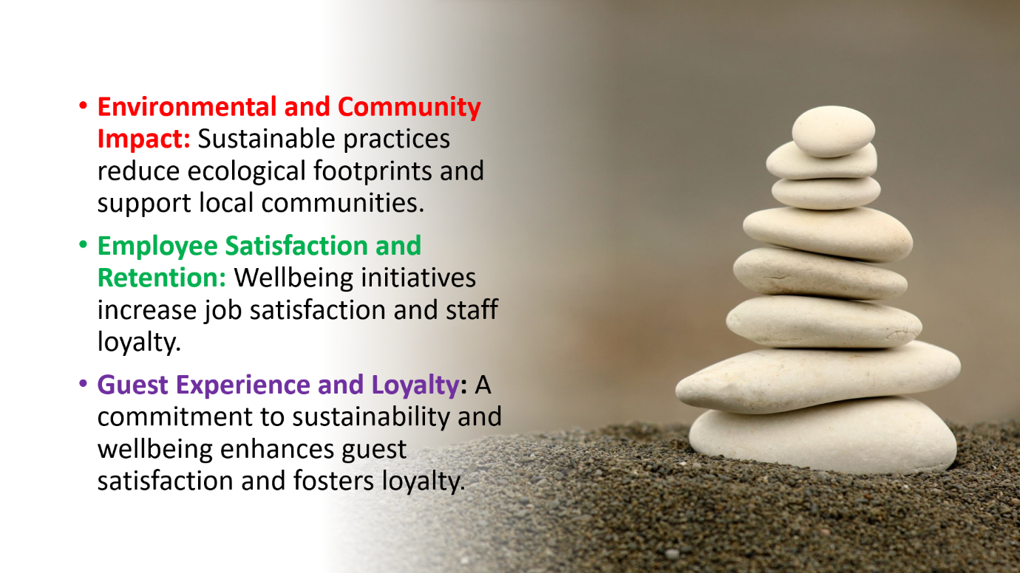
Sustainability in our industry extends beyond caring for the environment—it's about fostering a culture of conscious living that benefits our guests and our workforce alike. As global awareness of ecological and social issues grows, our sector is poised to lead by example, incorporating sustainable practices into our daily operations to positively influence both the planet and the people.
Wellbeing is critical, particularly post-pandemic, evolving from a luxury to a fundamental necessity. Our employees, the heart of our hospitality services, directly influence guest experiences. Prioritizing their wellbeing ensures they feel appreciated and supported, enhancing the quality of service they provide.
In unison, sustainability and wellbeing are powerful drivers for the advancement of the hospitality industry. Let's embrace these not as passing trends, but as vital elements for our enduring success.

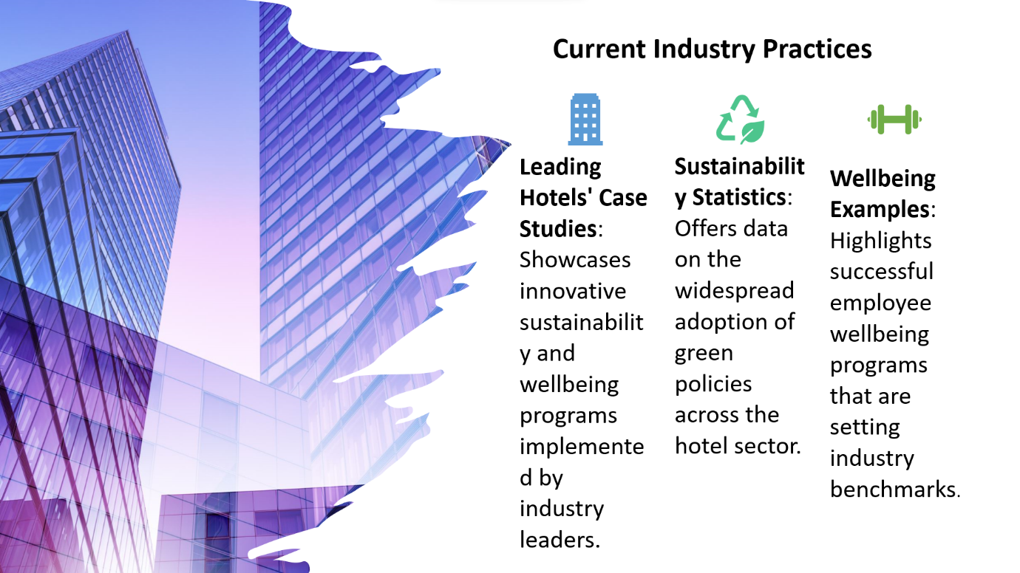
Benchmarking Industry Practices
In the realm of current practices within the hospitality industry, there is a treasure trove of case studies from leading hotels that exemplify the integration of cutting-edge sustainability and wellbeing initiatives, with comprehensive statistics indicating a positive trend in the adoption of eco-friendly and health-cantered practices, alongside a myriad of innovative wellbeing programs that are being embraced to bolster employee satisfaction and redefine the standards of guest services

Treating employees as guests embodies a philosophy where monthly benefits are extended to staff, allowing them to experience and appreciate firsthand the very services and amenities they provide. This initiative not only enhances their understanding of the guest experience but also serves to improve service offerings through a robust feedback loop, ultimately fostering a culture of continuous improvement and empathy within the hotel sector. It cultivates a shared experience between guests and employees, encouraging a deeper connection to the hotel's mission and values, and empowering employees to contribute to service development and refinement with their unique insights.


Tackling Food Waste - A Dual Benefit Approach
Adopting a dual benefit strategy, our food waste reduction efforts engage employees in environmental stewardship, which not only conserves resources but also provides them with tangible economic and mental health benefits, thereby reinforcing the value of sustainability initiatives within our workforce.
This approach to reducing food waste encompasses strategies that not only lessen the environmental impact but also actively involve employees in sustainability efforts, thereby fostering a sense of ownership and responsibility towards eco-friendly practices. By giving employees the opportunity to take home food that cannot be served to guests, the initiative provides economic benefits and contributes positively to their mental health. This proactive stance on food waste contributes to a more sustainable operation, reduces costs, and demonstrates the company's commitment to its staff's wellbeing, creating a win-win scenario that supports the environment and enhances the employee experien
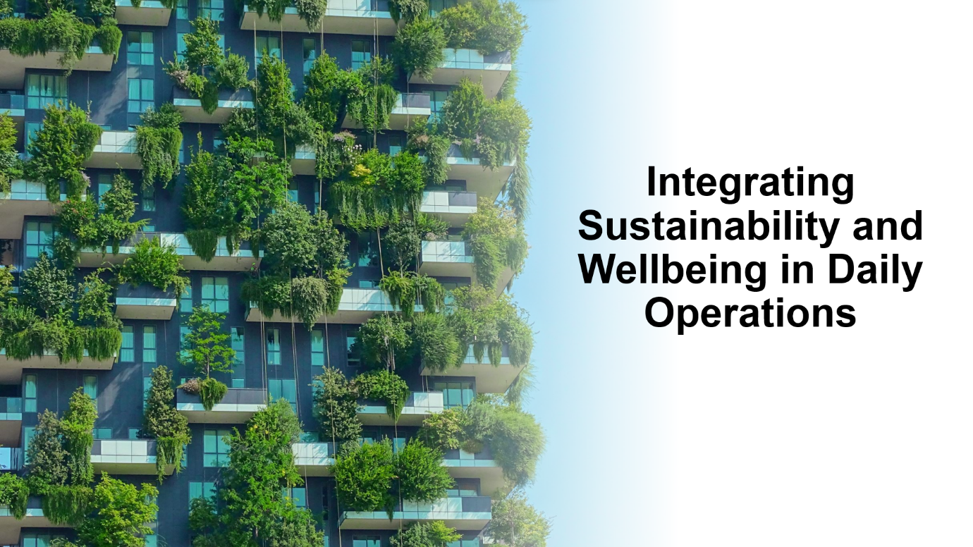
In the hotel and hospitality sector, embedding sustainability and wellbeing into daily operations involves actively engaging employees in eco-friendly services, rolling out comprehensive training and awareness programs, and establishing robust monitoring and reporting mechanisms. This holistic approach ensures that sustainability and wellbeing are not just concepts, but actionable practices that every team member understands, participates in, and benefits from, leading to a culture where environmental consciousness and employee welfare are cornerstones of everyday business.


Evaluating future policy and management options requires developing inclusive policies that reflect the diverse needs of both the environment and the workforce. It entails setting clear, measurable goals and objectives to track progress and success in sustainability and wellbeing. Moreover, embracing technological solutions can streamline these initiatives, providing innovative ways to enhance efficiency and engagement. These strategies will guide the hotel industry in adapting to changing global standards and expectations, ensuring a resilient and responsible business model.


stands as a testament to sustainable success in the hospitality industry. It operates with renewable energy systems, water-saving mechanisms, and food waste reduction programs that involve staff directly, offering them food that cannot be sold. This hands-on approach has led to a stronger environmental commitment among employees, better guest experiences, and numerous accolades. Positive staff feedback and customer reviews highlight the dual benefits of this model: operational efficiency and a boost in satisfaction across the board.
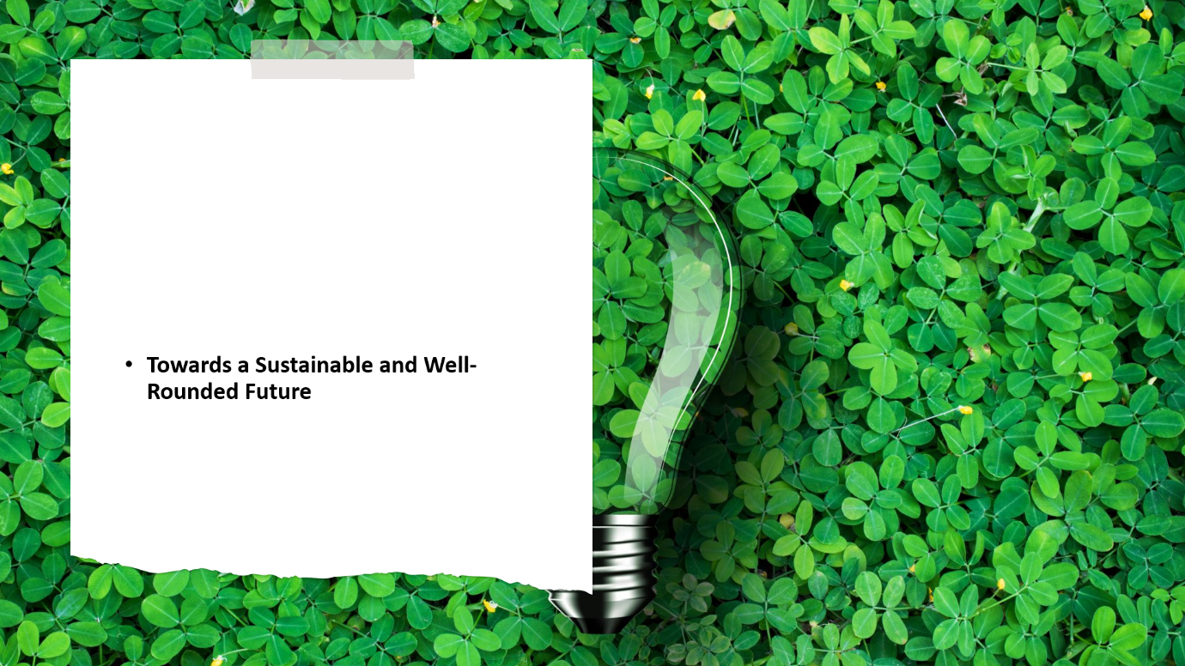
In conclusion, our journey through the interconnected realms of sustainability and employee wellbeing has highlighted their critical importance to the future of the hospitality industry. We've seen how leading hotels are setting the pace, adopting eco-friendly practices and wellbeing initiatives that not only benefit the environment but also enhance the lives of their employees. These actions, in turn, elevate the guest experience and foster brand loyalty.


- Acknowledging Sources and Further Reading
In the spirit of academic rigor and continuous learning, I would like to acknowledge the rich tapestry of sources that have informed today's discussion:
- Academic Journals and Articles: These provide the empirical evidence and theoretical frameworks for sustainability and wellbeing practices. Key journals include the International Journal of Hospitality Management and the Journal of Sustainable Tourism.
- Industry Reports and Sustainability Indexes: Reports such as the Cornell Hotel Sustainability Benchmarking Index and publications by Greenview offer valuable insights into industry trends and benchmarking data.
- Books and Thought Leadership on Hospitality Management: Titles like "The Heart of Hospitality: Great Hotel and Restaurant Leaders Share Their Secrets" by Micah Solomon and "Sustainable Hospitality and Tourism as Motors for Development" by Willy Legrand offer in-depth perspectives on integrating sustainability into hospitality management.
- 3. Bramwell, B., & Lane, B. (2013). Sustainable tourism and the evolving roles of government planning. Journal of Sustainable Tourism, 21(3), 287-305.
- 4. Gössling, S., Scott, D., & Hall, C. M. (2016). Tourism and water: Interactions and impacts. Channel View Publications.
- 5. Weaver, D. B. (2011). Sustainable tourism. Routledge.
- 6. Gursoy, D., Chi, C. G. Q., & Lu, L. (2010). Antecedents and outcomes of travellers’ information search behaviour in the context of travel planning. Journal of Travel Research, 49(3), 266-276.
- 7. Hjalager, A. M. (2010). A review of innovation research in tourism. Tourism Management, 31(1), 1-12.
- 8. Sigala, M. (2017). Collaborative commerce in tourism: Implications for research and destination management. Tourism Management, 58, 51-62.
- 9. Kim, S. S., & Ritchie, J. B. (2014). Cross‐cultural validation of a generalized perception of success scale. International Journal of Tourism Research, 16(6), 594-604.
- 10. Tew, C., & Barbieri, C. (2012). Sustainable Culinary Systems: Local Foods, Innovation, Tourism, and Hospitality. Routledge.
- 11. Gössling, S., Scott, D., & Hall, C. M. (2017). Tourism and water. Channel View Publications.
- 12. Bramwell, B., & Lane, B. (2015). Tourism and regional development: New pathways. Routledge.
- 13. Gössling, S., Scott, D., & Hall, C. M. (2018). Tourism and water: Interactions and impacts. Channel View Publications.
- 14. Sigala, M. (2015). Greening the tourist industry: Sectoral report on the policy implications of the environmental impact of tourism. European Parliament.

