Name: Cristian Ioan Spridon
Student number: 2118625
Module code and title: BMSW4002 Effective Team Working and Communication
Lecturer: Akash Puranik
Title: Component 1 Effective Teamworking for team success

Table of Contents
Introduction 3
How can you develop an effective team, and what theoretical model can be used? 3
What are the types of roles that are needed to create an effective team? 5
What type of impact can effective teamworking have on team success? 6
What are the barriers to effective teamworking identified in this scenario? 7
Conclusion 8
References: 9

Introduction
The following report aims to analyse how to develop an effective team and what theoretical models can be used, what are the types of roles for an effective team, what impact can have an effective team working on the team’s success and what are the barriers to effective teamworking. By analysing the case study of Next Plc, a company that is trying to launch a children’s wear line on an international level, the report will also propose how to solve the barriers on team working for an international team.

How can you develop an effective team, and what theoretical model can be used?

Teamwork is defined by Science Direct (2020) as a coordinated collective action resulting from the participation of all team members, effective communication, inspired confidence and the power to anticipate other people’s demands. In order to create a high-performance team, Page (2022) identifies six steps that need to be considered for an effective team such as defining the purpose of the team and the overall outcome, assembling the team with members that have complementary skills and abilities, determining the goals through deadlines and milestones, setting the expectation for each member and the whole team, monitoring and reviewing their activity, and celebrating and rewarding the work. An effective team is different for each company, but the main qualities include interdependence, trust, openness, decision making, conflict solving, a sense of ownership for the work, using individual talents for the team objectives, encouraging members to develop new skills and shared goals (Rose, 2022). In order to create an effective and efficient team, the new member has to pass through the five stages of team development proposed by Tuckman in his theory. The five stages proposed include the forming stage, where people get to know each other and their tasks, the storming stage, where the people may start to disagree, and leaders may appear, and the norming stage, where the team finally settles down and starts to work together, the performing stage where everyone is confident and motivated and finish the project, and the adjourning stage when the project is finished, feedback is received, and people move forward (Fresh Books, 2021).

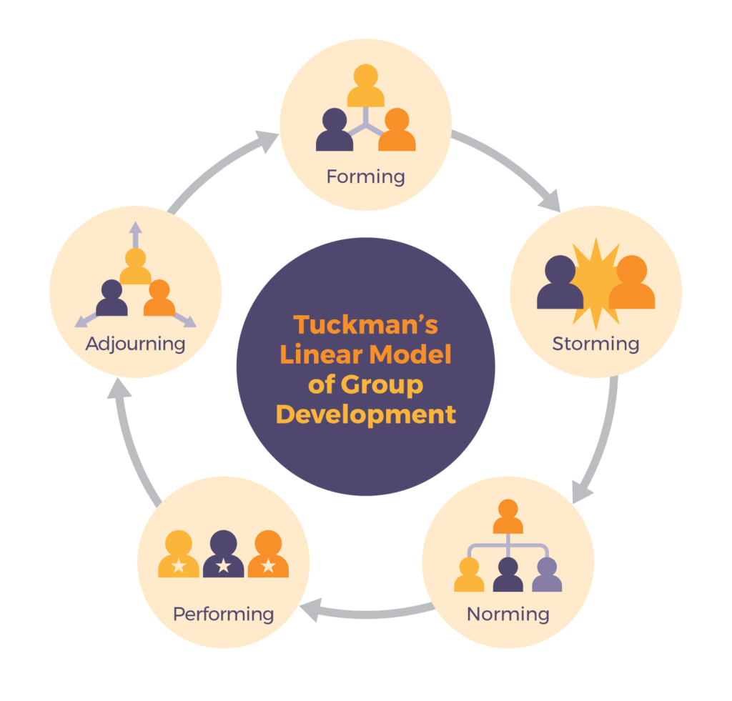
Image 1 – The stages of Tuckman’s Model

Another theoretical model that can be used in teams is Belbin’s theory, a theory that was created to examine the roles each member of the team has and how it contributes to the success of the project. The nine roles identified by Belbin include the resource investigator, the team worker, the coordinator, the plant, the monitor evaluator, the specialist, the shaper, the implementer and the finisher.

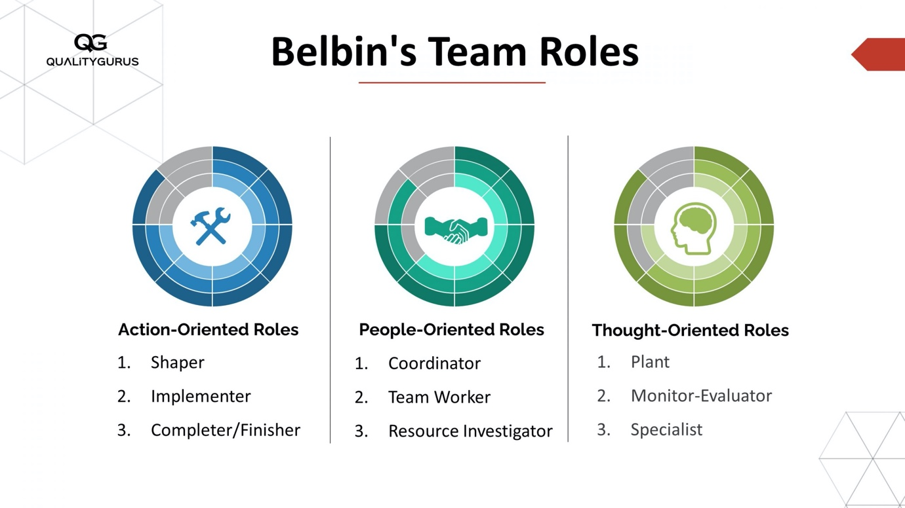
Image 2 – Belbin’s team roles

Although there is a large number of theoretical frameworks that can be used in order to create and develop an effective team, the most famous ones include Tuckman’s model, Belbin’s theory, the DISC model that divides the traits of the members into dominant, inspired, supportive and compliant, and the GRIP model that identifies the most important components of a team such as the goals, the roles, the processes and the interpersonal relationships (BC Campus, 2022).

What are the types of roles that are needed to create an effective team?

As identified before within the theoretical framework, Belbin defines very well the roles that can be encountered in teams, such as the resource investigator, the team worker, the coordinator, the plant, the monitor evaluator, the specialist, and the shaper, the implementer and the finisher. A more simplified version identified that there are only four roles in a team, the leader, which is responsible for providing direction and motivation for the team, the facilitator, which is responsible for helping the team make decisions, the coach, that provides training to each member of the team and the member who participate in meetings, do their assignments, brainstorm, create ideas and provide support (Quality Gurus, 2022). Indeed (2021) identifies that there are ten types of roles that groups in the workplace need roles that are divided into procedural roles, social-emotional roles and task roles. The main roles include the facilitator, who is usually the leader and has the responsibility to create the objectives and ensure that people in the team know what they need to do, and the initiator, which is also known as the problem-solving person that always comes with ideas and suggestions, the arbitrator that aims to reduce conflict, the notetaker who seeks to record every meeting and take notes, the coach who brings support to the team members and has a lot of knowledge about the roles and objectives of the team, the coordinator that helps people work together, the evaluator who analyses the KPI's in order to make adjustments in the team, the compromiser that aims to create solutions to compromise in case of a conflict, the gatekeepers which aim to improve communication in the team and the critic that see multiple perspectives before taking a final decision.
Based on the case study of Next, although the project manager has successfully set up the team, he needs to continue his leadership role in order to drive the team to a successful launch, not allow people to step over him and dominate the conversations and make sure everyone is being heard and participates in the discussions.

What type of impact can effective teamworking have on team success?

Teams in a modern company are a must, especially in bigger companies that work on projects, with teams being diverse, digital and dynamic. Hackman started studying teams and their behaviours in the 1970s, with conditions identified by him still being followed nowadays, conditions such as a good direction, a strong structure and a supportive context. Effective teamwork can be easily identified through people and their dependence on each other, the encouragement to express openly, the feeling of ownership for the success of the team, the encouragement to use their own talents, the open communication, the learning on the job and developing new skills, the decision making of the whole team and the constructively solving conflicts (Rose, 2021).
Teamwork can have a big number of benefits on individuals, but also on the whole company, and sometimes it can be more beneficial to work as part of the team rather than alone. Some of the benefits of working in teams, as identified by Middleton (2022), include identifying better solutions for problems, increasing the potential for innovation and creativity, increasing happiness and productivity in employees, enhancing personal growth, feeling less stress and burnout, encountering more opportunities to grow, boosting productivity, being smarter about the risks taken and making fewer mistakes. Teamwork does not only bring benefits for employees but also for the company by improving the overall productivity of the company, a greater synergy and cooperation, a better and increased innovation, more engaged employees, flexibility, overcoming obstacles easier, improving services levels, gaining fresh perspectives, building trust and simplifying conflict resolution (Bit.Ai).
In the presented case study, it is even more complicated to work as a team when the members are dispersed around the world, but digital innovation is making everything easier. The challenges identified in the team meetings are usually experienced due to the fact that the screens cannot represent correctly all the emotions and feelings people have, and the communication is limited. Some members tend to dominate the discussion, so one of the best strategies for the manager is to have individual conversations with each team member in order to understand them better and apply the feedback received for future digital meetings. Another strategy could be ensuring that at least once before the launch, the whole team meets in person at a destination that is suitable for all the members.

What are the barriers to effective teamworking identified in this scenario?

Indeed (2022) identifies that some of the barriers normal teamwork can identify during their cooperation include ineffective leadership, confusion of the goals, bad communication, no trust in the colleagues, inequitable decision making, the size of the team, accountability problems, poor skills in solving problems, physical separation and lack of incentives. On the other hand, the Next team is not a normal team that works at the same office, but a range of people working from different parts of the world, with different schedules. Some of the extra barriers added to an international team include language barriers where some people might express themselves better than others in English, cultural barriers, especially in the workplace environment, a big lack of trust because the employees cannot see each other, a reduced collaboration in the team, potential security risks and a difficulty in tracking the progress (Time Doctor, 2022). In order to solve the barriers to effective teamwork, the leaders need to make sure the team understands the roles of their members, establish open communication, develop relationships between the members, share information in order to fully understand the problems faced, align the people behind the company’s goals, arrange regular interactions between the team members and create opportunities for collaborations. In order to overcome the physical separation, the company needs to ensure the members meet face to face, especially at the beginning of the project, ensure good digital software and hardware for each member, establish core hours for different time zones, use chat tools and email notifications to get all the updates and encouraging people to work in pairs (Pabini, 2017).
In the case study for Next, it has been identified that there are some communication challenges during the team meetings due to some people dominating the meetings. Based on the barriers mentioned before, this problem could happen due to the language barrier where some people might lack the courage to express themselves, bad communication skills of certain people, lack of trust in the colleagues from different countries, also due to ineffective management or a manager who has poor problem-solving skills. The reduced collaboration is also an implication of the communication challenge, and some people tend to become leaders and overstep the manager.

Conclusion

In conclusion, the success of the team is the success of the manager and the success of the whole company. By analysing and applying all the tools and theoretical models for effective teamwork, a manager can drive their team to complete the project successfully even in an international environment where multiple barriers are standing in the way of it. Teamwork has been proven to be the most efficient way of working, especially in the bigger companies and launching a new line on an international market cannot be successful without a good team of professionals behind it. Next Plc can have a successful launch if the team puts aside their cultural differences and work together, and the manager leads with involvement and structure.

References:

BC Campus (2022) Five models for understanding team dynamics, available at: https://pressbooks.bccampus.ca/technicalwriting/chapter/understandingteamdynamics/ (Accessed at: 18 Jun 2022)

Belbin (2022) The nine Belbin team roles, available at: https://www.belbin.com/about/belbin-team-roles (Accessed at: 18 Jun 2022)

Bit.Ai. (2020) Top 10 benefits of teamwork you must know, available at: https://blog.bit.ai/benefits-of-teamwork/ (Accessed at: 21 Jun 2022)

Fresh Books (2021) Tuckman’s theory: five stages of team development, available at: https://www.freshbooks.com/hub/other/tuckmans-theory (Accessed at: 18 Jun 2022)

Indeed (2021) 10 Group roles for workplace teams, available at: https://www.indeed.com/career-advice/career-development/group-roles (Accessed at: 21 Jun 2022)

Indeed (2022) 11 Common barriers to teamwork and how you can overcome them, available at: https://www.indeed.com/career-advice/career-development/barriers-to-teamwork (Accessed at: 27 Jun 2022)

Quality Gurus (2022) 4 types of team roles, available at: https://www.qualitygurus.com/4-types-of-team-roles/ (Accessed at: 27 Jun 2022)

Michael Page (2022) Building an effective team, available at: https://www.michaelpage.ae/advice/management-advice/development-and-retention/building-effective-team (Accessed at: 18 Jun 2022)

Middleton, T. (2022) The importance of teamwork, available at: https://www.atlassian.com/blog/teamwork/the-importance-of-teamwork (Accessed at: 21 Jun 2022)

Pabini, G.P. (2017) Overcoming barriers to collaboration, part2, available at: https://www.uxmatters.com/mt/archives/2017/11/overcoming-common-barriers-to-collaboration-part-2.php (Accessed at: 27 Jun 2022)

Rose, D. (2022) 8 characteristics of an effective team, available at: https://skillpath.com/blog/8-characteristics-of-an-effective-team- (Accessed at: 18 Jun 2022)

Science Direct (2020) Teamwork, available at: https://www.sciencedirect.com/topics/medicine-and-dentistry/teamwork (Accessed at: 18 Jun 2022)

Time Doctor (2022) 8 virtual team advantages and 6 disadvantages, available at: https://biz30.timedoctor.com/virtual-team-advantages-and-disadvantages/#cons (Accessed at: 27 Jun 2022)

