Analysis of Results
Introduction
Analysis of results is vital when concluding a research project. This valuable information aids in finding common themes with expectancy to procure a conclusion from the results.
The previous chapter of this research project was the methodology. Within that chapter, it was outlined how a questionnaire/survey would be devised in order for the retrospective collated results to be analyzed as numerical data to find patterns and sequences (Mathers, Fox and Hunn, 2009).
By using the positivism research philosophy, this chapter aims to effectuate the primary data from the submitted surveys, to discuss the findings and achieve the objective of this research project
‘Has the role of a response officer has changed from fighting crime to safeguarding and welfare’
Data Analysis
The Survey platform ‘Survey Monkey’ (SurveyMonkey, 2021) was used in order to devise the questions. The survey consisted of ten closed questions devised around the topic area of safeguarding, public protection, crime fighting, the change in role of a response police officer and the perception of the role as a police officer in today’s society. The survey questionnaire link was sent via Email over the internet.
Demographics and Descriptive Statistics
The survey was sent to 50 serving police officers to obtain answers with the independent variable being that safeguard is incorporated into response policing and the dependant variable being the perceived opinion of how a response police officer’s role has changed in regards to safeguarding. The survey was sent to officers with varied years of experience on response policing. This was the moderating variable; that being, the number of years’ experience effected thoughts surrounding safeguarding and comparing safeguarding now to how it has changed from years ago when they first started. Before all surveys were returned, the tentative suggestion was that the more service a response police officer had, the more safeguarding was thought of as ‘extra process’ and change from the way response policing used to be. Safeguarding ‘is part of’ response policing and ‘is as important’ as fighting crime (Jen, 2021).
Even though 50 surveys were sent out, only 44 were returned. 6 officers did not fill the survey out in time. Only 40 responses could be analysed due to Survey Monkey only allowing to ‘free of charge’ analyse 40 responses.

Questionnaire Findings
Q1 - How many years’ service do you have as a response police officer?

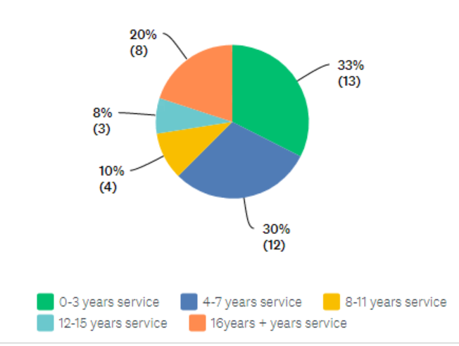
When analysing the 40 responses, this question demonstrates that the largest amount of responses from the police officers participating was those with 0-3 years service; 13 out of the 40 replies. Older in service officers, those with over 16 years’ service, was made up of 8 responses. As discussed in ‘The Conversation’ article, Sarah Charman calls newly recruited officers #newbreed of police officer. Charman followed new recruits, researching for four years and found that ‘communication and empathy rather than authority and physical strength’ was the general consensus rather than ‘crime fighting’ and ‘upholding the law’ found in the older police culture (Charman, 2018).

Q2 - Safeguarding plays a key role in response policing
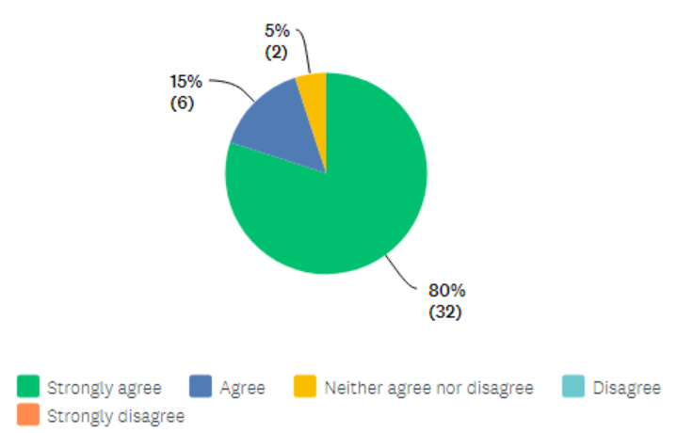
Evidently, when looking at the results of this question, 80%, 32 out of 40 respondents, strongly agreed that safeguarding plays a key role in safeguarding. No officers disagreed to this statement indicating that however long in service a response police officer has, or whatever opinion of safeguarding and public protection an officer has, it is understood and is the general conformity that safeguarding is a key role.
Q3 - Safeguarding takes precedence over crimes in response policing
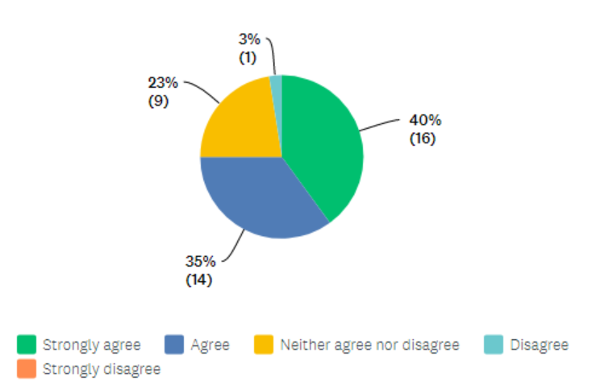
This question allowed responders to express a more opinionated answer rather than factual. The information shows that 40%, 16 out of the 40 respondents strongly agreed that safeguarding takes precedence over crimes with on 1 officer disagreeing with this statement. 23%, 9 officers neither agreed nor disagreed with this statement.
Q4 - Dealing with partnership agencies during and after response policing calls is time consuming
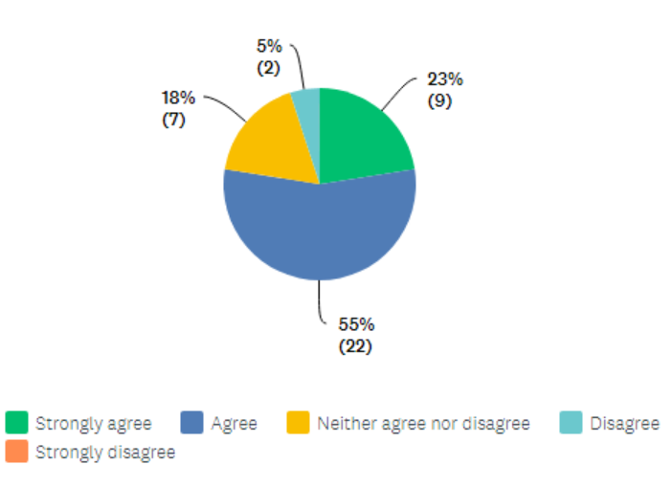
Again, this question is more opinionated rather the factual. There are no available statistics from South Wales Police to indicate the ‘actual time’ response police officers spend either talking on the phone or speaking face to face with partnership agencies during or after incidents. The strength of strongly agreeing was 55% in comparison with 5% of officers disagreeing. Many factors including experience with certain safeguarding sectors and personal experience with an individual within a partnership agency may have an effect upon the judgement in regards to ‘time consuming’.
Q5 - A response police officer's job role has changed from answering crime related calls to answering calls regarding social care issues (including mental health, housing, welfare, health issues, vulnerability, drug/alcohol abuse etc)
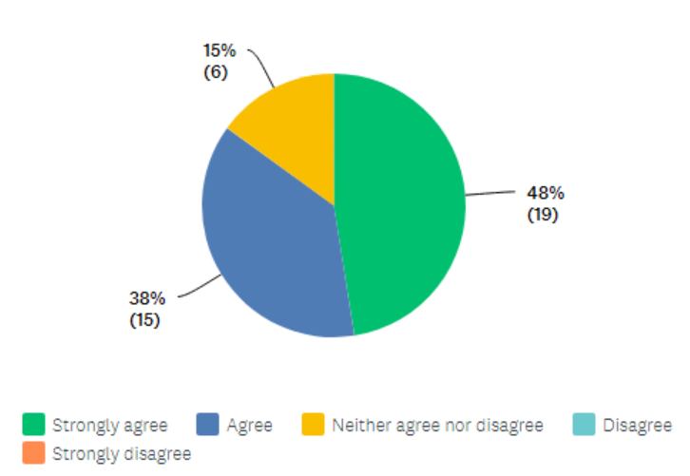
The response for this question indicates that the majority of officers agree with this statement. A combined score of 86% displays that officers believe the role of a police officer in regards to answering crime related calls has changed to social care issues. Incidents reported to the police control room by the public including non-crime, mental health, public protection and safeguarding, now account for a staggering 84% of incidents reported to the police in the UK (Ford et al., 2019). Andrew Millie (Millie, 2012) suggests that policing have made mandatory changes historically but more evident since 1990’s. This is due to encompassing more a more diverse public demand as well as advancement in criminal activity such as terrorism, internet based crimes and recognition of public protection with crime prevention and crime based reduction.

Q6 - Partnership agencies rely on response police to complete welfare checks (eg. Child welfare checks, mental health)
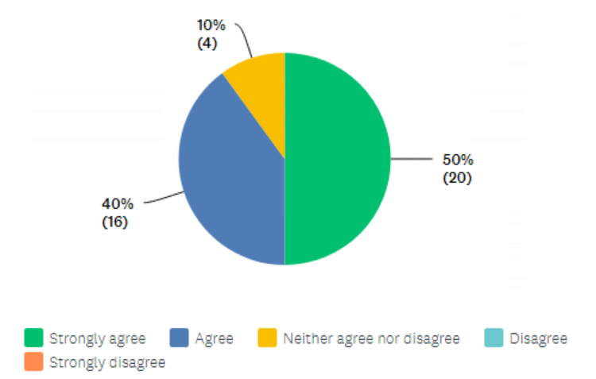
When analysing the data of the 40 respondents, 50% strongly agreed to this statement, with a further 40% agreeing. Only 4% neither agree nor disagreed that partnership agencies rely on response police officers to conduct welfare checks. No officers disagreed with this statement. Norfolk Police ‘welfare check’ policy stated that ‘the ‘welfare check’ term has common across all UK police forces. The police attend to a vulnerable person or a person at risk, when a request has been made by a partnership to conduct a welfare check. However, Insp R.Salmon states that ‘checking welfare is not solely the responsibility of the police; other agencies also have a role to play’ and ‘the police have finite resources. Requests to complete welfare checks which should be the responsibility of other agencies can increase the risk of harm to those needing police support elsewhere’ however are in strong support of working together with partnership agencies as police policy states as well as embracing the Early Action Together scheme and other public sector assistance such as education, health and social services (Salmon, 2018).
Q7 - PPNs are time consuming in the response police officer's tour of duty
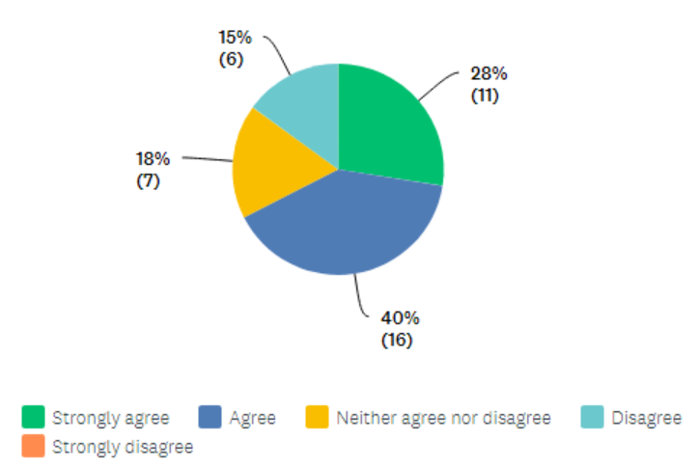
The officers responded by 27 of them strongly agreeing and agreeing with this statement. 6 officers disagreed with this statement believing that PPN’s are not time consuming. With a population of approximately 150,000 people, a welsh local authority, reported that nearly 3,500 PPN’s were submitted by the police during a one year period (Ford et al., 2019) Public Protection Notifications have been circulating in a certain fashion since Pace 1984. They have been renamed several times over however, since new legislation, such as the Wellbeing of Future Generations (Wales) Act 2015 and the Social Services and Well-being (Wales) Act 2014, the police have adapted the public protection notifications, introducing MASH teams (Multi-Agency Safeguarding Hub) to the police (Ford, Kelly, Evans and Newbury, 2017).
Q8 - Social media and the public has played a significant role of how response police officers deal with safeguarding issues
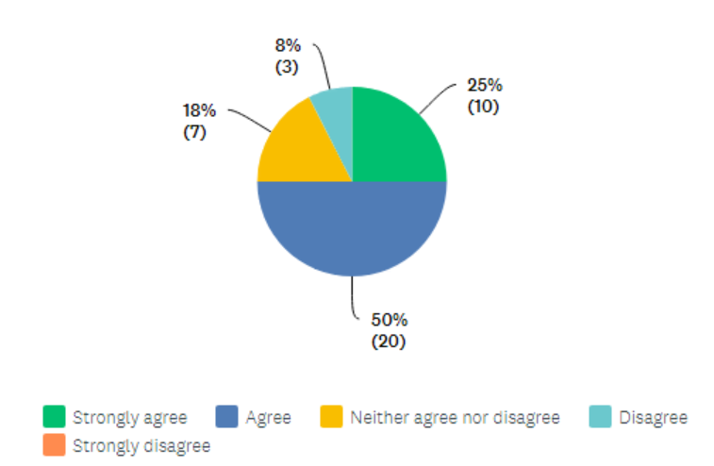

Even though social media aids police, providing positivity in many ways such as helping to find missing persons and crime awareness however, response police officers could be dealing with an incident of public protection and within 2 seconds, the incident can be posted online providing a negative, misjudged perception of the incident (Jones, 2011). This is indeed why some police officers will act differently due to the perception involving social media. The responses in this question indicate that 75% of those officer asked strongly agreed and agreed in with this statement with only 8% disagreeing. 18% of those officers asked neither agreed nor disagreed- this could be down to having little experience of negative or positive police influence in regards to social media.

Q9 - Safeguarding is a response police officer's current main role and not that of dealing with the initial crime
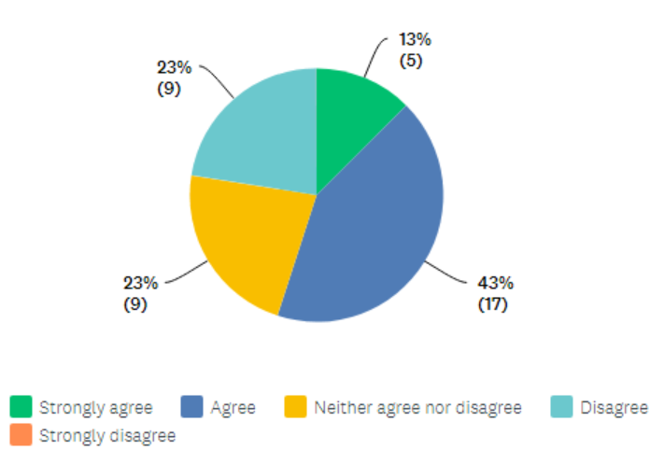
The respondents answered by only 5 officers strongly agreeing with this statement. However, 17 officers agreed with safeguarding being a response officers’ main role with 9 officer neither agreeing nor disagreeing. The relevance of this research project ‘Has the role of a response officer has changed from fighting crime to safeguarding and welfare’ has major relevancy to this question put to the officers to answer as even though safeguarding should come ‘hand-in-hand’ with crime fighting, only 9 officers answering this question disagreed with the statement.
Q10 - How response police officers deal with safeguarding, is dependent on the number of years’ service the officer has (in relation to younger in service officers having more initial training on safeguarding)
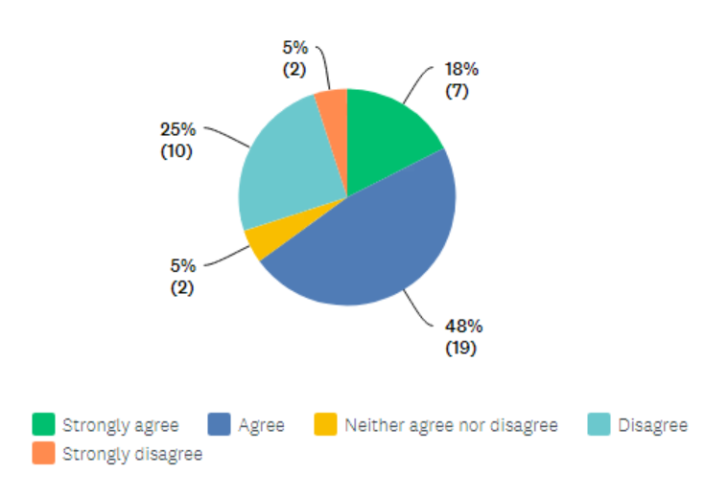
With 18% of officers asked strongly agreeing with this statement and 48% also agreeing with this statement forms many questions regarding police officers service length directly impacting the way in which safeguarding is dealt with. By more officers agreeing with this statement, does this suggest that newer in service officers deal with safeguarding incidents more appropriately due to more recent training and a younger ‘snowflake’ generational awareness? Does this indicate that older in service officers act appropriately in relation to incidents of safeguarding however, have had the same training in relation to safeguarding, just more of an experience with the general public. This is a very broad, generalized question that can be interpreted in different ways.
Conclusion
In conclusion, this chapter of the research project has successfully gathered 40 response police officers thoughts to closed questions (statements) put to them in relation to safeguarding. The findings of these results will be discussed in depth in the next chapter of this research project.

Word Count 1649

Bibliography
Charman, S., 2018. How new recruits are changing police culture for the better. [online] The Conversation. Available at: <https://theconversation.com/how-new-recruits-are-changing-police-culture-for-the-better-85221> [Accessed 30 September 2021].
Ford, K., Kelly, S., Evans, J. and Newbury, A., 2017. [online] Orca.cardiff.ac.uk. Available at: <https://orca.cardiff.ac.uk/134525/1/PHW%20Police%20&%20Crime%20final%20summary%20report.pdf> [Accessed 30 September 2021].
Ford, K., Newbury, A., Meredith, Z., Evans, J. and Hughes, K., 2019. [online] Orca.cardiff.ac.uk. Available at: <https://orca.cardiff.ac.uk/121110/1/0032258x19836144.pdf> [Accessed 30 September 2021].
Jen, 2021. What is Safeguarding and Why is it Important? | Care Check. [online] Care Check. Available at: <https://www.carecheck.co.uk/importance-of-safeguarding/> [Accessed 29 September 2021].
Jones, M., 2011. How Social Media Is Changing Law Enforcement. [online] GovTech. Available at: <https://www.govtech.com/public-safety/how-social-media-is-changing-law-enforcement.html> [Accessed 30 September 2021].
Mathers, N., Fox, N. and Hunn, A., 2009. [online] Rds-yh.nihr.ac.uk. Available at: <https://www.rds-yh.nihr.ac.uk/wp-content/uploads/2013/05/12_Surveys_and_Questionnaires_Revision_2009.pdf> [Accessed 29 September 2021].
Millie, A., 2012. The policing task and the expansion (and contraction) of British policing. Criminology & Criminal Justice, 13(2), pp.143-160.
Salmon, R., 2018. [online] Norfolk.police.uk. Available at: <https://www.norfolk.police.uk/sites/norfolk/files/welfare_checks.pdf> [Accessed 30 September 2021]
SurveyMonkey. 2021. SurveyMonkey - Free online survey software and questionnaire tool. [online] Available at: <https://www.surveymonkey.co.uk/welcome/sem/?program=7013A000000mweBQAQ&utm_bu=CR&utm_campaign=71700000059189067&utm_adgroup=58700005405718088&utm_content=43700049188975070&utm_medium=cpc&utm_source=adwords&utm_term=p49188975070&utm_kxconfid=s4bvpi0ju&language=&test=&gclid=EAIaIQobChMItL6p_6ar8wIVgp6zCh3uaQ0pEAAYASAAEgJIfvD_BwE&gclsrc=aw.ds> [Accessed 29 September 2021].

