Professional career development
BMSW4005
Term 2
Student name: Ana Maria Stanciu
Student number: 1909953
Lecturer name: Joy Botu


Table of Contents
Introduction 3
Self-reflection 3
Career plan development 5
Social care employment requirements 6
Self-motivation 7
Personal learning style 7
Personal development plan 9
What do social care do and employment requirements 12
Personal action plan 12
Reference list 12
Appendix 16

Introduction

Self-evaluation is the process where an individual evaluates on the job, subjective, accomplishment, outcomes, careers, and the procedures where he takes part. Because the evaluation takes part in the individual’s area of a chore, both the subject and the object of the evaluation is the individual itself.

My name is Ana and I am going to be the subject and the object of this self-evaluation. In my personal life, even if it sound shorter compared to other people’s life, I have experienced a multitude of positive and negative thighs that brought me here, experiences that I am proud of and experiences that I am not very proud of. One of the experiences that I am proud of is fact that I finally decided to continue my studies here in United Kingdom; experience not easy at al since I am from Romania and my mother tongue is Romanian. Back in Romania I left school when I was 19 years old then I went to work in Italy for four years. Seven years ago I decided to come in London following my boyfriend at the time, husband today. These seven years I have experienced a multitude of jobs; I worked in restaurants, hotels pubs and currently a self-employed beautician. However, I always thought of my self,
working with vulnerable people or troubled youth to try helping them go in the right direction because when I was really young I had an experience that resulted with me having to repeat my last year of high school and taking bad decisions. Likewise, I always thought that if I had the opportunity of having someone either experienced or educated to guide me at the time it would have been different. Therefore, the main reason that I am here doing this course is that I want to try and make a difference in someone’s life. The main reason that I have enrolled in the university is to concentrate and contribute to my career development plan.

Self-reflection
According to Dewey (1991), self-reflection can be defined as an effective, constant and comprehensive appreciation of any principle or presumed form of information in the glow of the reasons that fund it, and the additional decision to which it inclines. Furthermore, I have chosen Kolb’s reflective cycle because I founded more appropriate to my learning style.

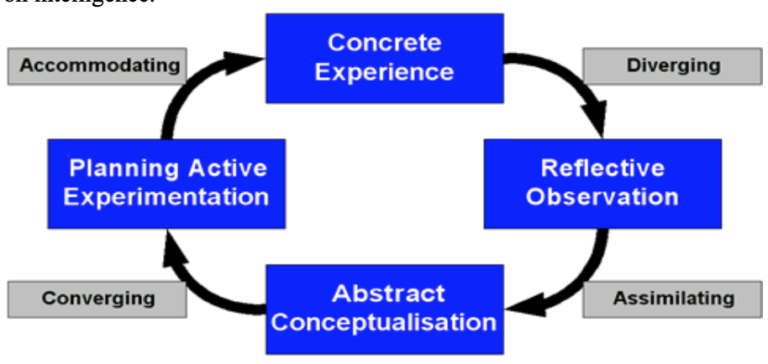
Kolb reflective cycle. Source: (Center for teaching, 2008)

Kolb’s (1984) reflective cycle in funded on Lewin, Dewey and Piaget learning styles and is an exploratory learning cycle. Kolb’s model is created by four phases and his principal is a modest explanation of the learning process which indicates how experience is summarized through an examination into theories which in the roll are utilized as mentors for effective experiment and the choose of new experience. Kolb learning style relates to these phases as:
- Concrete experience is the phase that describes the learner experience.
- Reflective observation is the phase that the learner reflects upon the above experience.
- Abstract conceptualization is the phase where the learner relates theory to the experience of what is to be examined.
- Active experimentation is the phase where the learner is trying to compare a strategy or a plan for the future (Learning south-west, 2006).
Since last year when I have started this course, I have gained a lot of knowledge about personal development, learning styles, self-awareness, CV writing, I have learn numerous strategies that were/are contributing to my career development. Furthermore, I have learned that the most important skill to possess in order to work in social care is empathy and active listening.

Even if I was enjoying very much as being part class, sometimes I had hard time concentrating because family, job and other external factor those contribute to my everyday thoughts. Those factors not only contributed to my everyday thoughts and stress but to my performance and level of conversation at school as well. I have started to notice that I started to be less interested in taking part of the in-class exercise and any team work that we had to do, where before I was extremely interested specially in doing team work because that was my opportunity to get to know my colleagues better since we where not doing much external socialization. For example, when we had teamwork exercise to do I was letting my colleagues to do the most of the work. After a while, I sit down and I reflected upon the situation that I was in, and I have decided to talk to someone about it, I knew we had councillors at school that we can freely talk with but on this occasion I have preferred to talk to one of my friends that she is a councillor herself and we close to. I have visited with her for a period of a few weeks and I have come back to how I previously was, excited about taking part in any school exercise and also I was able to focus again.

According to Krulik and Rudnik (1980), problem solving can be interpreted as the synthesis of each person’s knowledge and the ability to use the knowledge into a new circumstance. In my case witch I have talked about above, at the time it seemed obvious that I had a lack of problem-solving skills. On the other hand listening is the ability to be deeply committed to, and aware of what the lecturer has to say (Boston University, 2016). Likewise, my active listening was missing from my set of skills as well, since sometimes I was siting in classroom listening to the lecturer and suddenly realized that she has already advanced through several slides. Then suddenly realizing that I have missed a bunch of stuff that I did not understood as well.

In conclusion from all my experience I have leaned that in the future if I ever encounter similar situations I will have to try to solve personal problems before they interfere with my university or professional life.

Career plan development

According to Douglas (no date), a career plan is a perceived progression of behaviours and manners correlated with work events and actions over the interval of the individual life.

Current job role |  | Long term career aspiration
- Provide individualized nail assistance and procedures to customers, such as manicure and pedicure.  - Remove before apply nail polish, shape and soften the nail edges, clean the nails, soften, lift back and cut nails cuticles, and apply polish onto nails. |  | - Volunteer for a social care job.  - To be a confident communicator.  - Finish my university.  - To get a job in social care sector.
Two years goals | Development needs |  | CPD Activities
Develop good problem-solving skills to be able to solve my future problems.  Develop good listening, emotional-awareness and management skills mean.  Finish my university.  Get a job in social care. | Revise active problem solving from term one.  Revise listening, emotional-awareness and management skills and attend classes Health and Social Care.  Attending classes, engaging in classroom.  After a year of volunteer work it should be easier to get the actual job. |  | Practice problem solving by doing volunteer work and confront others problem not only mines by September 2020.  Practice those skills by volunteer work September 2020 to October 2021  Succeeding on my assignments to graduate by October 2022.  Applying everything all my knowledge from Health and Social Care university and my practice from the volunteer work by November 2022.

Social care employment requirements

My plan for the next year is to begin working in social care as I have mentioned above on my personal career development. In order to be an effective employee in social care is not much requirement for a qualification or work experience to get a job as a social worker. To be able to work effectively it is very important to possess the right values, behaviour and attitude. Values in social care are believes and views that people hold about what is wrong and what is right. Likewise, this are the most important values required to work in social care:
- Dignity and respect
- Learning and reflection
- Working together
- Commitment to quality and care support
By now, I believe, that I can meet all the values enumerated earlier. Furthermore, I have dignity and respect and I can demonstrate that by attending to peoples desires, honouring their bounds, their intentions and opinions. I do possess good communication skills that will help me communicate well using satisfactory speech. I can accept and think about acknowledgements obtained at work and I am capable to learn from it, I am credible and straightforward and never frightened to admit that I have made an error. I also know my limits therefore, when I get stressed from a lot of work or difficult tasks I know that I need help. I can work in a team of people by being devoted and help others within the team, and I can comprehend and value that others can have different priorities and needs. Likewise, I am capable of giving people full attention, this is one of the things that I do in my current job as a nails technician as well as being calm, warm, reliable, emphatic and compassionate. I believe that I possess all the right values and I exercise those abilities every day in my current job as well as at school and my home life. Therefore, I am confident that I can be an effective social worker and I can meet the employer’s requirements.

Self-motivation

The force to do something or to carry on a complicated chore can be defined as a motivation (Ryan and Deci, 2000).
In my every day life, I am very motivated to get what I really want. A good example can be, despite the language barriers I have enrolled in a University in United Kingdom. Furthermore, I have intentions of finishing this University and graduate by pushing my self very hard to pass my assignments without any external help, because I believe that searching for information and reading a lot it will help me gain more knowledge about what I am really doing. In the first term we had a self-motivation exercise, which was saying that there is a difference in between wanting to do something and being motivated to actually do it two different things. And yes, I believe, that there is a huge difference between the two, at least in my situation is the self-motivation not the desire to do what I really want to. Likewise, I am very motivated to finish this university because I believe it will bring me an additional understanding of the job that I want to do in the future, and yet it will instruct me to be effective worker on my job, by teaching me the right skills that I need to possess and the way to communicate adequately with co-workers as well as with residents or people that I have to assist. They have been times as I have mentioned earlier in my personal reflection that external factors have interfered with my studies and my concentration on what I was doing at school. Due to those factors, I did have the tendency to quit because I thought I could not do it. Yet I believe that my self-motivation pushed me to go on. The fact that I do want to work in social care and the fact that I want to graduate were the two factors that were pushing me to go on. Therefore, regardless of the specific circumstances self-motivation will help me to learn and grow, accomplishing my ambitions and succeed in my journey.

Personal learning style

VAK learning style

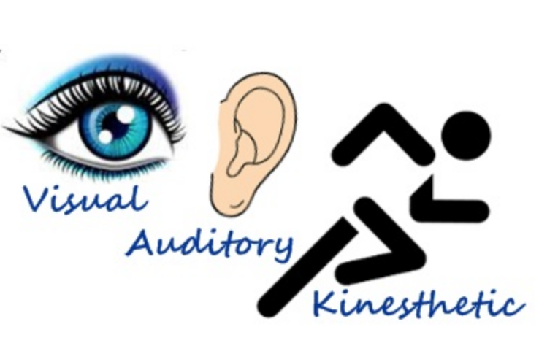
Source: The peak performance center (2020).

Fleming VARK is one of the most popular and widely-used authorization of the many models of learning styles, founded on the sensorial modalities which are pertained on grapping in data, delivering the student with a form of their learning style. This model was an improved based on neuro-linguistic programming models. In neuro-linguistic programing, feelings are divided into three denominations such as Visual, Auditory and Kinesthetic, which are related to as Representational System. This term suggests that the brain utilizes feelings to crate our interior manifestations or criterion of the world around us. Ever so often people have various ways to learn, which can very well be the three of the criteria’s. While some people have dominant preferences others can have a mixture of two or three learning styles. Simply when an individual understands their learning style they can decide how to learn. Just if each individual is born with particular inclinations of a learning style, young kids are all kinesthetic learners. During their childhood, they progress through many types of learning styles until they develop a dominant or multiple styles. Furthermore, the aspects of the three learning styles:
- Visual learning is the learning style where seeing things learn the information and according to the literature more than half of the population are visual learners.
- Auditory learning is the style where seeing makes the learning process or listening to information and this type of learning has it only a quarter of the population.
- Kinesthetic learning is the style where the learning is made by carrying out a physical activity, by doing the task rather than seen it or listen to it, and this type of learners are very few (Sreenidhi, S. K. and Tay, C. H., 2017).
I thought that the best way of reflecting upon this learning style is to do one of the VAK quizzes. Therefore, I did the VAK quiz that we had on Moodle and its been handed to us on the first term by the lecturer (please find my answers to the quiz in appendix). By doing the quiz I have found that I am a visual learner which means that I best learn be seeing how things should be done. Not only at the school but also in my work and daily life, I can easily recall things if I see them rather than if they have been explained to me. In addition to that I can say that during these two terms I have observed that every time the lecturer has explained my capacity of recollection was less than when she has shown haw to do the specific exercise. For example, I recall that the lecturer ones, among other explanations and things that se was doing for us in the classroom she has shown us a video about how to reflect on Honey and Munford learning style. When she has asked us to reflect on the learning style just mentioned it was fairly easy for me because I have already seen how to di it and I was remembering pretty much every word that has being said in the video. Likewise, I can say that I have better recollection of what has been shown to me than what has been explained during the two terms.

Personal development plan
Johary window

Joseph Luft and Harry Ingham in 1950, two Americans psychologists, created Johary window, naming it Johary after bending their first names Joe and Harry. This model is an easy and beneficial method utilized to comprehend and expand self-awareness, personal improvement, communication skills, interpersonal associations, team growth and intergroup relationships. The impact of soft abilities such as behaviour, compassion, partnerships, inter-group improvement and interpersonal growth makes the model to be particularly useful. Johary window is a message processing method that is utilized as a model of self-awareness using exposure and response about an individual in connection with others, from four viewpoints. The four areas that represent and contain the information are known as:
- The open area that contains the personal information known by individual and others.
- The blind area where the information it is known by others but not by the individual himself.
- The hidden area where the personal information it is known by the individual and hidden from others.
- The unknown area is the area that contains skills or abilities that are unknown both by the individual and others.

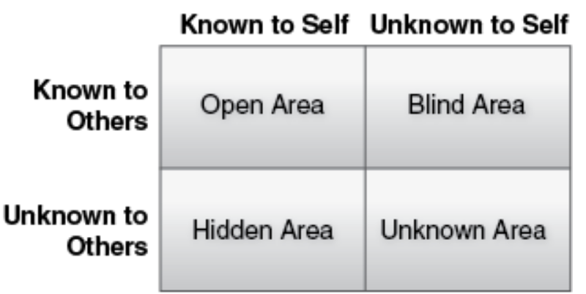
Johary window. Source: Salisbury M. D. (2017).

In a new team, the open area is always small but it grows as the individual starts to share information about him. The blind area neither beneficial nor profitable for an individual because contains matters that others are intentionally refusing from the individual. Aspiring or asking for feedback from others and thereby improving the open area can diminish this area. Yet the hidden area, which is formed by personal information’s, that individual is holding from others can be reduced in size only by disclosure by the individual himself. In this case, the disclosure has to be done constructively because it can bring disrespect to the individual from others or not, depending on the situation. The unknown area it is formed by information, feelings, abilities, aptitudes and experiences that are unknown by both the individual and the other people. Here it has to be a process of self-discovery in order to enlarge the area.
SWOT analysis

Strengths | Weaknesses | Opportunities | Treats
- Good communication skills  - Hard-working  - Ambitious | - Lack of time management  - I am too good with people and sometimes that can be taken as a weakness  - Emotional and nervous | - Enrolling into university gives me the opportunity boost my knowledge and improve my skills  - Working for my self has given me the opportunity to be independent and also to build management skills | - Family life can sometimes get in the way of my studies  - The fact that I tend to procrastinate things is not helping me at all because I am all most all the time behind with getting work done  - I am very emotional and nervous when I have to present something or to say something in front of a lot of people and that can affect me sometimes as it has happened in the past when I had to do a power point presentation. I got really nervous and I almost forgot everything.

What do social care do and employment requirements

My plan for the future as I have mentioned, before is to finish my studies, graduate and get a job in social care. The objective of a social worker is to facilitate human being rights and wellbeing, help people with social and interpersonal complications. (BASW, 2020). To become a social worker according to BASW (2020), there is a requirement of degree in social work (BA), which is my plan for the future, to graduate at University Trinity Saint David. Furthermore, the experience is required and for this I am planning on volunteering as a social worker to gain experience and knowledge about the job.
The benefits of working in social care from my perspective, despite the fact that it will bring me self-satisfaction, salaries are in between £22.000 and £40.000 per anum, which I believe is satisfactorily. Likewise, paid travel expenses for trips made on business purposes, flexible working hours and paid holidays.

Personal action plan

What do I need to improve? | What will I do to achieve this? | What support will I need or resources? | What will my resources criteria be? | Target date for review
How to defeat procrastination  To learn how to be less generous with people  To learn how to be less emotional and nervous | Select and schedule duties  Stop giving up my time and skills  Stop acting right away and chose courage over confidence | Either asking my husband to check up on me or rewarding my self with something that I really want.  Find a good reason to decline people desires from me  Learn how to be patient and learn how to breathe my way through it | Prioritising duties, and begin them early  To focus more in what I am receiving rather than what I am giving  Learn to replace my thoughts and learn my strengths | By the end of 2020  By 2022 since this is the hardest thing to do for me, in fact I am not confident that I will succeed  By June 2021

Reference list

BASW (2020), The professional association for social work and social workers, How to become a social worker. Available at:
- https://www.basw.co.uk/resources/become-social-worker/how-become-social-worker (Accessed: 8 May 2020).

Centre for teaching (2008), [online]. Available at:

- https://teach.its.uiowa.edu/sites/teach.its.uiowa.edu/files/docs/docs/David_Kolbs_Learning_Cycle_ed.pdf (Accessed: 1 May 2020).

Davis, B.E. (2015), The Art of Self Reflection. Available at:
- http://depts.washington.edu/lend/pdfs/10-5-15_art-self%20reflection.pdf (Accessed: 5 May 2020).

Learning South West (2007), Kolb’s Learning Theory. Available at:
- https://www.bradfordvts.co.uk/wp-content/onlineresources//teaching-learning/educational-theory/kolbs%20cycle.pdf (Accessed: 5 May 2020).

Ryan, R.M and Deci, E. (2000) ‘Intrinsic and Extrinsic Motivations: Classic Definitions and New Directions’, Contemporary Educational Psychology, 25 (1), pp.54-67.
Sreenidhi, S. K., and Tay, C.H. (2017) ‘Styles of Learning Based on the Research of Fernald, Keller, Orton, Gillingham, Stillman , Montessori and Neil D Fleming’, International journal for innovative research in multidisciplinary field, 3 (4), pp. 1-10.

Shaw, G.B. (2001), Self-evaluation in Educational Institutions. Available at:
- http://www.sigmus.edu.rs/eng/files/SELF-EVALUATION%20IN%20EDUCATIONAL%20INSTITUTIONS.pdf (Accessed: 5 May 2020).

Skills for care [online]. Available at:
- https://www.skillsforcare.org.uk/Documents/Recruitment-and-retention/Careers-in-care/What-values-do-I-need-to-work-in-social-care.pdf

Salisbury M. D. (2017), All Rights Reserved, The Johari Window: A Tool of Incredible Proportion – Understanding a Key Psychology Tool in Call Center Relations. Available at:
- https://dnc-consulting.com/2018/01/06/the-johari-window-a-tool-of-incredible-proportion-understanding-a-key-psychology-tool-in-call-center-relations/ (Accessed: 8 May 2020).

The peak performance center (2020), [online]. Available at:
- https://thepeakperformancecenter.com/educational-learning/learning/preferences/learning-styles/vak/ (Accessed: 5 May 2020).

The Johari Window model (2003), Johari Window. Available at:

- https://apps.cfli.wisc.edu/johari/support/JohariExplainChapman2003.pdf (Accessed: 7 may 2020).

Appendix


