In light of one of your visits, examine the arguments for and against removing monuments/artifacts OR buildings from their sites in the landscape to the safekeeping of the museum.

The removal of artifacts, monuments, or buildings from contexts to be placed within the ‘safekeeping’ of a museum has long been a point of contention within the heritage world. There are many arguments for and against this process, and how it is undertaken as well. There are also many examples of how this can take place, the primary example used in this report will be St Fagans National Museum of History. St Fagans is a museum which consists of various original buildings from various periods and locations in Wales that have been re-erected in the grounds of a 16th Century manor house. St Fagans aims to explore the history of Wales through these buildings and the stories that come with them, using these buildings to demonstrate and engage the public with the past, “The St Fagans of Iorwerth Peate focused on recreating an idealised version of a fast-disappearing, mainly Welsh-speaking rural past. Following the decline of heavy industry during the 1970s and 1980s, St Fagans changed direction from concerning itself exclusively with rural Wales to preserving and interpreting the life and culture of the people of urban and industrial Wales.” (McAleavey, 2009)

Preservation and Authenticity
The act of removing an artifact or monument to be placed in the ‘safekeeping’ of a museum can be viewed as a protective action. A decision made to ensure the preservation of the artifact for generations to come and a method of maintaining and ensuring that the artifact is protected. Daubney explains, “In England and Wales there exists a corpus of unprovenanced and unrecorded antiquities; a corpus adrift from archaeological context and now ebbing and flowing across the antiquities market and which could be described as ‘floating culture’” (2017, p. 785) Here attention is drawn to the knowledge that there is a large portion of the archaeological record that has been lost to private trade. Thus, the process of admitting an artifact into the ‘safekeeping’ of a museum may be used as an alternative in order to prevent artifact from entering the private trade and being removed from public eye. The case study of St Fagans National Museum of History is a prime example of how preservation of the monument is a major factor in favour of removing monuments from the original site. At this particular museum they have demonstrated how the removal of buildings and their re-erection on museum grounds aids in preserving parts of Welsh culture. The newest addition to St Fagans is the Vulcan Hotel. Until it was demolished to be re-erected at St Fagans, the Vulcan Hotel was situated in Cardiff, having been built during the middle of the 19th Century and was a centre for the Irish community living it what was then New Town (Wales, unknown) . Although pubs can still be seen throughout Wales and such certain cultural habits that come along with them, St Fagans have chosen to rebuild the Vulcan Hotel in the design that it had during 1915 after a refurbishment. This was chosen to reflect a certain style and section of the pub’s history that would be lost if it were to remain open and in its original site. The original site surrounding the pub had also recently become a car park, with the surrounding buildings becoming high rise blocks, see figure 1, and causing large amounts terrific to be passing nearby, it had the potential to have devastating effects on the pub. As such the removal of the building to the safety of St Fagans is an understandable and commendable decision, in these circumstances the protection and preservation of the building were the driving factors.
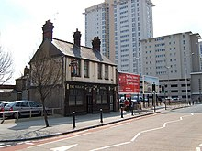
Figure 1- Source:https://en.wikipedia.org/wiki/The_Vulcan,_Cardiff
Although the goal of preservation may seem like a noble task to undertake when using case studies such as St Fagans, there is always an opposing view on this. One such view is that the buildings and the history presented by St Fagans can be viewed by some in certain contexts as only presenting a limited view and selection of Welsh culture. McAleavey uses this view to justify and place emphasis on why their new exhibition was necessary at St Fagans and how previous ones were inadequate in representing Welsh culture in its entirety, saying; “If Peate’s aim was to create a gallery that would unify Welsh culture, giving it one voice, our starting point was to emphasise that there is no such thing as one Welsh identity — there are many.” (2009, p. 60)

Preservation as a goal within the museum context and subsequently the removal of said object from the original site, can take many forms, one of these is the preservation of the methods in which artefacts were made. Brenna (2018) discusses how museums often create reproductions using existing artefacts in the collections via traditional methods, “museums have had scientific and aesthetic ambitions and an interest in representing totalities, both of which have led them to actively acquire and produce copies.” (p. 2)This acts as a conservation method ensuring that traditional production methods survive, this also requires a detailed study of the object. “This idea of authenticity and original artefacts in museums is also part of popular culture. For example, in a recent Sky Arts television documentary, Fake! The great masterpiece challenge, members of the public were invited to identify a range of copies which had ‘secretly’ taken the place of the originals in galleries and museums around the UK.” (Brenna, et al., 2018, p. 1) Recreating an authentic object has merits such as; allowing the original to be taken for restoration without preventing the public from viewing it, preventing the object from being stolen etc. However, there is a negative perspective, creating reproductions of an object that are acceptable enough to replace the object could lead to an influx being placed on the black market and replacing an object, even for a brief period could bring the authenticity of the museum itself into question. Using the case study of St Fagans, it brings the question of authenticity to the forefront. If an object or monument is a reproduction and this causes it to be inauthentic, therefore all the building and artifacts at St Fagans have the potential to be inauthentic. Buildings in St Fagans such as the Bryn Eryr Iron Age Roundhouses (Wales, unknown) (Anonymous, 2016) are reconstructions, rather than other building such as the Vulcan Hotel (Wales, unknown) which was an already existing building that was deconstructed and then reconstructed at St Fagans. If a comparison is made between the two construction techniques, the question of authenticity is made when studying the Roundhouses. They are not ‘authentic’ buildings in that they are reconstructions and if these ‘inauthentic’ do not reduce the validity of the museum, therefore it is not necessary for any other buildings to be ‘authentic’ such as the Vulcan Hotel (Wales, unknown). If the argument can be made that it is not necessary for a building to be ‘authentic’ then preservation becomes a key reason to remove a building from its original site.

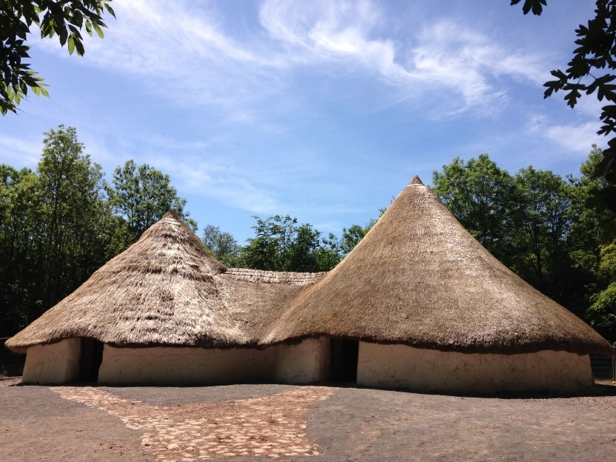
Figure 2 Bryn Eryr Iron Age Roundhouses Source: https://museum.wales/stfagans/buildings/bryneryr/

Engagement
A crucial part of museum culture is the engagement of the public with the artifacts and buildings within it. For engagement to occur effectively, with an inclusive and interactive when it is a building that an exhibit is focused around, it is easier in some respects to be able to be in direct contact with the building itself. The ability to physically be within are around an historic building or monument in a museum context, having been removed from its original location, provides experiences that would have potentially not have happened if the building or monument were to remain in the original location.
Engagement within a museum context varies, as Braswell (2012) discusses, between age groups such as children and adults. This variation requires a museum to have exhibitions that are appropriate for everyone and for every different engagement level. Exhibits that a particularly engaging with younger audiences tend to be, as Braswell (2012) identifies, focused on environments that focused on “providing opportunities for children to learn through play and exploration at the museum's exhibits.” (p. 124) St Fagans provides these opportunities through creating interactive exhibits within different buildings that provide spaces to teach traditional methods and to provide opportunities for children to learn about how lives were lived during the periods in which the buildings were originally from. One of these such buildings at St Fagans is the Gwalia Stores (Wales), this store was built in 1880 by William Llewellyn and it was eventually expanded to the point where in 1916 it included a bakery, ironmongery, gentleman’s outfitters, grocery and sold a selection of animal feed. The stores also provided accommodation for the workers in the rooms above. The buildings were moved to St Fagans in 1988, where they now operate, as a traditional style store selling things such as confectionary. In this instance the space provides children the opportunity to learn and understand how shops operated in past eras, experiencing aspects of life that previous generations were a part of, Braswell explains “more experienced others (such as adults) often will demonstrate or explain intended uses for artifacts, allowing children to understand these intentional affordances.” (2012, p. 124) Although in understanding this, there is an assumed knowledge of older individuals to have knowledge that is not given by the exhibit itself. The Gwalia Stores provide an excellent example of how removing a building or monument can benefit the public and how it can provide opportunities for learning and development. As McAleavey states “St Fagans has aimed to create exhibitions that “accommodate our audiences’ different levels of interest, skills and prior knowledge, our displays have been layered to provide a selection of different entry levels.” (2009, p. 61)

Engaging the public through removing a building or monument to the safety of a museum is a costly process that is time consuming and requires a large number of staff to complete the process. To create exhibits using buildings removed from original sites, within the museum context that are accessible “Importance was placed in creating opportunities for people of all ages and abilities to interact both physically and intellectually with the objects.” (McAleavey, 2009, p. 62) These forms of exhibit that are large and attention grabbing, they have the potential to defer the concentration of the public from smaller exhibits to the large buildings. This deference has the potential to reduce the impact of the museum as a whole and reduce the validity of the museum along with the justifiability of an exhibit remaining if it is not receiving the necessary amount of attention.

Removing a building, artifact or monument from a site to the safety of a museum is a difficult and expensive decision that requires extensive planning alongside gaining support from the public. While there are positive arguments in favour of taking these steps, such as to aid in the preservation of the building and traditional trades as well as to improve the engagement of the public. There are negative arguments as well, these include questioning the authenticity of other exhibitions within a museum that do not feature buildings removed from the original sites in which they were built and how these buildings can distract the attention of the public from other exhibits and draw the public away from less extravagant but no less important information points.

Bibliography
Anonymous, 2016. Bryn Eryr Iron Age Farmstead at St. Fagans. British Heritage, 37(6), p. 7.
Braswell, G., 2012. Variations in Children's and Adults' Engagement with Museum Artefacts. Visitor Studies, 15(2), pp. 123-135.
Brenna, B., Dam Christensen, H. & Hamran, O., 2018. Museums As Cultures Of Copies. New York: Routledge.
Daubney, A., 2017. Floating culture: the unrecorded antiquities of England and Wales. International Journal of Heritage Studies , 23(9), pp. 785-799.
Kaiser, W., Krankenhagen, S. & Poehls, K., 2014. Exhibiting Europe in Museums: Transnational Networks, Collections, Narratives, and Representations. 1 ed. s.l.:Berghahn Books.
McAleavey, M. W., 2009. Renewal or Betrayal? An Experiment in Reflecting Welsh Identity at St Fagans; National History Museum. Journal of Ethnological Studies, 47(1), pp. 58-65.
Wales, N. M., unknown. Bryn Eryr Iron Age Roundhouses. [Online]
Available at: https://museum.wales/stfagans/buildings/bryneryr/
[Accessed 27 September 2021].
Wales, N. M., unknown. Gwalia Stores. [Online]
Available at: https://museum.wales/stfagans/buildings/gwalia/
[Accessed 27 September 2021].
Wales, N. M., unknown. Vulcan Hotel. [Online]
Available at: https://museum.wales/stfagans/buildings/the_vulcan_pub/
[Accessed 22 September 2021].

