


Module: Changemakers: Building your Personal Brand for Sustainable Employment
Assignment Title: Component 1 Online portfolio
Module code: BMHP5015
Name: Charles Amegor
Student ID: 2413450
Module Leader: Caroline Salami
Word Count: 2092

Declaration
I confirm that I used generative AI as a study tool to support the structure and development of ideas in this assignment. All writing, analysis, critical reflection, and final content represent my own work, thinking, and interpretation. The AI was not used to write the assignment on my behalf, and all sources cited were independently checked and verified by me in accordance with university guidance.

Introduction
The Changemakers: Building Your Personal Brand for Sustainable Employment module has fundamentally enhanced my understanding of the personal and professional capabilities required to succeed within contemporary health and social care. As the sector continues to evolve in response to changing population needs, technological advances and workforce challenges, practitioners are increasingly expected to demonstrate self-awareness, adaptability, resilience and a commitment to lifelong learning alongside clinical and professional competence (World Health Organization, 2022; NHS England, 2023). Consequently, developing a strong personal brand is not merely a strategy for employability but an essential aspect of professional identity, ethical practice and effective leadership in health and social care (Montoya and Vandehey, 2009).
This portfolio critically reflects on my learning across the four units of the module: Brand You, It's a Small World, Opportunity Knocks and The Pursuit of Happiness. Drawing on lecture content, Moodle activities and relevant academic literature, I evaluate how each unit challenged my assumptions, influenced my personal and professional development and strengthened my readiness for sustainable employment. Throughout this portfolio, I demonstrate how reflective practice has enabled me to connect theoretical concepts with practical application, preparing me to deliver person-centred, culturally responsive and evidence-informed care while continually developing as a future health and social care professional.

Task 1, Reflection on Unit 1: Brand You.
Unit 1, Brand You, challenged my understanding of personal branding by demonstrating that it extends beyond self-promotion to encompass professional identity, values and credibility. Before studying this unit, I associated personal branding primarily with social media or marketing. However, through lectures and online activities, I recognised that healthcare professionals also develop a personal brand through their behaviour, communication, ethical practice and commitment to continuous professional development. Montoya and Vandehey (2009) argue that a strong personal brand is built on authenticity rather than creating an artificial image. This perspective encouraged me to evaluate how my own values and behaviours influence how others perceive me as a future health and social care practitioner.
One of the most valuable concepts I explored was self-awareness, particularly through reflecting on my strengths, weaknesses and professional aspirations. The Johari Window model (Luft and Ingham, 1955) demonstrated that self-awareness develops through both self-reflection and constructive feedback from others. This challenged me to recognise that my understanding of myself may differ from how colleagues, patients and service users perceive me. Consequently, I now appreciate the importance of seeking regular feedback to improve communication, empathy and professional relationships. Nevertheless, I also recognise that the Johari Window depends on honest feedback, which may not always be forthcoming in professional environments, highlighting the importance of fostering psychologically safe workplaces (Edmondson, 2019).
The Moodle activities further strengthened my understanding of autonomy, self-determination and networking. Defining autonomy and self-determination prompted me to reflect on their significance not only for my own career development but also for promoting person-centred care. According to Deci and Ryan (2000), individuals are more motivated and engaged when their needs for autonomy, competence and relatedness are supported. Applying this theory to health and social care, I realised that empowering service users to participate in decisions about their care can improve both wellbeing and health outcomes.
The networking activity also challenged my previous assumption that professional networking is limited to finding employment opportunities. Instead, I learned that effective networking enables practitioners to exchange knowledge, access mentorship and develop collaborative relationships that enhance multidisciplinary practice (Forret and Dougherty, 2004). Reflecting on my own responses, I recognised the need to expand my professional connections beyond my immediate field to gain broader perspectives and identify future opportunities.
Evidence from Moodle Activities, see appendix A.

Task 2, Reflection on Unit 2: It's a Small World.
Unit 2, It's a Small World, expanded my understanding of how globalisation, cultural diversity and organisational systems influence health and social care practice. Before studying this unit, I viewed healthcare largely from a local perspective. However, the lectures and Moodle activities encouraged me to recognise that health and social care are increasingly shaped by global migration, cultural diversity, technological advances and international policies. As a result, I realised that effective practitioners must develop cultural competence and adaptability to provide safe, equitable and person-centred care in increasingly diverse communities (World Health Organization, 2022).
One concept that significantly influenced my learning was bureaucracy. Initially, I regarded bureaucracy as an unnecessary obstacle that delayed decision-making. However, studying Weber's theory of bureaucracy (Weber, 1978) enabled me to appreciate that formal structures, policies and accountability mechanisms are essential for maintaining consistency, safeguarding service users and ensuring legal compliance within health and social care organisations. At the same time, I critically recognised that excessive bureaucracy may reduce flexibility and delay timely interventions, particularly in complex care situations. This reflection highlighted the importance of balancing organisational procedures with professional judgement to ensure high-quality, person-centred care (Ham, 2021).
The Moodle activity on changing perspectives also challenged my assumptions about professional practice. Reflecting on this exercise made me realise that individuals interpret situations differently depending on their cultural background, personal experiences and beliefs. Campinha-Bacote's (2002) model of cultural competence emphasises that cultural awareness is a continuous process of self-examination rather than a destination. This encouraged me to question my own unconscious assumptions and appreciate that culturally responsive care requires openness, empathy and effective communication with individuals from diverse backgrounds. Nevertheless, I also recognised that cultural competence models have limitations because they cannot fully capture the complexity and individuality of every person's lived experience (Kaihlanen et al., 2019).
Overall, Unit 2 transformed my understanding of healthcare as a globally interconnected profession. I now recognise that effective practitioners must balance organisational accountability with compassionate, culturally responsive practice while remaining open to different perspectives. This learning has strengthened my confidence that developing cultural humility, reflective practice and global awareness will enable me to contribute more effectively to multidisciplinary teams and deliver inclusive, evidence-informed care throughout my future career.
Evidence from Moodle Activities, see appendix B

Task 3, Reflection on Unit 3: Opportunity Knocks.
Unit 3, Opportunity Knocks, transformed my understanding of how opportunities are created and recognised rather than simply encountered by chance. Before studying this unit, I believed that career success depended largely on qualifications and experience. However, through the lectures and Moodle activities, I realised that developing a proactive mindset, challenging limiting beliefs and remaining open to unexpected opportunities are equally important for achieving sustainable employment in health and social care. This shift in perspective encouraged me to take greater responsibility for my own professional development instead of waiting for opportunities to emerge.
One of the most influential concepts explored during this unit was the serendipity mindset. The class discussions demonstrated that successful individuals often create opportunities by remaining curious, building relationships and responding positively to unexpected events. This aligns with Krumboltz's (2009) Planned Happenstance Theory, which argues that individuals can increase the likelihood of beneficial career opportunities by developing qualities such as curiosity, persistence, flexibility, optimism and risk-taking. Reflecting on this theory, I recognised that I had previously underestimated the importance of networking and embracing uncertainty. As a future health and social care professional, I now understand that adapting to change and engaging with diverse experiences can enhance both my career progression and my ability to respond effectively to the evolving needs of service users.
The Moodle activity exploring limiting beliefs encouraged me to critically examine the assumptions that may restrict my confidence and professional growth. I realised that fear of failure can discourage individuals from pursuing new opportunities or taking on additional responsibilities. Bandura's (1997) theory of self-efficacy explains that confidence in one's abilities strongly influences motivation, resilience and performance. This reflection helped me appreciate that developing self-efficacy requires continuous learning, constructive feedback and perseverance rather than expecting immediate success. Nevertheless, I also recognise that confidence alone is insufficient if it is not supported by competence, ethical practice and evidence-based decision-making.
Finally, the activity on achieving success and finding luck reinforced my understanding that sustainable career development depends on preparation as much as opportunity. Dweck's (2006) concept of the growth mindset suggests that individuals who view challenges as opportunities for learning are more likely to achieve long-term success. Consequently, I now intend to approach future placements and employment opportunities with greater resilience, openness and commitment to lifelong learning.
Evidence from Moodle Activities, See appendix C

Task 4, Reflection on Unit 4: The Pursuit of Happiness.
Unit 4, The Pursuit of Happiness, encouraged me to reflect on the importance of wellbeing, resilience and meaningful professional relationships in achieving sustainable employment within health and social care. Prior to this unit, I viewed career success primarily in terms of qualifications and employment opportunities. However, I came to understand that long-term professional fulfilment also depends on maintaining psychological wellbeing, adapting positively to challenges and seeking support through mentoring and reflective practice. These insights have reinforced my belief that effective practitioners must care for their own wellbeing if they are to provide safe, compassionate and person-centred care to others (NHS England, 2022).
One of the most valuable activities focused on mentoring. Reflecting on this discussion, I realised that mentoring extends beyond receiving career advice; it provides opportunities for professional growth, constructive feedback and emotional support. Clutterbuck (2014) suggests that effective mentoring promotes confidence, critical thinking and continuous learning, all of which are essential within health and social care. I recognised that developing mentoring relationships can help me navigate future challenges, strengthen my professional identity and improve my ability to work collaboratively within multidisciplinary teams. At the same time, mentoring requires commitment from both mentor and mentee, and its effectiveness depends on mutual trust, openness and shared expectations.
Another concept that significantly influenced my learning was antifragility. Taleb (2012) argues that some individuals and systems become stronger through adversity rather than merely resisting it. This idea challenged my previous understanding of resilience, which I had viewed as simply coping with difficulties. I now appreciate that setbacks, constructive criticism and unfamiliar experiences can become valuable opportunities for learning and professional development when approached with a reflective mindset. Nevertheless, I also acknowledge that personal growth from adversity is influenced by organisational support, access to resources and individual circumstances, meaning that resilience should not be viewed solely as a personal responsibility (West et al., 2020).
Finally, reflecting on my personal and professional goals highlighted the importance of maintaining a sense of purpose and work-life balance throughout my career. Seligman's (2011) PERMA model emphasises that wellbeing is achieved through positive emotions, engagement, relationships, meaning and accomplishment. Applying this model to my future practice, I intend to prioritise continuous learning, seek supportive professional relationships and regularly reflect on my experiences to maintain both personal wellbeing and professional effectiveness.
Evidence from Moodle Activities, See appendix D

Conclusion.
This portfolio has enabled me to critically reflect on how the four units of the Changemakers: Building Your Personal Brand for Sustainable Employment module have influenced my personal and professional development. Through Brand You, I developed a deeper understanding of personal branding, self-awareness and the importance of building professional relationships. It's a Small World broadened my appreciation of cultural competence, global perspectives and the need to balance organisational systems with person-centred care. Opportunity Knocks challenged me to adopt a proactive approach towards career development by recognising opportunities, overcoming limiting beliefs and embracing continuous learning. Finally, The Pursuit of Happiness reinforced the significance of wellbeing, resilience, mentoring and reflective practice in sustaining long-term professional effectiveness.
Collectively, these learning experiences have strengthened my confidence, critical thinking and commitment to lifelong professional development. I now recognise that becoming an effective health and social care practitioner requires more than technical knowledge; it demands adaptability, ethical leadership, cultural humility and evidence-informed decision-making. As I progress into professional practice, I intend to apply these principles to deliver compassionate, inclusive and high-quality care while continually reflecting on and improving my own performance.

References
Bandura, A. (1997) Self-Efficacy: The Exercise of Control. New York: W.H. Freeman.
Bridges, W. (2009) Managing Transitions: Making the Most of Change. 3rd edn. London: Nicholas Brealey Publishing.
Campinha-Bacote, J. (2002) ‘The process of cultural competence in the delivery of healthcare services: A model of care’, Journal of Transcultural Nursing, 13(3), pp. 181–184.
Clutterbuck, D. (2014) Everyone Needs a Mentor. 5th edn. London: Chartered Institute of Personnel and Development.
Deci, E.L. and Ryan, R.M. (2000) ‘The "what" and "why" of goal pursuits: Human needs and the self-determination of behaviour’, Psychological Inquiry, 11(4), pp. 227–268.
Dweck, C.S. (2006) Mindset: The New Psychology of Success. New York: Random House.
Edmondson, A.C. (2019) The Fearless Organization: Creating Psychological Safety in the Workplace for Learning, Innovation and Growth. Hoboken, NJ: John Wiley & Sons.
Forret, M.L. and Dougherty, T.W. (2004) ‘Networking behaviours and career outcomes: Differences for men and women?’, Journal of Organizational Behavior, 25(3), pp. 419–437.
Ham, C. (2021) Health Policy in Britain. 8th edn. London: Bloomsbury Publishing.
Health and Care Professions Council (2023) Standards of Proficiency. London: HCPC. Available at: https://www.hcpc-uk.org/standards/standards-of-proficiency/ (Accessed: 25 July 2026).
Kaihlanen, A.M., Hietapakka, L. and Heponiemi, T. (2019) ‘Increasing cultural awareness: Qualitative study of nurses’ perceptions about cultural competence training’, BMC Nursing, 18(38).
Krumboltz, J.D. (2009) ‘The happenstance learning theory’, Journal of Career Assessment, 17(2), pp. 135–154.
Luft, J. and Ingham, H. (1955) ‘The Johari Window: A graphic model of interpersonal awareness’, Proceedings of the Western Training Laboratory in Group Development. Los Angeles: UCLA.
Montoya, P. and Vandehey, T. (2009) The Brand Called You. Revised edn. New York: McGraw-Hill.
NHS England (2022) Our NHS People Promise. London: NHS England. Available at: https://www.england.nhs.uk/ournhspeople/ (Accessed: 25 July 2026).
NHS England (2023) NHS Long Term Workforce Plan. London: NHS England. Available at: https://www.england.nhs.uk/publication/nhs-long-term-workforce-plan/ (Accessed: 25 July 2026).
Seligman, M.E.P. (2011) Flourish: A Visionary New Understanding of Happiness and Well-being. New York: Free Press.
Taleb, N.N. (2012) Antifragile: Things That Gain from Disorder. London: Penguin Books.
Weber, M. (1978) Economy and Society: An Outline of Interpretive Sociology. Berkeley: University of California Press.
West, M., Bailey, S. and Williams, E. (2020) The Courage of Compassion: Supporting Nurses and Midwives to Deliver High-quality Care. London: The King's Fund.
World Health Organization (2022) Global Competency and Outcomes Framework for Universal Health Coverage. Geneva: World Health Organization. Available at: https://www.who.int/publications (Accessed: 29 July 2026).
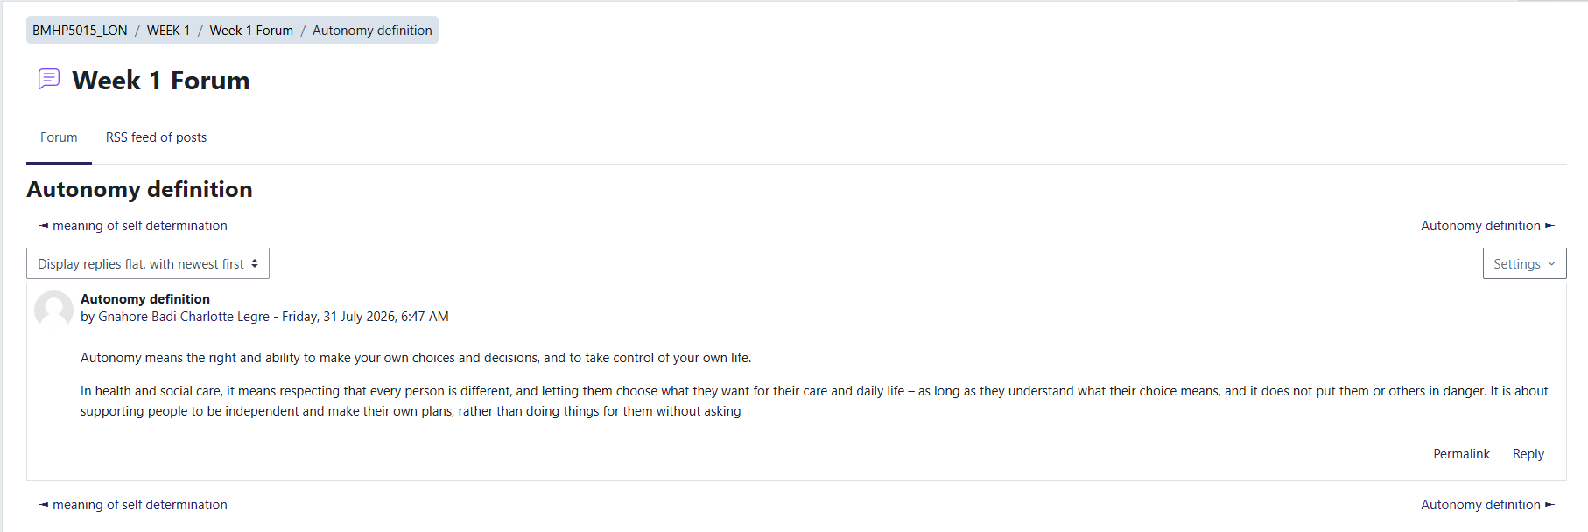
Appendix A: Figure 1. Moodle discussion defining autonomy and its importance in professional development.

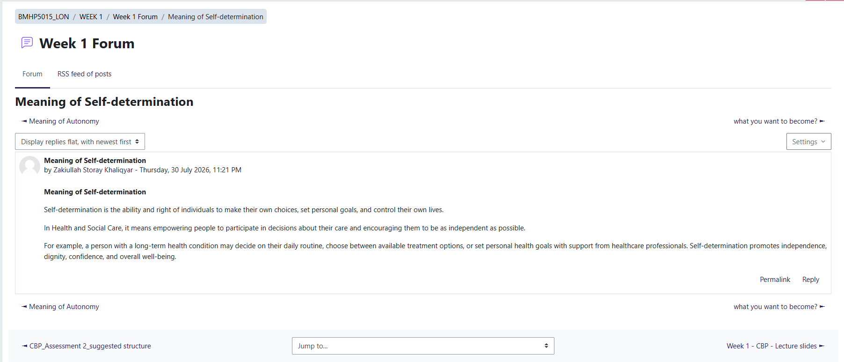
Figure 2. Moodle activity explaining self-determination and its relationship to personal growth.
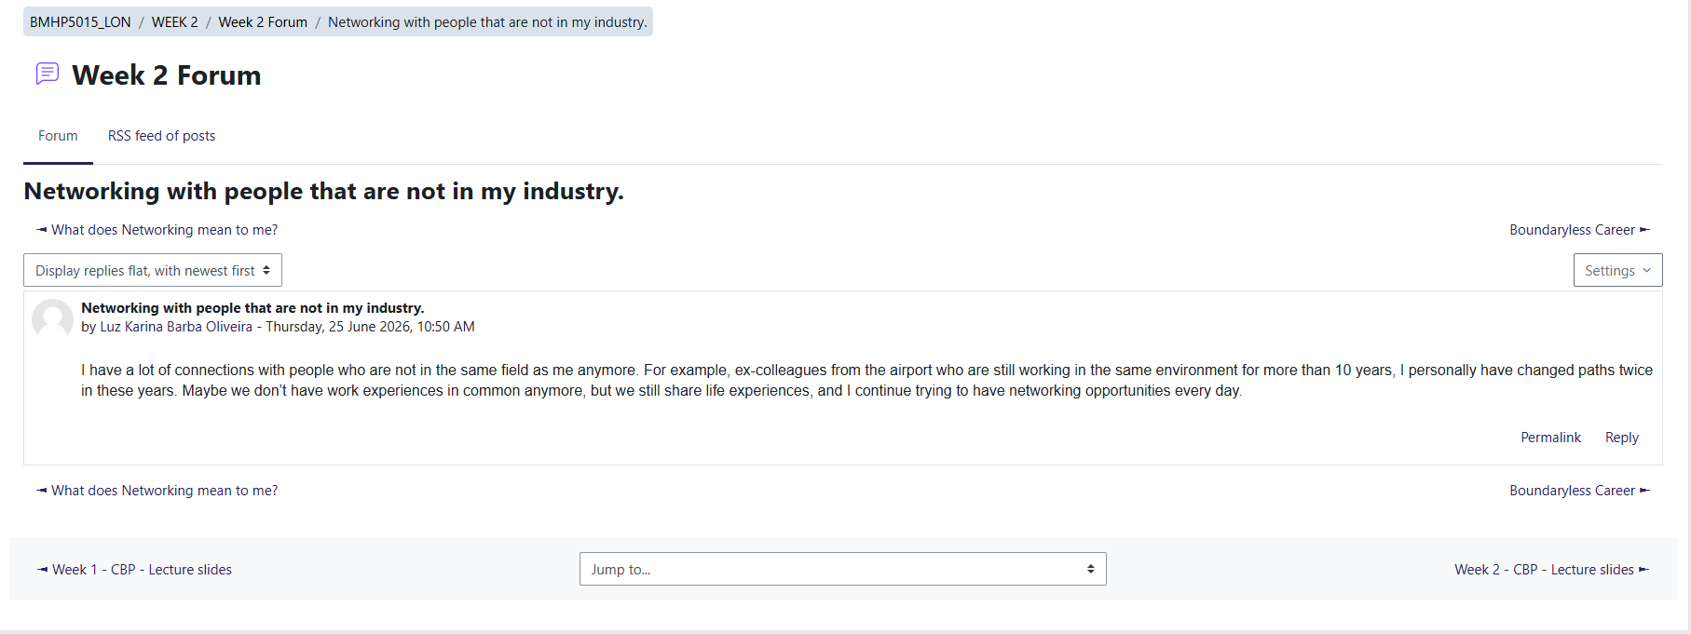
Figure 3. Moodle discussion on networking and building connections beyond my professional field.
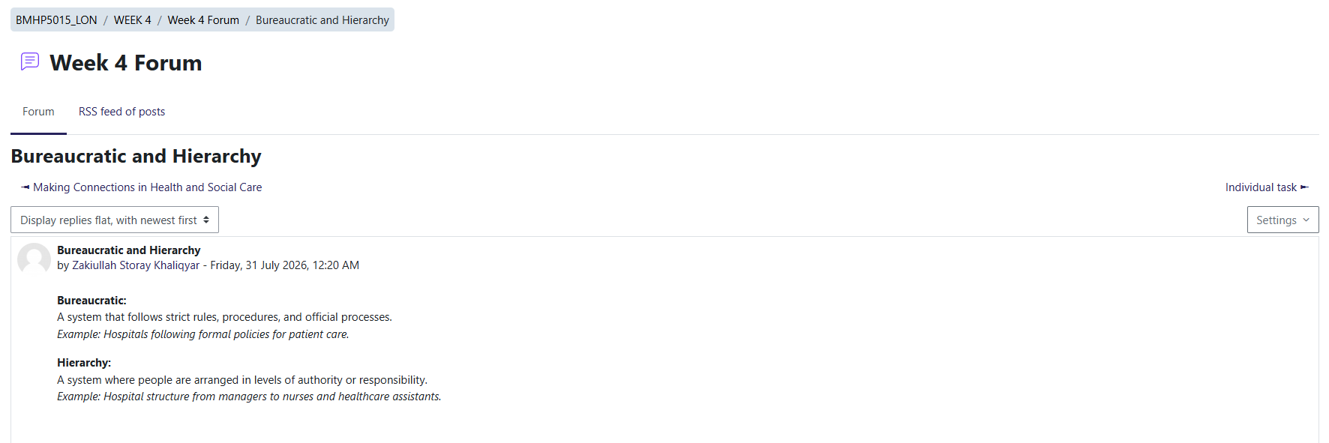
Appendix B. Figure 4. Moodle discussion explaining bureaucracy and its role within organisations.

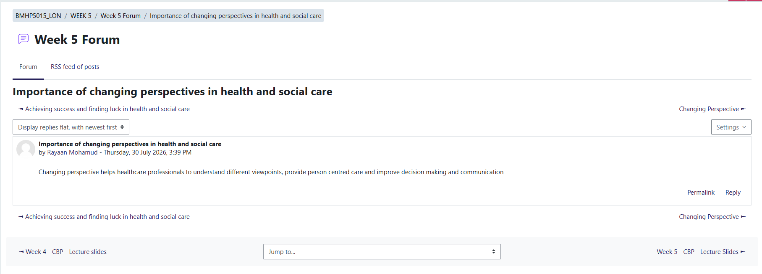
Figure 5. Moodle activity reflecting on how changing perspectives influence professional decision-making.
Figure 6. Moodle discussion on global connections and cultural awareness in health and social care.

Appendix C, Figure 7. Moodle activity reflecting on the concept of the serendipity mindset and recognising unexpected opportunities.
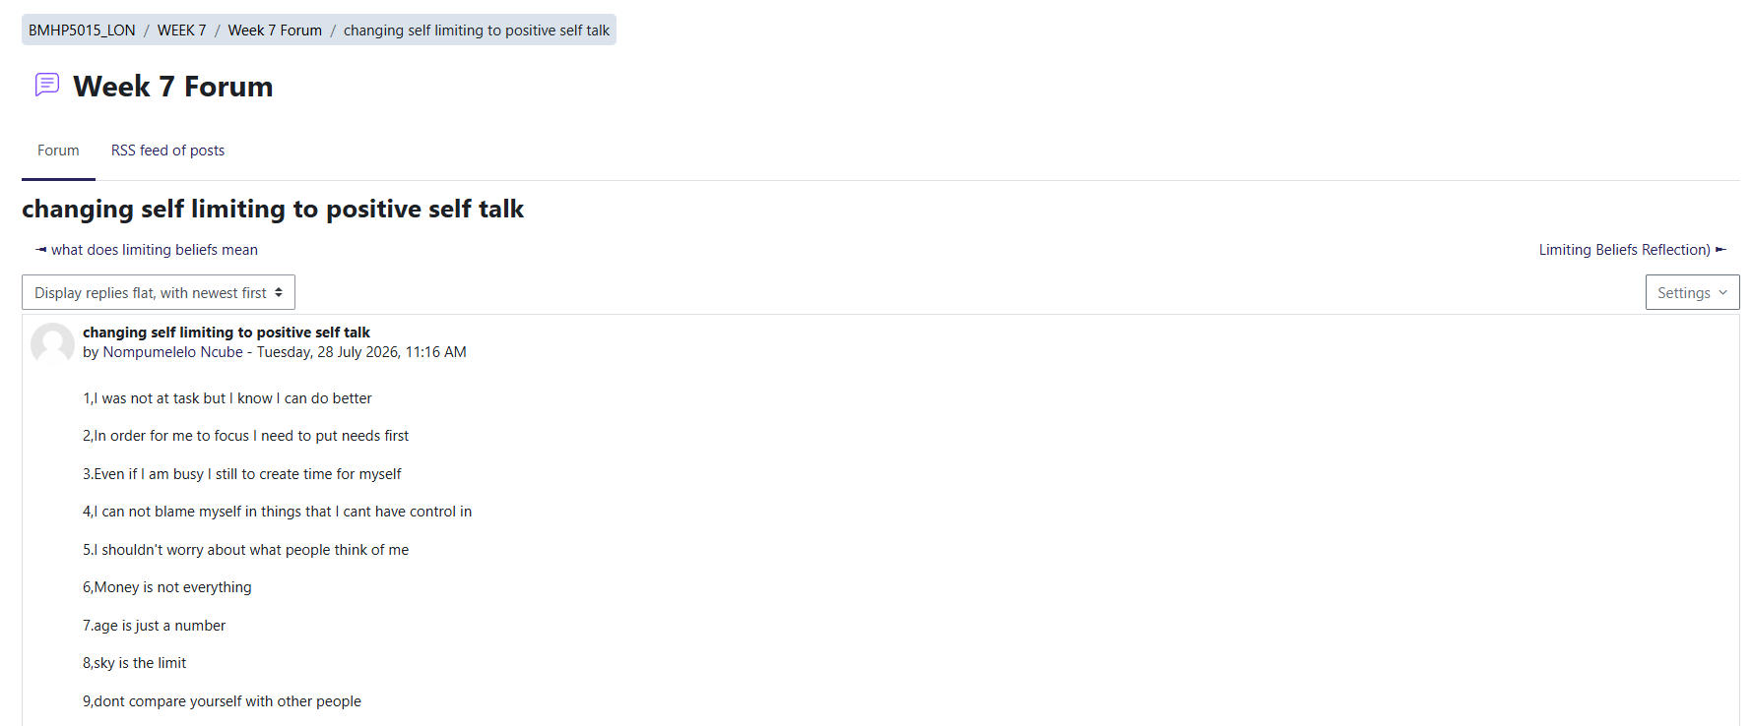
Figure 8. Moodle discussion identifying limiting beliefs that may affect personal and professional development.
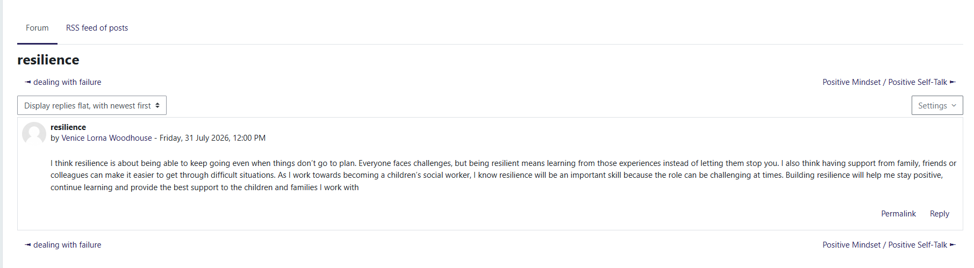
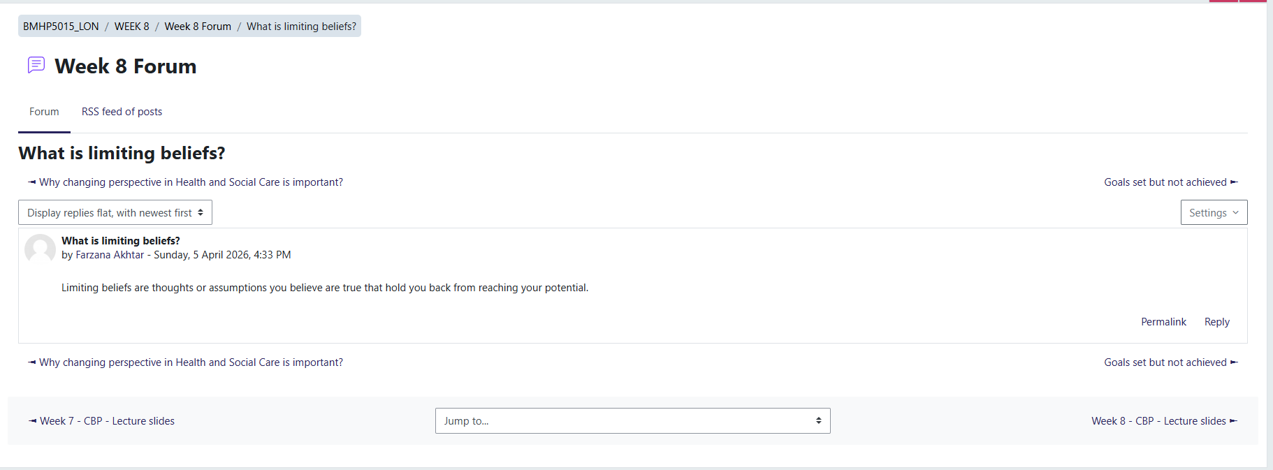
Figure 9. Moodle activity exploring how preparation, resilience and a positive mindset contribute to achieving success.

Appendix D: Figure 10. Moodle discussion explaining the importance of mentoring within health and social care.
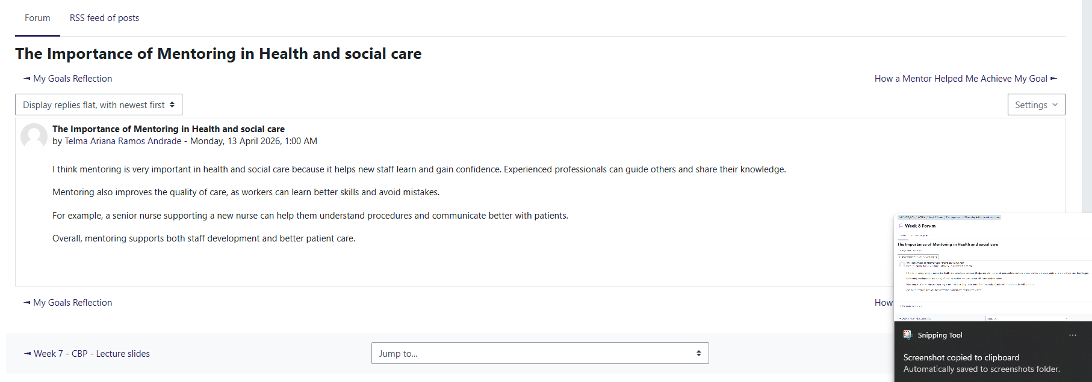
Figure 11. Moodle activity reflecting on personal and professional goals for future development.
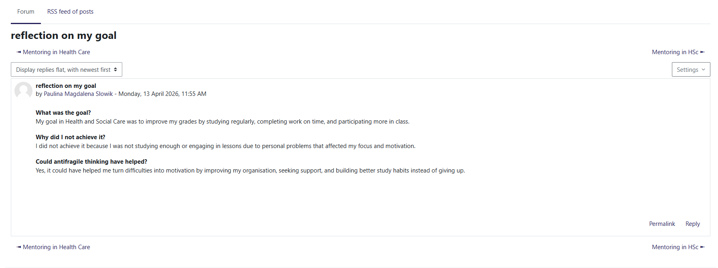
Figure 12. Moodle discussion exploring the concept of antifragility and learning from adversity.


