University of Wales Trinity Saint David
Wales Institute of Science and Art


Electronic circuits testing and applications

Electronic control systems | ACHA4010

Ewan Evans
2200899
2/04/2023
Contents
1 Task 1 1
1.1 A 1
1.2 B 1
1.3 c (i) 1
1.4 c (ii) 1
1.5 c (iii) 1
1.6 c (iv) 1
1.7 d 1
1.8 e 1
1.9 f 1
1.10 g 1
2 Task 2 2
2.1 Scope Time Division Calculations 2
2.2 Function Generator output sine wave 2
2.3 Unsmoothed Rectifier Wave 2
2.4 Smoothed Rectifier Wave 2
2.5 Drop in Voltage Question 2
2.6 Rectifiers use in Automotive applications Question. 2
2.7 Probing Question 2
3 Task 3 3
3.1 Scope Time Division Calculations 3
3.2 Function Generator output sine wave 3
3.3 Capacitor charge and discharge wave marked at correct points. 3
3.4 Basic Capacitor Calculations 3
3.5 Capacitor discharge table 3
3.6 Gradient Plot and calculations 3
3.7 Inaccuracies Question 3
4 References 4

Task 1

A

$$V=\frac{I}{R}$$
$$R= \frac{I}{V}$$
$$R=\frac{0.6}{0.5}$$
$$R=3 ohms$$

B

$$tI=aI+bI+cI$$
$$tI-aI=bI+cI$$
$$0.5-0.3=0.2$$
$$\frac{0.2}{2}=0.1 amps→for bI and cI individually$$

c (i)

$$I=\frac{Q}{T}$$
$$Q=I T$$
$$0.3 X 1=0.3$$
$$E=Q V$$
$$\frac{E}{Q}=V$$
$$\frac{0.9}{0.3} =3$$
$$V=I R$$
$$\frac{V}{I}=R$$
$$\frac{3}{0.3}=10 Ohms$$

c (ii)

$$V=I R$$
$$R= \frac{V}{I}$$
$$\frac{3}{0.1}=30 Ohms→B and C individual$$

c (iii)

3 volts in parallel so they have the same voltage.

c (iv)

$$5-3=2V$$
$$V=IR$$
$$\frac{V}{I}=R$$
$$\frac{2}{0.5}=4 Ohms$$

d

$$\frac{V}{I}=R$$
$$\frac{2}{0.5}=4 Ohms$$
$$tR= \frac{1}{\frac{1}{R1}+\frac{1}{R2}+\frac{1}{R3}+\frac{1}{R4}}$$
$$tR=1 Ohms$$

e

$$V=I R$$
$$V=0.5 X 0.6$$
$$V=3 volts$$

f

components resistance
A = 10
B = 30
C = 30
D = 4
E = 3
F = 6
R = 1
$$tR= \frac{1}{\frac{1}{Ra}+\frac{1}{Rb}+\frac{1}{Rc}}$$
$$tR= \frac{1}{\frac{1}{10}+\frac{1}{30}+\frac{1}{30}}$$
$$tR=6 Ohms→for resistors A,B and C combined$$
$$tR=tR of ABC+Rd+Re+Rf+Rr$$
$$tR=6+4+3+6+1$$
$$tR=20 Ohms$$

g

$$I X tR= ε$$
$$0.5 x 20= E$$
$$ε=10 volts$$
$$tV=battery V-E$$
$$tV=12-10$$
$$tV=2 Volts$$
$$\frac{2}{4}=0.5 volts per resistor$$

Task 2

Scope Time Division Calculations
$$T=\frac{1}{f}$$
$$T=\frac{1}{10}$$
$$T=0.1 seconds$$

Function Generator output sine wave
Scope of the sine wave given into the circuit using a function generator as the frequency
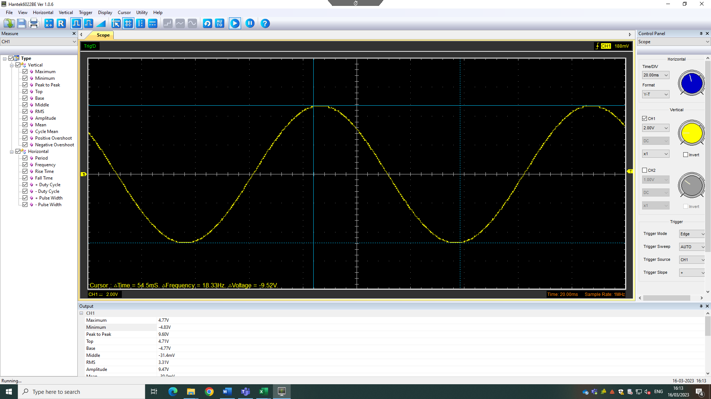
Maximum voltage = 4.77
Minimum voltage = -4.83
Total voltage = 9.6

Unsmoothed Rectifier Wave
Scope of the sine wave previously being changed into a unsmooth rectifier wave by connecting it to the rectifier circuit.
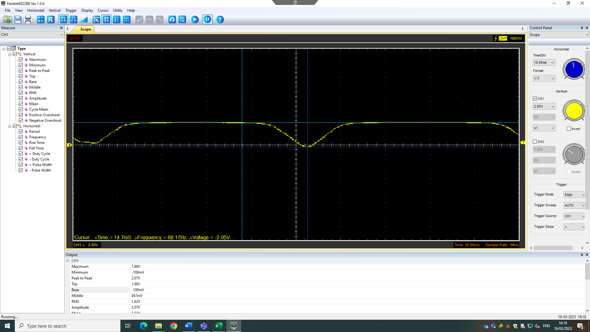
Maximum voltage: 1.88 v
Minimum voltage: -1.88mv or 0.000188 v
Total voltage:1.880188 v

Smoothed Rectifier Wave
Scope of the smooth rectifier wave by adding a capacitor to the circuit, changing the unsmooth rectifier wave to a smooth rectifier wave.
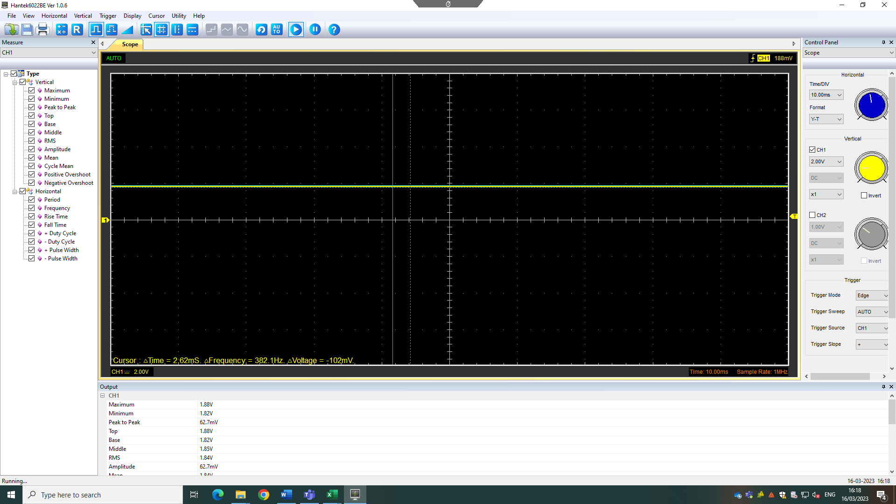
maximum voltage: 1.88 v
minimum voltage: 1.82 v
average voltage: 1.86 v

Drop in Voltage Question

Diodes are very good at stopping current being able to flow in the opposite direction, meaning that the circuit changes from AC to DC. When a circuit changes from AC to DC the current can only flow in one direction, ultimately leading to a drop in voltage.

Rectifiers use in Automotive applications Question.

Alternator is used to transfer mechanical energy into electrical energy. They often have a rectifier circuit built into it, because most car electronics is DC and therefore needs to transfer it into AC and DC. An alternator is then the inverse of a motor as the motor is used to change electrical energy into mechanical energy. Motors are used frequently in different areas of a vehicle.
Lights on vehicles can use an unsmooth rectifier as they allow vary periods of how long the lights can stay on for. This is due to lights turning on and off for set periods depending upon how the diodes and circuit is set up.
Sensors can be used to measure the position of something, such as a crankshaft sensor. This is because the sensor has a constant voltage going through it (smooth rectifier) and then when the sensor can see a tooth from the crankshaft it tuns of and then back on when it disappears, leaving an unsmooth rectifier wave.
Some other automotive applications that use rectifiers are ECU (electronic control system) and Stepper motors as the need a consistent voltage in order to operate.

Probing Question

The signal is the difference between the two points (earth and probe). This is due to the earth being connected to the electrical system and probes for the function generator. Meaning a different lead has the same potential as a lead in a different point of the circuit. Therefore, the probe is measuring it from both points not just the earth, meaning that the results being given from the two channels will not show a proper rectifier wave and instead a distorted signal.
When probing at either side of the function generator the circuit is being short circuited, this is because only half of the diodes are being conducted. The probes for the scoping of the function generator are scoping two different potentials. The diodes are being used opposite as some diodes are being used when a positive part of the cycle is taking place and then the others are being used when it is a negative part of the cycle. If this is done with a large enough voltage the equipment could have become damaged.
A way to get around the distorted signal is through the use a channel isolated scope as it will mean that both readings can be gathered and displayed as expected.

Task 3

Scope Time Division Calculations

$$T= \frac{1}{f}$$
$$T=\frac{1}{10000}$$
$$T=0.0001 seconds$$
2.2 capacitor (0.000022)
100 K resistor
$$T=RC$$
$$T=10000 X 0.000022$$
$$T=2 seconds$$

Function Generator output sine wave
Scope of the square wave given into the circuit using a function generator as the frequency
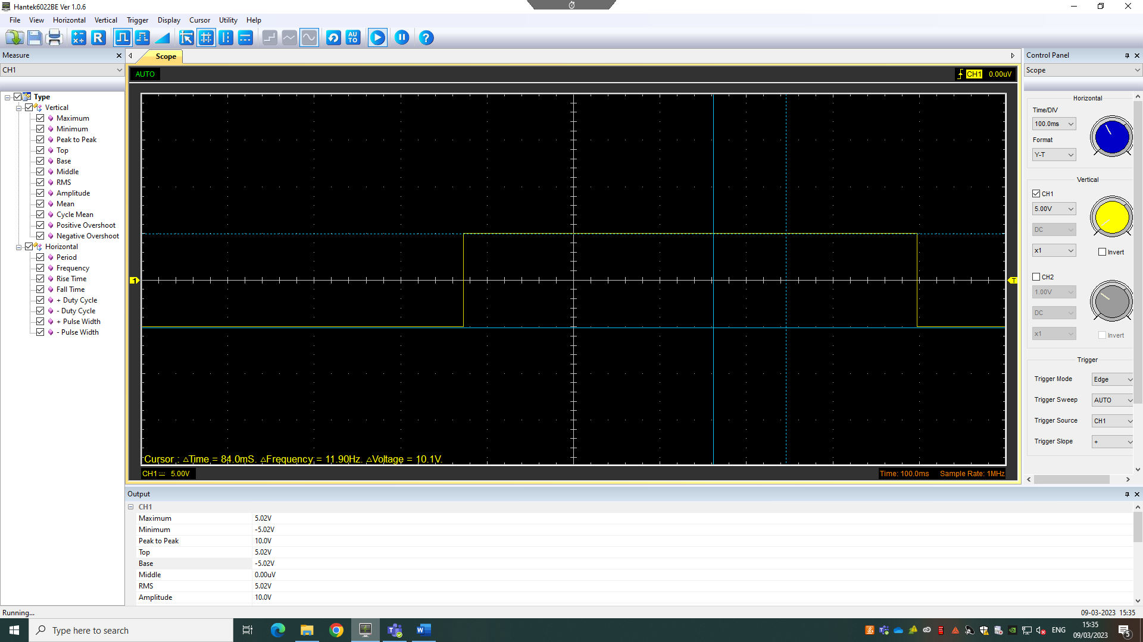
Maximum voltage: 5.02 V
Minimum voltage: -5.02 V
Combined voltage: 10.04 V

Capacitor charge and discharge wave marked at correct points.
Scope of the charge and discharge wave given into the circuit using a function generator as the frequency, from the previous square wave.

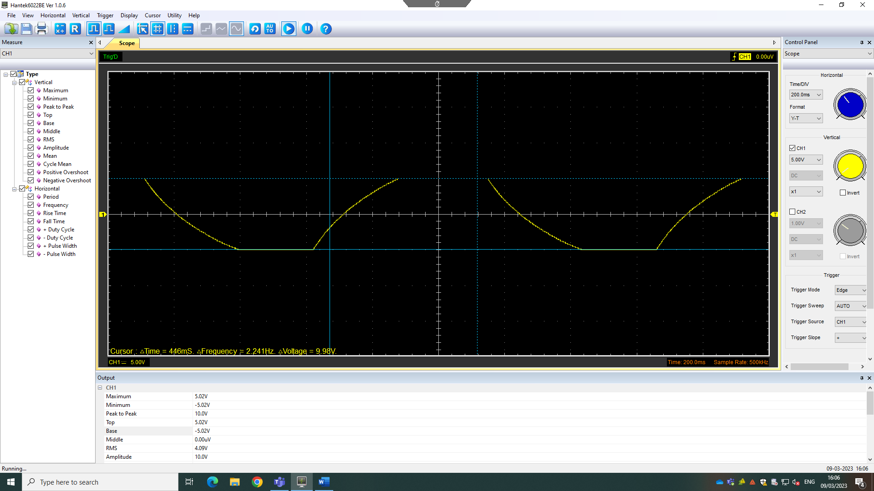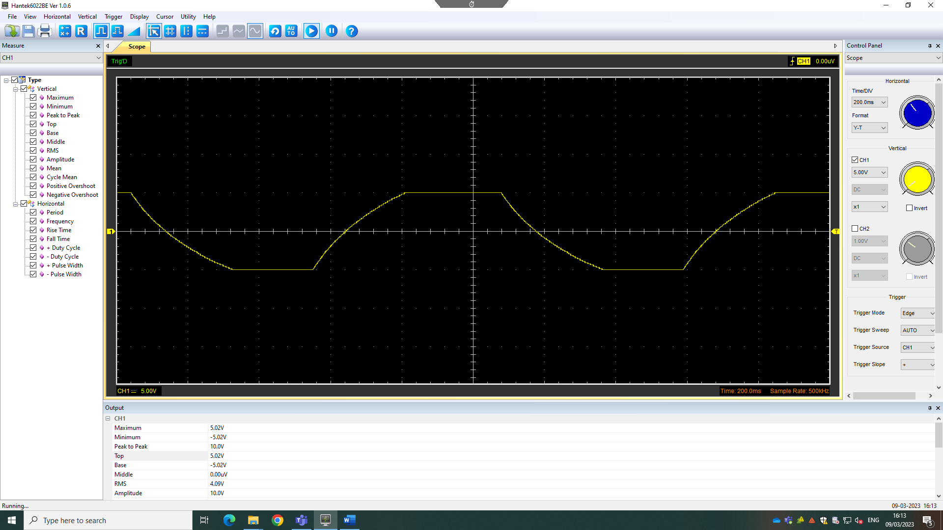
Maximum voltage: 5.02 V
Minimum voltage: -5.02 V
Combined voltage: 10.04 V

Basic Capacitor Calculations

$$T=RC$$

Time gathered at 66.67% = 4.2702 ms
$$gradient=\frac{-1}{T}$$
$$gradient= \frac{-1}{4.2702}$$
$$gradient= -0.234$$
$$\frac{T}{R}=C$$
$$\frac{4.2702}{10000}=0.000042702$$
Circuit capacitance = $0.000042702$
Calculated capacitance = 0.000022
$$\frac{0.000042702}{0.000022} X 100=194.1\%$$
$$or 1.94 times large than calculated$$

Capacitor discharge table

10 random points from the data gathered and their Ln value and their time.
voltage | Ln | Time (s)
7.6863 | 2.039439523 | 0.020993
7.2157 | 1.976259208 | 0.024994
6.902 | 1.931811225 | 0.027695
5.9608 | 1.7852047 | 0.038464
5.0196 | 1.613350249 | 0.050246
4.549 | 1.514907429 | 0.056482
4.0784 | 1.405704755 | 0.062358
3.451 | 1.238664044 | 0.073672
2.9804 | 1.09205752 | 0.081532
2.0392 | 0.712557574 | 0.098053

Gradient Plot and calculations

Log graph of 10 random points

Gradient = -0.1384
$$T= \frac{1}{gradient}$$
$$T=\frac{1}{0.1384}$$
$$T=7.2254$$
$$\frac{T}{R}=C$$
$$\frac{7.2254}{10000}=0.000072254$$
Circuit capacitance = $0.000072254$
Calculated capacitance = 0.000022
$$\frac{0.000072254}{0.000022} X 100=328.43\%$$
$$or 3.2843 times large than calculated$$

Inaccuracies Question
One way the results could deviate from the expected would be using poor equipment, this would lead to inaccuracy in areas such as the input values of the voltage, resistance and the readings of them values as well due to inaccurate scopes. The scopes being used may not have been scoped correctly, which would lead to some inaccuracies of the data.
Also, in the experiment it is likely that the function generator was not set up as optimally as it could have, as well as the scope not being able to read above 10 volts. This is because the data gathered looked like it maxed out at around 10 volts, before it reaches its actual maximum voltage. If it was better, it would have been able to show a better charge and discharge.
Some of the calculations could be done incorrectly. This is either due to using the formulas incorrectly or the data not being correct, either way this is going to leave some inaccuracy to the data being gathered from the experiment.
The circuit may not have been set up as the experiment specified, this is unlikely due to it likely giving out inaccurate readings and therefore would be easy to see and then rectify.

References

Khan academy diode as a circuit element [online] khan academy Diode as a circuit element (article) | Diode | Khan Academy (30/03/2023)
Stack exchange user why am I getting a half wave rectifier output when I am using a full wave rectifier? [online] stack exchange https://electronics.stackexchange.com/q/367731 (1/04/2023)
Mjlorton (2015) oscilloscope earthing/isolation challenges – Pt 1 [online] youtube Oscilloscope Earthing / Isolation Challenges - Pt 1 - YouTube (1/04/2023)
Olin Lathrop (11/09/2014) function genitor outputs [online] stack exchange https://electronics.stackexchange.com/q/128774 (30/03/2023)
Vadentu (26/03/2023) What is a rectifier [online] vadentu Uses of Rectifier (vedantu.com) (30/03/2023)
BYJUS Rectifier [online] BYJUS Rectifier – Explanation, Working, Types, Applications (byjus.com) (30/03/2023)
All about circuits rectifiers circuits [online] all about circuits https://www.allaboutcircuits.com/textbook/semiconductors/chpt-3/rectifier-circuits/ (2/04/2023)
Jefferson Bryant (29/05/2023) alternate source: inside an alternator [online] NAPA https://knowhow.napaonline.com/alternate-source-inside-an-alternator/ (2/04/2023)
John Santiago (26/03/2016) ten common mistakes in circuit analysis [inline] for dummies Ten Common Mistakes in Circuit Analysis - dummies (2/04/2023)

