Iavor Stanimirov

SID 1921573
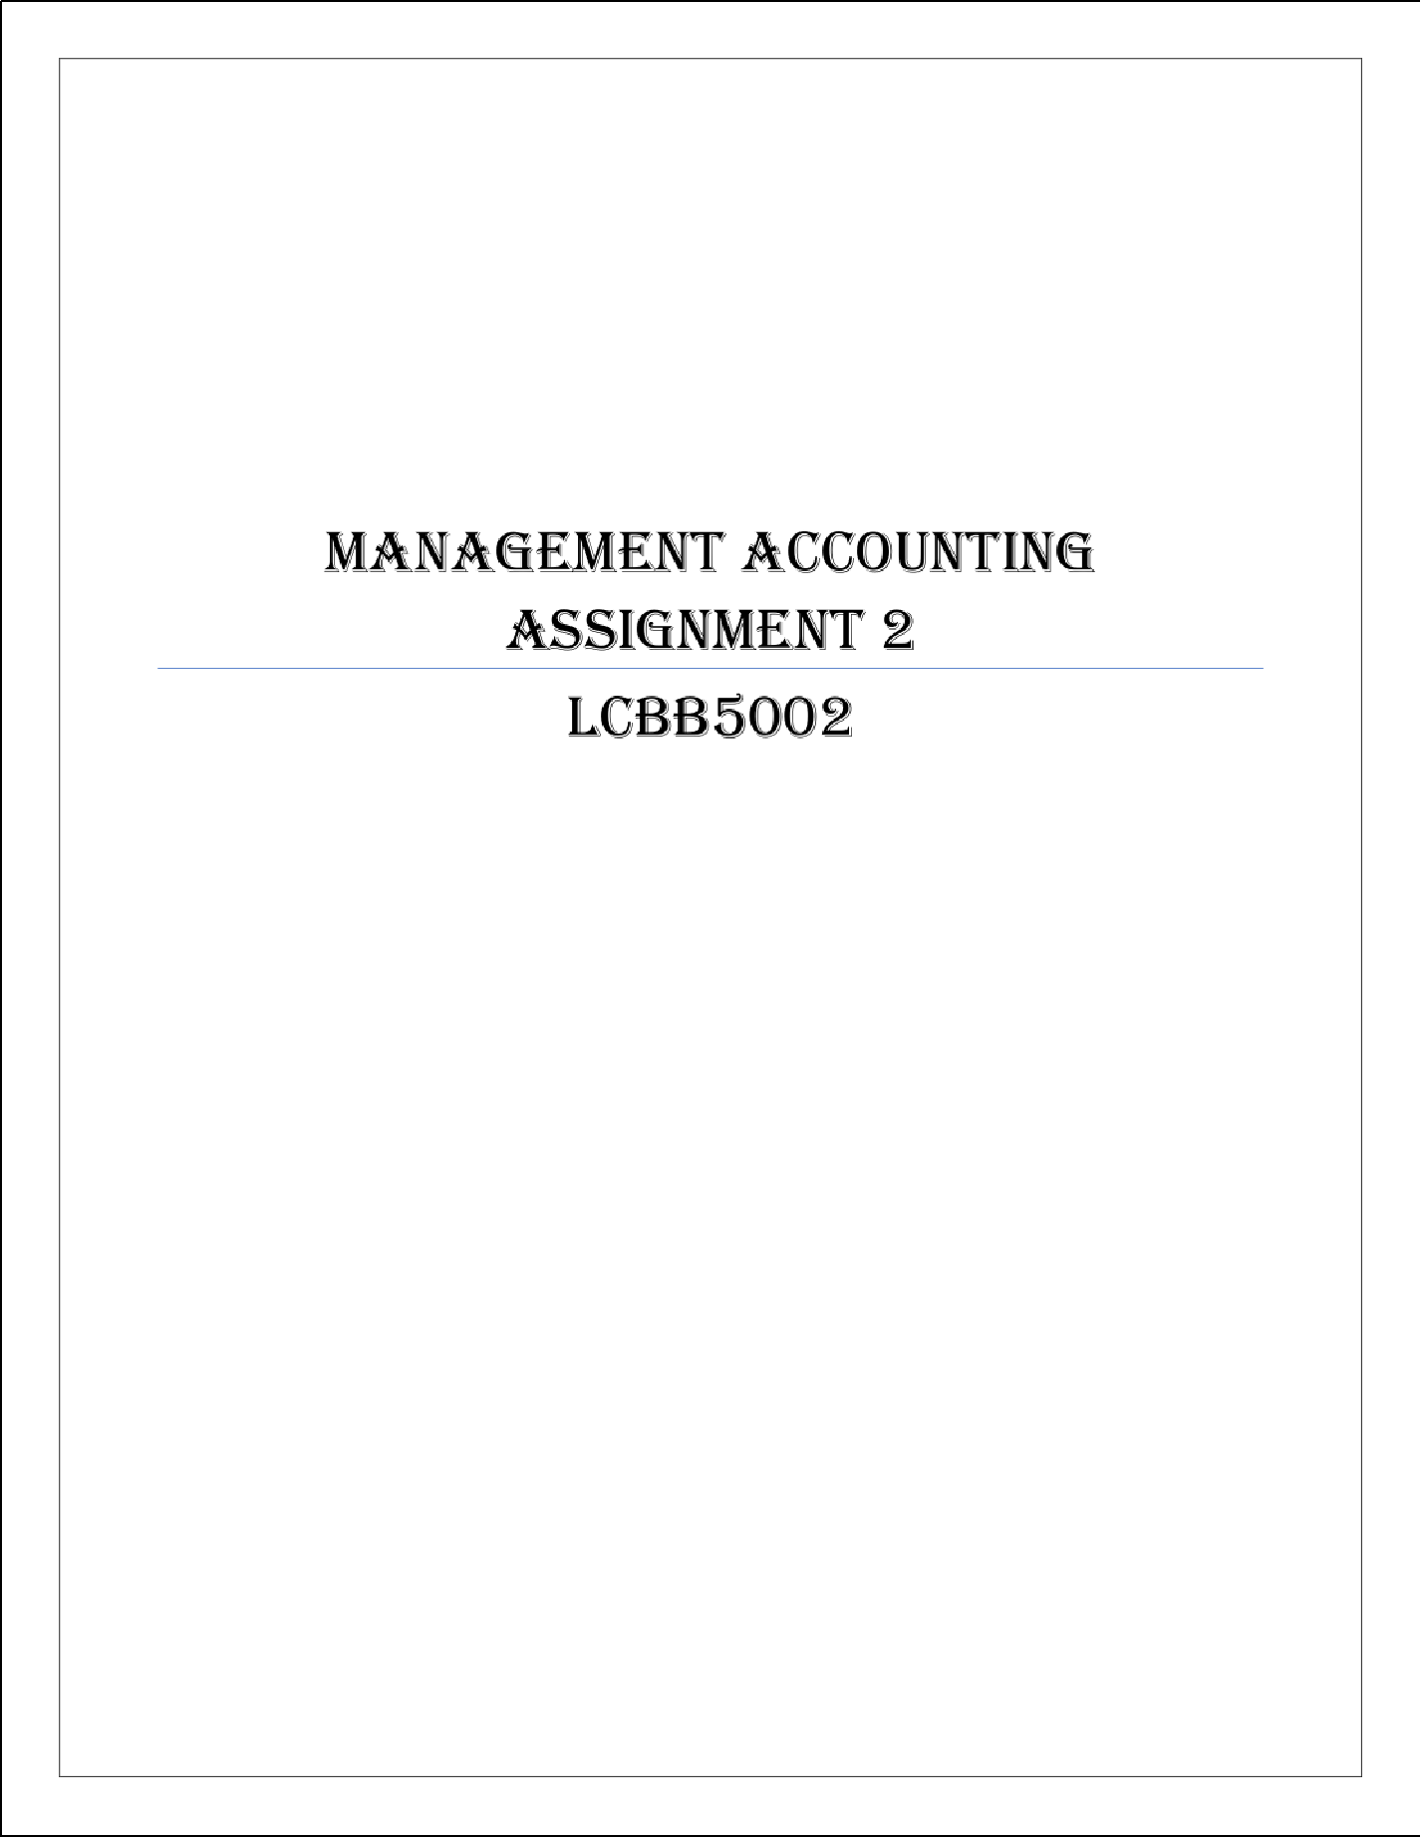

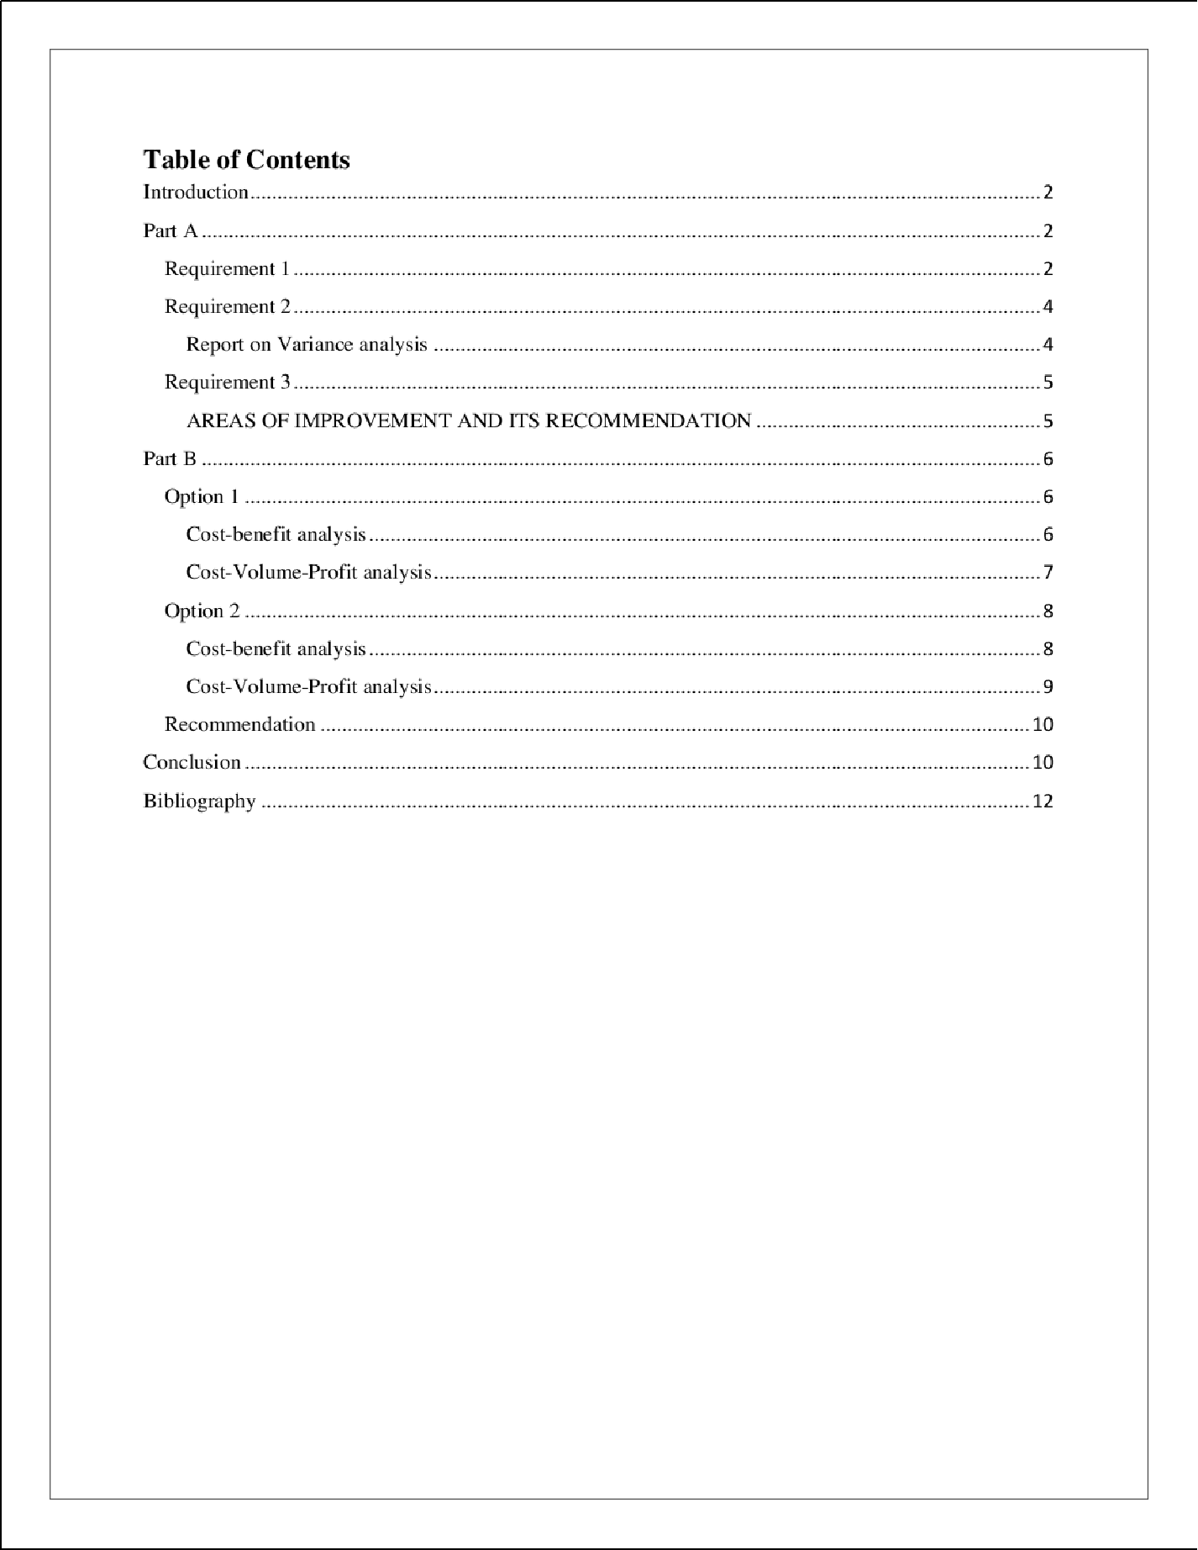

1

Introduction
When making certain managerial decisions, managers examine the existing condition with both budget and real costs to view the whole picture of their organization. We will look at Mr. Amana's aspects of business, and including initial budget, financial budget, including real expenses, as well as their variations, during this whole analysis. The initial portion of the report included an analysis, and a comprehensive explanation focusing mostly on outcomes will be published later, perhaps with some possible implications for Mr. Amana. The second season of the study will examine Mr. Amana's decision to start an “Internet company” in detail, keeping in mind all of the expenditures involved. Mr. Amana is just an English tourism businessman who might have faced several obstacles as a consequence of COV lD situation. The second portion of the article would examine Mr. A mana's decision to start an online firm in depth, especially when considering all of the expenditures involved. Mr. Amana is an English tourism businessman who has faced a number of obstacles as a consequence of the COV lD situation.

Part A

Requirement 1
Mr. Amana’s

Monthly Control Report

Particular | Original  budget  (1) | Flexible  budget  (2) | Actual cost  (3) | Activity  variance  (1-2) | Cost  Variance (2-  3)
\Jnits | 100,tl00 | 80,tl00 | 80,tl00
Variable cost
Materials  (Note I ) | 250,000 | 200,000 | 280,000 | 50,000(F) | (80,000)(U)
Labor  (Note 2) | 400,000 | 320,000 | 440,000 | 80,000 (F) | ( I 20,000) (U)
Overhead  (Note 3) | I 50,000 | 120,000 | 120,000 | 30,000 (F)

 | 800,000 | 640,000 | 840,000 | I 60,000 (F ) | (200,000) (U)
Fixed cost
Warehouse  rent | 200,000 | 200,000 | 170,000 |  | 30,000 (F)
Insurance | 100,000 | 100,000 | 100,000
Supervisor  salary | 50,000 | 50,000 | 35,000 |  | I 5,000 (F)
 |  |  |  |  | 45,000 (F)
Total  overhead  cost | 1150,000 | 990,tl00 | 1145,ft00 |  | 155,tl00 (U)

*F = Favorable

- U = Unfavorable

  - Note 1: Materials cost Original budget = (100,000 * 2.50)
= 250,000.

Flexible budget = (80,000 * 2.50)

= 200,000.

  - Note 2: Labor

Original budget = (100,000 * 4)

= 400,000.

Flexible budget = (80,000 * 4)

= 320,000.

  - Note 3: Overhead

Original budget = (100,000 * I .50)

= 150,000.

Flexible budget = (80,000 * I .50)

= 120,000.

Requirement 2

Report on Variance analysis
We created a monthly monitoring report to examine the current financial health of the company, which included “static budgeting, flexible budgeting, real expenses, and aberrations” in bnth operations and managing costs. We evaluated both productivity and cost reducing differences in order to make the best option possible. Regarding Mr. Amana's firm, combining activities plus cost cutting variation are advantageous (Jaedicke & Robichek, 2018). The following information has been given:
Both static and adaptable budgets underwent variance anal ysis. The difference between a static and flexible budget refers to the degree of activity fluctuation. Because the only difference in the two expenses is the dollar amount (100,000 and 80,000). We simply changed the component quantit y for investigate activities variance, so we can deduce whether fluctuating expenses were reduced in every case of operational expenses as a result of the lower unit price (Manes, 2017). While total fixed costs are unaffected by unit (activity) fluctuations, per unit fixed costs have increased due to a 20,000-unit drop in operating performance total sales. As a result, fixed unit rates have risen significantly. We did a standard costing and variance study as part of the regular controlling report. While comparing real expenses to static budgets is nonsensical since this budget repnrt used a completely different unit amount (100,000), however, due to all the COV lD situation, this unit were lowered to 80,000. We saw all the beneficial differences throughout the controlling report whenever simply connect the proper expense towards the static budget (Vickers, 20 17).
As a consequence, in terms of addressing the discrepancy, they did a gap analysis between certain flexible budget and the actual cost. Including an actual cost increase of $80,000, there really is a negative variance within components. Labor expenditures had risen approximately 120,000 as a result of the actual volume sold. The construction cost, however, has been reduced by $200,000 dollars. One might even notice a good financial position in the case of conventional

costs. As just a result, even if they recognize how fixed expenses did not affect in tandem with the machines, The company’s capital expenditures, meanwhile, have been cut by 45,000 as a result of the closure (Morrison & Kaczka, 2019). The rent was reduced by 30,000 dollars, whereas the manager's pay was reduced by I 5,000 dollars. Since there were no customers, so no need to spend more rent for such storage; on either extreme, the manager's income was lowered abnut $15,000 due to an effect on economic. Materials and equipment expenses had risen as a result of the outbreak. We already realize that all other businesses would be closed in 2020. lf a result, corporations boosted labor and equipment charges, particularly as they set away and ran the businesses to make up for their shortfalls during COVl D. As a consequence of its position, overall changing expenses have increased, deny the realit y that the item provided was considerably far less than budgeted cost (Dean, 2018).
Requirement 3

AREAS OF IMPROVEMENT AND ITS RECOMMENDATION
That's because the legislation imposes certain travelling limitations, Mr. Amana, as that of the owner of a tourist company, are encountering significant difficulties operating his business. Its cost structure, on the other hand, may be better. Given the facts in the earlier quote, many solutions are proposed:
- The operational expenditures of this organization have increased dramatically. They need numerous forms of payment for the items, and even the resources used to make these mementos, yet they are selling tourist keepsakes. Businesses require a mutually beneficial relationship with its supplier, including by having a deal with a fixed price, to ensure certain price changes are handled appropriately throughout the case of material scarcit y (McAleese, 20 1 6).
- The company could validate vendors to see if they deliver high-qualit y products at a fair price. Those who can then enlist vendors and engage them for a business transaction will help the firm accomplish things.
- Because activities of the company have not really returned to normal, companies can hire some laborers swiftly to skillfull y construct the keepsake plus arrange a fee with them.



- Administrative costs encompass operational and administrative expenses. Despite the fact that they are earning fewer revenue, businesses may cut costs. Expenses are visible and were spent according to budget, implying that even this expense was committed even during lockdown (Boyd, 2017). As a consequence, they might design a program for lowering overheads, at least at the moment.
- Companies can also reduce the warehouse rent therefore in circumstance. Additional inventories shouldn't have to be stored resulting in lower revenues. Therefore, in the current circumstances, the company can reduce this leasing expenditure or reduce it even further.
- They must use the actual market possibilit y of going online to try to improve company revenues. Individuals are bored during the lockdown and wish to decorate or bu y anything to make the home more beautiful. Like a consequence, they'll have to start marketing their products online (Cooper & Kaplan, 20 19).

Part B
Prior to the outbreak, the tourist industr y, like other businesses, has looked for new means of operating. Throughout terms of getting customers' interest, competition of that kind of organisation had turned with using the online to do operations, particularly producing and marketing. This organization will need to go digitally since it has two options. The organization does have a website; however it is primarily used for contact reasons. As a result, the company may go online as well as sell and market their items according to its internet marketing website or through Amazon (Whittenberg, 2018). Let's look at the risks and revenues of each option before choosing one.

Option 1
lf a firm wished to sell things on its own website, it would have to bu y things, make infrastructure upgrades, and boost the salary of an lT specialist, among other and expenses.

Cost-benefit analysis
Regarding cases involving changeable as well as constant costs, the real amount of funding would be assessed.

  - Total variable cnst:

Materials | = (280,000 / 80,000) | = 3.5
Labor | = (440,000 / 80,000) | = 5.5
Overhead | = (120,000 / 80,000) | = 1.5
Total | ---------- | 10.5
  - Total Fixed cost

Rent | = 170,000
Insurance | = 100,000
Supervisor salary | = 35,000
Cost of set up delivery network | = I 50,000
Cost of upgrading current  website | = 50,000
Salary of lT programmer | = 35,000
Total fixed cost | = 540 J00

Total cost = 540,000 + (100,000 * 10.5)

= 1,590,000

Total Revenue = (100,000 * 20)

= 2,000,000

Consequently, when we examine the past fixed costs incorporated throughout the new internet firm, the cost is rather substantial. Assume that its lease plus manager pay are linked towards the outlets which would be closed. (1 ,590,000 - 170,000 - 35,000) = 1385,000 would be the fixed cost. However, assuming any fixed expenses should be met, this offer's net contribution might be 410,000 (2000000 - 1590000), but instead if we include salar y and distribution center rent, the benefit would be 6 I 5,000. (2000000 - 1385000)

Cost-Volume-Profit analysis
The investigation will focus upon that areas of Brighton, Birmingham, and London. Such costs might be excluded in our CVP calculations.

  - Total variable cost per unit = 10.5
  - Total Fixed Cost = 335,000
  - Total selling price per unit = 20.

BEP = Fixed cost / (SP-VP)

= 335,000/ (20- 10.5)

= 35,263 (unit)

Therefore, since Amana souvenir wanted to recoup its whole expenditure, something should be producing 35,263 copies, because we realize because if the situation becomes digital or online after consumer research, it can sell 100,000 pieces every year. In the end or conclusion of this choice, the marginal costing unit is 64,737 (100,000-35,263), and indeed the amount is 615000 (64,737 * 9.5). Option I highlights the following points:
- When Amana souvenir uses all of its homepage, this might produce 100,000 items globally, depending on market conditions.
- Participants didn't consider labour plus leasing expenses within the costing system since Amana might close three among its locations whether it began processes and functions, but instead we assumed that those same costs will be connected to those three places (McAleese, 201 6).
- lt is indeed evident whether Amana may benefit from this decision after deducting some of its
coss.

Option 2
Other way to shop online with Amana Souvenir is through Amazon. We'll analyze, much like option I , mostly without pay plus renting as relex’ant costs.

Cost-benefit analysis Total Variable cost = 10.5
Total Fixed cost

Fulfillment fees + Insurance

= 50,000 + 100,000

Total Fixed cost = I 50,000. Total Revenue = 65000 * 20
= 1300,000

Total benefit = ( 1300000 — I 50,000)

= I 150,000.

Overall profit will be I I 50,000 if two running expenses were also, as is shown in the cost-benefit analysis previously. When those two expenses are added together, the profit is (1300000 - I 50,000 - 170,000 - 35,000) = 945,000. As a result, after deducting its expenses incurred (remuneration and rent), an earnings of 945,000 is obtained.

Cost-Volume-Profit analysis
Total fixed cost = I 50,000 (without rent and salary) Total variable cost per unit = 10.5
Total Selling price per unit = 20

BEP = 150,000/ (20- 10.5) = I 5,789 units.

As a result, if Amana chooses this option, their flexible budget unit would be 49,2 I I which is calculated by subtracting 65,000 from 15789. BEP = 355,000/9.5 = 37,368 units when those two charges are included.
Thus, there are 27,632 flexible budget units. There are some factors to consider before deciding the case:
  - Amana should compete on Amazon versus a slew of rivals and produce a variety of products for doing so.
  - Almost ex’eryone know that Amazon is an internet platform where people may seek, pick, and disregard things. As a consequence, Amana will be impossible to succeed unless it offers unique things (Bradman & Sñrbu, 2017).

  - Revenue would rise in response to customer needs, thus businesses To generate marketing opportunities, you may need to invest thousands on advertisements. Therefore, in order to keep going out, its personnel costs may even be high.
- Amana had little discretion on price since Amazon would set it, or the firm will either have to follow Amazon's return policy, which could be difficult for Amana to comply.
Recommendation
We conducted two analyses for each alternative to ensure advantage receiving, and using CVP, they could estimate what has been the least rex’enue with each alternative when all fixed and variable costs are included (Yeunyong, 2017).
Option I has a higher cost element because Amana would have to start their own online firm and doesn't have an y technological capabilities that beginning with from a retail outlet. As a consequence, any costs connected with hiring an lT expert to assist only with update might be reimbursable. Therefore, whether it utilizes Amazon like a virtual site, company might save money and have a smaller volume of revenue whereas if it dr›es have an online, but even the benefits will outweigh the disads’antages (Boyd, 2017).
Option 2 has the major drawback of losing oversight across the pricing model but unable to set a cancellation policy, as well as facing severe pressure from Amazon. Option I might, but at the other hand, be more expensive, but this will result in more revenue, and certain prices, including upgrade & transportation cost, may easily lead to losses. Howev’er, throughout the long run, this alternative would therefore pros’e beneficial. Companies might continue to employ this option once the COV lD problem is fixed, allowing them to serve customers equally physical and digital. Additionally, they will have total control across all activities, or the qualit y web redesign will attract bu yers here to products (Sutton, 2016). Like a result, 1 should urge Amana Tourist to choose Option I it has a good prospect or might assist the company in many ways by enhancing operational capabilities and growing its marketing strategy.

Conclusion
As the world is towards healing itself, so the industries like tourist industry which have been affected so much due to this situation they will regain their prosperit y. When making certain

managerial decisions, managers examine the existing condition with both budget and real costs to view the whole picture of their organization. We will lcink at Mr. Amana's aspects of business, and including initial budget, financial budget, including real expenses, as well as their variations, during this whole analysis. As a consequence, in terms of addressing the discrepancy, they did a gap analysis between certain flexible budget and the actual cost. Including an actual cost increase of $80,000, there reall y is a negative variance within components. Labor expenditures had risen approximately I 20,000 as a result of the actual volume sold. The initial portion of the report included an analysis, and a comprehensive explanation focusing mostly on outcomes will be published later, perhaps with some possible implications for Mr. Amana. So, the organization should improve all the cost management related area so that after starting the normal situation it can start work to recover itself instead of wasting time in cost management then.

Bibliography
Boyd. (2017). Cost Information: The Use of Cost Information for Making Operating Decisions.
.lout nail r›/C’r›.ti M‹in‹ipement, 23 1 2), 1 21- 142.

Bradman, & Sñr bu. (2017). Advantages and disadvantages of the strategic management in the current economic contex. .Iourn‹il of Ad on‹ ed M‹in‹ipement S‹ tend e. , 21 -35.
Cooper, & Kaplan. (2019). The Promise and Peril of 1ntergrated Cost System. Hur urd Bu.sinews
Em7m',/9(5),109119.

Dean. (2018). Managerial Economics. Prenti‹ e-Hall, 22 9), 2 I -31 .

Jaedicke, & Robichek. (2018). Cost-Volume-Profit Analysis Under Conditions of U ncertaint y.
Studies in C’s›.ti Anal vets, 21 I I ), 106-274.

Manes. (201 7). A New Dimension to Break-even Analysis. .lrstir.t in C’s›.ti Anal vets, 33 ! 2), 275 9.
McAleese. (201 6). Managerial accouting and Outbreak . .Journal r›/ A‹ ‹ ountinp and Firt n‹ e, 35 16), 31-45.
Morrison, & Kaczka. (2019). A New Application of Calculus and Risk Analysis to Cost -volume- profit Changes. Prenti‹ e-Hull, /9(2), I 16-29.
Sutton. (2016). “Enterprise Systems and The Re-Shaping of Accounting Systems: A Call for Research”. Internotiort 1 .font ml r›{A‹ ‹r›unting In[ormotion .iv.ttems, I —6.
Vickers. (2017). On the Economics of Breakeven. C’ontemporurv Issues in C’s›.ti A‹ ‹ountinp, 35 1 2), 284-294.
Whittenberg. (2018). Decision Usefulness of Budgeting Management Accounting Systems in Constraints Based Manufacturing Operations. AN Unpublished DBA Dissertation. M‹in‹ipement A‹ ‹ ountinp, 29 7), 20-21. .
Y eunyong. (2017). “Causes And Consequences Of AIS Effectiveness ln Manufacturing Firms: Evidence From Thailand”. Intern‹itiort 1 .font nail r›/ Business Reseur‹ h, 56-78.

