

LCBB5000- Data Handling and Business Intelligence

Report on the relation between coffee consumption and the health index score.
Tableau
Data Mining Cycle

Student name: Vali-Daniela Pantazi
Student number:2212835

Lecturer: Sharin McDowall-Emefiele

Table of Contents
Introduction 3
SECTION 1 3
1. Coffee consumption data 3
2. Data spread 3
3. Statistical analytics with Excel and SPSS 4
Line chart 4
Correlation 4
Scatterplot 5
4. Conclusion 6
Section 2 6
Introduction 6
Tableau, advantages, and disadvantages 6
The meaning and importance of the Data Mining Cycle with examples. 8
Conclusion 9
References 10
Appendix 11

Introduction

This report presents the analysis of a data set related to coffee consumption and the effects of coffee on the health index score. The data set contains 40 values, and the findings are based on the daily cups of coffee consumed.

SECTION 1

Coffee consumption data

In this data set the mean value of 2ups/day suggests that if were to distribute the total amount of coffee consumed evenly among all individuals in the dataset, each person would have consumed, on average, 2 cups of coffee per day.
This measure provides a central tendency or typical value around which the coffee consumption data is distributed. It's important to note that while the mean gives us an idea of the average coffee consumption, it may not necessarily reflect the consumption patterns of every individual in the dataset, especially if there are outliers or extreme values.
The median is a robust measure of central tendency that is not influenced by extreme values or outliers, making it a useful indicator of the typical value in the dataset. In this case, a median of 3.50 cups per day suggests that this is the typical level of coffee consumption among the individuals surveyed.
This implies that half of the individuals in the dataset consume less than 3.50 cups of coffee per day, while the other half consume more than 3.50 cups per day.
The mode value is 2 cups per day in the context of the "Coffee Consumption (cups/day)" variable, which means that 2 cups per day is the most common or frequently occurring value in the dataset.
This suggests that a significant proportion of individuals in the dataset consume 2 cups of coffee daily. The mode provides insight into the typical or common value in the dataset, highlighting the prevalence of a particular consumption level.
In this case, with a mode of 2 cups per day, it indicates that a notable number of individuals in the dataset consume this amount of coffee daily, making it the most prevalent consumption level.

Data spread

The standard deviation of 13.42 suggests that the coffee consumption data points are, on average, approximately 13.42 units away from the mean coffee consumption value. This indicates that there is a moderate amount of variability or spread in the amount of coffee consumed per day among the individuals in the dataset. It implies that while there may be a typical or average level of coffee consumption, there is also a significant degree of deviation from this average among the individuals surveyed. Higher standard deviation values suggest more dispersion in the data, meaning that people's coffee consumption habits vary considerably from one person to another.
In the given coffee consumption dataset, the variance of 4.34 indicates how much everyone’s coffee consumption deviates from the average coffee consumption across all individuals in the dataset.
This standard deviation value represents the typical amount of variation or dispersion in the health index scores within the dataset. A higher standard deviation indicates greater variability in health effects among individuals, while a lower standard deviation suggests less variability.
The dataset shows that the health index score has a larger variance of 179.9, while coffee consumption only has a variance of 4.35. Additionally, the health index score also has a larger standard deviation of 13.42 compared to coffee consumption's standard deviation of 2.084. Therefore, it can be concluded that the health index score exhibits greater variability and spread in the dataset than coffee consumption.

Statistical analytics with Excel and SPSS

Line chart.

Correlation

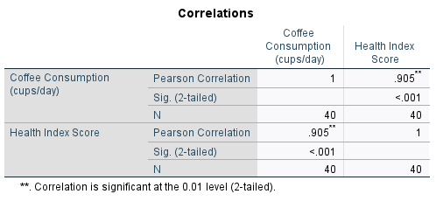
Based on our analysis of the dataset, we can confidently state that there is a strong positive relationship between coffee consumption and health index score, with a correlation coefficient of 0.905. However, it's important to note that correlation doesn't mean causation. While there is a strong association between these two variables, it doesn't imply that coffee consumption leads to changes in health index scores. Other factors may also contribute to the results.
In summary, a correlation coefficient of 0.905 indicates a strong and significant relationship between coffee consumption and health index score in the dataset.

Scatterplot

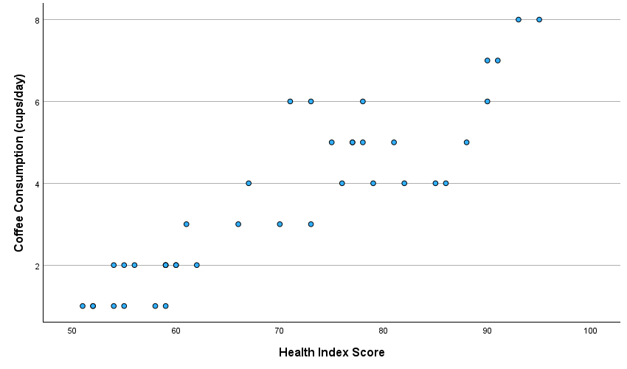
The data points tend to cluster around a straight line from the bottom left to the top right of the plot, it suggests a positive linear relationship, indicating that as coffee consumption increases, health index scores tend to increase as well.
Conversely, if the data points tend to cluster around a straight line from the top left to the bottom right of the plot, it suggests a negative linear relationship, indicating that as coffee consumption increases, health index scores tend to decrease.
In summary, the scatter plot provides a visual representation of the relationship between coffee consumption and health index score, allowing us to interpret the data and draw conclusions about how these variables are related.

Conclusion

The coffee consumption data suggests that most individuals consume a moderate amount of coffee, with consumption levels ranging from 2 to 5 cups per day. There is variability in consumption habits among individuals, but no extreme outliers. The standard deviation of approximately 2.084 cups per day indicates that individual coffee consumption habits tend to cluster around the average consumption level of approximately 2 cups per day.

Section 2

Introduction

Data analytics can be a valuable tool for businesses to improve their efficiency by identifying areas where they are not performing optimally. By collecting and analysing large volumes of data, companies can pinpoint weaknesses in their business model that may otherwise go unnoticed. Inefficiency is often one such weakness, which can have a significant impact on a company's profits and even lead to its downfall. However, determining where inefficiencies lie can be challenging, which is where data analytics comes in (www.zucisystems.com, n.d.).

Tableau, advantages, and disadvantages

To make it efficient and accurate companies are using platforms such as Tableau.
The primary objective of Tableau was to enhance the flow of analysis and make data more accessible to individuals using visualization techniques (Tableau, 2023). Tableau is a powerful analytics platform that enables users to easily explore, manage, and share data-driven insights. Like other platforms, Tableau can have advantages such as:
A user-friendly interface
A retail company's marketing team can leverage Tableau's interactive dashboards to track sales performance in various regions. They need not possess extensive technical skills to visualize sales trends, customer demographics, and product performance. This facilitates data-driven decision-making, enabling the team to make informed choices. (Source: KnowledgeHut, 2019).

Data visualization
According to Knowledge Hut (2019) a healthcare organization can utilize Tableau to create visualizations of patient data, such as demographics, medical conditions, and treatment outcomes. These visualizations help healthcare professionals identify patterns, trends, and correlations in patient data, leading to more personalized care and improved health outcomes.
Data integration
A financial services firm can connect Tableau to various data sources, including transactional databases, market data feeds, and external APIs, to analyse market trends, monitor portfolio performance, and conduct risk analysis. Tableau's ability to integrate with diverse data sources streamlines the analysis process and enables comprehensive financial reporting (AbsentData, 2020).
There are also some disadvantages for companies when using the platform:
Cost:
A small nonprofit organization may find Tableau's licensing fees prohibitive, especially if they have limited financial resources. As a result, they may need to explore alternative, more cost-effective solutions for data visualization and analysis, such as open-source tools or Excel (Mindbowser, 2021).
Steep Learning curve
An academic research team embarking on a data analysis project may encounter challenges in mastering Tableau's advanced features and functionalities. Without adequate training and support, researchers may struggle to leverage Tableau effectively for data visualization and exploration, potentially delaying their research progress (Mindbowser, 2021).
Performance limitations
A manufacturing company working with large datasets of sensor data from production lines may experience performance issues when visualizing this data in Tableau. Complex visualizations or frequent data refreshes can strain Tableau's resources, leading to slower rendering times and decreased user experience. In such cases, the company may need to optimize its Tableau workbooks or invest in more powerful hardware to improve performance (Team, 2018).
Big companies across different industries utilize Tableau for analyzing data, deriving insights, and making informed business decisions. Netflix, Facebook, and Amazon use Tableau for various purposes such as analyzing viewer data, tracking content performance, analyzing user engagement metrics, sales data, and inventory management. Tableau's data visualization capabilities enable these companies to identify popular items, forecast demand, and optimize pricing strategies. The tool's versatility and user-friendly interface make it a valuable tool for organizations to visualize and understand their data effectively.

The meaning and importance of the Data Mining Cycle with examples.

The Data Mining Cycle refers to the iterative process of extracting meaningful patterns, trends, and insights from large datasets to support decision-making and improve business outcomes. It involves several stages, each aimed at uncovering valuable knowledge from raw data. Let's delve into each stage and its importance, accompanied by examples:
The first stage involves gathering relevant data from various sources, such as databases, files, sensors, or web sources. This data may include structured data (e.g., databases, spreadsheets) or unstructured data (e.g., text documents, social media posts). For example, a retail company collects transactional data, customer demographics, and website interactions to understand consumer behaviour (Royal Society of Chemistry, n.d.).
In the preprocessing stage, the collected data is cleaned, transformed, and formatted to ensure its quality and compatibility for analysis. For instance, a healthcare organization preprocesses electronic health records (EHRs) to remove errors and inconsistencies before analysing patient data.
EDA involves visualizing and exploring the data to understand its characteristics, patterns, and relationships. Descriptive statistics, data visualization techniques, and exploratory techniques (e.g., clustering, dimensionality reduction) are used to uncover insights and identify potential patterns of interest.
Statistical and machine learning models are developed to uncover patterns and relationships within the data in the model-building stage. This may involve techniques such as regression analysis, classification, clustering, and association rule mining. For instance, a financial institution builds predictive models to assess credit risk, detect fraudulent activities, and personalize marketing offers based on customer profiles and transaction history (www.adaptiveus.com, 2021).
The models developed in the previous stage are evaluated to assess their accuracy, reliability, and generalization performance. This may involve splitting the data into training and testing sets, cross-validation techniques, and performance metrics such as accuracy, precision, recall, and F1 score (Linoff and Berry, 2011). For example, an online streaming platform evaluates recommendation algorithms based on user feedback, click-through rates, and retention metrics to improve content recommendations.
Once the models are evaluated and validated, they are deployed into operational systems or decision-making processes to generate insights and support business objectives (www.adaptiveus.com, 2021). For instance, a manufacturing company deploys predictive maintenance models to anticipate equipment failures, minimize downtime, and optimize maintenance schedules based on sensor data and historical maintenance records.
The final step involves continuously monitoring the performance of deployed models, updating them as needed, and adapting to changing business requirements and data characteristics. This ensures that the models remain accurate, relevant, and effective over time (Linoff and Berry, 2011). For example, an e-commerce platform monitors customer behavior and updates recommendation algorithms to reflect changing preferences, trends, and market dynamics.

Conclusion

The Data Mining Cycle is a systematic approach to extracting actionable insights from data, driving informed decision-making, and improving business performance. By following this cycle, organizations can unlock the full potential of their data assets and gain a competitive advantage in today's data-driven world (Linoff and Berry, 2011).
.

References

AbsentData (2020). Advantages and Disadvantages of Tableau. [online] AbsentData. Available at: https://absentdata.com/advantages-and-disadvantages-of-tableau/ [Accessed 25 Mar. 2024].
KnowledgeHut (2019). Top 8 Amazing Benefits of Using Tableau For Your Projects. [online] KnowledgeHut Blog. Available at: https://www.knowledgehut.com/blog/business-intelligence-and-visualization/tableau-advantages-disadvantages [Accessed 25 Mar. 2024].
Linoff, G.S. and Berry, M.J.A. (2011). Data mining techniques: for marketing, sales, and customer relationship management. Indianapolis, Ind.: Wiley Pub., Inc.
Mindbowser. (2021). Key Pros And Cons Of Tableau For Your Project Development. [online] Available at: https://www.mindbowser.com/pros-and-cons-of-tableau/ [Accessed 25 Mar. 2024].
Royal Society of Chemistry. (n.d.). Text and data mining (TDM). [online] Available at: https://www.rsc.org/journals-books-databases/research-tools/text-and-data-mining/?gad_source=1&gclid=Cj0KCQjwwYSwBhDcARIsAOyL0fgDgLHsM54FVzyqP1hyZjGyH4M6rj2mDf5KK1A6dIwYb2Jg3jgX3yUaAum-EALw_wcB [Accessed 25 Mar. 2024].
Tableau (2023). What Is Tableau? [online] Tableau. Available at: https://www.tableau.com/en-gb/why-tableau/what-is-tableau [Accessed 19 Mar. 2024].
www.adaptiveus.com. (2021). Data Mining: History, Techniques, Advantages, and Example. [online] Available at: https://www.adaptiveus.com/blog/business-analyst/technique/data-mining/.
www.zucisystems.com. (n.d.). How Is Data Analytics Used in Business? [online] Available at: https://www.zucisystems.com/blog/how-is-data-analytics-used-in-business/#:~:text=Data%20analytics%20can%20help%20improve [Accessed 25 Mar. 2024].
www.zucisystems.com. (n.d.). How Is Data Analytics Used in Business? [online] Available at: https://www.zucisystems.com/blog/how-is-data-analytics-used-in-business/#:~:text=Data%20analytics%20can%20help%20improve [Accessed 25 Mar. 2024].

Appendix

b. Line chart
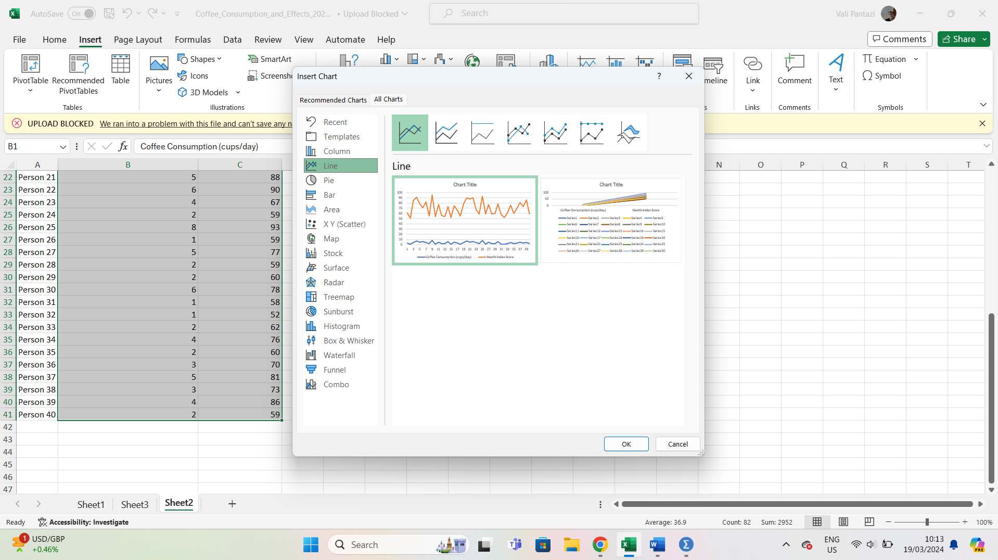

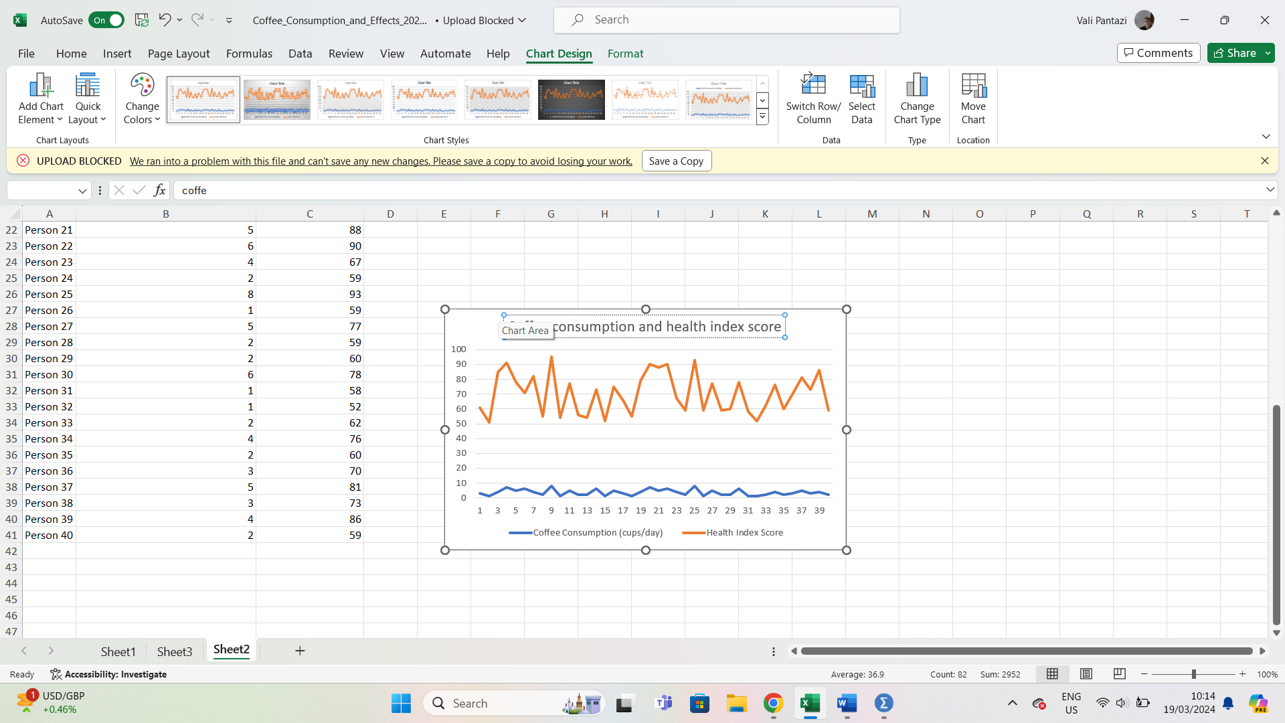
c. Correlation

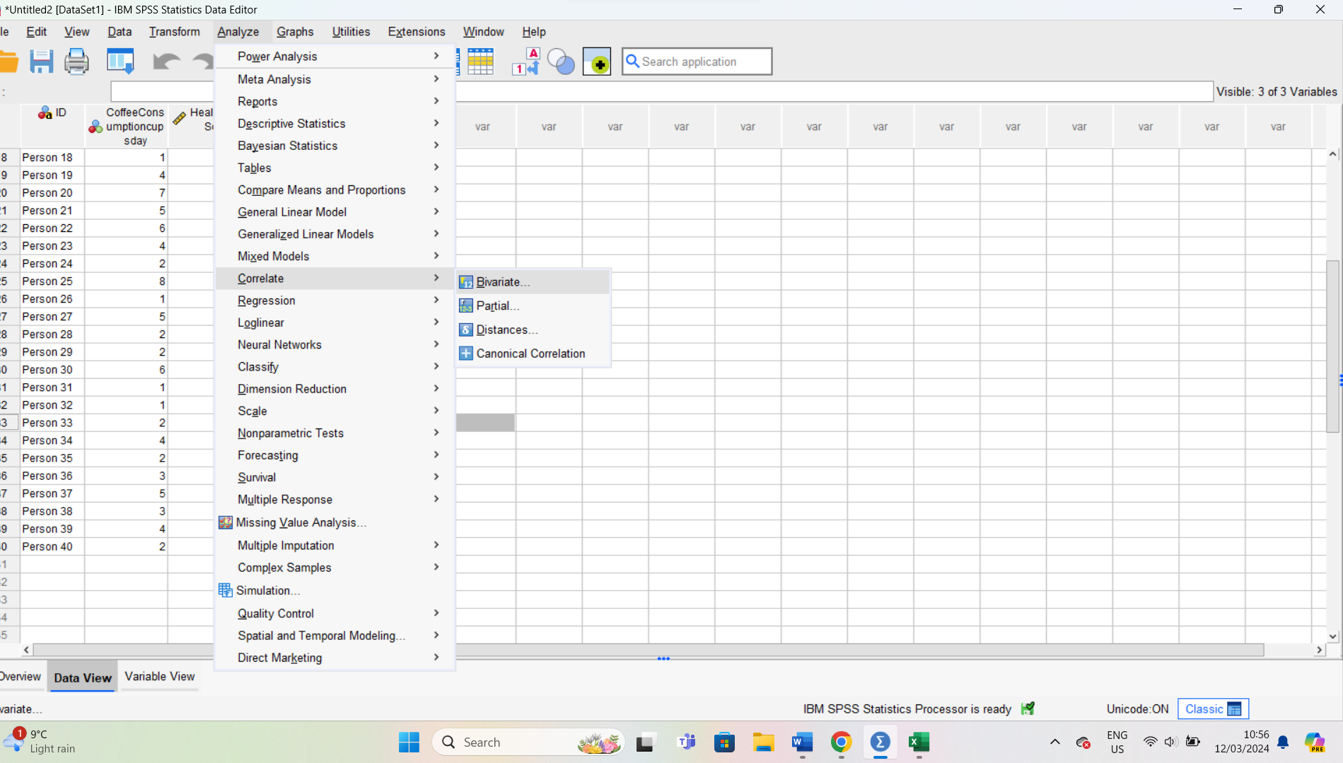
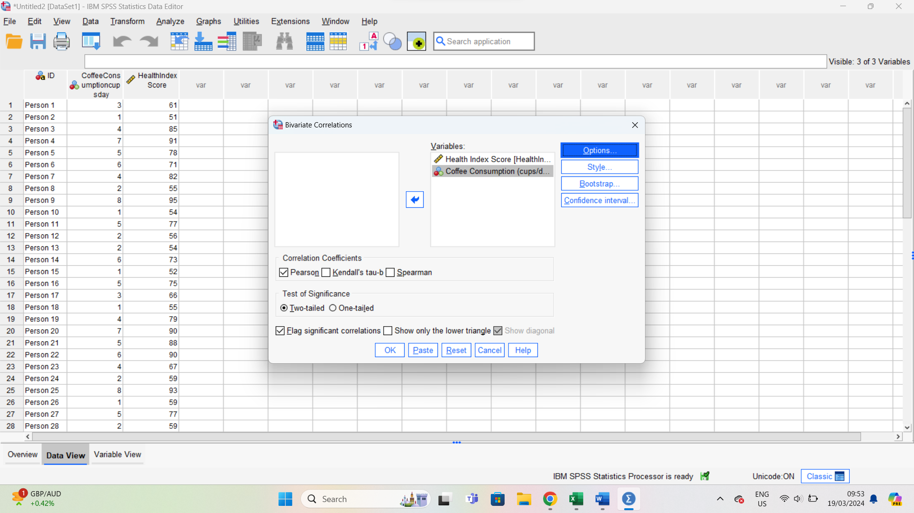
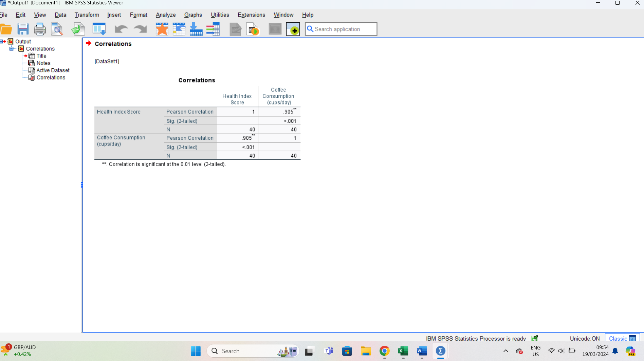

d. Scatterplot



