Student name: Tyrell Graver (2027780)
Eseosa Darame (2108564)
Ionela Fulga (2113507)
Programme: Certificate in Higher Education Skills for the Workplace
Module: Managing Enterprise in the 21st Century
Module code: BMSW 4006
Lecturer: Dr Olu Adegbite
Assignment Title: Written Business Plan, Group task

Executive summary: To summarise, we followed our smart goals and created a business plan enabling us to successfully start up a profitable laundrette company which is both affordable and reliable to all customers and environmentally friendly. We have managed to effectively include multiple services (I.e., washing, drying, steaming, ironing, delivery and pickup) in our laundrette making us innovative and of higher value than regular basic laundrettes. use of market audit, swot analysis and pestle analysis allowed us to evaluate our weak points and develop our strengths in all areas, we have set out lists of all possible problems/issues we may face and put resolutions in place. Using all the information gathered through these processes we collectively created a marketing plan which enabled us to affordably yet successfully boost sales. Management team members kept business flowing smoothly, roles were assigned based on experience; Tyrell G- marketing & management security, Eseosa D- workforce planning, accountancy and company statistics manager, Ionela F- customer service, enterprise, Jamal D- head of collection and delivery. The financial plan we formed enabled us to keep track of profit/loss, turnover, cashflow forecast and steppingstones/milestones for our business keeping us organised. all these elements conjunctively resulted in a steady profit, creating an innovative laundrette experience and a smooth flowing business.

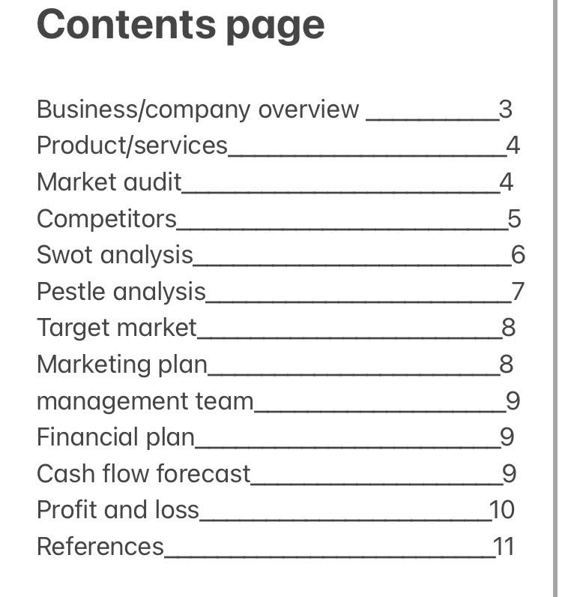

Business/Company Overview
This group project entails our three members deciding on a business idea which we can bring into fruition, operating a successful company and make profit, we chose laundromat as our business not only because of the launderette industry having a success rate of 95% (Key Statistics Laundromat Investors Should Know, 2022), but because of potential community benefits. The first thing we did after deciding on our business idea, was creating a company name. After brainstorming names I.e. ‘budget washer’, we chose ‘Refresh’. We felt it reflected our company best as a pose to ‘budget washer’ as we offer much more than just washing services. Refresh insinuates cleanliness, purity, to restore, to renovate, to replenish, to recharge, to revitalise, to revive and renew. Refresh is the image we want to portray for our business, when you think laundrettes, you think clean smells, clean clothes, warm dry laundry and our name achieves this. A slogan is important as all big brands have them making them memorable. everybody knows ‘one sheet does plenty’ is plenty kitchen towels. After careful consideration we narrowed down our slogan ideas to, ‘start fresh with refresh’. The alliteration of ‘fr’ give an airy breathless sound which works well with our company as we believe we are a breath of fresh air in the laundry business.
To briefly describe our company, it is an affordable and reliable laundry service that is convenient and accessible to all. Our short-term smart goals are to create several partnerships/ sponsorships with established companies. Our long-term smart goals as a company are to be as environmentally friendly as possible. To open multiple laundrettes in multiple locations to become even more accessible and reach more customers.

Product and Services
We offer a variety of laundry services; dry cleaning, ironing, streaming and delivery services.
Costs of services:
- Washing machine - £3.50 per load
- Dryers - £0.50 per 4 minutes
- Ironing – trousers £10, shirts £8
- Steaming – suits £20-30, dresses quoted prices based on size, weight and
material, prices from £20-80
- Delivery - £5 per 10kg plus £4.99 pickup and delivery fee per customer
Market audit
Any business or your own business requires an internal as well as external analysis of the marketing environment. Through it, a generalisation of the business, the strong and weak points, the opportunities and the threats that can cause damage is made. By means of the SWOT analysis, it is easy to detect all these involved points. But why is this strategy so important when you want to open a business? As mentioned, (Kolderu T. 2008) a marketing audit helps to understand the current stage your business is at, which marketing strategies to use along the process and to detect in advance what problem may arise along the way.

Competitors
It is difficult for a start-up to fight for survival in a market dominated by large or already known corporations. if you're successful, it's only a matter of time before competitors appear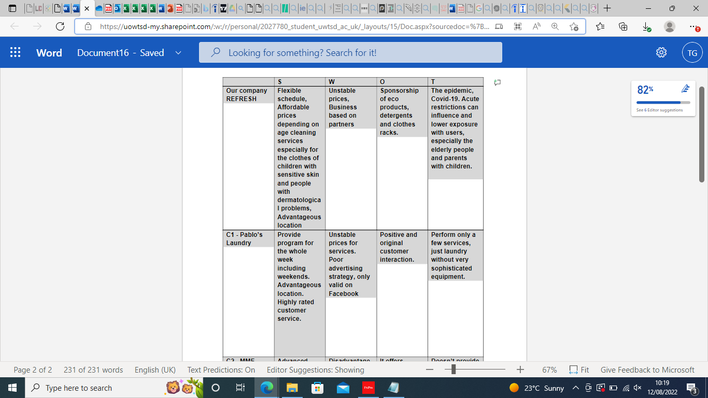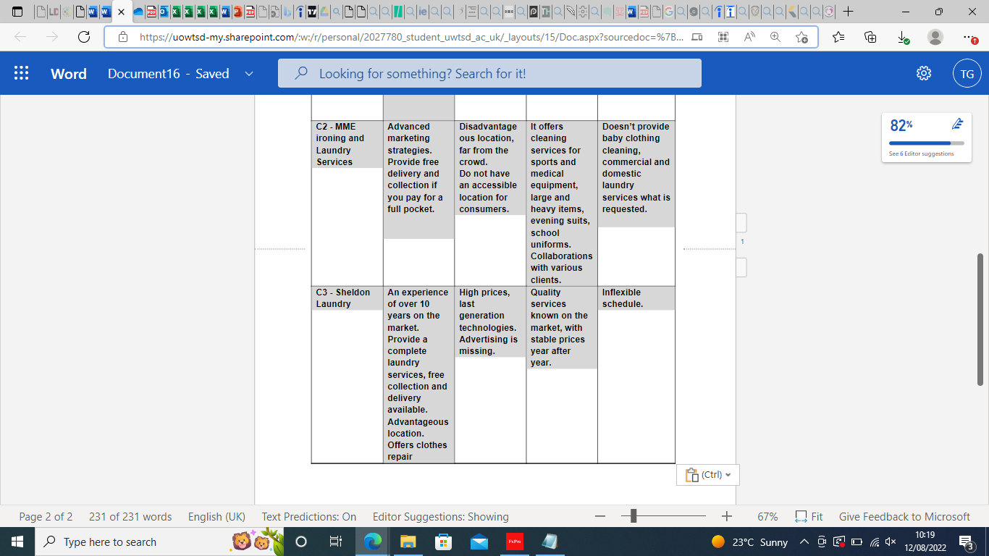

SWOT Analysis
Strengths
A strength of our laundrette business it provides a steady income.
It is easy to operate and low labour costs.
This business offers a great deal of freedom; you may stay and oversee everything, or you can step away and let the operation operate smoothly whilst earning more money. Additionally, you can work a second job during your free time. In simpler terms, we will not need to be present if everything works automatically.
There are several concepts in this industry that we may offer to our clients; We provide a door-to-door service where we pick up your clothing, bring them back to our store and wash, dry and iron them for you.
Although this service is ideal for everyone, it is especially good for students and elderly, people who do not have the time do laundry or people who struggle to do these daily chores.
We will have loyalty cards for people so we may ensure returning customers. Do 20 loads with us and get 1 load washed, dried, and ironed for free.
Weaknesses
The business is just starting up so will we not see profit for the first few months.
Since we are a small business, if the location of our service is poorly chosen, customers will not find it convenient to come and utilise our services, which may result in losing money.
We will face competition from previously established firms who have an advantage over us with experience in the industry and loyalty from customers. To improve, we will need to accumulate a lot of experience.
Opportunity
We will offer flash sales and student discounts to attract more business.
We can start with cheaper laundry prices than competitors while were starting up, this will help to attract more customers and make our company more popular.
Seek out people that have busy schedules, we will be able to convince them of how our convenient services would aid them in their day to day lives.
Threats
It can be challenging to compete with larger laundry services that have more experience and have established loyal customers however our discounts and cheaper rates should help us overcome this.
Other laundrettes might feel threatened when we offer our money saving deals to people and try to price match, but we have so much to offer the right customers will choose our quality services.

PESTLE Analysis
Political: political variables- the government can change the corporate tax rate, which will affect the earnings of companies like washing services. By raising the value added tax or the cost of the goods that the company uses to wash people's clothing, the government may also have an impact on the industry. The national minimum wage is one example of a new rule the government may enact that would affect corporate profits and employee rights. As a result, the company will have to raise its prices to turn a bigger profit. We could even lose a lot of consumers because they might not be able to pay our services.
Economic: Economic factors, for example interest rate, tax rate, laws, policies, wage, and government activities. This will not really affect the laundry business.
Social: there is such a thing as bad publicity.
we want to make alliances with customers so they will recommend us to friends, family, neighbours. However, if we do not make a good impression on individuals, it may hinder our services. News spreads fast within communities and within businesses, we will have a bad reputation and it is difficult to get rid of.
Technological
Technological factors bring in a lot of advantages and a lot of opportunities for businesses such as laundrettes, we can create a new app a new product and services for the customers. There by creating an entire new market for businesses with that we will be different from other businesses because we have something different that no other business as also, we are creating new products it can also reduce costs.
Legal
Legal factors may affect both internal and external environment of the business for example laundrettes. this could affect the policies in the procedures of the company, and it could control the employment safety and regulations this could include your employment laws, consumers protection and environmental regulations.
Environmental
Environmental factors could affect our business for example if its running if we do not have the right packaging it could complicate things.

Target Market
Our target market is people who need their laundry done. Our business offers services, such as ironing Primarily students and elderly. Residents in our area band. Busy working people who want to have more time for themselves/their kids. Homeless people will have cheaper rates specifically for themselves, additionally family's or individuals in temporary accommodations who do not have access to washing machines/dryers etc.
Marketing Plan
After researching the best options, our plan to boost sales are simple and cheap. We have found a cheap outlet to print on demand flyers with a price of £38.32 for 4000 pieces, up to £126.28 for 16,000 pieces, we plan to hand out as many leaflets per day with a minimum of 100 per day this will be done in highly populated walk paths or areas were many pedestrians walk through introducing our brand to consumers. The location we have chosen for our business is located next door to a popular music venue called O2 academy that holds 3009 people, the reason I mention this is because the que for this venue can wrap around the area, bring great opportunities for us to promote our business with flyers and attract sales. We have also spoke to nearby shops/post offices, high rises, student accommodations if we could leave a few leaflets there, the shops refused due to insufficient space, but the rest of the locations agreed with no fees attached. We also plan to use free social media platforms to promote the business further some platforms off amazing features that give us an opportunity to extend our visibility by boosting our company's visibility, for a certain amount of time for a small charge, which increases price there more boosted visibility time you want. Additional to these promos, we are a going to promote our business using truck advertisements which daily is seen on average 55,000 times, this puts the average cost per thousand at 75p making truck advertisements the most cost-effective advertising platform in the Uk. (The Trucking Industry: How to Start a Business, 2019), we will be using our investors trucking company (J Davidson Logistics) for not only delivery services but for the truck advertisements saving us the cost of leasing vehicles. All we had to do was find cheap materials that are environmentally friendly as well as effective and weatherproof. This was challenging at first but after extensive research I came across the perfect material, whether resistant vinyl, to lower the cost of this we decided to source the raw materials, that take it to the printer company, then arose the task of finding a manufacturer/ distributor. This was not difficult as we knew that the best manufactures for this job would be China.

Management Team
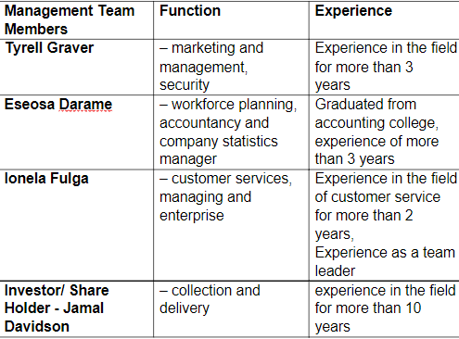
7. Financial Plan
Our plan is to increase our sales by 35-40% every month to cover running costs, for us to be able to make a considerable amount of profit at the end of the year we will need to increase sales by 50% every month. Based on our calculations, by year 3, our financial projection will enable our company to make all the money back from investments and grants.
7.1 Cashflow Forecast 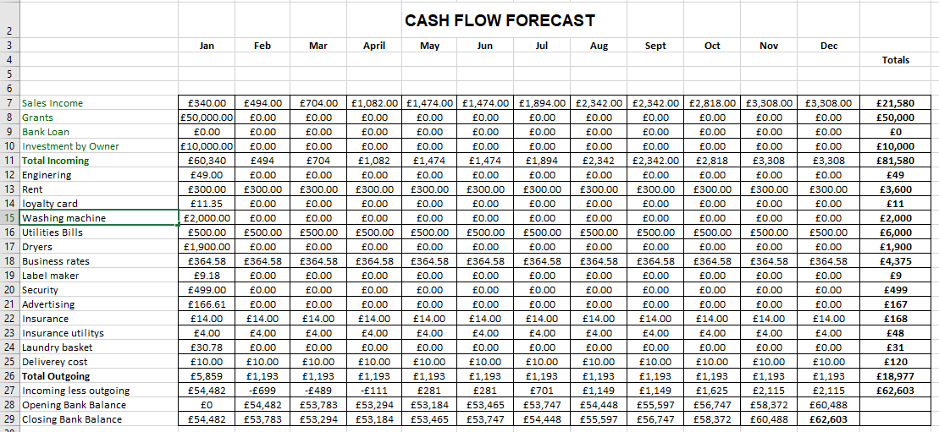

Profit & Loss
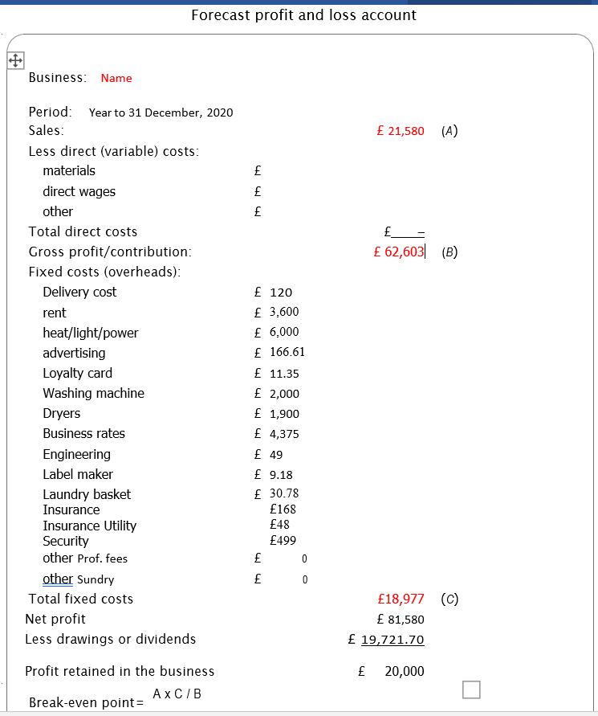

8. Reference
CIPD. 2022. PESTLE Analysis | Factsheets | CIPD. [online] Available at: <https://www.cipd.co.uk/knowledge/strategy/organisational-development/pestle-analysis-factsheet#gref> [Accessed 10 August 2022]. (PESTLE Analysis | Factsheets | CIPD, 2022)
Li, S., 2019. Why Does Truck Advertising Stand Out?. [online] movia. Available at: <https://movia.media/moving-billboard-blog/why-does-truck-advertising-stand-out-1/#:~:text=Truckside%20ads%20stand%20out%20by%20being%20on%20top.,most%20affordable%20alternative%20advertising%20platform%2C%20as%20shown%20below.> [Accessed 22 July 2022].
Libguides.library.usyd.edu.au. 2022. Subject guides: Marketing: PESTLE Analysis. [online] Available at: <https://libguides.library.usyd.edu.au/c.php?g=508107&p=5994242> [Accessed 10 August 2022]. (Subject guides: Marketing: PESTLE Analysis, 2022)
Martinray.com. 2022. Key Statistics Laundromat Investors Should Know. [online] Available at: <https://martinray.com/p-33942-key-statistics-laundromat-investors-should-know.html#:~:text=%20Key%20Statistics%20Laundromat%20Investors%20Should%20Know%20,coin%20laundries.%20More%20than%2060%25%20of...%20More%20> [Accessed 9 August 2022].
Mindtools.com. 2022. SWOT Analysis: Strengths, Weaknesses, Opportunities, Threats. [online] Available at: <https://www.mindtools.com/pages/article/newTMC_05.htm> [Accessed 10 August 2022]. (SWOT Analysis: Strengths, Weaknesses, Opportunities, Threats, 2022)
Parsons, N., 2022. What Is a SWOT Analysis and How to Do it Right in 2021 (With Examples). [online] LivePlan Blog. Available at: <https://www.liveplan.com/blog/what-is-a-swot-analysis-and-how-to-do-it-right-with-examples/> [Accessed 10 August 2022]. (Parsons, 2022)
Your Bibliography: T, K., 2022. [online] Cjournal.cz. Available at: <https://www.cjournal.cz/files/149.pdf> [Accessed 12 August 2022].
CIPD. 2022. SWOT Analysis | Factsheets | CIPD. [online] Available at: <https://www.cipd.co.uk/knowledge/strategy/organisational-development/swot-analysis-factsheet#gref> [Accessed 12 August 2022].
(SWOT Analysis | Factsheets | CIPD, 2022)

