Task 1a: Report on Essential Academic and Employment Skills
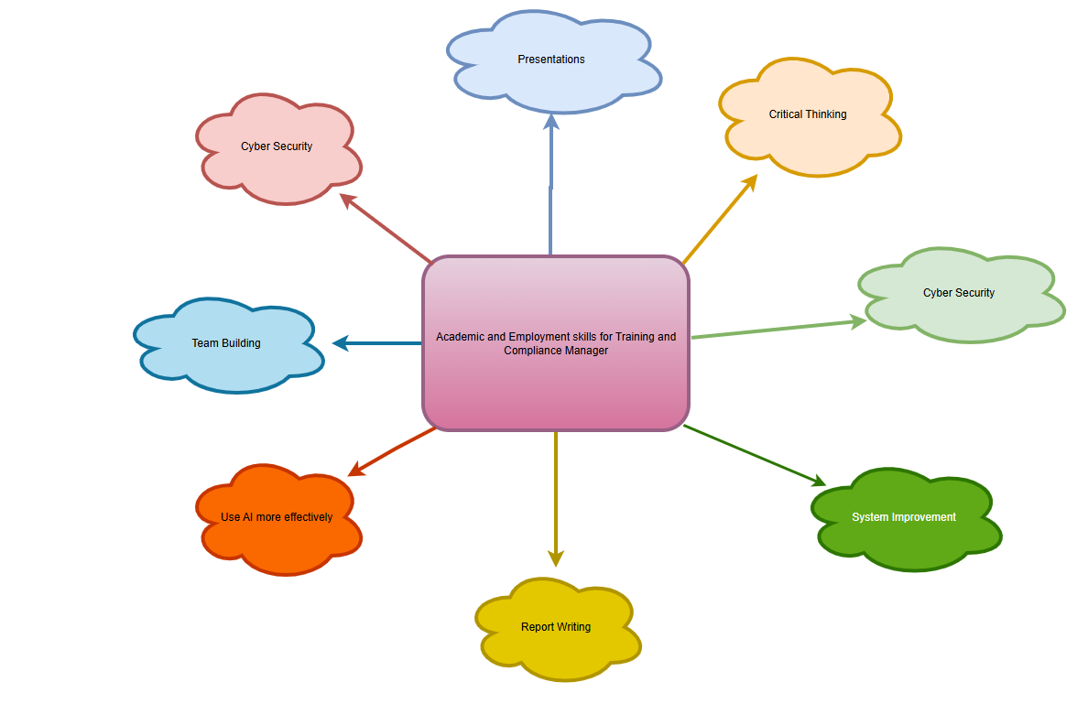
I currently work at Luton Airport with the Assisted Travel team supporting guests with any kind of disability physical or hidden travel through the airport based on the kind of assistance they require. As a contractor our client is LLA, we also work alongside other contractors, stakeholders and service providers to ensure they guests journey is seamless. My role within the company is Standards & Compliance manager, I am responsible for staff training, maintaining compliance, and monitoring operational standards.
As a trainer presentations are an essential medium used to deliver training the staff members. The presentations should be engaging, have concise visual content. To improve engagement presentations should use concise visual content, minimise text, and incorporate AI- generated images and videos where appropriate. [1][2]
In our Software Solutions for Business module I can further improve on my analytical skills needed to track training records and maintain audit records and reports.[3] These skills will support evidence-based decisions-making and improve operational efficiency.
The module Learning in the Digital Era will strengthen my critical thinking, collaborations and team building skills, as these are critical skills in any workforce especially as a manager [4].
Cyber Security is essential in any workforce especially in an airport. Through this course I will gain a better understanding of the risks and how to mitigate them within the team. It will also help me better evaluate our current systems in place and how I can improve them.[5]

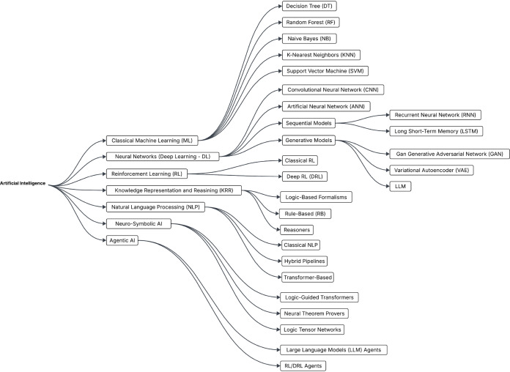[6]

