Module: Introduction to Health and Social Care
Module Code: LCHS4003
Name: Mihaela Alina Stoian
ID: 2505442

Table of Contents
Task 1 3
Task 2 4
Introduction 4
Origins and Historical Development 4
How the Service Functions Today – Critical Evaluation 4
Significance in Enhancing Quality of Life 5
Conclusion 5
References 6

Task 1
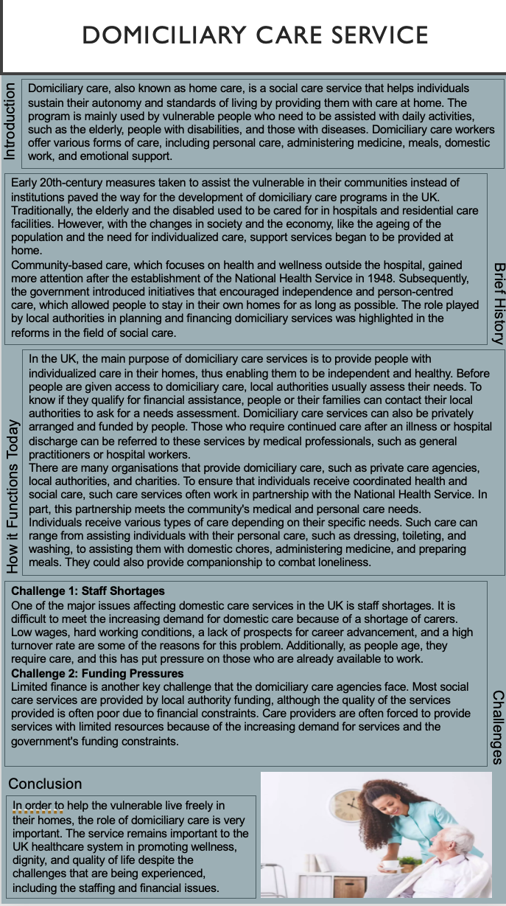

Task 2

Introduction
In the UK, ambulance services are a crucial part of the emergency health system since they provide individuals in serious health conditions immediate medical attention. The ambulance services, which are provided by the National Health Service (NHS), are crucial in the maintenance of life and the improvement of health results. This essay discusses the history and evolution of ambulance services, a critical analysis of the current ambulance services, and the importance of ambulance services in improving the lives of individuals who receive the services. Understanding the evolution and importance of ambulance services is crucial in appreciating the importance of ambulance services in the health system.

Origins and Historical Development
Initially, ambulance services were established to transport wounded soldiers during times of war, but later they were adapted for use by civilians in the 19th century (NHS England, 2019). Most of the ambulance services were nonprofit organisations, and their primary role was to offer transportation, not medical care. The local governments took charge of providing emergency transportation services in the early 20th century, which made it easier for people to access ambulance services.
An important milestone was reached in 1948 with the establishment of the National Health Service, which included ambulances as part of the publicly funded healthcare system, providing free emergency services at the point of delivery (The King’s Fund, 2020). As the years went by, the role of the ambulance crew was no longer just that of an emergency transport crew, but also that of highly skilled paramedics who could provide life-saving treatment on the spot.
With the increase in population, improvements in technology, and the growing need for emergency medical services, the role and services provided by ambulances have also evolved, especially in response to changing societal demands and improvements in healthcare policies.

How the Service Functions Today – Critical Evaluation
Currently, the UK’s ambulance services are provided by regional NHS ambulance trusts, which offer patient transport services, emergency response services, and urgent healthcare services. The services are mainly accessed via emergency phone lines, for example, 999 or 111, whereby operators who are qualified assess the emergency level and provide the required assistance (NHS England, 2019). The emergency medical technicians and paramedics provide stabilization, treatment, and transportation of patients to hospitals as needed.
The prompt medical attention provided by modern ambulance services is one of its best features, and this improves survival rates and reduces complications resulting from life-threatening ailments. Paramedics offer top-notch pre-hospital care due to their extensive training and equipment. By connecting patients to the right resources and reducing avoidable hospitalizations, the program is a major contributor to healthcare in the community.
However, there are a number of challenges that need to be addressed by ambulance services, for example, increasing demand, long response times, and strain on resources (The King’s Fund, 2023). The effectiveness of ambulance services and patient outcomes may be affected by an increase in emergency calls and delays in hospital admissions. These challenges, therefore, pose questions regarding accessibility and sustainability, suggesting that even though ambulance services are still important, they need to be better funded, staffed, and organized.

Significance in Enhancing Quality of Life
Therefore, the accessibility of ambulance services provides easy access to emergency health services, which improves the quality of life in the lives of individuals and the general community. The chances of survival increase, and the risks of health consequences are reduced in the long term when life-threatening conditions such as heart attacks, accidents, and breathing problems are addressed quickly (Department of Health and Social Care, 2022).
The public is also assured of their safety and comfort with the service, knowing they have access to qualified help in case of an emergency. Ambulance services provide for vulnerable populations, mental health cases, and community patients, contributing to public health. Ambulance services are important for public safety and the improvement of the standard of living for people. They do this by providing public access to urgent care and health and wellness services.

Conclusion
To recap, ambulance services have developed from simple transportation means to advanced emergency medical care service providers. They remain essential in facilitating timely medical care and improving health outcomes in spite of challenges like increasing demand and resource constraints. The maintenance of an effective healthcare system and promotion of public health depend on their continued development.

References
(2019) NHS choices. Available at: https://www.england.nhs.uk/2019/01/long-term-plan/.
(2020) The next steps towards Integrated Care | The King’s Fund. Available at: https://www.kingsfund.org.uk/insight-and-analysis/long-reads/next-steps-towards-integrated-care.
Department of Health and Social Care (2022) Health and Social Care Integration: Joining up care for people, places and populations, GOV.UK. Available at: https://www.gov.uk/government/publications/health-and-social-care-integration-joining-up-care-for-people-places-and-populations#:~:text=It%20sets%20out%20measures%20needed,and%20better%20person%2Dcentred%20care.

