DBA

Module: LCDB7007

Research Principles and Philosophy

Module Lead: Dr. Caroline Jawad

Spring 2023

ASSESSMENT BRIEF

Student name: | QURATULAIN | Student ID number: | 2223727
Program: | Doctor of Business Administration
Module: | Research Principles and Philosophy
Module code: | LCDB7007 | Contribution to Overall Module Assessment (%): | 100%
Lecturer: | Dr. Caroline Jawad | Internal Verifier: | Steve Griffiths
Assignment Title: | Report | Word count (or equivalent): | 7,500 words
Submission deadline: | 31st MAY 2023 | The return date of provisional marks & written feedback: | 17 JUNE 2023

Table of Contents
ASSESSMENT BRIEF 1
Case study research to examine the relationship between digital entrepreneurship and digital radical innovation with the mediation function of the IIOT 5.0 Industry leading to the sustainability of an economy. 4
EXECUTIVE SUMMARY 4
1. Introduction 5
1.1Background to the Problem 5
1.2 Research Rationale 7
1.3 Implications of Research 7
1.4 Research Purpose 8
1.5 Research Objectives 8
1.6 Research Questions 8
Chapter 2 9
2.0 Literature Review 9
2.1 Digital Entrepreneurship 9
2.2 Digital Radical Innovation 10
2.3 Internet of Things Industry IIOT 5.0 10
2.4 The rationale following the progression of Industry 5.0. 11
2.5 Sustainable Development of an Economy 11
2.6 Smart Hospitals as a Future with Industry 5.0 12
Chapter 3 13
3.1 Conceptual Framework 13
Chapter 4 14
Implementation of theories: 14
4.1 Entrepreneurship Innovation Theory 14
4.2 The digital technology entrepreneurship theory 14
4.3 Disruptive Innovation Theory 15
Chapter 5 15
Research Paradigm and Philosophy 15
5.1 Epistemology 16
5.2 Ontology 17
5.3 Axiology 18
5.4 Methodology of Research 18
5.4.1 Mixed method research 18
5.5 Methods of conducting qualitative research 19
5.6 The Case Study Research Design 20
Chapter 6 21
6.1 Ethical Considerations 21
Seedhouse Ethical Grid 21
- External (outer) layer 22
- Consequential layer 22
- Deontological consideration 22
- The inner layer, which is the top layer. 22
Chapter 7 22
7.1 Reliability and Validity 22
7.2 Estimates of Reliability 23
Chapter 8 23
8.1 Conclusion and Contribution to Research 23
Reference List 24

Case study research to examine the relationship between digital entrepreneurship and digital radical innovation with the mediation function of the IIOT 5.0 Industry leading to the sustainability of an economy.

EXECUTIVE SUMMARY

The study's purpose is to ascertain the fact that in the healthcare industry, the term "industry 5.0" might help define the relationships between digital innovation, digital entrepreneurship, and fifth-generation traits. A comparison between Industry 5.0's features and earlier industrial evolutions is also made. Also covered are how industry 5.0 applications, like those in healthcare, can be developed and made viable by digital technology. This report elaborates on the key technologies of Industry 5.0, such as big data analytics, the Internet of Things, collaborative robotics, blockchain, and digital triumphs. The upcoming technology of the previous generation, known as "Industry 5.0," is made for effective and intelligent machines. The research attempts to shed light on how utilizing digital devices makes it harder to understand issues in the healthcare sector. Finally, the study aims to provide insights into how the usage of digital devices in the healthcare sector might contribute to economic sustainability. The fact that people are now at the center of industrial processes, however, sets Industry 5.0 apart from all other alternatives. Intelligent robots will dramatically alter both the production workflow and the supply chains for manufacturing and will lead towards the sustainability of the economy and improvement of wellbeing.

Word Count: 7730
Key Words: Digital Entrepreneurship, Digital radical innovation, IIOT 5.0, Sustainability, Digital Devices, health care Industry.

CHAPTER 1

1. Introduction
  - Background to the problem
Despite having existed since the early 1990s, digital entrepreneurship is frequently regarded as a recent development. Digital entrepreneurship is acknowledged in many nations, particularly those that are members of the European Union, as a pillar of development, job creation, and innovation. To support and strengthen the significance of this revolution and the digital innovation that we are currently seeing in real-time, digital technology can be employed as a driver of digital transformation (Ungureanu, P. et al., 2021). Digital entrepreneurial behavior, culture, and strategy have a significant impact on a country's ability for digital entrepreneurship, and innovation is a collaborative ecosystem involving governments, enterprises, sectors, non-governmental organizations, and educational institutions. For enterprises to adopt Industry 5.0, staff members must effectively communicate with workers and technology. It includes an understanding of scientific fields like technology and artificial intelligence (Zhang C, Chen YA, 2020 and Chowdhury MZ, et al., 2020). Kim and Ha,2023 research study diagram in Figure 1.0 explain in the best possible way the relationship between entrepreneurship, innovation, technology, and sustainability.
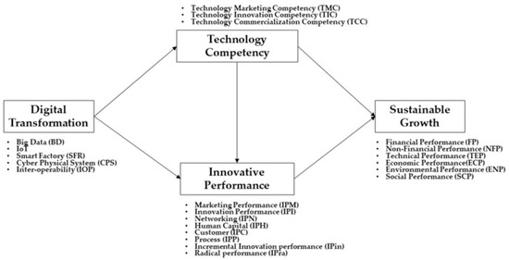(Reference Kim and Ha,2023)
Figure 1.0
The phrase "digital entrepreneur" is becoming frequently used by academics. In addition to including, it as a variable, the study also links digital entrepreneurship to digital innovation. The disruption of the corporate environment brought about by technology is a concern for established companies' founders, and they have good reason to be concerned (Satalkina, L., Steiner, G, 2020). The next generation of technology, called "Industry 5.0," is designed for powerful and clever machines. As seen by the Industry 5.0 revolution, humans and machines are collaborating more effectively to increase industrial output. Because of human labor and ubiquitous robots, the manufacturing industry is becoming more productive (Majumdar A, Garg H, Jain R.2021).
The phrase "Internet of Things (IoT) industry" refers to the development and deployment of the IoT in industrial applications and sectors. Businesses and industries may function more effectively and dependably thanks to the Internet of Things (IoT), which emphasizes big data, machine learning, and interactions between machines (M2M) strongly. The Internet of Things includes industrial applications such as software-defined manufacturing procedures, robotics, and medical technologies. Manufacturing industrial robots and robotics will be Industry 5.0's future priority. The industrial sector has advanced and business efficiency has sped up thanks to the development of cognitive computing and artificial intelligence technologies (Chen H et al., 2020).
Figure 2.0
(Reference Chen H et al., 2020)
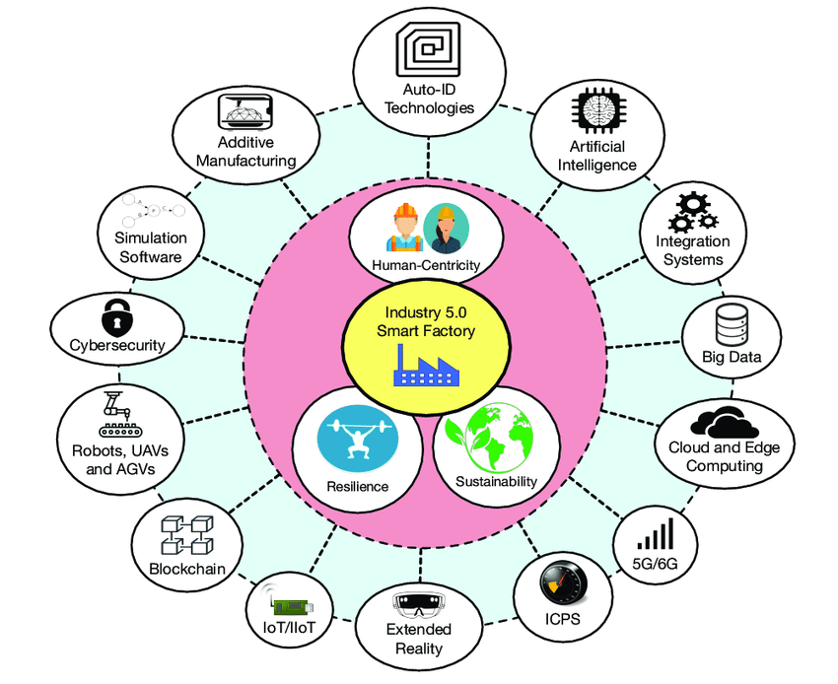

1.2 Research Rationale
This study compares the association between digital entrepreneurship and radical digital innovation for firm survival empirically. We employ the Internet of Things industry mediators between these variables to promote the sustainable growth of present and future businesses using the aid of digital gadgets in the healthcare sector. Industry 5.0 mandates the use of resources that have been altered to fulfill the needs of the industrial sector as it exists now. Human-machine collaboration produces adaptable business models. Together with creative activities, local production makes economies sustainable (Saraswa V et al.,2021, Javaid M et al., 2020).
Peter F. Drucker, the father of management, in his book on Innovation and management, said, "Innovation is an entrepreneur's specific tool, how he uses a chance for a different product or service to emerge." (Schumpeter, 1997) is extremely clear about the economic role of the entrepreneur; he believes that it serves as the catalyst for economic growth and that the entrepreneur's job is to invent or implement new ideas. Not including these technologies represents the risk of losing big in competition. Internet of Things advancements will greatly amplify the platform and value-sensing effects that characterize the digital economy (Wagner, D.N., 2020).
The term "Industry 5.0" workers refers to employees who use robots and intelligent machines. Robots will utilize cutting-edge technology like big data analytics to speed up human labor. "Industry 5.0" is the revolution where man and machine are figuring out how to work together to increase the methods and efficiency of industrial production (Javaid M et al., 2020; Martos V et al., 2021).

1.3 Implications of Research
In the past, innovation and entrepreneurship have fostered development and raised standards of living. Finding the most effective model to describe innovation clustering is a research goal to improve firms' innovation capacity and value chain. Global competition has led to investments in research and development. Smaller countries are looking to invest more in knowledge, which is reflected in an increase in the number of entrepreneurs and an opening up of the economy (Leong Y.K.et al.,2021).
The time frame from invention to market has been greatly reduced and a systematic approach to the theory of innovation has been introduced. If you want to cross borders, you must build networks and foster a culture of innovation. This is only possible if entrepreneurs use different digital approaches in their enterprises. This study is about how digital entrepreneurship, along with the Internet of Things industry, is tied to digital and radical innovation in organizations to help them survive in the times to come. It helps you be more adaptable and competitive overall (Abubaker M et al., 2020).
Significant productivity increases will result from the economy's adoption of the Internet of Industries. It serves as an innovation that benefits both the creation of consumer goods or services as well as internal operations including management, logistics, and customer service (Longo F et al., 2020, Angelopoulos A et al., 2019).
The use of robotic and artificial intelligence technology is a requirement of the modern workforce. Robotic teams that work together are being developed for real human interaction. Digital twin development needs industry 5.0 technologies. By using visual representations of the goods, processes, and production, comprehension and testing will be improved. With the help of the integrated system known as "Industry 5.0," businesses may quickly transition to being digitally driven. The lifestyles of earlier generations changed to accommodate the capabilities of machines (Wang M et al., 2020; Deepa N et al., 2021).

1.4 Research Purpose
This research aims to compare empirically the relationship between digital entrepreneurship and radical digital innovation as well as the effects of digital entrepreneurship on long-term economic growth. The research tries to explore the challenges and barriers to implementing digital devices in the healthcare industry. We employ IIoT intermediaries among various factors, which will result in the growth of sustainable businesses.
The digitization of the business environment is both an ongoing connection to data and a significant transformational process, necessitating deliberate strategic planning on the part of businesses to advance. The 21st-century economic landscape demonstrates how the economy is gradually becoming international because of digitization and the ongoing development of new information and communication technology. This study examines the key components of 21st-century digitalization, the significance of digital commerce, and the function of digital innovation in international trade.
This study focuses on elucidating the significance of digitizing global business by employing a methodology based on important research techniques. To help entrepreneurs succeed in today's cutthroat business environment, this study will highlight the relationship between digital business and digital innovation as well as techniques for building successful IoT practices. The business opportunity assessment is summed up in the globalization theme, which also explains the objectives of international trade. The digitization of business creates a creative atmosphere where it is possible to monitor market trends and cutting-edge technological advancements. Industry 5.0 is viewed as the frontier of the smart factory, where it interacts with both humans and robots (Carayannis, E.G. et al., 2022) and communicates with both. Communication between human and electronic componentry is facilitated through social networks. Industry 5.0 introduced ideas that are strong, economically viable, and human-centric to the industrial revolution. It will revolutionize production methods across the world by freeing human labor from boring tasks (Ietto B et al., 2022).

1.5 Research Objectives
The objectives of the research are set below to achieve the research aim:
- To explore the challenges and barriers that digital entrepreneurs will experience in the implementation of digital devices in the healthcare industry.
- To understand how digital devices used in the healthcare industry can lead to the sustainability of the economy and the improvement of well-being.
- To explore the relationship between digital entrepreneurship and digital radical innovation?
- To examine how the Internet of Things Industry 5.0 mediates the relationship between digital entrepreneurship and digital radical innovation?

1.6 Research Questions
Therefore, according to my research objectives above, the specific research questions in my study are put forward as follows.
- What are the challenges and barriers that digital entrepreneurs will experience in implementing digital devices in the healthcare industry?
- What is the relationship between digital devices used in the healthcare industry with the sustainability of the economy and the improvement of well-being?
- What is the relationship between digital entrepreneurship and digital radical innovation?
- How does the Internet of Things Industry 5.0 mediate the relationship between digital entrepreneurship and digital radical innovation?

Chapter 2

2.0 Literature Review
A literature review is an essential component of almost any research project. It serves as the foundation for advancing knowledge, facilitates theory development, closes mature research, and uncovers novel research areas (Webster and Watson 2002).

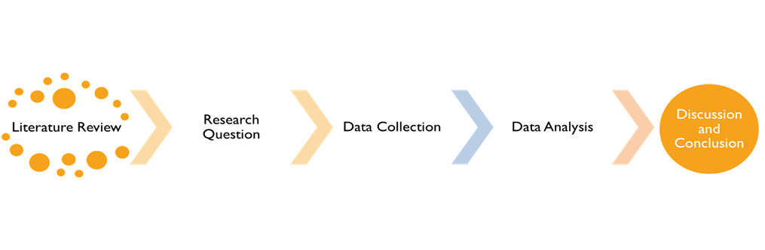

2.1 Digital Entrepreneurship
Digital entrepreneurship, according to Hull et al., (2007), is "the reconciliation of traditional entrepreneurship with the new way of creating and doing business in the digital era," where some or all of what would be physical in a traditional organization has been digitalized (Dinh et al., 2018, p. 1). A slightly different definition of digital entrepreneurship is offered by Davidson and Vaast (2010), Digital entrepreneurship refers to the search for business prospects based on the use of digital media and other information and communication technology.
Any entrepreneurial activity that moves a key product, service, or element of the business online can be widely referred to as digital entrepreneurship. Hull et al., (2007) study found that digital entrepreneurs face several differences from traditional business owners. Entrepreneurs who operate in the digital space and those that can’t be distinguished primarily by the products, marketing approaches, and workplaces they use. By spotting and seizing chances to enhance organizational performance, address issues in novel ways, and make effective and efficient use of the organization's resources, entrepreneurs inspire and empower businesses to implement procedures that support the culture of organizational innovation (Rae, 2016).
Greenberg et al. (2013) defined entrepreneurs as those who perceive opportunities to provide value for their companies and stakeholders as well as for society at large and who stand up to manipulate others and the settings of the working environment. An entrepreneur is a combined construct of initiative, invention, and risk-taking, according to Chen (2007), who noted that this construct resides at the intersection of entrepreneurship. This viewpoint is consistent with the theoretical framework for this type of digital entrepreneurship provided by Gupta et al., (2004). Entrepreneurial leaders drive innovation and opportunity recognition in SMEs by developing a vision, anticipating, and imagining change, and preserving flexibility (Bagheri, 2017; Renko et al., 2015; Cogliser & Brigham, 2004).

2.2 Digital Radical Innovation
According to Caceres et al., (2011), innovation is a continuous process of developing usable resources that are subsequently employed to produce goods and current items more cheaply and with higher quality. In a similar vein, innovation was defined by Ilori et al. (2017) as the incorporation of new information into procedures, goods, and services. According to Drucker 1998, innovation is at the core of all entrepreneurial activity, and many entrepreneurs carry out their operations because of innovation. Innovation is one of the factors considered when a firm is strategically expanded, as well as when entrepreneurship is encouraged (Freel and Robson,2004)
Hamel, G. 2000 even goes so far as to assert that the originality of a company's strategy is its most important component. Innovations give entrepreneurs the means to search for opportunities. Corporate entrepreneurship includes the establishment of new organizations by (or inside) an existing business, as well as the development of novel ideas, products, organizational structures, and manufacturing techniques. From this vantage point, we can assume that innovation would encourage their activities and have a positive response. In other words, innovation in entrepreneurship spurs other entrepreneurs to engage in their activities (Caceres et al., 2011; De Cleyn and Braet, 2012; Zortea-Johnston et al., 2012).
To establish a link between innovation and entrepreneurship, the knowledge spillover theory of entrepreneurship (Audretsch, 1995) asserts that entrepreneurial firms can identify and seize opportunities brought about by knowledge spillovers as a result of innovative activities.

2.3 Internet of Things Industry IIOT 5.0
Rising levels of automation and data sharing are linked to the fourth industrial revolution. It urges the development of novel manufacturing techniques and services based on the fusion of technological advancements like the Industrial Internet of Things (IIoT), 5G, artificial intelligence (AI), big data analytics, blockchains, and more (Arnold et al., 2016; Cockburn, D. 1996; Leone et al., 2021; Chen et al., 2022). The Industrial Internet of Things (IIoT) concept is an expansion of the Internet of Things that incorporates the digitization of production (Boyes et al., 2018; Kiel et al., 2017).
According to Gubbi et al. (2013), the Internet of Things is distinguished by three key features: context, omnipresence, and optimization. New avenues for performance research are now available because of the Internet of Things. For instance, road transport vehicles might be automatically controlled by host requirements. This will enable the trucks to operate at a steady speed and by predetermined intervals, optimizing their fuel efficiency and lowering their environmental effect (Witkowski, 2017).
The Internet of Things (IoT) offers a multi-modal perspective to assist various industries, including the public and private sectors, healthcare, transportation, and the environment. Different researchers have offered different explanations of the IoT concerning specific subjects and features. A massive number of interconnected devices and sensors make up an IoT system. The number of these sensors and devices is rising quickly because of the extensive growth and extension of IoT networks. Over the internet, these gadgets exchange information and communicate with one another. Due to its size and constant stream, this data might be referred to as big data (Rymaszewska et al., 2017).
As IoT-based networks continue to grow, complicated problems including data management and collecting, storage and processing, and analytics become more prevalent. Managing oxygen levels, measuring smoke and dangerous gases, and measuring brightness are just a few of the difficulties that IoT big data frameworks for smart buildings may help with (Bashir MR, Gill AQ, 2016).
This framework can do data analytics decision-making and gather data from the sensors deployed in the buildings. A cyber-physical system built on the IoT that includes tools for knowledge acquisition and information analysis can also increase industrial productivity (Lee C, Yeung C, Cheng M, 2015).

2.4 The rationale following the progression of Industry 5.0.
Figure 3.0
Industrial Evolution 1.0- 5.0 Industry.

2.5 Sustainable Development of an Economy
The potential of digital entrepreneurship to help firms achieve their commercial objectives serves as a symbol of its significance. Through increasing staff productivity and overall business performance, leaders and managers in organizations with digital entrepreneurial competencies contribute to the success of the company. Digital entrepreneurship is the newest trend in academia and is not a luxury for businesses. Business managers who merely possess entrepreneurial traits, however, will not be able to compete in the present business environment (Esmer,2016).
In a nutshell, managers require more than only entrepreneurial or technological skills to carry out their organizations’ development and sustainability goals and strategies. On the other hand, competitor managers should have both entrepreneurial and digital abilities to innovate, take chances, seize opportunities, and eventually thrive (Javaid M, et al., 2020).
Utilizing resources that have been altered to fit the needs of the manufacturing industry today is a commitment made by Industry 5.0. Flexible business models are the product of human-machine cooperation. Overproduction also requires regulation to eliminate waste. Local production and new initiatives provide sustainable economic growth. (Saraswa V et al.,2021).
With Industry 5.0, corporate innovations are turning the tide. It leads to the establishment of sustainable policies, such as reduced waste generation and management, which can improve the efficiency of the company. Industry 5.0 purposely emphasizes cutting-edge research and prioritizes information, positioning it at the forefront of evolution with a practical design. It is thought to be distinguished by a resolve that goes beyond merely creating goods for profit (Leone et al., 2021).
Three principles that underpin Industry 5.0 are sustainability, human-centeredness, and resilience. The productivity and efficiency of people are improved by new technologies. Robots that collaborate with people carry out risky and boring jobs so that people may focus on developing creative and successful business solutions (Yu M et al., 2018).

2.6 Smart Hospitals as a Future with Industry 5.0
The construction of a real-time, intelligent hospital is the aim of Industry 5.0. Remote monitoring systems are a potential benefit of technology in the healthcare industry (Phuyal S et al., 2020). It is crucial to making doctors' lives better. Using this smart healthcare technology, doctors can focus on infected patients during the COVID-19 pandemic and provide useful information for better treatment (Lima F et al., 2019).
Additionally, the COVID-19 outbreak provides medical students with the training they require. According to Naha Vandi (2019), machine learning (ML) is used for genetic data, natural language processing, and medical imaging. It is concentrated on the identification, detection, and prognosis of diseases. Abdel Majeed and Zayed stated in 2020 that iIndustry5.0 enables the proper manufacture of personalized smart implants by changing client requirements. Artificial intelligence technology is becoming more popular among medical practitioners as a way to monitor various issues including glucose levels. Creating implants per patent match, which are the initial requirements for orthopedics, aids in the implementation of mass personalization. Even if the traditional process of creating implants for patients changes, it is still capable of improving a wide range of medical tools and equipment. Technologies are utilized in surgery because they enable exact execution (Lutz J et al., 2019).
It is advantageous for medical students to use better teaching, learning, research, and expansion strategies (Saxena A et al., 2020). High-quality, individualized implants with a long lifespan are required by the orthopedic Industry 5.0. It helps to solve problems like excessive production, bad tool selection, and lack of transparency (Tosh D et al.,2020, Sherburne C, 2020).

Chapter 3

3.1 Conceptual Framework

Figure 4.0

Chapter 4

Implementation of theories:

4.1 Entrepreneurship Innovation Theory
One of the greatest economists of the 20th century, Joseph Alois Schumpeter 1997, is credited with giving the concepts of innovation and entrepreneurship life. His argument states that innovation can be utilized to:
1. Introduce a completely new product or an upgraded version of an existing one.
2. Using innovative sales or production techniques
3. The opening of a new market
4. Purchasing fresh sources of basic materials
5. Making use of an altered industry structure, like the dissolution of a monopoly
This is one of the most well-liked entrepreneurship principles. Entrepreneurs don't merely operate their companies to improve their life. Instead, via their efforts, people can impact social and economic growth. The idea's originator, Joseph Schumpeter 1997, claimed that imagination and foresight are essential to the growth of an entrepreneur. Also, don't see a slowdown in entrepreneurial innovation any time soon. In the end, novelty wins out over familiarity, all in the name of promoting change.

4.2 The digital technology entrepreneurship theory
Tony Bailetti 2012 made a crucial addition to the field's definition of technology entrepreneurship. Technology entrepreneurship, according to his definition, is " investment made in a project that assembles and utilizes specialists and a variety of resources that are closely tied to scientific and technological advancements to create and capture value for a company (Bailetti, 2012).”
The greatest initial public offering (IPO) from a technology business ever occurred around the time Bailetti's essay was published: Facebook raised over $16 billion when it was listed on the stock market. We have seen a mobile and social media revolution in the five years since Facebook went public (Hanna et al., 2011).
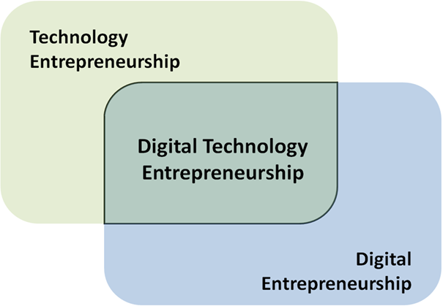
Figure 5.0

4.3 Disruptive Innovation Theory
Christensen's put out this theory. The Harvard Business Review first introduced the disruptive innovation theory in 1995. This theory aids in the development of our fourth research question because it has proven to be a highly useful instrument for considering innovation-based growth.
Innovation cannot be referred to as such if it does not provide a company with improbable earnings that can be sustained. This well-known term, which Alan Afua came up with, makes it apparent that innovations of any kind would consider the issue of "Economic Sustainability." There are also other instances where businesses make investments to deliver a better value trajectory by including the sustainability of the environment through green efforts like waste management, pollution reduction, and other issues.

Chapter 5

Research Paradigm and Philosophy
For Kuhn 1970, a paradigm has two main interpretations. The first is the definition of a Disciplinary Matrix in its broadest sense, which is the grouping of ideas, methods, standards, and presumptions that together constitute a common worldview and study agenda for normal science. In the first definition, he uses the term "Disciplinary Matrix" to describe a paradigm. According to Kuhn, for science to advance, the relevant scientific community needs to be steadfastly committed to its shared theoretical viewpoints, values, tools, techniques, and even metaphysics. The Disciplinary Matrix is the constellation of shared commitments that Kuhn refers to, and this is the earliest definition of the term paradigm. This notion of a paradigm contradicts the conventional wisdom that rules are what makes science what it is. Contrarily, science advances in the absence of rules, according to Kuhn.
This notion of a paradigm contradicts the conventional wisdom that rules are what makes science what it is. Contrarily, science advances in the absence of rules, according to Kuhn. The second way Kuhn defines a paradigm is as an example. The general agreement among experts on the subject is that these are excellent examples of scientific study. Kuhn uses the word "paradigm" in this second, more limited definition to refer to these examples.
According to Lincoln and Guba (1985), who were quoted by Kivunja and Kuyuni (2017), a paradigm is made up of four components: epistemology, ontology, methodology, and axiology. Each paradigm's foundational presumptions, beliefs, standards, and values are made up of these components. Every research is predicated on philosophical presumptions about reality (Ontology), knowledge (Epistemology), and how the researcher discovers knowledge (Methodology). So, the paradigm that directs the study approach determines the choice of research methodology.

5.1 Epistemology
Wisdom is a major theme in epistemology. The focus of epistemology is on how we know what is, as opposed to questions regarding what is. Sociology can be studied in a variety of ways. We can interview people or even observe them in their natural environment to learn general agreement on a topic. We might completely omit face-to-face participation by mailing questionnaires for individuals to complete independently or by reading people's opinions in newspaper editorials. Every method of data collection has its own set of epistemological assumptions about how knowledge is acquired (Saylor Academy, 2012). Positivism and interpretivism are the two fundamental divisions in epistemology.
According to Kivunja and Kuyuni, epistemology primarily focuses on determining the truth and what constitutes knowledge in the universe (2017). Intuitive, authoritative, logical, and empirical knowledge are the four types of knowledge identified by Slavin (1984), as quoted by Kivunja and Kuyuni, (2017). Moreover, epistemology offers a conceptual foundation for determining the types of knowledge that are feasible as well as how to assure the sufficiency and legitimacy of such information (Crotty, 1998). According to Denzin and Lincoln (2007), the epistemological assumption of qualitative research requires the researcher to try to establish a close relationship with the participants to acquire subjective data. This is what is categorized as warrantable and, therefore, acceptable knowledge, according to Bryman (1990).
This study's epistemology combines logical, empirical, and authoritative knowledge. The study methodology is subjectivist epistemology and interpretive constructivism. Information from corporate executives, project review documents, company archives, books, scholarly publications, and academic journals will be used by the researcher. In a constructivist paradigm, the investigation's goal is to comprehend the nature of knowledge based on human reconstructions, and the quality standards are based on dependability and authenticity, claim Guba and Lincoln (2004). The social phenomenon under study, which is highly complicated and involves interaction between humans and nonhuman beings, is the basis for doing this research in this paradigm.
The researcher will begin the study with a comprehensive and methodical review of the concepts and literature as part of the research plan for a conceptual framework. This technique will be used to align the literature. A non-foundationalist methodology will be used in the research to better comprehend the knowledge and truth that underlie technology strategy. While non-foundationalists contend that these criteria will depend on the contextual elements that are active at the time, foundationalists contend that there is an ultimate standard to verify the dependability and validity of phenomena (Guba and Lincoln, 2005).
For the researcher to act on the implications, the study findings must be legitimate and reliable to that level (Guba and Lincoln, 2004). According to Denscombe, M. (2010), obtaining accurate measurements and results—i.e., data that reflect reality and address important issues—is what validity is all about. Credibility, dependability, conformability, and transferability are additional considerations that might be used to examine these two major criteria.
In terms of epistemology, the researcher's and interviewees' interpretations are always speculative because the study stresses a reality created by various viewpoints merged into various groups within the organization with the researcher's worldview (Guba and Lincoln, 1994). As a result, this research will concentrate on understanding the intricate effects of modern technologies and considering how people behave differently under different circumstances. All information, opinions, and attempts to make sense of the phenomenon are explained using social constructivism.
By accurately documenting events and data gathered from participants, such as date, time, the type of question posed and the responses received, as well as by providing participants with the chance to access and verify the information recorded, the research will be given credibility and be confirmable. Findings will also be compared to pre-existing theories and frameworks, such as disruptive innovation theory, entrepreneurship innovation theory, and digital entrepreneurship theory, to minimize bias. Eventually, a comprehensive description of the complete study process will result in transferability.

5.2 Ontology
The word "ontology" comes from the Greek and implies "the study, theory, or science of being." According to Saunders et al., (2009), ontology is concerned with the nature of reality or what it is. It may involve issues that are extremely broad and challenging to resolve, like:
1. What is the point of living?
2. What, if anything, lies beyond our universe?
3. To what categories does it fit?
4. Does reality have an objective nature?
5. What is the meaning of the word "to be"? The two components of ontology are objectivism and subjectivism.
Social entities exist without the help of the social actors who are concerned about them, according to objectivism. According to subjectivism, the perceptions and actions of social actors who are interested in social phenomena are what causes them (Saunders et al., 2009).
According to Stephen and Hamza, (2015), who referenced Wand and Weber (1993), ontology is the study of the nature and organization of the world. The suggested research will be conducted under the interpretive paradigm employing subjectivist epistemology and relativist ontology, as was already mentioned. Prior ontological presumptions concerning technology strategy have centered on how innovation, business alignment, infrastructure, investments, and profitability are impacted by technology strategy inside organizations. This research will concentrate on what technology techniques are employed for major project implementations, building on these ontological presumptions. There will be multiple realities observed as part of the process because the phenomenon being investigated (human beings and organizations) is complex in nature.
According to subjective ontology, the phenomenon under study is subject to several realities. According to Chalmers, Manley, and Wassermann (2005), as stated in Kivunja and Kuyini, (2017), knowledge can be gathered by looking at the human and social interactions between participants and the researcher.

5.3 Axiology
Ethical considerations are incorporated into the research process through the nature of the research problem, the paradigm chosen to investigate the problem, the choice of theoretical framework, the methods used for data collection and analysis, and the interpretation and presentation of the findings (Lincoln & Guba 2004). Healthcare professionals will be contacted for semi-structured interviews and open-ended questionnaires that will collect the data for this study. Instead of the researcher's ideals, the researcher’s nature will determine how data will be collected. As a result, beliefs and values will be closely related to those of the participants, The fact that this research is also undertaken subjectively renders it value bound.
Because pragmatists emphasize pragmatic outcomes in particular situations, it is possible to apply mixed techniques effectively to answer study research concerns (Creswell et al., 2007). The pragmatism paradigm can assist the researcher in integrating viewpoints, and various methodologies, and advancing the practice of research in the future (Denscombe, 2010).

5.4 Methodology of Research
It is suggested by postmodern theories, according to Guba and Lincoln (2004), that some methodologies are better suited than others for doing a study on how people construct social realities. Research methodologies are referred to as a tool for data collection by Denscombe, M. (2010). According to Kaplan (1972), cited by Cohen et al., (2006), a methodology is meant to characterize the approaches to different sorts of paradigms, whereas research methodologies are concerned with the techniques used to collect data. The three types of research methodologies are quantitative, qualitative, and mixed.

5.4.1 Mixed method research
Utilizing multiple approaches this work provides a precise definition of the category of research that integrates quantitative and qualitative research methodologies, methods, approaches, concepts, or language into a single study. It stands for the "third wave" or third research movement in philosophy, which provides a reasonable and beneficial alternative to paradigm conflicts. The pragmatic approach and philosophical system are applied in mixed research in philosophy. As an example, de Waal (2001) describes how this technique of study uses induction (or pattern recognition), deduction (testing of ideas and hypotheses), and abduction (identifying and depending on the best of a collection of explanations for interpreting one's results.
Instead of limiting or restricting researchers' options (and in the process rejecting dogmatism), mixed methods research seeks to justify the employment of a variety of methodologies to solve research challenges. It is an innovative and open-ended method of inquiry rather than one that is restricted. The ability to be inclusive, pluralistic, and complementary allows one to use a variety of methods and conduct research in a variety of ways.
But as Morgan points out, Kuhn preferred a version of research paradigms that was more firmly established in research practice and research communities rather than in the spheres of ontology and epistemology dispute. According to him, these paradigms share four characteristics (Kuhn,1970, pp. 176–183). They first focus on a certain issue or set of issues that are thought to be particularly important for the development of knowledge. Second, they also concern common practice. Such paradigms entail a common comprehension of the research methodologies suitable for addressing that subject. These paradigms also incorporate a feeling of collective identity. This common identity, which is based in part on the practitioners' specialized field of study, is strengthened by the information-exchange mechanisms they employ (specialized journals and conferences), as well as by the social networks that practitioners build around their field of study. Fourth, these paradigms are carried out by teams of practitioners who work in research communities.
Exploratory sequential, explanatory sequential, and convergent designs are the three different categories of fundamental designs. The qualitative data is gathered, and the analysis phase precedes the later quantitative phase in the exploratory design. Quantitative data is collected, and the analysis step precedes the follow-up qualitative phase in the explanatory design. In the convergent design, both quantitative and qualitative data must be simultaneously gathered and analyzed, then the results must be combined (Stake, 2005).

5.5 Methods of conducting qualitative research
There are numerous qualitative research methods for studying business management. Creswell 1998 claims that these "strategies to research" have also been referred to as "strategies of inquiry" (Denzin and Lincoln 2003) and "varieties" (Tesch 1990), among other terms. All of these "types" of inquiry were categorized by Creswell (1998) into the following five "traditions":
- Phenomenology
- grounded theory
- ethnography
- case study
- biographies.

PHENOMENOLOGY | Understanding the heart of a phenomenon's experience
GROUNDED THEORY | Constructing a hypothesis based on field facts.
ETHNOGRAPHY | Understanding and describing a particular cultural and social group
CASE STUDY | Creating a thorough examination of a single instance or several cases.
BIOGRAPHY | A biography is a study of a person's life.
Figure 6.0
Source: Creswell, 1998, p. 245.
The table below compares these five "traditions" and highlights the key distinctions. Creswell (2007) revised his analysis, but the most significant alteration was the rechristening of the research methodology from "biography" to "narrative research."

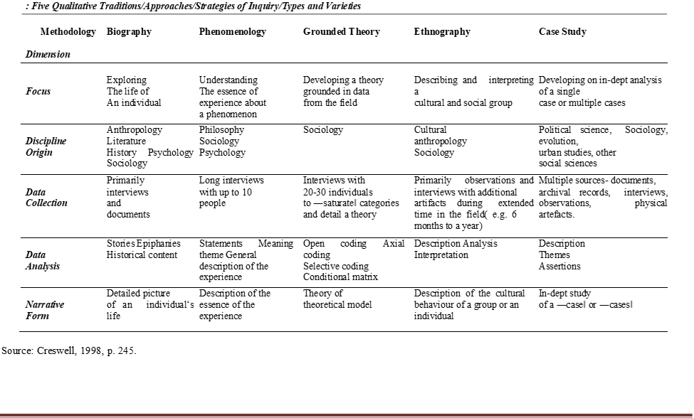
Figure 7.0
Source: Creswell, 1998

5.6 The Case Study Research Design
Yin (2003, p. 13) defined a case study as an empirical examination that examines a present occurrence in its actual context. This is especially true when it's difficult to distinguish between phenomenon and context. Given this, Woodside, and Wilson (2003, p.493) suggest that the term "case study research" be broadened to include "inquiry focused on describing, understanding, predicting, and/or controlling the individual (i.e., process, animal, person, household, organization, group, industry, culture, or nationality)". Stake (2005) distinguished three fundamental case study categories based on their purpose and nature: intrinsic (unique cases; not typical), instrumental (to provide insights or support an existing theory), and collective (generalization is the goal). Yin (1994), on the other hand, categorizes case study research into three primary areas based on their methodology, problems, and relevant theories. These three types of case studies are exploratory, descriptive, and explanatory.
The six approaches to qualitative research described by Creswell (2007) are constructivism, phenomenology, grounded theory, ethnography, case studies, and storytelling. Not all of these components will work well for this study. To review and analyze the issue at hand critically, the researcher will employ a case study methodology. The following critical assessment of these methodologies concerning the research study explains why the case study methodology should be used instead of the others.
Studying a problem as it is presented through one or more cases inside a constrained system is called case study research. The researcher examines one or more bounded systems over time using thorough, in-depth data collection from a variety of sources (such as observations, interviews, audiovisual material, documents, and reports) and then presents a case description and case-based themes. For the study, one can choose a single program (on-site study) or several programs (multi-site research). For instance, Yin (2003) addresses exploratory, explanatory, and descriptive qualitative case studies while advocating both quantitative and qualitative approaches to case study production.
The investigation will employ a case study research design. The goal of case study research is to go deeper into the issue by looking at one or more examples within a predetermined framework (Creswell, J. 2007). Thus, the goal of this case study research is to develop a comprehensive account of a case or case.
The case study is preferable for our line of work because it uses IIOT as a case study and operates inside the confines of the UK IT Telecoms business. The primary goal of the study will be to offer a thorough assessment and analysis of Technology strategy, including what it means for a business and how it applies to new technology developments. Case studies, according to Cohen et al. (2006), are most effective when looking at problems in constrained contexts since they assist people to grasp and clearly state the problem at hand.
The study adheres to the interpretive paradigm since it assumes that social reality is irrational and is formed by human views. The research paradigm provides direction for how the study should be carried out (Collis & Hussey, 2021). As a result, all participants’ opinions in the survey are based on their own opinions; this includes, for instance, their views on the technology they believe is crucial for a certain business. The paradigm is strongly related to the technique and research design we chose; thus, it was acceptable.
We obtain insight into how top companies are applying the technology through a qualitative multiple case study of businesses from the aerospace, heavy equipment, automation, electronics, and automobile industries. We offer the idea of production logic, which is based on the link between competitive priorities: quality, flexibility, delivery time, cost-effectiveness, and ergonomics, to discover the elements influencing how Industry 4.0 technologies are implemented and what common themes can be found. Data will be gathered through interviews, project documents, archival records, and audiovisual sources. A holistic and embedded analysis of the data will be done to provide a full description of the study.

Chapter 6

6.1 Ethical considerations
Educational research is no exception to the rule that all studies involving human contact will include an ethical component. Ethical issues are frequently difficult to navigate. Researchers must, on the one hand, be aware of the rules, policies, and standards of conduct that set down how they should conduct their research. On a different plane, one may argue that maintaining the integrity of the study itself presents an ethical conundrum. In research, moral dilemmas of both a macro and micro nature can arise. At a "macro" level, we'll be considering issues like accumulating sufficient data to make trustworthy conclusions; at a "micro" one, we'll need to consider issues like the intricacies of how we may conduct individual interviews.

Seedhouse Ethical grid
Philosopher Seedhouse in 1998 describes his ethical grid as a tool to aid the user in understanding the moral dilemmas they are confronted with. The grid was created for use in healthcare, but social scientists have effectively employed it in action research projects (Atkinson, 1989). Instead of offering solutions, the grid offers a framework to help users think through problems and come up with methodical solutions. The framework is provided in four overlapping layers: the outside, inner, consequential, and deontological layers.

1. External (outer) layer
All external concerns, including the legislation, norms of conduct, and utilization of resources, are included in this layer. The privacy of data about medical equipment used in the healthcare industry will be considered ethically in my research because, by the code of conduct, we are not permitted to exploit any patient’s private data without acknowledgment.

2. Consequential layer
The user is encouraged by this layer to consider the effects of potential acts on society, particular people, or groups of people. In this study, we must evaluate the risk posed by people utilizing digital gadgets and its repercussions.

3. Deontological consideration
'Duty' and assessment of potential actions are topics covered in this tier. It is more concerned with how things are done than with the results of doing them. 'Telling the truth ‘And ‘minimizing harm' are only a couple of the topics covered in the boxes in this tier. Before gathering information about participants' health during interviews, we should always disclose the truth to them.

4. The inner layer, which is the top layer.
The 'fundamental rationale' is covered here, which touches on concerns of autonomy and respect for the individual.

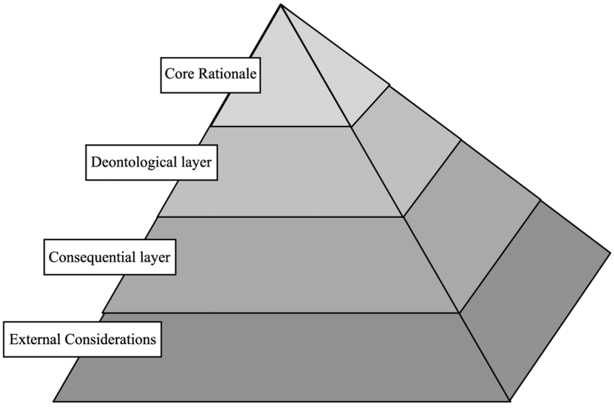
Figure 8.0

Seedhouse's Ethical Grid (Seedhouse, 1998).

Chapter 7

7.1 Reliability and validity
The ability to replicate a consistent outcome, or from various observers, displaying aspects like coherence, stability, equivalence, and homogeneity, is known as reliability. It serves as one of the primary standards for research quality (an instrument)."...the extent to which a test or measure yields the same results when used under identical conditions." Nelson (2006).
If an instrument measures exactly what it claims to measure, it is considered to be legitimate. Validity is not a feature of an instrument; rather, it needs to be evaluated for a specific problem once it is applied to a particular population. “The validity or suitability of a test or instrument in determining what it is intended to determine"(Vincent,1999).
It is appropriate to evaluate qualitative research using reliability, validity, and generalizability. Consistency among the used analytical techniques is referred to as reliability. The integrity and applicability of the employed methodologies are aspects of validity. It is appropriate to use alternative frameworks for creating rigor because qualitative methods are fundamentally different from quantitative approaches in terms of their philosophical stances and goals (Lincoln and Guba, 1985).
There are two methods for determining whether something is dependable. The first method is testing or testing again, and the second is internal consistency. The test and retest process are simple. Simply put, you run tests 1 and 2 on an idea. It must be measured twice at various intervals, and the results of the two tests must be compared. If the outcomes of the two tests are identical, it can be concluded that a measurement is accurate. Internal consistency is the next method of reliability estimation. You can achieve this by asking questions. Create various question sets that can measure the same factor. Let different individuals or groups respond to this. There are four different sorts of validity: conclusion, internal validity, construct validity, and external validity (Bollen, 1989).
When a psychological test is used to evaluate quality or behavior, reliability is a significant issue (Rosenthal & Rosnow, 1991). For essentially the same results to be achieved under various situations, a measurement must be reliable or stable (Nunnally, 1978). The results of behavioral research investigations can be impacted by measurement errors that are not under our control. However, systematic errors do not cancel out; they add to the average score across all individuals, making the average result either too high or too low.
Intentionally gathering participant thoughts and feedback, the research has produced a mixed bag of findings that include input from stakeholders. The study's success has been supported by the findings' overall excellent reliability and validity.

7.2 Estimates of reliability
The correlation coefficient, which is sometimes referred to as the reliability coefficient, is the most used approach for estimating reliability (Rosenthal & Rosnow, 1991). The consistency of a measurement over time or the stability of a measurement under various circumstances is reliability. The term "research" in the social sciences is problematic since various people have varied definitions of what it means. According to Silverman, 1993, research is 'one of the ways to get answers to your problems' in the simplest sense. Finding solutions to questions regarding a subject that is moving slowly and constantly changing—namely, the social world—represents a challenge and source of debate. There has been an ongoing discussion among social science academics on how "research" ought to be performed since the turn of the twentieth and the beginning of the twenty-first centuries (Bulmer, 1983; Kirk and Miller, 1986; Welch, 1991; Neuman, 2002).
The present dispute in social research is between quantitative and qualitative research traditions. In connection to the social world, each tradition has a unique ontological and epistemological perspective. In a metaphorical sense, it's like seeing the social world through several glasses; different things appear to be essential, and as a result, various queries seek various answers. In other words, the social world is seen in quantitative research as distinct from the observer; this ontological objectivism then nurtures a positivist epistemological alignment to see the social world as a measurable object. Contrarily, qualitative research is epistemologically interpretivism since it considers the social reality ontologically as a fabrication of the researcher and those being the researcher.

Chapter 8

8.1 Conclusion and Contribution to Research
This study compares the association between digital entrepreneurial leaders and radical digital innovation for firm survival empirically. We employ the Internet of Things industry mediators between these variables to promote the sustainable growth of present and future businesses in the healthcare industry. Industry 5.0 has reached the pinnacle of excellence and is replacing earlier innovations. This process is successful because machine work requires less time and effort from human labor (Adadi A, Berrada M., 2018).
In addition to the difficulties, the study emphasized the approach used by commercial organizations to implement Industry 5.0. With the help of the medical industry, experts are working on developing a synthetic pancreas. This undertaking has not yet been completed. Patients who have been given a Type-1 diabetes diagnosis have been given a monitoring device that measures their blood sugar levels. The device that can give insulin to the body is connected to this one. One of the innovative technologies is this one. In terms of giving the patient a reliable and practical control system, this is one of the cutting-edge technologies designed and produced just for patients. By enabling doctors to provide their patients access to a smartphone application they can use to track their lifestyles and daily activities and develop a personalized treatment plan for them, Industry 5.0 is advancing this level of personalization. Because the technologies are based on artificial intelligence (AI) systems, they would be a game-changer for persons with Type-1 diabetes. These AI systems can understand and detect numerous bodily responses and react appropriately.

Reference List
Abubaker, M. et al. (2020) “Sustainable and Smart Manufacturing: An Integrated Approach,” Sustainability, 12.
Acs, Z. J. and Sussan, F. (2017) “The digital entrepreneurial ecosystem,” SSRN Electronic Journal. doi 10.2139/ssrn.2918535.
Adadi, A. and Berrada, M. (2018) “Peeking inside the black box: a survey on explainable artificial intelligence (Xai),” IEEE Access, 6, pp. 52138–52160.
Angelopoulos, A. et al. (2019) “Tackling faults in the Industry 4.0 era-A survey of machine-learning solutions and key aspects,” Sensors (Basel, Switzerland), 20(1), p. 109. doi 10.3390/s20010109.
Arnold, C., Kiel, D. and Voigt, K.-I. (2016) “How the Industrial Internet of Things changes business models in different manufacturing industries,” International Journal of innovation management, 20(08), p. 1640015. doi 10.1142/s1363919616400156.
Atkinson, C.J. (1989). A lost dimension in soft systems practice. Journal of Applied Systems Analysis, 16, 43–53
Audretsch, D. B. (1995) “Innovation, growth, and survival,” International Journal of industrial organization, 13(4), pp. 441–457. doi: 10.1016/0167-7187(95)00499-8.
Bagheri, A. (2017) “The impact of entrepreneurial leadership on innovative work behavior and opportunity recognition in high-technology SMEs,” The Journal of High Technology Management Research, 28(2), pp. 159–166.
Bailetti, T. (2012) Technology Entrepreneurship: Overview, Definition, and Distinctive Aspects Tony Bailetti.
Bashir, M. R. and Gill, A. Q. (2016) “Towards an IoT big data analytics framework: Smart buildings systems,” in 2016 IEEE 18th International Conference on High-Performance Computing and Communications; IEEE 14th International Conference on Smart City; IEEE 2nd International Conference on Data Science and Systems (HPCC/SmartCity/DSS). IEEE.
Bellenger, D. N. et al. (1986) “Reliability and validity in qualitative research,” JMR, Journal of marketing research, 23(4), p. 397. doi 10.2307/3151819.
Bollen, K. A. (1989) Structural equations with latent variables: Bollen/structural equations with latent variables. Hoboken, NJ, USA: John Wiley & Sons, Inc.
Boyes, H. et al. (2018) “The industrial Internet of things (IIoT): An analysis framework,” Computers in industry, 101, pp. 1–12. doi 10.1016/j.compind.2018.04.015.
Bryman, A. (1990) “Quantity and quality in social research,” Contemporary sociology, 19(2), p. 325. doi 10.2307/2072662.
Bulmer, M. and Blumer, H. (1983) “Critiques of research in the social sciences: An appraisal of Thomas and Znaniecki’s The Polish peasant in Europe and America,” The British Journal of Sociology, 34(1), p. 144. doi 10.2307/590627.
Caceres, R., Guzman, J. and Rekowski, M. (2011) “Firms as a source of variety in innovation: influence of size and sector”,” International Entrepreneurship and Management Journal, 7(3), pp. 357–372.
Carayannis, E. G. et al. (2022) “Known unknowns in an era of technological and viral disruptions—implications for theory, policy, and practice,” Journal of the knowledge economy, 13(1), pp. 587–610. doi 10.1007/s13132-020-00719-0.
Chen, H. et al. (2020) “Fundamentals, applications, and future directions of bioelectrocatalysis,” Chemical Reviews, 120(23), pp. 12903–12993. doi: 10.1021/acs.chemrev.0c00472.
Chen, L. et al. (2022) “IIoT talent cultivating mechanism in line with industrial internet,” Procedia computer science, 199, pp. 377–383. doi: 10.1016/j.procs.2022.01.046.
Chen, M.-H. (2007) “Entrepreneurial leadership and new ventures: Creativity in entrepreneurial teams,” Creativity and innovation management, 16(3), pp. 239–249. doi: 10.1111/j.1467-8691.2007.
Chowdhury, M. Z. et al. (2020) “6G wireless communication systems: Applications, requirements, technologies, challenges, and research directions,” IEEE Open Journal of the Communications Society, 1, pp. 957–975. doi: 10.1109/ojcoms.2020.3010270.
Cockburn, D. (1996) “Artificial Intelligence System for Industrial Applications,” Artificial Intelligence System for Industrial Applications. Found. Distrib. Artif. Intell, 9.
Cogliser, C. C. and Brigham, K. H. (2004) “The intersection of leadership and entrepreneurship: Mutual lessons to be learned,” The leadership quarterly, 15(6), pp. 771–799. doi: 10.1016/j.leaqua.2004.09.004.
Cohen, E. H. (2006) “Research in religious education: Content and methods for the postmodern and global era,” Religious education (Chicago, Ill.), 101(2), pp. 147–152. doi 10.1080/00344080600639980.
Collis, J. and Hussey, R. (2021) “Red Globe,” in Business research: A practical guide for students.
Creswell, J. W. (1998) Qualitative inquiry and research design. Thousand Oaks, CA: Sage.
Creswell, J. W. (2007) Qualitative inquiry and research design; Choosing among five traditions. Thousand Oaks, CA: Sage.
Creswell, J. W. (2013) Qualitative inquiry and research design: Choosing among five approaches. Thousand Oaks, CA: Sage.
Creswell, J. W. (2014) Research design: Qualitative, Quantitative and Mixed Method Approaches. Thousand Oaks, CA: Sage.
Crotty, M. (1998) The Foundations of Social Research: Meaning and Perspective in the Research Process. London: SAGE Publications Ltd.
David Silverman (2011) Interpreting Qualitative Data. A Guide to the Principles of Qualitative Research.
Davidson, E. and Vaast, E. (2010) “Digital entrepreneurship and its socio-material enactment,” in Proceedings of the Annual Hawaii International Conference on System Sciences. IEEE, pp. 1–10.
De Cleyn, S. H. and Braet, J. (2012) “Do board composition and investor type influence innovativeness in SMEs?”,” International Entrepreneurship and Management Journal, 8(3), pp. 285–308.
Deepa, N. et al. (2021) “An AI-based intelligent system for healthcare analysis using Ridge-Adaline Stochastic Gradient Descent Classifer,” J Supercomput, 77(2), pp. 1998–2017.
Denscombe, M. (2010) The Good Research Guide: for small scale social research projects. New York: McGraw-Hill.
Dewar, R. D. and Dutton, J. E. (1986) “The adoption of radical and incremental innovations: An empirical analysis,” Management Science, 32(11), pp. 1422–1433. doi 10.1287/mnsc.32.11.1422.
de Waal, (2001). Society for the Advancement of American Philosophy, “Early defenders of pragmatism,” Newsletter of the Society for the Advancement of American Philosophy, 29(90), pp. 5–8. doi: 10.5840/saap2001299027.
Dinh, L., Vu, T. and Ayayi, M. C. (2018) “Towards a living lab for promoting the digital entrepreneurship process,” International Journal of Entrepreneurship, 22(1), pp. 1–17.
Djamba, Y. K. and Neuman, W. L. (2002) “Social research methods: Qualitative and quantitative approaches,” Teaching Sociology, 30(3), p. 380. doi 10.2307/3211488.
Drucker, P. F. (1998) “The discipline of innovation”,” Harvard Business Review, 76(6).
Esmer, Y. (2016) “A New Paradigm In Management : Ethical Leadership,” Akademik Bakis Uluslararasi Hakemli Sosyal Bilimler Dergisi, 57, pp. 38–54.
Frank, A. G. et al. (2019) “Servitization and Industry 4.0 convergence in the digital transformation of product firms: A business model innovation perspective,” Technological forecasting and social change, 141, pp. 341–351. doi 10.1016/j.techfore.2019.01.014.
Freel, M. S. and Robson, P. J. A. (2004) “Small firm innovation, growth, and performance: Evidence from Scotland and Northern England,” International small business journal, 22(6), pp. 561–575. doi 10.1177/0266242604047410.
“HAMEL, G (2000), leading the Revolution, Harvard business school press, Boston,” Revista Empresa y Humanismo, pp. 205–208. doi 10.15581/015.3.34682.
Giones, F. and Brem, A. (2017) “Digital technology entrepreneurship: A definition and research agenda,” Technology innovation management review, 7(5), pp. 44–51. doi 10.22215/timreview1076.
Gohmann, S. F. (2012) “Institutions, latent entrepreneurship, and self–employment: An international comparison,” Entrepreneurship theory and practice, 36(2), pp. 295–321. doi: 10.1111/j.1540-6520.2010.00406. x.
Green, S. G., Gavin, M. B. and Aiman-Smith, L. (1995) “Assessing a multidimensional measure of radical technological innovation,” IEEE Transactions on engineering management, 42(3), pp. 203–214. doi 10.1109/17.403738.
Greenberg, D., McKone-Sweet, K. and Wilson, H. J. (2013) “Entrepreneurial leaders: Creating opportunity in an unknowable world,” Leader to leader, 2013(67), pp. 56–62. doi 10.1002/ltl.20063.
Gubbi, J. et al. (2013) “Internet of Things (IoT): A vision, architectural elements, and future directions,” Future generations computer systems: FGCS, 29(7), pp. 1645–1660. doi 10.1016/j.future.2013.01.010.
Gupta, V., MacMillan, I. C. and Surie, G. (2004) “Entrepreneurial leadership: developing and measuring a cross-cultural construct,” Journal of business venturing, 19(2), pp. 241–260. doi: 10.1016/s0883-9026(03)00040-5.
Hanna, R. (2011) “We’re all connected: The power of the social media ecosystem May 2011Business Horizons 54(3):265-273 SourceRePEc,” Horizons, 54(3), pp. 265–273. doi 10.1016/j.bushor.2011.01.007.
Harrison, C., Burnard, K. and Paul, S. (2018) “Entrepreneurial leadership in a developing economy: a skill-based analysis,” Journal of small business and enterprise development, 25(3), pp. 521–548. doi: 10.1108/jsbed-05-2017-0160.
Huang, S., Ding, D. and Chen, Z. (2014) “Entrepreneurial leadership and performance in Chinese new ventures: A moderated mediation model of exploratory innovation, exploitative innovation, and environmental dynamism: Entrepreneurial leadership and performance in Chinese new ventures,” Creativity and innovation management, 23(4), pp. 453–471. doi: 10.1111/caim.12085.
Hull, C. E. et al. (2007) “Taking advantage of digital opportunities: a typology of digital entrepreneurship,” International Journal of Networking and virtual organizations, 4(3), p. 290. doi: 10.1504/ijnvo.2007.015166.
Ietto, B. et al. (2022) “The role of external actors in SMEs’ human-centered industry 4.0 adoption: An empirical perspective on Italian competence centers,” IEEE Transactions on engineering management, pp. 1–16. doi: 10.1109/tem.2022.3144881.
Ilori, A. B., Lawal, A. and Simeon-Oke, O. O. (2017) “Innovations and innovation capability in palm kernel processing industry in southwestern Nigeria,” International Journal of innovation science, 9(1), pp. 102–114. doi: 10.1108/ijis-10-2016-0045.
Imoize, A. L. et al. (2021) “6G enabled smart infrastructure for a sustainable society: Opportunities, challenges, and research roadmap,” Sensors (Basel, Switzerland), 21(5), p. 1709. doi 10.3390/s21051709.
Vincent-Smith (1999) “Inter-examiner and intra-examiner reliability of the standing flexion test Author links open overlay panel”.
Javaid, M. (2019) “Industry 5.0 and its applications in Haleem orthopedics,” J Clin Orthop Trauma, 10(4), pp. 807–808.
Javaid, M. et al. (2020) “Industry 5.0: Potential applications in COVID-19,” Journal of Industrial Integration and Management, 05(04), pp. 507–530. doi 10.1142/s2424862220500220.
Jazdi, N. (2014) “Cyber-physical systems in the context of Industry 4.0,” in Proceedings of 2014 IEEE International Conference on Automation, Quality, and Testing. Robotics, AQTR.
Kaplan, R. (1972) “The dimensions of the visual environment: methodological considerations,” in Mitchell, W. J. (ed.) Proceedings of the Environmental Design Research Association Conference Three. Los Angeles.
Kiel, D. et al. (2017) “Sustainable industrial value creation: Benefits and challenges of industry 4.0,” International Journal of innovation management, 21(08), p. 1740015. doi 10.1142/s1363919617400151.
Kim, S. and Ha, T. (2023) “Influential Variables and Causal Relations Impact on Innovative Performance and Sustainable Growth of SMEs in Aspect of Industry 4.0 and Digital Transformation,” Sustainability.
Kozłowski, R. (2010) “Entrepreneurial Leadership and Its Influence as an Innovation Catalyst in Modern Management,” Współczesne Zarządzanie, (4), pp. 55–62.
Kraus, S. et al. (2019) “Digital entrepreneurship: a research agenda on new business models for the twenty-ﬁrst century,” Int J Entrep Behav Res, 25, pp. 353–375.
Kuhn, T. S. and Sternfeld, R. (1970) “BOOK AND FILM REVIEWS: Revolutionary view of the history of science: The structure of scientific revolutions,” The physics teacher, 8(2), pp. 96–98. doi 10.1119/1.2351447.
Lee, C. K. M., Yeung, C. L. and Cheng, M. N. (2015) “Research on IoT based Cyber-Physical System for Industrial big data Analytics,” in 2015 IEEE International Conference on Industrial Engineering and Engineering Management (IEEM). IEEE.
Leone, D. et al. (2021) “How does artificial intelligence enable and enhance value co-creation in industrial markets? An exploratory case study in the healthcare ecosystem,” Journal of business research, 129, pp. 849–859. doi: 10.1016/j.jbusres.2020.11.008.
Leong, Y. K. et al. (2021) “Significance of Industry 5.0,” in The Prospect of Industry 5.0 in Biomanufacturing. First edition. | Boca Raton, FL : CRC Press, [2021]: CRC Press, pp. 95–114.
Li, C. et al. (2020) “Does entrepreneurial leadership foster creativity among employees and teams? The mediating role of creative efficacy beliefs,” J Bus Psychol, 34(2), pp. 203–217.
Lima, F. et al. (2019) “Digital manufacturing tools in the simulation of collaborative robots: Towards Industry 4.0,” Brazilian Journal of Operations & Production Management, 16(2), pp. 261–280. doi 10.14488/bjopm.2019.v16.n2.a8.
Lincoln, Y. S., Guba, E. G. and Pilotta, J. J. (1985) “Naturalistic inquiry,” International journal of intercultural relations: IJIR, 9(4), pp. 438–439. doi: 10.1016/0147-1767(85)90062-8.
Lincoln, Y. and Guba, E. (2004) “The roots of fourth generation evaluation: Theoretical and methodological origins,” in Evaluation Roots. 2455 Teller Road, Thousand Oaks California 91320 United States of America: SAGE Publications, Inc., pp. 226–241.
Longo, F., Padovano, A. and Umbrello, S. (2020) “Value-oriented and ethical technology engineering in industry 5.0: A human-centric perspective for the design of the Factory of the Future,” Applied sciences (Basel, Switzerland), 10(12), p. 4182. doi 10.3390/app10124182.
Lutz, J. et al. (2019) “Wearables for integrative performance and tactic analyses: Opportunities, challenges, and future directions,” International Journal of environmental research and public health, 17(1), p. 59. doi 10.3390/ijerph17010059.
Macher, J. T. and Richman, B. D. (2004) “Organizational Responses to Discontinuous Innovation: A Case Study Approach,” International Journal of Innovation Management, 8(1), pp. 87–114.
Mageed, A. and Zayed, S. (2020) “A study of literature in modular integrated construction-critical review and future directions,” J Clean Prod, 277.
Majumdar, A., Garg, H. and Jain, R. (2021) “Managing the barriers of Industry 4.0 adoption and implementation in textile and clothing industry: Interpretive structural model and triple helix framework,” Computers in industry, 125(103372), p. 103372. doi 10.1016/j.compind.2020.103372.
Martos, V. et al. (2021) “Ensuring agricultural sustainability through remote sensing in the era of agriculture 5.0,” Applied sciences (Basel, Switzerland), 11(13), p. 5911. doi 10.3390/app11135911.
Mason, C. and Brown, R. (2014) “Entrepreneurial ecosystem and growth-oriented entrepreneurship,” 40, pp. 211–225.
Masood, T. and Sonntag, P. (2020) “Industry 4.0: Adoption challenges and benefits for SMEs,” Computers in industry, 121(103261), p. 103261. doi 10.1016/j.compind.2020.103261.
Nagano, M. S., Stefanovic, J. P. and Vick, T. E. (2014) “Innovation management processes, their internal organizational elements, and contextual factors: An investigation in Brazil,” Journal of Engineering and Technology Management, 33, pp. 63–92.
Nelson, L. (2006) Teacher Technology Needs Assessment Survey.
Nunnally, J. C. (1978) “An overview of psychological measurement,” in Clinical Diagnosis of Mental Disorders. Boston, MA: Springer US, pp. 97–146.
Ocicka, B. and Turek, J. (2021) “Supply chain sustainability risk management in a digitally VUCA changing world,” in The Economics of Sustainable Transformation. London: Routledge, pp. 167–190.
Oura, M. M., Zilber, S. N. and Lopes, E. L. (2016) “Innovation capacity, international experience, and export performance of SMEs in Brazil,” International Business Review, 25(4), pp. 149–157.
Pereira, A. G., Lima, T. M. and Santos, F. C. (2020) “Industry 4.0 and society 5.0: opportunities and threats,” Int J Recent Technol Eng, 8(5), pp. 3305–3308.
Phuyal, S., Bista, D. and Bista, R. (2020) “Challenges, opportunities and future directions of smart manufacturing: A state of the art review,” Sustainable Futures, 2(100023), p. 100023. doi 10.1016/j.sftr.2020.100023.
Rae, D. (2016) “Developing entrepreneurial leadership: the challenge for sustainable organizations,” International Journal of Work Innovation, 2(1), pp. 76–100.
Rashidi, R. et al. (2013) “Presenting a butterfly ecosystem for digital entrepreneurship development in the knowledge age,” in 2013 7th International Conference on Application of Information and Communication Technologies. IEEE.
Renko, M. et al. (2015) “Understanding and measuring entrepreneurial leadership style,” Journal of small business management, 53(1), pp. 54–74. doi: 10.1111/jsbm.12086.
Richter, C. et al. (2017) “Digital entrepreneurship: Innovative business models for the sharing economy,” Creativity and innovation management, 26(3), pp. 300–310. doi: 10.1111/caim.12227.
Richter, C., Kraus, S. and Syrjä, P. (2015) “The sharing economy as a precursor for digital entrepreneurship business models,” Int J Entrep Small Bus, 25, pp. 18–35.
Rifkin, J. (2011) The Third Industrial Revolution: How Lateral Power is Transforming Energy, the Economy, and the World.
Rosenthal, R. and Rosnow, R. L. (1991) Essentials of behavioral research: Methods and data analysis. New York: McGraw Hill.
Rymaszewska, A., Helo, P. and Gunasekaran, A. (2017) “IoT powered servitization of manufacturing – an exploratory case study,” International Journal of production economics, 192, pp. 92–105. doi: 10.1016/j.ijpe.2017.02.016.
Saraswat, V., Jacobberger, R. M. and Arnold, M. S. (2021) “Materials science challenges to graphene nanoribbon electronics,” ACS Nano, 15(3), pp. 3674–3708. doi: 10.1021/acsnano.0c07835.
Satalkina, L. and Steiner, G. (2020) “Digital entrepreneurship and its role in innovation systems: A systematic literature review as a basis for future research avenues for sustainable transitions,” Sustainability, 12(7), p. 2764. doi: 10.3390/su12072764.
Saunders, M., Lewis, P. and Thornhill, A. (2009) Research methods for business students. Essex, England: Pearson Education.
Saxena, A. et al. (2020) “Emergence of educators for industry 5.0: an Indological perspective,” Int J Innov Technol Explore Eng, 9(12), pp. 359–363.
Saylor Academy open textbooks (2012) Saylor Academy. Available at: http://www.saylor.org/books.
Schumpeter, J. A. (1997) “Economic theory of leadership, innovation, and entrepreneurial history,” Explorations in Enterprise, pp. 45–64.
Seedhouse, D. (1998) Priory Medical Journals Online Priory.com. Available at: http://www.priory.com/ (Accessed: May 31, 2023).
Sherburne, C. (2020) “Textile Industry 5.0? Fiber computing coming soon to a fabric near you,” AATCC Review, 20(6), pp. 25–30. doi: 10.14504/ar.20.6.2.
Şimşit, Z. T., Vayvay, Ö. and Öztürk, Ö. (2014) “An outline of innovation management process: Building a framework for managers to implement innovation,” Procedia, social and behavioral sciences, 150, pp. 690–699. doi: 10.1016/j.sbspro.2014.09.021.
Soomro, B. A. and Shah, N. (2019) “Determining the impact of entrepreneurial orientation and organizational culture on job satisfaction, organizational commitment, and employee’s performance,” South Asian Journal of business studies, 8(3), pp. 266–282. doi: 10.1108/sajbs-12-2018-0142.
Stake, R. E. (2005) The Sage Handbook of qualitative research. Edited by N. K. Denzin and Y. S. Lincoln. Thousand Oaks, CA.
Stephen K and Hamza K (2015) “Qualitative and Quantitative Research Paradigms in Business Research: A Philosophical Reflection”.
Teece, D. J. (2010) “Business models, business strategy and innovation,” Long-range planning, 43(2–3), pp. 172–194. doi 10.1016/j.lrp.2009.07.003.
Tesch, R. (1990) Qualitative research: Analysis types and software tools. Bristol, PA, Falmer.
Tosh, D. et al. (2020) “Towards security of cyber-physical systems using quantum computing algorithms,” in 2020 IEEE 15th International Conference of System of Systems Engineering (SoSE). IEEE.
Kivunja, Charles; Kuyini” (2017) “Understanding and Applying Research Paradigms in Educational Contexts: International Journal of Higher Education, 6.
Ungureanu, P. et al. (2021) “Multiplex boundary work in innovation projects: the role of collaborative spaces for cross-functional and open innovation,” European Journal of innovation management, 24(3), pp. 984–1010. doi: 10.1108/ejim-11-2019-0338.
Vandi, N. (2019) “Industry 5.0-a human-centric solution,” Sustainability, 11(16).
Vincent-Smith (1999) “Inter-examiner and intra-examiner reliability of the standing flexion test Author links open overlay panel”.
Vinitha, K. et al. (2020) “Review on industrial mathematics and materials at Industry 1.0 to Industry 4.0,” Materials Today: Proceedings, 33, pp. 3956–3960. doi: 10.1016/j.matpr.2020.06.331.
Wagner, D. N. (2020) “Economic patterns in a world with artificial intelligence,” Evolutionary and institutional economics review, 17(1), pp. 111–131. doi: 10.1007/s40844-019-00157-x.
Wang, M. et al. (2020) “A systematic review of digital technology adoption in of-site construction: current status and future direction towards industry 4.0,” Buildings, 10(11).
Welch, J. K. et al. (1991) “Designing Qualitative Research,” Modern Language Journal, 75(1), p. 123. doi 10.2307/329843.
Witkowski, K. (2017) “Internet of things, big data, industry 4.0 – innovative solutions in logistics and supply chains management,” Procedia Engineering, 182, pp. 763–769. doi: 10.1016/j.proeng.2017.03.197.
Woodside, A. G. and Wilson, E. J. (2003) “Case study research methods for theory building,” Journal of Business & industrial marketing, 18(6/7), pp. 493–508. doi 10.1108/08858620310492374.
Yin, R. (1994) Case study research: Design and methods. Beverly Hills, CA: Sage Publishing.
Yin, R. K. (2003) Case study research; designs and method. Thousand Oaks, CA: Sage Publications, Inc.
Yu, M., Lou, S. and Gonzalez-Bobes, F. (2018) “Ring-closing metathesis in pharmaceutical development: Fundamentals, applications, and future directions,” Organic process research & development, 22(8), pp. 918–946. doi: 10.1021/acs.oprd.8b00093.
Zhang, C. and Chen, Y. (2020) “A review of research relevant to the emerging Industry trends: Industry 4.0, IoT, Blockchain, and Business Analytics,” Journal of Industrial Integration and Management, 05(01), pp. 165–180. doi 10.1142/s2424862219500192.
Zonnenshain, A. and Kenett, R. S. (2020) “Quality 4.0—the challenging future of quality engineering,” Quality Engineering, pp. 1–13. doi 10.1080/08982112.2019.1706744.
Zortea-Johnston, E., Darroch, J. and Matear, S. (2012) “Business orientations and innovation in small and medium-sized enterprises”,” International Entrepreneurship and Management Journal, 8(2), pp. 145–165.

