

Changemakers: Creativity and Value Creation
Professions (BMHP5014)

Component 1: Online Portfolio of Set Exercises

Student name: Patricia Lopes Faria Falcao
Student number: 2426390
Lecturer’s name: Sadiq Soban

Submission date: 31 July 2026
1 Introduction
This portfolio explores the key concepts of creativity, innovation, value creation and change within health and social care. It demonstrates my understanding through a range of activities, including systems thinking, reflective practice, digital innovation, leadership and research-based learning. Throughout the portfolio, apply relevant theories and academic evidence to explain how creative thinking and innovation can improve the quality of care, support service users and strengthen professional practice. Completing these tasks has also helped me develop my critical thinking, problem-solving and communication skills, preparing me for future practice in health and health and social care.

2 Innovation
Innovation refers to implementing new or improved ideas, technologies or ways of working that create positive change. Health and Social Care services use innovation to respond to increasing demand, limited resources and changing service user needs. NHS virtual wards, for example, enable suitable patients to receive clinical monitoring and support at home. Rogers’ Diffusion of Innovations Theory suggests that the adoption of innovation is influenced by perceived benefits and compatibility with existing practices (Rogers, 2003). Therefore, successful innovation depends not only on the quality of an idea but also on staff engagement effective leadership, and organisational support.

2.1 Creativity
Creativity involves developing ideas that are original and useful and often become the starting point for innovation. In health and social care professionals may use creative thinking to adapt care to individual needs, particularly when standard approaches are ineffective. For example, visual communication tools and personalised routines can support autistic service users who experience communication difficulties. Amabile’s Componential Theory of Criativity highlights the importance of relevant knowledge, creative-thinking skills and motivation (Amabile, 1996). This suggests that creativity can strengthen person-centred care, although professionals also need sufficient time and organisational support to apply new ideas.

2.2 Value Creation
When creative ideas are implemented, their value depends on whether they produce meaningful benefits for service users, professionals and organisations. Integrated care for instance can improves coordination between health and social care professionals, supporting people with complex needs. Porter’s Value-Based Health Care framework emphasises achieving better health outcomes in relation to the resources used (Porter, 2010). However, value should not be judged through efficiency or cost saving alone, because service user experience and person-centred outcomes are also important indicators of quality.

2.3 Change
Change enables organisations to introduce and sustain improvements in response to new needs, policies or technologies. The implementation of electronic health records is a good example of this process, as professionals must adapt established working practices and develop digital skills. Lewin’s Change Management Model describes three stages: unfreezing current practices, implementing change and refreezing new practices (Lewin, 1947). Nevertheless, limited training, staff resistance and organisational pressures can prevent improvements from being sustained. This shows that successful change also requires effective leadership, good communication and ongoing organisational support.

3 Mind Map
The mind map below presents a systems thinking analysis of long waiting times in NHS services. It illustrates the main causes, impacts and possible solutions, highlighting how different factors are interconnected rather than resulting from a single issue. This approach supports a broader understanding of the problem and identifies opportunities for service improvement (Meadows, 2008).

Figure 1. Mind map development by the author. Ai was used only to assist with the visual presentation of the diagram; the content and analysis are the author own.

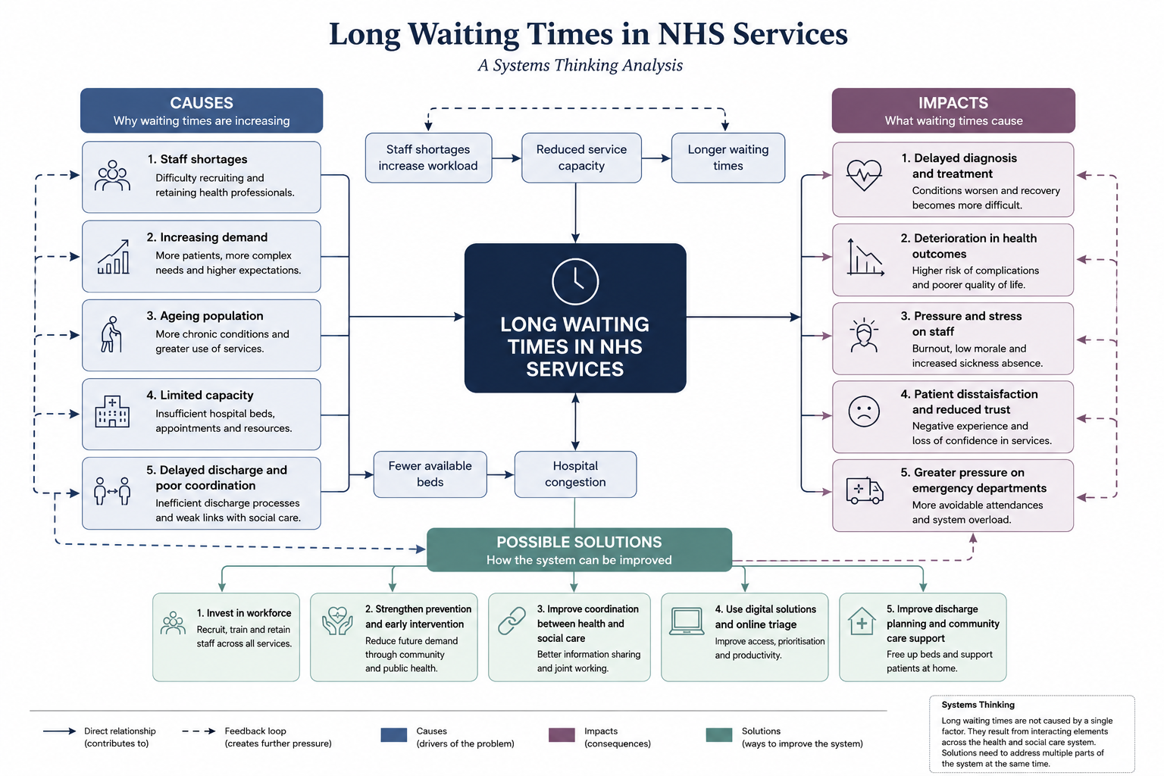
Explanation
Long waiting times are a major challenge in NHS services because they can delay diagnosis, treatment and access to appropriate care. This problem affects patients, healthcare professionals and the wider health and social care system. The mind map uses a Systems Thinking approach (Meadows, 2008) to show that long waiting times are caused by interconnected factors, including staff shortages, increasing demand, limited capacity and delayed hospital discharge. These factors place pressure on the NHS and lead to poorer health outcomes, increased staff stress and lower patient satisfaction.
The proposed solutions, such as investing in the workforce, improving discharge planning prevention and increasing collaboration between health and social care, address different parts of the system. A coordinated approach is more likely to reduce waiting times and approach is more likely to reduce waiting times because it addresses several interconnected causes at the same time, leading to improved quality and efficiency of care.

3 Self-Reflection of Group Activity
Working on the group activity helped me understand how different ways of thinking can improve decision-making in health and social care. At the beginning of the discussion, I preferred to listen carefully to other group members before sharing my own ideas. This helped me understand different perspectives and gave me the confidence to contribute more actively. When the group discussed different suggestions, I tried to combine ideas and reached decisions through discussion and mutual agreement.
The activity also helped me understand the difference between divergent and convergent thinking. Divergent thinking encouraged us to generate a range of ideas, while convergent thinking helped us. experience using Gibbs’ Reflective Cycle (1988), I realised that effective teamwork depends on both active listening and clear communication. In future group activities, I will aim to share my ideas earlier while continuing to respect and learn from the opinions of other, I believe these skills will help me collaborate effectively with multidisciplinary teams and provide better support for service users

.

4 UK Innovation Case Study NHS App
The NHS App is a digital innovation that improves access to healthcare services in the United Kingdom. It allows users to book GP appointments, order repeat prescriptions, view their medical records and receive important heath information through one secure platform. This innovation was introduced to make healthcare services more accessible, efficient and person-centred, while reducing unnecessary administrative work for healthcare professionals (NHS England, 2024).
The NHS App creates value for both service users and healthcare organisations. It gives people greater control over their own health and makes it easier to access services at a convenient time. For healthcare professionals, the app can reduce paperwork and improve communication with patients. This may contribute to more efficient use of NHS resources and support better continuity of care. However, although the NHS App offers many benefits, not everyone can use digital services confidently. Older adults and people with limited digital skills may still need face-to-face support or alternative ways to access healthcare. Therefore, digital innovation should complement, rather than replace, traditional healthcare services to ensure equal access for all.

5 Long Waiting Times in NHS Services
Long waiting times are a significant challenge because they can affect patient safety, service quality and access to treatment. The King’s Fund (2024) explains that waiting times across NHS services are interconnected. For example, limited social care capacity may delay hospital discharge, reducing the availability of hospital beds and increasing waiting times in A&E. The report argues that staff shortages, limited resources and rising demand create pressure across the whole health and social care system.
Jones et al. (2022) examined data from more than five million patients admitted through major emergency departments in England. The study found that delays of more than five hours between arrival and hospital admission were associated with increased 30-day mortality. Both sources demonstrate that long waiting times cannot be understood as an isolated problem. However, while The King’s Fund focuses on the wider causes and connections across services, Jones et al. provide evidence of the impact on patient outcomes. Together, these sources show that delays are caused by pressures across the whole health and social care system and can have serious consequences for patient safety. These finding suggest that reducing waiting times requires improved workforce capacity discharge planning and better coordination between health and social care services.

6 Discuss one benefit of using wearable health technologies (e.g. smartwatches) to support the management of chronic health conditions.
Wearable health technologies, such as the Apple Watch and Fitbit, can help people manage chronic health conditions by monitoring their health in real time. One important benefit is the early detection of changes in a person’s health, allowing users to seek medical advice before their condition becomes worse. For example, the Apple Watch can detect irregular heart rhythms, which may help identify atrial fibrillation and reduce the risk of serious complications such as stroke. Wearable devices also encourage people to became more involved in managing their own health by tracking physical activity, heart rate and sleep patterns. According to the Technology Acceptance Model (DAVIS, 1989), people are more likely to use digital technology when they find it useful and easy to use. Therefore, wearable technologies can improve self-management, encourage healthier lifestyles and contribute to better long-term health outcomes.

6.1 Describe how electronic health records (EHRs) improve communication and collaboration between healthcare providers.
Electronic Health Records (EHRs) improve communication by allowing healthcare professionals to access and securely share accurate patient information quickly. GPs, hospital doctors, nurses, pharmacists and other professionals can view. the same medical records, including diagnoses, allergies, medications and test results. This helps reduce errors, avoid unnecessary repeated test and support better clinical decisions. For example, if a patient is admitted to hospital, the medical team can immediately access their health history and current medications, improving the continuity of care. Better information sharing strengthens collaboration between health and social care services, particularly for people with complex or long-term conditions. According to NHS England (2023), digital health records help improve patient safety, efficiency and coordination across healthcare services. Effetive communication between professionals contributes to more person-centred care and better health outcomes.

6.2 Explore how digital technology can support preventive care and health promotion, using a real or hypothetical example.
Digital technology plays an important role in preventative care and health promotion by helping people make healthier lifestyle choices and manage their healthier lifestyle choices and manage their heath before problems become more serious. A good example is the NHS App, which allows users to access trusted health information, book appointments, order repeat prescriptions and receive reminders about vaccinations and screening programmes. These features encourage people to take an active role in their health and seek support at an active role in managing their health and seek support at an early stage. Digital technology can also promote healthier behaviours through fitness tracking, medication reminders and health education. According to the Technology Acceptance Model (Davis, 1989), people are more likely to use digital tools if they are useful and easy to use. Although some people may still need support to use digital services, these technologies can improve health promotion, encourage prevention and reduce pressure on NHS services.

7 Explain the NHS Leadership Model and why it is important in Health and Social Care
The NHS Leadership Model provides a framework that helps leaders develop the knowledge, skills and behaviours needed to deliver high-quality health and social care services. It encourages leaders at all levels to work collaboratively, support continuous improvement and promote person-centred care. The model includes key leadership behaviours such as Leading with Care, Inspiring Shared Purpose, Sharing the Vision, Engaging the Team, Evaluating Information, Connecting Our Service and Holing to Account (NHS Leadership Academy, 2013).
These behaviours help leaders build positive relationships, encourage teamwork and improve decision-making. Effective leadership is essential because it creates a supportive working environment where staff feel valued and motivated. This can improve staff wellbeing, increase the quality of care and contribute to better outcomes for service users. In health and social care good leadership also helps organisations respond effectively to changing needs.

7.1 Leading with Care.
Among the leadership behaviours, Leading with Care is particularly important because it encourages leaders to support both staff and services users. A leader who listens, shows empathy and values the wellbeing of the team creates a positive working environment where people feel confident to share news ideas. This can encourage creativity and continuous improvement in health and social care services. For example, a manager who supports staff to suggest new ways of reducing patient waiting times or improving communication can help deliver safer, more person-centred care. Thise leadership behaviours promote trust, collaboration and innovation, which are essential for improving service quality.
8 Reflection
This module has helped me understand that creativity and innovation are not only about developing new technology but also about improving the way health and social care services are delivered. Throughout this module, I learned that small changes, effective teamwork and good communication can have a positive impact on the quality of care. I also gained a better understand of how digital technology, evidence-based practice and leadership can support better outcomes for service users.
Completing this portfolio has increased my confidence in researching, evaluating information and presenting ideas clearly. In my future career in health and social care, I will use what I have learned by listening to services users, working collaboratively with colleagues and being open to new ideas that improve care. Overall, this module has changed my perspective and has shown me that creativity is an important part of providing safe, person-centred and high-quality care.

Reference List
Amabile, T. M. (1996) Creativity in Context. Boulder, CO: Westview Press.
Bass, B.M. and Avolio, B.J. (1994) Improving Organizational Effectiveness through Transformational Leadership. Thousand Oaks, CA: Sage Publications.
Davis, F. D. (1989) Perceived usefulness, perceived ease of usefulness, perceived ease of use, and user acceptance of information technology’, MIS Quarterly, 13(3), pp. 319-340.
Gibbs, G (1988) Learning by Doing: A Guide to Teaching and Learning Methods. Oxford: Oxford Polytechnic.
Jones, S., Moulton, S., et al. (2022) Association between delays to patient admission from the emergency department and all-cause 30-day mortality’, Emergency Medicine Journal, 39(3), pp.168-173.
King’s Fund (2024) Long waits, missing patients and stalled reform: The NHS at breaking point. Available at: https://www.kingsfund.org.uk (Accessed:22 July 2026)
Lewin, K (1947) Frontiers in group dynamics’, Human Relations, 1(1), pp.5-41.
Meadows, D.H. (2008) Thinking in Systems: A Primer. White River Junction, VT: Chealsea Green Publishing.
NHS England (2023) What are Electronic Health Records? Available at: https://www.nhs.uk/nhs-app/ (Accessed: 22 July 2026).
NHS Leadership Academy (2013) Healthcare Leadership Model. Available at: https://www.leardershipacademy.nhs.uk (Accessed: 25 July 2026).
Porter, M. E. (2010) What is value in health care? New England Journal of Medicine, 363(26), pp.2477-2481.
Rogers, E.M. (2003) Diffusion of Innovations. 5th edh. New York: Free Press.

