2018


Change management process; a case study for Marriott International hotel (Brand Expansion from Organic Growth to Merger and Acquisition).

School of Tourism and Hospitality
Mtour Tourism and Events Management (547T) level 7
Student number: p150709
Module tutor: Mike Davies
Title of Module: managing change within Tourism and Events Organisations
abstract:
Submission date: 20th of July 2018

Student number: p150709

Content Page
Content ………………………………………………………. page number

Cover page …………………………………………………………………………1
Content page………………………………………………………………………...2
Aims …………………………………………………………………………………2
Executive summary…………………………………………………………………3
Introduction
- Background information…………………………………………………...4-5

What has changed…………………………………………………………………6
Reason for change………………………………………………………………...7
How Airbnb become competitive………………………………………………...7-8
Main body………………………………………………………………………….8
Change management model……………………………………………………...9-11
Findings and discussion………………………………………………………11-15
Methodology……………………………………………………………………. 15
Conclusion…………………………………………………………………...15
Recommendation……………………………………………………………...16
Appendixes ……………………………………………………………………16-19
Bibliography ………………………………………………………………….20-21

Change management process; a case study of Marriott international hotel inc (Brand Expansion strategy from franchise approach to merger and acquisition).

Aim of this report
This report is aiming to provide critical advice to Marriott international hotel chain on its recent change initiatives projects that involves brand expansion through merger and acquisition rather than franchise approach strategy.

Executive summery
Therefore, this case study examines the change occurred in Marriott international hotel, when the company decided to expand its brand portfolio from organic growth approach to merger and acquisition approach.

The successful merger with Starwood hotel has given Marriott enough room to provide broad selection of diverse hotel brands to its guests than ever; with more than 5,700 hotels and over one million rooms in 110 countries across the world, guests can now access the best hotel and resort whenever they are.

The merge between Marriott and Starwood hotel is much associated with Marriott’s key response to Airbnb which has now became a threat to traditional accommodation providers due to its business operational model.

Marriott’s decision to acquire Starwood hotel was massive transition that needed effective strategic process that involves many elements such as leadership style, resources, time management skills and other aspect.

Introduction
This report will provide a critical analysis and evaluation for Marriott’s recent change on “brand growth strategy” through which senior management team were the key implementer of the change in question. The first section of the report will consist a brief background information on Marriott’s current market position and other relevant information. The report will then provide in-depth explanation on what has changed and explain reason for its change. Furthermore, the report will then explore different change management models and assess how can they be utilized when the organisation considering undertaking small scale or large-scale change initiative programme. Alongside that, the report will also explain possible measures that helps to identify and deal with resistance factors to change. The final part of the report will be the conclusion of the research, followed by recommendation and bibliography.

Background information
Marriott international hotel is one of the largest traditional accommodation providers around the world, it became the world leading hospitality company after the acquisition of Starwood hotel in 2016. Prior this, Marriott was second largest hotel chain while Hilton hotel was ranked at first position according to Forbes (2015).
Like many other organisations seeking to survive in current crowded market environments, Marriott is currently undertaking massive brand expansion projects across the world to gain an unrivalled range of accommodations to suit every traveller. To the end of 2016, the company had 569 properties in Asia Pacific, over 200 hotels in Africa, followed by 512 properties in Continental Europe, this means that guests now have access to broad selection of hotels and resorts wherever they are. Marriott international’s portfolio now includes a series of quintessential luxury and life style names. For instance, the Ritz-Carlton, Bulgari Hotels & Resorts, W Hotels, JW Marriott, The Luxury Collection and EDITION define a new era of luxury travel, with dynamic brand such as Westin, Renaissance and Autograph collection occupying an evolving lifestyle category. Moreover, Moxy Hotels, AC Hotels and Aloft provide fun and unique experience for authentic travellers, while premium brands like Marriott Holes and Sheraton provide a broad array of choice across the for business and leisure travel.
https://www.marriott.com/marriott-brands.mi (Accessed: 15/07/2018).
Its current rapidly brand growth was achieved through merger and acquisition approach which gave the company the opportunity to enlarge its size within short period of time. Table below indicates Marriott’s growth rate from 2009 to 2016, it is therefore clear the adoption of merger and acquisition approach between 2014 to 2016 had increased Marriott’s brand portfolio across the world. Prior this, Marriott’s growth strategy was based on the franchise approach which benefited the company through franchise fees. More than 95% of operating profit is generated from asset-light franchise and management contracts. It has been claimed that 9-12 percent of total sale generated from franchised property goes to brand owner.
Table 1: Number of Marriott International Hotel Rooms worldwide from 2009-2016

Year | Number of room
2009 | 595461
2010 | 618104
2011 | 643196
2012 | 660394
2013 | 675623
2014 | 714765
2015 | 759330
2016 | 1190604
https://www.statista.com/statistics/247304/number-of-marriott-international-hotel-rooms-worldwide/ (Accessed/01/12/2017).

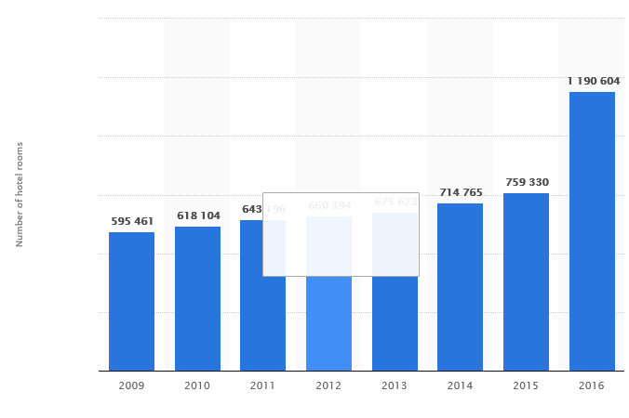
Source: https://www.statista.com/statistics/247304/number-of-marriott-international-hotel-rooms-worldwide/(Accessed/01/12/2017)

What has changed?

Marriott is one of the organisations that embrace change constantly, however, between 2014 to 2016 Marriott adopted new growth strategy known as merger and Acquisition growth approach. Through this approach Marriott international is now a primary owner of Pretoria and Starwood hotels. The acquisition of the two well established hotels have helped Marriott to expand its brand portfolio and focus on customer experience. With Pretoria buy, has now positioned Marriott as the largest hotel company in Africa, while the acquisitions of Starwood hotels, has strengthened Marriott brand portfolio from 87 countries and territories 122(Whitmore, April/ 18/ 2018)

Reason for its change
Organisational change is unavoidable element to most organisations if they need to survive in current dynamic market environment ((Todnem, 2005). Nowadays most organisations work in dynamic business environment that require them to undertake different change initiatives projects to proactive respond to both internal and external challenges (O’Toole, 1995). Marriot hotel is among organisations that implements different change initiatives to its company to meet the needs and demands of is customers (Wille and Hodgson, 1991). The rise of sharing economy has directly and indirectly affect majority of accommodation provider around the world. Marriott is among organisations affected by this business venture. Its well known that, hotel industry operates under restricted rules and regulation, pays tax to government, need human labour to operate, while most of sharing economy business venture operates under minim regulation, their business model does not rely on human labour. Therefore, sharing economy business model allow business owners to offer products and service in lower price compare to hotel industry. Because of this, Marriott stared to see:
- Decline in room occupancy rate, as its shown in appendix 1
From business point of view, the primary purpose for any business is to generate profit, the decline in occupancy rate led Marriott international to acquire Starwood hotel to respond to sharing economy business ventures

Moreover, nowadays most organisations operate under constantly changing environment, factor such as globalization led by rapidly advanced technology, cultural diversity, change in global economy, environmental impact, change in government policies, change in consumer behaviour and many other factors have continues to challenge many organisations (Mest, March 21.2017)
Therefore, organisation’s ability to recognise the need for change and implementation of change in effective manner, in a proactive to respond to both internal and external pressure is critical essential for the performance of organisation.

How Airbnb became competitive

Airbnb is online market place that permits the large-scale rental of spaces from one ordinary person to another. Its business model is part of a large rise in the “sharing economy” which characterised with the concept of individuals renting access to their unused assets, ranging from living spaces to cars to power tool (Guttentag, 2013). From business operation point of view, the process of digitalisation is disrupting old business models harder than most organisation can realise, the traditional market for tourism accommodation which involves tourists renting rooms from formal business, such as hotel has now been challenged by this new business model. Through new communication technologies and the internet everybody communicates with everything, this technology innovation has successful allowed individuals to become entrepreneurs who challenges traditional suppliers such as Marriott. Since then Airbnb has rapidly grown with more than two million listings worldwide, and over 50 million guests that used the service by 2017. The company drives revenue from guest and host, Airbnb charge guest 12 percent and hosts 3 percent through each transaction from booking made via Airbnb website.
The rise of Airbnb has become good news for tourists who seek for cheap accommodation, and hosts who wanting to earn extra income, but it bad news for hospitality industries. Hospitality industry describes Airbnb business model as disruptive innovation, however from business point of view, this type of business can be described as entrepreneurship process (Bamford, and Forrester, 2003).
Airbnb’s business model focused on exiting gap in hospitality industry which traditional hotel provider failed to deal with it. Airbnb position itself as a cheap option, offer unique experience, that allow guest to interact with local communities. Marriott should remember that, travel is all about people, and Airbnb succeed by bringing the human element back into travel industry, not just from staying like a local but by providing space for people to stay together.

Main body

Organizational change can be defined as a transition period when a company move from its current state to some desired future state (Bamford, and Forrester, 2003). Change in organisation can happen deliberate and structured, or happens spontaneous, as if it is evolving naturally (Todnem, 2005). Whether is planned or emergent change programme, but in most cases, change is difficult and complex and can often be uncertain, therefore, how the organisation think about change may well determine how it define change management, and consequently how will manage it (Todnem,2005; Burnes, 2004) and develop relevant model.
Pettigrew (1993) argued that, for organisations to understand change, it first need to understand the process of change which includes the environment in which it is happening, what the change is and the way the changes will be implemented. For instance, planned change approaches relays more on the assumption that, the organisation’s environment is knowns, while emergent change emphases the need to be responsive and adaptive.

Theory of change management; planned or emergent

There are different change management models to help and guide academics and practitioners’ in how changes should be planed, managed and implemented. Whether is large or small-scale change initiative programme, but organisations’ ability to respond to change varies from one organisation to another, this could be based on assumption that, much of the theory of change and the associated models are rooted in how change is understood (Carnal, 2003).
According to Burnes (2004) change is an ever-present feature of organisational life, both at an operational and strategic level. Therefore, there should no question regarding the importance to any organisations, of its ability to identify where it needs to be in the future, and how to manage the changes required getting there. either is careful planed and structured change, in most circumstances change is like to have features of emergent change, its advisable for organisation to adopt theory change management that fits the context and constraints of organisation (Pettigrew, 1993).

One among many other change management models is Lewin’s Change Management Model that describes three stages (unfreeze, move and refreeze), (Lewin, 1950), that should be consider when organisation considering to undertaking change initiatives programme. This means that, when Marriott realised it needed to change its growth strategy, based on Lewin’s force field analyse, the first step was “unfreeze” their current growth strategy. This can be done in many ways, includes hiring an experienced private consultant who can take close look at how things are done. Doing this will help to eliminate any existing bias and commonly accepted mistakes, as well as prepare the company for upcoming change and their natural resistance to it. Forcing sudden change only breeds resentment, so its management’s duty and responsibility to prepare their team for new elements in order to let them take hold when deployed. It is important for management to let everyone know what is wrong with their current growth strategy, why it needs to be changes, how the merger and acquisition of Starwood will benefit them. Once the change is shared, it is time to deploy the change and guide the team as they adopt. This can be achieved by setting up effective communication channels (regular meeting, emails) and provision of enough support and train to limit any difficulties in the process of transition and any issues could be detected easily. Once the change is implemented, measured, and reviews according to feedback, then management need to refreeze their new status quo. The new change should be reviewed, and reward should be given to those who constantly keep to a new method.
In general view, this model is helps to uncover hidden mistakes which were taken for granted, since it allows the organisation to analyse every aspect of the change involved. however, due to scale of unfreezing process, this model can be difficult and time consuming.

Another change management model that can help Marriott International on its current merger and acquisition growth approach is McKinsey 7-S Model (Peters and Waterman, 1980s). by analysing the seven-aspects indicated in this model, it can help Marriott to detect any further change needed to create united approach to the business. This model helps the organisation to effective analyse following elements and assess how they affect each other.
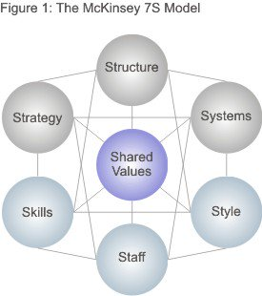
Source: the model adapted from; https://www.mindtools.com/pages/article/newSTR_91.htm (accessed: 17/ 07/2018)
Alongside that, the model also helps the company to detect weaknesses and highlights the areas that requires attention when implementing change. However, this model only works for small organisation with few employees, but this model can still benefit Marriott as the model works for those organisations that knows they can change for better.

Kotter’s 8 step Change Model is another useful tool for Marriott, hence it focusses less on change itself and more on the people behind it. Considering Marriott’s reason for change, this means that Kotter’s theory will help Marriott to consider improving the quality of its service to suite individual needs.

Despite of the fact that, change has become an integral of organisation’s life, and many theories and approaches are developed to guide academics and practitioners, to many organisations, change has become a painful process, around 70 per cent of all change programme initiated around the world failed to achieve the desirable outcome (Balogun and Hope, 2004).

It may be suggested that this low success rate indicates a fundamental lack of a valid framework of how to implement and manage organisational change (Todnem, 2005), because what is current available to academics and practitioners is a wide range of contradictory and confusing theories and approaches (Burnes, 2009). However, if the managements have to critical asses how the organisation works, and functions will help them allocate relevant approaches that can help produce better outcome.

Findings and discussion
Organisational change is one of the important aspects to be considered throughout organisation’s life circle, because when it happens it effects the entire organisation rather than part of it.

Change management process: Marriott international Hotel

According to Moran and Brightman, (2001:111) defined change management as “the process of continually reviewing an organisation’s direction, structure and capabilities to serve the ever changing needs of external and internal customers”(cited by Todnem, 2005).

Although there is not one widely accepted, clear and practical approach to organisational change management that explains what changes organisation need to make and how to implement them, however to some extent the planned approach to organisational change management attempts to explain the process that bring about change (Todnem,2005; Burnes, 2004). Moreover, the planned approach emphasises the importance of different states which an organisation will have to go through in order move from its current unsatisfactory state to an identified desired state (Todmen, 2005; Eldrod II and Tippett, 2002).
The concept of planned approach change was initiated in 1946 by Lewin, who was a theorist, researcher and practitioner in interpersonal, group, intergroup, and community (Eldrod II and Tippett, 2002; Todnem, 2005). He believed that, before change and new behaviour can be adopted successfully, the previous behaviour has to be discarded (Burnes, 2004). According to Lewin (1952 in Cameron and Green, 2009; Todnem, 2005, Eldrod II and Tippett, 2002) for change to be successful archived, the organisation must therefore follow three steps. The first step involves unfreezing the current state of affairs, and then moving to new level and final step is refreezing the new state.
Even though this model was adopted as a general framework for understanding the process of organisation change, it rather broad and does not seem to fit in the modern changing environment (Todnem, 2005). Therefore, several authors have later developed Lewin’s works in an attempt to make it more practical (Todnem, 2005). For instance, Bullock and Batten developed a four-phase model of planned change, that sprits the process in to exploration, planning, action and integration (Burnes, 2004). Some scholars agreed that, Bullock and Batten’s planned change approach is a highly applicable model for most change situation (Todnem, 2005; Burnes, 2004, Hodgson and Wille, 1991).
Despite the fact that the planned approach to change is long established and seem to be highly effective, however this approach focuses more in how to deal with small-scale and incremental change, therefore, the approach is not applicable to situations that require rapid and transformational change (Todnem, 2005)

Because of this the emergent approach has gained ground, this approach to change provide general knowledge on the basis that, change should not be perceived as a series of linear events within a given period of time, it rather be considered as a continuous, open ended process of adapting to changing circumstance and conditions (Todnem, 2005; Burnes, 1996, 2004). Despite the fact that, there is no universal rules when it comes to leading and managing change but advocated to this model have suggested sequences of actions that organisations should follow when planning change initiatives (Burnes, 2009). Kotter’s (1996) Eight-stage Process and Luecke’s Seven Steps (2003) (Todnem, 2005), are best suited advocated for emergent to change approach. See the table below for further explanations about Kotter’s and Luecke’s change management models.

Kotter’s Eight-Stage Process | Luecke’s Seven Steps
Establishing a sense of urgency | Mobilise energy and commitment through joint identification of business problems and their solutions
Creating a guiding coalition | Develop a shared vision of how to organise and manage for competitiveness
Developing a vision strategy | Identify the leadership
Communicating the change vision | Focus on results not on activities
Empowering broad-based action | Start changes at the periphery, then let it spread to other units without pushing it from the top
Generating short-term wins | Institutionalise success through formal policies systems, and structure
Consolidating gains and producing more change | Monitor and adjust strategies in response to problems in the change process.
Anchoring new approaches in culture
Source: (Todnem, 2005).

How organisation works
one way of understanding how organisation may react to change is though how the organisation work. People have different assumptions and view point about how the organisation works. The use of metaphors has become important way of expressing these assumptions. Some people describe organisation as a political system where coalition are formed and power rules the supreme (Carnall, 2003), and others believe organisation work as a machine, organisms as well as flux and transformation.
As a change agent, it its critical essential to understand the way the organisation in question work and function, through its organisation metaphor will help understand how the proposed change should be approached and allocate the best suited change management model that fit the purpose.

For stance, when dealing with change that related to strategic growth, managers and leaders should understand and consider the importance of organisational factors in translating a growth strategy into reality; because this can actual dampen a company’s growth plans (Dewhurst et al, 2011). Therefore, when a need of change required, it is worthwhile for leaders and managers to invest their time to assess if the existing structure are flexible enough to support the new initiatives, as well as to examine if key employees have adequate knowledge and skills needed to cope with additional complexity that growth brings.
Marriott for example, wanted to expand its brand portfolio that will appeal to different market segments, especially the millennials (who are tech-savvy and value experience “live like local”) as well as to compete with Airbnb. To retain its existing market and attract new market niche, Marriott bought Pretoria hotel and Starwood hotel. The common idea was to create new hotel platform that will provide services that fits individual needs such as high-end market. The acquisition has successful increased Marriott image and popularity; however, Marriott invested massive time and money to purchase the two hotels, this means that, it will take time for Marriott to return the money invested, and time invested can’t be replaced. Therefore, the rapidly growth approach Marriott continues to embrace, may negatively affect organisational performance in years to come. Despite with the outstanding growth potential, factors such as political unrest in Middle East, post- Brexit in Europe, economic issues in Brazil, oversupply hotels in America, fluctuation in exchange rates are challenges the growth of tourism industry, “Marriott Rides on Expansion, 2010”.

How to identify and deal with resistance factors for change
Organisation’s ability to accept, address and share the need for change right at the beginning is among of the methods that will help the organisation to understand the supporters and non-supporter to the proposed change initiatives. From human behaviour perspective, resistance to change is the normal reaction from people who have become accustomed to a certain way of doing things, however, people do not resist change, but they tend to resist the aspect of change that is more likely to affect them. If the change is not well communicated and explained to those involves, it can create fears, conflict among individuals and reduces people’s morale. Therefore, change management approaches should not be classified and used as just a tool that guide and lead mangers how to deal with resistance when occurs, it rather be considered as an effective equipment for activating and engaging employees. As an example, system thinking approach will be best way of engaging the employees this model sees communication as an integrated process that facilitates change within the organisation. Organisation can communicate change through training, surveys, reward system, team building workshops, and seminars.

Once the change has implemented, the organisation need to refreeze by developing new ways that of working through the adoption of new norms, policies and procedures that will allow the business to operate in effective ways. Management can easily understand if the desirable outcome was achieved through the way people cope with new ways of doing thing. If the tension is higher the comfort, this means that the management deed to review the strategy gain and highlight any issue that cause discomfort. This bring us back to the approach that described change is a continuous process.

Methodology
This report is written using both academic and non-academic materials, however, more academic materials were utilized throughout the process. Both primary and secondary research were conducted, through varies methods and data collected were utilized and analysed using appropriate tools and techniques. data were collected from various sources such as text books, journal articles, online data base, classroom notices, government reports, online new papers. Online data bases were accessed through google scholar, Moodle, and other search engines. Data were analysed and presented in irreverent format includes tables and bar charts.

Conclusion
After to critical analyse change management models and how can they be utilized when the organisation undertaking incremental change initiative programme, it therefore clear that, for the organisation to effectively manage change, the organisation should understand that managing change is all about managing a process, using appropriate approaches based on the nature of the change involved.
- Change can be guided by perceptive facilitation, recognising the organisational context and constraints
- Change theory and models should be applied selectively, with thought to best fit the nature of change and to the context within which the change is occurring
- How the organisation thinks about change start to shape how it define it.

Recommendations
Relaying on government intervention over this new business operation model could be time consuming, hence regulatory change takes years if not decades to be amended or introduced. Alongside that, having many hotels chain in globally does not guarantee better performance, it rather increases the cost of operational and running company. Therefore, Marriott could have focus on improving its existing products by paying more attention on the elements that an average Airbnb host can not provide. For instance, while some Airbnb hosts may provide additional service such as swimming pool, however, majority of hosts cannot offer Spa service, restaurants, and clubs which are important elements for most business travellers.

Appendix

Table 1: Number of Marriott International Hotels worldwide from 2009 to 2016
Year | Number of hotel
2009 | 3420
2010 | 3545
2011 | 3718
2012 | 3801
2013 | 3901
2014 | 4175
2015 | 4424
2016 | 6080
Source: https://www.statista.com/statistics/247304/number-of-marriott-international-hotel-rooms-worldwide/(Accessed/01/12/2017)

Table2: Occupancy rate of Marriot International Hotels worldwide from 2010 to 2016 by region.
 | North America | Caribbean & Latin America | Continental Europe | United Kingdom | Middle East & Africa | Asia Pacific | Overall worldwide
2010 | 68.1% | 70.7% | 71.1% | 76.4% | 70.5% | 66.7% | 68.7%
2011 | 70.2% | 72.6% | 73.2 | - | 58.8% | 73.1 | 70.3
2012 | 71.6% | 72.5% | 72.7 | - | 61.8 | 73 | 71.4
2013 | 72.3% | 73.6% | 73.5 | - | 55.7 | 73 | 70.7
2014 | 74.2% | 73.6% | 74.9 | - | 60 | 73.7 | 73.1
2015 | 74.7% | 72.4% | 75.9 | - | 61.2 | 74 | 74.1
2016 | 75.8% | 65.3% | 71.8 | - | 64.6 | 75 | 72.5
Source:http://www.macrotrends.net/stocks/charts/MAR/balance-sheet/marriott-intl-a-assets-liabilities-equity-history( Accessed: 01/12/2017)

Income of Marriott International Worldwide from 2007 to 2016(in million US dollar)
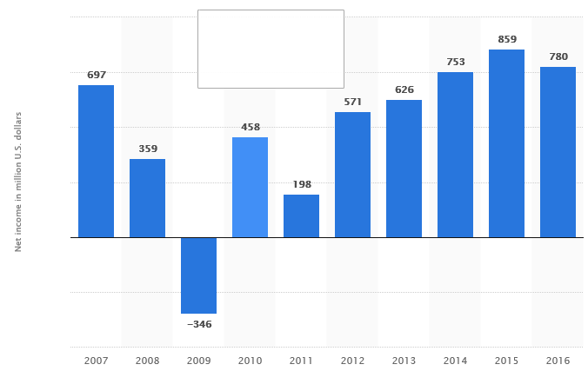
Source: https://www.statista.com/statistics/256252/net-income-of-marriott-international/

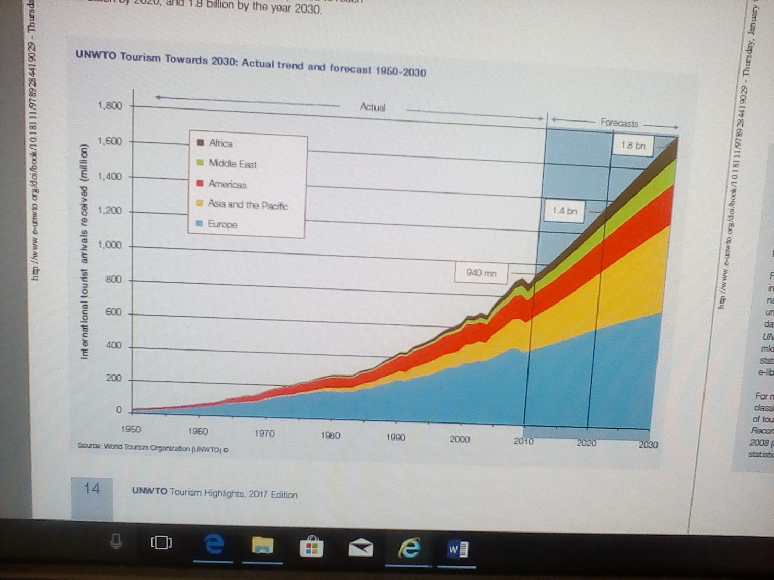

Number of international tourist arrivals worldwide from 2005 to 2016, by region (in millions)
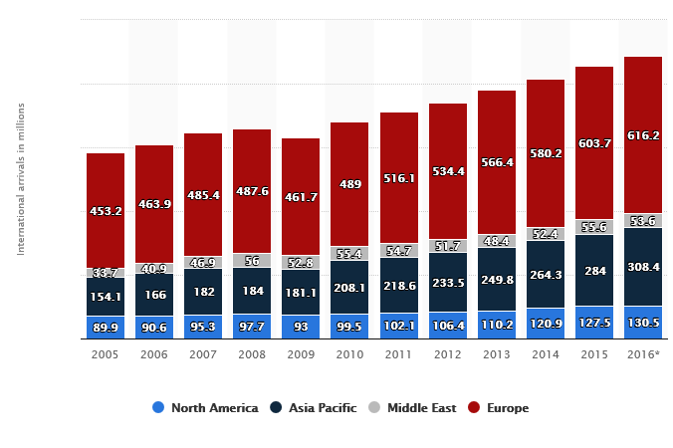
https://www.e-unwto.org/doi/pdf/10.18111/9789284419029 (Accessed: 30/12/2017)

References
Burnes, B (2009). Managing Change. 5th ed. England : Pearson Education Limited. p 109-117.
Carnall, C (2007). Managing Changes in Organisation. England : Pearson Education Limited. P95-108.
Cameron, E and Green, M (2004,2009). Making Sense of Change Managemnt. 2nd ed. London : Kogan Page Limited. P34-85.
Ottaway, R (1779). Change Agents at work. London : Association Business Press. 52-74.

Mest, Elliot (2017, March 21) “5 growth opportunities for Marriott. Hotel Management retrieved https://www.hotelmanagement.net/development/marriott-s-3-year-plan-includes-300-000-new-rooms

Tully, S (June, 2017)”why Hotel Giant Marriott is on an Expansion Binge, as it Fends off Airbnb. Fortune newspaper. Retrieved http://fortune.com/2017/06/14/marriott-arne-sorenson-starwood-acquisition-airbnb/

Wille, E and Hodgson, P (1991). Making Change Work. London : Mercury Books. p 12-25.

http://fortune.com/2017/06/14/marriott-arne-sorenson-starwood-acquisition-airbnb /(Accessed: 27/12/2017)

http://news.marriott.com/2017/03/marriott-international-announces-2020-growth-vision-europe-post-starwood-acquisition/ ( Accessed: 27/12/2017)

http://www.nasdaq.com/article/marriott-rides-on-expansion-initiatives-revenue-woes-stay-cm843233 ( Accessed: 30/12/2017)

https://www.prnewswire.com/news-releases/marriott-international-embarks-on-global-independent -( Accessed:30/12/2017 )hotel-expansion-as-more-consumers-and-owners-seek-unique-experiences-powered-by-marriott-300468223.html

https://www.hotelmanagement.net/development/5-ways-marriott-planning-for-development-domination ( Accessed: 05/01/2018)

http://www.travelweekly.com/Travel-News/Hotel-News/Marriott-plans-massive-expansion-of-select-service-brands ( Accessed: 05/01/2018)

https://www.hospitalitynet.org/news/4081596.html( Accessed: 12/07/2018)

https://www.forbes.com/sites/geoffwhitmore/2018/04/18/details-surrounding-the-marriott-starwood-merger/( Accessed: 12/07/2018)
https://www.mindtools.com/pages/article/newSTR_91.htm (Accessed: 17/ 07/2018)

