ACCB5017
Games Architecture and Mechanics

Jamie Richards (0852036)
ACCB5017 – Games architecture and mechanics
Table of Contents
1 – Introduction Page – 2
2 – Numerical Integration Methods Page – 2
2.1 – Euler Method Page – 3
2.1.1 – Advantages Page – 3
2.1.2 - Disadvantages Page – 3
2.2 – Verlet Integration Page – 4
2.2.1 – Advantages Page – 4
2.2.2 - Disadvantages Page – 4
2.3 – Other Methods Page – 4
2.3.1 – The Runge-Kutta Page – 5
2.3.2 – Leapfrog integration Page – 5
2.3.3 – Midpoint method Page - 5
3 – Task Page – 5
4 – Conclusion Page - 8
5 – References Page – 9

1 - Introduction

This report will consist of two parts, part one will describe and detail two numerical integration methods, the Euler method and the Verlet Integration method. Both will highlight the advantages and disadvantages in their usages, included in this part of the report there will be a further description on a few other common numerical integration methods such as the Runge-Kutta.
The second part of this report will comprise of a task where the above numerical integration methods will be used to simulate the movement of a spring powered model dragster car.
Finally, a brief conclusion will be presented on the finding of the above task ending this report.

2 – Numerical Integration Methods

There are several different numerical integration methods or techniques, each with their own purpose, however the main reason for its use is to estimate the results of a complex or impossible mathematical problem, involving its area and volume. [1]
Used in complex equations the different numerical integration methods available allow users to obtain solutions in different intervals of time, consisting of a number of algorithms to produce its results.
“The antiderivatives of many functions either cannot be expressed or cannot be expressed easily in closed form (that is, in terms of known functions). Consequently, rather than evaluate definite integrals of these functions directly, we resort to various techniques of numerical integration to approximate their values.” [2]
The above quotation referenced from an article on website libretexts mathematical, briefly explain the reason numerical integration methods are used.
Quadrature or numerical quadrature is the process of finding the value of a known integral, numerical integration for ordinary differential equations is where the aim is to calculate the equation over a set time frame during its change, this is done by updating results during different time steps.
Second order differential equations are where a second result along with the first result affects the function, explained in the context of a falling object, where the speed of the object would be determined by its speed however the object would also be accelerated by gravity pulling it down.

2.1 – Euler Method
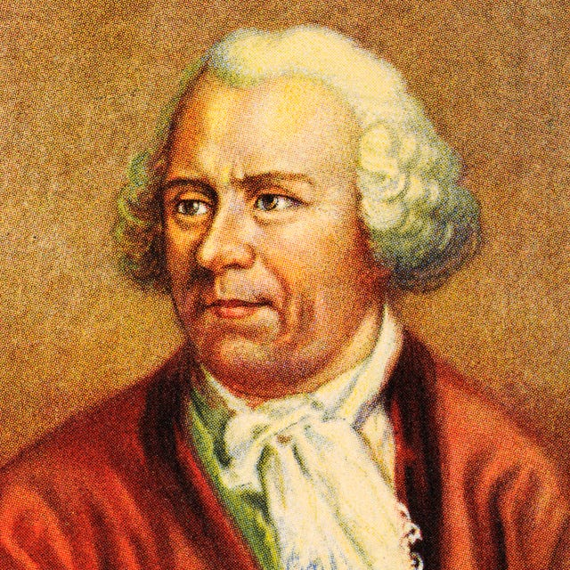
Also known as the forwarding Euler method, the Euler method is essentially a solution to solve ordinary differential equations, created by Leonhard Euler.
Figure 1 to the left illustrates a portrait of Leonhard Euler. [3]
The Euler method is used for solving differential and second order differential equations, or at least approximating the solutions by breaking the results down into small manageable steps.
Beginning with a starting point the Euler method then moves in increments to produce a calculation of its next step in turn giving guesstimates of its next result and so on.
Within a first order differential equation the Euler method would use either the position or velocity to approximate its results. Where as in a second order differential equation the Euler method would use more than one step allowing further calculations.

2.1.1 – Advantages

The Euler method can be used in a variety of difference fields in real life such as physics and even economics and can be considered simple to execute making this numerical integration method somewhat basic.
Being simple and basic has its advantages in some scenarios meaning the calculations needed for a single function fits this integration method perfectly. The method provides a fast understandable implementation to a otherwise difficult equation. [4]

2.1.2 – Disadvantages

As already mentioned above the Eulers method is considered a simple numerical integration which can sometimes produce poorly accurate results when used in more difficult situations, for instance if this method was used in a situation which required a big number of steps to calculate its results, then the approximation would have inaccuracies and errors.

2.2 – Verlet Integration

This numerical integration method is commonly used in computer graphics and molecular simulations where it predicts the position of objects using the current and previous positions.
The Verlet integration was discovered back in 1791 and then rediscovered in the 1960s by physicist Loup Verlet. Its main purpose was to calculate trajectories in simulations and utilized Newton’s laws of motion.

2.2.1 – Advantages
Similar to Eulers method the Verlet integration method can also be considered to be simple to implement however the algorithm of this method can be more efficient especially when calculating larger and longer time steps.
The Verlet integration main advantage is its stability when calculating over time which is one of the key disadvantages of other integration methods.

2.2.2 - Disadvantages

Verlet is not self starting meaning it would require another algorithm to obtain the first few time steps in order to be used correctly. Similar to the Eulers method the longer used over time the more risk of errors occurring

2.3 – Other Methods

Other commonly used numerical integration methods include names such as the Runge-Kutta method or the fourth variant named RK4 for short, the leapfrog integration and midpoint method to name a few.
Each of these methods can have their own advantages and disadvantages as well as the two methods already discussed however they are specifically useful in the gaming environment.

2.3.1 - The Runge-Kutta

This method provides a more transitional calculation through the time steps allowing higher accuracy when approximating the results, this can be done by predicting the future movements of an object by moving forward a few time steps checking each step and calculating its path.
In gaming this method is extremely useful for its accuracy in situations such as character movement and animations.

2.3.2 – Leapfrog Integration
This numerical integration method is similar to the Verlet method however as the name suggests this method leapfrogs or jumps between each time step when calculating an objects position.
Leapfrog integration can be used in gaming similar to the Verlet method where Newton’s law of motions are used to provide accuracy in animation designs such as objects falling.

2.2.3 – Midpoint method

The midpoint method like other methods is an improvement on the Euler method and is used by approximating the middle of the time steps or midpoint, hence the name.
Again used in gaming when simulations are needed, the midpoint method allows better accuracy than the Euler method but other methods could perform greater such as the Rune-Kutta.

2 – Task

In this task a spring powered model dragster car will be used to move, to begin a number of equations are needed to determine the tractive force of the car along with the drag force if any and acceleration. Once this is complete numerical integration methods will be used to find out the velocity and position of the car during its movement, the results of this will be recorded before a different numerical integration is used to discuss any differences in recording.
To obtain the force of the car the spring will be used to push the car forward. The force is given with the below equation:
Ft=1.2(16-x)
Force being F and the x will be the distance the car would of travelled, finally t would be the time taken.
Naturally the car would receive resistance during its forward motion which will be made up of tyre resistance, wind resistance and brake force this will be known as fd and for this the equation will be used:
Fd=cr.mg +1/2 cd ρav2
The tyre resistance will be cr and will be set to 0.21
The weight of the car represented by m will be set to 1kg
The increase in speed due to gravity will use 9.81 m/s2 and identified as g
The drag coefficient, cd will be set to 0.34
Air density or ρ will be set to 1.2kg/m3
The frontal area of the vehicle, A, will be set at 0.01m2
Finally the velocity of the vehicle will be identified as v

Applying this to Visual Studio in C++ looks like:
const double CR = 0.21; // Setting Tyre Resistance
const double m = 1.0; // Setting Weight of the car in kg
const double g = 9.81; // Setting Increase in speed due to gravity m/s^2
const double CD = 0.34; // Setting Drag coefficient
const double rho = 1.2; // Setting Air density in kg/m^3
const double A = 0.01; // Setting Frontal area of vehicle in m^2

Next in order to generate the cars acceleration the following equation will be used:

a = (Ft – Fd)/m

The code will be used in a loop and will output the time position and velocity.

double F_net = Ft - Fd;
double a = F_net / m;

V = V + a * dt;
x = x + V * dt;
t += dt;

cout << "Time: " << t << " s, Position: " << x << " m, Velocity: " << V << " m/s, Acceleration: " << a << " m/s^2" << endl; }
In order to calculate the movement of the dragster car within a certain amount of time a set condition is placed within the program to allow this, in this instance the simulation will end after the car reach four metres
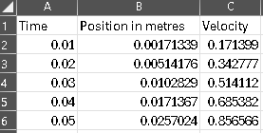
The image to the left is a screen grab with the outcome of the above code and using a spreadsheet program to record the results of the first 0.05 second recording.

Next using the Eulers numerical integration method within the code produces the recording of the velocity and position which are update every time step of 0.01 seconds this will continue until the car has reached its targeted distance which is set to four metres as shown below.
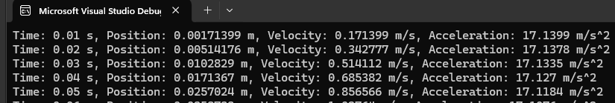
Finally using the Verlet method within the same code by adding a previous position as a variable and using it to approximate the results in each time step now gives a different result shown below.
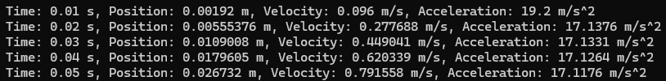
This shows the difference in accuracy between the two numerical integration methods.

5 – Conclusion

Considering the brief time stamps on each of the numerical integration methods used in the task in this report, they both show similar results meaning the accuracy of the methods are reasonably close. The methods themselves were simple to implement into place and provided results quickly however used in more strenuous circumstances could test the limitations of the methods.

5 – References
[1] Krishna. Krishna. What is numerical integration? What is numerical integration? 2021. Available: https://www.goseeko.com/blog/what-is-numerical-integration/.
[2] Anonymous (-09-19T15:23:43). 2.5: Numerical Integration - Midpoint, Trapezoid, Simpson's rule. Available: https://math.libretexts.org/Courses/Mount_Royal_University/MATH_2200%3A_Calculus_for_Scientists_II/2%3A_Techniques_of_Integration/2.5%3A_Numerical_Integration_-_Midpoint%2C_Trapezoid%2C_Simpson's_rule.
[3] Anonymous (-05-20T18:57:00). Leonhard Euler - Education, Facts & Early Life. Available: https://www.biography.com/scientist/leonhard-euler.
[4] Anonymous. Euler’s method – all you need to know about it! Euler’s method – all you need to know about it! 2021. Available: https://techpatio.com/2021/articles/eulers-method-all-you-need-to-know-about-it.

