Data Handling and Business Intelligence


(LCBB5000)

Student name: Cornelia-Roxana Rad Coordinator: Anupam Mazumdar Student number: (2023709)

Table of Contents
Part A 3
  - Pre-processing data 3
- Data Cleaning 4
- Data Transformation 4
  - Data Analysis and Visualization with Excel 5
- VLOOKUP Function 5
- Pivot Tables 6
Part B 13
Clustering Example and Analysis 15
Data Mining and Text Mining Methods 18
Advantages and Disadvantage of using SPSS and Excel 19
Conclusion 21

References Error! Bookmark not defined.

Data Manipulation, Representation and Evaluation of the UK’s Crime Rates

The assignment has supplied a detailed dataset relating to the UK’s crime rates. This was segmented within a base year “0” and the current year “10”. The crime rate was defined as per the demography of the population where the categories of gender, education, labour force, youth, wages, unemployment, and many others. The functionalities like “Pivot Tables” and Excel charts and graphs will be utilised towards forming a meaningful data interpretation within this assignment. With the help of such analytical and visual interpretations, the UK’s crime rate in the diverse demography will be understood in detail.

Part A

1.Pre-processing data

We have a data file in Excel which is called crime data, where we need to analyses and evaluate this rate.. To do this we will use Microsoft Excel, which is a calculation program that analyses and compares them. This program has been used both by researchers and by managers of some organizations, representing a rather advantageous and effective tool for the analysis of this data. To analyse the data, we must first form it for analysis by processing it but also start transforming this raw data, this type of data pre-processing can be described as a processing done on the data with a single purpose, namely, to share them (H. Tang, 2008).

Data Cleaning

Data cleaning is a process of collecting missing data, correcting, and removing inconclusive or even incorrect data from the data set. This can be done by handling missing data and imputing missing values using an associated value. Inconclusive data strictly refers to those data that have some useless access points, these data are irrelevant and end up being grouped together. For the pre-processing of the data set we use some existing techniques, these would be:
By considering the values and neighbourhood around these bunning methods can level or arrange the assorted data. Regression is another process that is used to decide which of the variables will end up being applied to our analysis, which helps to assimilate large volumes of data. This is a technique known as statistics that uses a model that predicts the relationship between several variables such as dependent and independent variables.
Another method like regression is correlation, there is some confusion between these two. The difference between these two methods is that regression measures how one variable ends up with another variable and correlation measures the relationship between two variables. We can see some strong correlations between the variables in our data set.

Data Transformation

After cleaning the data, the process begins through which the transformation of the data takes place, which ends up having a consistent and appropriate format, and thus it will be much easier to visualize, interpret, but also understand, of course, and easier to analysed. There are a variety of transformations that link our analysis, but they all end up depending on the specific requirements. Our mission or goal is to transform the data into a format that allows them to be translated, understood, and used much easier. This process involves converting data from one format to another, an example would be a document, basic file, or an Excel calculation. This transformation involves converting a raw data set into a newly validated and cleaned format ready to be used. Another data transformation method is the aggregation method where several values end up being aggregated or even converted into a single value.

Above I have listed some data transformation methods, here I will leave other data transformation methods:
-Aggregation

-Attribute Construction

-Discretisation

-Integration

-Manipulation

-Normalisation

-Smoothing

Data Analysis and Visualization with Excel

To analyse, visualize and interpret data Microsoft Excel provides several means, this can be done with simple commands, functions and tools given in Excel. The data that ended up being organized, cleaned, and processed thus being prepared for analysis. In this paper I chose to use two functions, these being Pivots and the V search, search to determine both the crime rate and to establish links between it and others.

VLOOKUP Function

This function can be represented as a tool through which we can obtain information in a data set or in a table, but also to obtain some information from them. It is well-known and can be easy to use even for those who use it for the first time, this function is easy to use and easy to use. This function is found in Excel and allows searches between columns (microsoft, 2021).
The formula syntax that this VLOOKUP function uses is:

= VLOOKUP(lookup_value, table_array, col_index_num, [range_lookup]) Specification:
Lookup_value - represents the value we are looking for in the first column.

Table_array – range of cells

Col_index_num - the number of the column in the table-array where we want to return

Range_lookup - the logical value that specifies what we want it to return, it can have the value True (1) or the value False (0)
From the data given in this paper on crimes I can provide practical one examples of these functions.
In the next figure below, we can see an example with the most used function

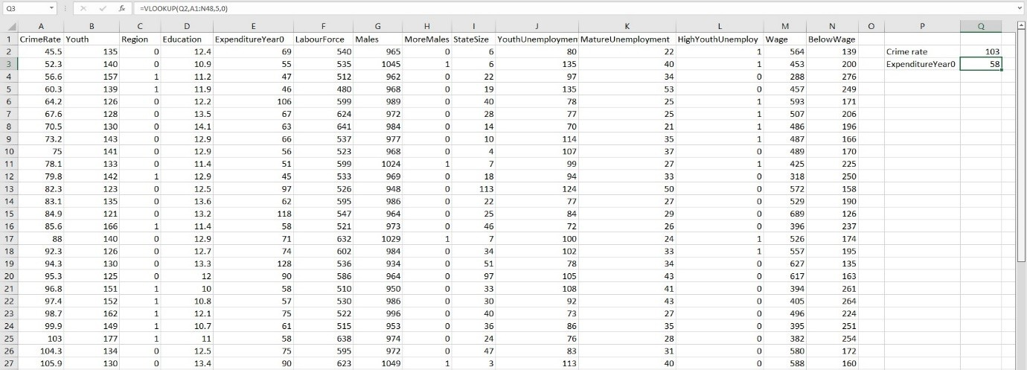

Here we can see the good formula was used, which shows us the value of crime rate it is total with 103.

Pivot Tables

The fastest but also the easiest way for the data to be analysed quickly and efficiently is represented by this function, namely pivot tables that we find in Excel. A pivot table gives us a different view of our data than a simple report. We can analyse data sets in small amounts with relatively little effort thus looking at different perspectives. Not only can we build graphs, visual reports, diagrams, but we can include and exclude different categories. One of the benefits represented by pivot tables is the simplicity with which reports can be configured and customized without including various formulas that can be quite complicated. I will try to

analyse the crime set and exemplify the crime rate in relation to other variables, I will determine some quick and quite easy ways. Below I will leave pivot tables related to the crime rate and others.
Crime Rate Vs Crime Rate 10
200
180
160
140
120
100
80
60
40
20
0
1 3 5 7 9 11 13 15 17 19 21 23 25 27 29 31 33 35 37 39 41 43 45 47
Series of record
CrimeRate
CrimeRate10

Interpretation:
Crime Rate

From this data set it can be observed and analyzed that the crime rate for the year 0 to the 10th year, this crime rate had an increase, that is, Data Handling and smart business acquires a slight increase on the scale of crime.The 2-D line Excel chart and Pivot table containing percentages have deduced that the average crime rate trend in the UK has increased in the recent ten years against the base year.

CRIME RATE


Interpretation:
Youth 0 vs Youth 10
200
180
160
140
120
100
80
60
40
20
0
1 3 5 7 9 11 13 15 17 19 21 23 25 27 29 31 33 35 37 39 41 43 45 47
Youth
Youth10

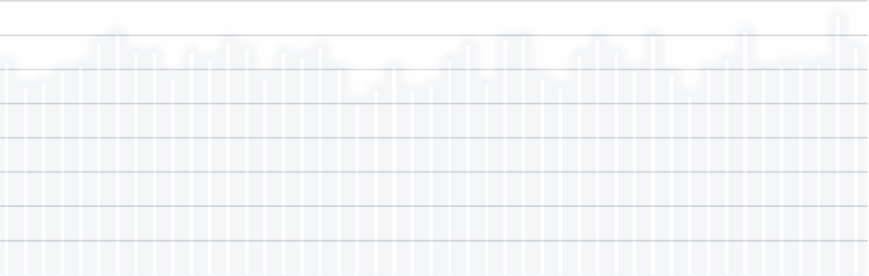
The 2-D line Excel chart and Pivot table containing percentages have deduced that the rate trend committed by the youth populace has decreased in the recent ten years against the base/previous year.
Crime Rate recorded for Education-oriented population
16
14
12
10
8
6
4
2
0
1 3 5 7 9 11 13 15 17 19 21 23 25 27 29 31 33 35 37 39 41 43 45 47
Reported Series

Education Education10
Crime Rate

Interpretation:




The Clustered Column Excel chart and Pivot table containing percentages have deduced that the UK’s crime trend in educational institutes has remained relatively same in the recent ten years against the base year.
Crime Rate recorded for the Expenditure Year/Period
ExpenditureYear0
ExpenditureYear10
180
160
140
120
100
80
60
40
20
0
1 3 5 7 9 11 13 15 17 19 21 23 25 27 29 31 33 35 37 39 41 43 45 47
Reported Series
Crime Rate

Interpretation:

The 2-D line Excel chart and Pivot table containing percentages have deduced that the UK’s crime trend during the expenditure period has continuously risen in the recent ten years against the base year.

CRIME RATE







(Creator)
Crime Rate population
1400
1200
1000
800
600
400
200
0
1 3 5 7 9 11 13 15 17 19 21 23 25 27 29 31 33 35 37 39 41 43 45 47
REPORTED SERIES

LabourForce LabourForce10

Interpretation:

The Stacked Area Excel chart and Pivot table containing percentages have deduced that the UK’s crime trend in the Labour populace has remained relatively same in the recent ten years against the base year.

CRIME RATE


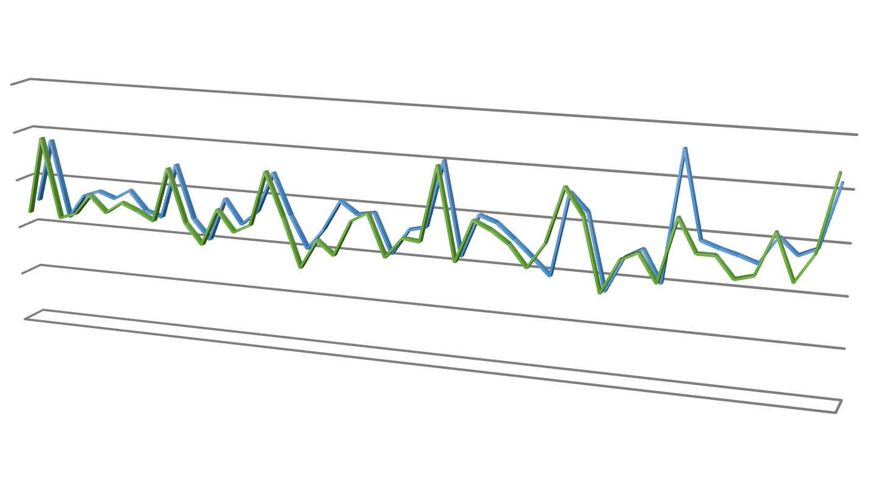

Interpretation:
Crime Rate reported against the Male public
1100
1050
1000
950
900
850
1 3
5 7
9 11 13 15
17 19 21 23 25 27 29 31
REPORTED SERIES
33 35 37 39 41 43 45 Males
47
Males Males10





























































































































































































































































































The 3-D line Excel chart and Pivot table containing percentages have deduced that the UK’s crime trend reported against the male populace has continuously risen in the recent ten years against the base year.
Crime Rate within the Unemployed populace
400
350
300
250
200
150
100
50
0
1 3 5 7 9 11 13 15 17 19 21 23 25 27 29 31 33 35 37 39 41 43 45 47
REPORTED SERIES
YouthUnemployment
YouthUnemploy10
MatureUnemployment HighYouthUnemploy
MatureUnemploy10
HighYouthUnemploy10
CRIME RATE

Interpretation:


The Stacked Column Excel chart and Pivot table containing percentages have deduced that the UK’s crime trend committed by the unemployed youth populace has always remained higher in the recent ten years than the mature unemployed populace.
Crime Rate due to Wage condition
800
700
600
500
400
300
200
100
0
1 3 5 7 9 11 13 15 17 19 21 23 25 27 29 31 33 35 37 39 41 43 45 47
Reported Series
Wage
BelowWage
Wage10
BelowWage10
Crime Rate

Interpretation:

The 2-D Line Excel chart and Pivot table containing percentages have deduced that the UK’s crime trend committed by people with low wages has always remained higher in the recent ten years. However, the crimes committed by people receiving lower than standard wages have remained constant in the ten years.

Part B

Q.1
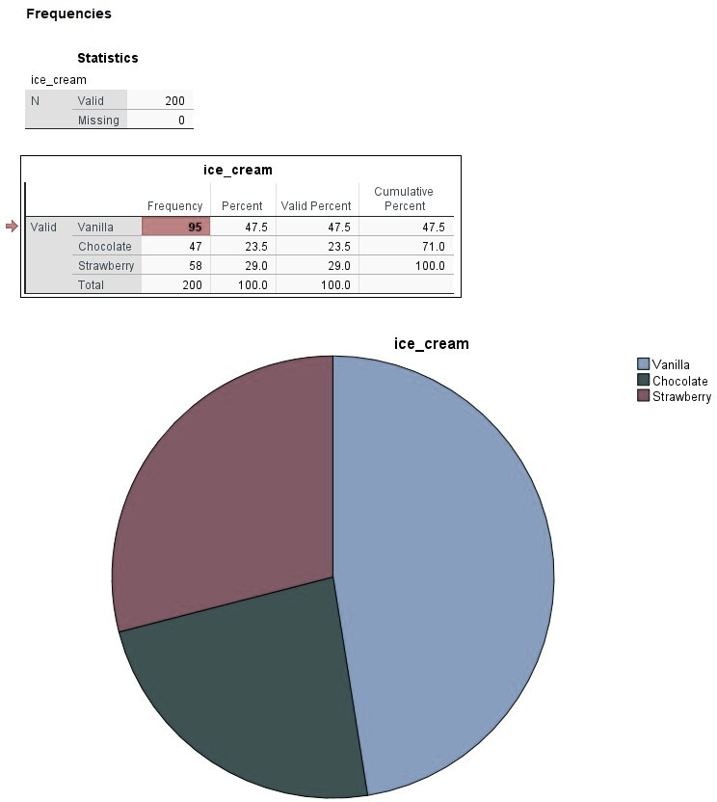

Q2.

Male and Female

Frequency Table

Gender
 |  | Frequency | Percent | Valid Percent | Cumulative Percent
Valid | Male | 91 | 45.5 | 45.5 | 45.5
Valid | Female | 109 | 54.5 | 54.5 | 100.0
Valid | Total | 200 | 100.0 | 100.0

Pie Chart

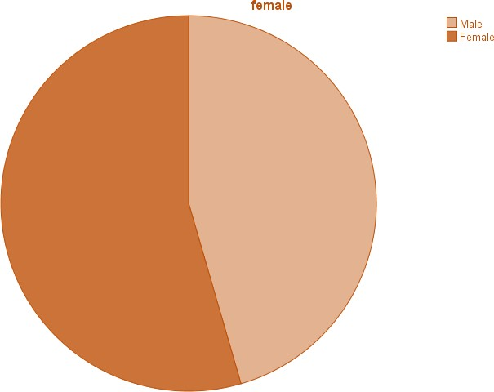

The total number of men is 91, and the total number of women is 109. So, the percentage of male students is 45.5%, and the percentage of female students is higher 54.5%, which means that there are more women than men.

Q.3

Mean and Median

Statistics
id ice-cream
 | Valid | 200 | 200
 | Missing | 0 | 0
Mean |  | 100.50 | 1.82
Median |  | 100.50 | 2.00

Frequency Table

ice-cream
Frequency |  |  | Percent | Valid Percent | Cumulative Percent
Valid | Vanilla | 95 | 47.5 | 47.5 | 47.5
Valid | Chocolate | 47 | 23.5 | 23.5 | 71.0
Valid | Strawberry | 58 | 29.0 | 29.0 | 100.0
Valid | Total | 200 | 100.0 | 100.0

Mean and Median first need to be analyzed, calculated based on the correct formal an frequency ,criterion, specifically based on the flavours of ice cream, so we can see that students have different tastes, and the highest degree of ice cream is held by the one with chocolate and strawberry flavours (Glend, 2021).

Clustering Example and Analysis

This analysis, called Cluster Analysis, presents a different technique, namely statistical arrangement by which a single set of objectives or points that have their own or similar

characteristics end up being grouped into different groups. This is a method by which all algorithms end up being used and grouped for arranging objects of the same type, i.e., similar.

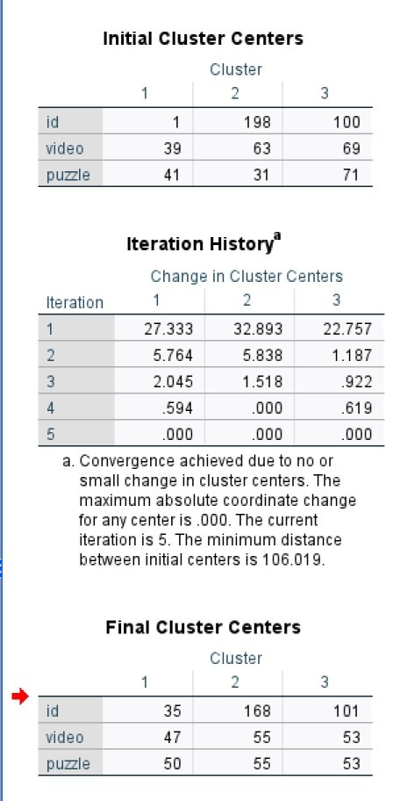

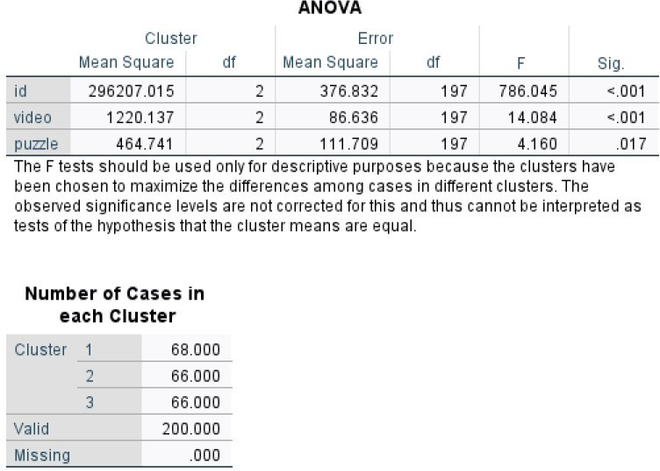

In the screenshots shown above, we can see how the centre of the cluster ends up changing, but only up to the 5th inertia, where it stops at the final destination, namely the 4th and 3rd iterations, with only a few minor movements and those being accommodating or helpful. In the Anova table, the wave between the variables has the biggest contribution to reach a final solution.

Data Mining and Text Mining Methods

Data mining is a rather complex process by discovering different models in as large data sets as possible, which can be used in many business systems even applications.
Speaking of business data mining this is a more detailed analysis of the historical activities of a business they are stored in statistical data in the data warehouse more precisely in the basic data.
Data mining software uses recognition algorithms, these algorithms are very advanced in verifying data that can be found in fairly large quantities. Some companies use this data mining because they want to include a market analysis to identify different product packages, more precisely to find the exact cause or main source of production problems to prevent other problems late. In today's world, data is being collected by companies at a very explosive rate. an example would be a company that processes over 22 million transactions every day. This data ends up being stored in a centralized database (Azevedo & Santos, 2021) (Them, 2022) where it would be useless without software to extract all the data coming to be analysed. Every time we use a type of loyalty card, credit card or even a store card to get a discount or complete a warranty card, we end up offering information about us to different companies (Talend, 2021). But this information is stored in a data set. We humans have a large amount on social networks, we have a lot of information on various platforms, Facebook, google and even Amazon. used to improve our lives. The more information a company has about us, the better it gets to know our material needs (Witten, et al., 2011).
Science and the art of acquiring knowledge is text mining which is a vast database collection. Text mining uses a vocabulary as close as possible to the natural one, thus allowing the machines to understand the human language and to process it automatically. text mining works on different text formats, namely from any format business documents, word, PDF files. In a legal profession, the sources of text mining are included completely differently because they approach lions, ordinances, and court deliberations, all of which are included in text mining. In the field of marketing, text mining would include customer feedback and advertising (Lingumatics, 2022).
These are just a few examples given above. What I want to prove is that text mining is different for everyone because it also matters a lot in the field in which you work. Each field uses a

different understanding of the text, a much easier way to understand the average person (Elsevier, 2016).

Advantages and Disadvantage of using SPSS and Excel

Advantages of using Excel | Disadvantages of using Excel
Microsoft excel is one of the most equipped or  more accurate data organization analysis systems. | Virus attack-can be easily attacked because  excel contains macros.
Office work - which can be used for day-to-day accounting or financial work. | Difficult to learn -Learning this software can be quite problematic, that is, difficult for a person who is new to this software, it is the formula that must be applied and for a  beginner it can seem quite complicated.
Tables - which can be easily created, dynamic and  easy to select and refer. | Have a high price
Passwords protect - you can password protect  your Excel file so no one else can connect to your Excel data. | Become slow
A lot of data - In this software you can store a lot of data, you can organize the data using different tools such as visualization, diagrams, table all that  are valid in this software. | Errors –Appear in that moment when you don’t use a good formula then everything would become wrong.
You can use Microsoft Excel on window or Mac
on android or IOS.

 | Advantages of using SPSS | Disadvantages of using SPSS
 | This software can be used without much effort. | Requires some time to spend for training.
 | The possibility of encountering an error with  this software program is minimal. | Similar whit Microsoft excel.
 | Data processing time is shorter with this SPSS  program. | Requires licence.
 | Displays data tables fairly quickly but also fairly easily. | It is an easy to download platform but difficult  to start because you need licenses every year and it costs quite a lot.
 | Reading the results or more precisely  interpreting them is relatively easy. | SPSS cannot analyse a lot of data, i.e., at a  large level.
 | It can help you save a lot of time if you work  because the calculations are given immediately. | It takes a lot of patience at first.
 | Easy to learn and quick. | Errors are sometimes difficult to understand.
Share- you can share by email with your
colleagues, or you can print the documents what you need.

Conclusion

In this paper I managed to discover but also to demonstrate the definition of the data mining process but also text mining what it means and what tools it uses. I've heard both the disadvantages and the advantages of SPSS software and Microsoft Excel. In this paper I have demonstrated the calculations in the pivot table, and I have tried to give a reasonable explanation for each calculation I had. This report helped me to really understand what Data Handling & Business Intelligence means, and how often we use this module in our daily lives without realizing it.

References

Witten, I. H., Frank, E. & Hall, M. A., 2011. Data Mining: Practical Machine Learning Tools and Techniques. 3 ed. Amsterdam: Elsevier/Morgan Kaufmann.
Azevedo, A. & Santos, M. F., 2021. Integration Challenges for Analytics, Business Intelligence, and Data Mining. Hershey: IGI Global.
Talend, 2021. Data mining. [Online] Available at: https://www.talend.com/resources/what-is-data-mining/ [Accessed 10 05 2022].
Elsevier, 2016. What is Text Mining?. [Online] Available at: https://www.youtube.com/watch?v=I3cjbB38Z4A [Accessed 11 05 2022].
Lingumatics, 2022. What is Text Mining, Text Analytics and Natural Language Processing?.
[Online]
Available at: https://www.linguamatics.com/what-text-mining-text-analytics-and-natural- language-processing
[Accessed 10 05 2022].

microsoft, e., 2021. Microsoft. [Online] Available at: https://support.microsoft.com/en-us/office/vlookup-function-0bbc8083-26fe- 4963-8ab8-93a18ad188a1
[Accessed 25 08 2022].

Glend, S., 2021. Statistics How To. [Online] Available at: https://www.statisticshowto.com/probability-and-statistics/statistics- definitions/mean-median-mode/
[Accessed 2 09 2022].

Them, 1. K. D. M. T. a. H. B. U., 2022. Georgia Profesional Tech Education. [Online] Available at: https://bootcamp.pe.gatech.edu/blog/10-key-data-mining-techniques-and-how-

businesses-use-them/ [Accessed 4 09 2022].
[H. Tang, "A Simple Approach of Data Mining in Excel," 2008 4th International Conference on Wireless Communications, Networking and Mobile Computing, 2008, pp. 1-4, doi: 10.1109/WiCom.2008.2679Accessed 10 05 2022] .

