
Effective team-working and communication
A report on communication within the workplace

July 5, 2019
Corey jones

1.0 Terms of Reference

On June 10th Lecturer Jess Shore requested a report on effective team- working and communication skills This report aims to discuss why effective communication verbal and non-verbal is important, the importance of two way communication and teamwork theories which could improve team work within an organisation, the researcher will produce the report based on a case study and will research models to illustrate points from the internet using references. The report was completed by Corey Jones and submitted on the 5th July 2019.

2.0 Procedure

The information conducted by the researcher and was gathered using information acquired from a case study and websites relevant to the report.

3.0 Findings

3.1 why effective communication is important

Effective communication is essential in any organisation in order for the business to run as well as it should. After reading the case study the reporter found that in order for the grocery store in Neath owned by Terrance Thomas to continue to grow Communication is essential. With so many employees different ages, experiences being able to communicate effectively will increase productivity giving clear directions and helping managers understand their employees’ talents/skills and what role would suit them best to work to their full potential given them a clear understanding. for the business to be a success there should be a manager on duty every shift there needs to be a formal team within the workplace so everyone knows what role and shift pattern they be on and who to turn to if a problem arises in the workplace, communication is essential for the five employees working in the stock room, being able to communicate effectively between one another if there was no communication it would lead to mistakes and could over order supply’s or under order so would have to ensure that all employees work as a team in order to complete the re-stocking, filling and deliveries are correct for the organisation to run as it should.
The importance of effective communication is that all staff can work together as part of a team good communication improves team building being honest and effective creates a good team it boosts growth contributing to the growth of the business,
Increasing innovation, if there is an open line of communication between managers and staff members, they are encouraged to be more creative and innovative within the workplace and are likely to put forth new creative ideas. Effective communication can improve productivity being able to communicate effectively can increase productivity giving clear instructions helping managers understand their employees attributes and placing them in a specific role that will encourage them to work to their best potential, good communication will increase efficiency when instructions are not provided clearly , mistakes are bound to be made and the quality of work could be low, need to be clear with instructions to eliminate the need to clarify and correct issues.
Good communication can increase loyalty if you have good communication skills, you will feel more comfortable discussing any professional or personal issues and will feel more committed to the company, good communication also reduces conflict working with different personalities requires excellent communication skills to limit any conflict, got to consider the communication pattern of the receiver to get a better understanding of what they are trying to say it increases employee engagement, good communication is connecting and engaging with others, when teams are engaged they are more aligned with company goals and generally more motivated to works towards set targets.
To be able to resolve problems there are bound to be characters that clash, as opinions differ within working environment, best way to solve is Clear Communication not about who is right and who Is wrong having an open honest and positive discussions to ensure everyone needs can be met and come to an agreement.
Communication skills an also enhance skills, managers can identify hidden talents when they communicate clearly with employees, they get a chance to find out skills and enhance them, which will contribute to the overall success of the business (Workspirited, n.d.)
Effective communication is significant for managers in an organisation, being able to plan, organise, lead and control helps managers perform their job and responsibilities adequately.
non verbal communication is important as having the right body language Non -verbal messages are an important part of the communication process because they provide added information the receiver can use in interpreting what is said.
Verbal communication is enhanced when a person is an effective listener. Listening doesn’t simply mean hearing; it is understanding another person’s point of view.
Watching other people’s body language, facial expressions and intonations, and being conscious of your own physicality and feelings can enhance non-verbal communication.

3.2 The importance of two-way communication

Two - way communication allows for instant feedback, seeking for clarification and interaction between the sender and receiver, it is typically seen as more efficient than one - way communication for information and feedback delivery. Two-way communication creates a more democratic environment, whereby people can share their thoughts, ideas and opinions, and improve relationships right across the structure. (mHub, n.d.)
Effective two-way communication is required in order to solve problems better. It helps everyone understand the business better and creates better relations throughout the company by ensuring everyone is engages with the latest business updates, objectives, and progress
Two - way communication is a form of transmission in which both parties involved transmit information it would be very beneficial in Terrence Thomas company, Terrence Thomas’s company would work more efficient if there was to be more two – way communication, it would benefit staff as they would know who would be doing what shifts arranging days and times, putting a staff rota together making formal teams so everyone knows what there particular role is making the business run smoothly.

3.3 Teamwork Theories

In 1965 Bruce Tuckman a Psychology professor carried out research into a theory of group dynamics, he published one of his theory’s Tuckman’s theory, Tuckman identified four stages of group development, suggesting that teams go through stages before becoming a self-reliant, unit making sure issues of processes and feelings have been satisfactory addressed otherwise the final stage is likely no to be met. Tuckman’s 4 stages include:
- Forming- With anxiety and uncertainly forming together and meeting people for the first time, feeling nervous, beginning to form first impressions of another and gaining what first impressions of another and what the group would do together, understanding the groups purpose, settling how will the group be organised outlining general group rules and what could be brought to the group.
- Storming-The groups are more confident by this stage as they would know their group purpose, the groups allocated tasks, learning their individual role and tasks at this second stage of group development the group starts to sort itself out and gain each other’s trust, Often voicing opinions and as a result of this a conflict could arise between members as power and status are assigned. As group members start to work together, they start learning about individual working styles and what it is like working together with different behaviours, dealing with conflict and complaints in an appropriate manner.
- Norming-The norming stage is when team members are positive about their team as a whole and what they are individually doing, acknowledging each other’s skills/attributes and experiences. They respect each other and the group remains focused on the purpose of the end result, this stage responsibilities and relationships are now established, allowing individuals to demonstrate attributes, allowing individuals to work unaided and taking greater responsibility if a team can reach a norming stage, they are close to succeeding towards their goal.
- Performing-At this stage individuals are relaxed with one another, confident and independent and able to make decision process without the need of leader’s supervision demonstrating great working relationships. They can clearly identify issues and work from them.
Any team stays together will change and develop, Tuckman noted there are three issues how a team could work well:
CONTENT- What a Team does
PROCESS-How a Team works
FEELINGS-How Team members relate to one another
BELBINS THEORY is a questionnaire designed to help you discover your preferred role at your team of work developed in 1970s by Dr Meredith Belbin, Belbin suggest a person who is a team member tends to adopt one or more styles of behaviour within the team, tending to fill certain roles. Belbin’s research development led to nine clusters of behaviours that individuals adopt when participating in a team the nine behaviours are:
- Shaper- challenging, thrives off pressure got the drive and courage to over come obstacles, prone to stirring offending peoples feelings.
- Implementor-(IM) Disciplined, reliable, conservative and efficient, turns ideas into practical actions, somewhat inflexible. slow to new possibilities.
- Complete finisher-(CF) Tends to have attention to detail, strives for perfection can be trusted to do work to the highest standard and o be completed on time, they expect the same high standards from people around them.
- Co-ordinator (CO) Mature, Confident, helps others towards goals, quick to spot individual talents and use them in pursuit of group objectives can be seen as manipulative, can manipulate others to work towards the shared goal. they are likely to have a wide outlook perspective sometimes CO’s tend to clash with shapers due to their distinctive management styles
- Team worker (TW) Co-operative and process mild perceptive and sociable temperament, genuinely supportive and concerned about others, because of their qualities being flexible and adapting to different situations and people, being diplomatic caring and a good listener, they are known to be popular with their colleagues, by creating harmony and avoiding conflict, can be indecisive when faced with solo difficult situations.
- Resource investigator (RI) Tend to be extrovert, enthusiastic, they are natural communicators also natural negotiators and enjoy exploring new opportunities, RI are effective using other people’s ideas promoting them. They can think on their feet probing others for information.
- Plant (PL) Creative, imaginative providing original ideas to support change, prefer operating by themselves or at a distance from other members of the team, react strongly to criticism and change suggesting solutions for problems.
- Monitor Evaluator (ME) Serious minded, slow in making decisions sees all options, judges accurately lack drive and ability to inspire others.
- Specialists (S) Single minded, love learning and building of knowledge main reason for their existence they are seen as experts to turn to for guidance as managers they command respect because of there in depth knowledge,

(TrainingZone, n.d.)

4.0 Conclusion

The reporter believes in order for Terrence Thomas grocery store to continue to grow rapidly, there needs to be more organisation within the business starting with group meetings and arranging a staff rota. There seems to be not enough communication and information in the workplace getting shared effectively, as well as no manager on duty in the nights. Terrence could also think about the amount of staff he has working part-time hours he could make some more permanent and work full time hours, saving on training new staff.
The reporter thinks Terrence Thomas grocery store staff would benefit by using Belbin theory, as individuals would have a greater self-understanding of their strengths, which leads to more effective communication between colleagues and managers. Great teams can be put together, existing teams can be understood and improved, and everyone can feel that they are making a difference in the workplace.
From the descriptions of Tuckman’s Theory, it can be seen each team role has its own characteristics with potential strengths and weaknesses the action-oriented roles would best suit characteristics the Shaper, implementer, Complete finisher. People -oriented roles would best suit Co-ordinator, Team worker, Resource investigator. And best suited characteristics for thinking oriented roles would be plant, monitor Evaluator, Specialist. Each all bring something together to work well as a team.

5.0 Appendices

(Bing.com, 2019)
Two way communication
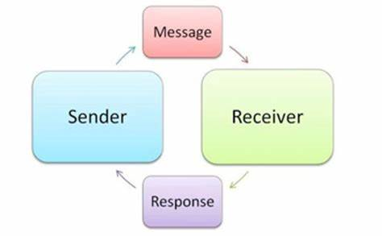
(Bing.com, n.d.)

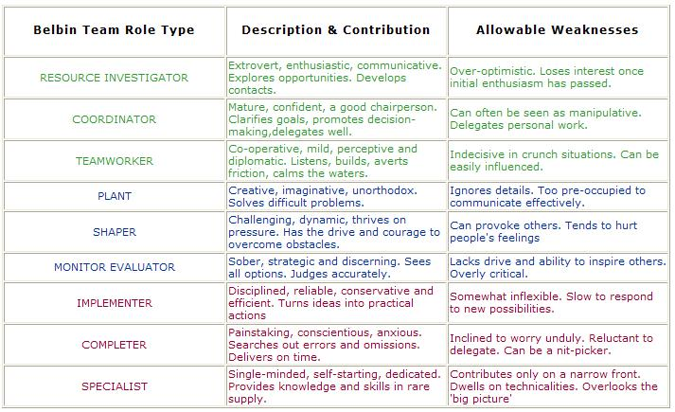

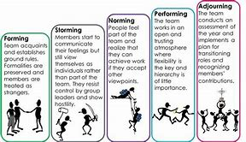
(Bing.com, n.d.)

6.0 References

References
Priestley, D. (2019). Forming, Storming, Norming, Performing: The Stages of Team Formation. [online] Ventureteambuilding.co.uk. Available at: http://www.ventureteambuilding.co.uk/forming-storming-norming-performing/ [Accessed 5 Jun. 2019].

Accelerate UK. (2019). 9 Belbin Team Roles - Discover the Belbin Team Inventory | Accelerate UK. [online] Available at: https://www.accelerate.uk.com/training-tools/belbin/nine-belbin-team-roles/ [Accessed 5 Jun. 2019].
Bing.com. (2019). two way communication models - Bing. [online] Available at: https://www.bing.com/images/search?view=detailV2&id=976BB5F4DA121F33A0CA9F95125C603FEEF9A4E2&thid=OIP.5M-x6g1UsufLOx0yH3EjJAHaEl&mediaurl=http%3A%2F%2Feducation-portal.com%2Fcimages%2Fmultimages%2F16%2Ftwo_way_communication_model_resized.jpg&exph=224&expw=362&q=two+way+communication+models&selectedindex=3&qpvt=two+way+communication+models&ajaxhist=0&vt=0&eim=1,6 [Accessed 28 Jun. 2019].
Bing.com. (n.d.). belbin questionnaire - Bing. [online] Available at: https://www.bing.com/images/search?view=detailV2&id=3A51BB0DF03507E8A86AC763D0DC941852200522&thid=OIP.unyIkR23I15GV_2fbqLozgHaKe&mediaurl=http%3A%2F%2Fwww.belbin.ie%2Fwp-content%2Fuploads%2F2014%2F07%2FObserver-Assessment.jpg&exph=618&expw=437&q=belbin+questionnaire&selectedindex=16&ajaxhist=0&vt=0&eim=1,6&ccid=unyIkR23&simid=608043647208915457 [Accessed 27 Jun. 2019].
Bing.com. (n.d.). tuckman's theory - Bing images. [online] Available at: https://www.bing.com/images/search?q=tuckman%27s+theory&FORM=HDRSC2 [Accessed 27 Jun. 2019].
mHub. (n.d.). The importance of two-way communication - mHub. [online] Available at: http://www.mhub.tv/importance-two-way-communication/ [Accessed 27 Jun. 2019].
TrainingZone. (n.d.). Belbin and Tuckman. [online] Available at: https://www.trainingzone.co.uk/community/blogs/belbin/belbin-and-tuckman [Accessed 25 Jun. 2019].
Workspirited. (n.d.). Why Effective Communication in the Workplace is Highly Important. [online] Available at: https://workspirited.com/effective-communication-in-workplace [Accessed 29 Jun. 2019].
Workspirited. (n.d.). Why Effective Communication in the Workplace is Highly Important. [online] Available at: https://workspirited.com/effective-communication-in-workplace [Accessed 1 Jul. 2019].

