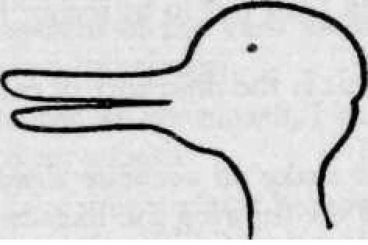
Wittgenstein: Seeing and seeing-as

‘The concept of the 'inner picture' is misleading, for this concept uses the 'outer picture' as a model; and yet the uses of the words for these concepts are no more like one another than the uses of 'numeral' and 'number'. (PI, p.167)

‘The concept of a representation of what is seen, like that of a copy, is very elastic, and so together with it is the concept of what is seen. The two are intimately connected. (Which is not to say that they are alike.)’ (PI, p.169)

The empirical-representative picture
- To investigate the picture of sensation/seeing as the ‘immediate sensory effect of the objective world’; of hearing as ‘different pitch, frequency and loudness’. (MG 178)
- ‘”What I really see must surely be what is produced in me by the influence of the object"—Then what is produced in me is a sort of copy, something that in its turn can be looked at, can be before one; almost something like a materialisation.
And this materialization is something spatial and it must be possible to describe it in purely spatial terms. For instance (if it is a face) it can smile;’. (PI, p.170)

Problems with the representative picture
- Do we just “see” “data”? What about our interpretations?
- What does it mean to see qualities or resemblances etc.? E.g. do you see Rembandt’s self-portraits – smiles, eyes, hair etc. and something else that we call a “resemblance”?
- For example, could I see “friendliness” in the picture of a smile? ‘the concept of friendliness… has no place in an [empirical] account of it, but is foreign to such an account…’ (PI, p.170)
- Where does this representative picture come from? Grounded in a theory of perception??? It ‘draws on a scientific understanding of the eye and of the patterns of light that stimulate it.’ (MG p.179) W: but it originates in unclarity about how the concept of visual experience actually functions.

How to explore the issue?
- Avoid assumptions! ‘Only do not think you knew in advance what the "state of seeing" means here! Let the use teach you the meaning.
We find certain things about seeing puzzling, because we do not find the whole business of seeing puzzling enough.’ (PI, p.181)
- ‘What we have rather to do is to accept the everyday language-game, and to note false accounts of the matter as false. The primitive language-game which children are taught needs no justification; attempts at justification need to be rejected.’ (PI, p.171)

Investigation: “The Visual Room”
- An investigation into the representative picture of sensation. “I see a room”.
- The picture: as I look at the room I am directly experiencing subjective, private room-like “ideas” or sense-data. ‘I think we can say: you are talking (if, for example, you are sitting in a room) of the 'visual room'.’ (PI 398)
- Interlocutor: ‘"But when I imagine something, or even actually see objects, I have got something which my neighbour has not." —I understand you. You want to look about you and say: "At any rate only I have got THIS.”’ (PI 398)

Problems with the picture
- My sensation: “I have got THIS!” ‘—What are these words for? They serve no purpose.— Can one not add: "There is here no question of a 'seeing'—and therefore none of a 'having'—nor of a subject, nor therefore of I either"? Might I not ask: In what sense have you got what you are talking about and saying that only you have got it? Do you possess it? You do not even see it. Must you not really say that no one has got it? And this too is clear: if as a matter of logic you exclude other people's having something, it loses its sense to say that you have it. But what is the thing you are speaking of?’ (PI 398)
- Our language forces physical object pictures on us. But they have no currency here. ‘The 'visual room' is the one that has no owner. I can as little own it as I can walk about it, or look at it, or point to it. Inasmuch as it cannot be any one else's it is not mine either. In other words, it does not belong to me because I want to use the same form of expression about it as about the material room in which I sit. The description of the latter need not mention an owner, in fact it need not have any owner. But then the visual room cannot have any owner. "For"—one might say—"it has no master, outside or in."’ (PI 398)
- ‘Think of a picture of a landscape, an imaginary landscape with a house in it.—Someone asks "Whose house is that?"—The answer, by the way, might be "It belongs to the farmer who is sitting on the bench in front of it". But then he cannot for example enter his house.’ (PI 398)
- ‘What we’re beginning to see is that when we try to apply the picture of a visual impression as something that I have whenever I see something - which initially seems so intuitive and unproblematic - we cannot make it connect with anything, for there is nothing that is both an object of consciousness and accessible to the subject alone.’ Doing philosophy turns the “visual room” into a ‘quasi-material thing’. ‘We want to assign a grammar to this concept – the grammar of an object term – which is simply inappropriate, or which it cannot be made to fit.’ (MG p.183)

How do we see?
- We should be aware of distinctions in the use of the concept of seeing. ‘The one: “What do you see there?” – “I see this” (and then a description, a drawing, a copy). The other: “I see a likeness between these two faces.”’ (PI, p.165) How is it possible to “see” a likeness? Need to note the ‘difference of category between the two “objects” of sight.’ (PI, p.165)
- Drawing two faces: ‘The one man might make an accurate drawing of the two faces, and the other notice in the drawing the likeness which the former did not see.
I contemplate a face, and then suddenly notice its likeness to another. I see that it has not changed; and yet I see it differently. I call this experience "noticing an aspect".’ (PI, p.165) But the object hasn’t changed!
- We must investigate this region of our language-game. Our interest: ‘the concept and its place among the concepts of experience.’ (PI, p.165)
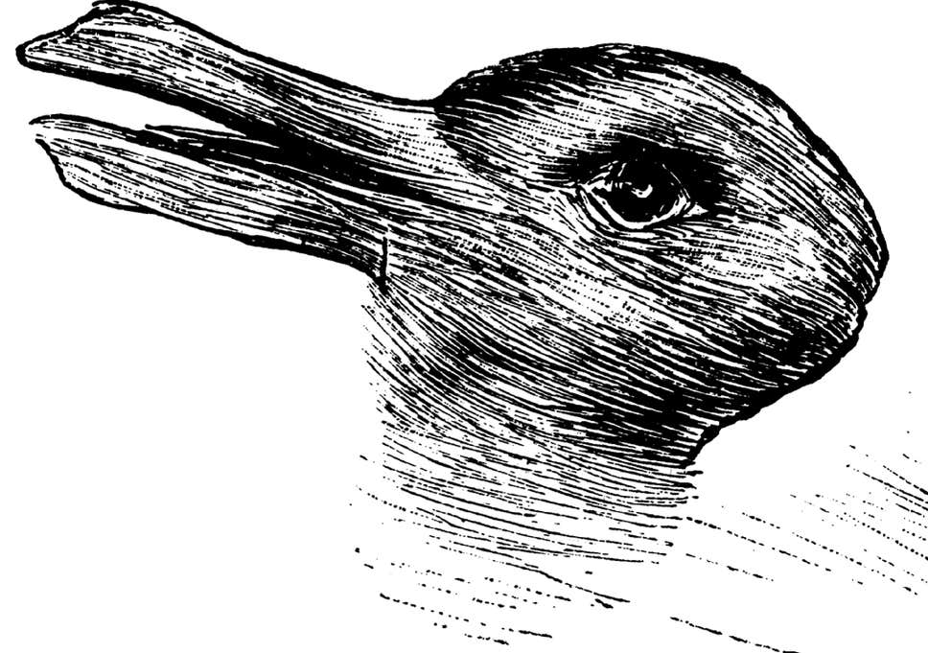
Jastrow’s duck-rabbit!
- ‘I shall call the following figure, derived from Jastrow, the duck- rabbit. It can be seen as a rabbit's head or as a duck's.
And I must distinguish between the 'continuous seeing' of an aspect and the 'dawning' of an aspect.
The picture might have been shewn me, and I never have seen anything but a rabbit in it. (PI, pp.165/6)
But what is different? ‘my impression? my point of view?—Can I say? I describe the alteration like a perception; quite as if the object had altered before my eyes.’ (PI p,167)
- Our temptation is to fall back on the notion of an “inner picture”: ‘And above all do not say "After all my visual impression isn't the drawing; it is this——which I can't shew to anyone."—Of course it is not the drawing, but neither is it anything of the same category, which I carry within myself.’ (PI, p.167)
- So what is going on here?

Solution: understanding responsiveness
- We must not think of the concept of perception in terms of something given or as something caused within us. If that were the case, we couldn’t describe the duck-rabbit example.
- We can see through the example how the subject places the picture in different contexts. We can see the difference in the way the subject responds. ‘Someone suddenly sees an appearance which he does not recognize (it may be a familiar object, but in an unusual position or lighting); the lack of recognition perhaps lasts only a few seconds. Is it correct to say he has a different visual experience from someone who knew the object at once?’ (PI, p.168)
- ‘what I perceive in the dawning of an aspect is not a property of an object, but an internal relation between it and other objects. (PI, p.180)
- ‘ ‘Seeing as . . . .' is not part of perception. And for that reason it is like seeing and again not like.
I look at an animal and am asked: "What do you see?" I answer: "A rabbit".—I see a landscape; suddenly a rabbit runs past. I exclaim "A rabbit!"
Both things, both the report and the exclamation, are expressions of perception and of visual experience. But the exclamation is so in a different sense from the report: it is forced from us.—It is related to the experience as a cry is to pain.’ (PI, p.168)
- ‘I meet someone whom I have not seen for years; I see him clearly, but fail to know him. Suddenly I know him, I see the old face in the altered one. I believe that I should do a different portrait of him now if I could paint.’ (PI, p.169)
- We must recognize the elasticity of representation: ‘If someone sees a smile and does not know it for a smile, does not understand it as such, does he see it differently from someone who understands it?—He mimics it differently, for instance.
Hold the drawing of a face upside down and you can't recognize the expression of the face. Perhaps you can see that it is smiling, but not exactly what kind of smile it is. You cannot imitate the smile or describe it more exactly.
And yet the picture which you have turned round may be a most exact representation of a person's face.’ (PI, p.169)
- There is an indefinite number of potential descriptions of what is seen. ‘The concept of 'seeing' makes a tangled impression. Well, it is tangled.—I look at the landscape, my gaze ranges over it, I see all sorts of distinct and indistinct movement; this impresses itself sharply on me, that is quite hazy. After all, how completely ragged what we see can appear. And now look at all that can be meant by "description of what is seen".—But this just is what is called description of what is seen. There is not one genuine proper case of such description—the rest being just vague, something which awaits clarification, or which must just be swept aside as rubbish.
Here we are in enormous danger of wanting to make fine distinctions.—It is the same when one tries to define the concept of a material object in terms of 'what is really seen'.—What we have rather to do is to accept the everyday language-game, and to note false accounts of the matter as false. The primitive language-game which children are taught needs no justification; attempts at justification need to be rejected. (PI, p.171)
- ‘In this way, the case of seeing-as works against our inclination to think of perception in terms of the influence of objects on a receptive faculty, and draws our attention to the role of an active, responding subject in determining the nature of visual experience, or in fixing what is seen.’ (MG p.195)
- ‘Hence the flashing of an aspect on us seems half visual experience, half thought.’ (PI p.168)
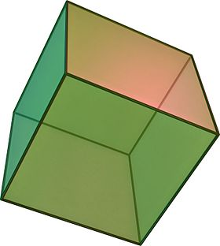
- The cuboid: ‘ You could imagine the illustration… appearing in several places in a book, a text-book for instance. In the relevant text something different is in question every time: here a glass cube, there an inverted open box, there a wire frame of that shape, there three boards forming a solid angle. Each time the text supplies the interpretation of the illustration.
But we can also see the illustration now as one thing now as another. —So we interpret it, and see it as we interpret it.’ (PI p.165)

