Assignment 2 : Project Outcomes

Video Link 3
Screenshot of the e-portfolio 3

Video Link
https://www.youtube.com/watch?v=WnCrC5Tp2YM

Screenshot of the e-portfolio

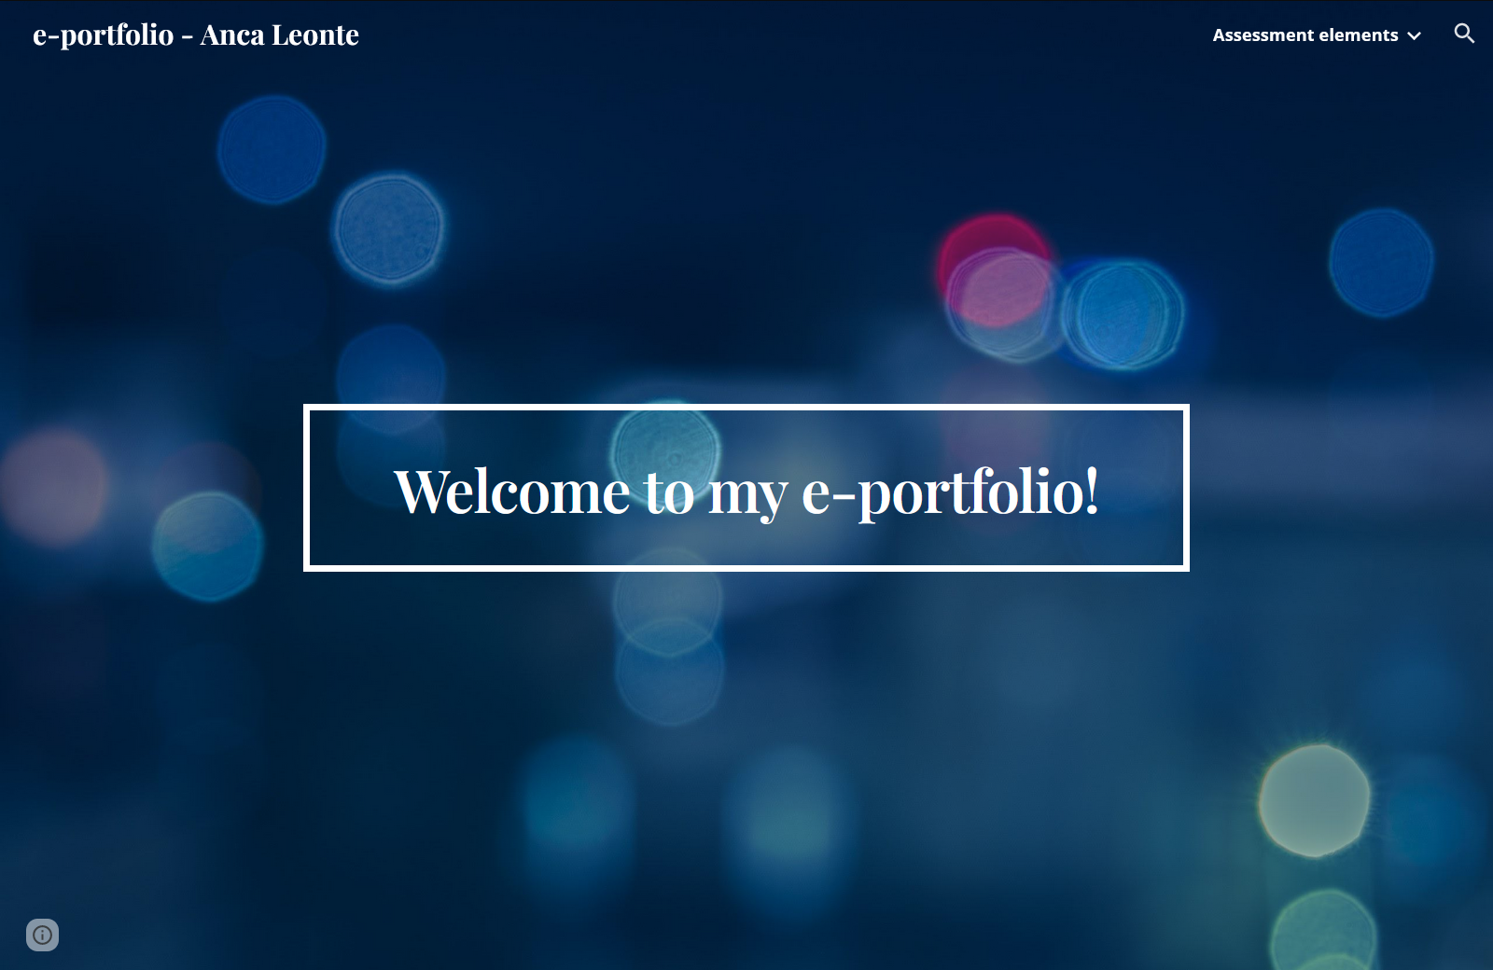
Figure 1: Screenshot of the e-portfolio

