`

the importance of acamedia | Diana Demeterova  Study Skills

Content page
Introduction 2
Main Body 3
Referencing 3
Critical Thinking 5
The power of reflection 7
Academic misconduct 8
Conclusion 9
References 10

Introduction

This report will review all the skills and knowledge students receive from study skills. This report will include the four key factors, such as:

- Resilience
- Critical thinking
- The power of reflection
- Academic misconduct

The importance of academia is complicated as it includes a variety of factors which encourages knowledge development, improvement in society, and personal improvement.

According to Altbach P.G., Reisberg, L., & Rumbley, L. E. (2009), education and skill development is a key factor significant to academia. They had mentioned that in order to provide a formal education and training, academic institutions such as Colleges and Universities are necessary. They offer individuals the knowledge, skills, and potential for critical thinking that is required for a variety of careers and sectors.

The Nations Academies of Sciences, Engineering, and Medicine. (2018) had mentioned that global collaboration is another key factor significant to academia. They said that global collaboration and intellectual discussion have been made easier by academia. Research and education collaborations on a global scale promotes a greater understanding of problems and the development of international solutions.

According to Marginson, S. (2016), professional development and networking is a key factor that s significant to academia. It was mentioned in her book ‘The Dream is over’ that academic institutions such as Colleges and Universities provides opportunities for networking and professional development. Interactions with individuals from the business community, peers, and experts can be beneficial to students and researchers since they can result in chance for a promotion in their career and collaboration.

Main Body

Referencing

According to University of New South Wales, adding references to your work allows you to give credit to other authors and researchers for what they have contributed. References are required for any academic work in higher education which includes the concept, words, or research of other individuals. University of New South Wales also mentioned that plagiarism can be referred to as using incorrect sources or no references at all. An assignment without references suggests that all ideas, fact, and words are your own.

Why reference?

According to University of Birmingham, academic writing requires the use of references, which not only confirms your argument and conclusion but also demonstrates to the reader which sources you have considered when researching the subject at hand. Referencing your sources is an essential requirement for academic writing, whether you are writing a piece of coursework or research.
Here are some examples of why you should reference:
- To make it easier for readers to locate and verify the sources you have referenced in your writing.
- To make it easier for you to reference specific quotes or pieces of evidence in your own writing in the future.
- To stay clear of plagiarism accusations.
- To encourage you to re-evaluate your academic writing.

Referencing methods

It was said by the University of New South Wales that there are numerous methods of referencing. They mentioned that academic skills provide simple referencing guides for three major styles:
- The Oxford (footnote/bibliography)
- The Harvard (in-text) method
- The APA (American Psychological Association)

How to reference specific type of resources

Books and E-Books
According to University of Wales Trinity Saint David, many book references should follow this general style in the given example however, there might be slight changes.
Reference list / Bibliography:
• Author/editor
• Publication year (in round brackets) • Title (in italics)
• Edition (if not the first)
• Place of publication: publisher

In-text citation:
(Author’s surname, year of publication, page number)

(Smith, 2016, p. 5)

Smith, E. (2016) How to improve your research project. 2nd edn. Plymouth: Kiln Press.

Internet – website with an author
According to University of Wales Trinity Saint David, individuals and organisations had created webpages typically to follow the format in the given example bellow. However, some aspects may vary significantly based on the sources used by students. Here is the example.

Reference list / Bibliography:
• Author/organisation
• Publication year (in round brackets) • Webpage title in italics
• Available at: URL
• (Accessed: date)

In-text citation:
Author’s surname/organisation (year of publication)

Kennedy, N and Bandyopadhyay, A. (2023) Linking police and healthcare data could help better identify domestic abuse - new research. Available at: https://theconversation.com/linking-police- and-healthcare-data-could-help-better-identify- domestic-abuse-new-research-208986 (Accessed: 11 August 2023).

Kennedy and Bandyopadhya (2023) discuss...

Critical Thinking
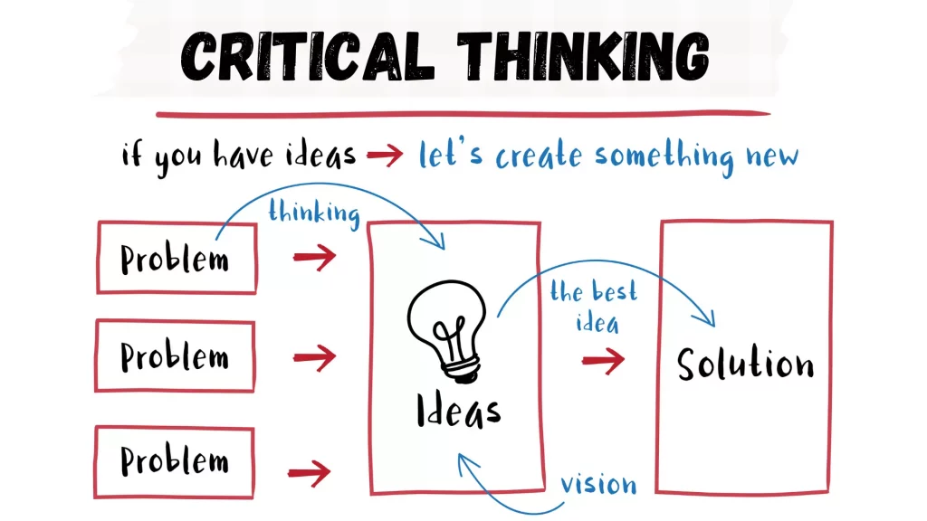

According to University of Louisville, clarity, articulation, and justification of positions are a few skills that have been defined as critical thinking. It additionally includes questioning, acknowledging, and testing presumptions, recognising confusion, examining, understanding, evaluating, and reflecting.

Why focus on critical thinking?

According to the University of The People, the decision you make will have an impact on your everyday way of living. Additionally, you should make thoughtful choices if you want to ensure that you lead the most productive, happiest, and richest life. Critical thinking is a basic skill that can be used to do that. They also mentioned key factors of the importance of critical thinking, which includes.

- Critical thinking being universal. Domain-general thinking skills include critical thinking. It suggests that all these skills will be useful and relevant to individuals’ success, regarding of the career or path they choose.
- It is crucial for the economy. Innovation, information, and technology will determine our future. Our rapidly growing economies require critical thinking to find a quick and efficient solution to issues.
- Critical thinking improves language and presentation skills. Individuals need to develop the ability to think with clarity and discipline to express themselves most effectively, which means individuals must engage in critical thinking. As a result, critical thinking involves analysing text to enhance understanding.
- Critical thinking promotes creativity. By engaging in critical thinking, individuals allow themselves to solve issues as well as offer original and imaginative solutions. By using critical thinking, they can evaluate these concepts and make modifications that are required.
- Critical thinking is important for self-reflection. To reflect on themselves, defend their believes, and lifestyles, individuals require this ability. The ability to critically think gives individuals the means to assess themselves as necessary.

Why is critical thinking important in academia and how does it apply in academia?

According to University of Wollongong Australia, critical thinking is crucial in academia because it enables students to understand and analysis the point of view, theories, and evidence related to your specific subject of study. Individuals can comprehend the problems and data they process by using critical thinking. The ongoing process of inspiration, discussion, and reflection maintains academic fields. For all discipline of study to survive and succeed critical thinking is therefore necessary.

University of Kent had mentioned how critical thinking applies to some academic methods. This includes.
- Research. Critical thinking examines its limitations and questions to why and how something was done.
- Journal articles. Critical thinking recognizes important issues and investigates their rationale and correctness.
- Survey results. Critical thinking methods by examining what they demonstrate or suggest.
- Ideas. Critical thinking points out its weaknesses and conflicts while also asking why it is important.

The power of reflection

According to Michael. F (2023), the power of reflection enables us to recognise gaps in understanding and come up with solutions for them. Additionally, reflection encourages us to go beyond the present situation and consider new opportunities, which can inspire creativity and innovation. Furthermore, reflection increases resilience. Michael. F mentions that by analysing our success and flaws we may develop a growth mindset that views challenges as opportunities for improvement and development. With this kind of thinking, we may overcome difficulties and deal with challenging circumstances with more self-assurance and creativity.
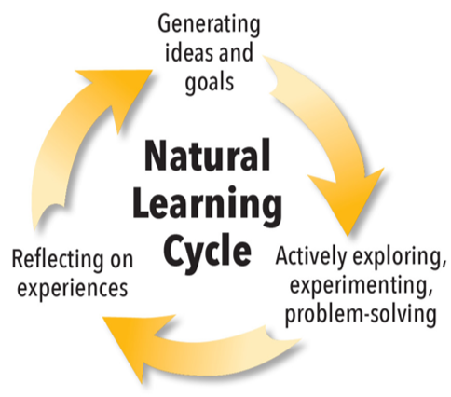
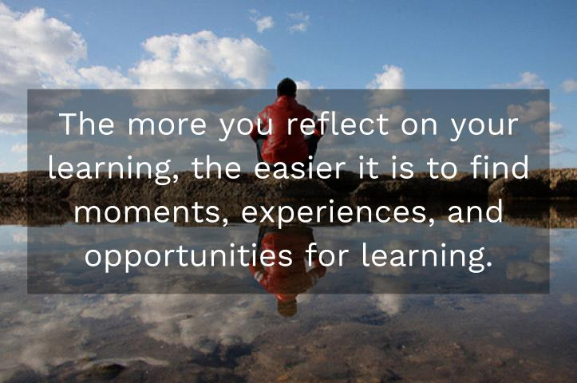

Benefits of the power of reflection.

According to Sanjana. G (2023), there are many benefits of the power of reflection. This includes:

- An increase in self-awareness. A key component of emotional intelligence is self-awareness. It supports your ability to identify and comprehend your own feelings as well as how they affect your attitudes and actions.
- Improved communication skills. You may improve your communication skills by self-reflection, which could improve your relationships. Understanding how you are feeling will enable you to communicate with clarity, honesty, and empathy.
- Better decision-making skills. Developing a deeper understanding of who you are, will make you analyse your alternatives and their potential effects on you clearly. This may help you in making wise choices that you feel more comfortable with.
- Increases level of alignment with core values. This can make sure that both your actions and your words are more in line with your beliefs. Additionally, it may decrease emotional dissonance, which is the unease you might feel when your actions differ from your principles.

Academic misconduct

According to University of Cambridge (2023), academic misconduct refers to any behaviour that could compromise the high standards required for academia and research, as well as any attempts to gain or help others in looking for an unfair academic advantage in assessments.
Academic misconduct includes:
- Plagiarism. This means copying ideas, phrases, information, or other work created by others without giving credit.
- Self-plagiarism. This means using the original thoughts, phrases, information, or other work created by students and submitted for official assessments at university or publishing elsewhere without responsibility.
- Impersonating someone or being impersonated. This is used when taking an exam or setting someone up to take the test/exam in the persona of someone else.
- Failure to meet legal, ethical, and professional obligations. This includes partnering with others to engage in misconduct in research or keeping such activities hidden, as well as breaking regulations. This covers any schemes or agreements to try to carry out any of these actions.

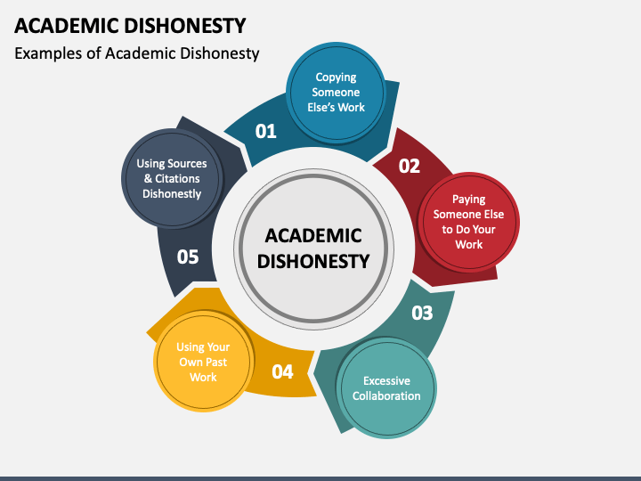
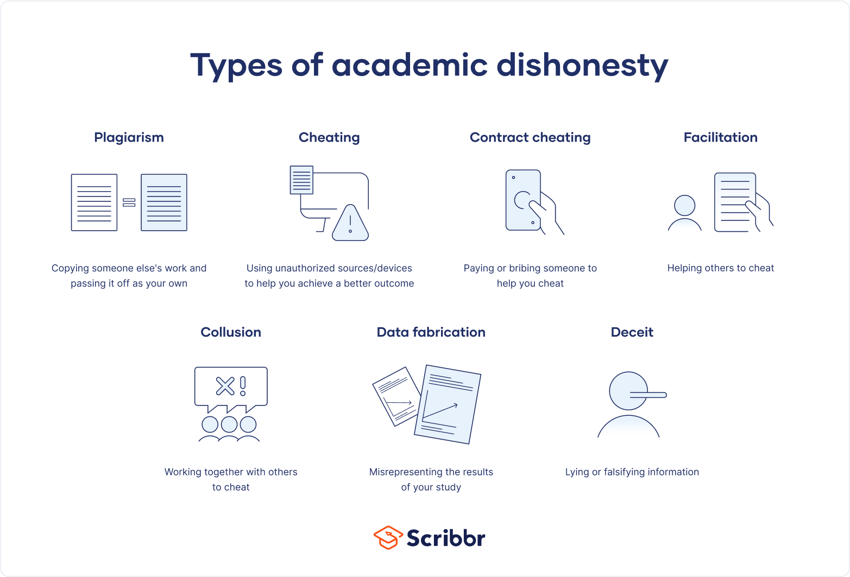

How to prevent plagiarism from accruing?

According to the University of Cambridge (2023), proofreading is the key skill to prevent plagiarism from accruing. They mentioned that while students are ultimately responsible for their own work, it might be beneficial to have an outside proof-reader for example, a teacher, to review and provide feedback on your work. When it comes to proof-reading, it is crucial that students, supervisors, examiners, and proof-readers are aware of what is and is not appropriate.

Conclusion

To summarise this report, it is important to use all of these skills in higher education to prevent any misconduct with academic work and conflict within academia.

References

Altbach, P. G., Reisberg, L., & Rumbley, L. E. (2009). Trends in global higher education: Tracking an academic revolution. United Nations Educational, Scientific and Cultural Organization (UNESCO).
https://unesdoc.unesco.org/ark:/48223/pf0000183168

Marginson, S. (2016). The dream is over: The crisis of Clark Kerr's California idea of higher education. University of California Press.
https://www.luminosoa.org/site/books/m/10.1525/luminos.17/

Michael foully (April 24th 2023) The Power of Reflection: Unlocking Personal and Professional Growth
https://www.linkedin.com/pulse/power-reflection-unlocking-personal-professional-growth-kouly-#:~:text=It%20allows%20us%20to%20identify,Additionally%2C%20reflection%20fosters%20resilience.

National Academies of Sciences, Engineering, and Medicine. (2018). Open Science by Design: Realizing a Vision for 21st Century Research. The National Academies Press.
https://nap.nationalacademies.org/read/25116/chapter/1

Sanjana Gupta (may 26th 2023) The Importance of Self-Reflection: How Looking Inward Can Improve Your Mental Health
https://www.verywellmind.com/self-reflection-importance-benefits-and-strategies-7500858

University of Birmingham
https://intranet.birmingham.ac.uk/as/libraryservices/library/referencing/icite/why-reference.aspx#:~:text=To%20allow%20a%20reader%20of,books%2C%20articles%2C%20or%20websites.

University of Cambridge (September 7th 2023) plagiarism and academic misconduct.
https://www.plagiarism.admin.cam.ac.uk/definition

University of Kent
https://www.kent.ac.uk/guides/independent-learning-and-critical-thinking/critical-thinking#:~:text=It%20helps%20you%20make%20informed,at%20higher%20or%20degree%20level.

University of Louisville
https://louisville.edu/ideastoaction/about/criticalthinking/what#:~:text=Critical%20thinking%20has%20been%20described,%26%20Smith%2C%201961%3B%20Ennis%2C

University of New South Wales
https://www.student.unsw.edu.au/why-referencing-important#:~:text=Referencing%20allows%20you%20to%20acknowledge,have%20borrowed%20words%20and%20ideas.

University of New South Wales
https://www.student.unsw.edu.au/poor-referencing-skills#:~:text=Inaccurate%20references%20or%2C%20worse%20still,claims%20in%20your%20own%20assignments.

University of south Wales trinity Saint David
https://moodle.uwtsd.ac.uk/pluginfile.php/852583/mod_resource/content/0/harvard_en_v.1.3_final.pdf

University of the people
https://www.uopeople.edu/blog/why-is-critical-thinking-important/#:~:text=There%27s%20no%20doubt%20about%20it,and%20trust%20our%20gut%20feeling.

University of Wollongong Australia
https://www.uow.edu.au/student/learning-co-op/assessments/critical-analysis/#:~:text=Why%20is%20it%20so%20important,your%20particular%20field%20of%20study.

