

BA (Hons) Leadership and Management Skills for the Workplace
Module: Leading and Implementing Change (LCLM6003)
Assignment Title:
A Strategic Change Plan
Student Name: Suleha Begum Azad
Student ID: 2325115
Lecturer(s): Dr Eric Osei
Submission Date: 20/07/2026
Word Count: 4458

Executive Summary

This report critically evaluates Jaguar Land Rover's (JLR) Reimagine Strategy, which seeks to reposition the organisation as a sustainable modern luxury automotive manufacturer through electrification, digital transformation and environmental sustainability. Strategic analysis using PESTLE, Porter's Five Forces and SWOT demonstrates that while the strategy is well aligned with external market trends, its successful implementation will depend on effective organisational change, leadership and employee engagement.
The report critically examines contemporary change management models, including Lewin's Three-Step Model, Kotter's Eight-Step Model and the ADKAR Model, together with the influence of leadership and organisational culture on strategic transformation. Based on this evaluation, a Strategic Change Management Plan is proposed, incorporating stakeholder analysis, communication strategies, implementation phases, performance measures and risk management to support the successful delivery of the Reimagine Strategy.
The report concludes that although JLR's strategic direction is appropriate for responding to technological, competitive and regulatory change, achieving sustainable competitive advantage will depend on embedding organisational change alongside technological innovation. Consequently, Lewin's Three-Step Model is recommended as the most appropriate framework because it provides a practical and structured approach to preparing the organisation for change, implementing transformation and embedding new behaviours to support the long-term success of the Reimagine Strategy.

Table of Contents
Executive Summary 2
1.0 Purpose of the Report 4
1.1 Introduction 4
2.0 Strategic Drivers of Organisational Change 5
2.1 PESTLE Analysis 7
2.2 Industry Analysis: Porter's Five Forces 7
2.3 Internal Analysis: SWOT Analysis 9
2.4 Triggers for Organisational Change 9
2.5 Chapter Summary 10
3.0 Critical Evaluation of the Reimagine Strategy 10
3.1 Strategic Objectives of the Reimagine Strategy 10
3.2 Critical Evaluation of the Reimagine Strategy 11
3.3 Implementation Challenges 11
3.4 Chapter Summary 12
4.0 Evaluation and Selection of Change Management Models 12
4.1 Evaluation of Lewin's Three-Step Model 12
4.2 Comparison with Kotter's Eight-Step Model and the ADKAR Model 13
4.3 Justification for Selecting Lewin's Three-Step Model 14
4.4 Chapter Summary 14
5.0 Leadership, Organisational Culture and Stakeholder Engagement 15
5.1 Leadership Styles and Their Impact on Organisational Change 15
5.2 Organisational Culture and Its Impact on Organisational Change 16
5.3 Stakeholder Engagement and Its Impact on Organisational Change 16
5.4 Chapter Summary 16
6.0 Strategic Change Management Plan 17
6.1 Stakeholder Analysis 17
6.2 Implementation Framework 18
6.3 Communication Plan 19
6.4 Financial and Resource Plan 20
6.5 Risk Management and Mitigation Plan 21
6.6 Performance Evaluation and Key Performance Indicators (KPIs) 22
6.7 Chapter Summary 23
7.0 Discussion and Critical Reflection 23
8.0 Conclusion 24
References 26

Purpose of the Report

This report critically evaluates the strategic drivers influencing organisational change at Jaguar Land Rover (JLR) and assesses whether the Reimagine Strategy provides an effective response to the transformation of the premium automotive industry. It analyses the external and internal factors shaping strategic change, evaluates alternative change management models and proposes a Strategic Change Management Plan for implementation. It also examines the contribution of leadership, organisational culture and stakeholder engagement to sustaining organisational change (Burnes, 2020; Hayes, 2022).

Introduction

The automotive industry is undergoing significant transformation driven by electrification, digital technologies, artificial intelligence (AI), changing consumer expectations and increasingly stringent environmental regulation. These developments are reshaping competition and requiring manufacturers to develop new organisational capabilities alongside technological innovation (Johnson et al., 2023; Verhoef et al., 2021).
Jaguar Land Rover (JLR) provides an appropriate case study because its Reimagine Strategy seeks to reposition the organisation as a sustainable modern luxury manufacturer through investment in battery electric vehicles, software-defined technologies and sustainable operations (Jaguar Land Rover, 2021). Although aligned with major industry trends, its success depends on effective organisational change rather than strategic intent alone.
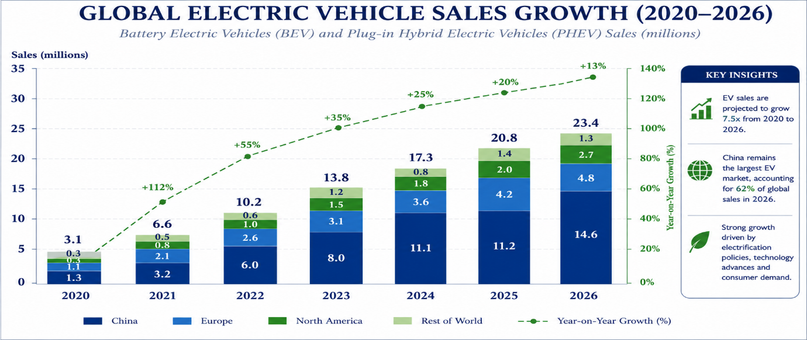
Figure 1: Global Electric Vehicle Sales Growth (2020–2026)
Source: Author's own figure, adapted from International Energy Agency (2026), Global EV Outlook 2026.
Figure 1 illustrates continued growth in the global electric vehicle market, reinforcing the strategic importance of electrification and digital innovation within the automotive sector (International Energy Agency, 2026).

The report analyses the strategic drivers influencing JLR's operating environment, evaluates the Reimagine Strategy and supporting change management models, and presents a Strategic Change Management Plan.

2.0 Strategic Drivers of Organisational Change

Jaguar Land Rover (JLR) operates within a rapidly evolving automotive industry characterised by technological innovation, environmental regulation and changing customer expectations. These drivers are reshaping competition and requiring manufacturers to adapt their business models and organisational capabilities. Figure 2 summarises the principal strategic drivers influencing JLR's Reimagine Strategy. This chapter applies PESTLE, Porter's Five Forces and SWOT analyses to evaluate JLR's external and internal environment before identifying the principal triggers for organisational change.
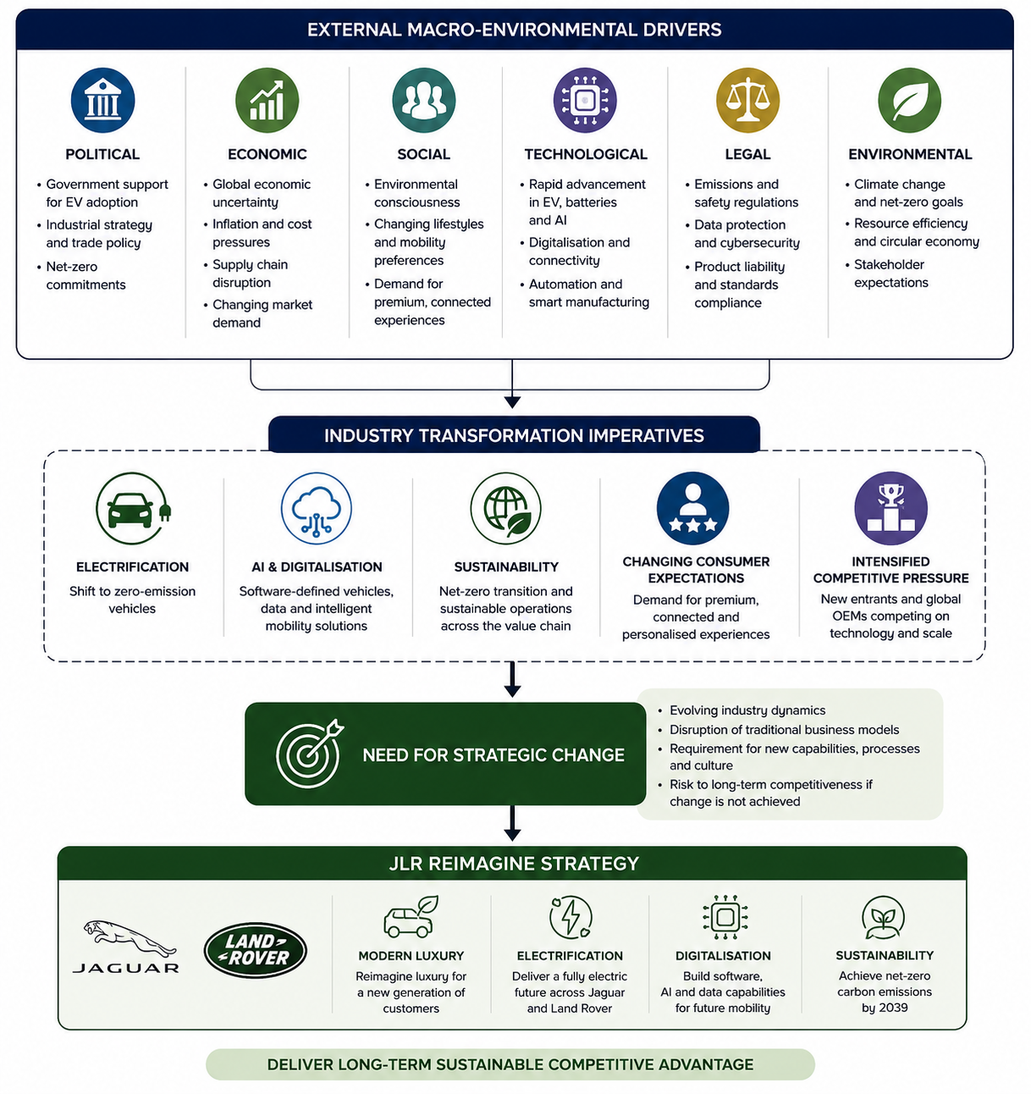
Figure 2: Strategic Drivers Influencing Jaguar Land Rover's Reimagine Strategy
Source: Author's own illustration, informed by Johnson et al. (2023), Porter (2008), Department for Transport (2025), Deloitte (2025) and Jaguar Land Rover (2021).

2.1 PESTLE Analysis

Table 1: PESTLE Analysis of Jaguar Land Rover (JLR)
Factor | Key Strategic Issues | Implications for JLR
Political | Net-zero policies and government support for zero-emission vehicles | Accelerates investment in electrification.
Economic | Inflation, supply chain disruption and global market uncertainty | Requires operational resilience and cost management.
Social | Demand for sustainable, connected and personalised mobility | Increases demand for premium electric vehicles.
Technological | AI, connectivity, software-defined vehicles and automation | Drives digital transformation and capability development.
Legal | Emissions regulation, safety standards and data protection | Requires ongoing compliance and investment.
Environmental | Carbon reduction targets and sustainability expectations | Supports JLR's net-zero strategy and sustainable manufacturing.

Source: Author's own analysis based on Johnson et al. (2023), Department for Transport (2025), Deloitte (2025) and Jaguar Land Rover (n.d.).
Political and environmental policies continue to accelerate the transition towards zero-emission mobility, whilst economic uncertainty and supply chain disruption require greater operational resilience. Technological advances in artificial intelligence (AI), connectivity and software-defined vehicles remain the principal driver of transformation by reshaping product development, manufacturing and customer experience (Verhoef et al., 2021). Collectively, these factors indicate that JLR's transformation reflects long-term structural change rather than short-term market fluctuations.

2.2 Industry Analysis: Porter's Five Forces

Porter's Five Forces framework indicates that Jaguar Land Rover (JLR) operates within an increasingly competitive premium automotive market, where sustaining competitive advantage depends on continuous innovation rather than brand heritage alone (Porter, 2008).
Table 2: Porter's Five Forces Analysis of Jaguar Land Rover (JLR)
Competitive Force | Impact on JLR
Competitive rivalry | High competition from premium manufacturers, including BMW, Mercedes-Benz, Audi, Tesla and emerging Chinese electric vehicle manufacturers such as BYD.
Threat of new entrants | Moderate. Significant capital investment creates barriers to entry; however, advances in digital technologies have enabled new competitors to enter the electric vehicle market.
Buyer power | High. Customers have greater access to information and increasing expectations regarding technology, sustainability and product quality.
Supplier power | Moderate to high due to dependence on semiconductor manufacturers, battery suppliers and specialist technology providers.
Threat of substitutes | Moderate, with changing mobility preferences, public transport, mobility-as-a-service and shared transport offering alternative transport solutions.

Source: Author's own analysis based on Porter (2008), Johnson et al. (2023) and Deloitte (2025).
Competitive rivalry is the dominant competitive force because established manufacturers and emerging electric vehicle producers continue investing heavily in electrification and digital technologies. As technological capabilities converge, competitive advantage increasingly depends on innovation, customer experience and premium brand positioning rather than traditional manufacturing strengths (Johnson et al., 2023).

Buyer and supplier power continue to intensify competitive pressures by increasing customer expectations and supply chain risk, reinforcing the need for resilient supplier relationships and continuous innovation (Deloitte, 2025).

Overall, Porter's Five Forces highlights an increasingly competitive environment in which technological disruption and evolving customer expectations reinforce the strategic necessity of continuous innovation and the Reimagine Strategy.

2.3 Internal Analysis: SWOT Analysis

The SWOT analysis indicates that JLR's strengths support the Reimagine Strategy, although continued investment in organisational capability and operational resilience remains essential (Jaguar Land Rover, 2025; Deloitte, 2025).
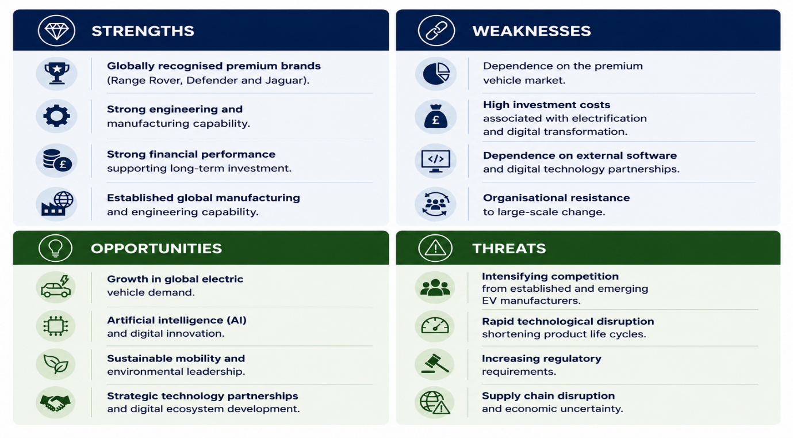
Figure 3: SWOT Analysis of Jaguar Land Rover (JLR)
Source: Author's own analysis based on Johnson et al. (2023), Jaguar Land Rover (2025) and Deloitte (2025).
Despite these strengths, JLR faces significant challenges, including high investment requirements, competitive pressure and dependence on global supply chains. Addressing these challenges will require continued investment in organisational capability, operational flexibility and technological innovation (Jaguar Land Rover, 2025; Deloitte, 2025).

2.4 Triggers for Organisational Change

The environmental and organisational analyses demonstrate that JLR's transformation is driven by several interconnected triggers for change. Technological disruption is the most significant, as advances in artificial intelligence (AI), software-defined vehicles and connected technologies are reshaping vehicle development, manufacturing and customer expectations (Verhoef et al., 2021). At the same time, increasingly stringent environmental regulation and growing demand for sustainable mobility have accelerated investment in electrification and reinforced the strategic importance of the Reimagine Strategy (Department for Transport, 2025; Jaguar Land Rover, 2021).
Competitive pressure further intensifies the need for change as established manufacturers and emerging electric vehicle producers continue investing heavily in digital technologies and battery electric vehicles (Porter, 2008). Collectively, these technological, regulatory and competitive pressures justify organisational transformation and reinforce the rationale for JLR's Reimagine Strategy.

2.5 Chapter Summary

The strategic analysis establishes the need for organisational change and provides the context for evaluating JLR's Reimagine Strategy in Chapter 3.

3.0 Critical Evaluation of the Reimagine Strategy

Jaguar Land Rover's (JLR) Reimagine Strategy represents a long-term response to the structural changes reshaping the premium automotive industry. Introduced in 2021, the strategy aims to reposition JLR as a sustainable modern luxury manufacturer through electrification, digital innovation and environmental sustainability (Jaguar Land Rover, 2021). This chapter critically evaluates whether the strategy effectively addresses the external and internal challenges identified in Chapter 2, while recognising the opportunities and limitations that may influence its successful delivery.

3.1 Strategic Objectives of the Reimagine Strategy
Jaguar Land Rover's (JLR) Reimagine Strategy aims to reposition the organisation as a sustainable modern luxury manufacturer by integrating electrification, digital innovation and environmental sustainability into its long-term strategy (Jaguar Land Rover, 2021). Its principal priorities include expanding the battery electric vehicle (BEV) portfolio, developing software-defined and connected vehicle technologies, strengthening manufacturing capability and achieving net-zero carbon emissions by 2039 (Jaguar Land Rover, n.d.). These objectives align with changing customer expectations, technological innovation and increasingly stringent environmental regulation. They also reflect SMART principles by establishing specific strategic priorities supported by measurable outcomes, achievable implementation phases, alignment with JLR's long-term vision and defined timescales.
Table 4: Strategic Objectives of the Reimagine Strategy
Strategic Objective | Purpose | Expected Outcome
Electrification | Expand the battery electric vehicle portfolio | Enhanced competitiveness within the premium electric vehicle market
Digital transformation | Develop software-defined and connected vehicle technologies | Improved customer experience and digital capability
Sustainability | Achieve net-zero carbon emissions by 2039 | Greater environmental sustainability and regulatory compliance
Modern luxury | Strengthen premium brand positioning | Increased market differentiation and long-term competitive advantage

Source: Author's own table, adapted from Jaguar Land Rover (2021; 2025).
The objectives align with the external drivers identified in Chapter 2. However, successful delivery depends on effective implementation, workforce capability and sustained investment as competitors pursue similar priorities (Johnson et al., 2023; Verhoef et al., 2021).

3.2 Critical Evaluation of the Reimagine Strategy

The Reimagine Strategy responds effectively to the strategic drivers identified in Chapter 2 by prioritising electrification, digital capability and sustainability. Investment in battery electric vehicles and software-defined technologies positions JLR to meet evolving customer expectations and regulatory requirements (Jaguar Land Rover, 2021). However, its success depends on effective execution, organisational adaptability and continuous innovation rather than strategic intent alone. As competitors pursue similar priorities, sustainable competitive advantage will increasingly depend on integrating technological innovation with operational excellence and customer value (Verhoef et al., 2021). Overall, the strategy provides a coherent framework for future growth, although its long-term success will ultimately be determined by implementation and measurable business performance.

3.3 Implementation Challenges
Successful implementation of the Reimagine Strategy requires JLR to address organisational and operational challenges. Investment in electrification, digital infrastructure and workforce capability places considerable pressure on financial resources, while dependence on advanced technologies and global supply chains increases operational complexity (Jaguar Land Rover, 2025).
Organisational readiness is equally critical. Employees must develop new technical capabilities and adapt to revised ways of working through effective leadership, workforce development and clear communication to minimise resistance (Hayes, 2022). JLR must also remain agile by continuously reviewing organisational capabilities in response to evolving market conditions.
Collectively, these challenges demonstrate that strategic success depends not only on the quality of the Reimagine Strategy but also on JLR's ability to translate strategic ambition into effective organisational delivery. Addressing these challenges requires an appropriate change management approach capable of supporting organisational adaptation, employee engagement and sustained behavioural change. The following chapter therefore evaluates alternative change management models to identify the most appropriate framework for implementing the Reimagine Strategy.

3.4 Chapter Summary

The evaluation demonstrates that successful delivery of the Reimagine Strategy depends on an appropriate change management framework, which is evaluated in Chapter 4.

4.0 Evaluation and Selection of Change Management Models

Successful organisational transformation depends not only on a clear strategic direction but also on an appropriate change management approach. As discussed in Chapter 3, implementing JLR's Reimagine Strategy requires organisational readiness, employee engagement and the integration of new ways of working alongside technological investment. This chapter critically evaluates Lewin's Three-Step Model, Kotter's Eight-Step Model and the ADKAR Model to identify the most appropriate framework for supporting JLR's transformation.

4.1 Evaluation of Lewin's Three-Step Model

Lewin's Three-Step Model provides a structured framework for managing organisational change through the sequential stages of Unfreeze, Change and Refreeze (Lewin, 1947). Its emphasis on preparing employees for change, supporting behavioural adaptation and reinforcing new organisational practices makes it particularly relevant to JLR's transition towards electrification and digital transformation (Burnes, 2020).
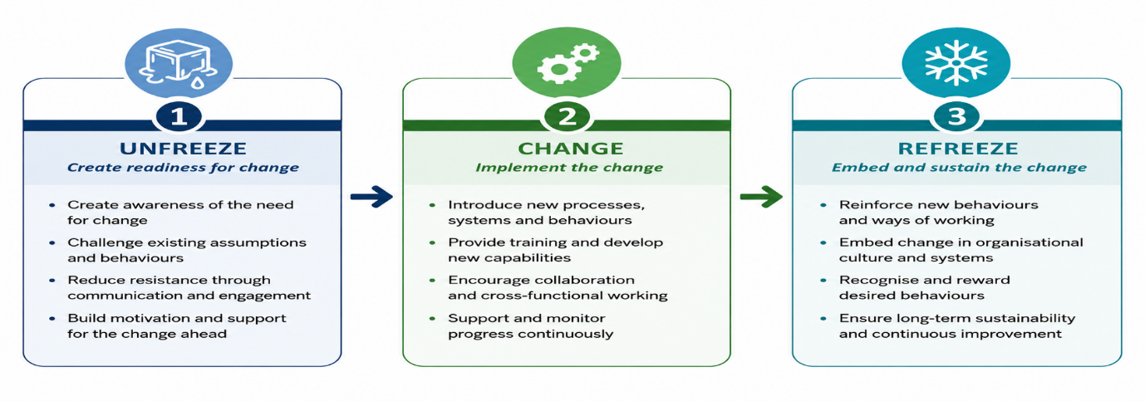
Figure 4. Application of Lewin's Three-Step Model to the Reimagine Strategy
Source: Adapted from Lewin (1947), Burnes (2020) and Hayes (2022).
A key strength of Lewin's model is its emphasis on organisational readiness and reinforcing new behaviours after implementation, aligning with JLR's need to develop workforce capability alongside technological investment. However, it has been criticised for presenting change as a linear process despite organisations operating in environments requiring continuous adaptation (Hayes, 2022). Nevertheless, when applied iteratively, the framework remains a practical and flexible approach to embedding strategic change.

4.2 Comparison with Kotter's Eight-Step Model and the ADKAR Model

Whilst Lewin's Three-Step Model provides the principal framework for this report, Kotter's Eight-Step Model and the ADKAR Model offer valuable perspectives on organisational change. Kotter (1996) emphasises leadership, vision and sustaining momentum through a structured eight-stage process. Its focus on urgency and organisational commitment makes it well suited to large-scale transformational change. However, the model can be resource-intensive and less flexible, particularly where organisations must respond quickly to evolving market conditions.
The ADKAR Model adopts a different perspective by focusing on individual behavioural change through five sequential stages: Awareness, Desire, Knowledge, Ability and Reinforcement (Hiatt, 2006). Its strength lies in supporting employee engagement and addressing individual barriers to change, particularly where workforce adoption is critical. However, because the model concentrates primarily on individual change, it provides less strategic guidance for managing organisation-wide transformation.

Both models offer valuable insights that complement JLR's transformation. Kotter emphasises leadership and strategic vision, whilst ADKAR reinforces employee engagement and capability development. However, neither balances organisational readiness, behavioural change and long-term reinforcement as effectively as Lewin's Three-Step Model, which aligns more closely with the objectives of the Reimagine Strategy.

4.3 Justification for Selecting Lewin's Three-Step Model

Based on the comparative evaluation, Lewin's Three-Step Model provides the most appropriate framework for implementing JLR's Reimagine Strategy. Unlike Kotter's Eight-Step Model, which places greater emphasis on leadership and sequential implementation, Lewin offers a more adaptable framework centred on organisational readiness, behavioural change and reinforcing new working practices (Burnes, 2020). This aligns closely with JLR's need to integrate technological innovation with workforce capability and organisational adaptation.
Although the ADKAR Model strengthens employee engagement by addressing individual behavioural change, it provides less strategic guidance for managing organisation-wide transformation (Hiatt, 2006). In contrast, Lewin's model balances organisational and behavioural perspectives, enabling JLR to prepare employees for change, implement new technologies and embed revised practices within everyday operations.
Consequently, Lewin's Three-Step Model provides the strongest foundation for implementing the Reimagine Strategy by aligning strategic objectives with practical organisational change. Its emphasis on preparation, implementation and reinforcement supports sustainable transformation across the organisation.

4.4 Chapter Summary

The evaluation identifies Lewin's Three-Step Model as the most appropriate framework for implementing JLR's Reimagine Strategy (Burnes, 2020; Hayes, 2022).

5.0 Leadership, Organisational Culture and Stakeholder Engagement

Successful organisational change depends on leadership, organisational culture and stakeholder engagement alongside an appropriate change management model. This chapter evaluates their contribution to implementing JLR's Reimagine Strategy (Hayes, 2022; Schein and Schein, 2021).

5.1 Leadership Styles and Their Impact on Organisational Change

Effective leadership is fundamental to organisational transformation because it influences employee commitment, organisational readiness and the adoption of change (Northouse, 2022). The effectiveness of different leadership styles depends on the strategic context.
Transformational leadership is particularly suited to JLR's Reimagine Strategy because it promotes innovation, communicates a shared vision and motivates employees to embrace change. As JLR transitions towards electrification and digital transformation, leaders must foster collaboration, continuous learning and adaptability to support new technologies and ways of working (Bass and Riggio, 2006).
In contrast, transactional leadership focuses on performance management, clearly defined responsibilities and reward systems. Whilst this approach strengthens operational control and accountability, it is less effective in promoting innovation because it prioritises maintaining performance over organisational transformation (Northouse, 2022).
Situational leadership recognises that leadership approaches should vary according to employee capability and organisational circumstances. During large-scale transformation, leaders may need to adopt more directive or supportive behaviours depending on workforce readiness, making this approach particularly valuable during different stages of implementation (Hersey, Blanchard and Johnson, 2013).

Overall, transformational leadership provides the strongest strategic fit for JLR, particularly when complemented by situational flexibility and transactional controls (Bass and Riggio, 2006; Northouse, 2022).

5.2 Organisational Culture and Its Impact on Organisational Change

Organisational culture influences how employees perceive, accept and sustain change. A culture that promotes innovation, collaboration and continuous learning strengthens organisational adaptability and supports strategic transformation (Schein and Schein, 2021; Burnes, 2020).

Several models provide different perspectives on organisational culture. Schein's model explains culture through three interconnected levels: artefacts, espoused values and underlying assumptions. This framework is particularly valuable because sustainable organisational change requires behavioural, cultural and value-based alignment with organisational strategy (Schein and Schein, 2021; Burnes, 2020).

In contrast, Hofstede's cultural dimensions focus primarily on national culture and how cultural differences influence organisational behaviour across countries (Hofstede, Hofstede and Minkov, 2010). Whilst valuable for multinational organisations such as JLR, the model provides less guidance for managing internal organisational transformation.

Similarly, Handy's cultural typology categorises organisations according to power, role, task and person cultures, offering useful insights into organisational structure and decision-making (Handy, 1993). However, it provides less insight into how culture evolves during large-scale organisational change.

Overall, Schein's model provides the strongest framework for JLR by aligning organisational values, behaviours and underlying assumptions with strategic objectives, thereby strengthening employee engagement and supporting the long-term sustainability of the Reimagine Strategy (Schein and Schein, 2021; Burnes, 2020).

5.3 Stakeholder Engagement and Its Impact on Organisational Change

Stakeholder engagement is critical to successful organisational change because it builds trust, reduces resistance and encourages shared ownership of strategic initiatives. Large-scale transformation affects employees, suppliers, customers, investors and regulators, all of whom influence organisational performance and the successful implementation of change (Hayes, 2022).

For JLR, stakeholder engagement supports collaboration across the organisation and supply chain. Early consultation improves decision-making, strengthens commitment to strategic objectives and promotes organisational learning through continuous feedback (Hayes, 2022).

Although stakeholder engagement cannot eliminate all resistance, it improves transparency, strengthens relationships and increases the likelihood of successful implementation. Consequently, it should be regarded as a strategic capability supporting JLR's long-term transformation (Hayes, 2022).

5.4 Chapter Summary

Leadership, organisational culture and stakeholder engagement provide the people-centred foundation for implementing JLR's Reimagine Strategy and the Strategic Change Management Plan presented in Chapter 6 (Hayes, 2022; Schein and Schein, 2021).

6.0 Strategic Change Management Plan

Building on the analysis presented in Chapters 2–5, this chapter presents a Strategic Change Management Plan for implementing JLR's Reimagine Strategy through stakeholder engagement, implementation, communication, performance measurement and risk management.

6.1 Stakeholder Analysis

Stakeholder analysis enables JLR to identify the interests and influence of key stakeholders, prioritise engagement, allocate resources effectively and reduce resistance throughout implementation (Hayes, 2022).
Table 5: Stakeholder Analysis for the Reimagine Strategy
Stakeholder | Interest in Change | Level of Influence | Engagement Strategy
Employees | Job security, skills development and career opportunities | High | Continuous consultation, training and involvement in decision-making
Senior Leadership Team | Strategic performance and successful implementation | High | Regular progress reviews and strategic oversight
Suppliers | Supply chain continuity and long-term partnerships | Medium–High | Collaborative planning and regular communication
Customers | Sustainable, innovative and high-quality products | Medium | Product updates, marketing communications and customer feedback
Investors | Financial performance and long-term business growth | High | Performance reporting and investor briefings
Regulators | Compliance with environmental and safety legislation | High | Ongoing compliance monitoring and regulatory reporting

Source: Author's own table, informed by Hayes (2022), Johnson et al. (2023) and Lock (2003).

The analysis highlights the importance of tailoring engagement according to stakeholder influence to strengthen organisational support during implementation.

6.2 Implementation Framework

The implementation framework applies Lewin's Three-Step Model to guide delivery of the Reimagine Strategy. Combined with project management principles, it supports organisational readiness, coordination, accountability and performance monitoring throughout implementation (Burnes, 2020; Lock, 2003).
Table 6: Implementation Framework Based on Lewin's Three-Step Model
Lewin's Stage | Key Implementation Activities | Expected Outcome
Unfreeze | Communicate the strategic vision, engage stakeholders, identify capability gaps and deliver employee training. | Organisational readiness and reduced resistance to change.
Change | Implement electrification initiatives, digital technologies, revised operational processes and workforce development programmes. | Successful adoption of new ways of working and strategic initiatives.
Refreeze | Reinforce change through performance management, continuous learning, recognition and regular performance reviews. | Sustainable organisational change embedded within everyday operations.

Source: Author's own table, adapted from Lewin (1947), Burnes (2020), Hayes (2022) and Lock (2003).

Together, Lewin's framework and project management principles provide a structured approach to implementing and sustaining organisational change.

6.3 Communication Plan

Effective communication reduces uncertainty, strengthens stakeholder confidence and maintains engagement throughout implementation (Hayes, 2022).
Table 7: Communication Plan for the Reimagine Strategy
Stakeholder | Communication Objective | Method | Frequency | Responsibility
Employees | Communicate the purpose of the Reimagine Strategy and organisational changes | Town hall meetings, team briefings and intranet updates | Monthly | Senior Leadership Team
Line Managers | Provide implementation updates and coordinate departmental activities | Management meetings and progress reports | Fortnightly | Project Manager
Suppliers | Communicate operational requirements and implementation timelines | Supplier meetings and email updates | Monthly | Procurement Manager
Customers | Promote sustainability initiatives and new product developments | Website, social media and marketing campaigns | Quarterly | Marketing Department
Investors | Report implementation progress and organisational performance | Investor briefings and annual reports | Quarterly | Executive Leadership Team

Source: Author's own table, informed by Hayes (2022) and Lock (2003).

The communication plan promotes transparency, stakeholder engagement and effective implementation through clearly defined communication responsibilities.

6.4 Financial and Resource Plan

The successful implementation of the Reimagine Strategy requires adequate financial investment and the effective allocation of organisational resources. Beyond technological investment, JLR must ensure that sufficient resources are available to support workforce development, project management and stakeholder engagement throughout the transformation process. Aligning financial and human resources with strategic priorities strengthens implementation capability and supports the long-term sustainability of organisational change (Lock, 2003; Hayes, 2022).
Table 8: Financial and Resource Plan
Resource Area | Investment Priority | Purpose
Workforce training | Technical skills development | Equip employees with the capabilities required for electrification, AI and digital technologies.
Digital infrastructure | Software, AI and connected vehicle technologies | Support innovation, operational efficiency and digital transformation.
Project management | Implementation teams and project coordination | Ensure effective planning, monitoring and delivery of change initiatives.
Communication and engagement | Employee and stakeholder communication activities | Maintain stakeholder commitment and reduce resistance throughout implementation.
Performance monitoring | KPI systems and performance reviews | Evaluate implementation progress and support continuous organisational improvement.

Source: Author's own table, adapted from Lock (2003), Hayes (2022) and Jaguar Land Rover (2021).
Effective resource allocation enables JLR to coordinate organisational, financial and technological investments in support of the Reimagine Strategy. Regular reviews of resource utilisation will help ensure that implementation remains aligned with strategic priorities, enabling the organisation to respond effectively to emerging challenges while maintaining operational performance.

6.5 Risk Management and Mitigation Plan

Effective risk management is essential to minimise disruption and support the successful implementation of JLR's Reimagine Strategy. Identifying risks and implementing mitigation strategies enables the organisation to maintain implementation progress, strengthen resilience and respond proactively to emerging challenges (Lock, 2003; Hayes, 2022).
Table 9: Risk Management and Mitigation Plan
Risk | Potential Impact | Mitigation Strategy | Responsibility
Employee resistance to change | Delays in implementation and reduced employee engagement | Deliver leadership support, employee training and continuous communication | Senior Leadership Team
Supply chain disruption | Production delays and increased operational costs | Diversify suppliers and strengthen supplier relationships | Procurement Manager
Skills shortages | Reduced capability to support electrification and digital technologies | Invest in workforce development and targeted technical training | Human Resources
Technology implementation delays | Slower deployment of digital systems and operational disruption | Phase implementation, monitor milestones and allocate contingency resources | Project Manager
Regulatory changes | Increased compliance requirements and implementation delays | Monitor legislative developments and conduct regular compliance reviews | Compliance Manager

Source: Author's own table, adapted from Lock (2003), Hayes (2022) and Jaguar Land Rover (2025).
Regular monitoring and review of implementation risks enable JLR to respond proactively to changing organisational and external conditions. Clearly defined responsibilities and mitigation strategies strengthen accountability, minimise disruption and support the successful delivery of the Reimagine Strategy.

6.6 Performance Evaluation and Key Performance Indicators (KPIs)

Monitoring organisational performance is essential to evaluate the successful implementation of the Reimagine Strategy. Establishing clear Key Performance Indicators (KPIs) enables JLR to measure progress against strategic objectives, strengthen accountability and identify areas requiring corrective action throughout the implementation process (Lock, 2003; Hayes, 2022).

Table 10: Performance Evaluation Framework
Strategic Objective | Key Performance Indicator (KPI) | Target | Review Frequency
Expand battery electric vehicle (BEV) portfolio | Percentage of BEV sales | Increase annually in line with the Reimagine Strategy | Quarterly
Strengthen digital transformation | Percentage of new vehicles using software-defined technology | Full implementation across new platforms by 2028 | Quarterly
Develop workforce capability | Percentage of employees completing technical training | 100% of targeted employees within 24 months | Six-monthly
Improve sustainability performance | Reduction in operational carbon emissions | Achieve net-zero operational emissions by 2039 | Annually
Enhance customer satisfaction | Customer satisfaction index and brand perception | Year-on-year improvement | Quarterly

Source: Author's own table, adapted from Jaguar Land Rover (2021; 2025), Lock (2003) and Hayes (2022).
Regular performance reviews enable JLR to assess implementation progress, evaluate organisational performance and respond promptly to emerging issues. Measurable KPIs support evidence-based decision-making and help ensure that the Reimagine Strategy remains aligned with its strategic objectives throughout implementation.

6.7 Chapter Summary

The Strategic Change Management Plan provides a practical framework for implementing and sustaining JLR's Reimagine Strategy (Burnes, 2020; Hayes, 2022).

7.0 Discussion and Critical Reflection

The proposed Strategic Change Management Plan provides a structured framework for implementing Jaguar Land Rover's (JLR) Reimagine Strategy by integrating stakeholder analysis, Lewin's Three-Step Model, communication planning, performance evaluation and risk management (Burnes, 2020; Hayes, 2022). Integrating strategic planning with behavioural change principles strengthens organisational readiness and supports effective implementation.

A key strength of the plan is its alignment of strategic objectives with implementation, recognising that successful transformation depends on leadership, employee engagement, organisational culture and technological innovation (Schein and Schein, 2021). However, the analysis relies on publicly available information and cannot account for confidential organisational data or internal operational challenges. Although Lewin's Three-Step Model provides a practical framework, organisations operating in rapidly evolving industries may require more iterative and adaptive approaches alongside traditional models (Burnes, 2020).

Overall, the proposed plan provides a practical foundation for supporting JLR's transformation. This evaluation highlights that successful strategic change depends not only on selecting an appropriate change management framework but also on leaders' ability to adapt its application to changing organisational and external conditions. Its long-term success will depend on effective implementation, continuous performance monitoring and the organisation's capacity to adapt strategically to changing market conditions while sustaining stakeholder commitment and organisational learning.

8.0 Conclusion

This report critically evaluated the strategic drivers influencing organisational change at Jaguar Land Rover (JLR) and assessed the effectiveness of the Reimagine Strategy in responding to the transformation of the premium automotive industry. The analysis demonstrated that electrification, digital transformation, sustainability and increasing competitive pressure are the principal drivers requiring JLR to develop new organisational capabilities alongside technological innovation.
The evaluation concluded that the Reimagine Strategy provides a well-aligned response to these strategic challenges, but that its success depends on successful implementation rather than strategic intent alone. Following a comparative evaluation of established change management models, Lewin's Three-Step Model was identified as the most appropriate framework for supporting JLR's transformation because of its emphasis on organisational readiness, behavioural change and the reinforcement of new working practices (Burnes, 2020; Hayes, 2022). The proposed Strategic Change Management Plan demonstrates how stakeholder engagement, communication, resource allocation, performance evaluation and risk management can support successful implementation.
Overall, JLR has a clear strategic direction for future growth. However, achieving sustainable competitive advantage will depend on the organisation's ability to implement change effectively, develop organisational capability and adapt to future technological and market developments while maintaining stakeholder commitment and continuous organisational learning (Hayes, 2022).

References

Bass, B.M. and Riggio, R.E. (2006) Transformational leadership. 2nd edn. Mahwah, NJ: Lawrence Erlbaum Associates.
Burnes, B. (2020) Managing change. 8th edn. Harlow: Pearson.
Deloitte (2025) 2025 Global Automotive Consumer Study. London: Deloitte. Available at: https://www.deloitte.com (Accessed: 26 June 2026).
Department for Transport (2025) The transition to zero emission vehicles: Progress report. London: Department for Transport.
Handy, C. (1993) Understanding organizations. 4th edn. London: Penguin Books.
Hayes, J. (2022) The theory and practice of change management. 6th edn. London: Bloomsbury Publishing.
Hersey, P., Blanchard, K.H. and Johnson, D.E. (2013) Management of organizational behavior: Leading human resources. 10th edn. Harlow: Pearson.
Hiatt, J. (2006) ADKAR: A model for change in business, government and our community. Loveland, CO: Prosci Learning Centre Publications.
Hofstede, G., Hofstede, G.J. and Minkov, M. (2010) Cultures and organizations: Software of the mind. 3rd edn. New York: McGraw-Hill.
International Energy Agency (2026) Global EV Outlook 2026. Paris: International Energy Agency. Available at: https://www.iea.org/reports/global-ev-outlook-2026 (Accessed: 26 June 2026).
Jaguar Land Rover (2021) Reimagine: A strategy for modern luxury. Available at: https://media.jaguarlandrover.com/news/2021/02/reimagine-strategy-modern-luxury (Accessed: 26 June 2026).
Jaguar Land Rover (2025) Annual report 2024/25. Coventry: Jaguar Land Rover. Available at: https://www.jaguarlandrover.com/investors (Accessed: 26 June 2026).
Jaguar Land Rover (n.d.) Sustainability. Available at: https://www.jaguarlandrover.com/sustainability (Accessed: 26 June 2026).
Johnson, G., Scholes, K., Whittington, R. and Angwin, D. (2023) Exploring strategy: Text and cases. 13th edn. Harlow: Pearson.
Kotter, J.P. (1996) Leading change. Boston, MA: Harvard Business School Press.
Lewin, K. (1947) 'Frontiers in group dynamics', Human Relations, 1(1), pp. 5–41.
Lock, D. (2003) Project management. 8th edn. Aldershot: Gower Publishing.
Northouse, P.G. (2022) Leadership: Theory and practice. 9th edn. Thousand Oaks, CA: Sage.
Porter, M.E. (2008) 'The five competitive forces that shape strategy', Harvard Business Review, 86(1), pp. 78–93.
Schein, E.H. and Schein, P.A. (2021) Organizational culture and leadership. 6th edn. Hoboken, NJ: John Wiley & Sons.
Verhoef, P.C., Broekhuizen, T., Bart, Y., Bhattacharya, A., Dong, J.Q., Fabian, N. and Haenlein, M. (2021) 'Digital transformation: A multidisciplinary reflection and research agenda', Journal of Business Research, 122, pp. 889–901.

