

LCBB4004 Marketing Fundamentals

Assignment: 1

Student Name: Bogdan Hodor
Student ID: 1917709
Contents
Blog 1: Dieselgate Scandal: A Complete Transformation of Automobile Industry 3
Blog 2: B57S- Best Ever Engine Made by BMW 5
Blog 3: BMW is expensive but worthy of it 7
Blog 4: Decentralized Production and Extensive Distribution Added Convenience to Enjoy Ultimate Driving Experience 9
Blog 5: Shifting Focus on Social Media Marketing: Connect the Millennials 11
Blog 6: Virtual Reality: The Simulated Real-life Experience 13
References: 15

Blog 1: Dieselgate Scandal: A Complete Transformation of Automobile Industry

The German leading automobile brand, Volkswagen was accused of fabricating the carbon emission testing result of its vehicles in 2015 that is renowned as the Dieselgate scandal, the total automobile industry of the country was under the pressure of such an accusation and the governments in the EU countries were enforcing on the automobile industry to reduce the carbon emission shifting to an electric car or hybrid car (Blackwelder, et al. 2019). The following section is going to communicate the effort of BMW on this issue.
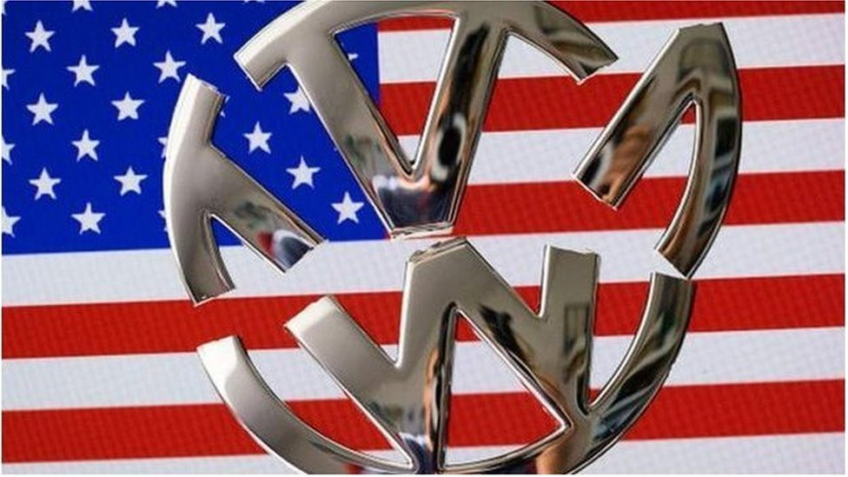
According to Siano, et al. (2017), in 2015, Volkswagen was accused of cheating violating the Clean Air Act of America by providing the fabricated result of carbon emission test with the defeat device. A defeat device is a software that is set in the engine helping it to detect when the car is testing its emission rate, it improves its performance then and later on, it emits more than the accepted amount of carbon in the air. Environmental Protection Agency of America has discovered that over 11 million cars of Volkswagen are fitted with this cheating device resulted in a huge shame with a drastic impact on the German automobile industry.
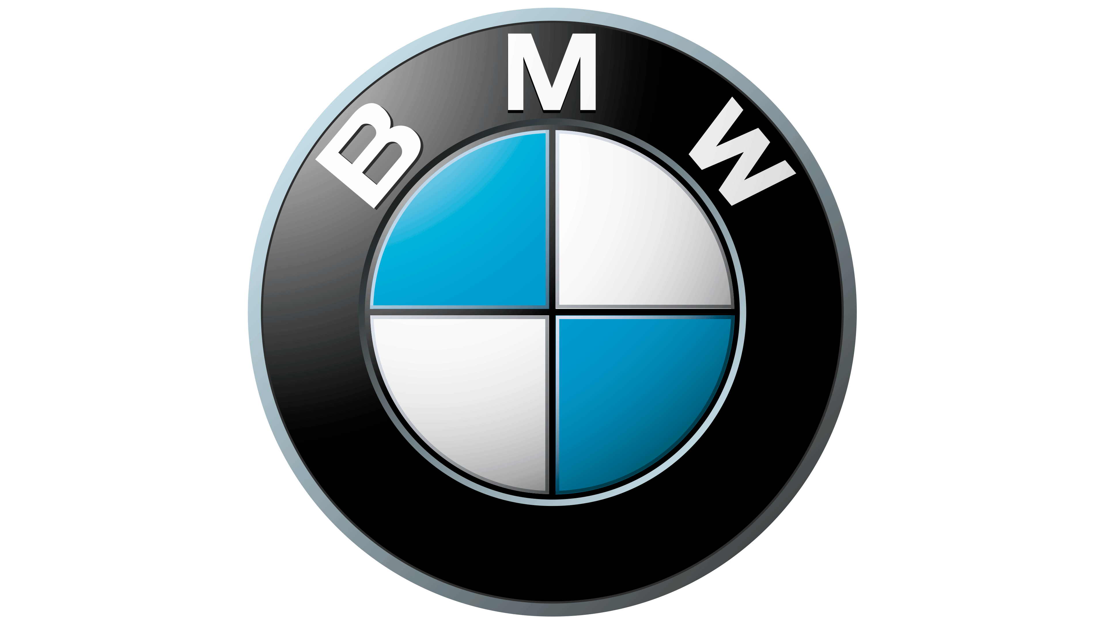
BMW is one of the leading automobile brands of the world as a German giant since 1916 producing luxury vehicles. The band has been recognized as the third most valuable automobile brand in the world in 2019. The brand has proficiency in creating a new experience with the luxury cars claiming to be the ultimate driving machine and currently, it has added the pleasure of driving in their portfolio mentioning the marvelous driving experience. The brand has also experienced the pressure generated by the scandal and it has proven that it is the only car brand that is dedicated to reducing the emission rate deliberately since 1995 and has already reduced 40% of the carbon emitted from the vehicle in the last decade as demonstrated in BMW Blog (2020). The brand has come up with the mild-hybrid cars with a constant decrement in carbon emission rate of the automobiles.

Blog 2: B57S- Best Ever Engine Made by BMW

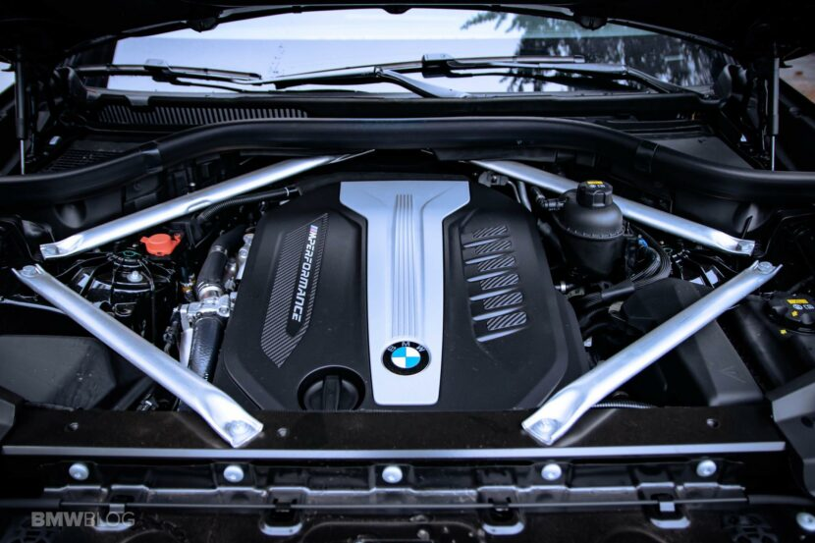
Though BMW could not completely transform its operation from diesel to electric car, it has increased its competency in carbon emission-reducing further in 2021 that is highly effective in comparison to other brands as illustrated by Eidenböck, et al. (2020). The brand has claimed that the car performs the best with diesel, the alternative fuel cannot assure the optimized performance and cost-efficiency too. Therefore, the brand has built up their final edition of engine operated by diesel named B57S and the brand is putting huge effort into cleaning the fuel with new mills preparing the tedious process of manufacturing a car. This is the last diesel-based engine of BMW and later on, it is going to invest further in hybrid and electric cars. The diesel-based car has higher performance in consideration to the electric car and BMW X7 with the M50 engine can go for 13.38 kmpl and B57 is going to be more fuel-efficient with lower emission rate.
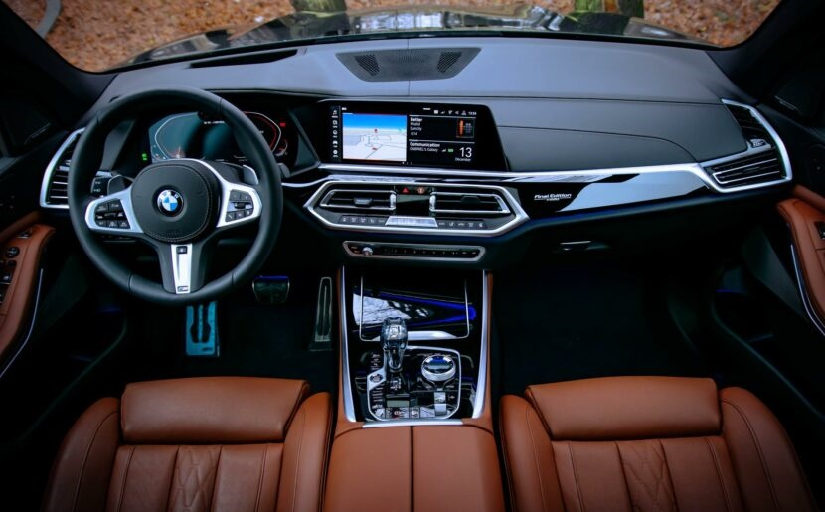
According to Steinparzer (2020), the brand is ready to launch this final edition of the diesel engine with 220 BMW X5 with a complete equipment packaging encouraging the passionate car owner with laser light, professional driving assistant, comfortable seats, clear craft in the cockpit, exquisite design, double-glazed windows, and numerous options for the add-on. The thematic colour of the car brings about an absolute prestigious look, especially in the black theme. The sportiest experience driving this car is incredible and fun enough with seamless acceleration and tones of torques. Therefore, this fourth-generation X5 has performed in the market more than its expectation, and now the brand is in a dilemma to leave the diesel-based operation as such experience cannot be assured in other alternatives.

Blog 3: BMW is expensive but worthy of it
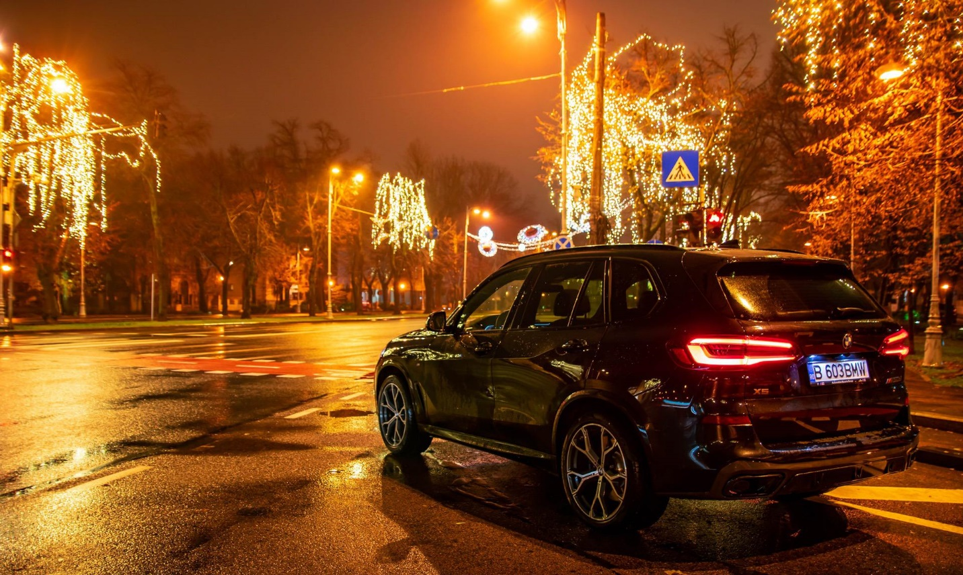
According to Johansson-Stenman and Martinsson (2020), the new edition of BMW is going to come up in the market approximately with 1,27,100 euro. The classy outlook, considerable performance, concern on the long-term relationship with the consumers, have penetrated the penny to be worthy of spending on it. The newly introduced engine can be used with BMW X5 is supposed to cannibalise the demand of BMW X5 xDrive45e as they both share the same power with a straight-six under the hood using petrol instead of diesel.
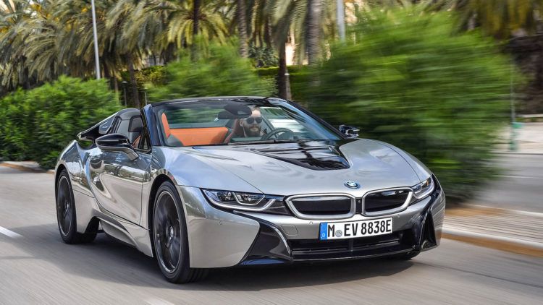
This last version of the diesel-based car is supposed to put the last stone of the brand in its competent area to create a sportier experience with the diesel engine as explained by Koehn and Eckrich (2020). The cleaner engine of diesel is not satisfactory for the environmentalists but highly demandable by the sportscar lover due to its better performance at the lower fuel. The brand has assured value for every penny with its value-based pricing strategy providing exclusive internal and external functionality and aesthetic design and combination of color. Such a posh outlook and prestigious image inclined with the product has boosted its brand value and balanced the functional and aesthetic value of the product with the specialised position in the consumer’s mind. Therefore, the money spent on buying and managing a BMW car is worthy of it and the buyer does not require to regret purchasing such an exclusive car with ultimate fun in driving it.

Blog 4: Decentralized Production and Extensive Distribution Added Convenience to Enjoy Ultimate Driving Experience
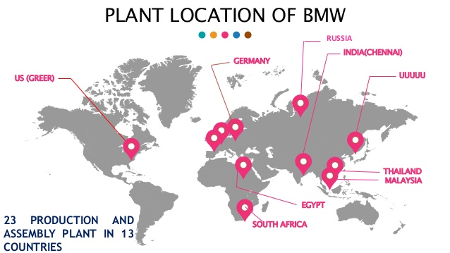
As reported by Nadarajah, et al. (2020), BMW has a vast and well-spread supply chain across the world establishing 23 manufacturing units (now 30) in 13 countries (now 13) that represents the brand in 140 countries of the world. In its home country, the brand has four manufacturing and assembling units. China is the most profitable provider of BMW assuring the highest quality of goods with the lower charge and India is following this strategy along with creating a potential market for BMW with the constant increment in the purchasing power of the upper-class population there with the theme of capitalism. The largest manufacturing unit is situated in the USA in Spartanburg controlling operations all over the country and meeting the growing demand there with ultimate perfection. The expansion of manufacturing units in South Africa, Brazil, and India are contributing to its cost-efficiency in managing exclusive cars but at a controllable cost as the cost of the production follows the investment in it.
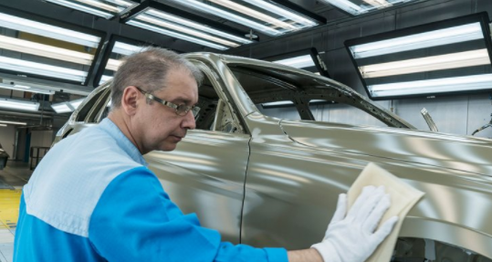
The brand has obtained fuel efficiency and the transformation from diesel to clean energy solution with the engaged participation of all its production and manufacturing unit following standardization in all four steps of the manufacturing process of BMW. The brand has assured differentiation in every product with excessive product depth with 2,000 interior and exterior variety as expressed by Tookanlou and Wong (2020). A level of automation is notable in the production process of BMW in all the production center with the direct involvement of the expert employees at every segment from top formation, manufacturing body, painting, mounting, to final assembly. Such excellence has contributed to the brand’s promise to create the ultimate driving experience.

Blog 5: Shifting Focus on Social Media Marketing: Connect the Millennials
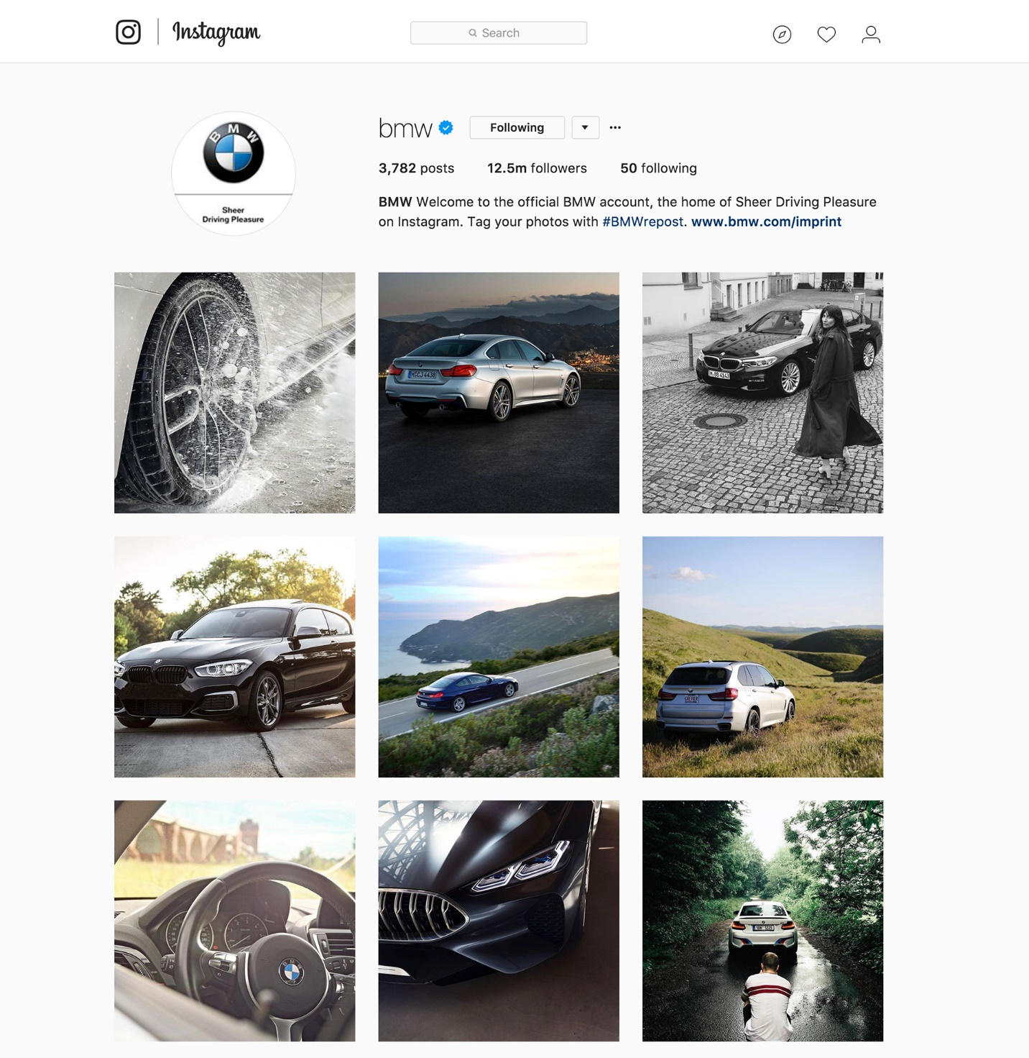
BMW is currently targeting the environmentally concerned millennials who are the potential consumers of the brand with the increasing purchasing power entering into the job market of the world and already captured 47% of the job market with higher knowledge on technology and excessive involvement in social media. According to Statista (2020) 92% of the high-income millennials are highly active in social media marketing and 87% of them have agreed that they are influenced by the social media marketing program engaging with the brand especially when it is a luxury brand. The development of the digital brand community is less expensive but highly effective as opined by 67% of the luxury brands. The Senior Vice President of BMW has expressed that there is no alternative to take part in social media to reach the millennials as they are less responsive now to the traditional media.
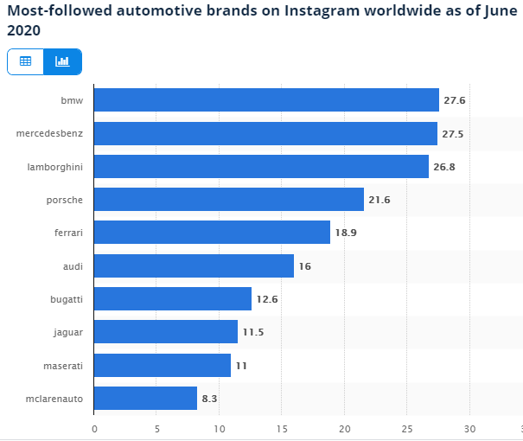
The millennials have opined that they are no more interested in knowing what features it is providing, what is the price, how to buy it, or where to buy rather they like to live with the brand with lively experience with the integration of artificial intelligence and visual experience with the social media. They like the brand to act like a human being and they get connected with the brand when they find it relevant to their life as opined by Hanna, et al. (2020). A thinner difference is notable between their virtual life and real-life. The brand has already come up with its Instagram presence obtaining 27.6 million followers and now it is the most followed automobile brand in the world. It has introduced the BMW Blog, where the consumers share their thoughts and experience freely and communicate with one another within the community.

Blog 6: Virtual Reality: The Simulated Real-life Experience

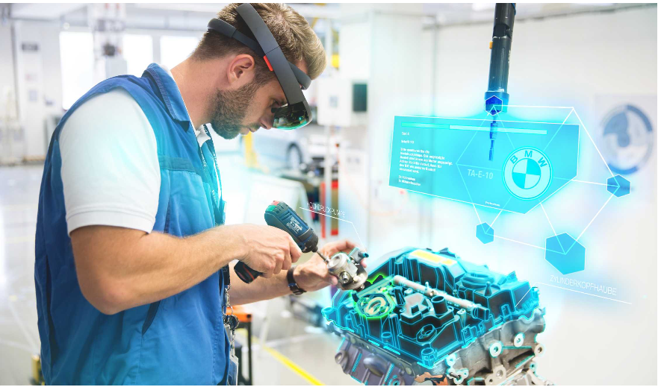
To improve the proficiency in managing the supply chain and implementing changes in operation and training and developing the employees, BMW has executed the integration of augmented reality and virtual reality creating a simulated real-world where things absolutely real. With the 3D scanner and high-resolution camera, the total workstation is captured and using the digital reconstruction facilities, the operation manager design and present the workstation planning portraying the simulated scenario of applying the new planning and comparing between the current and expected workstation efficiency as delineated by Hořejší (2020). The execution of augmented reality goggles in the training and development session of BMW for the employees is so real that the employees could learn the assembly system receiving guideline lively like real participation in assembling them. The success rate of the augmented reality training and development program is similar to the traditional manual training and development session.
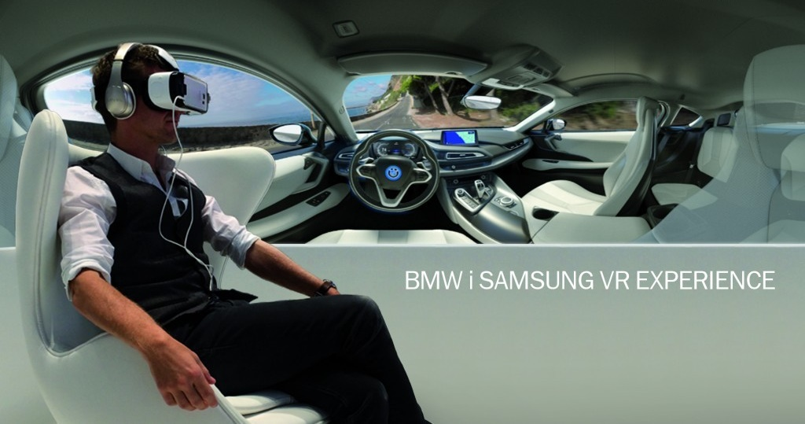
Morkos, et al. (2019) reported that BMW in alliance with Samsung has provided the customers with exclusive experience about the product with the visit to the car using simulation interior and experience of test-driving with the virtual reality. The brand has especially used the gaming technology in the new product development process providing the developer with greater flexibility in operation understanding the impact of changes in functionality and even the simulated journey in the city. Such integration of virtual reality and augmented reality should be applied in the social media to engage the potential and current consumers with the brand in developing a new sheering experience for them.

References:
Blackwelder, B., Coleman, K., Colunga-Santoyo, S., Harrison, J.S. and Wozniak, D., 2019. The Volkswagen Scandal.
BMW Blog, 2020. These Are The Top Five Best Upcoming Bmws In 2021. [online] BMW BLOG. Available at: <https://www.bmwblog.com/2020/12/23/top-five-best-bmws-in-2021/> [Accessed 26 December 2020].
Eidenböck, T., Mayr, K., Neuhauser, W. and Staub, P., 2020. The New BMW Six-Cylinder Diesel Engine with Three Turbochargers. MTZ worldwide, 73(10), pp.18-25.
Hanna, R., Rohm, A. and Crittenden, V.L., 2020. We’re all connected: The power of the social media ecosystem. Business horizons, 54(3), pp.265-273.
Hořejší, P., 2020. Augmented reality system for virtual training of parts assembly. Procedia Engineering, 100(January), pp.699-706.
Johansson-Stenman, O. and Martinsson, P., 2020. Honestly, why are you driving a BMW?. Journal of Economic Behavior & Organization, 60(2), pp.129-146.
Koehn, P. and Eckrich, M., 2020. Active steering-the BMW approach towards modern steering technology (No. 2004-01-1105). SAE technical paper.
Morkos, B., Taiber, J., Summers, J., Mears, L., Fadel, G. and Rilka, T., 2019. Mobile devices within manufacturing environments: a BMW applicability study. International Journal on Interactive Design and Manufacturing (IJIDeM), 6(2), pp.101-111.
Nadarajah, S., Cordeiro, G.M. and Ortega, E.M., 2020. General results for the beta-modified Weibull distribution. Journal of Statistical Computation and Simulation, 81(10), pp.1211-1232.
Siano, A., Vollero, A., Conte, F. and Amabile, S., 2017. “More than words”: Expanding the taxonomy of greenwashing after the Volkswagen scandal. Journal of Business Research, 71, pp.27-37.
Statista, 2020. Instagram: Most-Followed Car Brands Worldwide 2020 | Statista. [online] Statista. Available at: <https://www.statista.com/statistics/993686/most-followers-instagram-cars-motorbikes-global/> [Accessed 26 December 2020].
Steinparzer, F., 2020. The BMW six-cylinder engine with two-stage turbo charging. AutoTechnology, 7(3), pp.44-47.
Tookanlou, P.B. and Wong, H.W., 2020. Product line design with vertical and horizontal consumer heterogeneity: the effect of distribution channel structure on the optimal quality and customization levels. European Journal of Marketing.

