Improvement of an HR priority area
in the Centrica PLC

Name: Waruna Galagedara
Student No.: 2206302
Program: MBA
Module: Human Resource Management
Lecturer: James Moore
Module code: BMMB7007
Submission Deadline: 26th March 2023
Word count: 2,596 words

- Executive Summary

Well-being in the workplace refers to all aspects of working life, including the physical environmental quality and safety as well as employees' attitudes towards their jobs, their working environments, and the work culture, and work organisation. According to the CCLA survey, Centrica PLC is one of the top three businesses managing and disclosing workplace health (CCLA, 2022).
The company's HR department has designated well-being as a focus issue for 2023. The HR division's priority area is to improve, the reasons to improve that area, current shortcomings and the benefits of doing so have all been covered in this report. Physical, emotional, financial health, and psychological well-being .are parts of the employee well-being. Financial well-being is the current evolving issue for companies.
.
Personal well-being, the importance of well-being and mental health training for line managers, have been discussed as priority areas of Centrica PLC. Employees can suffer health issues due to a lack of knowledge of the importance of physical and mental health. The benefits of employees’ well-being are to improve profitability and productivity. Line managers need to identify the early signs of stress in their employees. In recommendations, the researcher has suggested two proposals; implementing a revised training program for line managers and using digital or non-digital resources to communicate well-being to staff. The company can use AI to identify the wellness of the employees.

Table of Contents

Page No.
- Executive Summary 1
- Introduction
  - Introduction of well-being at the workplace 4
  - Organisational overview 5
- What is the priority area that needs improving in Centrica PLC? 5
- Why does this need improvement; what are the current shortfalls? 6
- What impact is this deficiency having on the effectiveness
of the company? 8
- What are the benefits of improving this priority area for
a) the Centrica PLC 8
b) the employees 9
c) other stakeholders 10
- Conclusion 11
- Recommendation 12
- References 13
- Appendices 17

List of Appendices

Page No.

- Key Domain of well-being 17

- Managing Health at work for employers 18

- Musculoskeletal conditions and work 18

- New and long-standing cases of work-related
ill health by type, 2021/22 19

- Health and safety statistics 19

- Annual cost of poor mental health 20

- Introduction

2.1 Introduction of Well-being at the workplace.

A company's human capital, with its extensive knowledge base, skills, personalities, behaviours, and attitudes, truly adds value to the business (Roy, Nath, and Acharya 2022). The Management needs to keep attention on their employees’ well-being every time.

Promoting and supporting employee well-being is the major duty of company management. The purpose is to support better working lives because an effective well-being program can deliver mutual benefit to people, organisations, economies, and communities (CIPD, Nov. 2022).

Promoting well-being can be avoided stress and can create productive workplaces where people can thrive. Good health and wellness will result in higher employer engagement and organisational performance. Additionally, over the past few years, the COVID-19 pandemic has elevated employee health and wellness to the top of the corporate agenda.

Companies need to consider the following areas to maintain good well-being among their staff.

Health, Good work, Values, Social, Personal growth, Good lifestyle, and Financial well-being (CIPD, Nov. 2022).
The Chartered Institute of Personnel Development (CIPD) has identified initiatives and activities to support the well-being of the people at work (appendix 1).
In both our personal and professional lives, we have been subjected to pressures and changes that can affect one another.
Some of us may feel overburdened by our workloads.
Some are influenced by external influences or our work environment.
Occasionally, the ups and downs in our personal lives have an impact on our professional lives, and vice versa (World Health Organization. 2023). Centrica PLC’s priority area of staff well-being will be discussed in this report.

  - Organisational Overview

Centrica PLC is engaged in international energy services and solution business and supplying energy for Homes, Businesses and Communities for over 200 years. The company’s head office is based in Windsor, United Kingdom. There are more than 20,000 staff including over 7,000 engineers. They have served millions customers through trusted bands including British Gas, Bord Gais, and Centrica Business Solutions (Centrica, 2022a, p.1). The Chief People Officer heads the Human Resources division. There is a position as a Head of Health and Well-being in Centrica PLC. The company has introduced the “Flexible First” Program to enable the staff to balance their work life and their well-being (Centrica, 2022a, p.26). Centric PLC’s new healthcare plan has the same level of access to every employee in the organisation. The company is looking to use technology for health, which includes strategies for developing networks for mental health leaders and mental health programs to support the staff. Further, the company gives support by providing education on the life events of staff such as menopause, fertility treatments, and handling care responsibilities (Centrica, 2022a, p.27). In addition to that company organised programs to educate the staff about the importance of mental health issues and introduced mental health programs such as well-being apps and mental health aiders programs (Centrica, 2022a, p.36).

During the year 2021 company promoted 500 graduated people internally. In 2021 the company recruited 600 apprentices and expects to recruit 3,500 by 2030 (Centrica, 2022a, p.27).

- What is the priority area that needs improving in Centrica PLC?

The staff of the company faced challenging years after the post Covid period and the years of business restructuring. Staff is currently facing with new challenges such as the rising cost of living and higher inflation rates (Centrica 2021). The company is considering staff well-being on a daily basis.

Therefore, HR priority should be given to educating the staff on why well-being is important and the support that’s available to them from the company. Specific attention needs on personalised well-being and inspiring staff to get more active, improve nutrition and sleep. This will assist employees in better managing their weight. According to their health and well-being records weight of the people is the major issue of an unhealthy life (Centrica 2021, p5).

Further, mandatory mental health training should be provided for all line managers. It will help leaders to improve their communication with their teams and identify employees issues quickly (Centrica 2021, p5).

- Why does this need improvement? What are the current shortfalls?

Reasons to improve

The primary causes of absences among UK workers were psychiatric illnesses such anxiety, stress, depression, and others (Factorial 2022) Companies who prioritize the health and happiness of their workers have a wide range of quantifiable advantages, including increased productivity and profitability as well as decreased turnover and fewer safety issues (Gallup, 2023). Individual effects that are detrimental to their well-being include higher absenteeism, poorer job performance, and more frequent decisions to leave their jobs (COMĂNIŢĂ, 2022, p.174).

A high-quality working environment is seen to depend even more on effective communication, listening, clear guidance, and the capacity to inspire employees (CMI, 2023, p10). The company needs to communicate the support available to the employee on well-being. One-third of workers with chronic health issues have not brought it up with their employers. (Appendix 2).

An individual's health and well-being are influenced by their physical health, mental and emotional well-being, and good lifestyle. No one is exempt from mental illness; it can strike at any time. People need to treat their mental health seriously, just like handling physical health, and recognize that both can change throughout the course of life (Mental Health at work, 2021). Managing stress and mental illness is the major area of health that has an impact on wellness (Appendix 1).

In 2021/22 stress, depression or anxiety accounted for 51% of all work-related ill health cases and 55% of all working days lost due to work-related ill health (Health and Safety Executive 2023).

Line managers are primarily responsible for monitoring the health and well-being of their staff on a daily basis. This entails putting stress management plans into action, recognizing early indicators of stress, making helpful changes at work, and making good relationships.
According to the Health and well-being survey 2022 in CIPD, Poor management style is a major contributor to stress at work (CIPD Nov. 2022a).

Mandatory training should be given to all executives. Supervisors and line managers must understand what is expected of them in terms of health and safety as well as how to meet those expectations. They must be aware of your health and safety procedures. How the organization wants health and safety to be managed and where they fit in. They could also require instruction on the particular risks associated with the company's processes and how those risks are expected to be managed.

Current Shortfalls of the Well-being at Centrica

There are only 40% of the line managers have completed their well-being training (Centrica, 2022, P.6). The company needs to improve its maximum percentage of mental health training as soon as possible. The work-related mental health issues in 2021 were reported as 286/100,000 employees, there was an increase from 17 incidents compared to 2020 (Centrica, 2021a). Absenteeism was reduced to 10 days in 2022 and needs to be reduced more in 2023 (Centrica, 2022, p.6).

- What impact is this deficiency having on the effectiveness of the company?

The above shortfalls give a negative impact on the company’s ability to fulfil its strategic goals. In addition to that the cost will increase due to absenteeism from work, labor turnover, and reduced quality product or service quality, which will harm the organisation’s reputation (ISO 2023). Employers are under pressure as mental health problems develop in their companies. Employees who are absent due to mental health issues leave the companies understaffed (staff turnover), but presentism also causes issues because workers who are experiencing mental health issues can’t cope with being productive on the job (Mcgregor Boyall, 2022). If employees are ill, they shouldn't feel forced to report to work (Perkbox,2021) as a result, productivity suffers, which in turn lowers company profits and morale. Centrica PLC’s total recordable injury frequency rate per 200,000 hours ‘increased by 3% in 2021 (Centrica, 2022a, p.15). Company’s safety incidents frequency rate improved to zero compared to the three accidents in 2021 (Centrica, 2022a, p.36). According to the recent Bloomberg report, British workers missed work due to illnesses related to their mental health. It has cost companies almost £43 billion in 2021 alone (Mcgregor Boyall, 2022).

Due to a lack of knowledge and communication about well-being, workers may be more susceptible to chronic illnesses and health problems (Monteiro, E & Joseph, J.2022, p.387).

- What are the benefits of improving this priority area?

- To the Centrica PLC,

The company will get the following benefits by improving the knowledge of staff, and training line managers to ensure well-being; improved recruitment, retention, and diversity, which enhances worker engagement, increases innovation, legal compliance, and reduced absence due to workplace stress burnout, anxiety, and depression (BSI. 2023). The Centrica PLC is regularly monitoring the health and safety targets to review diversity, health, and engagement (Centrica, 2022b, p5).

The government has released a framework to assist firms to gather and voluntarily disclosure of data on workplace well-being, mental health, and disabilities. The framework asks firms to give information on worker training and assistance, the rates of recruitment and retention of workers, and results from staff surveys (NHS, 2023, p.117). This legal compliance can be adopted by improving the well-being of staff. Centrica PLC engages regularly with HSE UK and leading trade unions to understand that they are to comply with legislation (Centrica, 2022b, p15).
According to the Forbes survey, 87% of employees consider Health and Safety packages before accepting the jobs (Forbes, 2018). Many leading companies now advertise well-being counselling and medical facilities to their employee advertisements (Hrheads, 2023). Communication about well-being packages among the staff will benefit the company’s long-term profitability. The company currently uses virtual town halls, leader newsletters, and ‘Unmind’ which is a well-being app to communicate information to staff (Centrica, 2022b, p.60).
According to the Maricutoiu et al. (2016) performance and absenteeism are closely related to work engagement, and both are related to employees’ motivation, well-being, and health (Neuber et al., 2022). Better communication of health practices builds trusts between management and staff.

The well-being of employees is significantly influenced by managers and leaders, who should take their responsibility seriously. Managers and leaders develop safe practices in the workplace through actions and words, and this has a regular impact on the lives and well-being of their staff. Line managers help staff to manage physical and mental health issues at work. Line managers are the key controllers of employees’ sicknesses and absenteeism and return to work. They can prevent and manage poor performances and absenteeism by incorporating Health and Safety procedures (CIPD, Nov 2022b). Therefore, training staff is of paramount benefit to the company.

- To the employees

The well-being of the workplace helps employees in numerous ways; implementing a workplace wellness program shows workers that their needs are recognised and valued, which encourages cooperation and trust (Hunterlink 2023).

Employees can increase their overall health and safety at work and save money by employees staying healthy, which enables them to increase their disposable income (BHN, 2021).

Workers can maintain a better work-life and can increase their satisfaction with work and their personal life (BHN, 2021) by improving their knowledge of well-being.

Employees can benefit from the workplace's happiness and safety by receiving ways to manage stress and cope with change, which can help them deal with challenges and change. It can decrease workplace accidents, restrict sick leave, reduce conflicts, and foster an organisational culture that is more caring to all. Employees feel safer, more appreciated, and more committed to their work and to their organisation when workplace health is supported (Hunterlink 2023). Since 2020 no fatalities were recorded in the company (Centrica, 2022c, p35).

- To other organisational stakeholders

The wellness vendors (Trainers/HRM companies), Healthcare plan reps, Trade unions, Spouses of staff, (Chapman Institute, 2020). Society and Government can be listed as wellness stakeholders.

Wellness vendors can sell their products to the company and maximize their profits from keeping the customer satisfied. Centrica uses several apps like Unmind and Myhealth and helps staff to communicate with the HR division and the health aiders.
Healthcare plan companies can provide health benefit packages to employees and spouses. They can optimize sales and earn profit from satisfied customers. Spouses can use of wellness programs and can get the maximum benefit from it.

Society and the Government
Employee turnover will be reduced and employment and productivity will rise if employees are informed about their well-being and benefits. Society will benefit from it. As corporate profitability rises and individual income rises, tax revenues will rise as well. Since employees are healthy then public health expenditure and benefit expenditure will be decreased (Haptivate,2020). (Appendix 6)

- Conclusion

The management must provide a stress-free environment for the employees. Businesses need to provide their employees with better remuneration in order to encourage them to work. Employees who experience stress, anxiety, and sadness as a result of their workload, family responsibilities, and line supervisors' statements (wordings). The company can increase productivity and profitability, lower staff turnover, and reduce workplace accidents by enhancing employee well-being. Improved communication is a key component of a productive workplace. The advantages and benefits of well-being should be known by the staff. Line managers need to identify workers’ early indicators of stress. Presentism also major impact on the wellness of the staff. Managers need to communicate the importance of sick days and health-related time off to the employees.

In conclusion, Centrica PLC must take into account the staff's wellness by communicating its significance and the support it offers. In addition to that needs to educate the staff about the importance of personal well-being. Line managers also need to be trained to recognize employee needs in advance of any emergency.

- Recommendations

Centrica PLC needs to evaluate the current line managers’ training program and get a consultation from Human resources professionals. Further, the company needs to design and develop a program for line managers to increase their knowledge about the following areas; (i) how to apply self-care methods; (ii) implementing techniques to prevent work-related stress in staff; (iii) management competencies to prevent and reduce stress; (iv) How to communicate with employees about mental health; (v) building a safe physical and mental health work environment. This can be done in the collaboration with Health and Safety Executive organization (HSE) and with qualified human resources trainers.

The company needs to use tools and resources to support the personal well-being of the staff. It can be digital and non-digital methods. According to the Deloitte survey about these tools Well-being apps (Headspace, Calm, Thrive, Catch it), educational materials, and in-person face-to-face therapy are among the top three tools (Deloitte, 2022). Currently, the company uses the “Unmind” well-being app which includes strong 130 mental health first aiders. However, the company needs to utilize this app for the better well-being of the staff. Further the company can use Artificial Intelligence to monitor environmental factors in the workplace and track workers’ health indicators.

The cost of improving these priority areas depends on the stage of the intervention offered, the size of the group recipients and the types of involvement offered.

The main disadvantage of this wellness program is that it demands employees to reveal personal information to their employers. If employees have not given proper information, then the entire health problem might be to blame. Employers find it challenging to make employees follow a doctor's advice because adults cannot be forced to give up their regular habits. Employers need to cover the first one or two years’ cost without getting any benefits.
The business could develop a monitoring and measurement system for employee well-being after putting procedures in place.

- References

BHN (2021) Why your company needs an employee benefits scheme. Available at:https:// blackhawknetwork.com/uk-en/resources/employee-benefits-scheme (Accessed: 17th March 2023).

BSI (2023), ISO 45003- Psychological safety at work. Available at:https://www.bsigroup.com/en-GB/iso-45003/ (Accessed: 16th March 2023).

CCLA (2022) CCLA Corporate Mental Health Benchmark UK 100 Report 2022. available at:www. ccla.co.uk › documents › 2022-mental-health (Accessed: 12th March 2023).

Centrica (2021) Our Health and well-being statement 2021. Available at:https://www.centrica.com/media/5558/health-well-being-statement-2021.pdf (Accessed: 14th March 2023).

Centrica (2021a) Data Centre. Available at: https://www.centrica.com/sustainability /performance-reporting/data-centre/ (Accessed: 14th March 2023).

Centrica (2022) All reports and data. Available at https://www.centrica.com/sustainability /performance-reporting/all-reports-data/ PDF file available at : https://www.centrica.com /media/ 6052/health-well-being-statement-2022.pdf (Accessed: 16th March 2023).

Centrica (2022a) Annual Report and Accounts 2021. Available at:https://www. centrica.com/media/5585/centrica-annual-report-2021.pdf/ (Accessed: 14th March 2023).

Centrica (2022b) All reports and data. WDI Response 2022 (2021) Available at https://www.centrica.com/ sustainability/performance-reporting/all-reports-data/ (Accessed: 16th March 2023).

Centrica (2022c) All reports and data. People & Planet Plan 2021 Available at https://www.centrica.com/ sustainability/performance-reporting/all-reports-data/ (Accessed: 16th March 2023).

Chapman Institute (2020) Stakeholders and interest. Available at:https:// chapmaninstitute.com/wp-content/uploads/2014/02/E03_Stakeholders_ and_Interests.pdf (Accessed: 18th March 2023).

CIPD (Nov. 2022) What is well-being at work. Available at : https://www.cipd.co.uk/ knowledge/culture/well-being/factsheet#19510 (Accessed: 14th March 2023).

CIPD (Nov. 2022a) Everyone has responsibility for fostering well-being. Available at : https://www.cipd.co.uk/knowledge/culture/well-being/factsheet (Accessed: 16th March 2023).

CIPD (Nov. 2022b) Line Manager support. Available at : https://www.cipd.co.uk /knowledge/ fundamentals/people/line-manager (Accessed: 16th March 2023).

COMĂNIŢĂ, O., RUS, C. and FODOR, O.C., (2022).’Linking multiple team membership to work-family conflict through work-related well-being and burnout’: An Interdisciplinary Journal. Cognition, Brain, Behavior, 26(3), pp. 173-195.

CMI (2023) Management transformed .Available at:https://www.managers.org.uk/ knowledge-and-insights/research-thought-leadership/management-transformed/ (Accessed: 15th March 2023).

Deloitte (2022) Mental health and employers –The case for investment - pandemic and beyond. Available at:https://www2.deloitte.com/uk/en/pages/consulting /articles/mental-health-and-employers-the-case-for-investment.html (Accessed: 19th March 2023).

Factorial (2022) Sick Leave UK: How to Build a Sickness and Absence Policy That Works. Available at:https://factorialhr.co.uk/blog/sick-leave-uk/#:~:text =But%20in%20fact%2C%20anxiety%2C%20stress,programs%20to%20support%20their%20employees (Accessed: 14th March 2023).

Forbes (2018) Win With wellness- Attract and retain talent. Available at : https: //www.forbes.com/sites/ forbesbusinessdevelopmentcouncil/ 2018/08/27/win-with-wellness-attract-and-retain-talent/?sh=4a19f7471648 (Accessed: 16th March 2023).

Gallup (2023) Why should employers invest in employee well-being. Available at:https://www.gallup.com/workplace/404105/importance-of-employee-well-being.aspx.aspx#ite-404129 (Accessed: 14th March 2023).

GOV UK (2019) Health Matters: Health and work. Available at: https://www.gov.uk/ government/publications/health-matters-health-and-work/health-matters-health-and-work (Accessed: 16th March 2023).

Haptivate (2020) Benefits of Well-being at Work What the data says and where to start. Available at:https://haptivate.co.uk/blog/the-benefits-of-well-being-at-work-where-to-start-what-works/#h.61x05b8xd2k0 (Accessed: 18th March 2023).

Health and Safety Executive (2023) Work-related ill health and occupational disease in Great Britain. Available at: https://www.hse.gov.uk/statistics/causdis/index.htm (Accessed: 15th March 2023).

Hrheads (2023) How employee well-being will impact the future of recruitment and retention. Available at:https://www.hrheads.co.uk/blog/how-employee-well-being-will-impact-the-future-of-recruitment-and-retention/ (Accessed: 16th March 2023).

Hunterlink (2023) Who benefits from workplace. well-being Available at:https:// hunterlink.org.au/training/who-benefits-from-workplace-well-being/ (Accessed: 18th March 2023).

ISO (2023) A new era for mental health at work Available at:https://www.iso.org/ contents/news/2022/04/mental-health-at-work.html (Accessed: 16th March 2023).

Mcgregor Boyall (2022) Mental Health in the work place- its impact on recruitment and retention. Available at: https://www.mcgregor-boyall.com/our-thinking-library/2022/07/mental-health-in-the-workplace-its-impact-on-recruitment-and-retention/323 (Accessed: 16th March 2023).

Mental Health at Work (2021) Creating a culture of support and understanding at Lewis Silkin. Available at:https://www.mentalhealthatwork.org.uk/case-study/creating-a-culture-of-support-and-understanding-at-lewis-silkin/ (Accessed: 15th March 2023).

Monteiro, E & Joseph, J. (2022). ‘Establishing Healthy Workplaces: A Case Study on the Employee Well-Being Initiatives in the IT Sector’, International Journal of Case Studies in Business, IT, and Education, 378-392. 10.47992 /IJCSBE. 2581 . 6942.0203.

Neuber, L., Englitz, C., Schulte, N., Forthmann, B. and Holling, H.,(2022).’How work engagement relates to performance and absenteeism: a meta-analysis’, European Journal of Work and Organizational Psychology, 31(2), pp.292-315.

NHS (2023) The NHS Long term plan. Available at:https://www.england.nhs.uk /publication/2023-24-priorities-and-operational-planning-guidance/ PDF access available at:https://www.longtermplan .nhs.uk/wp-content/uploads/2019/08/nhs-long-term-plan-version-1.2.pdf (Accessed: 19th March 2023).

Perkbox (2021) employee well-being initiatives to implement at work. Available at:https://www.perkbox.com/uk/resources/blog/employee-well-being-initiatives/ (Accessed: 18th March 2023).

Roy N., Nath, S.N. and Acharya.J.,( 2022) ‘A Study Of Impact Of Presenteeism On Workforce Productivity In Steel Manufacturing Firms In Odisha, Including A Gendered Perspective Of The Same’, Journal of Positive School Psychology, 6(8), pp.2932-2949 Available at : https://www.journalppw.com /index.php/ jpsp/ article/ view/10325 (Accessed 14th March 2023).

World Health Organization (2023) WHO Director-General's remarks at the Mental Health At Work platform and app launch – 16 May 2022. Available at: https://www.who.int /director-general/speeches/detail/WHO-Director-Generals-remarks-at-Mental-Health-At-the-Work-platform-and-app-launch-16-May-2022 (Accessed: 14th March 2023).

Appendices

The key domains of well-being

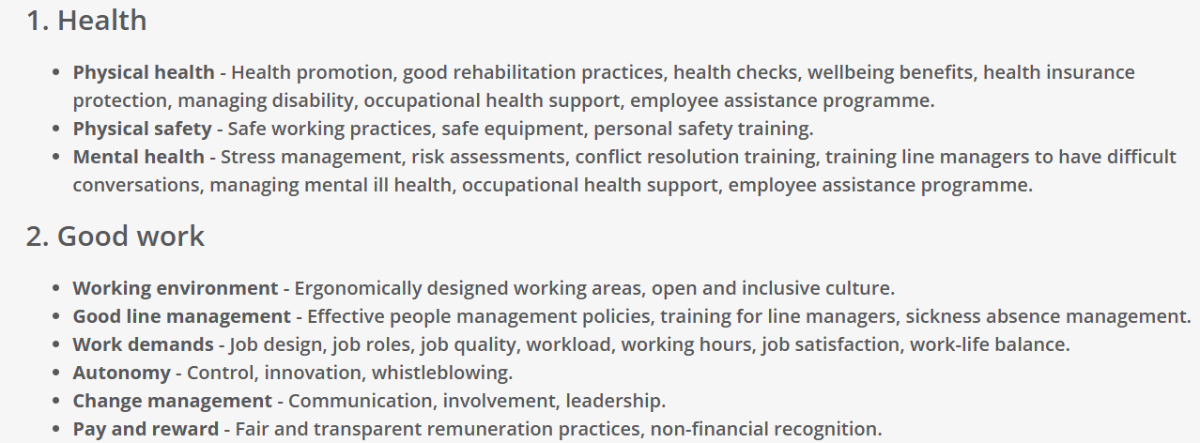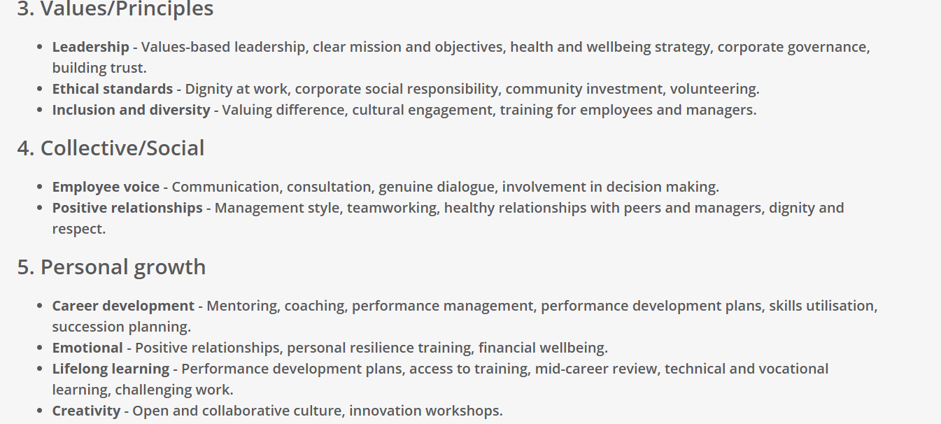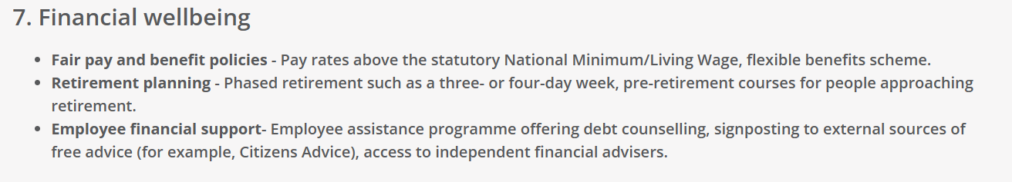

(Source: cipd.co.uk well-being at work 2022)

Appendix 2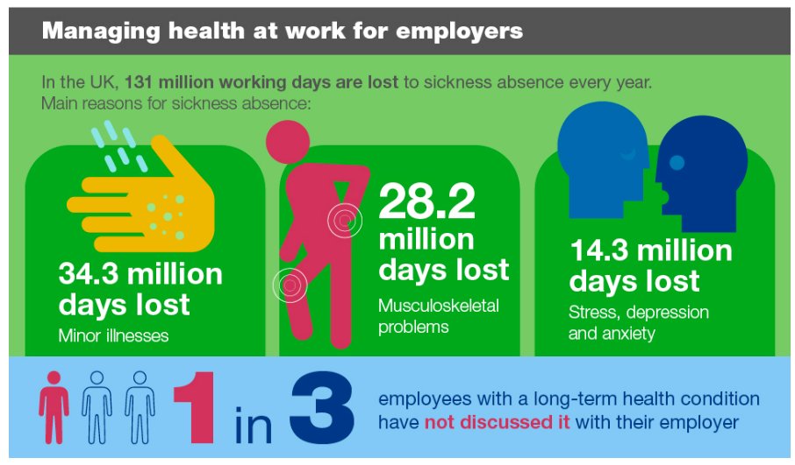

(Source: Gov.UK – Health matters, 2019)

Appendix 3

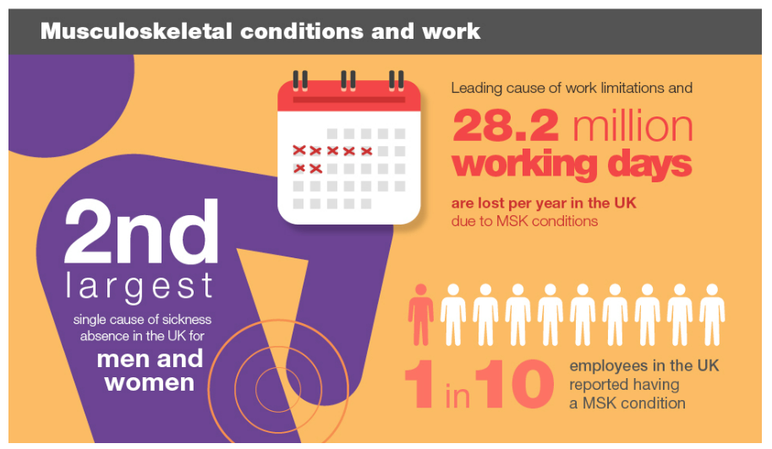

(Source: Gov.UK – Health matters, 2019)

Appendix 4

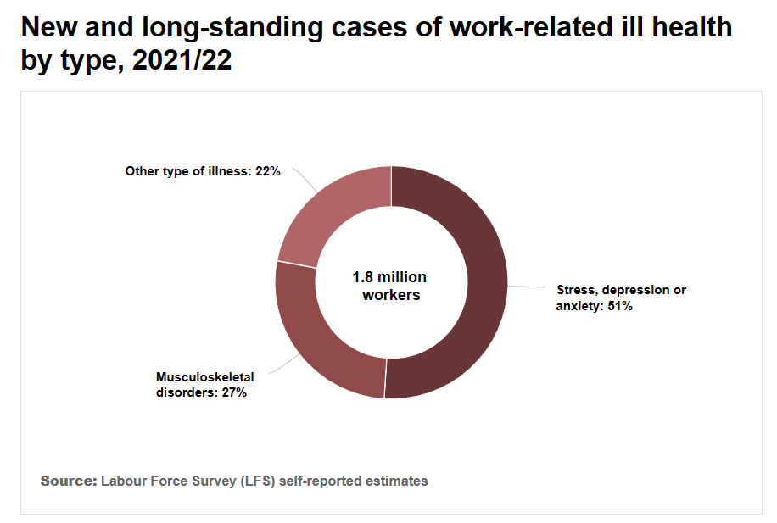

Appendix 5

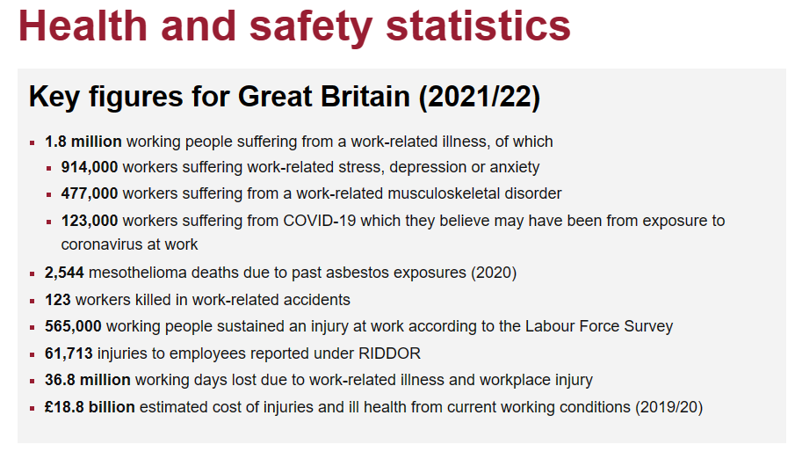

(Source: Health and Safety Executive)

Appendix 6

Annual cost of poor mental health

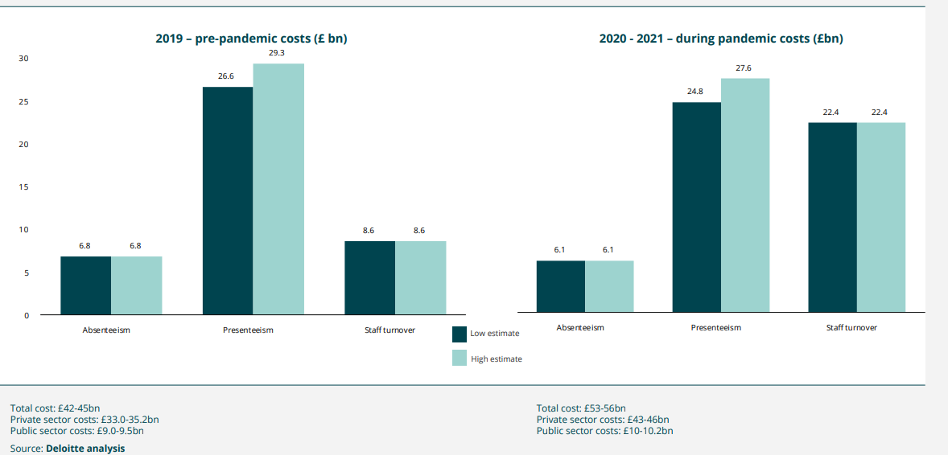

(Deloitte, Mental health and employers, 2022)

