BMSW4004 Problem Solving and Decision Making

Student’s ID:1916878
Student’s Name:Marian Ursu
Table of Contents
Introduction 3
Defining a complex problem in the workplace including its scope and impact 4
Analysation of information for the identified problem for making a suitable decision 5
A range of alternative solutions to the problem 7
Decision-making technique to evaluate different solutions to identify the most appropriate solution 8
Development of a plan to implement the solution 10
Communication of the plan to the stakeholders 10
Suitable monitoring and review techniques for successful implementation of the solution 11
Conclusion 12
References 13

Introduction
The ability to solve a problem and to make a suitable decision is effective skill and knowledge for an employee. In a workplace, different problems arise but there are also specific solutions to these problems. The management needs to investigate the suitable solution to solve the problem. In this report, a complex problem in the workplace is discussed and Tesco is selected for the workplace. The report also discussed techniques to select the most appropriate solution and the technique to implement the plan to solve the problem suitably.

Defining a complex problem in the workplace including its scope and impact
Problem is something or a situation which can harm an individual, organisation or society. Problem is difficult to solve and it takes good planning and decision-making strategy to overcome a problem (Maund, 2017). The problem occurs when a task or decision is taken without taking into account the consequence of the task or decision. Problems can be faced in a different stage of life, however, problems in the workplace are the most complex ones because it is related to organisation productivity, profit and other business operations. For defining a complex problem in the workplace, Tesco is selected as the workplace and the complex problem is job dissatisfaction experienced by the employees of Tesco. The employees of Tesco are not the only employees experiencing this problem but the employees of other retail organisation in the UK such as ASDA, Sainsbury and M&S are also experiencing a similar problem which impacting the business productivity, profitability and in business operations. Because of job dissatisfaction, organisations are also experiencing increased employee turnover rate which creates a gap of talented employees in the organisation. Below the scope and impact of this problem is discussed briefly-
Scope
The problem is associated with the management level because managers and leaders can also experience job dissatisfaction. Lower remuneration, limited promotion scope and lack of recognition are some of the causes which are accountable for this problem (Cole, Cole and Henrick, 2011). Because of this job dissatisfaction, employees are getting disengaged with the organisation which will lead to reduced productivity; thus, the business of Tesco can be unsustainable in the market. Job dissatisfaction is the problem for which the organisation is not able to take any decision because the employees are less interested to make any decisions, thus, the scope of this problem is huge.
Impact
The problem job dissatisfaction can have the following impact on the organisation-
Employee Turnover
Employee turnover rate increases when the organisation does not fulfil the demand of the employees (Esty and Simmons, 2011). This way the organisation can lose their talented people. Because of employee turnover rate, the organisations need to invest again to recruit employees and the organisation also needs to use resources to train the new employees which reduce the revenue of the organisation.
Decrease productivity
Job dissatisfaction leads to decreased productivity because when employees are not satisfied with their work, they lose interest in working (Brislin, 2010). Thus, the organisation cannot manufacture enough product because of lack of employee’s skill and knowledge which in turn decreases the productivity of the organisation.

Analysation of information for the identified problem for making a suitable decision
To give suitable and specific solution to a problem it is needed to acknowledge the cause of the problem, thus, analyse of information is the only way to make an effective decision. Below some information is provided for analysation of the identified problem which is job dissatisfaction to make a suitable decision-
According to Herzberg’s two factors, employee satisfaction and dissatisfaction depends on some facts which are provided below-
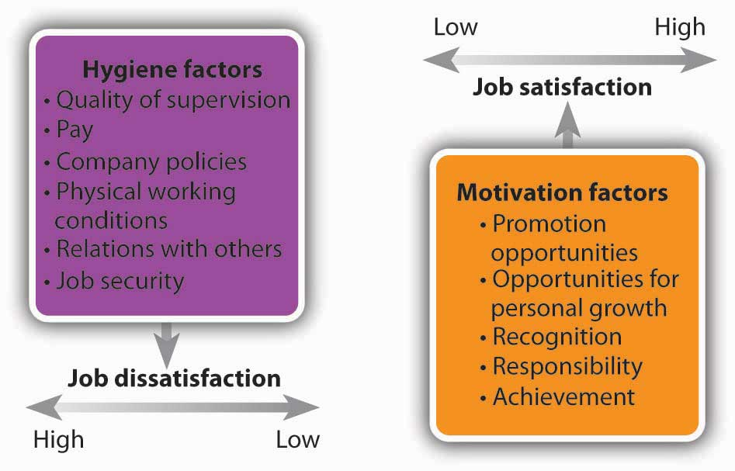
Figure 1: Herzberg’s two factors
(Alshmemri, 2017)
From the image, it can be said that the hygiene factors that are accountable for job dissatisfaction are quality of supervision, pay, company policies, physical working conditions, job security and relations with others. From this theory, it can be said that, if employees experience any of these factors then they get unsatiated with their job. This theory is the evidence that employees can experience job dissatisfaction when their needs and demands are not fulfilled by the organisation. To avoid this problem, the management of an organisation needs to take into account these factors so that employees can be satiated with their job role.
A stat provided below which is conducted to collect and analyse information from the employees of Tesco about how satisfied they are with their jobs and the result is provided below-
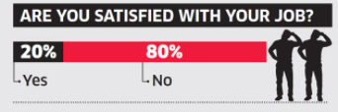
Figure 2: Statistics about job satisfaction
The graph portrays that the majority of the employees of Tesco is not satisfied with their job. 80% of the employees of Tesco said that they are not satisfied and only 20% of the employees said that they are satisfied with their job. Below a graph is provided to discuss the reason for their job dissatisfaction-
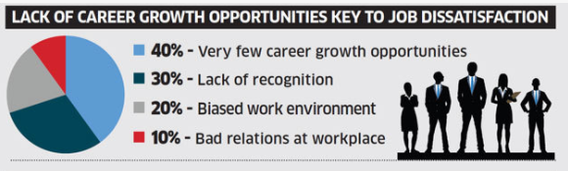
Figure 3: Reasons for job dissatisfaction
(De Jong, 2017)
The graph portrays that the key reason for job dissatisfaction is lack of career growth opportunities as 40% of the employees from Tesco agreed with the statement. 30% of the employee said that lack of recognition is the reason they are dissatisfied with their job. 20% of the employees said that biased work environment is accountable for their job dissatisfaction and 10% of employees reported that bad relations with co-workers at the workplace is accountable for their job dissatisfaction.

A range of alternative solutions to the problem
The identified problem is job dissatisfaction at the workplace and the solution to this problem is identifying the factors that are accountable for job dissatisfaction so that these factors can be eradicated to satiate the employees. Below some solution is provided for the identified problem which is job dissatisfaction-
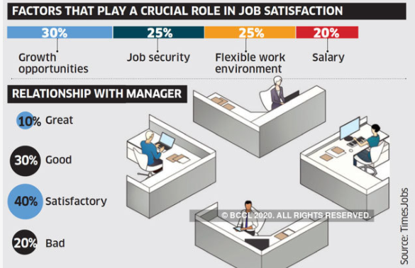
Figure 4: Factors that play a crucial role in job satisfaction
(Khuong, 2017)
From the graph, it can be said that there is a range of alternative solution available for the problem job dissatisfaction such as growth opportunities, job security, flexible work environment and salary. The graph portrays that 30% of the employees of Tesco will satiate with their job if they receive growth opportunities, 25% of the employees said getting job security will aid them for job satisfaction, 25% of the employees said flexible work environment will give them job satisfaction and 20% of the employees said increased remuneration is the key to their job satisfaction.
Moreover, Herzberg’s also proposed some factors in his two factors theory for job satisfaction which is provided below-
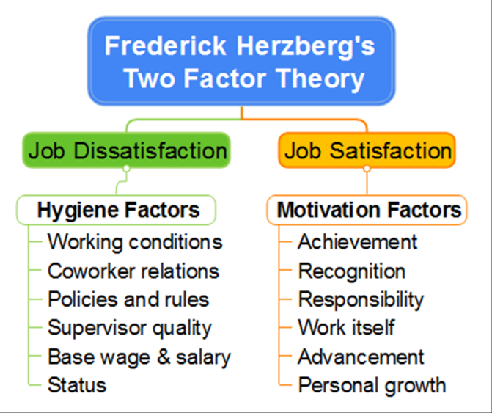
Figure 5: Herzberg's Two Factor Theory
(Alshmemri, 2017)
From the theory, it can be said that some motivation factors increase employees job satisfaction such as recognition, personal growth and promotion opportunity. If the employees of Tesco receive these benefits, then their job dissatisfaction can be eradicated. The management of Tesco needs to take different initiatives so that they can fulfil these demands from employees, thus, the identified problem can be solved which is job dissatisfaction faced by their employees.

Decision-making technique to evaluate different solutions to identify the most appropriate solution
A range of solution is proposed to solve the problem, however, to apply all these solutions an organisation have to use more resources, hence, it is needed to identify the most appropriate solution so that the impact of the problem can be reduced. There is a different decision-making technique available to evaluate different solutions, thus, the appropriate solution can be selected. Evaluating the solutions based on their advantage and disadvantage can support to make the most appropriate decision and it is also a suitable decision-making technique that requires less cost (Triantaphyllou, 2017). Below the decision-making, the technique is provided to identify the most appropriate solution-
Solution | Advantages | Disadvantages
Growth Opportunities | Employees growth can be ensured by providing training. When employees will grow their skill and knowledge will improve which they can apply for the benefit of the organisation. | When an employee will improve his skill and knowledge, he can demand promotion and increased remuneration.
Job Security | Providing job security will reduce the employee turnover rate. | Employees can disengage if they do not receive suitable benefit from the organisation.
Flexible Work Environment | Employees can work suitably maintaining a good work-life balance. It will also aid employees to reduce stress. | The productivity of employees can be reduced.
Recognition of employees | The advantages of employee recognition are increased productivity, positive workplace culture and the scope to retain top talent. | It is costly to recognise employees consistently.
Remuneration | When the remuneration of the employees will be increased, their productivity will also increase. | It can impact on organisations profitability as after the Covid-19 organisations are experiencing less customer flow.

Based on this decision-making technique it can be said that growth opportunities to the employees are the best solution for job dissatisfaction. Because this way, the organisation will not require to recruit new employees and the organisation can save their resources as after recruiting new employees, the organisation needs to give training to the employees which require resources. By providing growth opportunities, the organisation can improve the skill and knowledge of some employees, thus, these employees can train their co-workers which in turn will support the organisation to reduce their training cost. So, this is the best solution for job dissatisfaction at the workplace because this will aid an employee to get promoted and to get increased remuneration.

Development of a plan to implement the solution
To implement the solution which is growth opportunities to the employees, the management of Tesco can take into account the following development plan-
Defining the goal
In this step, the manager can set a goal and can brainstorm the tasks that need to be done to implement the solution.
Team Formation
The second stage of the plan is to form a team that can support employees for personal and growth opportunities. Skilled and talented leaders can be selected to guide different teams.
Assigning the Roles and Responsibilities
The management should give each leader specific roles and responsibilities which will help the leaders to understand the way to assess each employee to help them in personal and professional growth.
Action
In this stage, the leaders can take the necessary step to take any action to implement the solution. In this case, the leaders can take into the account SWOT analysis of individual employees to understand their strength and weakness, thus, the leader can assess the employees based on the result of SWOT analysis.

Communication of the plan to the stakeholders
Job dissatisfaction is a huge problem faced by the employees of the UK. The employees of Tesco that is a retail organisation also experience this problem, which led to analyse and find a solution to solve the problem. So, a plan is developed in which the organisation can use to solve the problem. To solve the job dissatisfaction problem, the organisation needs to ensure growth opportunities for its employees. To implement this plan, the management of Tesco needs to appoint leaders that can guide the employees to improve their skill and knowledge, thus, it will help the employees to get satiated from their job roles. The plan can be sent to the management of Tesco through e-mail in a poster, thus, it will be understood by the manager effective ways to solve the problem.

Suitable monitoring and review techniques for successful implementation of the solution
There are different monitoring and review techniques available for the successful implementation of the problem that is discussed briefly below-
Feedback System
Feedback is an effective review technique which can help to understand how effectively the solution is implemented (Triantaphyllou, 2017). The leaders can ask the employees whether they are satisfied with the training program or not, thus, it will help the management to understand the effectivity of the solution.
Observation
The management of Tesco can observe the progress of the employees to understand the effectivity of the solution. If the employees can take on bigger job roles, then the solution is effective and if the employees cannot take on a bigger job role then the solution is not effective.
Benchmark
The management can set a benchmark and can evaluate the employees against that benchmark to check their improvement (Reimer, 2015). Hence, it will help the management understand the effectivity of the solution.

Conclusion
In concluding, it can be said that at workplace different problem can arise, however, it is upon the management to search for a specific solution for the problem. In this case, the management can define the available solutions for the problem and can select the most appropriate one, thus, the management can develop a plan to implement the solution. The management can also take into account different monitoring and review techniques to evaluate the effectivity of the solution.

References
Alshmemri, M., Shahwan-Akl, L. and Maude, P., 2017. Herzberg’s two-factor theory. Life Science Journal, 14(5), pp.12-16.
Brislin, R., 2010. The Undreaded Job. Santa Barbara, Calif.: Praeger.
Cole, J., Cole, J. and Henrick, G., 2011. Moodle 2.0 For Business Beginner's Guide. Birmingham [UK]: Packt Pub./Open source.
De Jong, D., Grundmeyer, T. and Yankey, J., 2017. Identifying and addressing themes of job dissatisfaction for secondary principals. School Leadership & Management, 37(4), pp.354-371.
Esty, D. and Simmons, P., 2011. The Green to Gold Business Playbook. Hoboken, N.J.: Wiley.
Goyal, A. and Sardana, N., 2017. Optimizing bug report assignment using multi criteria decision making technique. Intelligent Decision Technologies, 11(3), pp.307-320.
Khuong, M.N. and Tien, B.D., 2017. Factors influencing employee loyalty directly and indirectly through job satisfaction–A study of banking sector in Ho Chi Minh City. International Journal of current research and academic review, 1(4), pp.81-95.
Maund, A. Schriek, M. and Tinkler, P. (2017). Certificate in Higher Education: Skills for the Workplace Student Yearbook. Sage Publications
Reimer, E., Jakobs, E.M., Borg, A. and Trevisan, B., 2015, July. New ways to develop professional communication concepts. In 2015 IEEE International Professional Communication Conference (IPCC) (pp. 1-7). IEEE.
Triantaphyllou, E., 2017. Multi-criteria decision-making methods. In Multi-criteria decision-making methods: A comparative study (pp. 5-21). Springer, Boston, MA.

