Name | Student Number | Date | Lecturer’s Name | Your score
Muhammed Hamza Mahee | 2514842 | 23/10/2025 | Caroline | To be filled by the marker  ___/40
You will have 75 minutes to complete this assessment. It is divided into three sections: note-taking, paraphrasing and writing a paragraph.
---------------------------------------------------------------------------------------------------------------------
1. Take diagrammatic notes from the passage below using the space provided:

As a student you've got a lot on your plate - academic work, social life, work commitments, career plans, relationships and finances - sometimes stress can get in the way of this juggling act. When you recognise that you have become overwhelmed with stress, adopt a few strategies to help you manage your triggers more effectively. Those strategies could include exercising; you simply need to get your heart racing, for example by going for a brisk walk or a bike ride. Another suggestion is to try mindfulness, a relaxation technique originating in Buddhism. It is used by clinicians to improve patients' physical and mental health as it can significantly lower stress levels. Thirdly, why not speak to your friends and family - they know you best and care about you the most. What's more, studies suggest that socialising with a friend just once a week can reduce your stress levels and improve your mood as much as therapy or counselling. Simple time management techniques can also help you to feel more relaxed and focused. Try creating a written schedule, breaking your tasks down into manageable chunks, planning accordingly and allocating yourself time every day to relax or socialise. Finally, an obvious but often overlooked solution: get enough sleep, as no one functions at 100% when they're tired.
Adapted from: https://www.prospects.ac.uk/applying-for-university/university-life/5-ways-to-manage-student-stress

Space for your notes (max 12 marks)
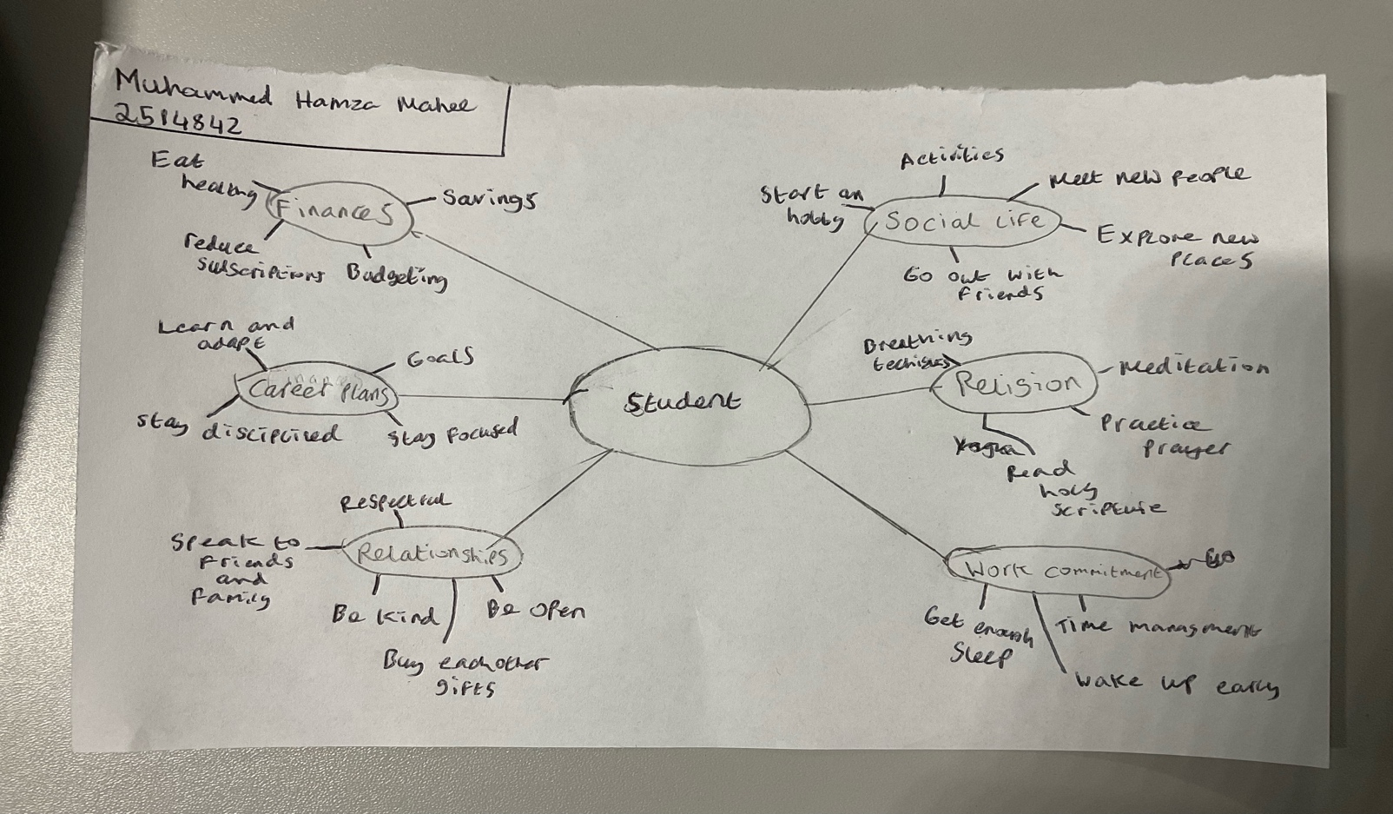

2. Paraphrase the following sentences (max 3 marks for each, max 12 marks in total)

a) Good time management techniques can help you feel more relaxed and focused.

Effective time management enables individuals to remain composed and maintain better concentration.

b) Speaking to your friends and family can significantly lower stress levels.
Engaging in conversations with friends and family members can greatly contribute to reducing stress

c) University life offers numerous opportunities for personal growth and development.
Higher education provides a wide range of experiences that foster personal improvement and self-development.

d) Attending lectures regularly is crucial for understanding course material.

Consistent participation in lectures is vital for achieving a thorough understanding of academic content

3. Write a well-structured paragraph (8 sentences) on the following topic:

Strategies for managing a student budget and reducing costs while at university.

Your paragraph must be written in full sentences (no bullet points) and in an academic style.

(max 16 marks in total)

Effectively managing a student budget and reducing costs while at university requires a combination of planning, discipline, and resourcefulness. The first step is to create a detailed monthly budget that tracks all sources of income and expected expenses. Students should prioritise essential costs such as rent, food, and transportation, and look for ways to minimise spending on entertainment and luxury items. Comparing prices and shopping during sales can help stretch a limited budget further. Additionally, preparing meals at home is not only healthier but also significantly cheaper than eating out regularly. Seeking out student discounts for travel, shopping, and cultural activities can also yield large savings. Sharing accommodation or utilities with roommates can further reduce living expenses. Finally, finding part-time work or freelance opportunities on campus can supplement income and provide valuable work experience. Adopting these strategies allows students to live within their means while still enjoying the university experience.

