MODULE: EFFECTIVE TEAM WORKING AND COMMUNICATION (BMSW4002_BIRM)

Effective Teamworking for Team Success

Student name: Andriana Migaes
Student ID: 2026738
Lecturer: Richmond Lamptey

Contents

Introduction 3
1. Team and teamworking 4
1.1. Definition of a team 4
1.2. The important characteristics that contribute to effective teamwork 4
2. Models of team development 5
3. Team roles 8
3.1. The advantages of effective teamworking 9
3.2. The impact of the ineffective or poor teamworking. 9
Conclusion 10
References 11

Introduction

Strong and successful teams have always existed because of effective teamwork and communication between team members, the team is defined as a group of people who have the same common goals and objectives.
In the next report will be explain more regarding the effective team working for team success for the cohort student at University Saint David of Wales.
Each of the teams at the time of formation goes through several important stages of evolution. Regarding Tuckman’s model (1965), which identified a 5 stage process that describes the formation of teams: forming, storming, norming, performing, and adjourning. If every team leader knows how is the best way to pass with success which stage, a lot of the companies could be more successful and more productive than they are. One of the important secrets to having a successful team or being a part of a successful team is the correct communication between each other.
Each of the members must know their role that is in the team, and how their role could contribute to becoming more effective and helpful for the company where them are working.
It is a great joy to work in a close and united team. Thus, the job you have becomes a hobby, because you do everything with love.

1. Team and teamworking

1.1. Definition of a team

Regarding to the best-selling business book The Wisdom of Teams (Harper Business Books 1994), Jon Katzenbach and Douglas Smith define a team as: ’’A small number of people with complementary skills who are committed to a common purpose, a set of performance goals and an approach for which they hold themselves mutually accountable’’.
Is very important as a team to have a common purpose and goals to achieve it more easier and have a great result.
As defined by Professor Leigh Thompson of the Kellogg School of Management, "… team is a group of people who are interdependent with respect to information, resources, knowledge and skills and who seek to combine their efforts to achieve a common goal."
To have a perspective and progressive team is good to set an objective and scope to identify the resources which you will need to act as a part of a success team, you need to have knowledge and skills to collaborate with each other in the team and be anytime an open mind for everything.

1.2. The important characteristics that contribute to effective teamwork
In order to have a successful team, it is good to identify the most important characteristics that influence the effectiveness of the team. As you identify those factors, you know how best to work in any team so that it is successful, and if you will relate to our case study regarding the students who must do a mutual assignment in team to have a success.
1. Common goals and a clearly defined and commonly shared purpose - materialized for final goals and common intermediate objectives, etc. standards; each member of the team knows very clearly what work he has to do. Each member of the team will then tell you exactly how the results of its work will be measured.
2. Common values (identity of the company/organization) - are given by: values, beliefs, and so on common principles; to start work, team members will have to respond to the following questions: "What values do we cultivate?", "What exactly do we believe in?". Every human problem can be solved when we return to values.
3. Mutual trust and respect- In teams where there is effective cooperation, members have mutual trust and respect. Everyone is aware that everyone has different skills and backgrounds and all these contributions are valid.
4. Clarity around individual roles and responsibilities- In performance teams every worker knows what his role is and what are their individual responsibilities.
5. High levels of communication and climate of cooperation - in each department there must be good communication channels and effective communication skills to prevent disruptions and cooperate effectively.

2. Models of team development
As a result of the team development analysis, many team development models were formed by a different authors which identified some stage of team evolution.
a. For example Wheelan, (1999) identified 4 stage of team evolution:
1. Dependency and Inclusion;
2. Counter dependency and fight;
3. Trust and structure;
4. Work and productivity.
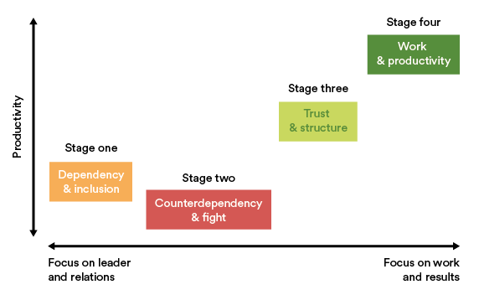
b. In 1988, Gersick considered that team development are happened in 3 phases:
1. Stable Phase- that is established by the end of the first meeting.
2. Instability Phase- this is when the group goes through a period of instability and transition before entering phase two.
3. Stability Phase- Where groups have fully transitioned into a performing team with clear goals, directions and are determined to achieve their collective goals.
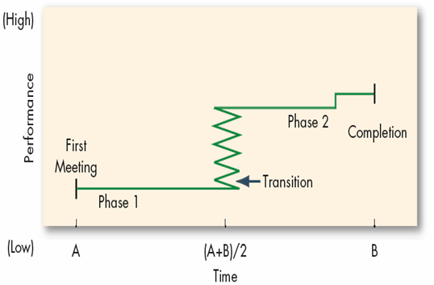
Gersick (1988), Team development stages.

c. According to Tuckman’s model (1965), teams usually go through 5 important stages:
1. Forming- It is the stage of gathering information, about the tasks as a team member, about rules, about working methods. It is a phase in which those who want to be part of the group/team move from the status of person/individual to that of a member of the group/team, define their role as a member, want to know them, and establish relationships with others, generally avoid sensitive topics or situations. In the case of teams that have changed leaders, missions, or members, they need continuity of security. Factors that determine the development of the team: mission, goal and common objectives, mutual trust; problem-solving and decision making; effective interpersonal communication; ways/style of conflict resolution; use of resources; reporting and control procedures; evaluation; creativity, etc.
2. Storming- Characteristic of this stage is the conflict between the assertion of one's individuality and the competition between various members of the group/team; some are overly zealous, others have hostile attitudes or behaviors, some tend to dominate others to withdraw.
3. Norming- Members have integrated the role of group/team member and work to establish, set the rules, rules, as well as to optimize the functioning of the team; the consciousness of belonging to the group/team appears; group cohesion develops.
4. Performing- It is the stage in which there is a real interdependence between the members of the group, the loyalty, and the group identity are manifested.
The efficiency of teamwork is influenced by:
• Personal motivation of members
• The training they benefit from - competence (and the feeling of being competent, good at work)
• Relationship between team members - the affective structure of the group, personal attraction, cohesion
• Knowledge and application of the principles of teamwork
• Leadership/organization style (mechanisms: prestige resulting from the leader's competence, appreciation/reward, guidance, formal/legal, coercion/sanction)
5. Adjourning- Team members focus on completing, completing tasks/missions.
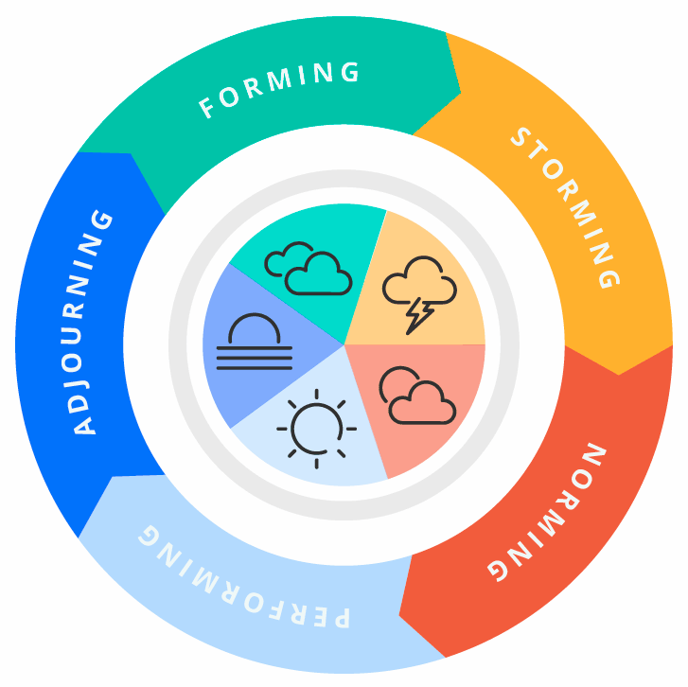
Tuckman’s model team development (1965).
In my opinion, the Tuckman model is the most relevant for describing the development stages of the team, he very well-identified the stages that most teams go through. The other authors have revealed other stages but which include in themselves the stages mentioned by Tuckman in his work.
I think that almost all of the teams passed through forming, storming, norming, and performing, depending on the situation if they passed by adjourning, but it could be more later.
Regarding to the student cohort at the University of Wales Trinity Saint David, who are very diverse in terms of gender, demographics, age, background, and experience, and was appointed to do an assignment, you can identify in work process each stage of the Tuckman’s model when they will be formed as a team for same purpose. After that could appear discrepancies related to the distribution of tasks for each, lack of effective communication between students. When all the problems will be resolved, the student team will started work together and be more loyal each to ether, performing to the presentation and adjourning when the purpose was done and all of student will finished.

3. Team roles
In each team, it is good that each member is assigned a role that you have played in teams to collaborate effectively and achieve considerable success. Each team must have different people who have their roles so that the work is distributed according to the role and work knowledge they possess.
If you relate these roles to the case study we have, when it comes to University students who have been assigned a team assignment, you need to distribute roles to each in order to be successful at the end of the task and avoid losing contact with other members.
Dr. Meredith Belbin, a researcher and theorist in the field of management, known especially for her work in the field of team management. Following this study, nine types of behaviors within the team were defined.
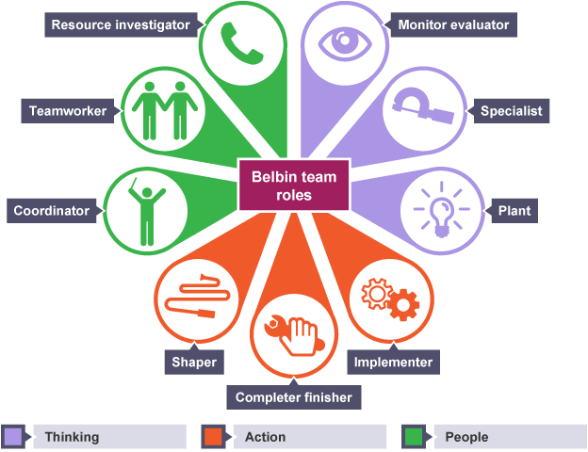
1. The coordinators are confident and focus on team goals, mature, tolerant and authoritarian. Coordinators make decisions and communicate to members.
2. The team worker is dedicated to achieving goals and always ensures that the team remains focused on the tasks to be performed. They are dynamic people who stimulate others.
3. The plant/ idea generator is a creative person, able to solve difficult problems. If an innovative idea is required, the plant is the one who will deliver it. He is intelligent, with unrestricted thinking and original.
4. The resource investigator is the one who charges the team members with momentum, energy and enthusiasm. It is a connecting element, takes over and develops the ideas of others, analyzes development possibilities and establishes the necessary contacts.
5. The implementers take the suggestions and ideas of team members and turn them into actions beneficial to the common goal.
6. The monitor-evaluator who monitors is rational, prudent and intelligent, whose main goal is not to achieve success.
7. The resource investigator have the role of raising the esprit of the group, encouraging the contributions of all members to the efficient accomplishment of the task.
8. The completer/ finisher are perfectionists, attentive to details and the complete completion of the task, work consistently, they must to ensure that everything is fine, and the activities for which they are responsible are monitored and checked.
9. Specialists are passionate about developing and improving in a certain field. Their contribution is essential for the fulfilment of the team's tasks, being indispensable when they are the only ones specialized in the respective field.

3.1. The advantages of effective teamworking

Teamwork requires trust between each member. Teamwork support each other and not think individually. The advantages of effective teamworking are:
- the support provided for learning and for overcoming difficult situations as soon as they arise;
- ensuring equal access for all team to express their views and agreed;
- a constructive and positive high-performance team communication, especially in difficult situations;
- understanding the emotional indicators within the interactions;
- setting clear goals and objectives, agreed by everyone;
- resources are used as needed;
- increases participation in the decision-making act;
- make better use of the resources of each member.

3.2. The impact of the ineffective or poor teamworking.

The ineffective or poor teamworking have impact in the present and future work. Various behaviors and attitudes can throw off the effectiveness of a group, lowering morale and even impacting overall job satisfaction. The impact of the ineffective teamworking could be:
- a bad attitude to the work and company;
- unwillingness to cooperate;
- infighting;
- conflicts;
- unclear expectations;
- derailed productivity.
As an example of ineffective teamwork, we can imagine what could happen in the bred factory if one of the staff didn’t work well and some were wrong, it could affect all departments. If the suppliers didn’t bring at the time the product to the factory, is a big risk to stop the activity for some time if the factory doesn’t have any savings, and that will affect the factory productivity, and their income will below.

Conclusion

Effective teamwork is one of the most important elements in any organization to achieve common goals and have maximum productivity.
In order to go through all the stages of a team's evolution and to work effectively no matter what role it played in the organization, we must be tolerant and empathetic to the other members. Professionalism and teamwork skills will ultimately achieve the desired goals.
Regardless of the difficulties that a team may encounter, if there is a good coordinator and good communication between team members, and when everyone breathes the same think, any challenge can be easily overcome and have a success team.

References

- Belbin, R. M. (1993). Team Roles at Work. Oxford: Butterworth-Heinemann.
- Cook, S, Cook, S, & Ummer, F 2009, Building a High Performance Team : Proven Techniques for Effective Team Working, IT Governance Ltd, Ely. Available from: ProQuest Ebook Central. [25 October 2021]
- Davis, J.; Millburn, P.; Murphy, T.; Woodhouse, M. (1992). Successful Team Building: How to Create Teams that Really Work. London: Kogan Page.
- Devine, D. J. (2002). A review and integration of classification systems relevant to teams in organizations. Group Dynamics: Theory, Research, and Practice, 6, 291–310.
- Gersick, C. J. G. (1988). "Time and transition in work teams: toward a new model of group development". Academy of Management Journal. 31 (1): 9–41. doi:10.2307/256496. JSTOR 256496.
- Griffith, BA, & Dunham, EB 2014, Working in Teams: Moving From High Potential to High Performance, SAGE Publications, Thousand Oaks. Available from: ProQuest Ebook Central. [25 October 2021]
- Stein, J. Using the Stages of Team Development [online]. [Accessed 25 October 2021]
- Thompson, Leigh (2008).
- Tuckman, B.W. (1965). 'Developmental Sequence in Small Groups,' Psychological Bulletin, 63(6)
- Wheelan, S. (2010). Creating Effective Teams: a team for 5 to 6 naks.

