Programme: BA (Hons) Leadership and Management Skills for the Workplace
Module: Organisational Culture
Module code: LCLM 5005
Lecturer Name: RICHARD ASHAYE
Student Name: Elena Buzatu
Student ID:2312849
Individual Report
Selected organisation: Toyota

Table of Contents
1. Introduction 3
1.1 Company Overview 3
1.2 Definition of Organisational Culture 3
1.3 Affectedness of Culture on Organisational Processes. 4
1.4 Purpose and Organisation of the Report 4
2. Influence on Structure & Decision-Making 4
2.1 Relationship between Organisational Culture, Structure, and Decision-Making 4
2.2 The Style of leadership and the flows of communication 5
2.3 Centralisation/Decentralisation of Decision-Making 5
2.4 Implementation of Structural Configurations of Mintzberg 5
2.5 The Levels of Organisational Culture of Schein 6
3. Identification & Analysis of Culture 6
3.1 Hofstede Cultural dimensions- The Global Orientation of Toyota 6
3.2 The Four types of culture proposed by Handy 7
3.3 Company Practice evidence: Leadership, HR Policies and Engagement. 7
4. Adaptation to External Environment 7
4.1 The influence of culture in reacting to external forces 7
4.2 Open Systems and Contingency application 8
4.3 Some instances where the culture contributed in adaptation. 8
4.4 Comparison of the success of the cultural responses. 8
5. Culture as Barrier or Enabler 9
5.1 Culture as enabler 9
5.2 Culture as barrier 9
5.3 Parent-child cultural conflict/transformation. 9
5.4 Overall concluding: barrier or enabler 9
6. Impact on Performance & Recommendations 10
7. Conclusion 11
References 12

1. Introduction

1.1 Company Overview
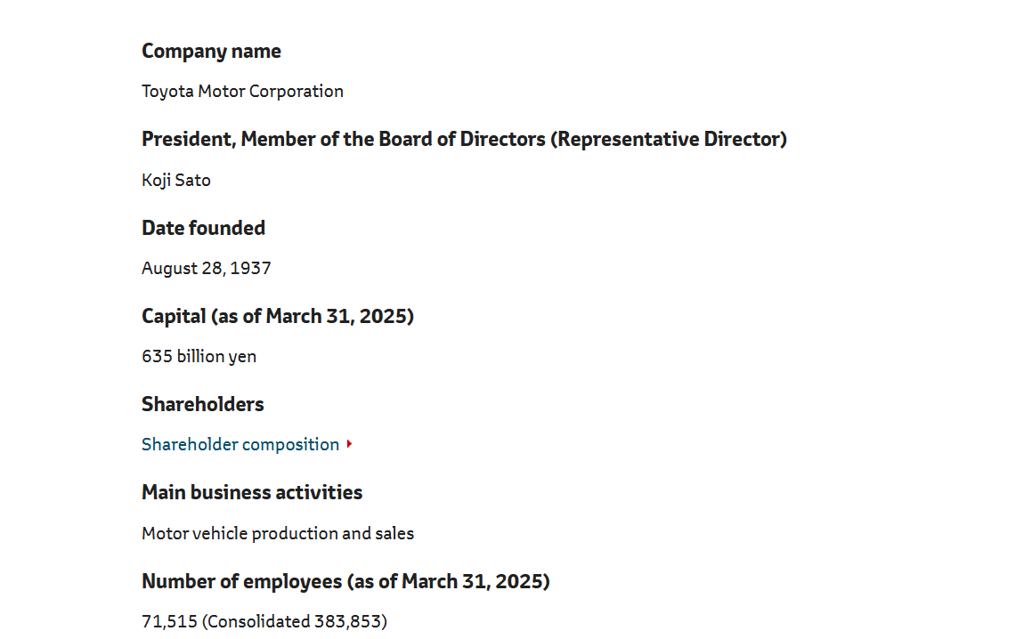
Figure 1: Overview of Toyota
(Source: Toyota, 2025)
Toyota Motor Corporation is a multinational corporation that deals with automobiles and was established in 1937 and is based in Aichi, Japan. It has presence in over 170 countries and regions, and it employs over 383853 employees all over the world (Toyota, 2025). The company manufactures a variety of cars, starting with the traditional cars equipped with a conventional combustion engine to the hybrid and electricity-powered ones, including Toyota and Lexus brands. The Toyota Way is a long-term philosophy that has brought Toyota much success in its reputation of continuous improvement, reliability of products, and innovation.

1.2 Definition of Organisational Culture
Organisational culture can be defined as the system of values, beliefs, attitudes, and assumptions common to various employees in an organisation as they decide on how to conduct themselves (Chalmers and Brannan, 2025). Schein (2010) states that culture has three levels artifacts, espoused values, and underlying assumptions, which when combined form organisational identity and actions (Hattangadi, 2020). In the perspective of Hofstede (2001), culture is the programming of the minds that makes the members of one group distinct to the members of another group, whereas Handy (1993) classifies cultures into power, role, task and person categories (Nickerson, 2025). Mullins and Christy (2016) and With and Mclean (2022) also explain culture as what is going on around here, informal norms that dictate how they arrive at decisions, which motivate and control their actions.

1.3 Impact of Culture on Organisational Processes.
Culture plays a key role in shaping the mode of operation in organisations, people management and decision making. In any global company such as Toyota, the culture is very robust and coherent in the sense that it maintains a similar performance, standards of ethics and alignment of the global subsidiaries. It also fosters innovation, collaboration, responsiveness to external change, which are important in the competitive industry.

1.4 Purpose and Organisation of the Report
In this report, a critical analysis of the role of organisational culture in determining the structure and decision-making by Toyota has been discussed. It further discusses the identification of culture within the most crucial theoretical frameworks, effects on environmental adaptation, possible impediments as well as its effects on performance. The report therein gives out recommendations to enhance the cultural effectiveness and global competitiveness of Toyota.
Year | Statistic
2023 | Toyota implemented 3,500+ kaizen improvement suggestions across its global plants.
2024 | 42% of major management decisions were delegated to regional operations to improve autonomy.
2025 | Toyota’s new Audit and Supervisory structure aim to cut executive decision-making time by 30%.
Table 1: Statistical representation of Toyota regarding culture and decision making
(Source: Created by the learner)

2. Influence on Structure & Decision-Making

2.1 Relationship between Organisational Culture, Structure, and Decision-Making
The organisation culture determines the way structures are developed, and decisions are made. Such relation at Toyota is seen in the company philosophy called The Toyota Way that focuses on respect towards people, teamwork, and continuous improvement (Toyota, 2023). The company strives to build a corporate culture, which improves individual creativity as well as the importance of teamwork and the value of mutual trust and respect between labour and management, which is stated in the Guiding Principles of Toyota (Toyota, 2019).
It is this cultural foundation that guides a structure that is based on cross-functional teams and a decision-making model, referred to as genchi genbutsu (“go and see) - where the leader and the employees make decisions based on their on-site observations. This philosophy is incorporated in all levels of managing Toyota where the authority to make any decisions relates to knowledge on the ground. Consequently, the structure does not postulate the strict hierarchy but a combination of the standardised processes and collective decision flow.

2.2 The Style of leadership and the flows of communication
The leadership style in Toyota is participatory and hands-on management. The leaders are also expected to observe operations first hand and make decisions before serving as leaders with both vertical and horizontal communication flowing (Hamed, 2023). Kaizen system (continuous improvement) would facilitate the participation of all employees by addressing the ideas, transparency, and shared responsibility.
The use of visual means of communication, like and on boards and daily stand-ups, makes it possible to share real-time information between the managers and the employees working in the shop-floor (Team, 2024).The system promotes the culture of empowerment and on-going communication in place of inflexible command lines.

2.3 Centralisation/Decentralisation of Decision-Making
Toyota has a mixed decision structure, and their global platform development or R&D investments are also made at the headquarters. As an example, the recent Toyota reorganisation in 2023 has created a new Software Development Centre to speed up the digital transformation (CORPORATION, 2023).
Operational decisions on the other hand are decentralised. Local subsidiaries and manufacturing plants have powers to make changes in the processes, which shows that Toyota values the local knowledge. The model is decentralised to promote team level responsiveness and accountability, and to keep in line with the global strategy. It accounts with efficiency and flexibility.

2.4 Implementation of Structural Configurations of Mintzberg
According to the theory of Henry Mintzberg (1979) there are structural configurations which included machine bureaucracy, adhocracy, and professional bureaucracy. As In the manufacturing process, Toyota can be compared with a machine bureaucracy in which the standardisation of the work process and accuracy grant quality and safety (Sekar, 2024).
- Toyota shows a hybrid form of organisation that involves these forms.
- Toyota in R&D and software segments exhibits adhocracy characteristics, which encourage innovation via projects.
- The firm in the engineering industry is a professional bureaucracy, which operates through expertise and specialised knowledge (Sekar, 2024).
- The hybrid model enables Toyota to have consistency in its operations and flexibility in innovation-oriented areas.

2.5 The Levels of Organisational Culture of Schein
Edgar Schein (2010) suggested that culture has 3 levels, that is artefacts, espoused values, and basic assumptions. As The Toyota Way principles such as the Respect to People and Continuous Improvement include espoused values (Lutkevich, 2023).
- Toyota on the artefacts side has visible artefacts such as kaizen boards, and on cords and standard operating charts.
.
- The simplified assumptions consist of ideas that solutions to certain issues are most appropriate at the core and that front-line employees possess vital insights into the matter at hand (Lutkevich, 2023). These levels interact with each other to facilitate group decision-making and drive the long-term orientations of Toyota to focus on learning and innovation.

3. Identification & Analysis of Culture

3.1 Hofstede Cultural dimensions- The Global Orientation of Toyota
Power Distance: Japan scores moderately in terms of power distance, although Toyota has adjusted to a lower power distance culture on a global scale (Faraj and Milod, 2024). The process of decision-making is frequently decentralised, and workers are supposing not to fear spanking because they can bring things up through and on systems. Leadership is conducted in the philosophy of a servant-leadership, in which the senior executives are supportive and not commanding.
Individualism vs. collective: The culture of Toyota is extremely collectivist and problem solution successes are rewarded by the teams but not individuals (Toyota, 2023b). The kaizen philosophy relies on teamwork and constant cooperation.
Uncertainty Avoidance: Toyota is highly uncertain avoidance, with using standardised procedures and quality checks to minimise the risk. It aligns with the error-proofing (poka-yoke) and disciplined process control the company aims at (Paul, 2023).
Masculinity vs. Femininity: The masculinity aspect of Japanese culture has had an impact on the company by the pursuit of quality, performance, and efficiency. Nevertheless, Toyota has been progressively adopting more inclusive leadership and flexible work patterns and is in line with the worldwide trends in diversity and inclusivity (Alcantara and Shinohara, 2022).
Long-Term Orientation: Toyota demonstrates the long-term orientation type behaviour that is based on the value of stability and sustainability and succeeding generation. It has been strategic with intergenerational responsibility, as its carbon neutrality roadmap is aimed at 2050 (Toyota, 2021).

3.2 The Four types of culture proposed by Handy
Role Culture: This is reflected in the Toyota manufacturing processes which are based on specific roles, processes, and hierarchy. The predictability linked to a role culture is reflected by standardised procedures of work and quality audits (Profiroiu et al., 2020).
Task Culture: At the same time, Toyota is promoting an environment where employees work in kaizen groups, cross-functional groups of solving problems. The flexibility of the company and collaboration to find solutions to certain technological problems is evidenced by its R&D and innovation centres, including Woven by Toyota (Profiroiu et al., 2020).
Power and Person Cultures: Senior leadership still has a strategic control but the process of making decisions is decentralized. The individual-focused person culture is not very compatible with the collective focus of Toyota.

3.3 Company Practice evidence: Leadership, HR Policies and Engagement.
Leadership: Leaders of Toyota should be familiar with genchi genbutsu and servant leaders. The executives, from CEO Koji Sato, have stressed empowering younger leaders and setting a flatter organisational communication structure (TMI, 2024).
HR Policies: Toyota encourages internal talent building by sustaining training and mentorship works. The employment of long term is the main and loyalty and stability is promoted. Sustainability and ethics training are also incorporated in the leadership programs by the company (Toyota, 2024).
Employee Engagement: Toyota uses kaizen program and suggestion system which involve all the personnel. In 2023 alone, thousands of process innovations were launched by the employees highlighting the fact that participation is an inherent cultural requirement (Toyota, 2024b).

4. Adaptation to External Environment

4.1 The influence of culture in reacting to external forces
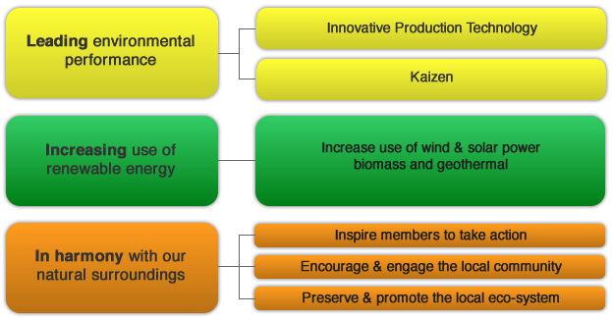
Figure 2: Sustainability process at Toyota
(Source: Toyota, 2024b)
In the case of Toyota Motor Corporation, the changes that have taken place in the globalisation, technology, sustainability, and pressure of regulation do not merely require process change, but rather culture alignment. Toyota philosophy of producing Happiness to All and its Sustainability Fundamental Policy directly states that the company will respect regional traditions and co-operate with the local society without neglecting to develop global technologies (Toyota, 2024b).

4.2 Open Systems and Contingency application
In the sense of the Open Systems, Toyota must engage dynamically with the environment - the external regulation, the taste of consumers, trends in technologies - and remake and renew its internal processes. The culture of continuous improvement (kaizen) and respect of people contributes to the said renewal through support of feedback loops (front-line to management) and adaptations that work out gradually (Toyota, 2022). According to a Contingency Theory school of thought, the culture-structure should respond to the environmental demands in a market where the regulation of electric-vehicles is strict, the regional units should make more expeditious decisions, embrace new technologies, and reorganize production. In fact, a study conducted in the Chinese NEV market regarding Toyota reveals that Toyota has developed local research and development centres, as well as manufacturing facilities to enhance flexibility and adaptability Chinese NEV market regarding Toyota reveals that Toyota has developed local research and development centres, as well as manufacturing facilities to enhance flexibility and adaptability. (CORPORATION, 2023b).

4.3 Some instances where the culture contributed in adaptation.
International expansion and localisation: Toyota invested more than 680 million Euros in the Czech Republic to be able to manufacture the first series of battery-electric vehicles in Europe (Carey, 2025). It explains how Toyota manages global networks of manufacturing and localisation to meet regional regulatory and market requirements.
Technology and innovation strategy: Toyota is working on developing an ecosystem of local experimentation and global technological ambition (TOYOTA MOTOR CORPORATION, 2025). A local model, in line with the trends of sustainability and mobility, through its subsidiary Woven by Toyota and through the Woven City project.

4.4 Comparison of the success of the cultural responses.
In general, the Toyota culture seems to allow adaptation of the company to work: its continuous improvement ethos does not allow the company to stand back, its respect-for-people virtue facilitates management of its global teams and local stakeholders (Srikrishna, 2025). The current investments that the company has made in Brazil in production of hybrids and battery depict the process through which culture, structure and strategy intersect with external market pressure

5. Culture as Barrier or Enabler

5.1 Culture as enabler
Effective functioning is highly facilitated by the organisational culture of Toyota in numerous ways. This focus on respect of the people and the teamwork concept along with the ongoing improvement encourages high employee engagement, quality control and operational excellence (Toyota, 2025a). The culture also enables front-line workers to voice issues, resolve them in addition to making a difference thereby matching the structure with decision-making and practice. This makes it reliable, globally consistent and adaptable to different markets.

5.2 Culture as barrier
Nevertheless, even the same culture may turn into an obstacle when some conditions are met. The emphasis on standardised routines, consensus-building and long-term orientation can act as hampering and slow decision-making and risky innovation. As an illustration, transition towards software and mobility services requires a more rapid experimentation, hierarchy reduction and risk-taking, which ill might slow Toyota (Toyota, 2025b). The presence of top-down strategic control and interdependence at regional levels also creates the threat of ethnocentrism: Japan-based national decision-making may constrain local responsiveness in international activities.

5.3 Parent-child cultural conflict/transformation.
The restructuring of Toyota (the formation of regional manufacturing hubs, software departments) in the age of mobility and indicates a change of culture. This change entails the change in the manufacturing-focused culture to the software, services and global responsiveness one. Internally such change may be resisted when the culture is too enshrined with the assumption of legacy concerning standardisation and hardware. The fact that the integration will be sluggish, agility will be diminished, and inter-unit friction between older and newer business units can be created through that resistance.

5.4 Overall concluding: barrier or enabler
Overall, the culture at Toyota serves as an asset rather than a liability: it brings the world reliability, continuous improvement and involving the employees in meaningful occasions. However, cultural rigidity acts as a limitation when outside circumstances require a fast strategic change or discontinuous innovation (Toyota, 2025b). Since a contingency theory approach views culture as well suited to stable environments that are efficiency oriented but less so to high-velocity change, the culture is perfectly aligned with the former. Therefore, in contrast to the case of enabling fundamentals, the barrier risk in the transformative context is higher, i.e., Toyota should proceed with its culture evolution to be globally competitive.

6. Impact on Performance & Recommendations
The Toyota Motor Corporation organisational culture has a high impact in performance outcomes in terms of employee motivation, innovation, customer satisfaction as well as financial results. The high staff engagement in organisation is due to the strong focus on people respect and continuous improvement by the company. The example is the case of Toyota where virtually 100 %. of the employee’s report having participated in kaizen improvement projects and a mentoring program in the Toyota Indiana plant which has also resulted in enhanced turnover rates.
In the US, Diversity + Inclusion report released by Toyota in 2023 states that they have high levels of employee-resource-group participation, comprising of 8,892 members within 116 chapters in 2024, which suggests greater motivation and a feeling of belonging (Faulner, 2024).
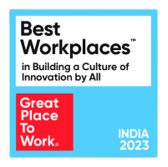
Figure 2: Toyota India won best winner workplaces
(Source: Toyota, 2023a)
Culture as innovation drivers on the innovation front, India Toyota under its Connected unit was ranked among the Top 25 Workplaces in India in the 2023 Innovation Index as a repository of innovation results (Toyota, 2023a).
Suggestions to improve culture:
- Nurture diversity and inclusion: Based on the already established D+I programmes in Toyota, the global extension of the inclusive leadership training, and monitoring the metrics of each region will reinforce the innovativeness and market competence.
- Cultivate culture of learning: Extend an at least manufacturing mentoring and kaizen systems to software and mobility divisions, to enable fast knowledge transfer and emergence of skills.
- Strike a balance between global consistency and local responsiveness: Strengthen core values of Toyota on a global level (respect, improvement) and allow regional units to shape decisions and culture Pear to local market (e.g. regional leadership councils and local employee boards).

7. Conclusion
This report has indicated that organisational culture is at the core of its structure, decision-making, and performance of Toyota. The culture of continuous improvement, respect of people and go and see leadership of the company underlies the organisation of work and flow of decisions and team work on the global scale. Notably, the culture has helped achieve good performance results: employee engagement, innovation awareness, customer retention, and financial sustainability. It can perceive how the Toyota culture is deeply rooted and internationally custom-tailored with the help of such paradigms as the levels provided by Schein, the Hofstede dimensions, and the kinds of cultures created by Handy, influencing such front-line activities like kaizen practices and such strategic platform decisions as international strategy. It can perceive how the Toyota culture is deeply rooted and internationally custom-tailored with the help of such paradigms as the levels provided by Schein, the Hofstede dimensions, and the kinds of cultures created by Handy, influencing such front-line activities like kaizen practices and such strategic platform decisions as international strategy.
However, in the fast-evolving mobile environment, the cultural adaptability is essential. Toyota should maintain sound cultural bases as it transforms decision making effectiveness, territorial agility and hospitality. By so doing, it strengthens its competitiveness in the world markets in the long-term. Organisational culture is not a soft-option, it is a strategic asset that governs the way things are conducted in this place and how Toyota will react to the new challenges and opportunities that arise in the future.

References
Alcantara, L. and Shinohara, Y. (2022). Diversity and Inclusion in Japan. London: Routledge.
Carey, N. (2025) Toyota to produce first fully electric car in Europe at Czech plant. Reuters. 3 Sep. Available at: https://www.reuters.com/business/retail-consumer/toyota-produce-first-fully-electric-car-europe-czech-plant-2025-09-03/ (Accessed 1 November 2025).
Chalmers, R. and Brannan, G.D. (2025) Organizational Culture. PubMed. Available at: https://www.ncbi.nlm.nih.gov/books/NBK560543/. (Accessed 1 November 2025).
CORPORATION, T.M. (2023a) TMC Announces Changes to Organizational Structure, Executive Structure, and Senior Professional/Senior Management Employees | Corporate | Global Newsroom. Toyota Motor Corporation Official Global Website. Available at: https://global.toyota/en/newsroom/corporate/39746366.html (Accessed 1 November 2025).
CORPORATION, T.M. (2023b). Toyota Accelerates Local Development of Intelligence and Electrification Towards Enhancing Competitiveness in the Chinese Market | Corporate | Global Newsroom. Toyota Motor Corporation Official Global Website. Available at: https://global.toyota/en/newsroom/corporate/39571600.html (Accessed 1 November 2025).
Faraj, O. and Milod, T. (2024). Case Study Analysis of Toyota Company and make time to market. ResearchGate, 22(11).
Faulner, M. (2024). The Journey Continues: Toyota Publishes 2024 North American D+I Annual Report - Toyota USA Newsroom. Toyota USA Newsroom. Available at: https://pressroom.toyota.com/the-journey-continues-toyota-publishes-2024-north-american-di-annual-report/ (Accessed 1 November 2025).
Hamed, M. (2023). Toyota Production System Concepts: The Guidebook to Toyota’s Corporate Strategy and Leadership – Series Books 1 to 6. Available at: https://www.researchgate.net/publication/378848980_Toyota_Production_System_Concepts_The_Guidebook_to_Toyota. (Accessed 1 November 2025).
Hattangadi, V. (2020). Edgar Schein’s three levels of Organizational Culture. Juni Khyat Journal, 10(6), pp.112–118.
Inagaki, K., Dempsey, H., Bott, I. and Keohane, D. (2025). ‘Full of bugs’: how the world’s biggest carmakers fell behind in software. @FinancialTimes. Available at: https://www.ft.com/content/d5d5b7fb-30fc-4f32-86d2-7499bcc433b6. (Accessed 1 November 2025).
Lutkevich, B. (2023) What is Toyota Way? - Definition from WhatIs.com. WhatIs.com. Available at: https://www.techtarget.com/whatis/definition/Toyota-Way (Accessed 1 November 2025).
Mullins, L., & Christy, G. (2016). Management & Organisational Behaviour (Eleventh ed., Always learning).
Nickerson, C. (2025) Hofstede’s Cultural Dimensions Theory & Examples. Simply Psychology. Available at: https://www.simplypsychology.org/hofstedes-cultural-dimensions-theory.html (Accessed 1 November 2025).
Paul, M. (2023). ENHANCING QUALITY AND EFFICIENCY: THE POWER OF POKA-YOKE. ENHANCING QUALITY AND EFFICIENCY: THE POWER OF POKA-YOKE, pp.242–243.
Profiroiu, M., Kaneko, H., Vlad, C., Dutescu, A. and Ishida, H. (2020). Toyota Motor Corporation’s Culture Strategy. Review of International Comparative Management, 21(4).
Sekar, N. (2024) Control Mechanisms at Toyota - Naresh Sekar - Medium. Medium. Available at: https://medium.com/@nareshnavinash/control-mechanisms-at-toyota-cbcb0f4057b4 (Accessed 1 November 2025).
Srikrishna, M. (2025) Culture Case Study: Toyota. Medium. Available at: https://medium.com/why-culture-matters/culture-case-study-toyota-7ffd2aa16ad1 (Accessed 1 November 2025).
Team, E. (2024) COVID-19 Situation: Six Sigma Ongoing Training Announcements. SixSigma.us. Available at: https://www.6sigma.us/manufacturing/operational-excellence-with-visual-management-tools-a-complete-guide/ (Accessed 1 November 2025).
TMI (2024). Toyota’s winning formula for employee engagement. Tmi.org. Available at: https://www.tmi.org/blogs/toyotas-winning-formula-for-employee-engagement (Accessed 1 November 2025).
Toyota (2019). Guiding Principles | Vision & Philosophy | Company | Toyota Motor Corporation Official Global Website. Toyota Motor Corporation Official Global Website. Available at: https://global.toyota/en/company/vision-and-philosophy/guiding-principles/ (Accessed 1 November 2025).
Toyota (2021) Toyota aims for carbon neutrality by 2050 . https://global.toyota/pages/global_toyota/sustainability/esg/environmental/carbon_neutrality_en.pdf.(Accessed 1 November 2025).
Toyota (2022) Technical eview R 66. Available at: https://global.toyota/pages/global_toyota/mobility/technology/toyota-technical-review/TTR_Vol66_E.pdf (Accessed 1 November 2025).
Toyota (2023a). Awarded India’s Best Workplaces Building a Culture of Innovation by All. Toyotaconnected.co.in. Available at: https://www.toyotaconnected.co.in/article/awarded-indias-best-workplaces-building-a-culture-of-innovation-by-all (Accessed 1 November 2025).
Toyota (2023b) The toyota way | toyota europe. Toyota EU. Available at: https://www.toyota-europe.com/about-us/toyota-vision-and-philosophy/the-toyota-way (Accessed 1 November 2025).
Toyota (2023c) What Is Kaizen, and Why Is It Important? Toyota Forklifts. Available at: https://www.toyotaforklift.com/resource-library/blog/toyota-culture/what-is-kaizen-and-why-is-it-important (Accessed 1 November 2025).
Toyota (2024a). Sustainability | Toyota Motor Corporation Official Global Website. Toyota Motor Corporation Official Global Website. Available at: https://global.toyota/en/sustainability/ (Accessed 1 November 2025).
Toyota (2024b) Sustainability | Toyota Motor Corporation Official Global Website. Toyota Motor Corporation Official Global Website. Available at: https://global.toyota/en/sustainability/ (Accessed 1 November 2025).
Toyota (2025a) Innovation at Toyota | Toyota Europe. Toyota EU. Available at: https://www.toyota-europe.com/innovation (Accessed 1 November 2025).
Toyota (2025b) INTEGRATED REPORT 2024. Available at: https://global.toyota/pages/global_toyota/ir/library/annual/2024_001_integrated_en.pdf (Accessed 1 November 2025).
Toyota (2025c) Overview | Profile | Company | Toyota Motor Corporation Official Global Website. Toyota Motor Corporation Official Global Website. Available at: https://global.toyota/en/company/profile/overview/ (Accessed 1 November 2025).
TOYOTA MOTOR CORPORATION (2025) Toyota Woven City Officially Launches as a Test Course for the Future of Mobility | Corporate | Global Newsroom | Toyota Motor Corporation Official Global Website. Toyota Motor Corporation Official Global Website. Available at: https://global.toyota/en/newsroom/corporate/43347785.html (Accessed 1 November 2025).
With, L. and Mclean, J. (2022. ORGANISATIONAL BEHAVIOUR IN THE WORKPLACE. Available at: https://www.pearson.de/media/muster/toc/toc_9781292245508.pdf (Accessed 1 November 2025).

