

Walmart : A case study
This report has been written as an assignment to Big Data course, Lecturer Dr. Terry Walcott, at T.S.D. University, London Campus

Author: Biancamaria Di Napoli

04/01/2021

Table of Contents
Abstract 3
Introduction 4
Methodology 4
Analysis and Results 5
Conclusion 9
Reference 10

Abstract

In this report, the dataset provided by Walmart was analysed, to respond to the business need to replace the current machine learning model with one that is more reliable. Having a prediction model that is reliable and accurate can allow a company to make a difference from a business point of view. This discussion presents a world, the big data world, which is constantly evolving and which offers many tools and frameworks that guide the data analyst in all phases of model processing (CRISP-DM). Several regression models are considered and in the end the one chosen is the one that proves to be the most performing through an empirical comparison analysis. But the work doesn't stop there! The model must in fact be placed in a real context and be used to understand if further changes need to be made. The DM is a continuous process in which it must be ensured that the model is always updated periodically to provide a consistently high performance.

Introduction

The technologies and information devices development and their increasingly widespread use, has been instrumental in dramatically increasing the amount of data produced. Data that over time have begun to have increasing relevance precisely because the possibility of collecting and analysing them has been understood to obtain information to be transformed into profit. The type of information that can be recovered from the data basically depends on the tools used for their interpretation and the way in which the information obtained is used constitutes the added value of a company. In fact, this is precisely the case of Walmart, an American multinational worldwide of large-scale distribution with about 11400 discount stores not only in the USA but also located in 26 other countries around the world. Walmart generated sales of approximately $ 524 billion in 2020 alone [1] and its transactions generated huge amounts of data that require specialized teams for storage and analysis. In this report we will deal specifically with the analysis of a dataset relating to sales from 2010 to 2012 of about 45 stores in the USA, to respond to a specific need of the company: to predict inventory flows relating to sales peaks during some times of the year. In fact, the system they are currently using has proved to be inefficient, providing the company with situations in which they unexpectedly finished the goods in the warehouse, resulting in lost earnings and above all inconvenience to customers. This problem highlights an ever-increasing need to have valid tools available in order to use advanced analysis techniques, in particular predictive and prescriptive analyses, capable of creating competitive advantages by trying to anticipate market events and trends.

Methodology

The diffusion of digital archives is increasingly widespread precisely to respond to a growing need to store big data, which therefore represent large amounts of data that cannot simply be managed with a database also because not all data are structured and this means in a tabular
format within a relational database, most are unstructured, such as video and audio files, and / or are semi-structured, which have a structured and an unstructured part. Therefore the tools used by experts in the field to extract useful information from the data contained in these archives are increasingly sophisticated [2]. In this context, Data Mining (DM) assumes fundamental importance, in fact it represents the set of techniques and methodologies used to extract useful information from big data [3]. Therefore, more and more companies are inclined
to integrate and exploit the potential of the DM, integrating them into the company mechanisms of processes analysis and forecasting [4]. The spread in the application of DM techniques has led to the development of a methodology aimed at identifying good practices to be performed to avoid common mistakes: the CRoss Industry Standard Process for Data Mining (CRISP-DM). The CRISP-DM, practically, defines a very precise sequence of instructions to follow in order to perform the DM effectively [5]. This process is widely used in the data mining analysis carried out for Walmart and in its entirety consists of six phases:

- Business understanding, the aim is to understand the need, the goal of the company where the definition of the problem is fundamental for the search for an adequate solution.
- Data understanding, aims to understand the nature of the data available and its design.
- Data preparation, where the available data are subjected to cleaning and preparation processes in order to be used.
- Modelling, aimed at defining the type of data analysis to be used.
- Evaluation, where an evaluation of the model used is carried out aimed at identifying whether the initial goal has been achieved.
- Deployment, is the phase in which the developed model is applied.

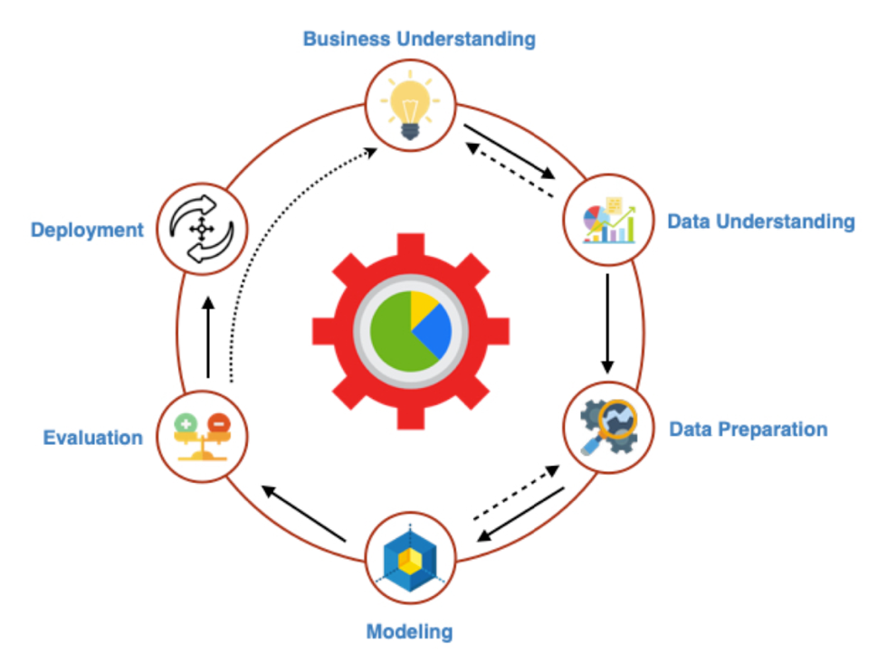

Figure 1. CRISP-DM process [2].

Compared to the original CRISP-DM methodology, it is worth adding a further seventh phase which represents the Monitoring & Feedback coming from the analysis of the results obtained by the model following its use [2].

Analysis and Results

In the Business understanding phase, it is clear that Walmart is currently facing a critical situation due to the exhaustion of stocks of the products sold, linked to the reduction initiatives carried out in certain Holiday periods during the year. This is the goal to be achieved through the use of Machine Learning, that are a series of algorithms by which a computer can learn data, recognize patterns and make decisions in a supervised manner. Supervised learning provides a learning function in which the model is first instructed through Data Training, with known prior data, and then tested to assess the accuracy of the model. This type of approach is considered in the analysis process for Walmart. However, there is also unsupervised learning, in which there is no known prior data and the available data is used to make predictions with inductive methods. The use of Machine Learning algorithms therefore leads to the formation of a mathematical and statistical model capable of providing predictive analysis that provides us with important information on what could happen in the future with a certain probability. Having defined the basis on which to set the analysis, it is important to understand what type of data we need for the design of the model [2]. Carrying out an analysis on a Retail activity, the data relating to Walmart sales are undoubtedly fundamental, divided by period and by shop in which it is possible to easily identify the downturns organized. The data provided to us by the company contains this main information divided into weeks, for 45 stores, with coverage ranging from 2010 to 2012 approximately. Data relating to the territory are also included, such as atmospheric temperature, fuel price, unemployment rate and so on. In this phase of Data Understanding it is clear that the focus of the model design is based on the prediction of sales in order to predict the demand with greater accuracy. The Data Preparation phase and the subsequent ones were carried out using Knime Analytics Platform. In this phase, precisely by virtue of the subsequent training phase of the model, the data in the table are prepared for their use as a reference dataset.
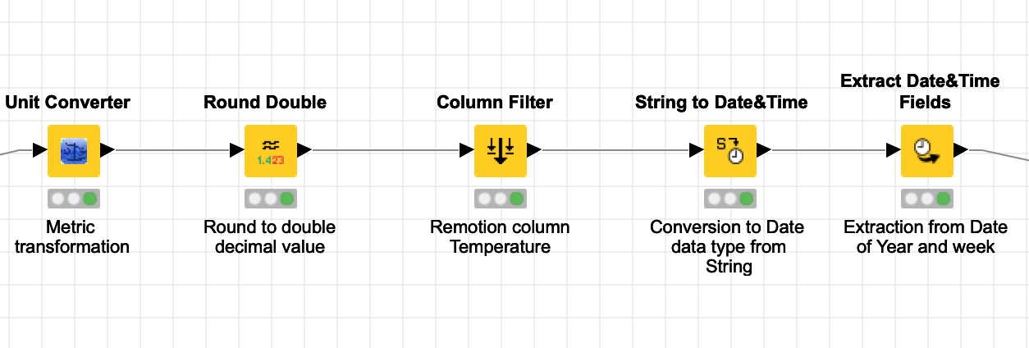
Figure 2. Data Preparation phase. Source(Author)
As can be seen from Fig. 2, only a few simple operations have been carried out, such as conversion from Fahrenheit to Celsius degrees, rounding off the decimal place and extracting the year and week from the date. The dataset thus constituted is ready to be divided into two potions, a Training portion, which constitutes 70% of the data selected in a random manner, and a Test portion, which constitutes 30% of the data selected in a random manner. In the Modelling phase, based on the way in which we have arranged the data in the previous phase, we determine which algorithm to use. In evaluating this decision we rely on the achievement of the target to be achieved: the forecast of sales, a forecast that can be reached through regression. In fact, in the regression models, the value to be estimated, target value, represents a dependent variable to which a certain number of independent variables are associated, represented by the values ​​that make up the dataset. During this phase, three different regression models were considered in order to choose the most performing one.
The first model used is Simple Regression Tree learner, highlighted by the red box in Fig. 3, in which the target value is represented by the weekly sales. The model uses 70% of the dataset for training purposes, in fact after its execution, the model created is transmitted to the Simple Regression Tree Predictor. This node uses 30% of the original dataset and based on the parameters learned in the model it elaborates a prediction based on the target value. At the end of this operation, the resulting final table is populated with an additional column which is represented by the values ​​of the prediction performed for each row of the dataset. In the Evaluation phase, a comparison is made between the values ​​of the weekly sales column and that of the prediction, using the Numeric scorer node, and parameters are obtained that can help us to make an objective evaluation of the model. The box with the resulting parameters of the model can be found on the right side of the red box in Fig. 3 and the parameter that identifies the validity of Data Mining is $R^{2}$ which is a coefficient of determination used in statistics and provides a measure of how the results are replicated by the model; the value of $R^{2}$ oscillates from 0 to 1, in which 1 represents the complete correspondence of the target value with that predicted by the model.
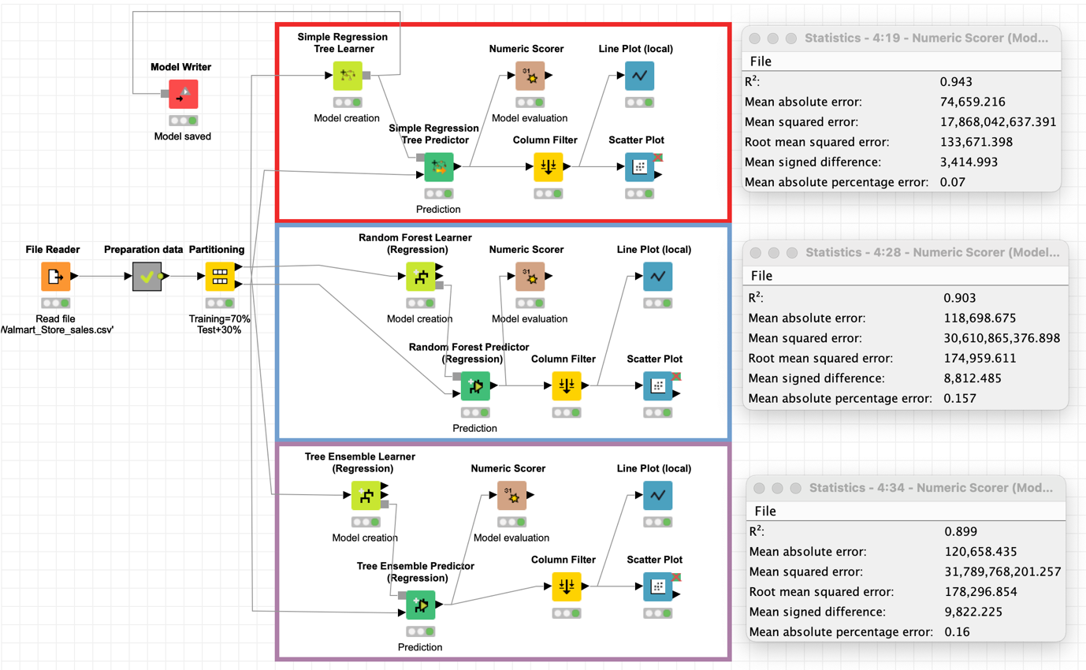
Figure 3. Walmart Data Mining workflow. Source(Author)
In the same way, two other models are used, the Random Forest Learner and the Tree Ensemble Learner which, using the same setting parameters of Simple Regression Tree Learner, they differ in the basic algorithm. At this point, the values relating to the validity of the models can be compared to understand which is the most suitable for our dataset. From a comparison of the results in the boxes of the resulting parameters, it is clear that the most reliable model is the Simple Regression Tree Learner, in fact the $R^{2}$ value is among the highest. Confirmation that comes from the observation of the Linear Plot and Scatter Plot obtained from the processing of each model in the following pictures.

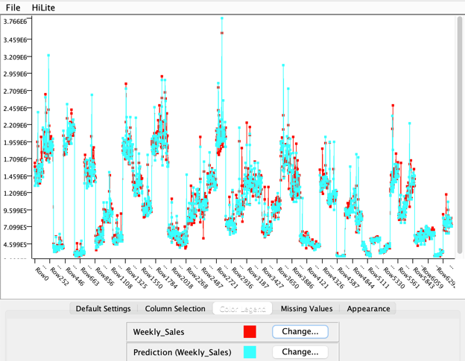  Figure 4. Linear Plot Simple Regression Tree Learner model. Source(Author) | 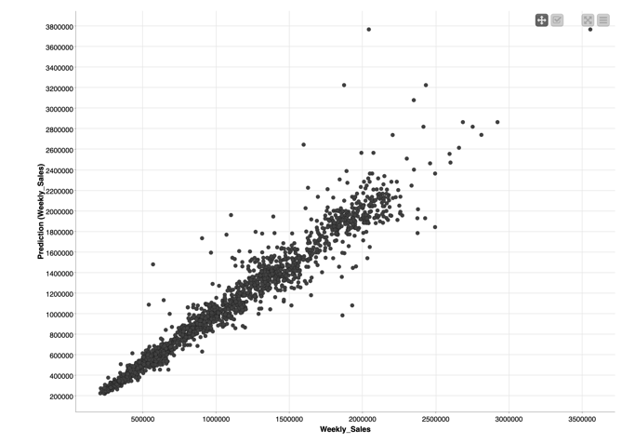  Figure 5. Scatter Plot Simple Regression Tree Learner model. Source(Author)

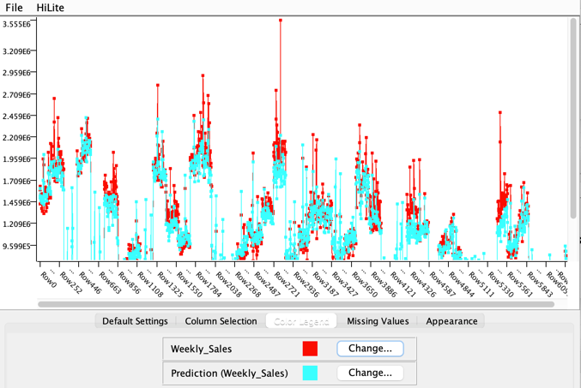  Figure 6. Linear Plot Random Forest Learner model. Source(Author) | 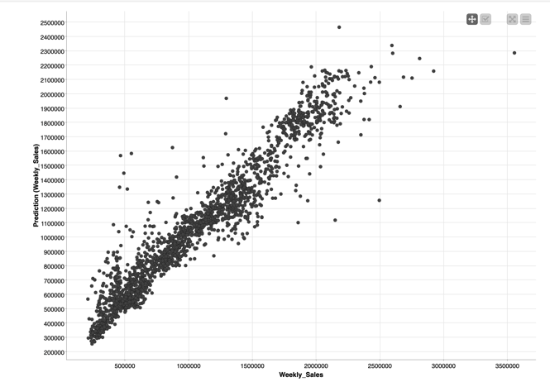  Figure 7. Scatter Plot Random Forest Learner model. Source(Author)

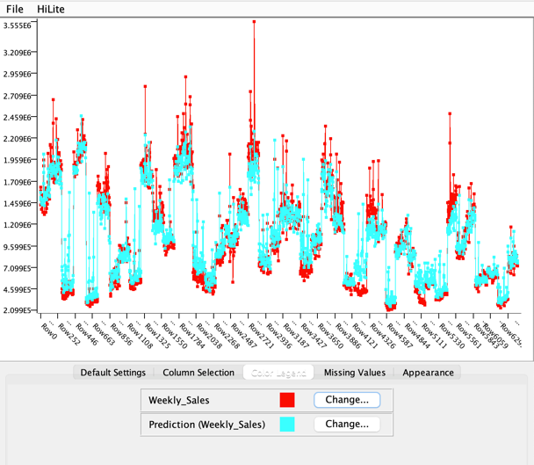  Figure 8. Linear Plot Tree Ensemble Learner model. Source(Author) | 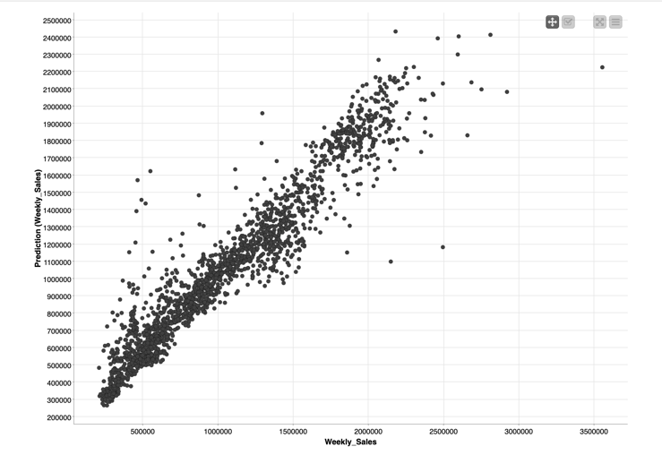  Figure 9. Scatter Plot Tree Ensemble Learner model. Source(Author)
The model chosen is the one developed by the Simple Regression Tree Learner node, for which it is saved and is ready for the subsequent Deployment phase which marks the beginning of the use of the model. Based on the results obtained during the Monitoring & Feedback phase, the model could undergo revisions to increase its reliability [2].
In addition to the development of a model for the forecast of future sales, an assessment was also made on the impact of the discount initiatives corresponding to the Holiday periods.

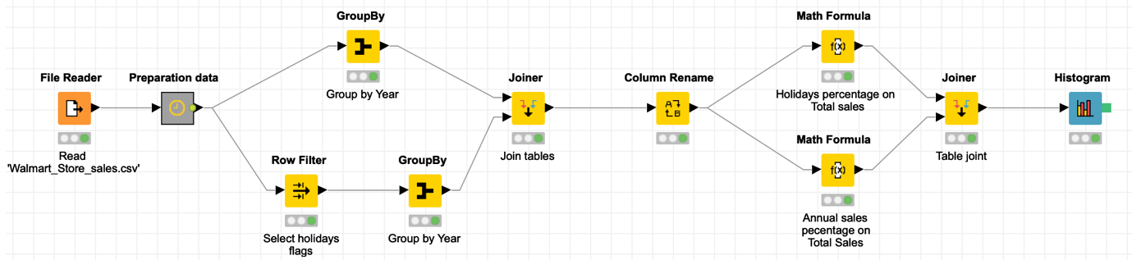
Figure 10. Workflow evaluating the weight of Holiday period on the Total sales. Source(Author)
First of all, a portion of the data containing Holiday flag corresponding to 1 (which indicates the discount period) was extracted from the original dataset, and then a sum of the total Holiday sales divided by year was performed which was compared with total annual sales. The second step involved the calculation of the percentage of sales made in Holiday and the percentage of Total sales. Fig. 11 illustrates the resulting table, which shows that the discount promotions carried out during that period have a very low incidence on total sales, confirming the reduction in sales due to the termination of goods being sold during the periods of greatest turnout.

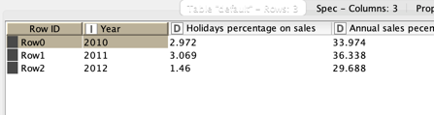  Figure 11. Percentage Holiday Sales. Source(Author) | 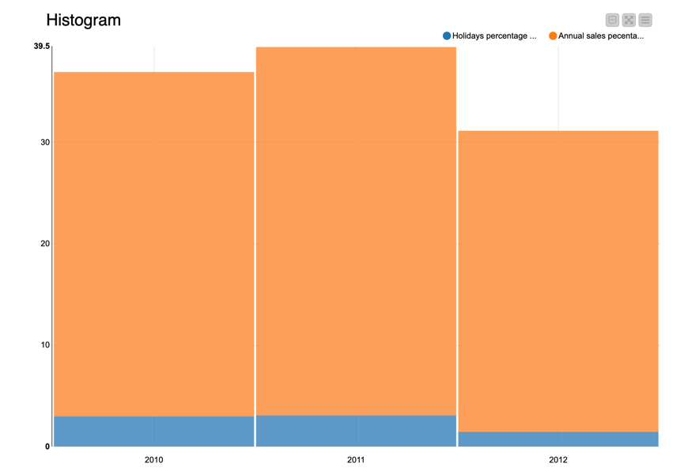  Figure 12. Graphic visualisation of Holiday sales percentage on Yearly sales percentage. Source(Author)

Conclusion

Following the CRISP-MD methodology we have been able to design a prediction model for Walmart which is a more effective alternative to the model currently in use. The model after having passed the successive phases of Monitoring & Feedback must in any case have a constant formation over time, the frequency of which depends on the complexity of the information processed. A constant training allows Machine Learning to continue the learning experience by releasing increasingly reliable predictions [2].

Reference

[1] | Walmart, “Our story,” 2021. [Online]. Available: https://corporate.walmart.com/our-story. [Accessed 02 01 2021].
[2] | D. Gosman, “Machine Learning type,” in Machine Learning, Color edition, 2020, pp. 19-35.
[3] | D. Talia, “Making Knowledge Discovery Services Scalable on Clouds for Big Data Mining,” 2015 2nd IEEE International Conference on Spatial Data Mining and Geographical Knowledge Services, pp. 1-4, 2015.
[4] | C. Z. J. B. H. O. Franziska Schäfer, “Synthesizing CRISP-DM and Quality Management: A Data Mining Approach for Production Processes,” 2018 IEEE International Conference on Technology Management, Operations and Decisions , pp. 190-195, 2018.
[5] | L. C.-O. C. F. J. `. e. H. ´. a.-O. M. K. ´. N. L. M. J. R. ´. ´.-Q. a. P. F. Fernando Mart´ınez-Plumed, “CRISP-DM Twenty Years Later: From Data Mining Processes to Data Science Trajectories,” IEEE Transactions on Knowledge and Data Engineering, 2019.
[6] | the Economist Times, “Data Mining definition,” 2021. [Online]. Available: https://economictimes.indiatimes.com/definition/data-mining. [Accessed 03 01 2021].

