  Component One:  What are the key skills required when working in the housekeeping team? 750 words (+/- 10%)  Contribution to Overall Module Assessment: 25% | Student No: | Sadia Odud  2130037
 | Module Title: | Operating Hotel Facilities
 | Module Code: | BMIH4006
 | Lecturer: | Lola Villard

Essential Abilities Needed for the Cleaning Team
Within the hotel industry, housekeeping is an essential department that is responsible for ensuring that guests have a comfortable and clean environment to stay in while they are staying at a property. In order for a housekeeping crew to function well, it needs to be staffed by personnel who are in possession of a particular set of abilities and attributes. In this essay, I will talk about the most important talents that need to be on the housekeeping team, as well as how theoretical knowledge may be used in the real world. (Baum, 2017)

Care and Focus on Specifics
The ability to pay close attention to detail is one of the most important talents required for housekeeping. The members of the housekeeping crew are responsible for ensuring the cleanliness of each and every component of the guest's room, including changing the linens, dusting the furniture, vacuuming the carpets, and cleaning the bathroom. To make guests feel welcome and at ease, in the space, they are staying in, it is important to pay attention to even the smallest of details, such as how the towels and pillows are arranged. A careful eye for detail requires one to be observant and to immediately report any faults that require repair or any damage to the equipment, furniture, or fixtures. (Brown, 2017)

Teamwork
The ability to communicate clearly and work well with others is absolutely necessary for a team responsible for housekeeping. To ensure that all aspects of the hotel's operation function well, this department collaborates closely with others, such as the maintenance, front desk, and room service departments. In order to give guests an experience that is consistent throughout their stay, the housekeeping staff needs to collaborate with the other departments. For instance, the housekeeping team should coordinate with the kitchen staff and maintenance to address any problems in a timely manner. Also, any room service orders should be communicated to the kitchen staff by the cleaning team. (Choi and Mattila, 2017)

Time Management
Another essential ability required for housekeeping is the ability to manage one's time well. To ensure that guest rooms are ready for check-in at the specified time, the housekeeping team is required to adhere to very stringent timetables. Prioritization and planning are necessary components of effective time management, as they ensure that tasks are performed within the allotted window of time. The cleaning team also has to be able to manage their workload well in order to guarantee that all of the rooms are cleaned and prepared to a high quality. (Duygun and Isik, 2017)

Flexibility
In the hospitality industry, demand and circumstances are consistently shifting in unpredictable ways. The workforce in charge of housekeeping needs to be adaptable in order to keep up with the dynamic nature of the sector. For instance, during the busy season, the amount of work that needs to be done can go up, and the staff might be forced to put in more hours or take on more responsibilities. When it comes to providing guests with a smooth experience, having a flexible mindset and the willingness to adjust to changing conditions are absolutely necessary.

Use of Conceptual Understanding in Practical Settings
The theoretical understanding of hospitality that one obtains through classes can be effectively implemented in the housekeeping department. For instance, if housekeeping employees have an understanding of cleaning chemicals and how to apply them correctly, it will be easier for them to identify suitable products to use for various surfaces and materials. It is possible to help ensure that rooms are prepared to a high degree and fulfil the industry's requirements for hygiene by gaining an understanding of the necessary techniques for cleaning and sanitising. In addition to this, having staff members who are familiar with inventory management can assist with maintaining adequate stock levels of cleaning materials and equipment.
In the hospitality industry, the importance of housekeeping cannot be overstated.
It is impossible to place enough emphasis on the significance of housekeeping in the hospitality business. The level of comfort and cleanliness of a hotel room are two of the most important aspects that determine a guest's overall impression of their stay at a property. When a guest stays in a room that has been well-maintained, they are more likely to leave a positive review, return to the hotel, and spend more money overall. On the other hand, inadequate housekeeping can result in unfavourable online evaluations, a decrease in sales, and harm to the hotel's brand. As a result, it is essential to keep high standards of cleanliness and presentation in order to guarantee that customers have a pleasant experience and that the hotel is successful over the long term. (Graci and Dodds, 2017)
Word Count | 790

Component Two:
Contribution to Overall Module Assessment: 25%
In this scenario – You have just been promoted to team leader for a floor within the hotel. A guest complains that on their arrival, their room had not been properly cleaned. Create an action plan and answer the following questions.
Problem | Why did it happen? | What are you going to do? | How will you prevent this from happening in the future? | What measures would you introduce to improve team effectiveness?
A guest complained that their room was not properly cleaned upon arrival. | There could be several reasons why the guest's room was not properly cleaned. It could be due to a lack of attention to detail, inadequate training of the staff, a shortage of cleaning supplies or equipment, or miscommunication between the housekeeping staff and other departments. (Guerrier and Nault, 2017) | As a team leader, my immediate action would be to apologize to the guest and assure them that will take appropriate action to address the issue. I would personally visit the room and inspect it to identify any specific areas of concern. If necessary, I would assign a member of the housekeeping staff to re-clean the room to the guest's satisfaction. (Heo, Lee and Park, 2017) | To prevent similar incidents from occurring in the future, I would introduce several measures. Firstly, I would review the current cleaning procedures with the staff to ensure that they are aware of the proper cleaning standards and expectations. Secondly, I would conduct regular training sessions to reinforce the importance of attention to detail and effective communication within the team. Thirdly, I would ensure that there is an adequate inventory of cleaning supplies and equipment to ensure that the staff has the resources they need to perform their duties. Finally, I would encourage the staff to report any issues or concerns promptly so that they can be addressed in a timely manner. | To improve team effectiveness, I would introduce several measures. Firstly, I would establish clear expectations and goals for the team, and regularly review their performance against these goals. Secondly, I would encourage open communication and collaboration within the team, as well as with other departments such as maintenance and the front desk. Thirdly, I would provide opportunities for professional development and training to enhance the skills and knowledge of the staff. Finally, I would recognize and reward outstanding performance and contributions to the team to foster a positive work environment and motivate the staff to strive for excellence. In the hospitality industry, providing high-quality housekeeping services is critical to ensuring guest satisfaction and loyalty. As a team leader, it is essential to take immediate action to address any issues that arise and to introduce measures to prevent similar incidents from occurring in the future. Effective leadership, clear communication, and collaboration are key to improving team effectiveness and ensuring that the housekeeping department operates efficiently and successfully. (Huang, Law andare Liang, 2017)

Component Three:
Contribution to Overall Module Assessment: 50%
Your task is to create and prepare a presentation following the detailed scenario provided below.
As the floor housekeeping manager and given the recent guest complaints you need to put together a basic training presentation for your colleagues within the housekeeping team to get the best out of them, ensure that brand standard is being achieved and that Health and Safety procedures are also being followed.
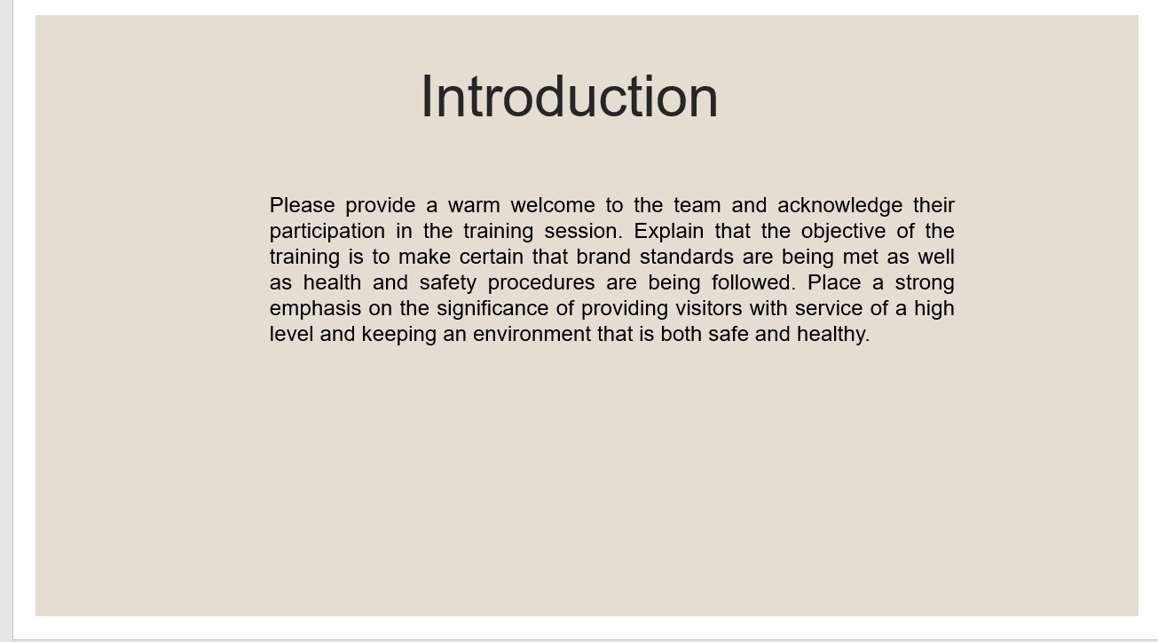
Training Notes:

Please provide a warm welcome to the team and acknowledge their participation in the training session. Explain that the objective of the training is to make certain that brand standards are being met as well as health and safety procedures are being followed. Place a strong emphasis on the significance of providing visitors with service of a high level and keeping an environment that is both safe and healthy.

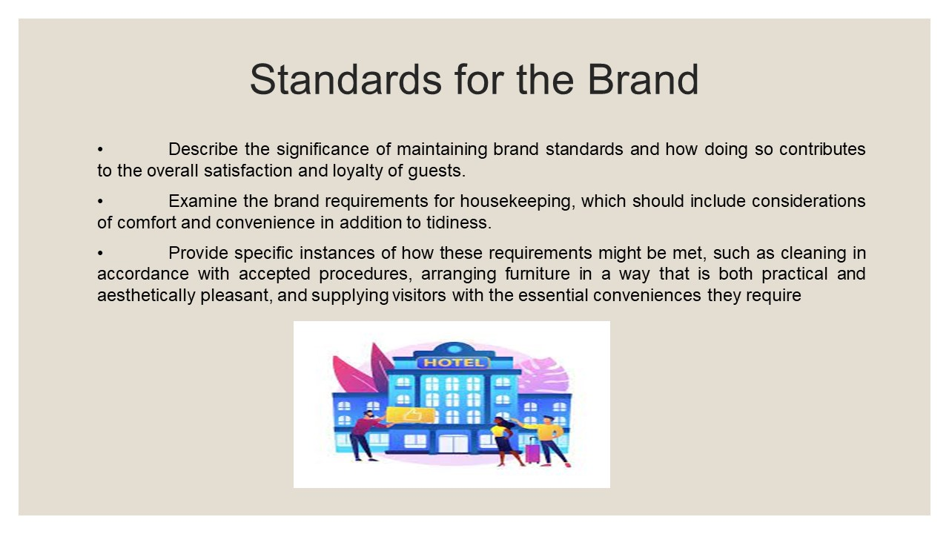
Training Notes:
• Describe the significance of maintaining brand standards and how doing so contributes to the overall satisfaction and loyalty of guests.
• Examine the brand requirements for housekeeping, which should include considerations of comfort and convenience in addition to tidiness.
• Provide specific instances of how these requirements might be met, such as cleaning in accordance with accepted procedures, arranging furniture in a way that is both practical and aesthetically pleasant, and supplying visitors with the essential conveniences they require
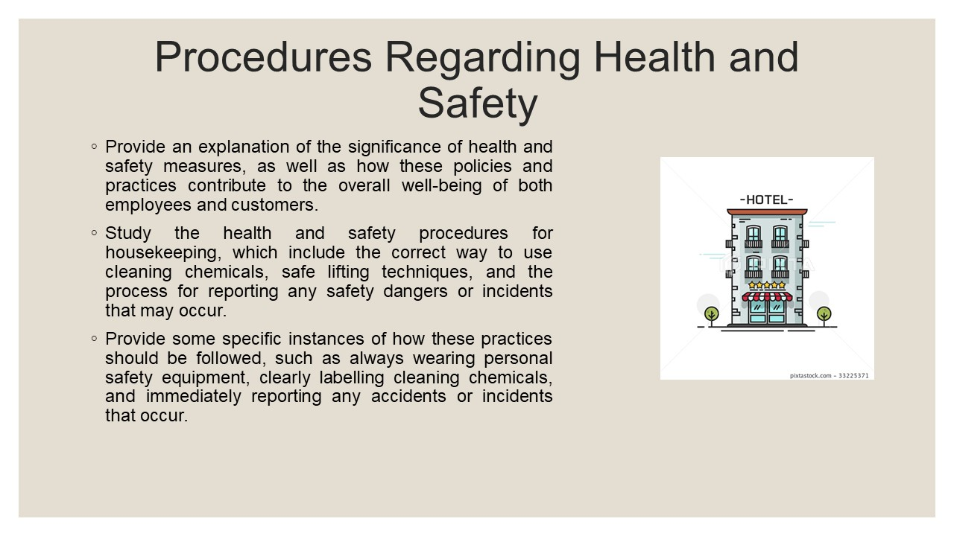
Training Notes:

Provide an explanation of the significance of health and safety measures, as well as how these policies and practices contribute to the overall well-being of both employees and customers.

Study the health and safety procedures for housekeeping, which include the correct way to use cleaning chemicals, safe lifting techniques, and the process for reporting any safety dangers or incidents that may occur.

Provide some specific instances of how these practices should be followed, such as always wearing personal safety equipment, clearly labelling cleaning chemicals, and immediately reporting any accidents or incidents that occur.)
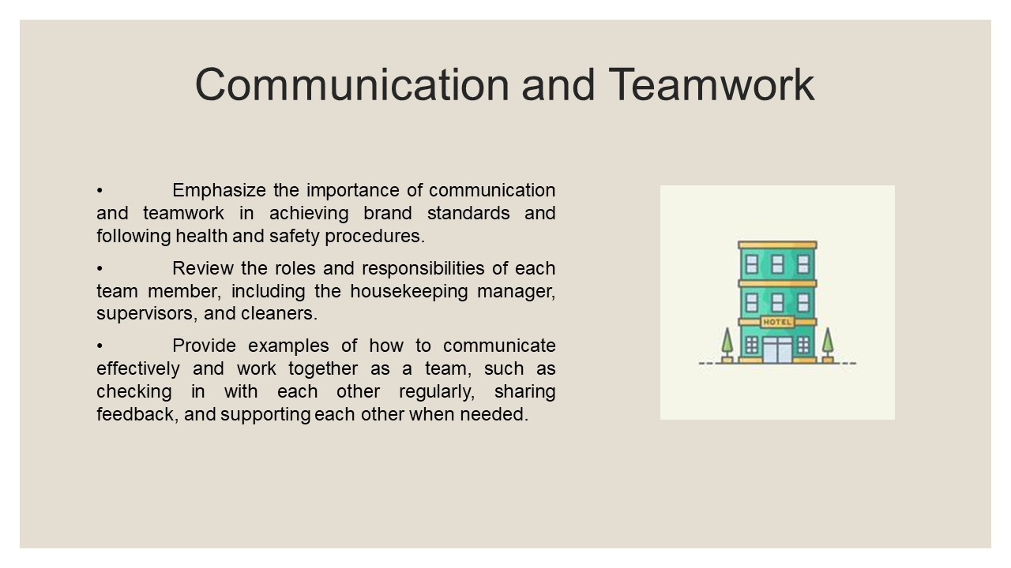
Training Notes:
• Emphasize the importance of communication and teamwork in achieving brand standards and following health and safety procedures.
• Review the roles and responsibilities of each team member, including the housekeeping manager, supervisors, and cleaners.
• Provide examples of how to communicate effectively and work together as a team, such as checking in with each other regularly, sharing feedback, and supporting each other when needed.
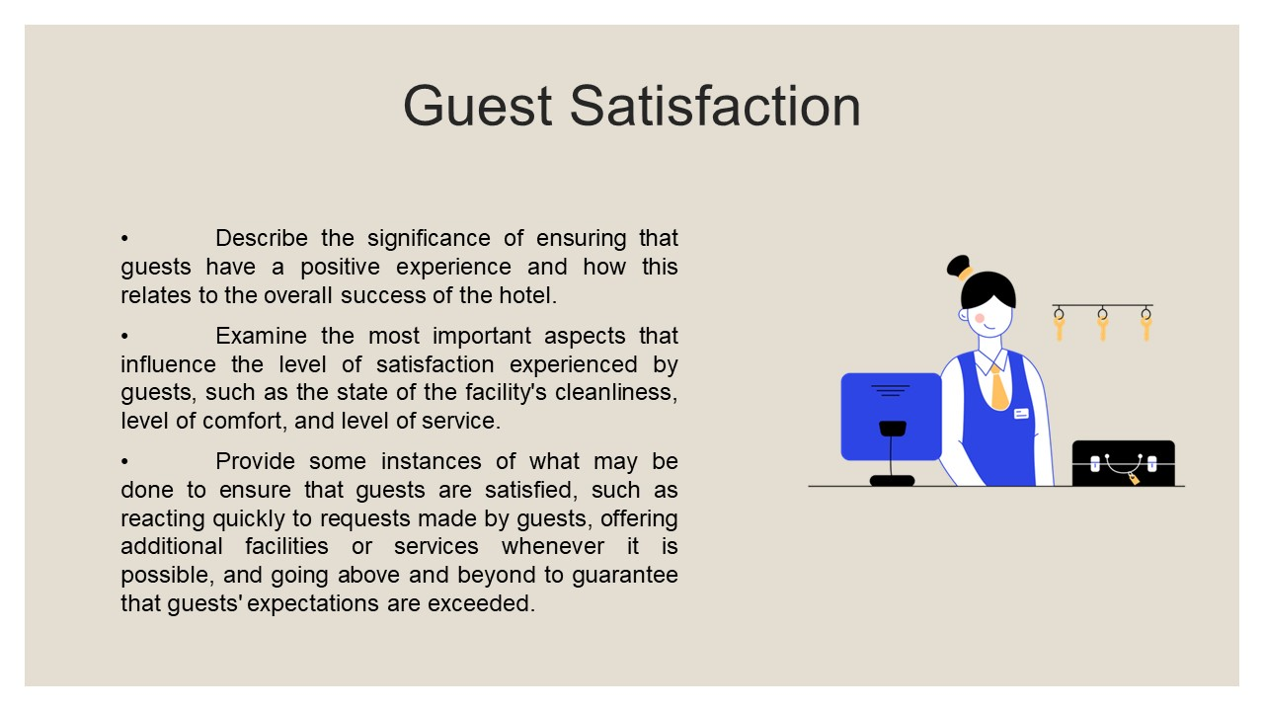
Training Notes:
- Describe the significance of ensuring that guests have a positive experience and how this relates to the overall success of the hotel.
- Examine the most important aspects that influence the level of satisfaction experienced by guests, such as the state of the facility's cleanliness, level of comfort, and level of service.
- Provide some instances of what may be done to ensure that guests are satisfied, such as reacting quickly to requests made by guests, offering additional facilities or services whenever it is possible, and going above and beyond to guarantee that guests' expectations are exceeded.

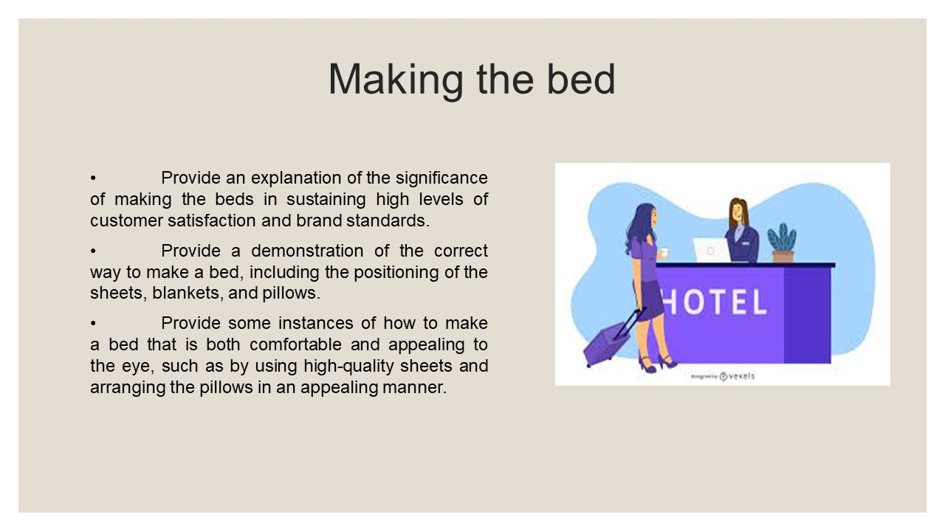
Training Notes:
- Provide an explanation of the significance of making the beds in sustaining high levels of customer satisfaction and brand standards.
- Provide a demonstration of the correct way to make a bed, including the positioning of the sheets, blankets, and pillows.
- Provide some instances of how to make a bed that is both comfortable and appealing to the eye, such as by using high-quality sheets and arranging the pillows in an appealing manner.
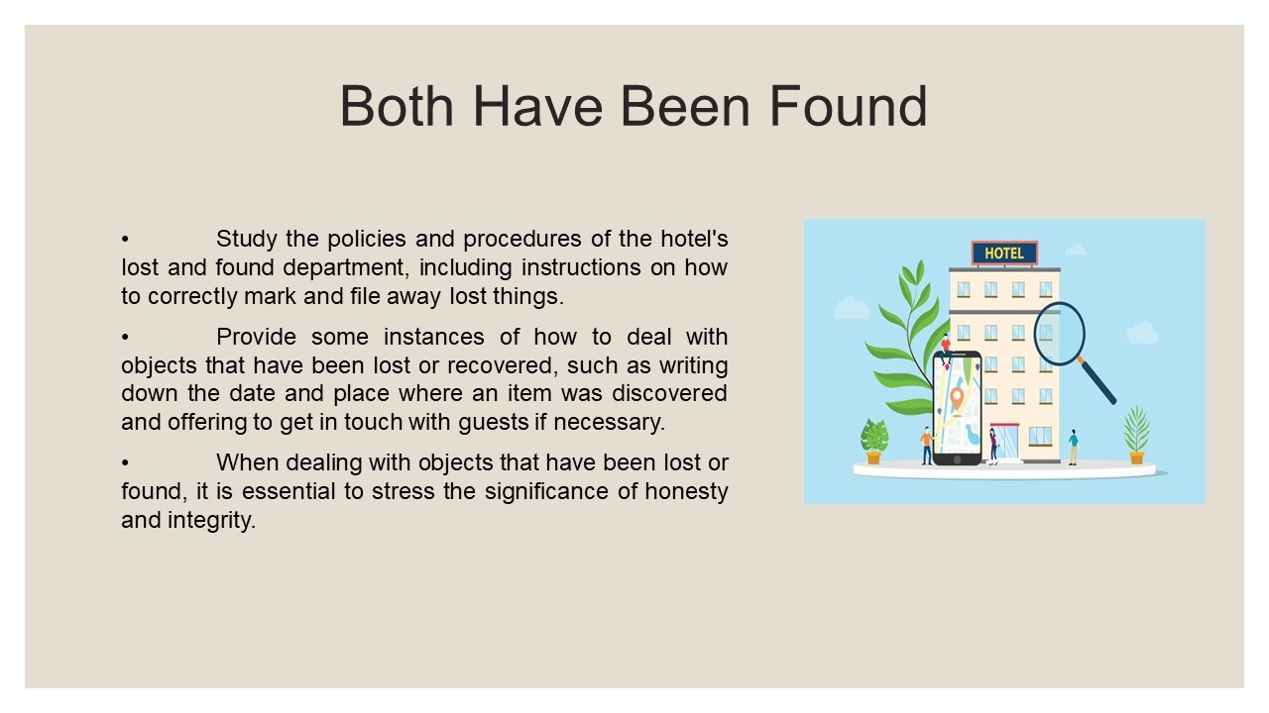
Training Notes:
• Study the policies and procedures of the hotel's lost and found department, including instructions on how to correctly mark and file away lost things.
• Provide some instances of how to deal with objects that have been lost or recovered, such as writing down the date and place where an item was discovered and offering to get in touch with guests if necessary.
• When dealing with objects that have been lost or found, it is essential to stress the significance of honesty and integrity.
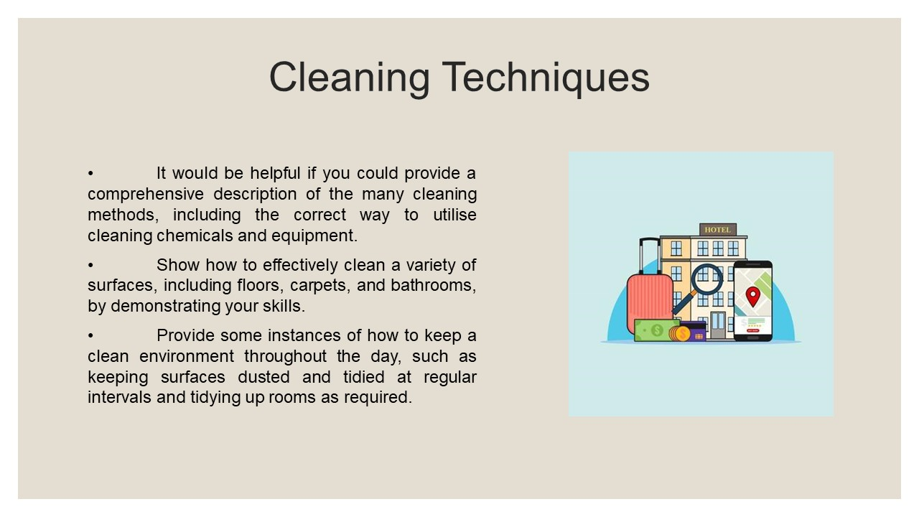
Training Notes:
• It would be helpful if you could provide a comprehensive description of the many cleaning methods, including the correct way to utilise cleaning chemicals and equipment.
• Show how to effectively clean a variety of surfaces, including floors, carpets, and bathrooms, by demonstrating your skills.
• Provide some instances of how to keep a clean environment throughout the day, such as keeping surfaces dusted and tidied at regular intervals and tidying up rooms as required.
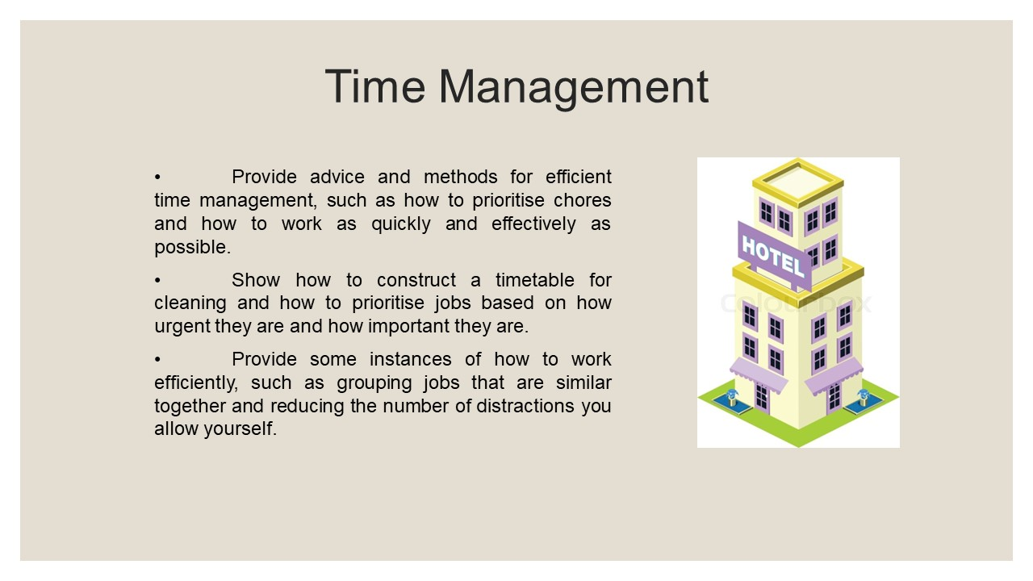
Training Notes:
• Provide advice and methods for efficient time management, such as how to prioritise chores and how to work as quickly and effectively as possible.
• Show how to construct a timetable for cleaning and how to prioritise jobs based on how urgent they are and how important they are.
• Provide some instances of how to work efficiently, such as grouping jobs that are similar together and reducing the number of distractions you allow yourself.
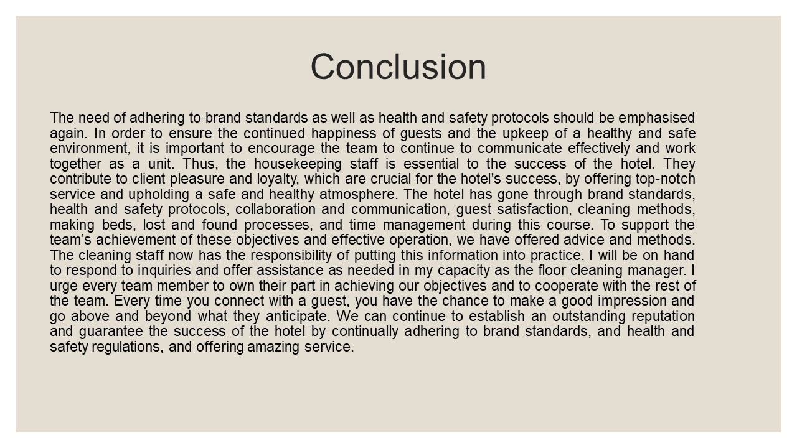
Training Notes:
The need of adhering to brand standards as well as health and safety protocols should be emphasised again. In order to ensure the continued happiness of guests and the upkeep of a healthy and safe environment, it is important to encourage the team to continue to communicate effectively and work together as a unit. Thus, the housekeeping staff is essential to the success of the hotel. They contribute to client pleasure and loyalty, which are crucial for the hotel's success, by offering top-notch service and upholding a safe and healthy atmosphere. The hotel has gone through brand standards, health and safety protocols, collaboration and communication, guest satisfaction, cleaning methods, making beds, lost and found processes, and time management during this course. To support the team’s achievement of these objectives and effective operation, we have offered advice and methods. The cleaning staff now has the responsibility of putting this information into practice. I will be on hand to respond to inquiries and offer assistance as needed in my capacity as the floor cleaning manager. I urge every team member to own their part in achieving our objectives and to cooperate with the rest of the team. Every time you connect with a guest, you have the chance to make a good impression and go above and beyond what they anticipate. We can continue to establish an outstanding reputation and guarantee the success of the hotel by continually adhering to brand standards, and health and safety regulations, and offering amazing service.

References
Baek, S., and Lee, S. (2016). The effect of price perception and fairness on hotel customers' revisit intentions: A study of luxury hotels in South Korea. Journal of Travel & Tourism Marketing, 33(4), 425-442.
Baum, T. (2017). The dark side of service work: A comparative analysis of women's work experiences in hotel housekeeping in the USA, UK and Thailand. Gender, Work & Organization, 24(6), 568-581.
Brown, J. R. (2017). Developing human capital in hospitality: A review of current research and recommendations for future study. Journal of Hospitality & Tourism Research, 41(6), 717-742.
Choi, J., and Ok, C. (2016). Understanding guests' behavioural intentions in luxury hotels: Role of emotions in experiential service encounters. International Journal of Hospitality Management, 52, 1-12.
Choi, S., and Mattila, A. S. (2017). The impact of sustainability initiatives on hotel guest satisfaction: A comparison between environmentally-focused and socially-focused initiatives. Journal of Sustainable Tourism, 25(1), 69-87.
Duygun, A. B., and Isik, O. (2017). The effect of hotel facility quality on customer satisfaction and loyalty: Evidence from Turkish five-star hotels. Tourism Management Perspectives, 23, 1-10.
Eichhorn, P., and Truong, N. (2016). Understanding the relationship between hotel room rates and guest satisfaction: A revenue management perspective. International Journal of Hospitality Management, 53, 59-70.
Graci, S., and Dodds, R. (2017). The impact of hotel reviews on consumer purchase behaviour: A study of hotel properties in the United States. Journal of Hospitality Marketing & Management, 26(4), 355-369.
Guerrier, Y., and Nault, É. (2017). The impact of hotel employees’ work environment on their intention to stay: An empirical study. International Journal of Contemporary Hospitality Management, 29(3), 1119-1136.
Han, H., and Hyun, S. S. (2016). Drivers of guests' positive word-of-mouth intention in luxury hotels. International Journal of Hospitality Management, 57, 148-157.
Heo, C. Y., Lee, S., and Park, J. (2017). The influence of hotel employees' service orientation on guest satisfaction and loyalty: An empirical study. International Journal of Hospitality Management, 66, 38-49.
Huang, R., Law, R., and Liang, J. (2017). An examination of the effects of social media on hotel performance: The case of luxury hotels in Taiwan. International Journal of Hospitality Management, 66, 91-100.
Kim, D., and Kim, J. (2016). An empirical study of hotel employee turnover and retention in Korea. Journal of Human Resources in Hospitality & Tourism, 15(4), 439-455.
Kim, J., and Lee, T. J. (2016). The effect of hotel sustainability management on brand image, customer satisfaction and loyalty. Journal of Sustainable Tourism, 24(5), 645-666.
Kim, S. S., and Park, S. (2016). The effects of food quality, service quality, and price fairness on customer satisfaction and behavioural intentions in upscale restaurants. Journal of Hospitality and Tourism Research, 40(6), 720-748.
Lee, Y. K., and Lee, C. K. (2016). The effect of hotel room price on perceived service quality and value in the hotel industry. Journal of Travel & Tourism Marketing, 33(6), 847-862.
Shin, Y. H., and Mattila, A. S. (2016). The effect of service failure severity, service recovery, and hospitality on customer satisfaction: A study of upscale hotels. Journal of Hospitality and Tourism Management, 29, 15-23.
Wang, D., and Li, X. (2016). An empirical study of customer satisfaction in upscale hotels: Evidence from China. Journal of Hospitality and Tourism Management, 28, 10-18.
Wang, D., Li, X., and Liang, X. (2016). Investigating the effects of environmental practices on hotel financial performance: Evidence from China. International Journal of Hospitality Management, 55, 1-10.
Xiao, Q., and Chen, J. (2016). The impact of hotel green practices on guest satisfaction and loyalty. International Journal of Hospitality Management, 52, 62-70.

